Logging a support ticket for eMHA
Internal Staff menbers
- Login to Service now via the application on your desktop
- Select Raise a request a shown in Fig 1.0
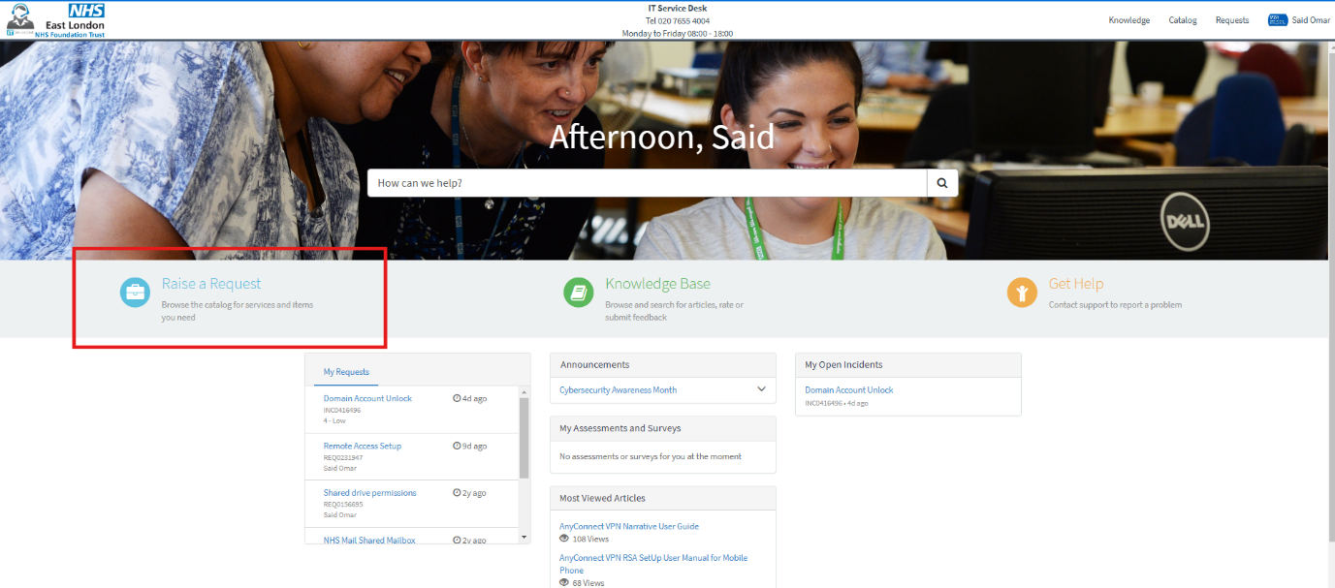
Fig 1.0

- Select Clinical Systems as shown in Fig 1.1
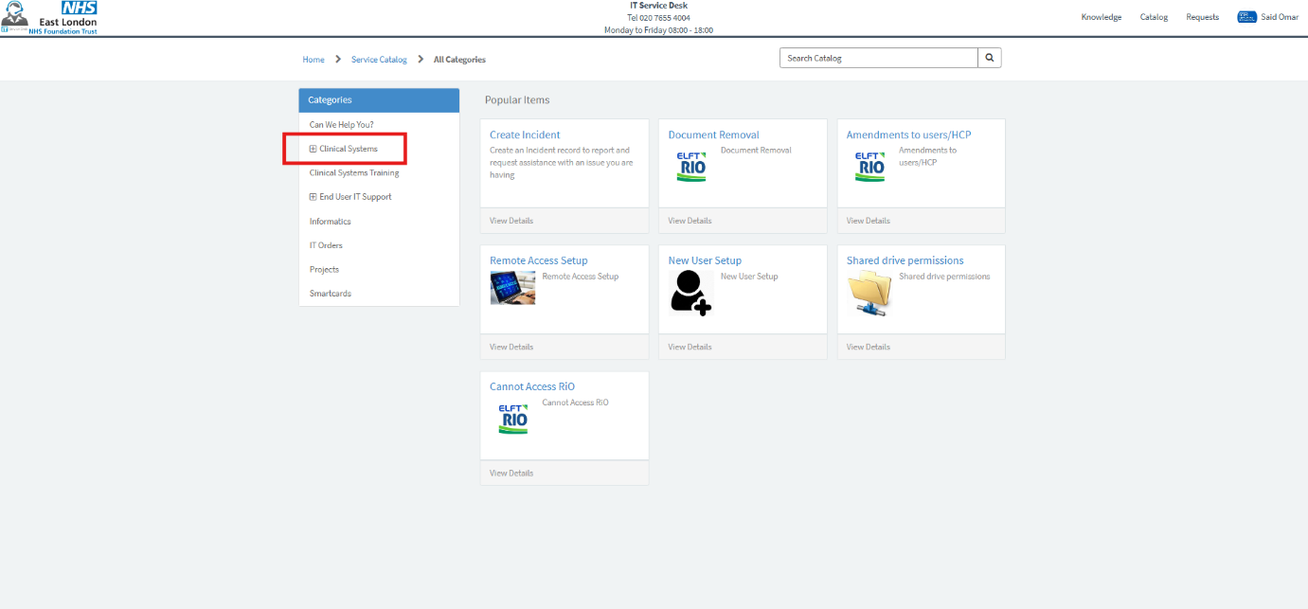
Fig 1.1

- Complete the form as shown in Fig 1.2 and select complete request.
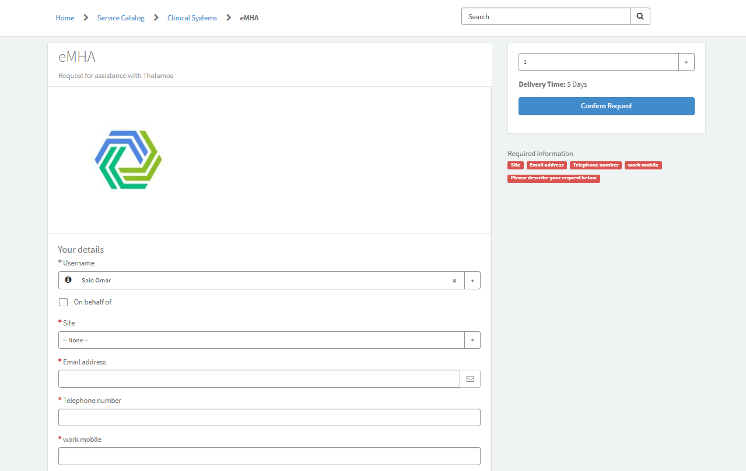
Fig 1.2

External Team members

You can submit a request for help via eastlondon@service-now.com or call 020 76554004.
For general enquiries the service desks operating hours are between
08:00 - 18:00 Monday to Friday.
For clinical enquiries operating hours are between 09:00- 17:00
Monday to Friday.
Follow your usual working processes for out of hours support.

