REMINDER: EPMA - How to Request Training

Dear Colleague,

We are changing the way we take training requests for EPMA.

All training requests will need to be made through the IT Service Desk Portal. We will no longer be able to take requests via email, Teams or over the phone.

How do I request EPMA training on the IT Service Desk Portal?

1. Access the IT Service Desk Portal through the desktop icon. |  | 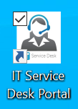

2. Raise a request. |  | 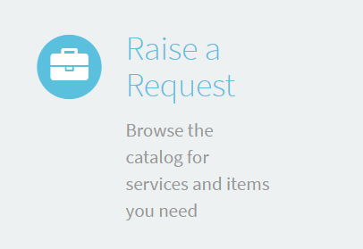

3. Select 'Clinical Systems Training' from the 'Categories' menu on the left-hand side and then 'Clinical System Training'. |  | 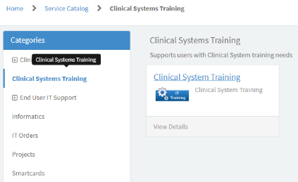

4. Complete the form ensuring you select 'EPMA' as the Clinical System you wish to be trained on and the most appropriate option for 'EPMA Training Required'. You will also have an opportunity in this form to specify the directorate you're working under, any dates you're unavailable for training and the details of another member of staff if completing the form on their behalf. Please see a section of the from to the right. |  | 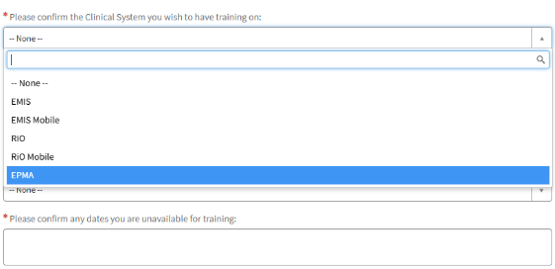

5. Once you've submitted the form, a member of the EPMA Training Team will contact you to organise your training session.

Kind regards,

The EPMA Team
elft.epma@nhs.net

