

Code of Conduct for All Staff

Version number: | 1.1
Consultation Groups | Joint Staff Committee
Approved by (Sponsor Group) | Joint Staff Committee Sub-Group
Date approved | 12th November 2024
Ratified by: | Joint Staff Committee
Date ratified: | 4 December 2024
Name of originator/author: | Staff side  People Business Partners
Executive Director lead: | Chief People Officer
Implementation Date: | 4 December 2024
Last Review Date | November 2024
Next Review Date: | November 2027

Services | Applicable
Trust wide | x
Mental Health and LD
Community Health Services

Version Control Summary

Version | Date | Author | Status | Comment
1 | August 2024 | Staff side  People Business Partner | Approved by JSC Policy Sub-Group but not JSC: as further updates requested | Code of Conduct has been separated from the Professional Boundaries and Relationship Policy and Code of Conduct for all Staff v 2.2, taking account some recommendations from Tower Hamlets CHS colleagues. Minor changes were made to the Code of Conduct during the review by Staff side and People and Culture.
1.1 | November 2024 | Staff side  People Business Partners |  | Updating Policy to take account of the NHS Sexual Safety in Healthcare Charter and the Worker Protection (Amendment of Equality Act 2010) Act 2023

Contents
1. Introduction 4
2. Aim of the Code of Conduct 4
3. Scope of Code of Conduct 4
4. Responsibilities 4
5. Trust Values, Vision and Behavioural and Leadership Frameworks 5
6. Sexual Safety in the Workplace 6
7. The Code of Conduct – 10 Key Professional Standards 6
8. Failure to Follow the Code of Conduct 7
9. Dissemination and Implementation of the Code of Conduct 7
10. Process for Monitoring Compliance and Effectiveness 7
Appendix A - ELFT Behavioural Framework 9
Appendix B - ELFT Leadership Framework 10

Introduction

  - This Code of Conduct is for all staff at the East London NHS Foundation Trust (herein referred to as ELFT). It details the values and standards that underpin all that we do in our daily working lives and the expected behaviours from all of our staff.

Aim of the Code of Conduct

  - The aim of the Code of Conduct is to make clear the key behaviours that are acceptable and unacceptable in the workplace. It is written as a set of general principles or standards rather than detailed prescriptions.

  - These standards and behaviours are not an exhaustive list and the Code of Conduct operates alongside other relevant Trust policies including but not limited to the Professional Boundaries and Relationship Policy, Dress Code Policy, Freedom to Speak Up (previously Raising Concerns/Whistleblowing) Policy, Disciplinary Policy, Dignity at Work Policy and the Standards of Business Conduct Policy. There policies are found on the internet, link here.

  - This Code has been designed to supplement rather than replace professional standards of behaviour and codes of conduct including but not limited to the GMC Code of Conduct, NMC Code of Conduct, and HCPC Code of Conduct.

Scope of Code of Conduct

  - This Code of Conduct is applicable to all staff at ELFT including substantive staff, staff on fixed term contracts, staff on honorary contracts, bank staff, agency staff, contractors, students, volunteers, secondees.

Responsibilities

  - It is the responsibility of all staff to:

    - Read the Code of Conduct and discuss with their line manager, any issues they are unsure about.

    - To ensure their behaviour is consistent with the Code of Conduct and other relevant policies.

    - Take appropriate action when they directly experience or observe behaviour, which they consider to be inappropriate by keeping a factual record of the incident (e.g. date, time, location, nature of the behaviour and witnesses) and to report this to their line manager or People and Culture department or Staffside representative or Freedom to Speak Up Guardian.

    - If appropriate, ask the person responsible for the behaviour to stop behaving in a certain way. This action should only be taken if the staff member is comfortable with interacting directly with the person responsible for the behaviour.

    - Acknowledge that they have read and understood the Code of Conduct.

  - It is the responsibility of line managers and supervisors to ensure:

    - Staff have access to copies of the Code of Conduct

    - The requirements of the Code of Conduct are reflected in the day-to-day management of their staff

    - Use the annual appraisal and supervision to discuss the code of conduct and/or behavioural expectations

    - Provide constructive feedback to staff about their behaviour

    - Take all necessary steps to resolve any conflicts that arise in the workplace

    - Appropriately deal with staff who do not meet the expected code of conduct or behavioural standards using the most appropriate policy, and if in doubt, to seek advice from the People and Culture department.

Trust Values, Vision and Behavioural and Leadership Frameworks

  - The Trust understands that different behaviours are acceptable in different environments. To provide guidance to staff, ELFT expect all staff to follow the Trust Values, the Trust Vision and the Behavioural Framework.

  - ELFT has three core values that underpin everything we do. The core values are:

- We Care – everyone is entitled to the highest quality care.
- We Respect – everyone should be treated with kindness and respect.
- We are Inclusive – everyone should have access to our services when they need them, and we actively seek suggestions from all on how we can improve.

  - Furthermore, The Trust’s mission is to improve the quality of life for all that we serve and by 2026 we will build on our success and lead on the delivery of integrated care. ELFT will do this by working purposefully in collaboration with our communities and our partners, always striving towards continuous improvement in everything we do. In order to achieve our vision ELFT’s main priorities are:

- Improving Population Health Outcomes
- Improving the Experience of Care
- Improving the Experience of Staff
- Improving Value

  - The Behavioural Framework (Appendix A) further demonstrates the expectation from all staff that underpin all that we do in our daily working lives and behaviours that we expect from all of our staff.

  - In addition to this, all staff should aim to practice leadership behaviours as noted in the ELFT Leadership Framework (Appendix B). The framework has three categories: leadership behaviours which all staff should display, additional leadership behaviours for staff who lead teams, and further leadership behaviours for senior leaders.

Sexual Safety in the Workplace

  - The Worker Protection (Amendment of Equality Act 2010) Act 2023, which came into effect on 26th October 2024, places a duty on ELFT to prevent sexual harassment of its staff. The legislation states that an organisation must ‘take reasonable steps to prevent sexual harassment of employees’ while they work with the organisation.

  - The Trust is able to carry out the above duty because it has signed up to the NHS Sexual Safety in Healthcare Charter 2023, committing to a zero tolerance approach to any sexual misconduct in the workplace.

  - The Trust therefore commits to the Charter’s principles, namely:

- We will actively work to eradicate sexual harassment and abuse in the workplace.
- We will promote a culture that fosters openness and transparency, and does not tolerate unwanted, harmful and/or inappropriate sexual behaviours.
- We will take an intersectional approach to the sexual safety of our workforce, recognising certain groups will experience sexual harassment and abuse at a disproportionate rate.
- We will provide appropriate support for those in our workforce who experience unwanted, inappropriate and/or harmful sexual behaviours.
- We will clearly communicate standards of behaviour. This includes expected action for those who witness inappropriate, unwanted and/or harmful sexual behaviour.
- We will ensure appropriate, specific, and clear policies are in place. They will include appropriate and timely action against alleged perpetrators.
- We will ensure appropriate, specific, and clear training is in place.
- We will ensure appropriate reporting mechanisms are in place for those experiencing these behaviours.
- We will take all reports seriously and appropriate and timely action will be taken in all cases.
- We will capture and share data on prevalence and staff experience transparently.

  - All staff must therefore conduct themselves in a professional manner at all times whilst at work, and, must not behave in a sexually inappropriate way towards staff, patients and other people who visit our services.

The Code of Conduct – 10 Key Professional Standards

  - In addition to the Trust core values, vision and the frameworks noted above, there are 10 key standards that are expected of staff and are considered to be central to improving patient and staff experience. These reflect the vision and values of ELFT. These are:

- To work co-operatively within teams and to treat your colleagues with dignity and respect, in line with the Behavioural Framework (Appendix A).

- To never put a service user at risk either physically, mentally, financially, emotionally or sexually.

- To understand that the staff-patient relationship is not equal and that all staff are in a unique position of trust, care, responsibility, authority and influence with service users.

- To provide good, strong and trusting relationships with service users and understand that you should be friendly, but you are not “friends”.

- To maintain and adhere to boundaries of the profession and to personal and social boundaries including social media boundaries.

- To dress in accordance with ELFT Dress Code Policy. (Link to ELFT Policies is found here).

- To avoid using your official position or information acquired in the course of your employment to further your private interests.

- To be accountable for all of your actions by making sure you can answer for your actions or omissions.

- To implement all statutory and mandatory training in the workplace.

- To undertake duties in line with your role and responsibilities.

Failure to Follow the Code of Conduct

  - Failure to follow the Code of Conduct may result in disciplinary/capability action.

Dissemination and Implementation of the Code of Conduct

  - The Code of Conduct will be introduced to staff by:

- Induction
- Chief Executive/Director briefings accessible by all staff
- Electronic communications
- Line Managers
- Intranet

Process for Monitoring Compliance and Effectiveness

  - The following processes will be used to monitor the impact of the code:

- Patient complaints
- Patient survey
- Patient experience tracker
- Staff survey
- Informal and Formal Employee Relations cases

Appendix A - ELFT Behavioural Framework

VALUE | INDIVIDUAL
We Care
Empathy | I use empathy to understand others’ feelings and respond appropriately.
Understanding impact of actions | I use self-awareness to understand the impact of my actions on others and can adapt my behaviour according to the person and situation I am dealing with.
Kindness | My language, tone and actions are always kind and considerate when dealing with patients and service users, their families and my colleagues. This includes verbal and email communication.
Going the extra mile | I regularly go the extra mile to play my part in delivering the best possible care for our patients and service users.
Listening | I make time to ask how people are and to listen carefully to them when they talk to me.
We respect
I can put myself in your shoes | I recognise that we are all different and always try to put myself in others’ shoes to see things from their perspective.
Trustworthy | I am honest and always act with integrity.
Active listening | I listen actively and with an open mind to patients, service users, families and colleagues, asking questions to help me understand their point of view.
Respecting dignity and privacy | I am always looking for ways to protect the dignity, privacy and confidentiality of patients, service users and colleagues.
Managing expectations | I deliver on my promises; when I can’t deliver what is expected of me by colleagues, patients, service users or families, I am clear about what they can expect and why.
We are inclusive
Having a can-do attitude & solution-oriented approach | I am quick to find solutions to problems and am always positive about what can be done to deliver the highest standard of care.
Flexibility | I am flexible and adaptable when things change and do my bit to make change successful.
Knowing when change is necessary | I recognise when change is necessary to improve things.
Removing barriers | Where barriers exist between people, whether physical or emotional, I do my best to remove them.
Recognising difference | I treat everyone as a unique and valued individual, recognising, accepting and celebrating difference.
Involvement in Quality Improvement (QI)
Curiosity | I am always looking for ways to improve the services that I provide
Dedication | I work hard to deliver what is expected of me and set high standards for myself.

Appendix B - ELFT Leadership Framework
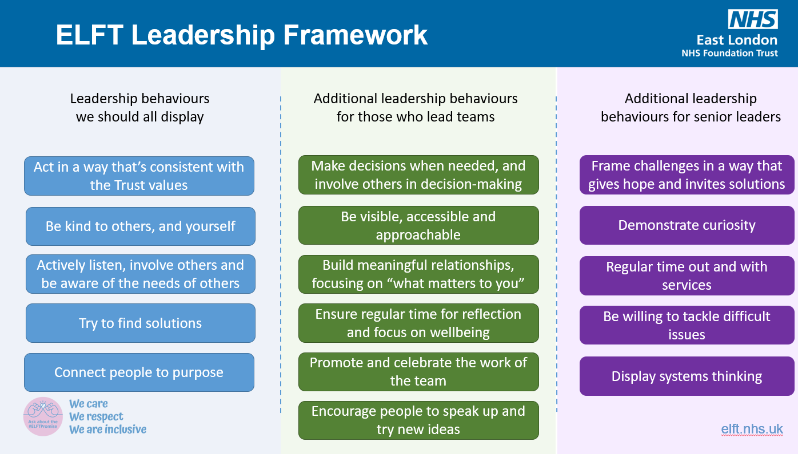

Source: https://www.legislation.gov.uk/ukpga/2023/51

