
Do Not Attempt Cardiopulmonary Resuscitation Decisions – Clinical Policy

Version number: | 15.0
Consultation Groups | End of Life Steering Group, Integrated End of Life Boards, Nursing Development & Steering Group, Palliative Champions Group, Medical & Clinical Directors, Operational Lead for Learning Disabilities, Head of Nursing for Children & Young People’s Services, Deputy Lead Nurses for Bedford & Newham, Resuscitation Service Barts Health, East of England Ambulance Service, London Ambulance, London Medical Committee
Approved by (Sponsor Group) | Clinical Policies Review Committee  Resuscitation Committee
Date approved | 28th November 2024
Ratified by: | Quality Committee
Date ratified: | 22nd January 2025
Name of originator/author: | Deputy Lead Nurse, Tower Hamlets CHS
Executive Director lead: | Chief Nurse
Implementation Date: | January 2025
Last Review Date | November 2024
Next Review date: | November 2027

Services | Applicable
Trust wide | X
Mental Health and LD
Community Health Services

Version Control Summary
Version | Date | Author | Status | Comment
Version 15 | 24/12/2024 | End of Life Lead | Final | Updated following CQC Guidance on DNACPR Update Aug 2024 and GMC End of Life Care Guidance Updated Dec 2024  Documentation and transfer of DNACPR decisions reviewed.  Guidance on use of ReSPECT document and Universal Care Plan (London only) added.  Consultation with London Ambulance & East of England Ambulance Services.
Version 14 | 01/04/2023 | Director of Nursing | Final | Updated with additional guidance and information
Version 13 | 26/10/2022 | Resuscitation Officer | Final | Appendix 1 added as an appendix requested by Quality Committee September 2022
Version 12 | Dec 2021 | Physical Health Lead Nurse |  | Updated guidance issued by BMA/RCN on decisions related to cardio pulmonary resuscitation
Version 10 | May 2015 | Lead Nurse Physical Health | Final | DNAR form reviewed
Version 9 | Apr 2011 | Lead Nurse Physical Health | Final | Reviewed
Version 8 | Nov 2010 | Physical Health Group | Final | Updated in line with Resuscitation Guidelines 2010
Version 7 | 2008 | Duncan Gilbert |  | ”
Version 6 | Apr 2007 | Sue Simister  Eirlys Evans

Contents
Section | Contents | Page
 | Executive Summary | 4
1. | Introduction | 4
2. | Statement of Purpose | 4
3. | Scope | 4
4. | Definitions | 5
5. | When an unexpected cardiac arrest occurs, and DNACPR status is not known | 5
6. | Roles and responsibilities | 6
7. | When to consider initiating a discussion about DNACPR | 6
8. | Decision making – key points | 7
9. | Key legislation and guidance | 7
10. | Involving the patient and those who are important to the patient | 8
11. | Situations where there is a lack of agreement | 9
12. | Where there is a lack of agreement – children & young people under 18 | 9
13. | Recording and sharing DNACPR decisions | 9
14. | Review | 10
15. | Training and competency | 10
16. | Monitoring and review | 11
17. | Roles and Responsibilities – Further information | 11
18. | References | 12
 | Appendix 1 Decision Making Framework | 13
 | Appendix 2 East of England DNACPR form | 14
 | Appendix 3 Milton Keynes University Hospital DNACPR form | 15
 | Appendix 4 ReSPECT | 16
 | Appendix 5 Universal Care Plan example | 18
 | Appendix 6 DNACPR form London | 19
 | Appendix 7 DNACPR from Children Less Than 16 | 20

Executive Summary

Do Not Attempt Cardiopulmonary Resuscitation (DNACPR) decisions aim to protect patients from inappropriate resuscitation attempts that have little or no chance of success.

When making a DNACPR decision the risks and benefits of cardiopulmonary resuscitation (CPR) should be considered, as well as the patient’s wishes, values and beliefs. The views of those close to the patient as well as the healthcare team, should also be considered.

It is important to communicate effectively about DNACPR decisions to avoid misunderstandings and distress.

The Human Rights Act 1998 and the Mental Capacity Act 2005 provide the legal basis for DNACPR decisions.

DNACPR decisions are not legally binding but are evidence that an advance clinical assessment and decision has been made.

DNACPR decisions should be documented according to place and communicated with everyone involved in a patient’s care. They should accompany the patient when they move between services.

- Introduction

Cardiopulmonary resuscitation (CPR) can be used to try to restart breathing and circulation in someone whose heart and breathing have stopped.

In certain circumstances if delivered promptly (for example, if someone experiences an acute event such as a myocardial infarction), it has a good success rate.

In other circumstances it has a low success rate.

For patients in the final stages of an incurable, life limiting condition, CPR is very unlikely to be successful and may mean that the patient dies in a traumatic and undignified manner (RCUK, 2021).

In these situations, it may then be appropriate to consider making a Do Not Attempt Cardiopulmonary Resuscitation (DNACPR) decision, to enable the person to die with dignity.

Patients who have already decided they would not want CPR to be attempted in the event of cardiorespiratory arrest and have the mental capacity to make the decision, should also be identified.

- Statement of Purpose

This policy will ensure that all people are initially presumed to be for cardiopulmonary resuscitation unless a valid DNACPR decision or a valid Advance Decision to Refuse Treatment (ADRT), refusing cardiopulmonary resuscitation, has been made and documented.

The policy is intended to prevent inappropriate, and/or unwanted attempts at cardiopulmonary resuscitation (CPR) and follows the guidelines from the British Medical Association, the Royal College of Nursing and the Resuscitation Council (UK).

The policy will provide a framework to ensure that DNACPR decisions:

- Respect the wishes of the patient / service user where possible;
- Reflect the best interests of the patient / service user;
- Comply with relevant legislation and guidance.

The policy will also help to inform end of life advance care planning for patients with a progressive life limiting illness.

The policy should be read alongside:
- Advance Decision to Refuse Treatment policy
- Deteriorating Patient policy
- End of Life Care policy
- Resuscitation policy

- Scope

The policy applies to all inpatient and outpatient services across London, Luton and Bedfordshire ELFT managed services.

The policy only applies to cardiopulmonary resuscitation and does not apply to any other aspect of care, for example, antibiotics, suction, treatment of anaphylaxis.

- Definitions

Advance care planning | A process where someone is supported to express and record their preferences for their future care.
Advance decision to refuse treatment (ADRT) | A statement of instructions to refuse specific medical care in the future, if the person were to lose capacity to make the decisions. A valid advance decision is legally binding.
Cardio-pulmonary resuscitation | Interventions to restart the heart and breathing and restore circulation. These will include chest compressions and may also involve ventilation, defibrillation and injection of drugs.
Court Appointed Deputy (CAD) | A person appointed by the Court of Protection to make decisions on behalf of someone who lacks the mental capacity to do so themselves, where an attorney has not been appointed under lasting power of attorney.
Do not attempt CPR decision | A decision in advance not to attempt CPR to ensure someone dies in a dignified and peaceful manner.
Mental Capacity Act 2005 | A legal framework supporting adults aged 16 and over who lack capacity and those who care for them, to make decisions
Independent Mental Capacity Advocate (IMCA) | An advocate who is appointed to act on behalf of someone who lacks the capacity to make certain decisions. Often appointed where there is no family member or friend available to consult regarding a best interest’s decision.
Lasting power of attorney for health & welfare | A legal document allowing a person to appoint someone to make decisions about their health and care, if they became unable to for example due to loss of mental capacity.

5. When an unexpected cardiac arrest occurs, and DNACPR status is not known

In the event of an unexpected cardiac arrest where a service user is unresponsive with absent or abnormal breathing, CPR should be commenced as soon as possible and every attempt made to resuscitate them unless a valid DNACPR or ADRT is in place.

However, the decision to withhold or stop CPR may be made if any of the criteria below apply (see Resus Council 2021 Ethics Guidelines):

- A valid documented DNACPR or ADRT becomes available;
- There is obvious fatal injury or irreversible death, for example rigor mortis, decomposition, decapitation.
- The safety of the staff member cannot be ensured, for example there is a threat of violence.

Suicide attempt should never be a reason for withholding CPR.

Any clinician who withholds CPR where DNACPR status is not known should clearly document the reason for this decision.

Decisions to withhold CPR should be audited.

- Roles & responsibilities – in relation to DNACPR decisions

The overall responsibility for making DNACPR decisions lies with the most senior clinician in charge of the patient’s care.

In an inpatient setting, this will normally be the responsible Consultant but may also be another Doctor or suitably qualified Senior Nurse, who has been delegated this responsibility. The senior clinician should discuss the decision with other members of the wider health care team involved in the patient’s care, and verify the decisions made where this has been delegated.

Occasionally a patient may require review of their DNACPR decision, for example in response to a change in the patient’s clinical condition.

The nurse in charge of patient care should confirm the CPR status of patients on the ward and ensure that CPR decisions are recorded correctly on the patient’s record. The senior nurse should also ensure that all those staff on duty are aware of the DNACPR status of patients on the ward.

In the community setting the overall responsibility for DNACPR decisions will usually lie with the GP. Other clinicians (for example palliative care nurses, experienced district nurses, children’s nurses) may also be involved with conversations about DNACPR as part of advance care planning discussions with patients who may be nearing the end of life.

In community health teams, the district nurse caseload holder or shift co-ordinator should review and confirm the CPR status of all patients referred to the service who may be nearing the end of life or in the terminal stages of a progressive, life limiting illness.

The caseload holder should also ensure the CPR status is reviewed for patients nearing the end of life at palliative care MDT / RAG meetings as well as during regular caseload review, and shared with the wider team during handover. Where decisions in relation to CPR are judged to be needed, this should be discussed with the GP and palliative care team.

- When to consider initiating a discussion about DNACPR

For the majority of service users receiving care either in hospital or community settings within East London NHS Foundation Trust (ELFT), there will be no reason to suspect that they are at imminent risk of a cardiac or respiratory arrest.

There is, therefore, no reason to routinely initiate discussions around decisions to be taken in such an event, unless the service user / patient themselves raises the subject.

The guidance from the BMA, RCN & Resuscitation Council (2021) state that a discussion about DNACPR should be considered in the following circumstances:

A cardiac or respiratory arrest is a clear possibility for the person and any of the below apply:

- CPR is unlikely to be successful;
- CPR might be successful, but would be likely to be followed by a length and quality of life that would not be acceptable to the person;
- The person is in the terminal stages of a progressive, life limiting illness, where death is unavoidable.

- Decision making – Key Points

DNACPR discussions and decisions can cause significant distress. However, research carried out by Compassion in Dying, found that people were often grateful for the opportunity to talk about their wishes and that distress was usually caused by poor communication.

Discussions about DNACPR should thus only be carried out by staff with the necessary skills and experience and are usually best held as part of a wider discussion around advance care planning. A DNACPR decision is not in itself legally binding but can be seen as a management plan to guide decision making in the event of a cardiac arrest.

The timing and nature of discussions about resuscitation are a matter of judgement for the clinical team. But they should be held as early as possible once it has been judged a DNACPR decision should be considered, to avoid conversations having to take place during times of crisis. Telling people in advance that the conversation is going to happen, can give people time to prepare and talk about it with those they are close to.

To enable effective communication and understanding, the clinician should:

- be mindful of the need for privacy, empathy and respect;
- offer information in an accessible way, considering reasonable adjustments such as arranging an interpreter, using easy read information;
- explain why it is felt that a discussion about DNACPR is needed;
- clarify that a DNACPR decision is only about CPR and any other appropriate care and treatment would still be given;
- offer information about the nature of CPR, the chance of success in the individual’s specific circumstances, and the likely risks.
- try to understand the person’s own wishes, beliefs and values in relation to CPR;
- invite questions.

See Appendix 1 for the decision-making framework.

- Key legislation and guidance

DNACPR decisions should always be made in line with the Mental Capacity Act, 2005, and clinicians should understand the implications for each patient for whom a DNACPR decision has been made.

The Mental Capacity Act states the legal requirements necessary for an Advance Decision to Refuse Treatment (ADRT) to be valid. Where a patient has a valid ADRT requesting CPR not be performed in the event of a cardiopulmonary request, this should be respected.

Decisions should be in line with the Equality Act 2010 and the Human Rights Act 1998. They must be free from discrimination and should never be based on a subjective view of the person’s quality of life. Decisions that deny resuscitation to a group of people (“blanket decision”) should never be made. For example “learning disability” should never be given as a reason for a DNACPR decision.

Article 2 of the Human Rights Act protects people’s right to life, however this does not mean a duty to prolong life regardless of the person’s quality of life or the burdens of treatment. Neither the patient nor their family, friends or advocates have the right to demand CPR if it is clinically inappropriate.

Article 2 could be breached however, if CPR was not provided where a person experienced a cardiopulmonary arrest and their DNACPR status was unknown. Not consulting with the person or their representative when making a DNACPR could risk breaching article 8 of the Human Rights Act (right to respect for private and family life).

- Involving the Patient and Those who are Important to the Patient

- Patients with capacity to make decisions about DNACPR
- A DNACPR decision should not be made unless everything possible has been done to involve the patient. This may include providing information in different formats, including translated into other languages, easy read, pictures;
- The patient should be asked if they would like anyone else to be involved in the discussion, for example relatives / carers. Family and friends should only be involved in clinical discussions about DNACPR, if the patient has given consent;
- Occasionally some individuals make it clear that they do not wish to talk about dying or end of life care, including DNACPR. In this case, their wishes should be respected and their consent sought to discuss any decision about CPR with other people, including family members;
- While everything possible should be done to involve the patient or those close to them, there may be some situations where it is agreed that discussing DNACPR could cause serious physical or psychological harm. In this case the reasons for not discussing DNACPR should be fully recorded.

- Patients who are assessed as lacking capacity to make decisions about DNACPR
- If the patient does not have capacity to be involved in advance decisions, the senior clinician must make any decision about DNACPR in the patient’s best interests, in line with the requirement of the Mental Capacity Act 2005;
- The clinician should discuss the decision with the patient’s family, friends and advocates, including where someone has been appointed using a lasting power of attorney (LPA) for health and welfare or any Court Appointed Deputy (CAD);
- They should try to understand if possible what the patient’s views and wishes were prior to incapacity, in order to support the best interest decision;
- If the patient has no friends, family or advocate to speak on their behalf, the Mental Capacity Act 2005 requires consultation with an independent mental capacity advocate (IMCA) requiring any serious medical treatment;
- If a DNACPR decision is needed urgently and an IMCA is not available, the decision should be made and the reasons for it recorded in the health record. The IMCA should be consulted with at the first available opportunity;
- The information provided by family, friends and advocates should be taken into account, but they do not have any decision making rights. The exception may be where a power of attorney document specifically states that the welfare attorney has the power to consent to or refuse life sustaining treatment including CPR.

- Children and young people under 18
- Decisions regarding children should involve the patient, their parents and the healthcare team;
- Young people aged 16 and over are presumed in law to be competent and can give consent for their own treatment. However, it is good practice to encourage the young person to involve their families, unless it is not in their interests;
- The Mental Capacity Act 2005 applies to young people aged 16 and over;
- Children under 16 can also be assessed as competent to consent to treatment (Gillick competence).

- Situations where there is a lack of agreement - adults

- An adult with capacity does have the right to refuse CPR against the advice of the clinical team. If the patient wishes to do this, they should be advised that the refusal will only be legally binding if they make a valid ADRT;
- A verbal request to decline CPR is not legally binding, however it should not be ignored and should be taken into account if a best interest decision is needed;
- Although individuals do not have a legal right to demand treatment including CPR against clinical judgement, their wishes should be respected if this is possible;
- Families, friends and advocates cannot insist on CPR being undertaken, if the healthcare team judge it would not have any overall benefit or be in the patient’s best interests;
- In case of ongoing disagreement, this should be discussed with the clinical Director of the service and a second opinion sought if necessary. Where it is still difficult to reach agreement, advice should be sought from the Trust legal team.

- Where there is a lack of agreement – children & young people under 18

- Where a competent child or young person under 18 makes an informed decision to refuse CPR against the advice of the healthcare team, legal advice should be sought;
- Where it is not possible to reach agreement around performing CPR for a child or young person under 18, legal advice should always be promptly sought.

- Recording and Sharing DNACPR decisions

- Inpatients settings

Decisions related to CPR for inpatients should be recorded on the approved DNACPR form or Recommended Summary Plan for Emergency Care and Treatment (ReSPECT) according to local policy (see appendices). The form should be uploaded onto the patient’s electronic care record, as well as included in any paper record. Additional information regarding the reasons for the decision, the wishes and preferences of the patient, and the conversations held should also be documented.

- Community Settings

In the community, DNACPR decisions are recorded by the GP on the patient’s electronic care record using the appropriate code. DNACPR decisions should be shared with everyone involved in the patient’s care according to local processes, including with the Out of Hours Services and Ambulance Services.

In Bedfordshire the DNACPR decision will be recorded according to place using either the East of England DNACPR form (appendix 2), the Milton Keynes University Hospital DNACPR form (appendix 3) or the Recommended Summary Plan for Emergency Care and Treatment (ReSPECT) (appendix 4).
In London the DNACPR decision can be shared electronically by the decision maker updating the patient’s Universal Care Plan (UCP) (appendix 5). London Ambulance Service (LAS) have access to the UCP. A DNACPR form (appendix 6) or printed copy of the DNACPR decision on the UCP should be kept in the patient’s home, in the event that an ambulance arrives and paramedics have not been able to view the UCP.
For children under 16, the DNACPR decision is shared according to place using the DNACPR form for Children Less than 16 Years of Age (appendix 6) or the ReSPECT form.

Patients, relatives, carers etc should be sensitively advised to have any DNACPR documentation available in the event of an emergency or an ambulance being called, to support health and care professionals faced with making immediate decisions and to avoid CPR being started if the DNACPR decision cannot be confirmed.

- During Transfer

DNACPR decisions should be communicated when patients transfer between different healthcare settings, between different services or wards within ELFT, or are discharged home. DNACPR documentation should always accompany the patient during transfer, to avoid the risk of inappropriate CPR.

DNACPR decisions should be reviewed as soon as possible following admission to ELFT inpatient settings.

DNACPR documentation accompanying patients discharged from hospital to community, may need to be validated by the patient’s GP once the patient’s discharge has been completed. Patients discharged from Bartshealth NHS Trust should have their DNACPR decision validated within 24 hours of discharge.

- Review

The frequency of review of DNACPR decisions should be determined by the senior clinician responsible for the patient’s care and should be based on the needs of the individual patient.

Situations where a DNACPR should be reviewed include where:

- A review date has been specified;
- When significant changes occur in the patient’s condition;
- When their expressed wishes change.

For some patients, for example those in receipt of end of life care, review of the decision will not be necessary.

15. Training and Competency

Annual face to face Resuscitation training is mandatory for all clinical staff.

Clinical staff involved in discussions about DNACPR should complete additional training and development such as advance care planning, talking about death & dying, having difficult conversations and advanced communication skills.

16. Monitoring and Audit

The effectiveness of this policy will be monitored by:

What will be monitored? | How? | When? | By who? | Reporting to
Audit of DNACPR decisions and documentation | Trust audit programme | Annually | Clinical Leads / Team Leads | Learning from Deaths Panel
Review of all clinical incidents, complaints and concerns associated with this DNACPR | Oversight of clinical incidents & complaints | Bi monthly | Clinical Leads / End of Life Leads | Learning from Deaths Panels

- Roles and Responsibilities in relation the Policy

Party | Key responsibilities
Divisional Medical Directors and Directors of Nursing | - To oversee the regular review of the policy.  - To oversee the monitoring of the implementation of the policy.  - To report any concerns to the Trust Chief Nurse and Medical Director, and to advise on remedial action where necessary.
Borough Lead Nurse, Clinical Leads, Team Leads | - To make sure staff are aware of and understand the policy.  - To implement the policy, ensuring staff have access to appropriate resources as needed.  - To plan staff rosters and skill mix to support the implementation of the policy.  - To ensure all staff involved in discussions around DNACPR have been assessed as meeting the required standards of competency.
All Registered Nursing Staff | - To be aware of the contents of the policy.  - To have been assessed as competent if their role involves discussing decisions about DNACPR.  - To work in accordance with relevant legal frameworks and standards of practice.
References

CQC (2020) Brief guide: Capacity and consent in under 18s Third version. https://www.cqc.org.uk/sites/default/files/Brief_guide_Capacity_and_consent_in_under_18s%20v3.pdf

CQC (2022) GP mythbuster: Do not attempt cardiopulmonary resuscitation (DNACPR) https://www.cqc.org.uk/guidance-providers/gps/gp-mythbusters/gp-mythbuster-105-do-not-attempt-cardiopulmonary-resuscitation-dnacpr

Compassion in Dying (2021) Better understanding, better outcomes: what we’ve learned about DNACPR decisions before and during the Coronavirus pandemic https://cdn.compassionindying.org.uk/wp-content/uploads/dnacpr-decisions-coronavirus-pandemic-march-2021.pdf

General Medical Council (2024) Treatment and care towards the end of life. https://www.gmc-uk.org/professional-standards/professional-standards-for-doctors/treatment-and-care-towards-the-end-of-life/cardiopulmonary-resuscitation-cpr

Human Rights Act. (1998) London: Crown Copyright. https://www.legislation.gov.uk/ukpga/1998/42/contents

Office of the Public Guardian (2007) Making Decisions: The Independent Mental Capacity Advocate (IMCA) Service 2nd edition (2007) https://assets.publishing.service.gov.uk/media/5a7eae52e5274a2e87db13a8/making-decisions-opg606-1207.pdf

Resuscitation Council UK (2016) Decisions relating to cardiopulmonary resuscitation; a joint statement from the British Medical Association, the Resuscitation Council (UK) and the Royal College of Nursing. RC (UK) 3rd Edition October https://www.resus.org.uk/sites/default/files/2020-05/20160123%20Decisions%20Relating%20to%20CPR%20-%202016.pdf

Appendix 1 – Decision making framework (British Medical Association, Resus Council & RCN, 2021)
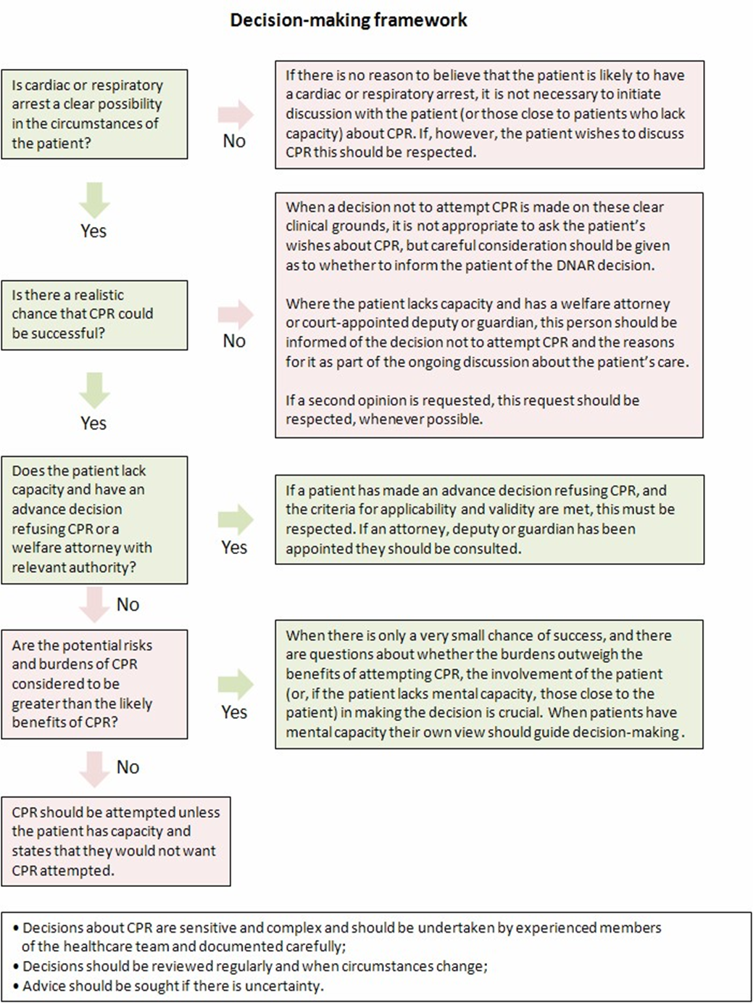

Appendix 2 – East of England DNACPR Form

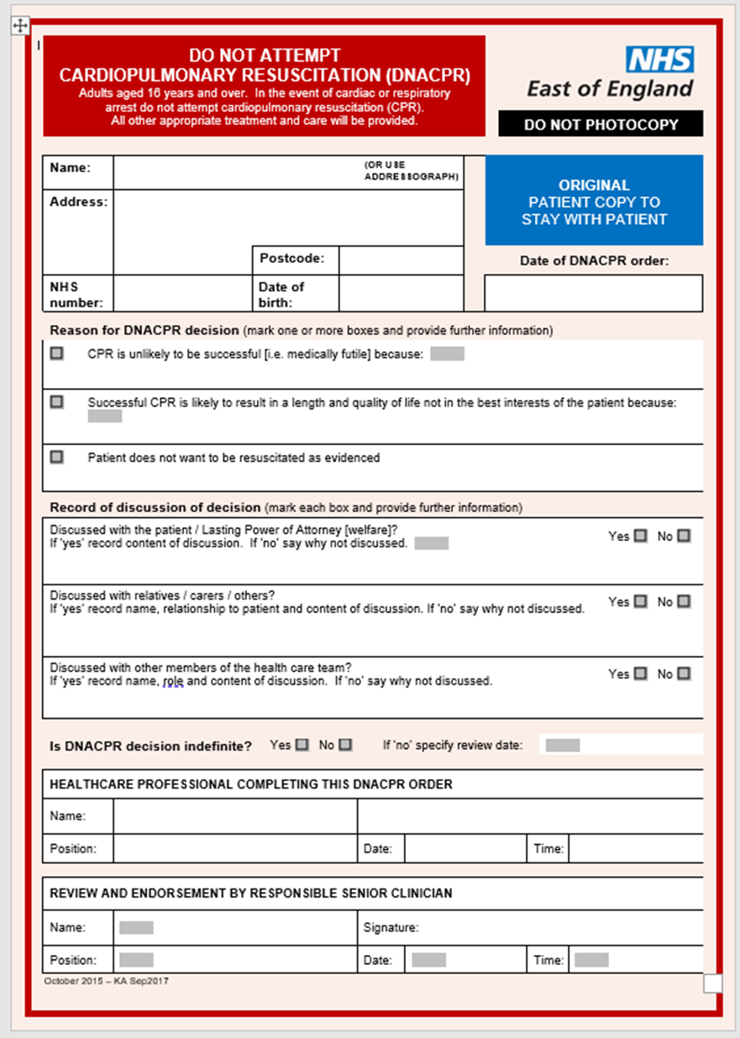

Appendix 3 – Milton Keynes University Hospital DNACPR Form
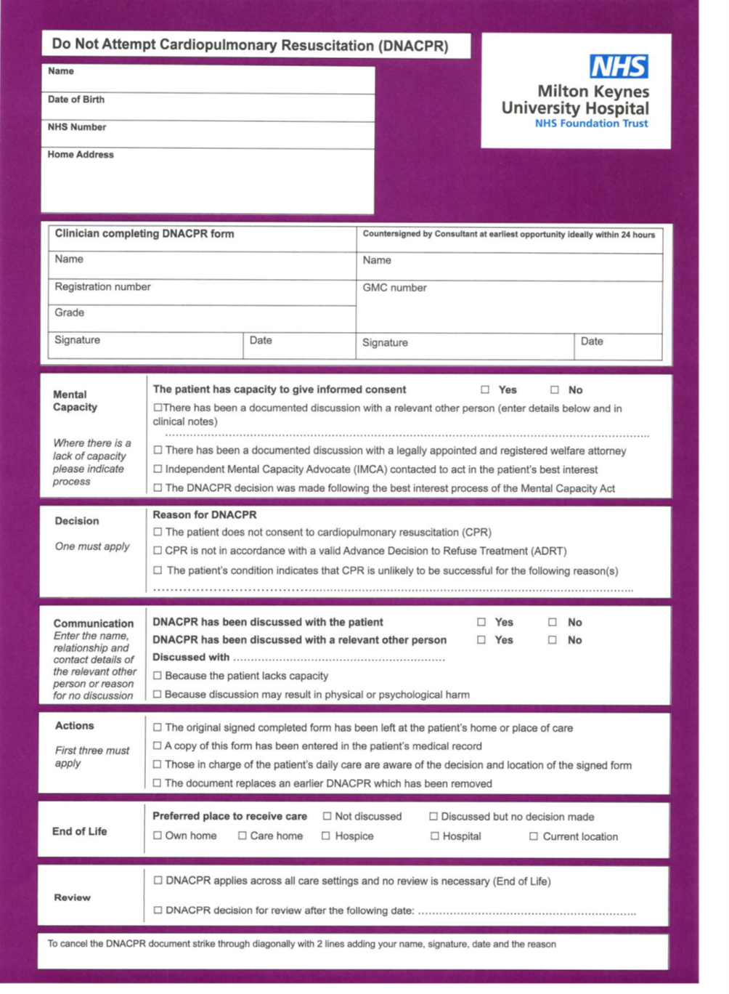

Appendix 4 - Recommended Summary Plan for Emergency Care and Treatment (ReSPECT)
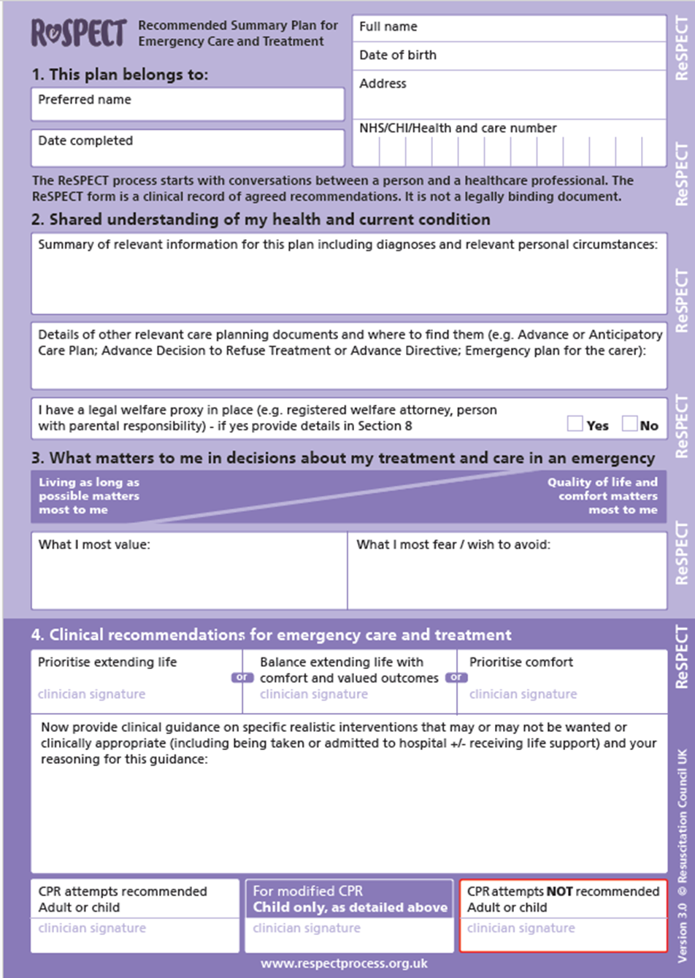

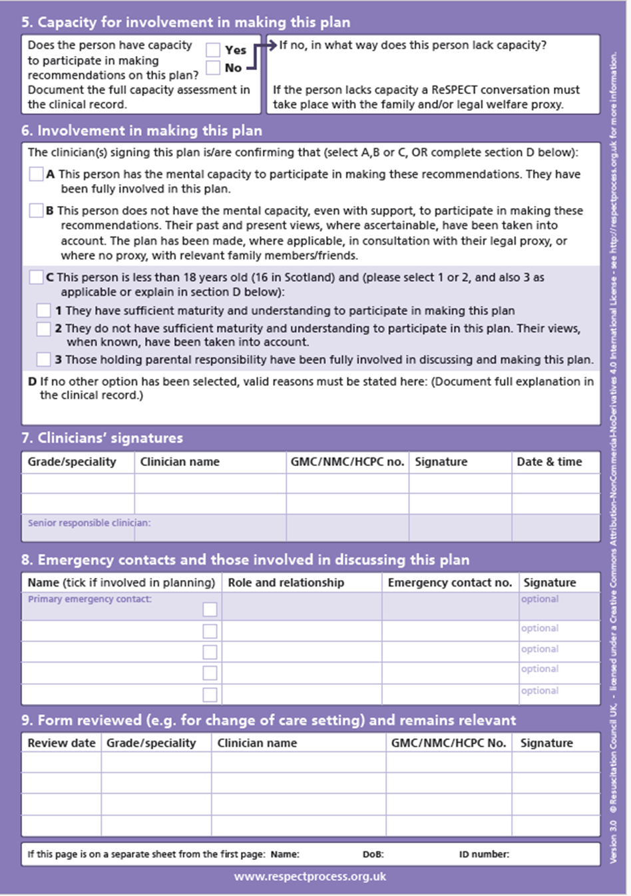
Appendix 5 – Universal Care Plan – Example Summary
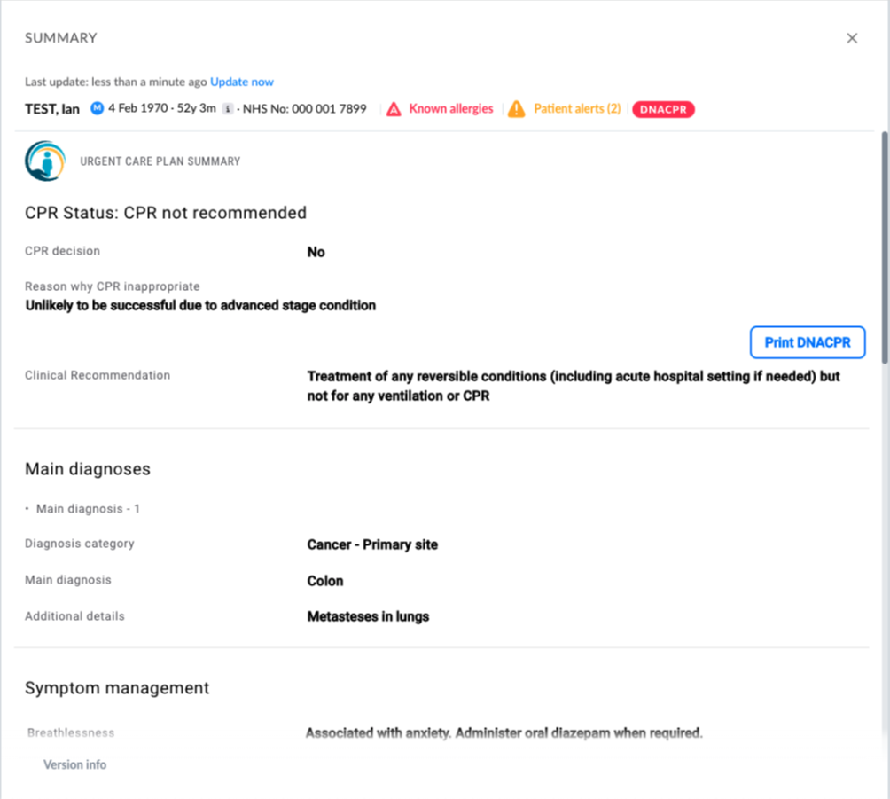
Appendix 6 – DNACPR Form Adults (aged 16 and over)
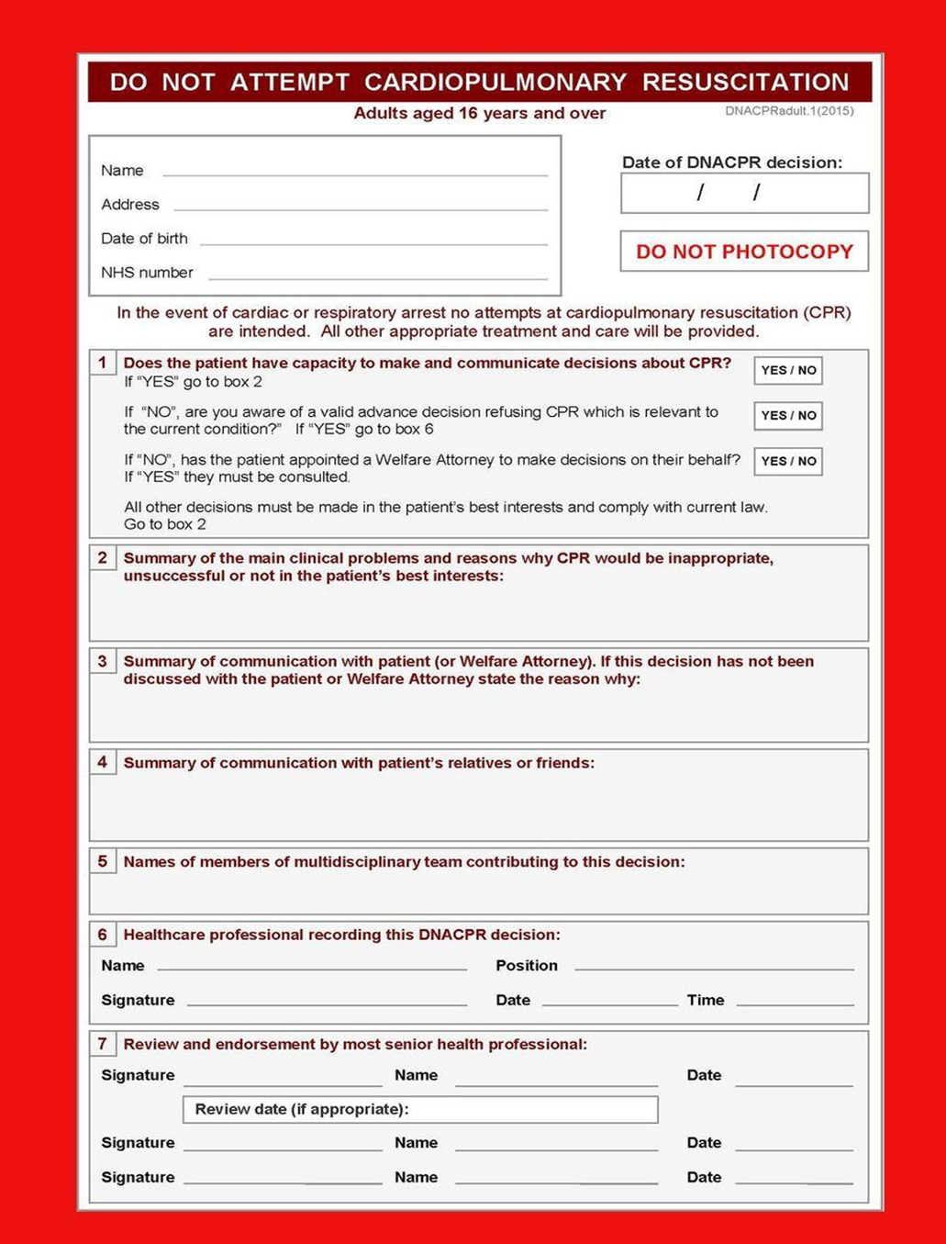
Appendix 7 - DNACPR Form Children less than 16 years old
