Title | MSO report November 2024
Authors | Rajesh Jethwa & Indreet Anand Trust Medicines Safety Officers (MSO’s)
Presented to | Medicines Committee
Date | 13th November 2024

Purpose of the Report:
This report provides a summary of medicines safety data that is collected in the Trust and is presented to the Medicines Committee for information. The committee is asked to consider the level of assurance provided by the report and decide whether further action is needed.

Strategic priorities this paper supports (Please check box including brief statement)
Improving service user satisfaction | ☒ | Improve service user-related outcomes by ensuring that they receive safe pharmaceutical care.
Improving staff satisfaction | ☒
Maintaining financial viability | ☐

Committees/Meetings where this item has been considered:
Date | Committee/Meeting
N/A | This report has not been considered in any other committees or meetings

Equality Analysis | This report has no direct impact on equalities
Contents
Section | Page | Source of information
Medication incident reporting | 2 - 3 | Inphase Dashboard
Key Medication Incidents | 4 -5 | Inphase + MSO
72 Hour medication incident reports | 6 - 7 | Inphase + MSO
Local Medication Safety Update | 8 | MSO
MHRA Drug Safety Updates | 9 -10 | MHRA
Medicines Safety Week Blog (4th- 10th November) | 11 -12 | Rajesh
Trust Wide Medicines Related Audit programme 2024/2025  - Controlled Drugs Audit Q3  - Clinical Use of Medicines Audit  - Safe and Secure Handling of Medicines | 13 | Inphase Audit Dashboard

Trust Wide Medication Incident Reporting

Figure 1 & 2 Total number of medication incidents reported per month (12 and 24 months)
Medication incident reporting fluctuates within control limits. Inphase incident reporting system went live 1st November 23. Overall increase in reporting since launch of Inphase shown by upward trajectory. There is a high reporting culture within our Community Health Services in particular Bedfordshire Community Health services (BCHS) and Tower Hamlets Community Health Services (THCHS). A significant proportion of the incidents reported are as a result of service provided by external agencies and some of the key themes relate to the transfer of care, insulin/LMWH administration (task allocation) and MAR chart errors. This reporting has stimulated system wide workstreams to address gaps in service provision.The impact of this work should slowly start to reflect on the type and frequency of incidents being reported within these services.
July 24 – October 24
Directorate
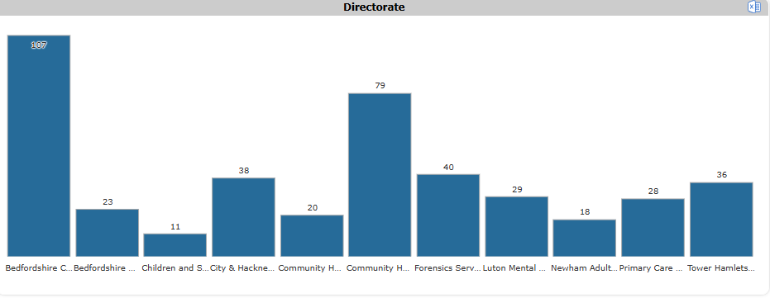
Figure 3- Total number of medication incidents reported directorate (July 24 – October 24)
Service/ward/department
A high reporting culture noted in below services.
- BCHS complex care
- BCHS community nursing twinwoods
- PCN Leighton road surgery
- THCHS NW locality
- THCHS Triage and assesment
Subcategory
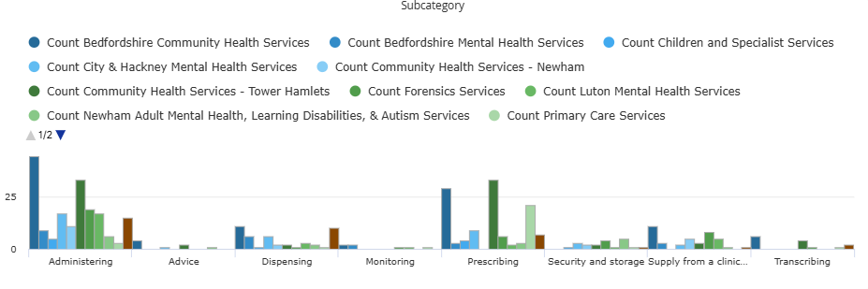
Figure 4- Total number of medication incidents reported by directorate and subcategory (July 24 – October 24)
It is expectated that a large proportion of the incident reporting is around administration which accounts for the largest amount of time spent with medicines. Majority being reported from the community services in tower hamlets and bedfordshire. The incident reporting in both these areas is around scheduling/referral of patients for medication adminsitration as well as transfer of care related incidents
Physical Harm
Physical Harm | Count | % of total harm
No | 305 | 74
Low | 93 | 23
Moderate | 10 | 2
Severe | 1 | <1%

Figure 5 Medication incidents broken down by type of physical harm (July 24 – October 24)
Reassuring that 2/3 of the medication incident reporting from July-October 24 resuled in no physical harm. The remaining 1/3 being categorised as low harm. It is important to note that despite physical harm being low or none, the new approach to learning focuses on learning from all harm levels.

High risk medicines

Figure 6 Medication incidents broken down by high risk medicine (July 24 – October 24)
This is showing that a small proportion of the medication incident reporting is involving what we describe as high risk drugs. High risk medicines have a higher risk of causing injury or harm if they are misused or used in error. Our top three priority areas from the graph above are
- Insulin
- Controlled drugs
- Clozapine.

Key Medication Incidents (July 2024 - October 2024) – FRAME ALL LEARNING USING SEIPS
LFPSE Incident ID | Date | Directorate | Ward | Incident description | Immediate actions | Harm (Physical/Psychological | Learning using SEIPS
00020518 | 06/10/2024 | BCHS | Rapid Response team | Call from spoa patient has no insulin needles and no cbg machine to administer insulin. Call received by SPOA as patient had called 111 for a prescription for insulin needles as he was discharged from a care home with no insulin needles to administer his insulin and no cbg machine to check his cbg levels. 111 service put through a 2 hour response call @ 23:40 05/10/24 for Rapid Response team to visit and assess patient. Although advised by Spoa team that this does not meet the threshold for the night service 111 requested for the patient to be seen the following day although the patient had missed three doses of twice a day insulin. At present patient had missed 8 doses of insulin. | Due to capacity, no visit allocated as no current dose of insulin on S1. Patient unable to recall doses. Safeguarding has been raised  Patient is now back at home with planned community nursing team support for insulin. | Moderate Physical harm and Low Psychological harm | External environment/Tasks No insulin has been administered since discharge form the care home as had run out of needles. No MAR chart/discharge paperwork was provided with the patient or to DN team
00018344 | 28/08/2024 | Newham CHS | Fothergill | This patient is on Fothergill ward for end of life care; he has a locally-advanced oropharyngeal cancer.  He had needed increasing doses of medicine for pain and agitation, and is now not able to take oral medication. On the afternoon of 27 August 2024 he was reviewed by the ward GP and the visiting palliative care clinical nurse specialist. They made the decision that a continuous subcutaneous infusion (CSCI; "syringe driver") of medicine for pain and agitation was now indicated.  The nursing team planned to set up and start the CSCI that evening; however one of the two RNs on the day shift had to leave work unexpectedly (her husband had been admitted to hospital and subsequently, tragically, died that same evening). The remaining RN was new in practice and was not confident to set up the CSCI; the night shift nurses were also ?not confident to do so.  The day shift nurses on 28 August knew that the CSCI needed to start but this had not been set up by 1100. The patient had been having intermittent prn subcutaneous medicine so had not been entirely without symptomatic relief. | The reporter and district nurse colleague (on the ward for independent prescriber training) set up and started the CSCI. | Moderate Physical Harm and No Psychological harm | Organisation and training  Tools and technology  Ensure that all RNs working on Fothergill ward are competent to set up CSCIs. Consider why this task was initially delayed until the evening. Consider barriers to using CSCI on Fothergill ward.

72 hour Medication Incident reports Commissioned (July – October 24)
A 72-hour report is designed to support staff in providing critical and relevant information related to a patient safety incident to help executive team understand what happened. This is done to support incident-grading panel with deciding on most appropriate form of learning.
Incident descriptions and learnings taken directly from inphase.
Incident ID | Directorate | Ward | Incident description | Harm (Physical/Psychological) | Learning using SEIPS
00020578 | Primary care services | Leighton Road surgery | During a routine medication review, patient mentioned she was running out of medication and her dose had been doubled. On further questioning, there had been a misunderstanding during a GP appointment, where the patient thought she was advised to double her dose of amlodipine. Has been taking amlodipine 10mg twice a day since 30/08/2024. Max dose is 10mg daily. | Moderate | Person  Possible overloaded patient with information by making multiple medication changes in one appointment  Multiple new diagnoses made together (Diabetes and high cholesterol)  Areas of good practice  - Patient gave positive feedback on information that she was given during medication review.  - Toxbase was contacted and relevant signposting to A+E, appropriate escalation once identified patients misunderstanding  - Appropriate treatment for each indication was initiated according to clinical guidelines,  - Good identification of long-term conditions and appropriate nurse follow up, with further blood tests requests  - Followed protocol for hypertension diagnosis with appropriate referrals for ECG/ investigations
00017115 | Tower Hamlets MH | Roman ward | Patient normally on clozapine at home - admitted to A&E and then transferred to MEH. Not prescribed clozapine for the day in A&E, then prescribed olanzapine on admission to MEH. Allergies stated to olanzapine and haloperidol noting NMS as reaction. Patient received one dose of olanzapine on 28/07/24 and developed NMS  Olanzapine discontinued on Monday 29/07/24 and clozapine re-commenced as was up to the 48 hour mark of clozapine administration | Moderate | Tools and Technology  Olanzapine was recorded as sensitivity and not allergy on JAC hence the doctor was able to prescribe the Olanzapine.  Olanzapine was prescribed despite the documented history of NMS with olanzapine, albeit in combination with haloperidol. The prescriber rationalised the decision by assuming a lower risk if only one of the medications was prescribed, but this decision was not fully justified or documented adequately.  Work will be undertaken to reflect documentation of severe reactions such as NMS in the allergy section within EPMA within Medicines Policy and standards for physical health monitoring of patients on antipsychotic treatment  This example to be used as part of EPMA training for new doctors  Areas of good practice  The incident was reported for review, demonstrating a culture of openness and learning. The recommendation for discussion in the EPMA and medicines safety group reflects a proactive approach to system-wide improvement.  The team worked collaboratively to address the incident once it was identified. The LD consultant’s prompt action in discontinuing the olanzapine the next day and reinstating clozapine was commendable.

LOCAL MEDICINES SAFETY UPDATES
- Trustwide Medicines Safety Group (MSG)
  - Good engagement across all disciplines
  - Workstreams underway to improve safety across the organisation.
  - Feedback MS forms survey sent to group – analysis of responses and implement findings

- Valproate Policy Implementation Group
- Working with informatics to build valproate reporting into Pharmacy PowerBI dashboard.
- Revised valproate form has been tested and approved. Awaiting go live date. Likely Jan 25
- MSO’s presenting key points from trust valproate policy at academic learning sessions

- System Wide Working
  - NEL MSQG: North East London Medicines Safety Quality Group. Workplan agreed for 24/25.
      - High-risk medicines – focus on teratogenic medicines. Safe use of valproate and Topirimate
      - Safe transition of care – anticoagulation safety, insulin safety, allergies de labelling and reduction in delayed and omitted doses
      - Incident management – Learning from medicine related patient safety incidents across the interface. Supporting implementation of LFPSE and PSIRF within NEL.
      - Safe use of dependent forming medicines across the system
  - BLMK Medicines Safety Group
    - Valproate presentation to other providers within the system

- Digital/Informatics update

  - Phase one completed with live dashboard on PowerBI. https://app.powerbi.com/groups/me/apps/1d64c7fa-1146-46e2-b054-ca6c969e8f92/reports/b30a2cec-6c61-4e0f-9fa6-7ebc48c3a0dc/58e88676e04d0c3a3808?ctid=b7a2ec96-1f25-4ba8-b4e2-019abc93697f&experience=power-bi

- Q3 24-25 Trust wide Medicines Safety Bulletin

- Rapid Tranqulisation Quality Improvement work
  - Focus on areas that have poor compliance as identified in medicines audit programme.
  - Revision of audit questions to improve clarity for auditors
  - Review of results from POMH-UK audit on RT in the context of pharmacological management of acutely disturbed behaviour

MHRA DRUG SAFETY UPDATES
SEPTEMBER 2024
- VALPROATE USE IN MEN: AS A PRECAUTION, MEN AND THEIR PARTNERS SHOULD USE EFFECTIVE CONTRACEPTION
ADVICE FOR HEALTHCARE PROFESSIONALS/PATIENTS.
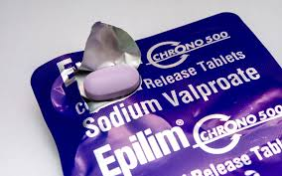
- COUNSELLING Inform male patient (of any age) who may father children of the possible risk at initiation of valproate or at their next regular treatment review.
- As a precaution, recommend that male patient use effective contraception (condoms plus effective female contraception) throughout the valproate treatment period and for 3 months after stopping valproate, to allow for one completed sperm cycle not exposed to valproate
- At the next regular treatment review, discuss with men on oral valproate treatment whether they are planning a family in the next year and if they are, refer to specialist to discuss alternative treatment options.
- If a female patient reports they are pregnant or planning a pregnancy with a man on valproate, refer for prenatal counselling
- Advise men not to donate sperm during valproate treatment and for 3 months after stopping valproate
- Report any suspected ADR associated with valproate through inphase and also on national yellow card system
OCTOBER 2024
- GLP-1 RECEPTOR AGONISTS: REMINDER OF POTENTIAL S.E AND TO BE AWARE OF POTENTIAL FOR MISUSE
ADVICE FOR HEALTHCARE PROFESSIONALS/PATIENTS.
- These are PRESCRIPTION ONLY MEDICINES (POM) to only be used under medical supervision.
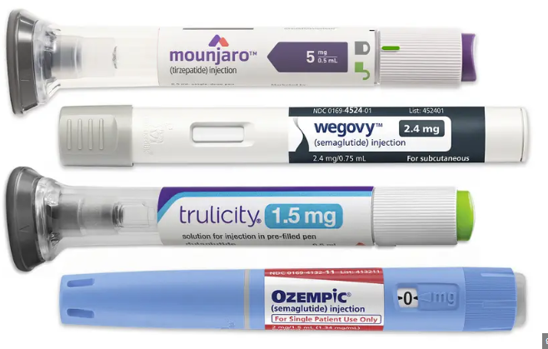
- Benefits and risks of using GLP-1RA’s for weight loss outside of licenced indication have not been studied
- Common side effects; nausea, vomiting, diarrhoea and constipation can persist for several days. 46 cases which have led to hospitalisation
- Throughout treatment stay well hydrated by drinking plenty of fluids.
- If obtaining a private prescription ensure medicine is dispensed from registered pharmacies to avoid risk of receiving falsified pens.

- INSULIN PUMPS AND CONTINIOUS GLUCOSE MONITORING EQUIPMENT
ADVICE FOR HEALTHCARE PROFESSIONALS/PATIENTS.
- Seek medical advice without delay if you have concerns that your health has been impacted by a potential safety issue
- Use an alternative device if you suspect your current device is not performing adequately in managing your diabetes
- It is important that you report safety concerns with your device using inphase and to the national yellow card scheme

- BROMOCRIPTINE: MONITOR BLOOD PRESSURE WHEN PRESCRIBING BROMOCRIPTINE FOR PREVENTION OR INHIBITION OF POST PARTUM PHYSIOLOGICAL LACTATION
ADVICE FOR HEALTHCARE PROFESSIONALS/PATIENTS.
- Bromocriptine is used to prevent or stop milk production after childbirth in women who are not breastfeeding only if there are medical reasons for doing so
- Other indications for Bromocriptine include hyperprolactinaemia, female infertility and menstrual cycle disorders. Blood pressure monitoring is required for all indicated treatments
- Inform your doctor if you had blood pressure problems before or during pregnancy or after giving birth
- Your doctor will need to check blood pressure regularly during the first few days of treatment
- Seek urgent medical attention if you experience symptoms of high blood pressure: chest pain, persistent headache with or without vision problems

MEDICINES SAFETY WEEK BLOG (4th-10th November)
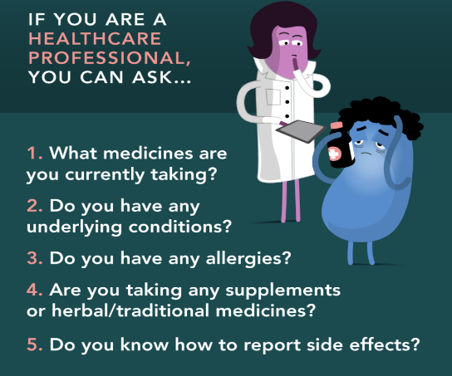
Using Medicines correctly is crucial to minimise side effects and ensure their effectiveness. This year will be the ninth annual #MedsSafetyWeek social media campaign. This week I want to start conversations around using medicines in the right way to prevent side effects and then explore how we may navigate the system as patients and staff to raise awareness/report side effects when they do occur.

Here are some key points to consider
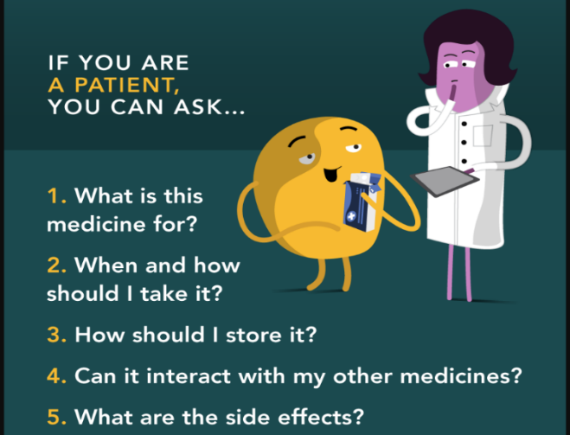
- Correct dosage: Taking the right amount which helps to avoid overdosing, which can lead to severe side effects, or underdosing which may render the medicine ineffective. Pay attention to labels for dosage instructions, possible side effects and specific administration guidelines.
- Timing and frequency: Adhering to the prescribed schedules to maximise benefits and maintaining therapeutic levels of the medicine in the body.
- Understanding interactions: Being aware of potential interactions with other medicines, food, alcohol, other substances can prevent harmful side effects
- Awareness of side effects: Knowing possible side effects allows for timely reporting to your healthcare provider, leading to quicker management and resolution of the issue.
- Patient education: Educating patients about their medicines promotes adherence and encourages informed decision-making, enhancing overall treatment outcomes. Understand what each medication is for, how it works and what side effects to look out for
- Tailored treatment: Individual responses to medicines can vary; following the prescribed plan ensuring that treatments are tailored to the patient specific needs and avoids problematic polypharmacy
- Preventing resistance: for antibiotics, using them correctly helps prevent resistance, ensuring they remain effective.
- Reporting side effects: Keep track of how you feel after starting a new medicine and report and unusual symptoms to your healthcare provider promptly. Reporting via the yellow card (https://yellowcard.mhra.gov.uk/) These reports are used to identify side effects and other safety information about medicines which might not have been known before. If a new side effect is found, the MHRA will review the way the medicine can be used and the warnings given to people taking it.
8.4m people in England are regularly prescribed 5 or more medicines. 1 in 5 hospital admissions in over 65’s are caused by adverse effects to medicines. The more medicine a person takes, there is a potentially higher chance that one or more of these medicines will have an unwanted/harmful effect. Medicine use is increasing and over the last 30 years, more and more medicines are being prescribed. Some of the reasons for this include advent of evidence-based medicine, increase in multiple morbidity and longevity, promotion of age independent access to the increasing number of treatments and increased expectation for pharmacological treatment from patients and families.
Overall reflecting on the correct use of medicine emphasises the importance of education, communication and responsibility in achieving optimal health outcomes. It is a partnership between patients and healthcare providers that ultimately leads to better health.

My name is Rajesh Jethwa. I am a Trust Medication Safety Officer at East London Foundation trust. Please feel free to reach out to understand more about my role or would like to have a discussion around medicine safety challenges or share good medicine practice. I also host the Trust Medicines Safety Group bi monthly so if you would like to be invited then get in touch. Here we discuss all medicine safety related topics with the aim of improving staff and patient experience of medicine.
Rajesh
📧 rajesh.jethwa1@nhs.net/elft.mso@nhs.net| @JethwaRajesh27
*ELFT Medicines Safety Pharmacy Page* Click on the link to access the latest information from the world of Medicines Safety.

Trust Wide Medicines Audit Programme – CONTROLLED DRUGS Q3 2024/25
Audit frequency: QUARTERLY
Audit are now hosted on INPASE. Directorates leads are expected to directly access results from INPHASE and to prompt teams to view their results; dicussion expected at DMTs and associated actions should be forwarded to the directorate QA manager.

KEY FINDINGS
- The % of completed CD audits has INCREASED from Q2 24/25 (87.93% to 100%)
- The % compliance against CD audit standards has INCREASED from Q2 24/25 (75.09% to 88.46%)
Q3 FINDINGS BY WARD
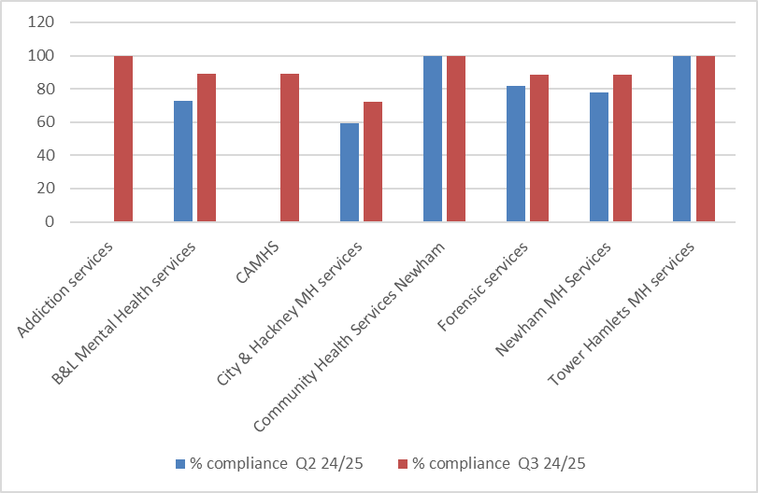
60-80% (compliance against audit standards)
- B&l Crystal ward
- B&L Coral ward
- CAMHS Galaxy ward
- FX Clissold ward
- Newham Emerald ward
<60% (compliance against audit standards)
- Brett ward
- Connoly ward
- Joshua
Note: Directorate teams can review individual ward audit data using the audit trend analysis tab on inphase

Trust Wide Medicines Audit Programme – CLINICAL USE OF MEDICINES AUDIT (MENTAL HEALTH) Q3 2024/25
Audit frequency: THREE X a year
KEY FINDINGS
- % compliance against audit standards for the last 2 cycles has been low (Q1 Cycle 1 61.51%), Q3 (Cycle 2 62.72%)
- FOUR directorates (TH MH, Newham MH, C&H MH and Forensic services) reported a marginal increase in performance against audit standards
- ONE directorate (B&L Mental Health services) reported decrease in performance against audit standards

GENERAL AREAS FOR IMPROVEMENT
- Completion of HDAT monitoring forms on RIO
- Completion of psychotropic monitoring form on RIO for patients prescribed lithium
- Documentation of withdrawal plans for BZD
- Completion of discharge checklists
Note: Directorate teams can review individual ward audit data using the audit trend analysis tab on inphase

Trust Wide Medicines Audit Programme – SAFE AND SECURE HANDLING OF MEDICINES Q3 2024/25
Audit frequency: TWICE a year
KEY FINDINGS
- Most directorates have scored above 80% compliance in this audit questionaire
GENERAL AREAS FOR IMPROVEMENT
- Appropriate signage of hazards in places where oxygen cylinders are stored
- Separate lockable storage location for patients own drugs
- Internal audit for the security,use and destruction of FP10 pads.
- Medication keys being held by registered nurse at all times
- CD keys separate to main medication keys
- Open dates added to multi dose medications
- Mechanisim in place to ensure that ward fridge is not switched off
- Daily ambient and fridge temperature monitoring
Note: Directorate teams can review individual ward audit data using the audit trend analysis tab on inphase

