

Anaphylaxis Recognition & Treatment Policy

Version number: | 1.1
Consultation Groups | Physical Health Committee
Approved by (Sponsor Group) | Resuscitation Committee
Date approved | 28th November 2024
Ratified by: | Quality Committee
Date ratified: | 22nd January 2025
Name of originator/author: | Resuscitation Lead
Executive Director lead: | Chief Medical Officer
Implementation Date: | January 2025
Last Review Date | November 2024
Next Review date: | November 2027

Services | Applicable
Trust wide | X
Mental Health and LD
Community Health Services

Version Control Summary

Version | Date | Author | Status | Comment
1
1.1 | 27/11/2024 | Simon Small  Resuscitation Lead | Review | Updated the RCUK guidelines to 2021  Changed DATIX to InPhase  Administration of Antihistamines and Corticosteroids removed  Change to definition of anaphylaxis

Contents
Paragraph | Contents | Page
 | Version Control Sheet | 2
 | Contents | 3
1.0 | Assurance Statement | 4
2.0 | Background Statement | 4
3.0 | Responsibilities | 4
3.1 | Chief Executive | 4
3.2 | Executive Director of Clinical Governance & Quality and Chief Nurse | 4
3.3 | Directors and Senior Management | 4
3.4 | Quality Committee | 5
3.5 | Governance | 4
3.6 | Pharmacy | 5
3.7 | Resuscitation Lead | 5
3.8 | Managers and other Persons in Charge | 5
3.9 | Individuals | 6
4.0 | Training | 6
5.0 | Dissemination | 6
6.0 | Resource implication | 6
7.0 | Consultation | 6
8.0 | Introduction | 7
9.0 | Aims & Objectives | 7
10.0 | Scope | 7
11.0 | Competencies | 8
12.0 | Patients to Whom this Procedure Refers | 8
13.0 | Recognition & Diagnosis | 8
14.0 | Cautions and Considerations for Treatment | 10
15.0 | Immediate Action | 10
15.1 | Call for Help | 11
15.2 | ABCDE | 11
15.3 | Allergen Removal | 11
15.4 | Patient Position | 12
15.5 | Adrenaline Administration | 12
15.6 | Doses of Adrenaline | 12
15.6.1 | Adults | 12
15.6.2 | Children | 12
15.7 | Intravenous Administration of Adrenaline | 13
15.8 | Administration of Antihistamines and Corticosteroids | 13
15.9 | Observation & Admission | 13
16.0 | Storage and Handling of Medicines | 13
17.0 | Associated Trust Procedural Documents | 13
18.0 | Patients Own Medication (Auto-injectors) | 13
19.0 | Community Teams | 14
19.1.0 | Tower Hamlets Community Health Service (Replaces SOP) | 14
19.1.1 | Storage where service needs have prevented otherwise | 15
19.1.2 | Procedure where temperature excursions have occurred | 16
20.0 | Clinical Areas | 16
21.0 | Record Keeping and Follow up | 17
22.0 | References | 17
Appendix 1 | Anaphylaxis Algorithm | 18
Appendix 2 | Adrenaline Packs in Community Services | 20
Appendix 3.1-2 | Pharmacy issued Anaphylaxis Shock Kits (pictures) | 21-22
Appendix 4 | THCHS Staff Agreement and Confirmation to work in line with Policy | 23
Appendix 5 | THCHS List of Persons authorised to have Responsibilities | 24
Appendix 6 | THCHS Team Specific Record Keeping of Anaphylactic Kits | 25
Appendix 7 | THCHS Anaphylactic Kit logging sheet | 26
Appendix 8 | THCHS Clinical Room/Storage Room Temperature Monitoring | 27-29

1.0 Assurance Statement
This policy sets out the required steps that apply to all qualified clinicians working in the Trust and set the standard for the management of patients (adults and children) who have an anaphylactic reaction following the administration of medication and other triggers e.g food and stings. The policy has been re-written and updated to incorporate the Resuscitation Council (UK) Management of Anaphylaxis in a Vaccination Setting (2021)¹ and Public Health England (PHE) advice in the Green Book (Chapter 8).²
2.0 Background Statement
Anaphylaxis appears to be increasingly common and has been strongly associated with the increasing prevalence of allergic disease over the last two or three decades.
The treatment of anaphylaxis needs a consistent approach which draws together relevant and appropriate expertise as provided by the Resuscitation Council (UK) 2021 and NICE Clinical Guideline CG134 recommendations.³
3.0 Responsibilities
3.1 The Chief Executive is responsible for:
Ensuring that the principles of this policy, the related procedural guidelines and other associated policies are implemented across the organisation;
3.2 The Executive Director of Clinical Governance & Quality and Chief Nurse will ensure:
- Policy and procedures are embedded into clinical practice as well as Best Practice Framework and in ensuring these are updated regularly.
- Ensure any identification and implementation of training educational needs arising from any relevant documentation.
- That any Clinical Risk issues are addressed with relevant line managers
- The implementation of National Guidance.
3.3 Directors and Senior Management will:
- Ensure that Trust Integrated Risk Team is appropriately notified of all incidents.
- Be able to evidence that ELFT policies have been followed.
- Ensure any lessons learnt are disseminated.

3.4 Quality Committee will:
- Review the updated policy and ensure implementation and compliance throughout the organisation

3.5 Governance arrangements within the Trust will ensure that:
- Appropriate systems are in place throughout the organisation to manage an anaphylactic reaction
- Statistics will be collected and report any trends to the Executive Team by the serious incident lead
3.6 Pharmacy will:
- Ensure that anaphylaxis packs are available in all clinical areas where medication is administered.
- Make recommendations to the Resuscitation Committee regarding any updates in the pharmacological management of anaphylaxis.
- Ensure that any medication that results in an anaphylactic reaction is reported to the MHRA.
- Provide support and advice to clinicians regarding the prescribing of alternative medication if a patient has had an anaphylactic reaction or is at high risk of anaphylaxis.
3.7 Resuscitation Lead will:
- Review and update the policy and ensure implementation and compliance throughout the organisation.
- Be responsible for the provision of anaphylaxis training, in conjunction with the Learning and Development department, which meets current legal and national requirements.
- Ensuring monitoring and reporting of training compliance meets Trust requirements.
- Provide knowledge and expert guidance at senior level through the Resuscitation Committee.

3.8 Managers and other Persons in Charge
It is the responsibility of the Line Managers and Matrons to:
- Ensure that staff are provided with the opportunity to complete training appropriate to their role.
- Ensure staff receive appropriate and correct training as per Trust policy.
- Ensure the procedures and principles detailed within this policy are followed, to meet with all relevant guidance.
- Ensure that all incidents are recorded on InPhase as per the Trust’s Incident Policy
3.9 Individuals
- Individual staff members are responsible for completion of training appropriate to their roles.
- Must ensure that they report all incidents of an anaphylactic reaction to their line manager.
- Must adhere to ELFT policy and guidelines.
- Compliance with the policy will be the responsibility of all Trust Staff, clinicians and practitioners.
4.0 Training
It is the responsibility of operational managers and service leads to ensure that appropriate mechanisms are in place to support the implementation of this policy, including appropriate training and maintenance standards.
5.0 Dissemination
Trust website
6.0 Resource implication
Provision of adrenaline treatment packs and staff time to complete required training.
7.0 Consultation
Nursing Development Steering Group, Resuscitation Committee and Medicine Committee

8.0 Introduction
Anaphylaxis is a severe, life-threatening, generalised or systemic hypersensitivity reaction. It is characterised by rapidly developing, life threatening problems involving: the airway and/or breathing and/or circulation. In most cases, there are associated skin and mucosal changes
The UK incidence of anaphylactic reactions is increasing, there are approximately 20-30 anaphylaxis deaths reported each year in the UK, although this may be a substantial under-estimate.
The policy is not intended to replace existing advice for defined groups.
9.0 Aims & Objectives
- To produce a comprehensive set of guidelines regarding the treatment of anaphylaxis.
- To provide a framework which facilitates early recognition and diagnosis of anaphylaxis.
- To promote consistency in the immediate emergency treatment of anaphylaxis.
- To determine the roles and responsibilities of clinical staff.
10.0 Scope
This policy applies to all staff employed by East London NHS Foundation Trust (ELFT) who have face to face contact with clients and patient’s and are involved with high risk activities. This particularly involves those who carry out clinical procedures such as vaccination, steroid injections, acupuncture and local anaesthesia.
Staff that are expected to recognise an anaphylactic reaction
- All healthcare staff, first-aiders, and non-clinical staff with frequent, regular contact with service users working within the Trust will be expected to recognise symptoms suggestive of an anaphylactic reaction and know how to summon emergency medical help.
- Healthcare Assistants that administer medicines are expected to recognise symptoms suggestive of an anaphylactic reaction, know how to summon emergency medical aid, but are not expected to treat anaphylaxis, if the patient becomes unresponsive they will commence CPR.

- Community Psychiatric Nurses (CPN’s) who administer depot antipsychotic medication only, are not required to carry adrenaline 1:1,000. CPN’s are expected to recognise symptoms and summon emergency medical help, if the patient becomes unresponsive they will commence CPR.

Staff that are expected to recognise and treat an anaphylactic reaction
Healthcare professionals that are expected to be able to recognise and treat an anaphylactic reaction are:
- Registered Nurses
- Paramedics
- Doctors
- Associate Practitioner’s
- Podiatrists who administer medications/injections.
- Physiotherapists who administer medications/injections

All healthcare professionals that have been trained to recognise and treat an anaphylactic reaction are also expected to treat any individual who experiences an anaphylactic reaction in any situation (whether that person is a patient, member of staff or member of the public) with basic life support and first aid.

Healthcare staff, first-aiders and non-clinical staff with frequent, regular contact with service users may administer an individual’s own adrenaline using an auto-injector e.g. Epipen®, Jext ®, Emmerade®, if the individual is unable to self-administer.

11.0 Competencies
All staff administering Adrenaline (Epinephrine) must be registered and working within the guidelines and Code of Conduct of their professional body.
All clinical staff will complete life support skills as part of the annual mandatory clinical updating programme
All staff undertaking treatment of anaphylaxis should have competency in basic life support, having attended induction training and annual updating.
All individuals have a professional responsibility to attend mandatory training.
It is the responsibility of the manager to ensure that all staff attends annual mandatory training, and every individual under their contract of employment comply with identified training needs.
12.0 Patients to whom this procedure refers
This procedure relates to all patients treated by, or in contact with clinicians in their working environment, who exhibit symptoms or signs of anaphylaxis or a severe allergic reaction following administration of medication, local anaesthetic, vaccine, injection, acupuncture or history of exposure to other antigen.
13.0 Recognition & Diagnosis
There is no universal definition of anaphylaxis though it is agreed that; “Anaphylaxis is a serious systemic hypersensitivity reaction that is usually rapid in onset and may cause death. Severe anaphylaxis is characterised by potentially life threatening compromise in airway, breathing and/ or circulation problems, and may occur without typical skin features or circulation shock being present.” (Resuscitation Council 2021).
A reaction may occur following exposure to a variety of different agents: -
- Drugs including:
- Vaccines and Immunisations
- Antibiotics
- Aspirin
- Non-Steroidal anti-inflammatory drugs (NSAIDs) or Heparin
- Blood and blood products or anaesthetic drugs
- Local anaesthetics – particularly Mepivacaine (brand name Scandonest),
- Lignocaine, Benzocaine, Procaine and Tetracaine.
- Contrast media.
- Some foods such as shellfish, bananas, eggs.
- Peanuts and tree nuts
- Insect stings
- Latex products
- Cosmetic dyes
This is not an exhaustive list and any substance may be implicated as a causative allergen.
A significant number of cases of anaphylaxis are termed “idiopathic”, either because a trigger cannot be identified or a non-immune mechanism is relevant. Nonetheless, the acute management of these cases is the same.
Anaphylactic reactions vary in severity and progress; they may be rapid or slow in onset. In rare events manifestations may be delayed by a few hours (adding to diagnostic difficulty), or persist for more than 24 hours.
The patient may show one or several of the following signs: -
- Hypotension
- Dyspnoea and wheezing
- Laryngeal oedema
- Classic angio-oedema (facial swelling)
- Urticarial rash and skin or mucosal changes (These alone are not a sign of anaphylaxis and may not be present in 20% of cases)
Other symptoms may include rhinitis, conjunctivitis, abdominal pain, vomiting, diarrhoea, and a commonly reported “a sense of impending doom”.
Cardiovascular collapse is a common manifestation, especially in response to intravenous drugs or stings, and is caused by vasodilatation and loss of plasma from the blood compartment.
There is no single set of criteria or symptoms to identify an anaphylactic reaction.
However, this range of signs and symptoms, which in certain combinations, make a diagnosis more likely and become the assessed elements of recognition strategy.
Sudden onset and rapid progression of these symptoms, problems with airway, breathing or circulations and skin and mucosal changes are the triggers for treatment actions.

14.0 Cautions and Considerations for Treatment
All who treat anaphylaxis should be aware of the potential for confusion between anaphylaxis and a panic attack. Victims of previous anaphylaxis may be particularly prone to panic attacks if they think they have been re-exposed to the allergen that caused a previous problem. The sense of impending doom and breathlessness leading to hyperventilation are symptoms that resemble anaphylaxis in some ways. Whilst there is no hypotension, pallor, wheeze, or urticarial rash/swelling, there may sometimes be an erythematous rash associated with anxiety which adds to the diagnostic difficulty.
A mild anaphylactic reaction which triggers panic causes particular diagnostic difficulty. Problems can also arise with vasovagal attacks after immunisation procedures, but the absence of rash, breathing difficulties, and swelling is a useful distinguishing feature as is the slow pulse of a vasovagal attack compared with the rapid pulse of an anaphylactic episode.
Fainting will usually respond to lying the patient down and raising the legs.
15.0 Immediate Action
Initial treatments should not be delayed by the lack of an incomplete history or definite diagnosis.
The initial treatment algorithm (Appendix 1) involves:
- Calling for help and dialling (9)999 (use 2222 at CHCMH and Caudwell Medical Centre), clearly stating “anaphylaxis”
- Patient assessment based on ABCDE approach.
- Remove suspected allergen where possible.
- Consideration of patient position.
- Administration of adrenaline.
All victims should recline in a position of comfort. Lying flat with or without leg elevation may be helpful for hypotension but unhelpful for breathing difficulties. Pregnant patients should lie on their left side to prevent Aortacaval compression. If available, oxygen should be administered at high flow rates (10-15 L per minute). Cardiopulmonary resuscitation must be performed in the event of cardiopulmonary arrest.
- Adrenaline should be administered intramuscularly (preferably in the midpoint of the thigh, anterolateral aspect) to all patients with clinical signs of shock, airway swelling, or definite breathing difficulty, and will be rapidly absorbed. This can be administered without a prior prescription for suspected life threatening anaphylaxis.
- Manifestations such as inspiratory stridor, wheeze, cyanosis, pronounced tachycardia, and decreased capillary filling alerts the responder to the likelihood of a severe reaction.

15.1 Call for help
Dial (9)999 for an ambulance, or 2222 for the Medical Emergency Team(s) at City & Hackney Centre for Mental Health and Caudwell Medical Centre (Bedford South Wing), clearly stating “anaphylaxis”.
15.2 ABCDE
Undertaking a full ABCDE examination will aid greatly in the diagnoses of anaphylaxis by confirming suspicions and, helping to exclude other possibilities.
Key points to look out for are,
Airway:
- Airway swelling, e.g. throat and tongue swelling (pharyngeal/laryngeal oedema). The patient has difficulty in breathing and/or swallowing and may complain that their throat is closing up.
- Hoarse voice.
- Stridor (a high-pitched inspiratory noise caused by upper airway obstruction).

Breathing:
- Shortness of breath – increased respiratory rate.
- Wheeze and/or persistent cough.
- Patient becoming tired with the effort of breathing.
- Cyanosis (mucous membranes appear blue) – this is usually a late sign.
- Respiratory arrest.

Circulation:
- Signs of shock – pale, clammy.
- Significant increase in heart rate (tachycardia).
- Low blood pressure (hypotension) – feeling faint (dizziness), collapse.
- Disassociation between manually palpated central and peripheral pulses.
- Decreased conscious level or loss of consciousness.

Disability:
- Confusion, agitation, and/or reduced level of consciousness (caused by hypoxia).
- Known history of allergies and/or anaphylaxis.
- Recent change in medication and/or brand of medication.
- Recent time of hormonal change e.g., adolescence, menopause, pregnancy.

Exposure:
- Look for signs of urticaria (hives, nettle rash, wheals or welts). These may be subtle.
- Check in soft-skin areas such as the creases of the elbows, knees, waistband or mucosal membranes (e.g. lips).
- Angioedema (swelling) in the eyelids or face.

15.3 Allergen removal
If possible limit or remove exposure to potential allergen, stop any drug suspected and remove bee sting. DO NOT encourage vomiting if ingested allergen suspected.
15.4 Patient position
NEVER STAND THE PATIENT UP! This may potentiate cardiovascular collapse and/or cardiac arrest.
All victims should adopt a position of comfort, lying flat with or without leg elevation may be helpful for hypotension but unhelpful for breathing difficulties.
15.5 Adrenaline administration
Adrenaline is a Prescription Only Medicine (POM), however it can be given in an emergency situation without the necessity of a Patient Group Direction (PGD) or prescription.
Adrenaline is generally regarded as the most important drug for any severe anaphylactic reaction.
Adrenaline should be administered intramuscularly (preferably in the midpoint of the thigh, anterolateral aspect) to all patients with clinical signs of anaphylaxis.
15.6 Doses of Adrenaline
15.6.1 Adults
A dose of 500 micrograms adrenaline 1: 1,000 solution (0.5 ml) should be administered intramuscularly, and repeated after 5 minutes in the absence of clinical improvement, or sooner if deterioration continues after the initial treatment, especially if consciousness becomes, or remains impaired. In some cases, several doses may be required.
If patient collapses and goes into cardiac arrest commence CPR.
15.6.2 Children
The dose of adrenaline administered in children is determined by age. The recommended doses are based on what is considered to be safe and practical to draw up and inject in an emergency (Resuscitation Council UK (2021)).
Adult and Child >12 years | 500 micrograms IM (0.5 mL)
(If >12year child is small or pre-pubertal) | 300 micrograms IM (0.3 mL)
Child 6-12 years | 300 micrograms IM (0.3 mL)
Child 6 months to 6 years | 150 micrograms IM (0.15 mL)
Child < 6 months | 100-150 micrograms IM (0.1 to 0.15 mL)

15.7 Intravenous Administration of Adrenaline
Intravenous adrenaline for the management of anaphylaxis must only be administered by a doctor who has received training in the use of intravenous adrenaline.
15.8 Administration of Antihistamines and Corticosteroids
Corticosteroids (e.g. hydrocortisone) are no longer advised for the routine emergency treatment of anaphylaxis.⁵
Antihistamines are considered a third-line intervention and should not be used to treat Airway/Breathing/Circulation problems during initial emergency treatment.⁵
15.9 Observation & Admission
All patients who have emergency treatment for suspected anaphylaxis should be admitted to hospital observed for 6-12 hours from the onset of symptoms, depending on their response to emergency treatment. NICE recommend the following: Children younger than 16 years who have had emergency treatment for suspected anaphylaxis should be admitted to hospital under the care of a paediatric medical team
16.0 Storage and Handling of Medicines
Adrenaline should be stored below 25*C in order to remain effective.⁶ Exposure to extremes of temperature may deem adrenaline as ineffective during an emergency therefore it is vital that anaphylactic kits containing adrenaline are stored within the recommended temperature range of below 25°C.
All packs are sealed and marked with an expiry date (Appendix 3.1, 3.2).
Packs that have one month left before expiry should be flagged to the team/service lead but stored securely until a replacement has been received after which they must be disposed of correctly.
All staff should be aware of the location and availability of drugs and equipment required for the emergency treatment of anaphylaxis.
17.0 Associated Trust Procedural Policies/Documents
This procedural document should be used in conjunction with:
- Resuscitation Policy
- Procedure for the Preparation and Administration of Injections
- Mental Capacity Act 2005
- Infection Prevention and Control Policy Manual
- Fridge and Clinical Room Temperature Monitoring for Safe Storage of Medicine

18.0 Patients Own Medication (Auto-injectors)
If patient carries their own prescribed pre-filled auto-injector device, eg. Epipen®, Jext®, Emerade®, anyone can assist the patient to take his or her medication.
These are single use devices and should be sent with the patient to secondary care.
Use of the device should follow manufacturer’s instructions; familiarity can be improved using instructional videos.
Jext® User Video (Link to You Tube)
Epipen® Demonstration Video (Links to supplier site)
Emerade® Demonstration Video (Links to supplier site)

19.0 Community Teams
Packs containing adrenaline (epinephrine) are provided by the Community Team Lead / Service Leads (Appendix 2, 3.1, 3.2). Packs are provided to all new members of staff following completion of internal training and recalled and replaced when expired.
Addition of syringes and needles to the adrenaline (epinephrine) will be the responsibility of each individual practitioner from within their own service stock. Adrenaline will be ordered centrally and supplied to the Community Team Lead / Service Leads.
All packs are sealed and marked with an expiry date and a central register of the issue of packs to staff will be held by each Team Lead.
It is the responsibility of all practitioners to be aware of the expiry date of their own pack and contact team leads for replacement. The Community Team Lead /Service Leads must be advised of any changes to their role or location. This will enable the tracking system for packs to be maintained effectively.
Adrenaline (epinephrine) should be kept in the original packaging. It should not be stored in hot places such as cars for prolonged periods or where it could be accessed by unauthorised persons.
19.1.0 Tower Hamlets Community Health Service (Replaces SOP)
Staff working in the Tower hamlets Community Health Service are required to sign confirming that they have read and understood their roles and responsibilities in line with this policy (Appendix 4). The document “Tower Hamlets Community Health Services: Standard Operating Procedure for the Storage and Transportation of Anaphylaxis Kits Version 1” has been incorporated into this policy, as such staff who have previously signed the “Staff Agreement and Confirmation to work in line with Standard Operating Procedure” are not required to sign again.
A central register of the issue of packs to staff should be held and maintained by each Team Lead (Appendix 6) this should be saved on the N drive in the Tower Hamlets Pharmacy Medicines Management Folder.
Expiry dates should be checked monthly and kits replaced at least 2 months before the specified expiry date.
An audit trail of anaphylactic kits in the service should be maintained. A sticker with practitioner name may be affixed to respective anaphylactic kits so that this is easier to track or kits can be numbered where they are for team use and this arrangement may not suit the needs of the service.
Where anaphylactic kits are allocated to individual practitioners, the team/service lead must be informed of any changes to practitioner role or location to enable the tracking system for packs can be maintained effectively.
Anaphylactic kits when not in use i.e. when not required for a patient visit must be stored in a secure, locked medicines cabinet on site. This is to protect the integrity of the Adrenaline and meet the safe and secure handling requirements as it is a POM.
The key to the medicines cabinet must remain in safe custody e.g. in a key safe with restricted access to mitigate any risk of loss.
A duplicate key should be available and stored safely in a key safe on site in case the original key is deemed missing.
A designated person should have oversight and ensure safe custody of the key.
Clinical leads are responsible for determining the local safe custody arrangements in each team (Appendix 5).
A named nurse or deputy should be designated responsibility and oversight of the cabinet in each team. (Appendix 5)
A log of the cabinet contents should be kept and anaphylactic kits logged in and out to maintain an audit trail. (Appendix 7)
Anaphylactic kits must be returned and logged in to the medicines cabinet at the end of the working day, unless service need prevents.
Anaphylactic kits must be stored below 25°C. Room temperature monitoring where the medicines cabinet is placed must therefore take place in order to ensure temperature breaches do not occur (Appendix 8). A digital minimum maximum room thermometer should be used for this purpose in line with trust Operational clinical room temperature monitoring.
A room temperature/cabinet temperature data logger may be particularly useful in addition to a digital minimum maximum room thermometer if the service is non-operational on weekends and temperatures cannot be physically recorded. A data logger will produce a graph of temperature readings which can easily be downloaded and stored on the N drive in the Tower Hamlets CHS Pharmacy folder.
19.1.1 Storage where service needs have prevented otherwise
If service needs have prevented the practitioner to return the anaphylactic kit to base due to the timing of the domiciliary visit the anaphylactic kit must be stored in the practitioner’s home overnight. Practitioners must assure that the anaphylactic kits are stored out of sight in a cool, dry, locked cupboard that cannot be accessed by anyone other than the practitioner and out of the sight and reach of children. The anaphylactic kit must be returned to the team’s base within 24 hours and documented as such on the logging out sheet. If temperature excursions have occurred or been suspected the practitioner is responsible for documenting this on the logging out sheet and informing the service/team lead so that they can order a replacement.
19.1.2 Procedure where temperature excursions have occurred
Anaphylactic kits stored on site
- The trust SOP for clinical room and fridge temperature monitoring should be utilised to guide the process of short dating kits that are exposed to a temperature excursion whilst securely stored on site. Team/Service leads must be informed of temperature excursions immediately and they should contact their local Pharmacy service for advice and support. It is the expectation that room temperature monitoring has taken place on a daily basis in line with trust recommendations. Where a data logger is in use the temperature excursion can be specifically identified. In the case of a temperature excursion on a trust site/site used by the trust the SOP states that medicines can be short dated to reflect the degree of temperature excursion, please consult with the local pharmacy team to support with determining this. The short date where applied (in consultation with pharmacy) should be documented on the Anaphylactic kit team record (Appendix 6) and logging our sheet (Appendix 7). Where the degree of the temperature excursion cannot be traced or identified the anaphylactic kit should be replaced and the records updated to reflect this.
Anaphylactic kits transported or stored in practitioner home
- Where a suspected temperature excursion has occurred when an anaphylactic kit is transported off site for the purpose of domiciliary visits or where a practitioner is unable to return to base as service needs have prevented and the temperature excursion has occurred in the practitioners home it is in the best interest of the service/team to replace this kit as the degree of temperature excursion cannot be determined. The Team/Service lead must be informed so that they can order a replacement kit from pharmacy at nearest opportunity and ensure that the existing kit is disposed of correctly.

20.0 Clinical Areas
Adrenaline for anaphylaxis is supplied via the usual route of medicines supply for each individual clinical area i.e. usual stock order form.
Checking of emergency drugs must be included in local processes to check expiry date, maintenance of seal and appropriate storage.
Further information please refer to the Medicines Policy for the processes for all medicines.
21.0 Record Keeping and Follow up
Document the acute clinical features of the suspected anaphylactic reaction and record the time of the onset of reaction. This is the time that symptoms are first noticed.
Record the circumstances immediately before the onset of symptoms to help identify any potential trigger.
A full record must be kept of adrenaline administered paying particular attention to timings.
Should the circumstances involve any drug, whether prescribed or otherwise, herbal or homeopathic treatment the reaction should be reported to the MHRA (Medicines and Healthcare Products Regulatory Agency) using the Yellow Card scheme. Details of the Yellow Card reporting process can be found on the specific website:
https://yellowcard.mhra.gov.uk/
Following any incident staff must report and record the episode in accordance with the Trusts Incident Reporting Policy using InPhase.
Consideration needs to be given to referral to allergy specialist as appropriate.
22.0 REFERENCES
- Resuscitation Council (UK) Management of Anaphylaxis in a Vaccination Setting (2021) https://www.resus.org.uk/about-us/news-and-events/rcuk-publishes-anaphylaxis-guidance-vaccination-settings
- The Green Book (Chapter 8). https://www.gov.uk/government/publications/vaccine-safety-and-adverse-events-following-immunisation-the-green-book-chapter-8
- Anaphylaxis: assessment and referral after emergency treatment Clinical Guideline CG134 14 December 2011 Updated 24 August 2020. https://www.nice.org.uk/guidance/cg134
- The Emergency Treatment of Anaphylactic Reactions. Guidelines for Healthcare providers. Resuscitation Council (UK) Guidelines January 2008, Annotated July 2012 with links to NICE guidance.
- Anaphylaxis guidance for vaccination settings. Resuscitation Council (UK) 10/08/2021 https://www.resus.org.uk/about-us/news-and-events/rcuk-publishes-anaphylaxis-guidance-vaccination-settings
- Adrenaline (Epinephrine) Injection BP 1 in 1000 SPC (eMC) www.medicines.org.uk

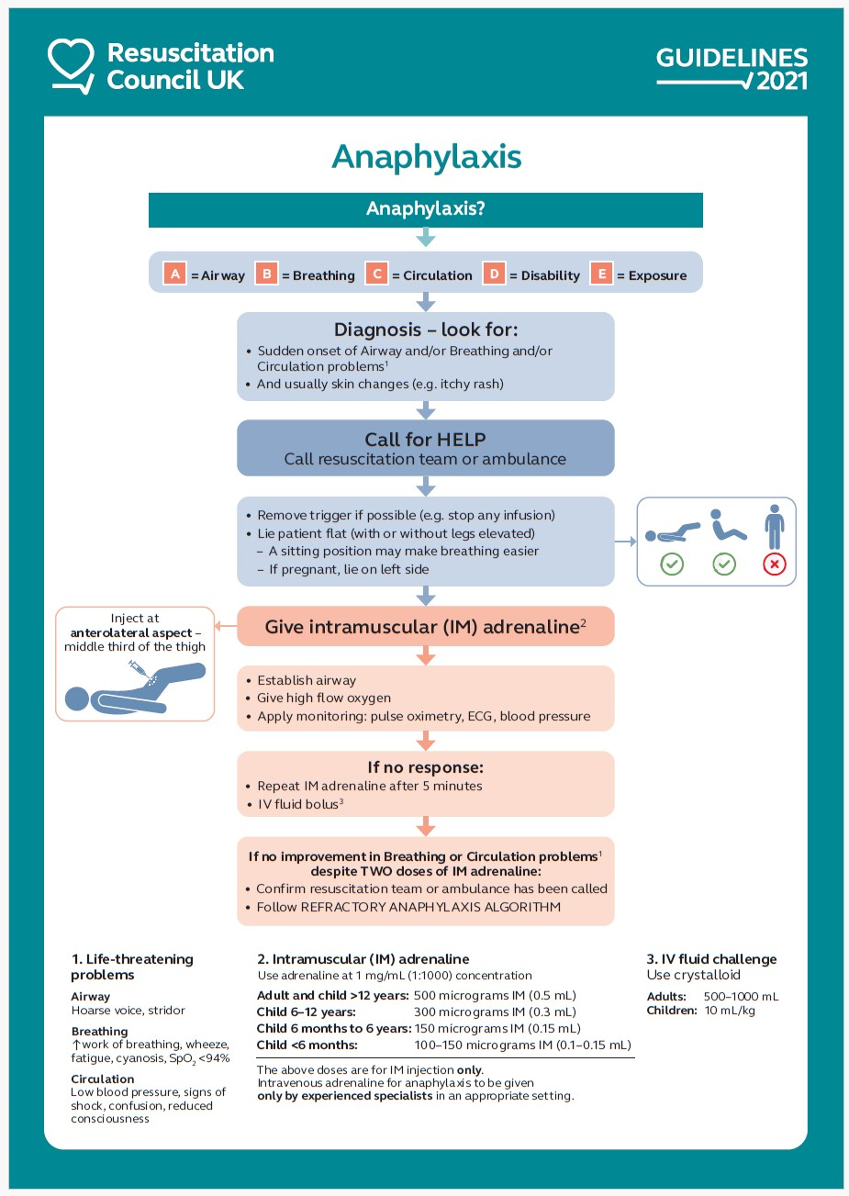
Appendix 1
Appendix 2

All packs to contain: Item | Amount |  | NHS Supply Chain
Blue Needles | X3
Green Needles | X3
1ml syringes | X3 |  | FWC429
1ml ampoules of adrenaline (epinephrine) 1:1000 (1mg/ml) packed down in white box | X3
Anaphylaxis protocol chart from the Resus Council | X1
All packs to contain dosage chart: Age | Dose
Less than 6 months | 150 micrograms IM |  | 0.15 ml 1:1000 solution
6 months – 6 years | 150 micrograms IM |  | 0.15 ml 1:1000 solution
6 – 12 years | 300 micrograms IM |  | 0.3 ml 1:1000 solution
12 years & over | 500 micrograms IM |  | 0.5 ml 1:1000 solution
Small or pre-pubertal child | 300 micrograms IM |  | 0.3 ml 1:1000 solution
Adrenaline (epinephrine) should be;
Kept in the original packaging and should not be spilt
Not be stored in hot places such as cars for prolonged periods of time
Not be stored in cars over night or where it could be accessed by unauthorised persons.
All packs should be sealed and marked with an expiry date and a central register of the location of packs will be held by each Team Lead. If not sealed these boxes need opening and checking daily
All packs must have an outside Label:  Batch Number |  | Expiry Date
Adrenaline (epinephrine) 1:1000 1mg/ 1ml
Date Sealed |  | Signature

Appendix 3.1

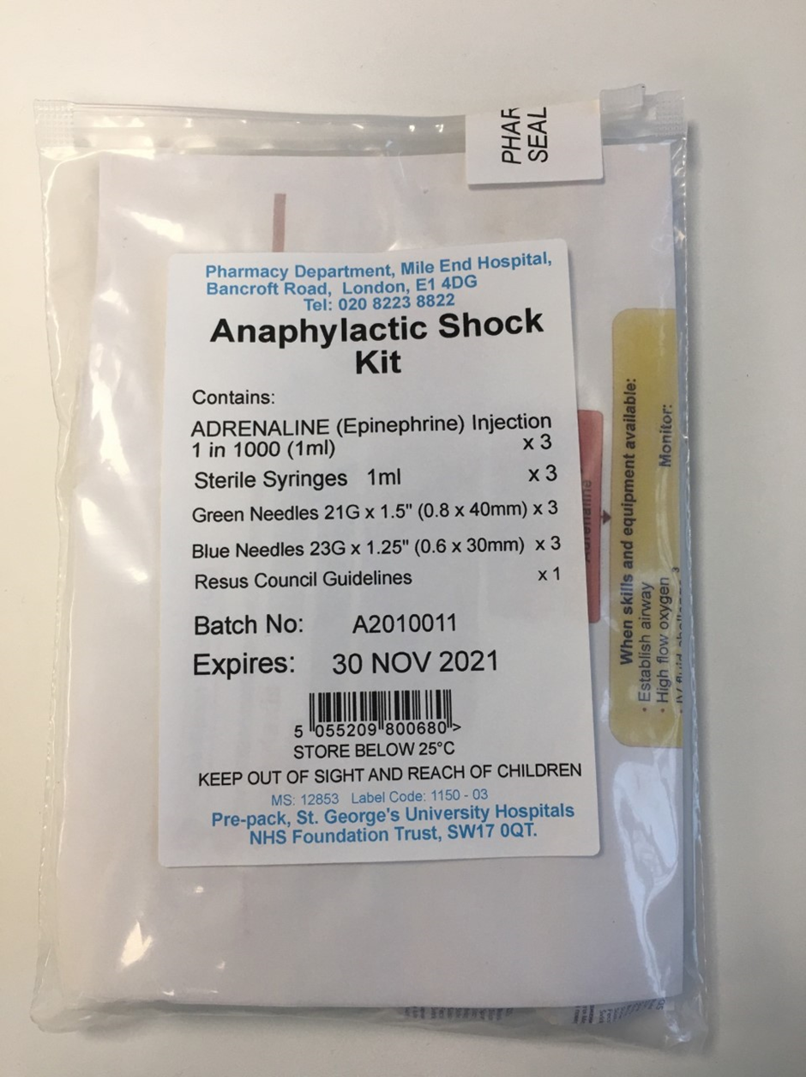

Appendix 3.2

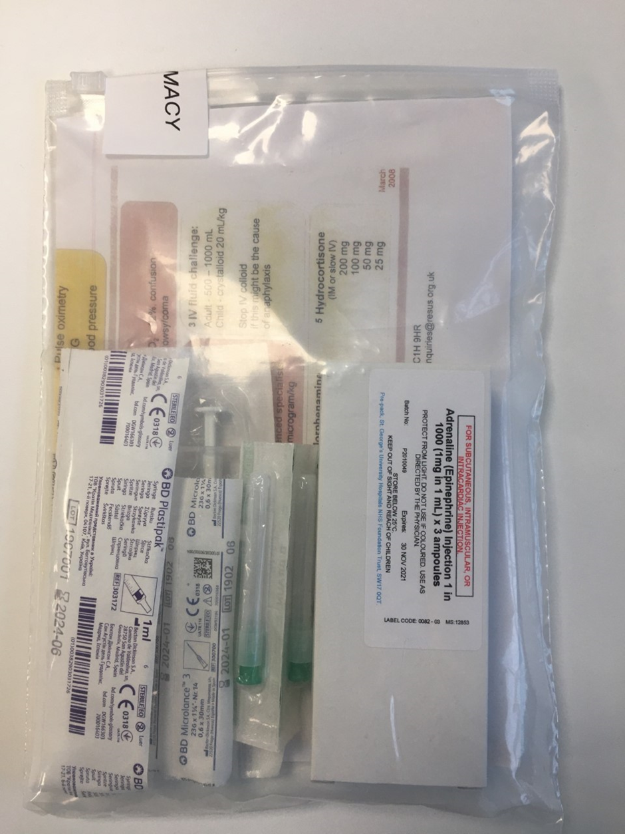


Appendix 4

THCHS Staff Agreement and Confirmation to work in line with Policy

By signing below, I confirm that I have read and understood my roles and responsibilities in line with this ‘Anaphylaxis Recognition & Treatment Policy

Team: ……………………………………………………………………

Date | Print Name | Role | Signature


Appendix 5

THCHS List of Persons authorised to have Responsibilities

Standard Operating Procedure For the storage and transportation of Anaphylaxis Kits in THCHS
Position of  responsibility & Team | Printed name  & Signature  of staff authorised to act with that level of Responsibility within this SOP | Printed name & signature  of authorising member of staff to oversee overall responsibility | Date
Example:  The Appointed Nurse in Charge | A.B.NURSE  A.B.Nurse | C.D.SENIOR  C.D.Senior | 10.01.2020

Appendix 6

THCHS Team Specific Record Keeping of Anaphylactic Kits

This is an example of a table format for record keeping of Anaphylactic kits however an Excel spreadsheet is the most appropriate form for record keeping as this can be easily updated. The table or Excel spreadsheet should be maintained by the Team Lead on the
N drive (TH CHS >Pharmacy folder) and a date placed in the diary for kit replenishment 2 months ahead of expiry dates

. Anaphylactic Kit Team Record
Staff Name | Kit Number | Batch Number | Expiry

Appendix 7

THCHS Anaphylactic Kit logging sheet
Anaphylactic kits should be logged out when intended for a patient visit and logged in at the end of the working day unless service needs prevent. (Refer to Anaphylaxis Recognition & Treatment Policy for the storage and transportation of Anaphylaxis Kits)

Adrenaline is a ‘Prescription Only Medicine’ and must be stored in a locked medicines cabinet when not in use.

Anaphylactic Kit Logging sheet Team:
Date | Kit Name/Number | Logged Out by: | Logged In by: | Comments (indicate where kit has not been returned to base where service needs prevent)

Appendix 8

THCHS Clinical Room/Storage Room Temperature Monitoring Chart (3pages)
Community Team __________________________________
Name of person(s) responsible for monitoring__________________________________
MONTH & YEAR ___________________________________
Temperature monitoring must take place every operational day of the service
Date | Time | Actual | Min | Max | Reset  Y/N | Temp >25°C Y/N |  | Name & Signature
  Action taken if temperatures was >25°C
03 | 09:00 | 10 | 3 | 8 | Y | N | Contacted pharmacy | A.N.Other
01
02
03
04
05
06
07
08
09
10
11
12
13
14
15
16
17
18
19
20
21
22
23
24
25
26
27
28
29
30
31

Additional reading carried out
Date | Time | Actual | Min | Max | Reset  Y/N | Temp >25°C Y/N |  | Name & Signature
  Action taken if temperatures was >25°C

Continued on next page

Information

- If ANY of the readings are above the 25°C range for 7 consecutive days do not use medication, contact your local pharmacy department immediately for advice.

- Clinical room readings must be carried out on each working day by a nominated person or a deputy in their absence.

Named Person:______________________

Named Deputy:______________________

- The ACTUAL, MINIMUM & MAXIMUM temperatures must all be read.

- The following information must be recorded on the monitoring chart overleaf

  - Date (already printed on monitoring chart)
  - Time
  - ACTUAL, MINIMUM, MAXIMUM temperatures
  - Whether temperatures are above 25°C range
  - Action taken if outside range
  - Name and signature of person carrying out reading

- Thermometer(s) must be rest after readings have been recorded.

- ALL readings should be <25°C, if outside this range for 7 consecutive days see point 1 above.

- Logs must be kept in a secure place for a minimum of 2 years or sent to Pharmacy MEH.

Source: ELFT Standard Operating Procedure Fridge and Clinical Room Temperature Monitoring for Safe Storage of Medicine

