Quick Reference Guide to the
Resuscitation Equipment New Style Check Sheet

Introduction
East London NHS Foundation Trust has introduced a Standardised Cheek Sheet for the MERT bags/trollies, which replaces the variety that are used across the Trust. The purpose is to ensure that the form is fit for current practice and standards, aid the checking of contents and to assist staff when moving from ward to ward or between Directorates to remain familiar with the layout and the forms completion.

Layout
Each Check Sheet covers a two week period and is split into four sections.

Section 1 is to be completed daily.

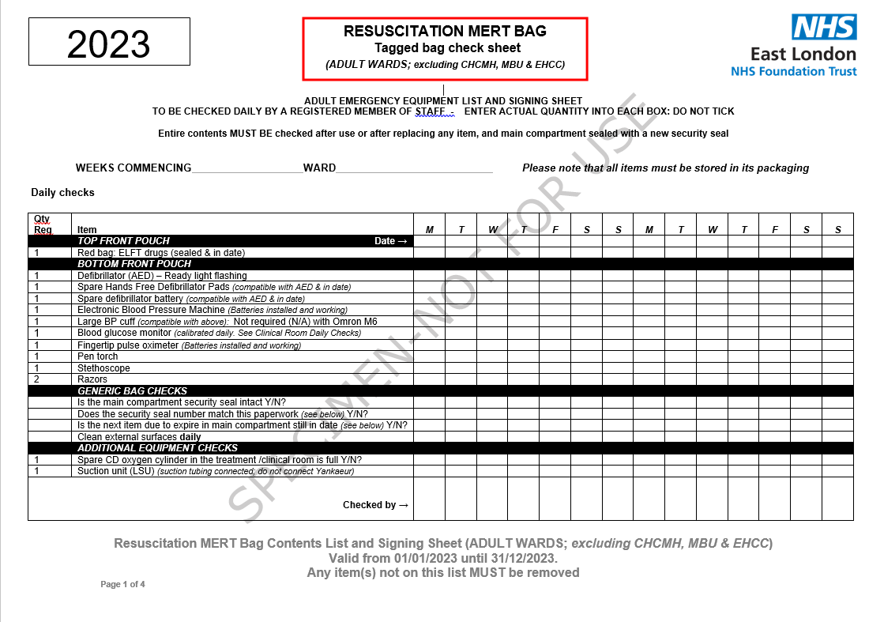

Section 2 is to be completed after use, when replacing an out-of-date/missing item or if found to be unsealed during the daily check.

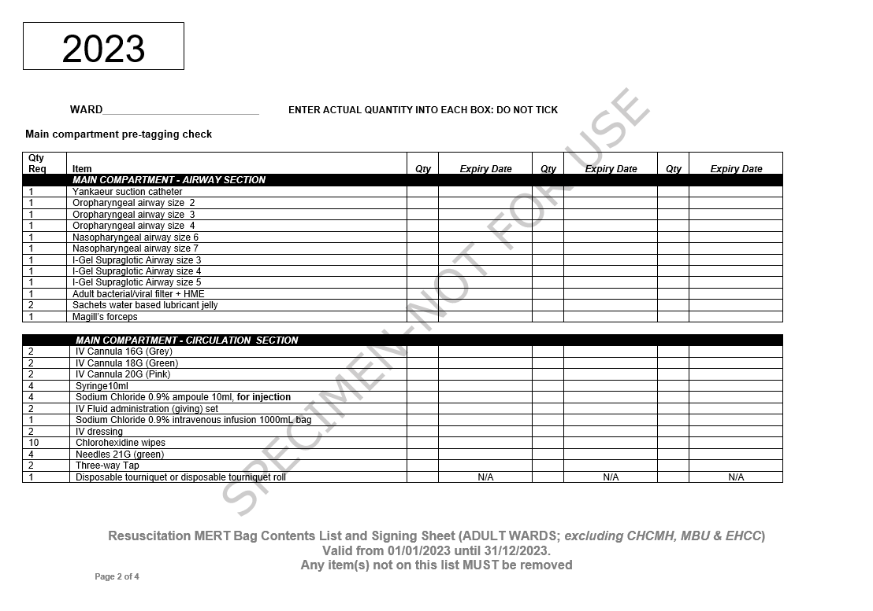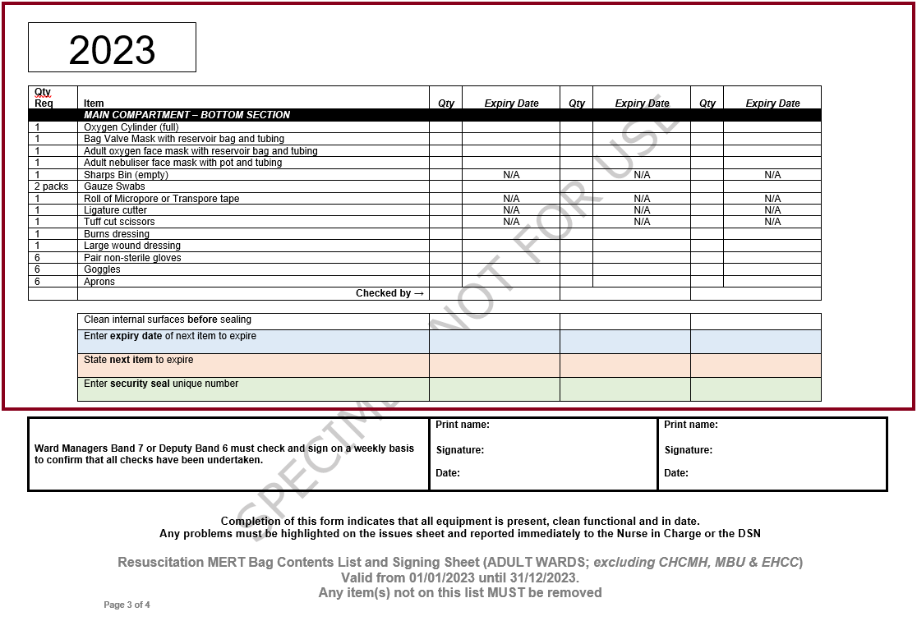

Section 3 is to be completed weekly

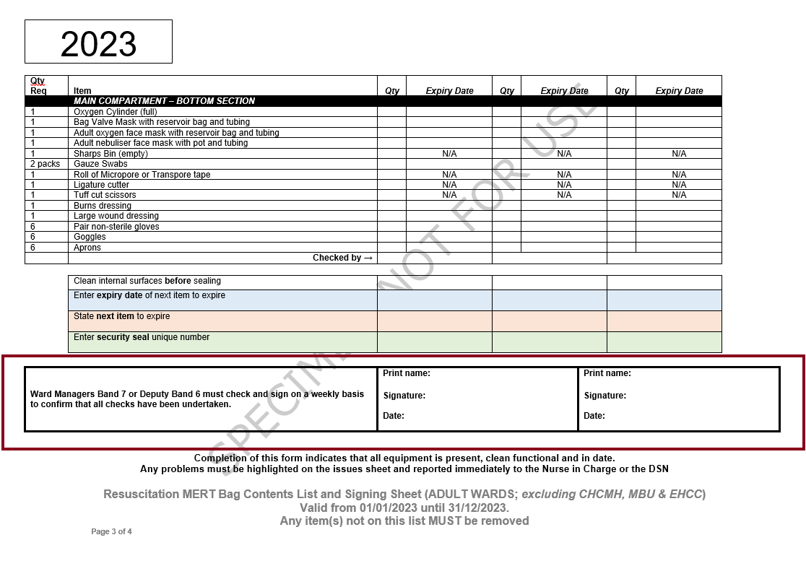

Section 4 is to be completed as required, to report or close an issue

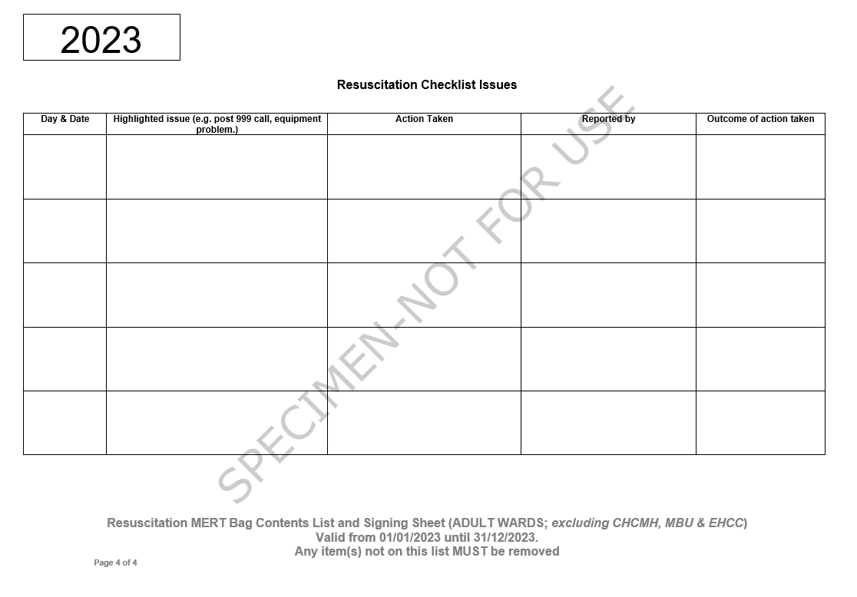

How to complete the Daily Checks

Enter the ‘Weeks Commencing’ date and the ‘Ward’ name

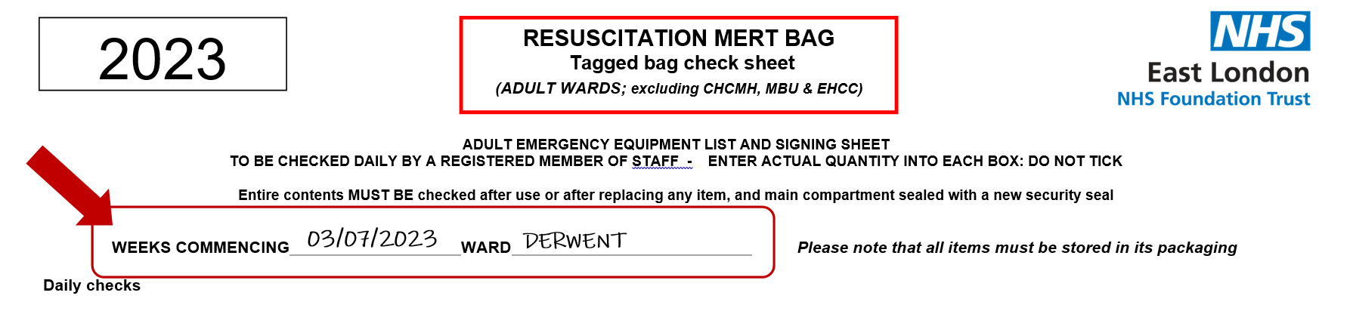

Enter the date for each day.
Enter the actual quantity into each box; do not tick.
Enter your initials.

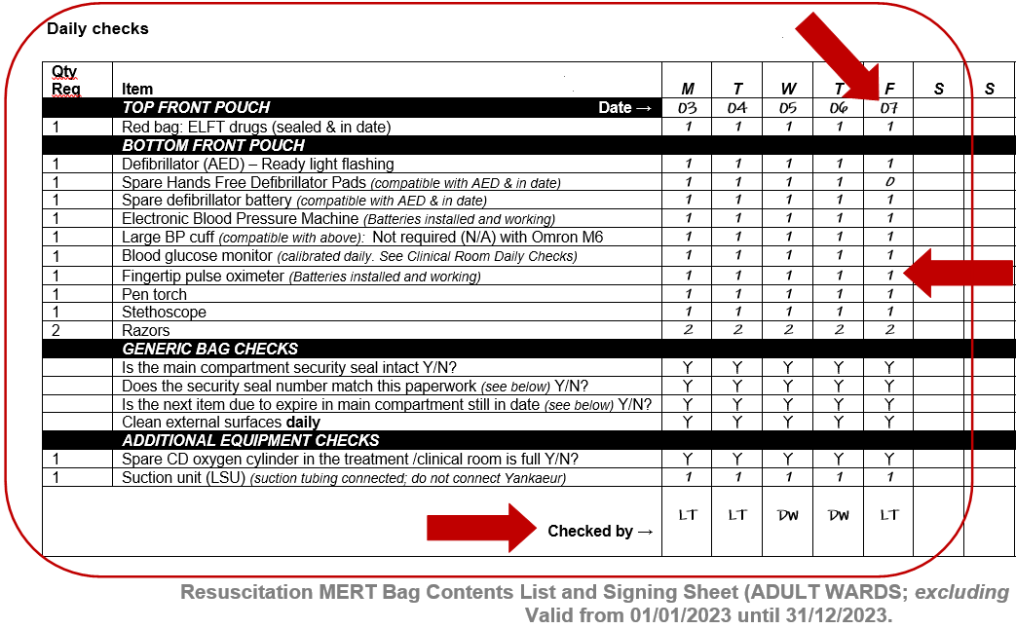

Generic Bag/Trolley Checks.
Cross reference that the security seal number matches the one further down in the document and that the next item due to expire in the main compartment is still in date.

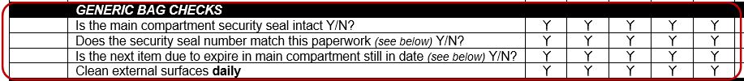

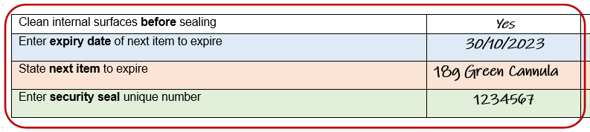
30/10/2150

Check the ‘Resuscitation Checklist Issues’ page for any reported issues. Follow up on those outstanding. Record any issues you have found during your check.

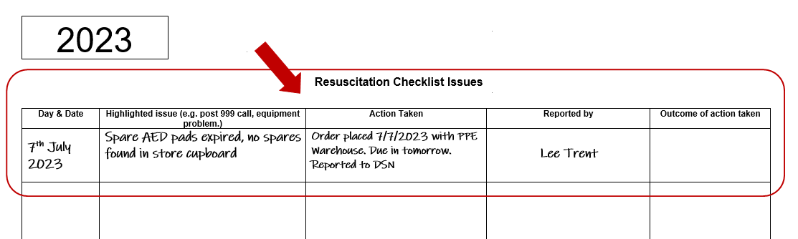

If the security seal number matches the paperwork and there are no items that need replacing or can be replaced from outstanding issues, there is no need to open the sealed compartment(s).

Management Weekly Checks.

Ward Managers Band 7 or Deputy Band 6 must check and sign on a weekly basis to confirm that all daily checks have been undertaken.

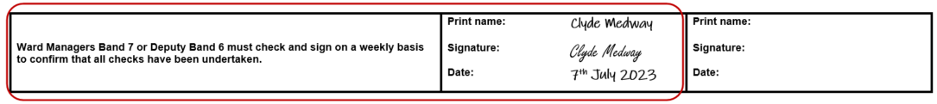

You are not signing to confirm the daily checks are accurate, merely that they have been performed daily. You should also review the ‘Resuscitation Checklist Issues’ page so you are aware of any issues, and to ensure outstanding issues are followed up promptly.

How to complete a Full Equipment Check (post incident/replacing equipment/opening).

A full equipment check must be undertaken whenever the main compartment or draws of the bag/trolley has been opened and/or the tamper seal has been removed.

Enter the actual quantity into each box; do not tick.

Enter the expiry date. Where the quantity is more than one for an item and each has a different expiry date, for example ‘2 packs Gauze Swabs’ where one pack expires 01/12/2163 and the second expires 28/02/2164, the date of the first to expiry must be used, therefore ‘01/12/2163’ is entered.

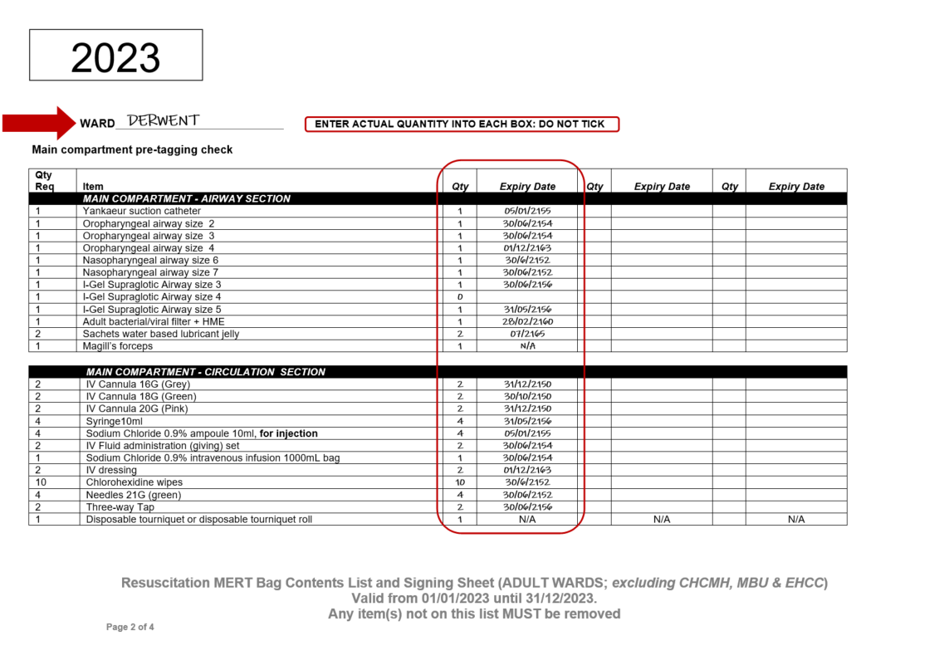

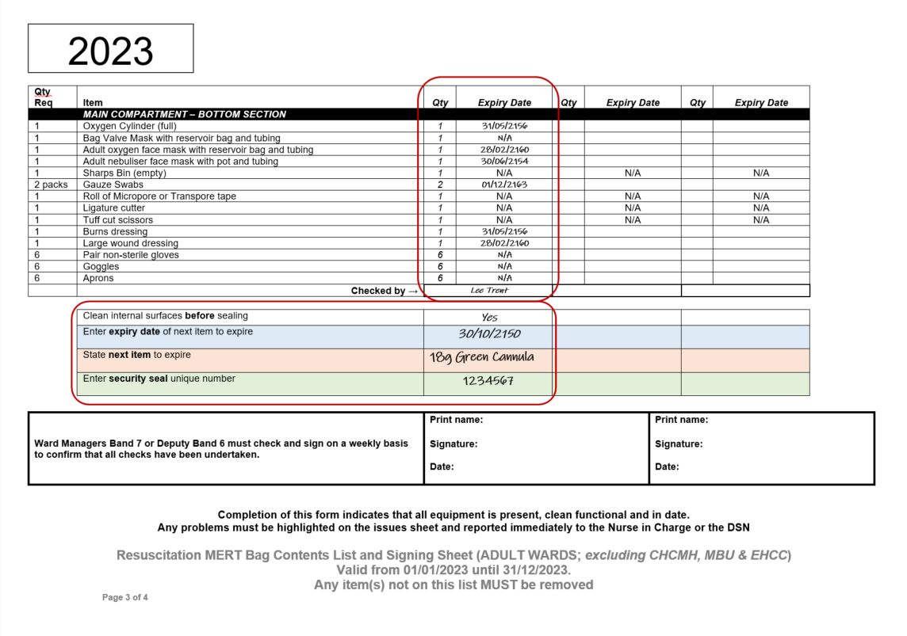

Clean all internal surface before attaching the security seal.
Enter the expiry date of the next item to expire and what that item is.
Attach a new tamper security seal and record its unique number.

30/10/2150

Further Guidance.

Further guidance can be obtained from;
- Physical Health Nurse(s)
- Ward manager(s)
- Resuscitation Lead

