RiO Recording Changes

By CAMHS Performance Team
RiO Recording Update
RiO Change/Update | Link to recording guide
Changes to the appointment process | Slide 3 - 6
Direct /Indirect Activity Change on RIO | Slide 7 - 8
Intended Activity | Slide 9 - 13
Did not attend/Was not brought | Slide 14 - 15
Link to RiO Guides (on intranet) | https://www.elft.nhs.uk/intranet/teams-support-me/digital/our-clinical-staff-and-digital/rio
This is an update from the CAMHS Performance Team containing information about recent changes to RiO recording

Changes to the Appointment Process – Part 01
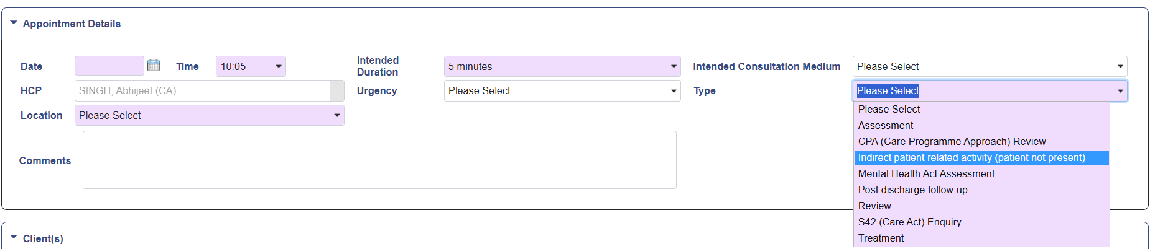
This guide is to show the user the new layout of the appointment booking process, as well as the process for booking client related activity when the client is not present.
No “Face to Face” Tick Box
With the new upgrade, the face-to-face box has now gone. If you are completing Service User related activity and the Service user or Parent/Carer is not present, you will now need to book the appointment with the appointment type of “indirect patient related activity (patient not present)”

Changes to the Appointment Process - Part 02

Booking an appointment
- Click on the desired appointment time as usual and find the patient you want to book into that appointment.
- On the appointment booking screen you will notice a number of differences. The client details, additional HCP, Intended activities and repeat appointment tabs are now separate section below the referral column.
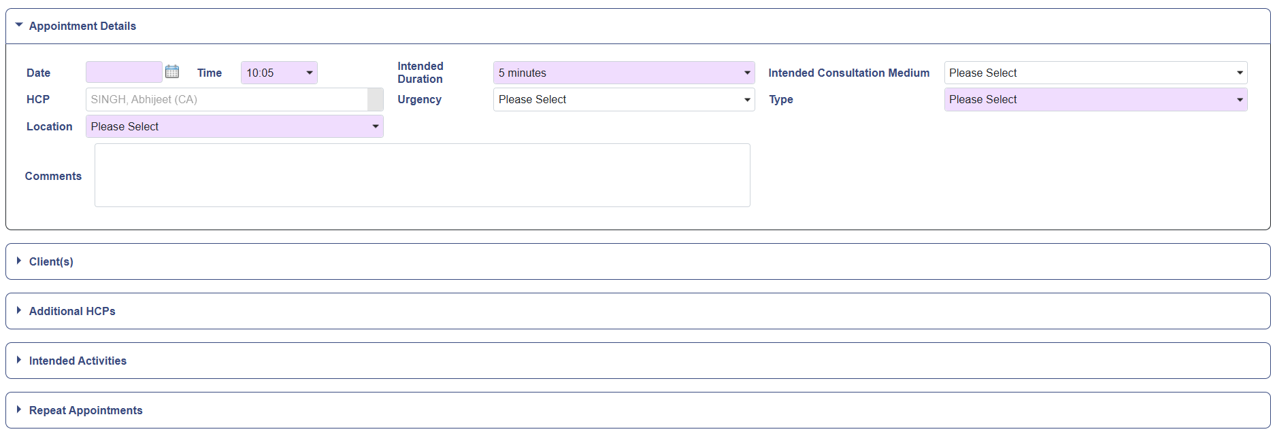
Changes to the appointment process - Part 03
To add an additional HCP, intended activity or repeat appointment, just click on the relevant box title to open it, and click on it again to close it. The information in these boxes works exactly as it did in previous versions of RiO.

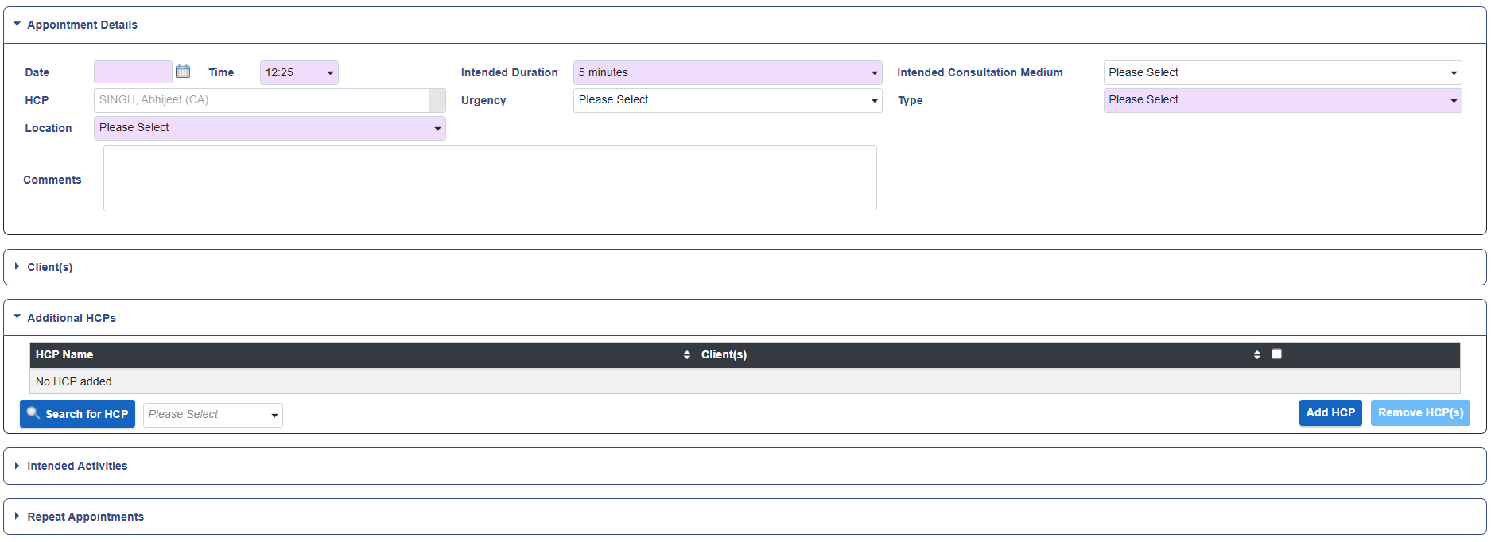

Changes to the Appointment Process - Part 04
New field in the outcome screen
There are two new field in the outcome screen. They currently do not feed into any reports but can still be used if you wish
- Follow-up - This allows you to show that a follow-up appointment maybe needed
- Who else was seen - This will allow you to show if the patient was accompanied by a carer or relative

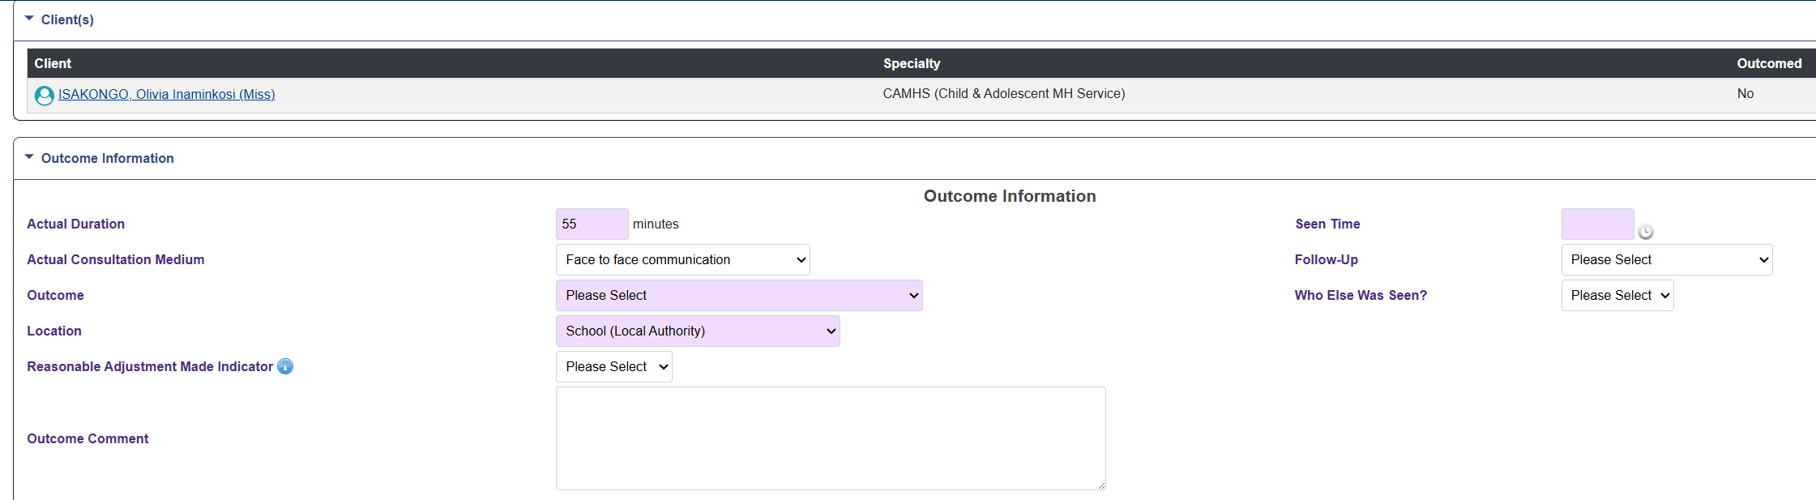

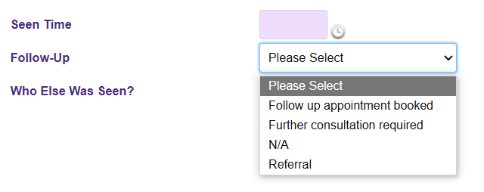

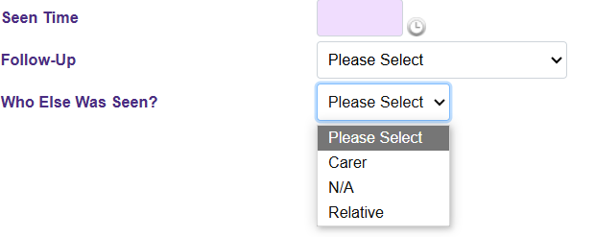

Direct /Indirect Activity Change on RIO

You will have seen information about the recent RiO upgrade. One of the key changes is the removal of the face to face tick box on the appointment screen, which was previously used when recording direct and indirect contacts in Rio.
This has been replaced by adding a new appointment type titled ‘Indirect patient related activity (patient not present)’.
Appointments will be deemed as direct contacts unless the new appointment type is selected, as shown in image below.

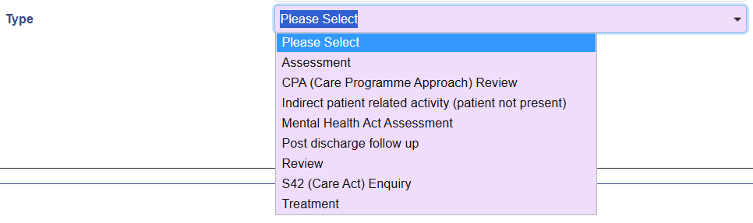

Indirect Activity Updated Crib sheet
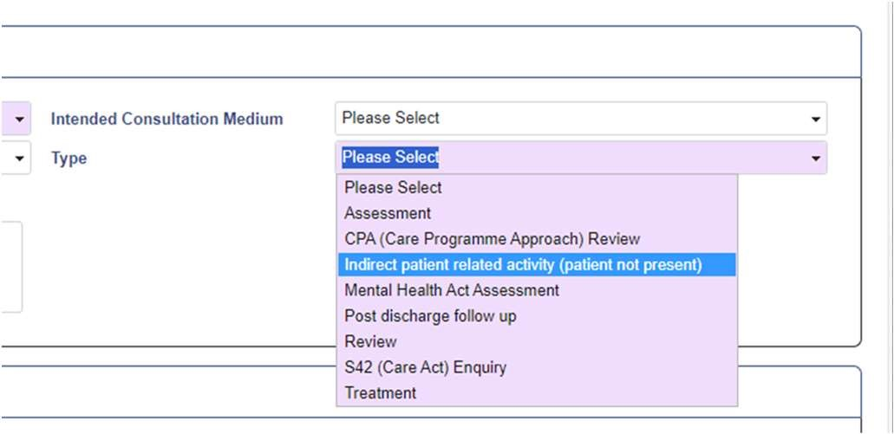
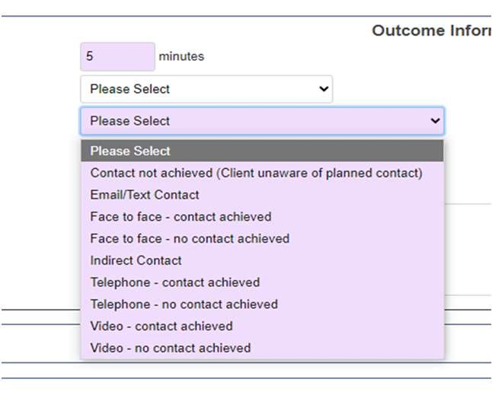
When booking the appointment, select an appointment type of “Indirect patient related activity (patient not present)”
When outcoming the appointment you will have the option of indirect contact for recording the appointment with the service user not present.

Recording on RiO- Intended Activity – Part 01
There is an additional new requirement on RiO, to record "intended activity" when booking and outcoming your direct and indirect appointments in the RiO diary.
Recording Intended Activities
- Open the Appointment Booking Page as shown below
- Fill in the mandatory purple fields as normal
- Click on the Intended Activities tab
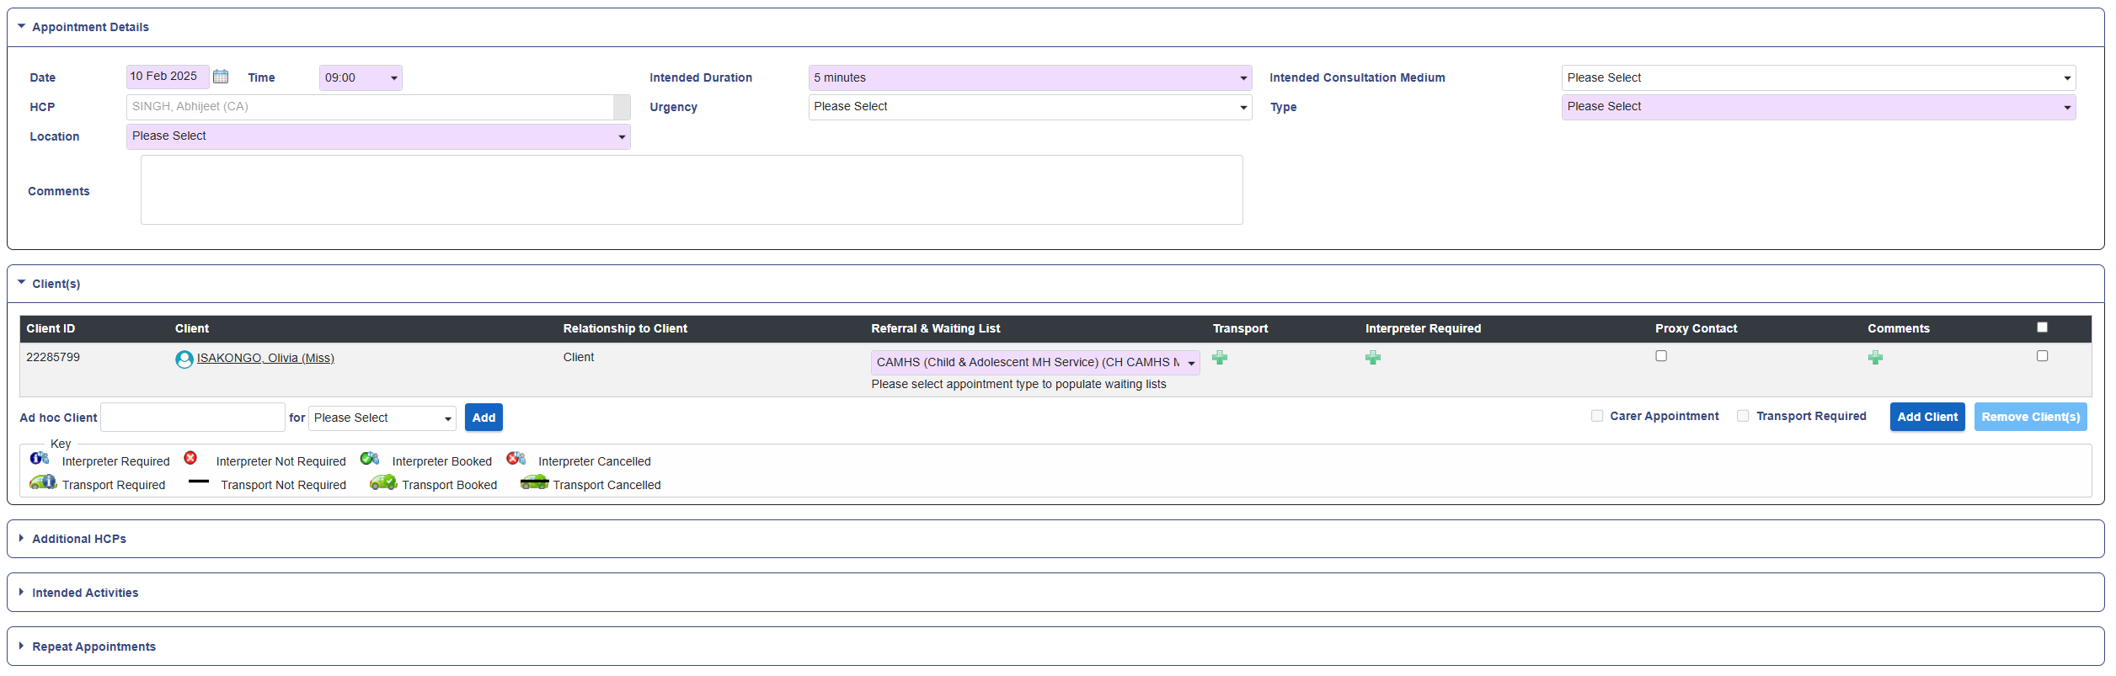
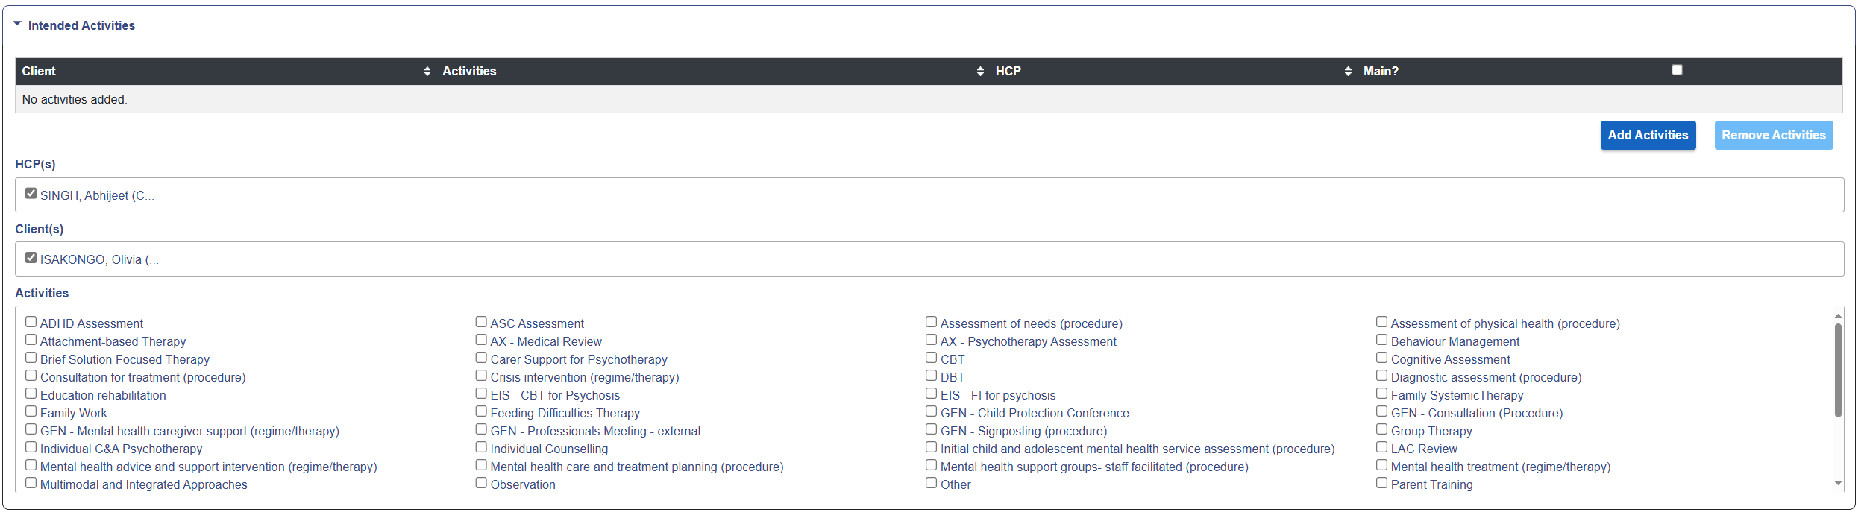
Recording on RiO- Intended Activity – Part 02
This will open up the list of Intended Activities available on RiO
- Select the appropriate activity (more than one can be selected)
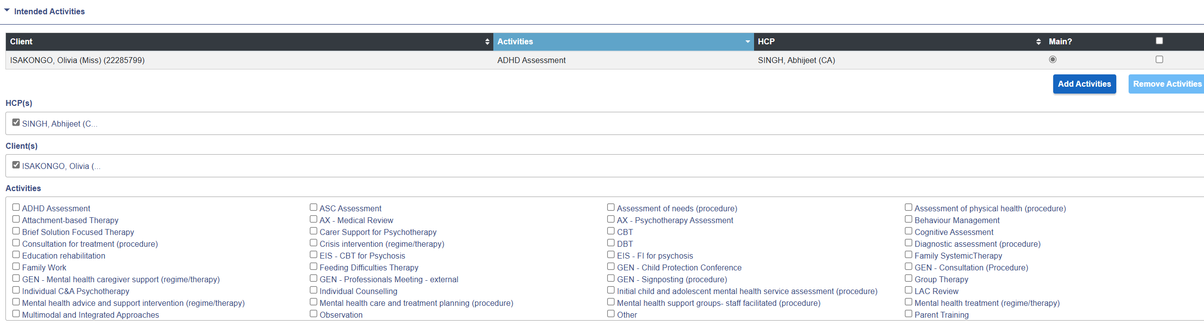
- Click on the Add button in the top right of the screen
- The activity you selected should now be listed under Activities
- After this, click on Book to finish booking your appointment

Recording on RiO- Intended Activity – Part 03

Recording Intended Activities – At Outcome Screen
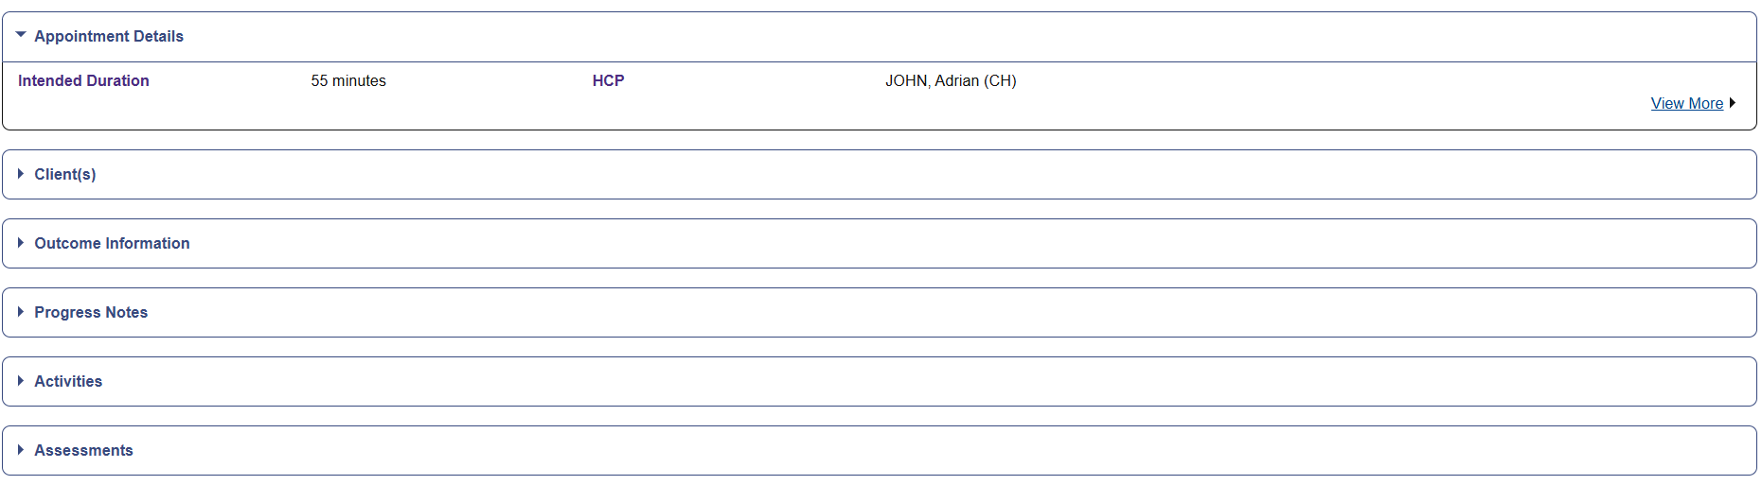
You can also add activities when outcoming your appointments, in case you forget to do so when initially booking the appointment

To do this, open the Appointment Outcome page (as below) and click on Activities

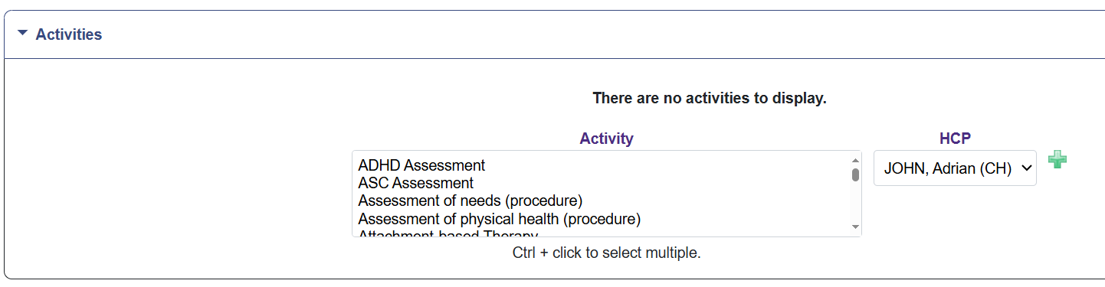
You will then be presented with a list of Activities
Select the appropriate activity (Use “CTRL + Click” to select more than one)

Click on the Green “+” sign to add your activities to the booking

Once activities have been added, they need to be outcomed (next page)
Recording on RiO- Intended Activity – Part 04
Outcoming Intended Activities
- Once Intended Activities have been booked in an appointment, they also need to be outcomed
- If you added your Intended Activities whilst booking the appointment - open up the Appointment Outcome page and click on Activities
- If you added your Intended Activities at the outcome screen, you will already be on the Intended Activities outcome screen
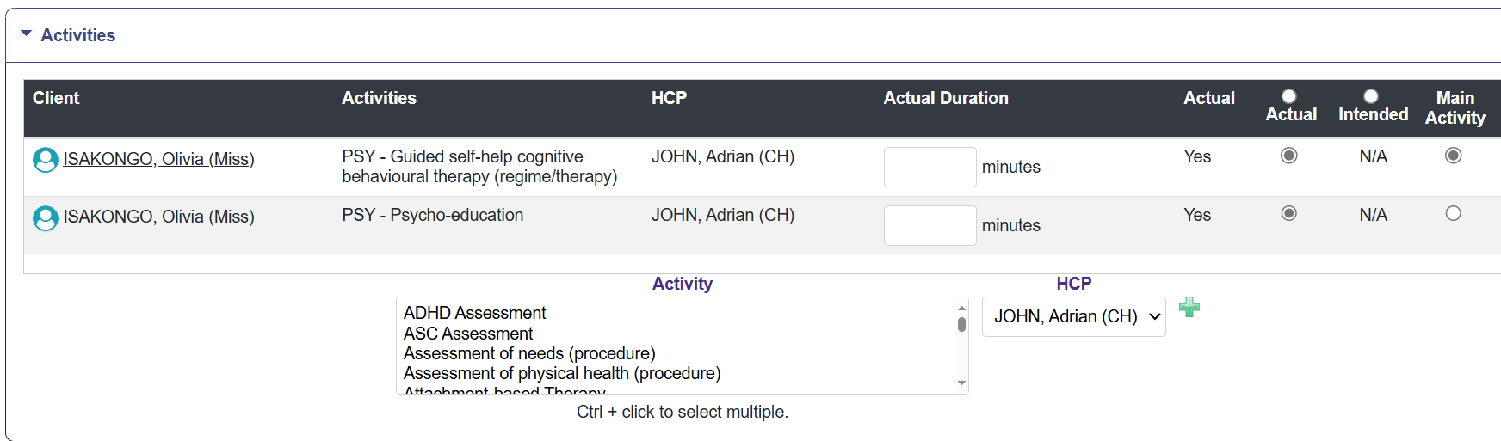
Here, you need to fill in two of the columns:
- Actual Duration: the number of minutes spent on each intended activity (please note: total number of minutes for all Activities cannot exceed the duration of the appointment e.g. If an appointment was 60 minutes long, the total minutes you enter for each activity has to equal
60 or below)
- Actual: Ensure all activities are ticked in the “Actual” column. If you did not carry out the planned activity, please tick the Intended column instead
Once this is done, click Save to outcome appointment
Recording on RiO - Intended Activity Guide

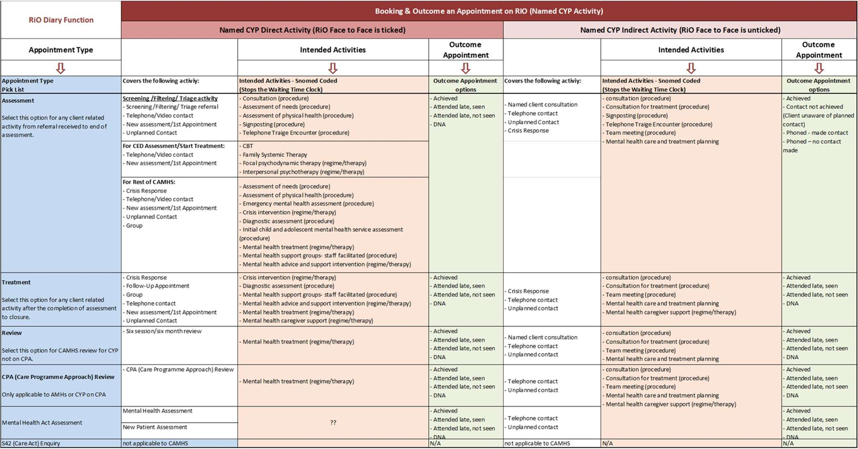

Recording on RiO - Did not attend/Was not brought
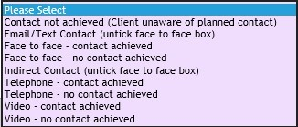
Any outcome with “no contact achieved” is recorded as a DNA
Please see link to ELFT CAMHS “Was Not Brought/Did Not Attend” policy:
https://www.elft.nhs.uk/sites/default/files/2023-11/DNAWNB%20Policy%20CYP-CAMHS%205.0.docx
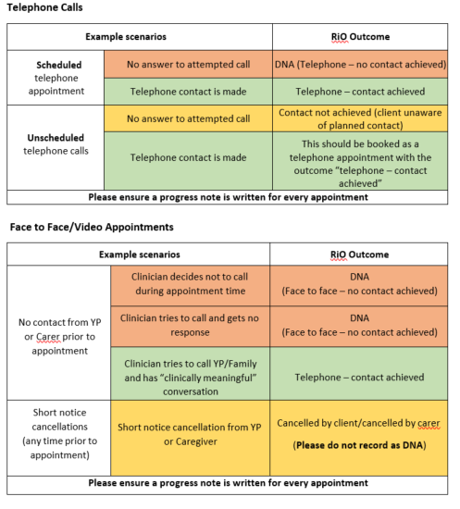

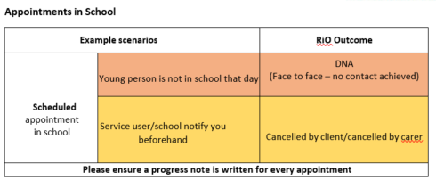

Recording on RiO- Did not attend/Was not brought
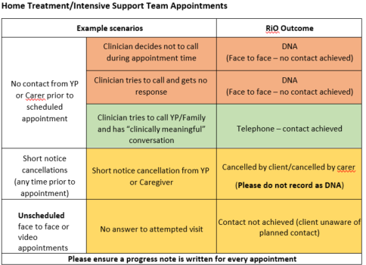

Definition of Clinically meaningful: “Clinically meaningful interactions are those that directly influence a patient’s care plan or other intervention that impacts the patient’s care. This can include advice, consultation, formulation, risk management discussion, care planning, delivery of treatment interventions and medication-related advice.”
Further information can be found here - https://www.transformationpartners.nhs.uk/wp-content/uploads/2022/12/Guidance-Measurement-of-clinicalactivity-a-London-approach-for-community-CAMHS-vFINAL.pdf

