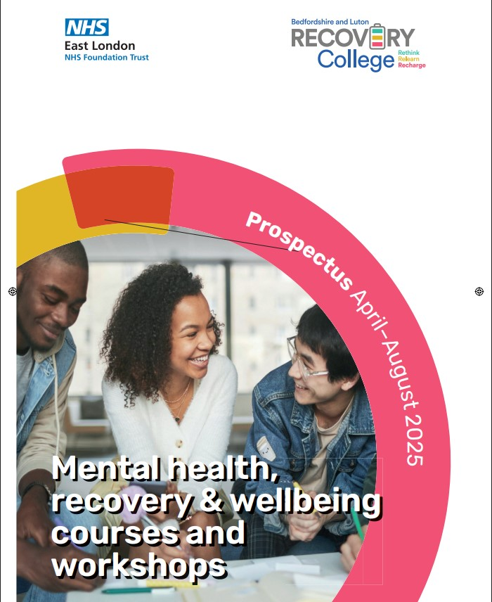



Completed A4 Prospectus April - August 2025 V.1.indd 1

07/03/2025 14:40:42



Scan to
download this
prospectus

This prospectus is the start of your journey and will cover:

- About us
- How the process works

- How to enrol

- What courses are available

Completed A4 Prospectus April - August 2025 V.1.indd 2

Your journey
starts today

Welcome to Bedfordshire and Luton Recovery College

We are part of the Bedfordshire Mental Health Academy which is a formal partnership with East London Foundation Trust (ELFT) and the University of Bedfordshire. The college is open to any adults who live or work in Bedfordshire
and Luton.

Our courses and workshops focus on mental health well-being and recovery.

They are delivered by people with lived experience and professional experience.

We promote a positive student experience based on the principles of recovery and the values of the University of Bedfordshire and ELFT.

All of our courses and workshops are free of charge.


07/03/2025 14:40:43

Contents

Our approach | 4
How to enrol | 5
4 Steps to start | 5
your journey | 5
Our values | 6
Involvement | 6
Student charter | 7
FAQs | 7
Our partners | 8-9

Completed A4 Prospectus April - August 2025 V.1.indd 3

Learning to suit you | 10
Ways of learning | 10
Our venues | 11
Courses & | 14-28
workshops
Index | 30

3

07/03/2025 14:40:43

Bedfordshire and Luton Recovery College
Our

approach

The Bedfordshire and Luton Recovery College is open to everyone aged eighteen and over, living, working or studying in Bedfordshire or Luton.

Rethink



Relearn


Recharge

Our Recovery College is inclusive to all; service users, carers, family, friends, neighbours, staff and the general public. All are welcome to enrol as students. The educational workshops and courses we offer are all free and focus on recovery and wellbeing. They are designed, co-produced and delivered in partnership with people with lived experience and professional experience as co-production is at the heart of everything we do.

Recovery has many definitions and one which resonates with many people is that it is about a deeply personal journey to live as well as possible and have a meaningful and satisfying life.

The tools we share in workshops and courses aim to support people to become an expert in their own recovery and understanding

by exploring hope, choice and opportunity. By learning together we can make progress in challenging the stigma surrounding mental illness, and over time we hope to contribute to changing society to be more tolerant, inclusive, accepting and compassionate.

Contact us

elft.recoverycollege@nhs.net

01234 263 621 or 01582 315 987

4

Completed A4 Prospectus April - August 2025 V.1.indd 4

07/03/2025 14:40:43

01234 263 621 | 01582 315 987 elft.recoverycollege@nhs.net


Scan to
enrol online

How to enrol

Our workshops and courses are free of charge and inclusive for all.

How to register

If you are new to the Recovery College you will need to register. You can do this by scanning the QR code at the top of this page or visiting http://tinyurl.com/ yckmucw5

Already registered?

Simply send us an email with your chosen course or workshop and specify whether you wish to attend online or classroom and which venue elft.recoverycollege@nhs.net


Further information

If you would like further information or would like to speak to us in person, do call us or visit our offices:

Recovery College Bedford

3 Woburn Road, Bedford. MK40 1EG Tel: 01234 263 621 Monday – Friday 9am – 5pm

Recovery College Luton

Luton Central Library, 2nd Floor, St. George’s Square, Luton. LU1 2NG Tel: 01582 315 987

Tuesday 9am – 5pm Thursday 12pm – 5pm Friday 9am – 5pm

- Find a course you wish to attend

- Check if you need to contact us directly or through our partners

- Enrol on our website, or contact the relevant partner directly




- Begin your journey towards recovery

Completed A4 Prospectus April - August 2025 V.1.indd 5

5

07/03/2025 14:40:43

Bedfordshire and Luton Recovery College

Our values

We promote a positive student experience based on the principles of recovery.

We believe by bringing together the Recovery College principles of recovery, East London Foundation Trust values and the University of Bedfordshire values we encapsulate a meaningful and solid value base that underpins everything we do in the development of the our


Recovery College principles of recovery

Opportunity: To do things you want to do

Choice: Control of your future

Hope: Believing a meaningful life is possible

East London Foundation Trust values

We Care

We Respect

We Are Inclusive


University of Bedfordshire values

Strive to offer

transformational

educational change for

people’s lives.


Involvement

Co-production

Co-production is at the heart of what we do at our Recovery College. People with personal and professional experience of mental health problems work together, equally, to design, facilitate and evaluate the courses and workshops. Our workshops and courses are co facilitated by a broad range of professional staff and people with lived experience including: University Lecturers, Doctors, Mental Health Staff, and Student Nurses alongside the expertise from staff from partner organisations.

Become a volunteer for us

Volunteering is a great way to develop your skills and experience to support your career aspirations and to do something meaningful and interesting in your free time to help others. If you are interested please email us at

elft.recoverycollege@nhs.net or telephone us on 01234 263 621 or 01582 315 987.

6

Completed A4 Prospectus April - August 2025 V.1.indd 6

07/03/2025 14:40:43

01234 263 621 | 01582 315 987 elft.recoverycollege@nhs.net


Student charter

Contact us with
any questions

elft.recoverycollege@.nhs.uk

You can expect us to:

- Provide information and guidance about our workshops and courses

- Offer high quality workshops and courses that focus on recovery and wellbeing

- ^{Respect}_{times} ^{you as an individual at all}

- Welcome your ideas about how we might improve and what we offer in the future

- Manage your enquiries and help you with the enrolment process if you need support

- Deliver workshops and courses in welcoming, accessible and positive environments which are free from discrimination and stigma

- Support your recovery journey with compassion and respect


FAQs

We will expect you to:

- Be prepared to give something new a try

- Be respectful of fellow students and staff views, opinions and beliefs

- Commit to attending courses and workshops you have enrolled

- Inform us if you can’t attend workshops or courses you have enrolled on

- Provide relevant details such as emergency contact information

- Give us feedback on how we are doing

- Share any ideas / suggestions you have about the Recovery College

- Ask the Recovery College staff or facilitator if you are unsure about anything

Confidentiality

As part of enrolment, students are asked to provide personal information and to agree to purposes it can

be used.

Personal information that will be passed to the workshop / course facilitator includes:
- Student’s name
- Student’s phone number

- Details of person to contact in case of an emergency

- ^{Specific}_{needs} ^{support and / or learning}

We will not share any information that you give us without discussing this with your first and asking for your consent. The only exception to this is if we consider that your life or wellbeing of someone else could be at risk.

Who facilitates the workshops? Workshops and courses are co-produced with people with lived experience of mental health problems and people with professional experience. The professionals include staff and students from the University of Bedfordshire, NHS staff and staff from partner organisations.

Who can enrol?
- People who use ELFT services

- People who are living with mental health problems

- Carers, family, friends, neighbours and general public (a few workshops related to employment may have some specific criteria)

- Volunteers

- Staff from ELFT, University of

Bedfordshire and local partner organisations

• People age 18 and over
Do I need to be referred to attend a workshop / course?

No one needs a referral to become a student – please contact us if you would like to enrol to attend a workshop or course.

Do you provide refreshments? Most if not all the venues we use offer tea, coffee (depending on the venues facilities) We are not able to provide lunch but you are welcome to bring something with you.

Do you pay travel costs for students?

We cannot reimburse you for any travel costs.

Will I get a place on the workshop / course I want?

The student places on our workshops / courses are allocated on a first come first served basis.

If there is particularly high demand for a workshop we will endeavour to facilitate an additional workshop.

Do you provide child care?

You would need to make your own child care arrangements.

7

Completed A4 Prospectus April - August 2025 V.1.indd 7

07/03/2025 14:40:44

Bedfordshire and Luton Recovery College

Our partners

Thank you to all our volunteers, service users, carers, students, staff, partners and everyone who has given time and shared ideas to develop the Bedfordshire and Luton Recovery College. We are delighted to have been able to work in partnership with local organisations to deliver high quality workshops and courses. Our partner list is growing as we further develop the range of courses and workshops for the next Recovery College prospectus.

Bedford Food for Thought
Penrose

Nature hub is a small Community Garden where individuals can get involved in the gardening or just come along to make new friends and local connections. Come along and join us at the garden, have a cup of tea and a chat whilst doing a little gardening to improve your general wellbeing.

Better place to start open up Possibilities Luton Adult Learning
A Better place to start is a short course that empowers learners to identify their own steps for a positive future, with personalised guidance and support.

Money Matters - Luton Adult Learning

Practical tips on why money matters, how to budget better, spend smarter and wise ways to save.

No Barries Here - Keech Hospice Care

No Barriers Here is an equity-oriented, arts-based, approach to advance care planning, aimed at people, groups and communities who may be marginalised in healthcare. Each workshop is designed to explore a different aspect of the advance care planning process.

Passport to the NHS - Luton Adult Learning

Interested in working with the NHS Receive free support for job readiness, skills building, applications, interviews and career planning. Learn about the variety of opportunities from Community Support and Hospital Settings to Admin, IT and Facilitties.

Roots to Recovery - Penrose

Nature hub is a large Community garden where individuals can get involved in the gardening or just come along to make new friends and local connections.

Recycle-a-Bike - Penrose

Upcycling and basic bike maintenance, working with donated bikes


Carers Information Support Programme Alzheimer’s Society
These are information sessions for carers of people with dementia with opportunities to meet other carers and share experiences with people who understand.

Compasionate Friends - Keech Hospice Care

Community of Compassionate Friends deliver care to help dispel the myths about dying and bereavement, helping communities to be better informed and more confident in a having these conversations.

Computer Skills for Beginners - Noah

Familiarise yourself with the digital world, in a safe and supportive beginner’s environment.

Connects - Penrose

Community gardening and the indoor activities are aimed at individuals who are making that first step out of social isolation or who need a smaller group to build their confidence.

Five Ways to Wellbeing - Luton Adult Learning

Explores the different ways you can include the five ways to wellbeing into you daily life.

Free Employability Workshops - Luton Adult Learning

Join one of our many Employability Workshops and take a positive step towards your future.

Get Into Volunteering - Luton Adult Learning

Volunteering can make a real difference to your own life and the lives of those around you. Giving some of your time to help others can be empowering.

Living Well with Dementia - Alzheimer’s Society

For people in the early stages of dementia with a diagnosis. They aim to increase your confidence in managing day-to-day and help you plan for the future.

Skills and CV - Luton Adult Learning

Identify the transferable and adaptable skills you possess, use them to create a personal statement. We also look at the key features that need to be included on a CV and focus.

Staying Safe Online - Luton Adult Learning

Keep yourself and your family safe and be aware of scams, fraud and harassment online.

Talking About Inclusive Healthcare Keech Hospice Care
A series related to inequalities and inequity within palliative care. The main focus is to highlight many lesser taught and misunderstood areas in care that require addressing when providing care for patients and relatives who are living with a life limiting condition.

- Pallative Care and the Homeless Community
- What Have I Done To Deserve This?

- LGBTQIA+ community living with a palliative illness

- Racialism & Casteism in Pallative Care

Roots to Success - Penrose

Basic horticulture alongside growing flowers and vegetables. Learning how to grow your own and build new friendships.

Your Digital Memories Matter - Keech Hospice Care We will provide you with an understanding of what your digital legacy means, what your digital assets are, where to go for help and how to turn this into conversation with family and friends.

8

Completed A4 Prospectus April - August 2025 V.1.indd 8

07/03/2025 14:40:44

01234 263 621 | 01582 315 987 elft.recoverycollege@nhs.net

Alzhiemer’s Society Telelphone: 01582 320224 Email: luton@alzhimers.org.uk

Website: www.alzheimers.org.uk

Contact Our partners

Luton All Women’s Centre

Telelphone: 01582 416 783

Email: support@lawc.org.uk

Website: www.lutonallwomenscentre.org.uk

Autism Bedfordshire | Mind BLMK
Telelphone: 01234 350 704 | Mind BLMK
Telelphone: 01234 350 704 | Telelphone: 0300 330 0648
Email: enquries@autismbedfordshire.org | Telelphone: 0300 330 0648
Email: enquries@autismbedfordshire.org | Email: hq@mind-blmk.or.uk
Website: www.autismbedfordshire.net | Email: hq@mind-blmk.or.uk
Website: www.autismbedfordshire.net | Website: www.mind-blmk.org.uk
Carers in Bedfordshire | Penrose Roots
Telelphone: 0300 111 1919 | Penrose Roots
Telelphone: 0300 111 1919 | Telelphone: 01582 343 230
Email: contact@carersinbeds.org.uk | Telelphone: 01582 343 230
Email: contact@carersinbeds.org.uk | Email: samantha.smith@socialinterestgroup.org.uk
Website: www.carersinbeds.org.uk/contact/us | Email: samantha.smith@socialinterestgroup.org.uk
Website: www.carersinbeds.org.uk/contact/us | Website: www.facebook.com/PenroseRoots


Disability Resouce Centre

Telelphone: 01582 470 900

Email: info@drcbeds.org.uk

Website: www.drcbeds.org.uk/contact-us

Groundwork

Telelphone: 0121 236 8565

Email: info@groundwork.org.uk

Website: www.groundwork.org.uk

Tibbs Dementia Foundation

Telelphone: 01234 210 993

Email: contact@tibbsdementia.co.uk

Website: https://tibbsdementia.co.uk

The Noah Academy

Telelphone: 01582 726 152

Email: academy@noahenterprise.org

Website: www.noahenterprise.org

Keech Hospice Care

Telelphone: 01582 492 339

Email: letmehelp@keech.org.uk

Website: www.keech.org.uk

Luton Adult Learning

Telelphone: 01582 490 033

Email: info@lutonacl.ac.uk

Website: www.lutonacl.ac.uk

Total Wellbeing Luton

Telelphone: 0300 555 4152

Email: info@totalwellbeingluton.org

Website: www.totalwellbeingluton.org

University of Bedfordshire

Telelphone: 01234 400 400

Email: study@beds.ac.uk

Website: www.beds.ac.uk

St Giles

Telelphone: 0207 708 8000

Email: info@stgilestrust.org.uk

Website: www.stgilestrust.org.uk

9

Completed A4 Prospectus April - August 2025 V.1.indd 9

07/03/2025 14:40:45

Bedfordshire and Luton Recovery College

Learning to suit you

We have four categories to ensure you can easily find the perfect course for you.

Recovery & Wellbeing | Building on Knowledge & Skills
These courses develop your understanding and | These courses and workshops are designed to
explore mood, thinking and behaviours which over | increase knowledge and skills on a number of mental
time can improve your recovery and wellbeing. | health and general wellbeing topics, exploring tools
 | that may support ourselves or others in their recovery
Creativity & Self Expression


These courses and workshops have positive effects on

mental, emotional and physical health, as they can relieve

stress, anxiety, depression, anger and improve wellbeing.
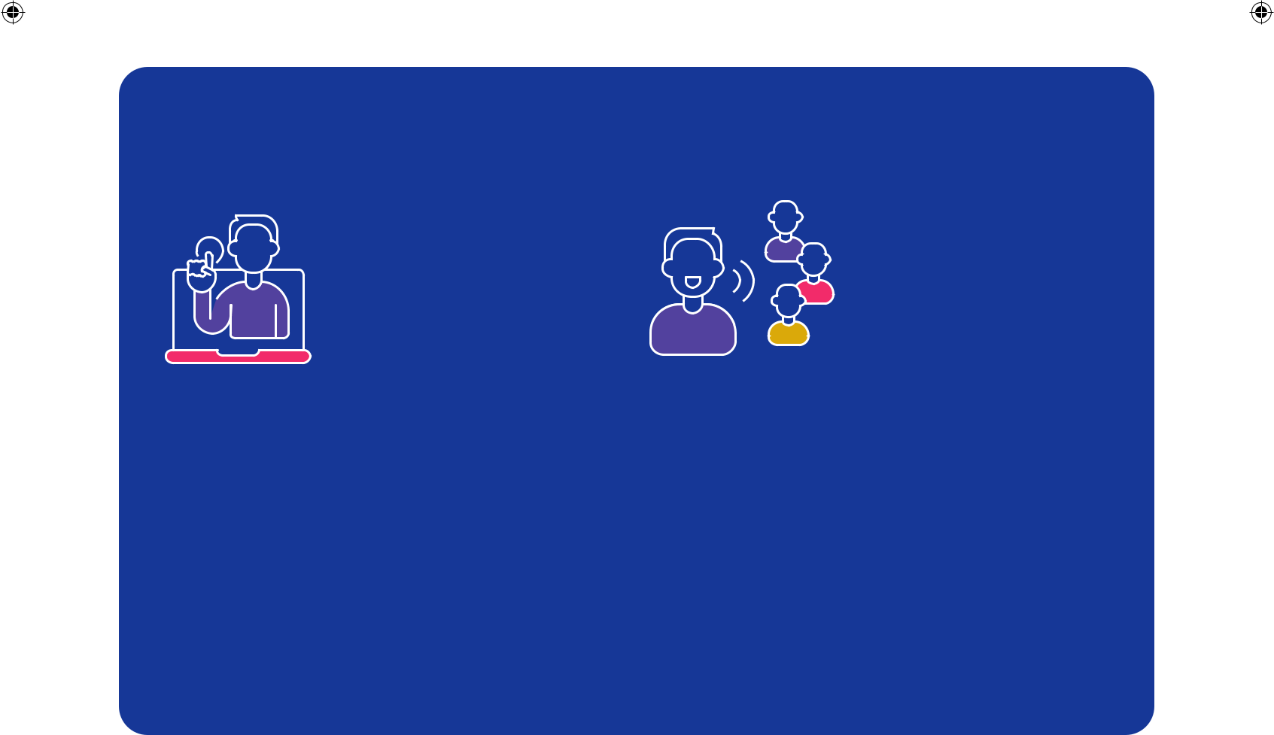

Ways of learning

Online Classroom

Online learning gives you the flexibility to study from Classroom learning offers real-time discussions, and

anywhere and the freedom to shape your learning face-to-face interactions, which is suited to those

experience on your terms. who prefer a hands-on experience.

Individual learning plans

An Individual Learning Plan (IPL) is an informal meeting where we can get to know you and let you know more about the Recovery College. We support you to identify your short term goals and longer term aspirations and, where possible, how the college can support these.

10

Completed A4 Prospectus April - August 2025 V.1.indd 10

07/03/2025 14:40:45

01234 263 621 | 01582 315 987 elft.recoverycollege@nhs.net
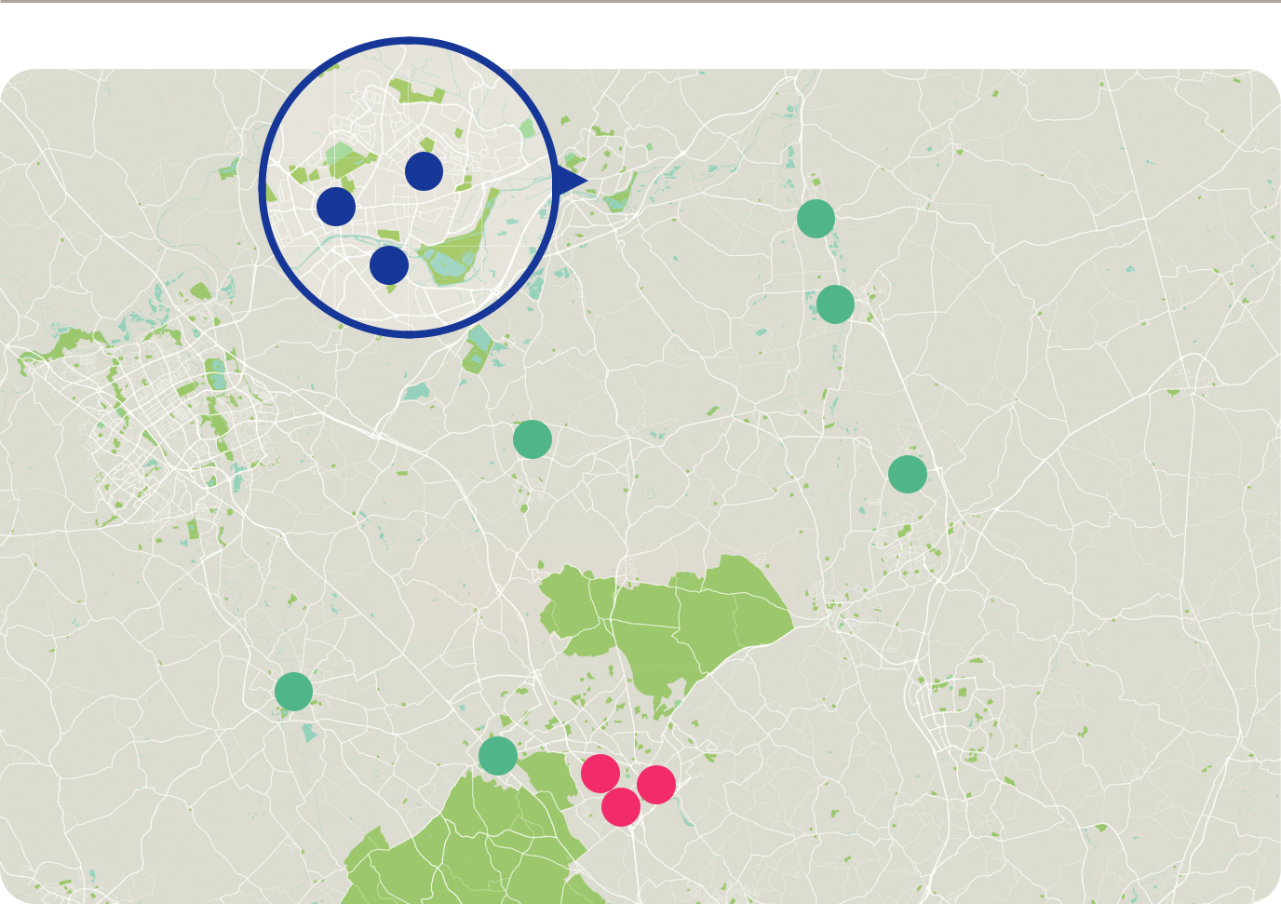

Bedford

3

2 | 8

1

9

6
Central 7

Bedfordshire

4

5 | 10 | 11
 | ¹²Luton

Our venues

Bedford Central Bedfordshire

Luton

- Jubilation Centre
Moulton Avenue, Bedford, MK42 0HL


- Recovery College Bedford
3 Woburn Road, Bedford, MK40 1EG

- University of Bedfordshire
Polhill Avenue, Bedford, MK41 9EA

- The Lighthouse Whichellos Wharf, The Elms,
Stoke Road, Leighton Buzzard, LU7 2TD

- Grove View Hub
Court Drive, Dunstable, LU5 4JD

- Parkside Community Hall
Woburn Street, Ampthill, MK45 2HX

- St Mary’s Church Hall
51 Church Road, Stofold, SG5 4NE

- Sandy Baptist Church Hall
1 Kings Road, Sandy, SG19 1EJ


- St Andrews Church
45 Shortmead Street, Biggleswade,

SG18 0AT

- Dunstable Town Football Club
Creasy Park Drive, Dunstable, LU6 1BB

- Recovery College Luton
Luton Central Library, 2nd Floor, St George’s Square, Luton, LU1 2NG

- University of Bedfordshire
University Square, Luton, LU1 3JU

- Luton All Women’s Centre
The Spires, Adelaide Street, Luton, LU1 5BB


11

Completed A4 Prospectus April - August 2025 V.1.indd 11

07/03/2025 14:41:38


Bedfordshire and Luton Recovery College

Find a course or workshop

P13 Recovery & Wellbeing

P21 Building on Knowledge & Skills

P25 Creativity & Self Expression

12

Completed A4 Prospectus April - August 2025 V.1.indd 12

07/03/2025 14:41:41


01234 263 621 | 01582 315 987 elft.recoverycollege@nhs.net

Recovery & Wellbeing

These courses, develop your understanding and explore mood, thinking and behaviour’s which over time can improve your recovery and wellbeing.

Completed A4 Prospectus April - August 2025 V.1.indd 13

13

07/03/2025 14:42:00

RECOVERY

Bedfordshire and Luton Recovery College


& WELLBEING

Diabetes - Type 2

Online Zoom

11/2 hours, 1 week, 2 sessions

Timings 14:00 – 15:30

Date Tuesday, 20 May

Date Tuesday, 15 July

Tutor Jen Menton, Yvonne Mountcastle

We will discuss the causes, signs, symptoms and the importance of seeking early treatment for this disease and the support and treatment options.

Diverse Cultures Men’s Group


Classroom 3 Woburn Road, Bedford

2 hours, 16 weeks

Timings 10:30 – 12:30

Date Wednesday, 16 April - 13 August

Break Wednesday, 28 May, 2 July

Tutor Amit Shenmar

Get together for friendships, mutual support and encouragement. A range of games and activities available. Options to bring in activity/hobby from home and work on in class.

Drug and Alcohol Family Support

Online Zoom

11/2 hours, 2 weeks, 4 sessions

Timings 18:30 - 20:00

Date Thursday, 17 April - 24 April

Date Thursday, 8 May - 15 May

Date Monday, 2 June - 9 June

Date Monday, 7 July - 14 July

Tutor Trishna Reid, Valarie Forsey

Addiction is a family disease. We aim to bring some awareness and knowledge of the support available for family/friends affected by a loved one in addiction (18+).

Let’s Talk Affirmations

Classroom Dunstable Town Football Club

11/2 hours, 1 week

Timings 13:00 - 14:30

Date Thursday, 5 June

Tutor Trishna Reid

Explore the theme of “affirmations” through warm-up activities, creative prompts, and a relaxed block of time to acknowledge the things that prevent your happiness.

Diverse Cultures Women’s Group

Classroom 3 Woburn Road, Bedford

2 hours, 16 weeks

Timings 11:00 – 13:00

Date Wednesday, 16 April - 13 August

Break Wednesday, 28 May, 2 July

Tutor Manjeet Gill-Saini, Jaswinder Gill

Building friendships, mutual support and encouragement. Optional Life skills learning available. Participants are welcome to bring in projects/hobby from home.

Let’s Talk Affirmations

Classroom Lighthouse, Leighton Buzzard

11/2 hours, 1 week

Timings 11:00 - 12:30

Date Wednesday, 25 June

Tutor Trishna Reid

Explore the theme of “affirmations” through warm-up activities, creative prompts, and a relaxed block of time to acknowledge the things that prevent your happiness.

Let’s Talk Anxiety

Classroom Luton Library, Floor 2

11/2 hours, 1 week

Timings 14:00 - 15:30

Date Thursday, 5 June

Tutor Amit Shenmar

Share tips around alleviating anxiety. We will discuss ways in which we can help with anxiety and to lessen ones stress.

14

Completed A4 Prospectus April - August 2025 V.1.indd 14

07/03/2025 14:42:01

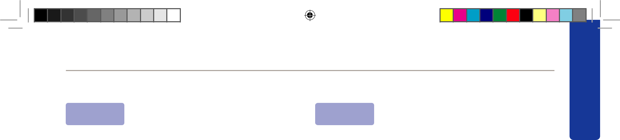
01234 263 621 | 01582 315 987 elft.recoverycollege@nhs.net

Let’s Talk Assertive Communication |  | Let’s Talk Compassion and Kindness
Classroom Dunstable Town Football Club |  | Classroom Grove View Hub, Dunstable
11/2 hours, 1 weeks |  | 11/2 hours, 1 week
Timings | 13:00 - 14:30 | Timings | 10:30 - 12:00
Date | Thursday, 12 June | Date | Monday, 19 May
Tutor | Trishna Reid | Tutor | Trishna Reid

RECOVERY & WELLBEING

Learn to communicate your ideas and needs clearly and confidently. Improve your listening skills and become more self-aware of your communication style.

Let’s Talk Body Image

Classroom Dunstable Town Football Club

11/2 hours, 1 week

Timings 13:00 - 14:30

Date Thursday, 15 May

Tutor Trishna Reid

Explore what the term ‘body image’ means and examine the link between a person’s perception and beliefs regarding their body image and the thoughts, feelings, and behaviour resulting from that perception.

Let’s Talk Body Image

Classroom Lighthouse, Leighton Buzzard

11/2 hours, 1 week

Timings 11:00 - 12:30

Date Wednesday, 11 June

Tutor Trishna Reid

Explore what the term ‘body image’ means and examine the link between a person’s perception and beliefs regarding their body image and the thoughts, feelings, and behaviour resulting from that perception.

Let’s Talk Boundaries

Classroom Luton Library, Floor 2

11/2 hours, 1 week

Timings 14:00 - 15:30

Date Thursday, 12 June

Tutor Amit Shenmar, Debbie Brathwaite

Looking at boundaries as a form of shaping relationships in a positive way, their importance, how to maintain them and enjoy better connections as a result.

Learn the skills of self-compassion so you can respond to life’s ups and downs with generosity, kindness, and care. Compassion helps us connect with others, mend relationships, and move forward with empathy.

Let’s Talk Compassion and Kindness

Classroom Lighthouse, Leighton Buzzard

11/2 hours, 1 week

Timings 11:00 - 12:30

Date Wednesday, 21 May

Tutor Trishna Reid

Learn the skills of self-compassion so you can respond to life’s ups and downs with generosity, kindness, and care. Compassion helps us connect with others, mend relationships, and move forward with empathy.

Let’s Talk Depression

Classroom Lighthouse, Leighton Buzzard

11/2 hours, 1 week

Timings 11:00 – 12:30

Date Wednesday, 23 April

Tutor Trishna Reid

Understanding depression, its cause, and its impact on daily life. Participants can openly discuss their experiences and feelings.

Let’s Talk Depression

Classroom Luton Library, Floor 2

11/2 hours, 1 week

Timings 14:00 - 15:30

Date Thursday, 19 June

Tutor Amit Shenmar, Debbie Brathwaite

Depression can happen to anyone as people go through life’s problems. Let’s share and learn about how we can feel better.

15

Completed A4 Prospectus April - August 2025 V.1.indd 15

07/03/2025 14:42:01

RECOVERY & WELLBEING

Bedfordshire and Luton Recovery College


Let’s Talk Emotions Let’s Talk Long Term Health Condition

Classroom Luton Library, Floor 2

11/2 hours, 1 week

Timings 14:00 - 15:30

Date Thursday, 26 June

Tutor Amit Shenmar, Debbie Brathwaite

Emotions can be a powerful feeling and can affect our thoughts and feeling both good and bad. Let’s share, tips, insights and ideas in a positive and non-judgemental way.

Let’s Talk Goal Setting

Classroom Luton Library, Floor 2

11/2 hours, 1 week

Timings 14:00 - 15:30

Date Thursday, 10 July

Tutor Amit Shenmar, Debbie Brathwaite

Goal setting is a great way to motivate people. The more realistic goal the better.

Let’s Talk Journaling

Classroom Luton Library, Floor 2

11/2 hours, 1 week

Timings 14:00 - 15:30

Date Thursday, 17 July

Tutor Amit Shenmar, Debbie Brathwaite

We will look at the process of journaling to explore its benefits in a non–judgemental space.

Classroom Luton Library, Floor 2

11/2 hours, 1 week

Timings 14:00 - 15:30

Date Thursday, 24 July

Tutor Amit Shenmar, Debbie Brathwaite

Practical hints and tips to cope, manage and support one another around long term health conditions.

Let’s Talk Low Mood

Classroom Lighthouse, Leighton Buzzard

11/2 hours, 1 week

Timings 11:00 - 12:30

Date Wednesday, 16 April

Tutor Trishna Reid

Understanding what triggers downward spirals in mood. We will offer tools and techniques that are used to tackle low mood.

Let’s Talk Low Mood

Classroom Dunstable Town Football Club

11/2 hours, 1 week

Timings 13:00 - 14:30

Date Thursday, 17 April

Tutor Trishna Reid

Understanding what triggers downward spirals in mood. We will offer tools and techniques that are used to tackle low mood.

Let’s Talk Living with OCD


Online Zoom

2 hours, 1 week

Timings 12:00 - 14:00

Date Thursday, 22 MAY

Tutor Claire Cooper, Petar Djukic

Taking place in a safe and confidential space where we will be sharing lived experiences and coping strategies, with a view to learning from each other.

Let’s Talk Low Mood

Classroom Luton Library, Floor 2

11/2 hours, 1 week

Timings 14:00 - 15:30

Date Thursday, 31 July

Tutor Amit Shenmar, Debbie Brathwaite

Improve our mood, state of wellbeing and self–worth. Moods and the type of mood can play a massive role in one’s mental health toolkit.

16

Completed A4 Prospectus April - August 2025 V.1.indd 16

07/03/2025 14:42:01

01234 263 621 | 01582 315 987 elft.recoverycollege@nhs.net

RECOVERY

Let’s Talk Managing Emotions

Classroom Dunstable Town Football Club

11/2 hours, 1 week

Timings 13:00 – 14:30

Date Thursday, 1 May

Tutor Trishna Reid

Let’s Talk Self Love

Classroom Grove View Hub, Dunstable

11/2 hours, 1 week

Timings 10:30 – 12:00

Date Monday, 28 April

Tutor Trishna Reid

& WELLBEING

Gain a greater awareness of what triggers intense | We offer support with self love, what parts of your life
emotions for you, as well as your emotional and | may have changed, how to identify it, and then create
behavioural responses to challenging situations. | an action plan in order to set your goals and reach them.

Let’s Talk Relationships

Classroom Luton Library, Floor 2

11/2 hours, 1 week

Timings 14:00 - 15:30

Date Thursday, 7 August

Tutor Amit Shenmar, Debbie Brathwaite

Explore and investigate different types of relationships. They are a key way in which we understand and move through the world.

Let’s Talk Relationship Breakdowns

Classroom Dunstable Town Football Club

11/2 hours, 1 week

Timings 13:00 - 14:30

Date Thursday, 22 May

Tutor Trishna Reid

Which situations cause relationships to breakdown, how we might be left feeling, and how emotions affect our thought patterns. We will explore how we can begin the healing process.

Let’s Talk Relationship Breakdowns

Classroom Lighthouse, Leighton Buzzard

11/2 hours, 1 week

Timings 11:00 - 12:30

Date Wednesday, 18 June

Tutor Trishna Reid

Which situations cause relationships to breakdown, how we might be left feeling, and how emotions affect our thought patterns. We will explore how we can begin the healing process.

Let’s Talk Self Love

Classroom Lighthouse, Leighton Buzzard

11/2 hours, 1 week

Timings 11:00 - 12:30

Date Wednesday, 14 May

Tutor Trishna Reid

We offer support with self love, what parts of your life may have changed, how to identify it, and then create an action plan in order to set your goals and reach them.

Let’s Talk Stress

Classroom Luton Library, Floor 2

11/2 hours, 1 week

Timings 14:00 - 15:30

Date Thursday, 14 August

Tutor Amit Shenmar, Debbie Brathwaite

Learn how we cope with stress. This is a good workshop for people who live a busy life and want to learn ways to relax.

Let’s Talk Understanding Anger

Classroom Grove View Hub, Dunstable

11/2 hours, 1 week

Timings 10:30 – 12:00

Date Monday, 12 May

Tutor Trishna Reid

We will discuss techniques to manage anger constructively and identify common triggers and underlying causes.

17

Completed A4 Prospectus April - August 2025 V.1.indd 17

07/03/2025 14:42:01

RECOVERY

Bedfordshire and Luton Recovery College


& WELLBEING

Let’s Talk Understanding Hoarding

Classroom Dunstable Town Football Club

11/2 hours, 1 week

Timings 13:00 - 14:30

Date Thursday, 8 May

Tutor Trishna Reid

We will explore and understand “hoarding” in more depth and its different forms. We will discuss a range of strategies that people might find useful.

Let’s Talk Understanding Hoarding

Classroom Lighthouse, Leighton Buzzard

11/2 hours, 1 week

Timings 11:00 - 12:30

Date Wednesday, 4 June

Tutor Trishna Reid

We will explore and understand “hoarding” in more depth and its different forms. We will discuss a range of strategies that people might find useful.

Let’s Talk Understanding My Sexuality

Classroom Grove View Hub, Dunstable

Men’s Health and Wellbeing

Online Zoom

1 hour, 4 or 5 weeks, 3 sessions

Timings 15:00 – 16:00

Date Thursday, 24 April - 22 May

Date Thursday, 5 June - 26 June

Date Thursday, 10 July - 7 August

Tutor Anthony Barron, Stuart Gill

To promote discussion on a relevant topic chosen by attendees and staff involved. Share lived experience and openly value everyone’s opinions.

Movement for Wellbeing

Classroom 3 Woburn Road, Bedford

11/2 hours, 16 weeks

Timings 13:30 – 15:00

Date Wednesday, 16 April - 13 August

Break Wednesday, 28 May, 2 July

Tutor Manjeet Gill-Saini, Jaswinder Gill

Interactive sessions focusing on movement for wellbeing. Exploring exercises, stretching, relaxation, balance, and dance. Options for those less mobile. (Please seek medical advice prior to exercising).

11/2 hours, 1 week

Timings 10:30 – 12:00

Date Monday, 14 April

Tutor Trishna Reid

Insight and awareness of different sexualities. There is no ‘right’ or ‘wrong’ sexuality; it is simply about how you identify and experience attraction.

Meditation with Petar

Online Zoom

1 hour, 12 weeks

Timings 13:00 – 14:00

Date Friday, 25 April - 25 July

Break Friday, 30 May, 4 July

Tutor Claire Cooper, Petar Djukic

This course provides space for you to put aside time to relax with guided meditation, using breathing and mindfulness techniques, which you can incorporate into your daily routine.

My Emotional Self

Classroom Luton Library, Floor 2

11/2 hours, 6 weeks

Timings 14:00 - 15:30

Date Friday, 11 July - 15 August

Tutor Amit Shenmar, Adrian Shearer

This course will explore psychological theory, peer learning and wellbeing.

Pathway to Inner Strength

Online Zoom

11/2 hours, 6 weeks

Timings 14:00 - 15:30

Date Wednesday, 7 May - 18 June

Break Wednesday, 28 May

Tutor Amit Shenmar, Debbie Brathwaite

Boost one’s self worth and respect in an uplifting and meaningful way.

18

Completed A4 Prospectus April - August 2025 V.1.indd 18

07/03/2025 14:42:02


01234 263 621 | 01582 315 987 elft.recoverycollege@nhs.net

Positive Thinking |  | The Future is in our Hands Art Project
Online | Zoom | Classroom Lighthouse, Leighton Buzzard
2 hours, 1 week |  | 11/2 hours, 1 week
Timings | 10:00 - 12:00 | Timings | 11:00 - 12:30
Date | Thursday, 10 July | Date | Wedneday, 7 May
Tutor | Claire Copper Fiona Thompson | Tutor | Trishna Reid

RECOVERY & WELLBEING

Explore how to achieve positive thinking through a few different techniques that have proven to be effective. Tips that can help train your brain to think more positively.

Power of Music

Online Zoom

11/2 hours, 4 weeks

Timings 10:30 – 12:00

Date Monday, 14 April - 19 May

Break Monday, 21 April, 5 May

Tutor Amit Shenmar, Michelle Wingrove

Let’s keep those Monday blues away. Join us if want to connect with others to have a laugh.

Relapse Prevention

Classroom Grove View Hub, Dunstable

2 hours, 6 weeks, 2 sessions

Timings 13:00 - 15:00

Date Tuesday, 15 April - 20 May

Date Tuesday, 3 June - 15 July

Tutor Trishna Reid, Nicola Webster

Practical tools, discuss potential triggers, conversations to support manage your recovery. The stigma that comes with lapse/relapse is something we recognise, we want to equip you to avoid/manage the situation.

Six Simple Tips to Help Reduce Worry

Online Zoom

2 hours, 1 week

Timings 12:00 - 14:00

Date Thursday, 19 June

Tutor Claire Cooper, Fiona Thompson

Worry is the wrong kind of self–hypnosis. We will look at why we worry, and how to reduce it with six simple tips to a solution focused result.

A calming creative Art Process for you to think about things/habits we’d like to leave behind and things we

hope for in the future.

Unlock Your Potential

Classroom Grove View Hub, Dunstable

11/2 hours, 6 weeks

(ALL 6 SESSIONS MUST BE ATTENDED)

Timings 10:30 - 12:00

Date Monday, 2 June - 14 July

Break Monday, 30 June

Tutor Trishna Reid, Angela Costello

Identify skills, support you with job search strategies, boost interview confidence, set employment and personal development goals, and create standout CVs.

Voice Box

Classroom 3 Woburn Road, Bedford

Online Zoom

11/2 hours, 22 weeks

Timings 14:00 – 15:30

Date Thursday, 3 April - 29 August

Tutor Kyle Mcdonald, Steering Panel

Have your say in a safe discussion forum that encourages participation regardless of age, ethnicity, or culture. Topics include mental health, identity, social/ economic issues, gender/LGBTQ+ awareness, and relationships.

19

Completed A4 Prospectus April - August 2025 V.1.indd 19

07/03/2025 14:42:02

RECOVERY &

Bedfordshire and Luton Recovery College


Wellbeing Course Ampthill

WELLBEING

Classroom Parkside Community Hall

2 hours, 15 weeks

Timings 10:00 - 12:00

Date Friday, 25 April - 15 August

Break Friday, 30 May, 4 July

Tutor Tara Curtis, Caram Jakhu

A friendly space to interact with others, helping manage your mental health, building self-confidence and self-esteem, whilst linking in with your local community.

Wellbeing Course Biggleswade

Classroom St Andrews Church

2 hours, 15 weeks

Timings 10:30 – 12:30

Date Tuesday, 15 April - 5 August

Break Tuesday, 27 May, 1 July

Tutor Sam Fossey, Claire Cooper

Come | 2nd or 3rd
along | Wednesday of
along | each Month
to the | each Month
to the | 17:30 – 19:00
over 50’s | The Recovery
Disco | College,
Disco | 3 Woburn Road,
 | Bedford, MK40
 | 1EG
To book a place call:
01234 236 621

A friendly space to interact with others, helping manage your mental health, building self-confidence and self-esteem, whilst linking in with your local community.

Wellbeing Course Sandy

Classroom Sandy Baptist Church

11/2 hours, 15 weeks

Timings 13:00 – 14:30

Date Tuesday, 15 April - 5 August

Break Tuesday, 27 May, 1 July

Tutor Sam Fossey, Claire Cooper

A friendly space to interact with others, helping manage your mental health, building self-confidence and self-esteem, whilst linking in with your local community.

Wellbeing Course Stotfold

Classroom The Roecroft Centre

11/2 hours, 15 weeks

Timings 13:00 – 14:30

Date Wednesday, 16 April - 6 August

Break Wednesday, 28 May, 2 July

Tutor Sam Fossey, Claire Cooper

A friendly space to interact with others, helping manage your mental health, building self-confidence and self-esteem, whilst linking in with your local community.

Come along and
meet people and
dance/listen to
tunes from 70’s,
80’s and 90’s

Your care worker
needs to accompany
you if you live
in supported
accommodation

20

Completed A4 Prospectus April - August 2025 V.1.indd 20

07/03/2025 14:42:02


01234 263 621 | 01582 315 987 elft.recoverycollege@nhs.net

Building on
Knowledge

& Skills

These courses and workshops are designed to increase knowledge and skills on a number of mental health and general wellbeing topics, exploring tools that may support ourselves or others in their recovery journey.

Completed A4 Prospectus April - August 2025 V.1.indd 21

21

07/03/2025 14:42:03

BUILDING

Bedfordshire and Luton Recovery College


ON KNOWLEDGE & SKILLS

ADHD and Me

Classroom 3 Woburn Road, Bedford

2 hours, 6 weeks

Timings 11:00 - 13:00

Date Friday, 25 April - 30 May

Tutor Carl Ramsey

An exploration into the common misconception and new understanding around ADHD. To book a place call Carl Ramsey 07554 499378

ADHD and Me


Online Zoom

11/2 hours, 6 weeks

Timings 10:30 - 12:00

Date Wednesday, 4 June - 16 July

Break Wednesday, 2 July

Tutor Dianne Thomas, Michelle Wingrove

An exploration into the common misconception and new understandings around adult ADHD. To book a place call Dianne Thomas 07767826776.

Are you Exhausted?

Online Zoom

1 hour, 1 week, 2 sessions

Timings 12:30 – 13:30

Date Monday, 9 June

Date Monday, 28 July

Tutor Dianne Thomas, Olive Hickmott

Learn effective techniques covering: Grounding and running positive energy while clearing energies that are not yours and empower yourself to manage your wellbeing better.

Collaging - Who am I?


Classroom Lighthouse, Leighton Buzzard

11/2 hours, 1 week

Timings 11:00 - 12:30

Date Wednesday, 30 April

Tutor Trishna Reid

A creative look at what makes “US”. We are unique, we are worthy. Using Collage to express your own story, looking at our “likes” and “loves”, our strengths and thoughts.

Digital Skills for Beginners

Classroom Lighthouse, Leighton Buzzard

11/2 hours, 2 days, 2 weeks

(ALL 4 SESSIONS MUST BE ATTENDED)

Timings 11:00 - 12:30

Date Wednesday 9 July - Friday 11 July

Date Wednesday 16 July - Friday 18 July

Tutor Trishna Reid, Angela Costello

Learn digital basics, from using a mouse, keyboard, to navigating the internet and sending emails. Using Microsoft you will learn to create letters and spreadsheets at your pace.

Domestic Abuse and Mental Health

Online Zoom (WOMEN ONLY)

11/2 hours, 1 week

Timings 10:30 – 12:00

Date Friday, 25 April

Tutor Luton All Women’s Centre

Explore how you can identify an abusive relationship and how LAWC can support with Domestic Abuse.

Domestic Abuse and Mental Health

Online Zoom (WOMEN ONLY)

11/2 hours, 1 week

Timings 13:00 – 14:30

Date Tuesday, 10 June

Tutor Luton All Women’s Centre

Explore how you can identify an abusive relationship and how LAWC can support with Domestic Abuse.

Domestic Abuse and Mental Health

Online Zoom (WOMEN ONLY)

11/2 hours, 1 week

Timings 10:30 – 12:00

Date Wednesday, 6 August

Tutor Luton All Women’s Centre

Explore how you can identify an abusive relationship and how LAWC can support with Domestic Abuse.

22

Completed A4 Prospectus April - August 2025 V.1.indd 22

07/03/2025 14:42:03

 |  |  |  |  |  |  |  |  |  |  |  |  |  |  | 01234 263 621 | 01582 315 987elft.recoverycollege@nhs.net
 |  |  | Healthy Relationships |  |  |  |  |  |  |  |  |  |  | How to Build Emotional Resilience
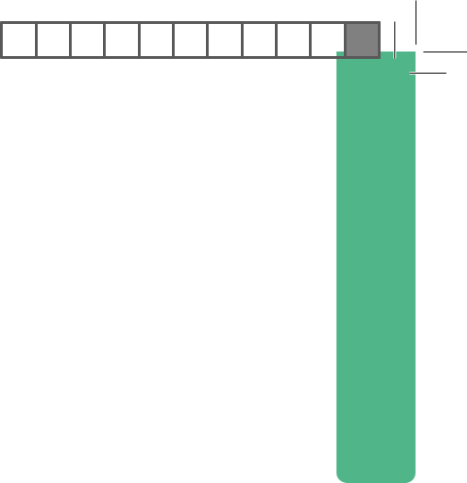


BUILDING ON

Classroom 3 Woburn Road, Bedford

11/2 hours, 9 weeks

Timings 13:00 - 14:30

Date Tuesday, 15 April - 17 June

Break Tuesday, 27 May

Tutor Carl Ramsey, Essma Bechkoum

Explore the complexities of modern-day relationships. We cover the personal, the professional, the familial and the emotional, in terms of relationships.

How to Become a Volunteer

Classroom Dunstable Town Football Club

11/2 hours, 4 weeks

(ALL 4 SESSIONS MUST BE ATTENDED)

Timings 13:00 – 14:30

Date Thursday, 19 June - 17 July

Break Thursday, 3 July

Tutor Trishna Reid, Angela Costello

This guide helps you take the first step toward learning about impactful volunteer work.

How to Build Emotional Resilience

Online Zoom (WOMEN ONLY)

11/2 hours, 1 week

Timings 10:30 – 12:00

Date Tuesday, 13 May

Tutor Luton All Women’s Centre

Looking at tools and resources that are known to help and create a plan of support.

How to Build Emotional Resilience

Online Zoom (WOMEN ONLY)

11/2 hours, 1 week

Timings 13:00 - 14:30

Date Monday, 16 June

Tutor Luton All Women’s Centre

Looking at tools and resources that are known to help and create a plan of support.

Online Zoom (WOMEN ONLY)

11/2 hours, 1 week

Timings 10:30 – 12:00

Date Wednesday, 16 July

Tutor Luton All Women’s Centre

Looking at tools and resources that are known to help and create a plan of support.

Improving sleep

Online Zoom

1 hour, 1 week, 3 sessions

Timings 12:30 – 13:30

Date Monday, 19 May

Date Monday, 14 July

Date Monday, 11 August

Tutor Dianne Thomas, Olive Hickmott

Identify unhelpful cycles around sleep, and explore how to make small changes to improve sleep.

Knitting/Crochet to Improve Wellbeing

Classroom 3 Woburn Road, Bedford

2 hours, 14 weeks

Timings 11:30 – 13:30

Date Monday, 14 April - 11 August

Break Monday, 21 April, 5 May, 26 May, 30 June

Tutor Anthony Barron, Heidi Quinn

Improve skills, dexterity, reduce stress, anxiety depression, cognitive function, boost self–confidence and combat social isolation.

LGBTQ+ and Allies – Being Me!

Online Zoom

11/2 hours, 1 week, 5 sessions

Timings 14:00 – 15:30

Date Monday, 14 April

Date Monday, 12 May

Date Monday, 9 June

Date Monday, 14 July

Date Monday, 11 August

Tutor Dianne Thomas, Debbie Brathwaite

KNOWLEDGE & SKILLS

Share and learn from each other. on topics related to

being an ally or part of the LGBTQ+ community.

23

Completed A4 Prospectus April - August 2025 V.1.indd 23

07/03/2025 14:42:03

BUILDING ON

Bedfordshire and Luton Recovery College


Lost Stories Neurodiversity – What is that?

KNOWLEDGE & SKILLS

Classroom Luton Library, Floor 2

Online Zoom

11/2 hours, 4 weeks

Timings 10:30 - 12:00

Date Tuesday, 3 June - 24 June

Tutor Dianne Thomas, Jaswinder Gill

Bedfordshire has an extremely rich cultural heritage with people from all sorts of backgrounds. Learn about different cultural histories, explore some of these stories and connect with others.

Making Sense Of Anger

Online Zoom

11/2 hours, 4 weeks

Timings 10:30 - 12:00

Date Wednesday, 23 April - 14 May

Tutor Tara Curtis, Natasha Farooq

We will cover recognising why you get angry, controlling anger safely, dealing with triggers, problem solving and how to change your thought process.

Making Sense Of Anger

Online Zoom

11/2 hours, 4 weeks

Timings 13:00 - 14:30

Date Monday, 21 July - 11 August

Tutor Tara Curtis, Natasha Farooq

We will cover recognising why you get angry, controlling anger safely, dealing with triggers, problem solving and how to change your thought process.

Online Zoom

11/2 hours, 6 weeks

Timings 10:30- 12:00

Date Tuesday, 15 April - 20 May

Tutor Dianne Thomas, Natasha Farooq

Find new ways to deal with daily life when you think and learn differently to others. Learn how your uniqueness can be empowered to use your strengths.

Resilience

Classroom Luton Library, Floor 2

Online Zoom

1 hour, 1 week

Timings 12:30 - 13:30

Date Tuesday, 5 August

Tutor Amit Shenmar, Total Wellbeing Luton

Learn how to bounce back, face setbacks and build resilience as a team.

Thriving with ADHD

Online Zoom

1 hour, 1 week, 3 sessions

Timings 12:30 – 13:30

Date Monday, 14 April

Date Monday, 2 June

Date Monday, 21 July

Tutor Dianne Thomas, Olive Hickmott

Live well with ADHD. Highlight some of the strengths it may bring and discuss some simple techniques to overcome the challenges and feel empowered.

Neurodiverse Thinking Skills

Online Zoom

1 hour, 1 week, 2 sessions

Timings 12:30 – 13:30

Date Monday, 28 April

Date Monday, 4 August

Tutor Dianne Thomas, Olive Hickmott

We will focus on the strengths that neurodiversity may bring to your life and discuss some simple techniques for overcoming some of the challenges.

Thriving with Dyslexia

Online Zoom

1 hour, 1 week, 2 sessions

Timings 12:30 – 13:30

Date Monday, 12 May

Date Monday, 7 July

Tutor Dianne Thomas, Olive Hickmott

Live well with Dyslexia. Highlighting some of the strengths of dyslexia and discussing some simple techniques to overcome some challenges.

24

Completed A4 Prospectus April - August 2025 V.1.indd 24

07/03/2025 14:42:05


01234 263 621 | 01582 315 987 elft.recoverycollege@nhs.net

Creativity & Self Expression

These courses and workshops have positive effects on mental, emotional, and physical health, as they can relieve stress, anxiety, depression, anger and improve wellbeing.

Completed A4 Prospectus April - August 2025 V.1.indd 25

25

07/03/2025 14:42:14

CREATIVITY

Bedfordshire and Luton Recovery College


& SELF EXPRESSION

Art and Wellbeing

Classroom 3 Woburn Road, Bedford

2 hours, 4 or 6 weeks, 3 sessions

Timings 11:30 – 13:30

Date Thursday, 17 April - 22 May

Date Thursday, 5 June - 26 June

Date Thursday, 10 July - 14 August

Tutor Anthony Barron, Geoff Bennett

Develop skills in painting and drawing, enhance social interaction, combat isolation and provide pathways in the community to engagement and support with all aspects of mental health.

Art Fusion


Classroom Luton Library, Floor 2

2 hours, 6 weeks

Timings 14:00 - 16:00

Date Tuesday, 15 April - 20 May

Tutor Amit Shenmar, Geoff Bennett

This course will explore art focusing on creativity and expression.

Art Led Peer Support

Classroom 3 Woburn Road, Bedford

2 hours, 14 weeks

Timings 09:30 – 11:30

Date Monday, 14 April - 11 August

Break Monday, 21 April, 5 May, 26 May, 30 June

Tutor Anthony Barron, Janet Goodman

This course encourages engagement with a variety of art materials, including acrylics.

Art Movements Throughout History

Classroom 3 Woburn Road, Bedford

2 hours, 6 weeks, 2 sessions

Timings 13:30 - 15:30

Date Tuesday, 15 April - 20 May

Date Tuesday, 8 July - 12 August

Tutor Anthony Barron

We aim to demonstrate particular art movements past and present and include their history, innovation and complexity. To be creative with in the session.

Art Therapy Butterfly Project

Online Zoom

11/2 hours, 11 weeks

Timings 10:00 - 11:30

Date Friday, 25 April - 25 July

Break Friday, 30 May, 20 June, 4 July

Tutor Moriam Grillo

Artmaking for women to explore personal narratives and reconnect with self. Hope to calm the mind and create space for new ways of being, thinking and feeling.

Calligraphy for Beginners

Classroom Luton Library, Floor 2

2 hours, 3 weeks

Timings 11:00 – 13:00

Date Friday, 9 May - 23 May

Tutor Amit Shenmar, Adrian Shearer

Calligraphy is a great skill to learn, let’s de-stress, have fun and learn the unique art which is Calligraphy.

Creative Cards Co-operative

Classroom Jubilation Centre, Bedford

2 hours, 14 weeks

Timings 10:00 – 12:00

Date Monday, 14 April 4 August

Break Monday, 21 April, 5 May, 26 May, 30 June

Tutor Sam Fossey, Claire Cooper

Build self-confidence and self-esteem while producing high quality products to sell. Good time keeping and prompt messages if you cannot attend.

Drama - Working with Scripts

Classroom Luton Library, Floor 2

11/2 hours, 6 weeks

Timings 13:30 - 15:00

Date Tuesday, 8 July - 12 August

Tutor Dianne Thomas, Kat Brkljac

Using various scripts to work towards an optional final performance. Led by people with drama and lived experience. Endeavouring to build confidence, creative thinking, and self-expression.

26

Completed A4 Prospectus April - August 2025 V.1.indd 26

07/03/2025 14:42:14


01234 263 621 | 01582 315 987 elft.recoverycollege@nhs.net

Expression Through Art Poetry In Emotions

CREATIVITY & SELF

Classroom Luton Library, Floor 2

2 hours, 4 weeks

Timings 14:00 - 16:00

Date Tuesday, 3 June - 24 June

Tutor Anthony Barron, Caram Jakhu

Take four artists, incorporate their art styles and themes onto a piece of work. To develop each weeks work related to each other.

Film Introduction to Screenwriting

Classroom Luton Library, Floor 2

2 hours, 10 weeks

Timings 10:30 - 12:30

Date Monday, 2 June - 11 August

Break Monday, 30 June

Tutor Amit Shenmar, Victoria Hayford

Classroom Luton Library, Floor 2

Online Zoom

2 hour, 6 weeks

Timings 13:00 - 15:00

Date Thursday, 17 April - 22 May

Tutor Dianne Thomas, Haneefah Muhammed

Explore your emotions and work towards restoring your health, using the creative and healing power of poetry.

Shout or Whisper


Online Zoom

11/2 hours, 4 weeks

Timings 19:00 – 20:30

Date Wednesday, 16 April 7 May

Tutor Amit Shenmar, Thomas Irvin

EXPRESSION

Learn to use creative talents to write a script. It is a | Poetry is a beautiful way to express yourself. Whatever
Learn to use creative talents to write a script. It is a | your literary level, be it a budding poet, a wilful scribbler,
unique way, use your imagination and learn fabulous
unique way, use your imagination and learn fabulous | or a wordsmith.
new skill. | or a wordsmith.

Model Making

Classroom 3 Woburn Road, Bedford

3 hours, 4 or 6 weeks, 3 sessions

Timings 10:00 - 13:00

Date Wednesday, 16 April - 21 May

Date Wednesday, 4 June - 25 June

Date Wednesday, 9 July - 13 August

Tutor Anthony Barron, Geoff Bennett

Build models and miniatures from past, present and future. Will provide guidance and tips to create models that are imaginative and educational to display finished.

Model Making

Wall Art

Online Zoom

2 hours, 2 weeks

Timings 10:00 - 12:00

Date Wednesday, 11 June - 18 June

Tutor Sam Fossey, Fiona Thompson

We will be making a stunning piece of wall art.Simple step by step instructions with incredible results. You will need; Pen, Ruler. Scissors, 6 cardboard toilet rolls tube, Canvas, acrylic paints, paintbrush, UHU Glue.

Writing for Self Expression

Classroom Luton Library, Floor 2

Classroom 3 Woburn Road, Bedford

2 hours, 4 or 6 weeks, 3 sessions

Timings 14:30 - 16:30

Date Thursday, 17 April -22 May

Date Thursday, 5 June - 26 June

Date Thursday, 10 July - 14 August

Tutor Sam Fossey, Geoff Bennett

Build models and miniatures from past, present and future. Will provide guidance and tips to create models that are imaginative and educationalto display finished.

Online Zoom

2 hours, 4 weeks

Timings 10:30 – 12:00

Date Friday, 6 June - 27 June

Tutor Amit Shenmar, Kat Brkljac

An excellent collaborative effort brought to you by the Royal Literary fund where we put our thoughts and feelings into words.

27

Completed A4 Prospectus April - August 2025 V.1.indd 27

07/03/2025 14:42:14

CREATIVITY

Bedfordshire and Luton Recovery College


& SELF EXPRESSION

Writing with Flair

Classroom 3 Woburn Road, Bedford

11/2 hours, 4 weeks

Timings 14:30 - 16:00

Date Wednesday, 9 July - 30 July

Tutor Anthony Barron, Michelle Wingrove

Express and create poems and short stories which align themselves to peoples lived experiences and imagination. To enhance their writing and literacy abilities.

Come along to the Bedford Beacon drop in space

Thursdays,

17:30 – 20:30

The Recovery

College,

3 Woburn Road,

Bedford, MK40 1EG

Games & activities Creativ
Arts and crafts

One-to-one support
Friendly atmosphere
Hot drinks & snacks

Drama sessions
Quiz nights
Chilled out space

28

Completed A4 Prospectus April - August 2025 V.1.indd 28

07/03/2025 14:42:14

01234 263 621 | 01582 315 987 elft.recoverycollege@nhs.net

Our
students

What our students


have to say about

their experiences

at the college.

ative writing

Very interesting and nice to be in a place where I felt excepted and able to share in a safe place.


Having a peer tutor made this course

really good. I shall try to attend next

time she does positive thinking.

This was one of those workshops on which

one wouldn’t mind staying longer when time

runs out: the slides were well presented and

easy to read, the overall content was relevant

and the interaction in the room was valuable

and very much appreciated. It was a great

workshop with a great group.


Very good understanding people lots of

good strategies and links to websites

Thankyou would deffo do this one again

29

Completed A4 Prospectus April - August 2025 V.1.indd 29

07/03/2025 14:42:14

Bedfordshire and Luton Recovery College

Index


ADHD and Me | 22
ADHD and Me | 22
Are you Exhausted? | 22
Art and Wellbeing | 26
Art Fusion | 26
Art Led Peer Support | 26
Art Movements Throughout History | 26
Art Therapy - Butterfly Project | 26
Bedford Food for Thought | 8
Calligraphy for Beginners | 26
Carers Information Support Programme | 8
Collaging - Who am I? | 22
Compasionate Friends | 8
Computer Skills for Beginners | 8
Connects with Penrose | 8
Creative Cards Co-operative | 26
Diabetes Type 2 | 14
Digital Skills for Beginners | 22
Diverse Cultures Men’s Group | 14
Diverse Cultures Women’s Group | 14
Domestic Abuse and Mental Health | 22
Drama - Working with Scripts | 26
Drug and Alcohol Family Support | 14

Expression Through Art | 27
Film Introduction to Screenwriting | 27
Five Ways to Wellbeing | 8
Free Employability workshop | 8
Get into Volunteering | 8
Healthy Relationships | 23
How to become a Vounteer | 23
How to Build Emotion Resillience | 23
Improving Sleep | 23
Knitting & Crochet to Improve Wellbeing | 23
Let’s Talk Affirmation | 14
Let’s Talk Anxiety | 14
Let’s Talk Assertive Communication | 15
Let’s Talk Body Image | 15
Let’s Talk Boundaries | 15
Let’s Talk Compassion and Kindness | 15
Let’s Talk Depression | 15
Let’s Talk Emotions | 16
Let’s Talk Goal Settings | 16
Let’s Talk Journaling | 16
Let’s Talk Living with OCD | 16
Let’s Talk Long Term Health Condition | 16
Let’s Talk Low Mood | 16
Let’s Talk Managing Emotions | 17

30

Completed A4 Prospectus April - August 2025 V.1.indd 30

07/03/2025 14:42:15

01234 263 621 | 01582 315 987 elft.recoverycollege@nhs.net


Let’s Talk Relationships | 17
Let’s Talk Relationship Breakdowns | 17
Let’s Talk Self Love | 17
Let’s Talk Stress | 17
Let’s Talk Understanding Anger | 17
Let’s Talk Understanding Hoarding | 18
Let’s Talk Understanding My Sexuality | 18
LGBTQ+ and Allies - Being Me! | 23
Living with Dementia | 8
Lost Stories | 24
Making Sense of Anger | 24
Meditation with Petar | 18
Men’s Health and Wellbing | 18
Model Making | 27
Money Matters | 8
Movement for Wellbeing | 18
My Emotional Self | 18
Neurodiverse Thinking Skills | 24
Neurodiversity - What is that? | 24
No Barries | 8
Parthway to Inner Strength | 18
Passport to the NHS | 8
Penrose Roots to Recovery | 8
Poetry in Emotions | 27

Positive Thinking | 19
Power of Music | 19
Recycle-a-Bike | 8
Relapse Prevention | 19
Resilience | 24
Roots to Recovery | 8
Shout or Whisper | 27
Six Simple Tips to Help Reduce Worry | 19
Skills and CV’s | 8
Staying Safe Online | 8
Talking about Inclusive Healthcare | 8
The Future is in our hands Art Project | 19
Thriving with ADHD | 24
Thriving with Dyslexia | 24
Unlock your Potential | 19
Voice Box | 19
Wall Art | 27
Wellbeing Course - Ampthill | 20
Wellbeing Course - Biggleswade | 20
Wellbeing Course - Sandy | 20
Wellbeing Course - Stotfold | 20
Writing for Self Expression | 27
Writing with Flair | 28
Your Digital Memories Matter | 8

31

Completed A4 Prospectus April - August 2025 V.1.indd 31

07/03/2025 14:42:15



Completed A4 Prospectus April - August 2025 V.1.indd 32

07/03/2025 14:42:15

