How to Enter and Save Armed Forces Status in ESR
Go to your ESR Dashboard Page, on the righthand side of the page (when accessing via Smartcard) and you will see My Personal Information, click on the blue arrow down icon to the right of your displayed name.
Note; If accessing without a Smartcard My Personal Information can be located by scrolling down past Payslips and all Trust Comms
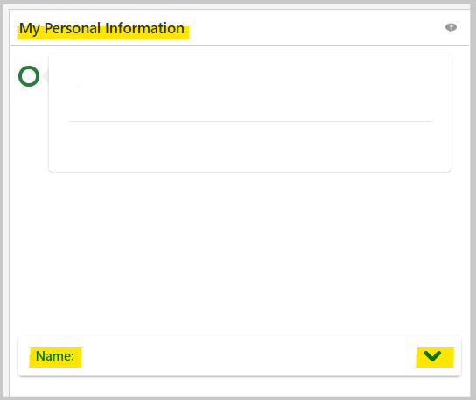
This will expand and you will now see the Update My Information Tab, click on this tab
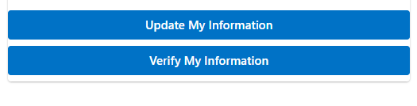
This will open a new screen, from here click on the My Wellbeing Information tab
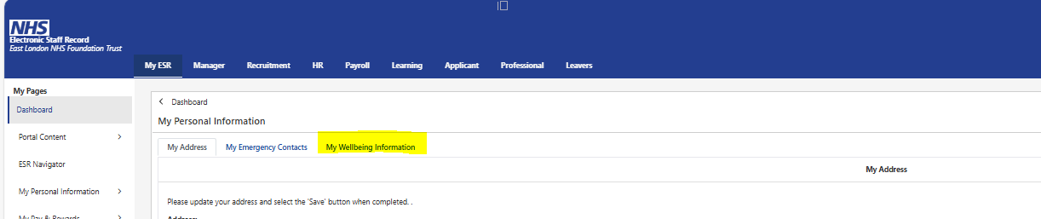

Select Yes for each Armed Forces status that is applicable and then click the blue Save button.
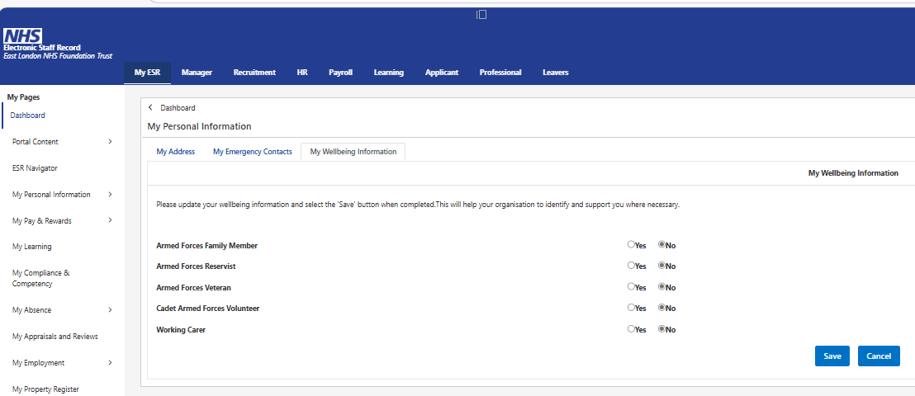
Update is now complete.

