

Standard Operating Procedure for Medicine Reconciliation

Version number: | 1.0
Consultation Groups | CHS Lead Pharmacists  BCHS Nursing Leads, BCHS Pharmacy team, Medicines Reconciliation Working Group
Approved by: | Saema Arain / Kelly Pritchard, Trust Medicines Committee
Date approved | 12th March 2025
Ratified by: | BCHS Quality Assurance Group (28.03.23), Trust Medicines Committee (March 2025)
Date ratified: | 12th March 2025
Name of originator/author: | Navreet Gill/ Jacqueline White
Lead Pharmacist/ Clinical Pharmacist | Saema Arain / Kelly Pritchard
Implementation Date: | April 2023 (BCHS), March 2025 (Trust wide)
*Last Review Date | November 2024
Next Review date: | November 2027

* All procedures must be reviewed every three years. A director may decide to set a shorter review period, if appropriate/required. There may also be a need to review a procedure in advance of a planned review date, i.e. due to changes in national policy or legislation, changes in service provision, recommendation from internal or external review, change in local and national reporting requirement or targets.

Services Applicable | Bedfordshire Community Health Services
 | Yes

Version Control Summary

Version | Date | Author | Status | Comment
1 | 29.03.2023 | Navreet Gill/ Jacqueline White

Contents
Executive summary: This procedure covers all pharmacy staff whilst working within the Bedfordshire Community Health Services including North, Mid and South Hub.

Introduction: Medicines related patient safety incidents are more likely when medicines reconciliation happens more than a week after discharge from a hospital or care setting. Undertaking medicines reconciliation in primary care allows early action when discrepancies between the list of medicines are identified.(for example , it can prevent people for being prescribed medicines that were stopped at the hospital or vice versa)

Purpose: Medication reconciliation is a commissioned service, to ensure patient safer care, Standard Operating Procedure and the NICE guidelines must be followed, at all times.

https://www.nice.org.uk/guidance/ng5
The safe and effective use of medicines to ensure best possible out comes through medicines reconciliations.
https://www.nice.org.uk/guidance/sc1/chapter/1-recommendations#accurately-listing-a-residents-medicines-medicines-reconciliation

Duties and Responsibilities: It is the responsibility of the pharmacy technicians to adhere to these Standard Operating Procedure when visiting patients in nursing and residential homes.

- BCHS Pharmacy Technicians to take initiative in starting and completing caseloads if
- BCHS Lead Pharmacists to provide technical and clinical assistance when required
- Prioritisation of cases (chronological from date of referral):
- Referrals are made via SPOA on SystmOne for the patients in care homes or could be emailed directly in the pharmacy generic inbox.
- Referrals are received in the Pharmacy generic inbox email by the nursing teams for patients in domiciliary settings.
- Referrals may also be received in CCT inbox email , the pharmacy technicians who have access to this inbox are expected to complete the case load and let the care home make aware of correct referral process , which is via SPOA or Pharmacy generic inbox.

Important:
- All caseloads to be completed and closed within 72 working hours from date of referral. (Sat & Sun excluded).
- For an inappropriate discharge (poor discharge) please follow the poor discharge process.
- A quarterly Level 2 pharmacy medicines reconciliation audit should be carried out by the clinical lead pharmacist and/or lead technician to ensure compliance with the trust medicines reconciliation policy that covers the clinical area they are responsible for.
- For any concerns which require escalation contact BLMK home care Pharmacy Technician (the can be found in SLA folder on K drive under MAPPS) or contact local authority directly on Bedford and Central Beds Council website.
- At the end of each month, pharmacy technician to filter through the care homes and contact the care homes via email where no referrals have been received via email and document on the assurance visit spreadsheet.

Adding Caseload to systmOne if Referral received through the email
- Home Screen
- Register: Like the arrow in the image below, click that link.
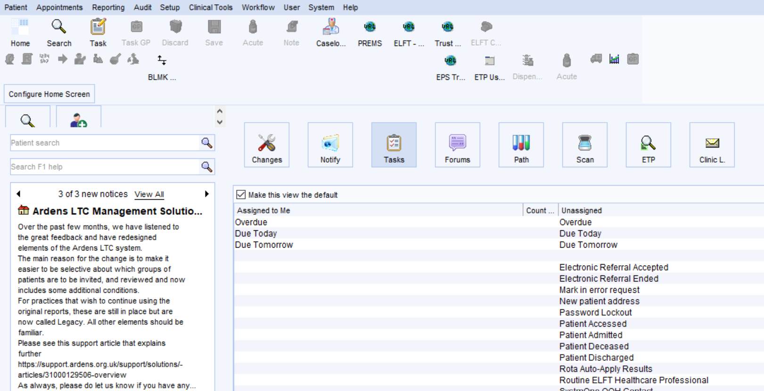

- Appears a page to search for the patient, like in the image below.
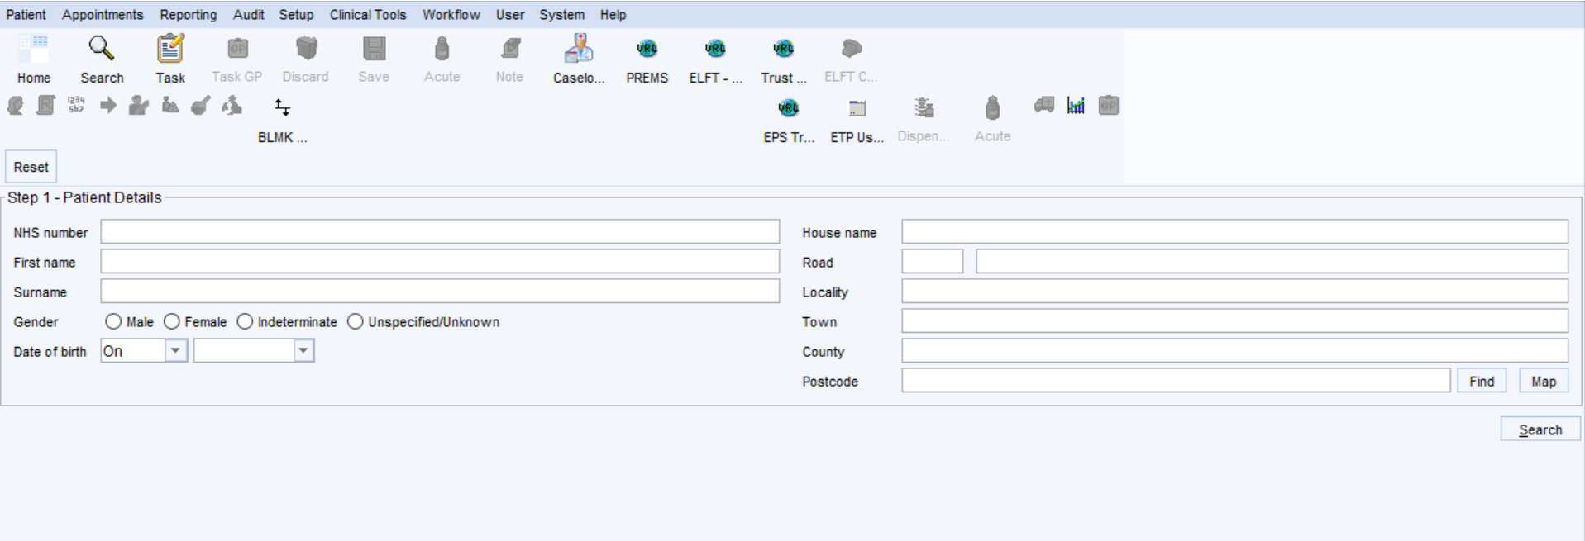
- Type the NHS number of the patient here, as shown in the above image.
- Search the patient as shown in above image (Yellow arrow).
- After the search, patient’s name will appear on the screen. Check if the DOB, address and Name matching to the referral.
- Click the Green tick button until the systm1 retrieve patient’s date. ( Might take few seconds)
- Then appears a template as image below:
- Fill the template with relevant information
- Service offered : Complex care, chose the referral for example north, Mids or south
- Urgency : Routine, until unless it is something urgent or end of life
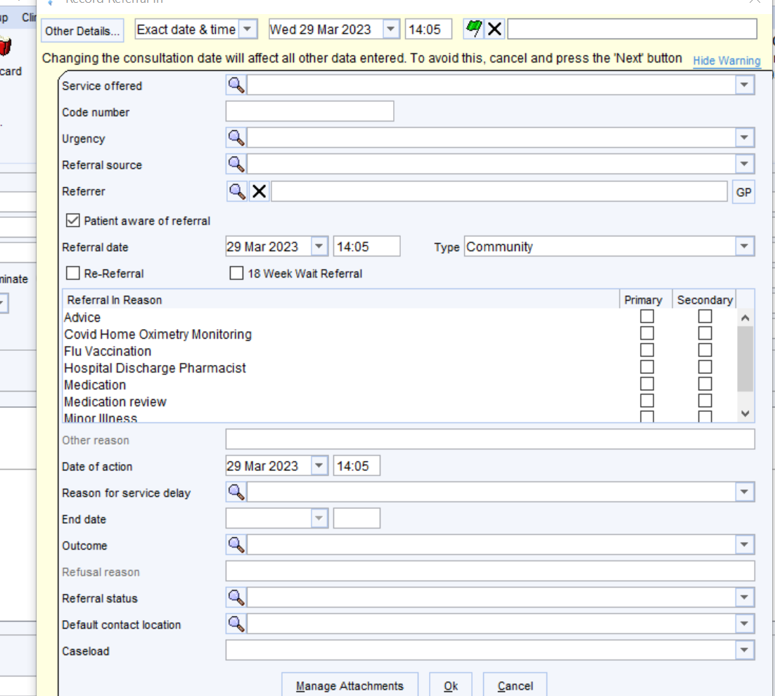

- Reason: Medication Review
- Date of action: Today’s date when you are adding this referral
- Outcome: Accepted
- Referral status: Receiving care
- Default: Residential care home
- Caseload: Pharmacy Consented – NORTH, MIDS or SOUTH
- Add: now press the OK button to save this information and it will add the patient to the system under the pharmacy section as image below in the box.
- Save the actual patients notes using administration. See saving a consultation part of this SOP.

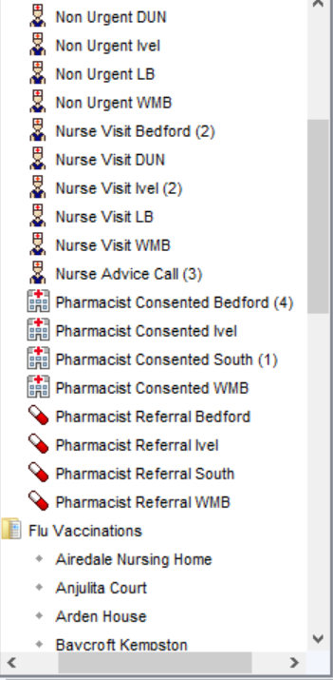

Medication reconciliation
1) Check the BCHS email inbox for referrals and add them to system one as above.
Check systm one for referrals under the complex care pharmacist section for all care home referrals.
Check other referrals that may come from any other portal on system one that you have access to. Usually by email first.
Add them to the excel sheet and allocate them under your name.
Whomever starts the caseload should finish it unless permission from the pharmacist or lead technician is given and they will allocate another member of the team to complete it.
2) Open the patient’s notes and check for record sharing, if there is no record sharing allowed contact the G.P to ask for access to be granted in a timely manner.
Sometimes even if record sharing is not granted, the SCR and some notes are still available enough to complete a medication reconciliation.
3) Complete a risk assessment.

METHOD OF RISK ASSESSMENT
- Check if the referral is appropriate.

- If Record sharing is unavailable or refer to G.P to open record sharing, within a timely manner. Most times the G.P SCR will be available even if record sharing is unavailable.

- Check medication history using GP SCR on SystmOne or hospital discharge letter etc.

- Check for high risk medication e.g. Insulins, Methotrexate, Lithium, epilepsy mental health medication, digoxin anticoagulants etc.
These patients will need to be completed first.

- Check for fridge items, controlled drugs, injections etc for supply and storage

- Ringing Care Home for urgent medication queries and explain when the caseload is expected to be complete.
- If 1 to 5 steps are all okay then okay to defer to later.
- If 1 to 5 do apply then it would require immediate attention.

These steps would help prioritising which caseloads/ referrals to be done first, and then continue in date order.
ALL CASELOADS NEED TO BE STARTED AND CLOSED WITHIN 72 HOURS, ONLY TO DEFER TO NEXT DAY IF NEEDED.
6. MONITORING
After the assessment the caseloads are over seen by the lead pharmacy technician, but overall responsibility is with the pharmacy technician allocated to the individual caseload
7. REFFERENCES
8. ASSOCIATED DOCUMENTATION

4) Fill in the medication reconciliation template with the patients name and date of birth and NHS number, and the name of the care home they are currently staying.
Complete a medication list from any of the sources available i.e. hospital discharge letter, clinic letter or G.P SCR. Ideally two sources will be used.
If there is no hospital discharge letter is on system one contact the care home to send it by email.
Perform a basic clinical check of the medication.
Note the allergies, weight, swallowing difficulties or anything that may hinder administration or need a change in dose.
Is the patient currently taking their medication covertly or any other compliance issues.
Any other comments you may have.
Check the past medication and past medical history on the G.P summery also any recent clinic letters that could have changed doses. Note any blood tests or referrals that may be needed.
Also, look at polypharmacy or any medication that may need adding to benefit the patient.
Save the template to your own H drive and print.
5) Visit the care home, wearing the appropriate PPE. Make an appointment if necessary.
Check the MAR chart is correct and complete a check of the medication paying attention to storage and expiry dates. Make sure allergies are noted.
Speak to the patient looking out for any safeguarding issues that they might be experiencing, and answer any questions they may have. Also that they are contented and calm.
Ask staff how the patient mobilises and transfers and if they have had, any falls in the past 3 months.
Any issues from any of the above, should be brought to the attention of the care home manager immediately, and resolved as soon as possible.
ONLY WITH PERMISION OF THE PHARMACIST OR LEAD TECHNICIAN CAN MAR CHARTS BE SENT BY EMAIL TO COMPLETE.
6) If visiting patients own homes wear the correct PPE and telephone to make an appointment.
Run through the medication with the patient or carer and answer any queries they may have. If needed take questions away and get back to them with an answer later.
7) Complete the caseload on systmone as per SOP on Complex care for care home patients only, along with all your notes. As per SOP.
Other referrals need completing on the correct portal of system one, not all services have ardens template and needs documenting on a note under pharmaceutical. All notes need uploading including a full list of medication also all encounters with the patient or relative documenting.
Send any tasks to other professionals that are needed.
Complete any DATIX or poor discharge. Poor discharge forms need to be emailed as per document.
After closing the caseload complete the excel sheet and file the email in the completed referral folder.
Delete the template from your file as these do not need to be kept, all the information has been transferred to systm one.
ALL REFERRALS NEED COMPLETING WITHIN 72 HOURS.
IF THE DELAY WILL BE OVER 72 HOURS, DISCUSS THIS WITH A PHARMACIST OR LEAD TECHNICIAN.
For medication reconciliation in domiciliary setting
Referrals can come from R&E, G.P, matrons or MDT.
Complete medication reconciliation as above but DO NOT add them to CCT system one as they will be added to whomever referred them to you, you can ask what section on system one they are added, to be able to access the notes.
You can then either telephone the patient or telephone to make an appointment to visit, depending on what the query that they are having with medication is.
Print a prompt sheet if you think this will help, from MAPPS (pharmacy) icon on your desktop.
Document all your findings on system one, including conversations and outcomes and your medication reconciliation.
This ideally will be using the ardens template but some system one’s only let us access a pharmacy note to document on, this will not record any audit parameters.
Task to GP sent if needed.
Although we can task GP to ask for some urgent medication but routine repeat medication should be ordered by the patient from their usual method of ordering.
Still complete any poor discharges or datix that is required.
DO NOT CLOSE THE REFERRAL AS THIS IS NOT OUR REFERRAL TO CLOSE.

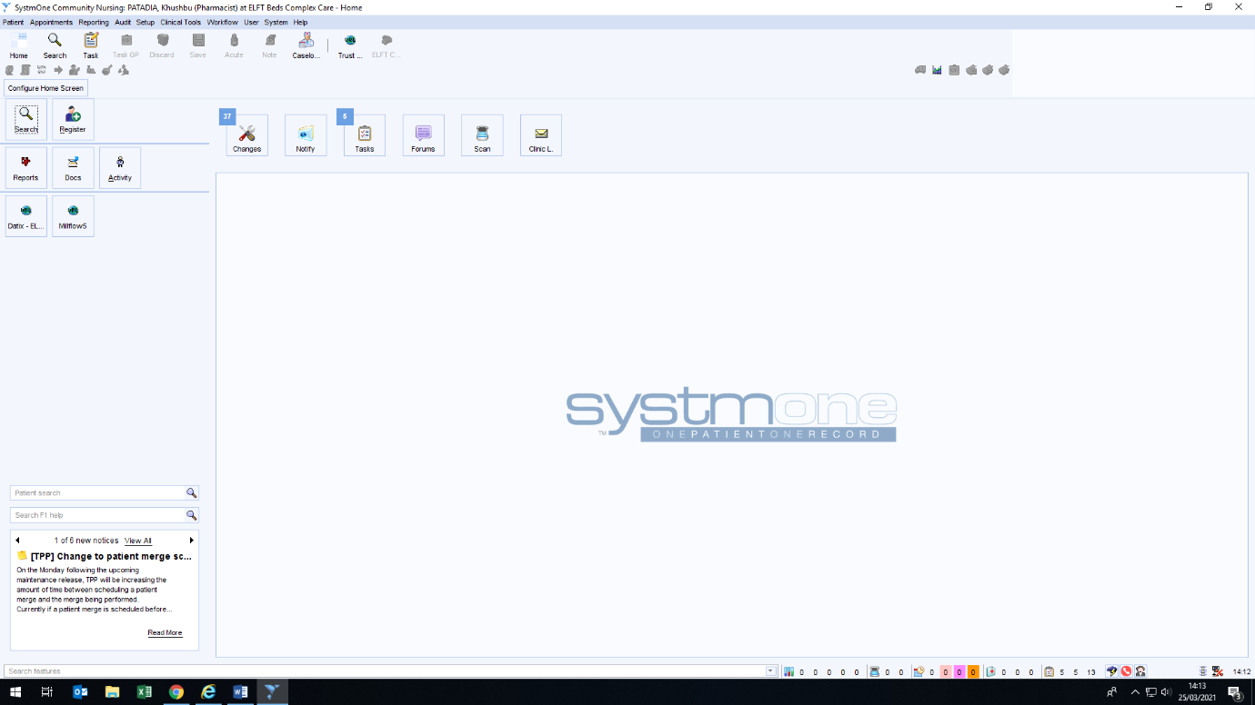
The main home screen of SystmOne looks as shown below. The essential tabs have been explained for ease of use.
1
2
3
Key
1 – Home: This will take you back to home screen from any other screen on S1.
2 – Caseload: This will take you to the CCT caseload (Nurses and Pharmacy team both).
3 – Tasks: This will provide you with a list of all the tasks sent to you.

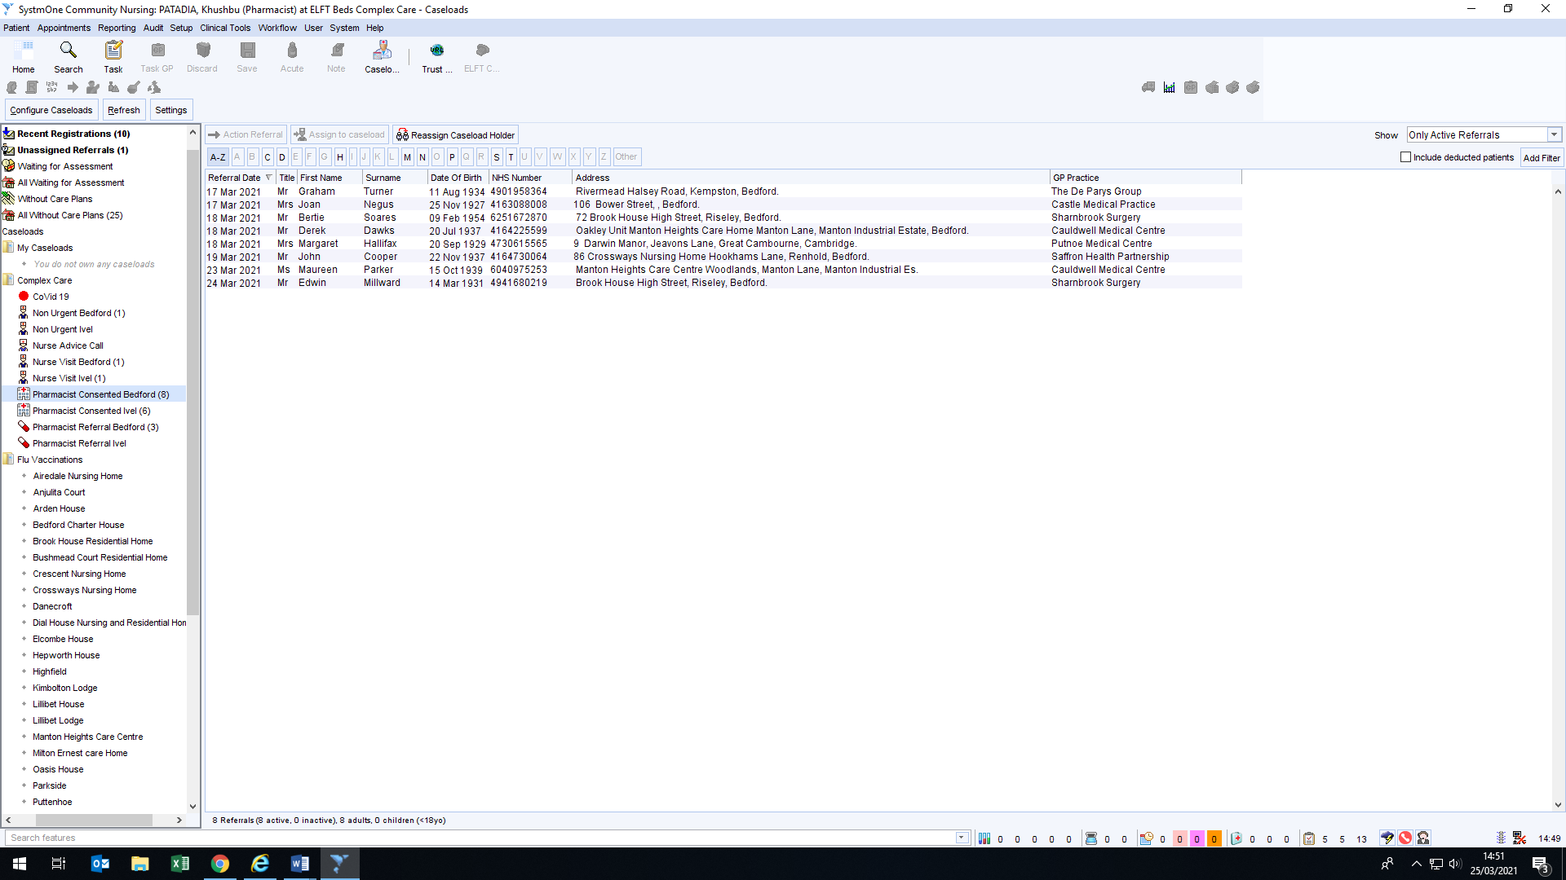
Click on ‘Caseload’ (number 2 above) to view the active referrals for Bedford, Ivel, WMB and South. The image on the left here illustrates what will be visible on the ‘Caseload screen’.
Consented Bedford, Ivel, WMB and South folders hold the referrals that have been approved by the pharmacy team after checking. Sometimes the admin approves, however we still need to check if it is an appropriate referral.
a) The reason for referral is valid,
b) Full record sharing is available
c) A review has not already been carried out previously by CCT/CCG/PCT

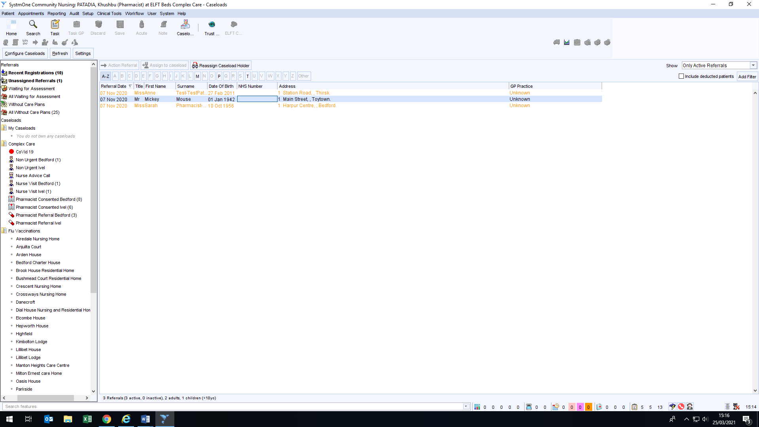
1

A). How to check the reason for referral
- Click on the patient
- The arrows below illustrate the two trees of information; Clinical and Administrative. Each tree has a range of nodes that provide certain information regarding the patient. Under the Clinical tree, click on ‘Referrals’.
- Then double click on the date the referral was made.
- Details of the referral will be provided on the bottom of the screen.
- Check the reason for referral.
B). How to check Record Sharing
Patients’ electronic medical records are shared within S1 with other NHS care providers that are also using S1. Services using S1, but not limited to, include: GP surgeries, district nurses, diabetic nurses, community phlebotomy, anticoagulation services, dieticians, speech and language therapy and pharmacists.
Records on S1 are shared in two ways:
- Sharing out: This controls whether the information recorded by the CCT is available to view by other NHS care providers with whom the patient may be receiving care (e.g. GP surgery).
- Sharing in: This controls whether the CCT can view information recorded by other NHS care providers. This is essential to enable a complete medication reconciliation for patients.
Both ‘sharing in’ and ‘sharing out’ should be agreed on/consented to, in order to comprehensively complete a referral made to the CCT. To check this status click on: Administrative Tree Record Sharing Check CCT and GP surgery are ‘sharing out’ and ‘sharing in’.
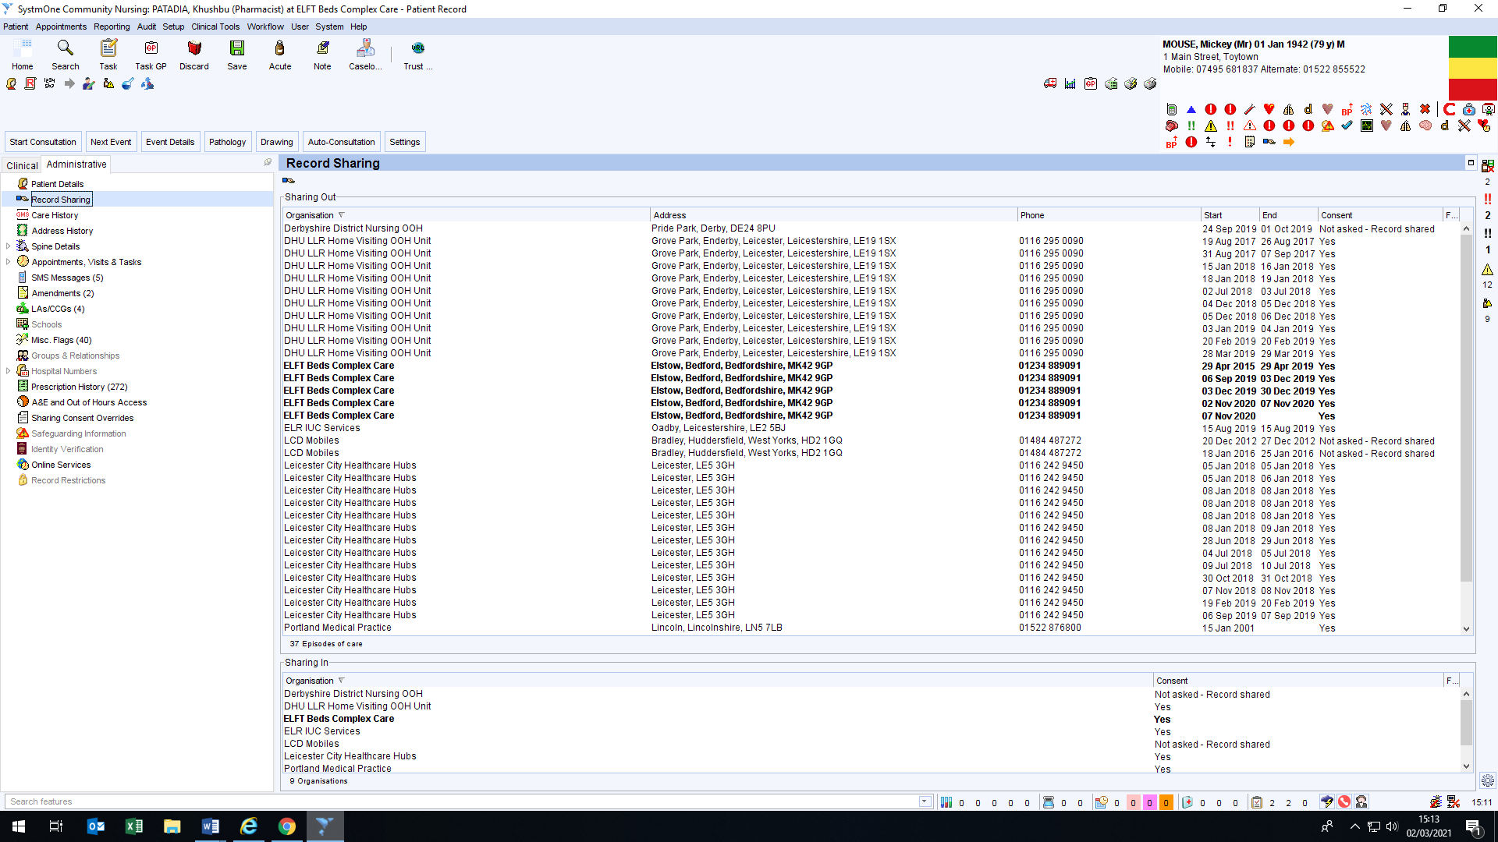

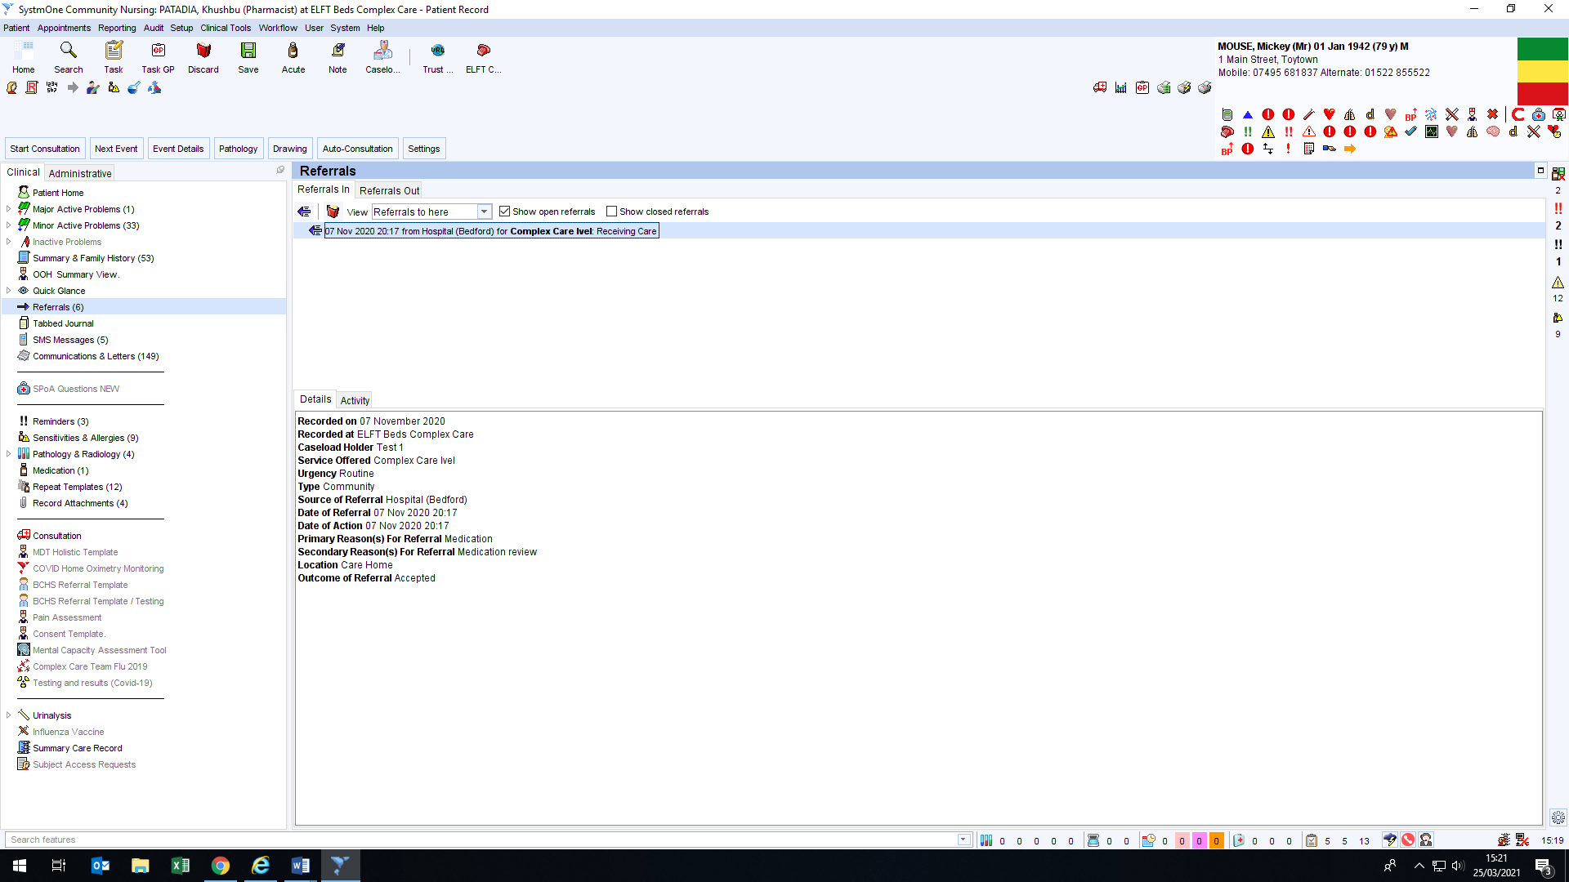
2
3
4
5

- Monitoring
- References
- Associated Documentation
Appendices
Appendix A
etc

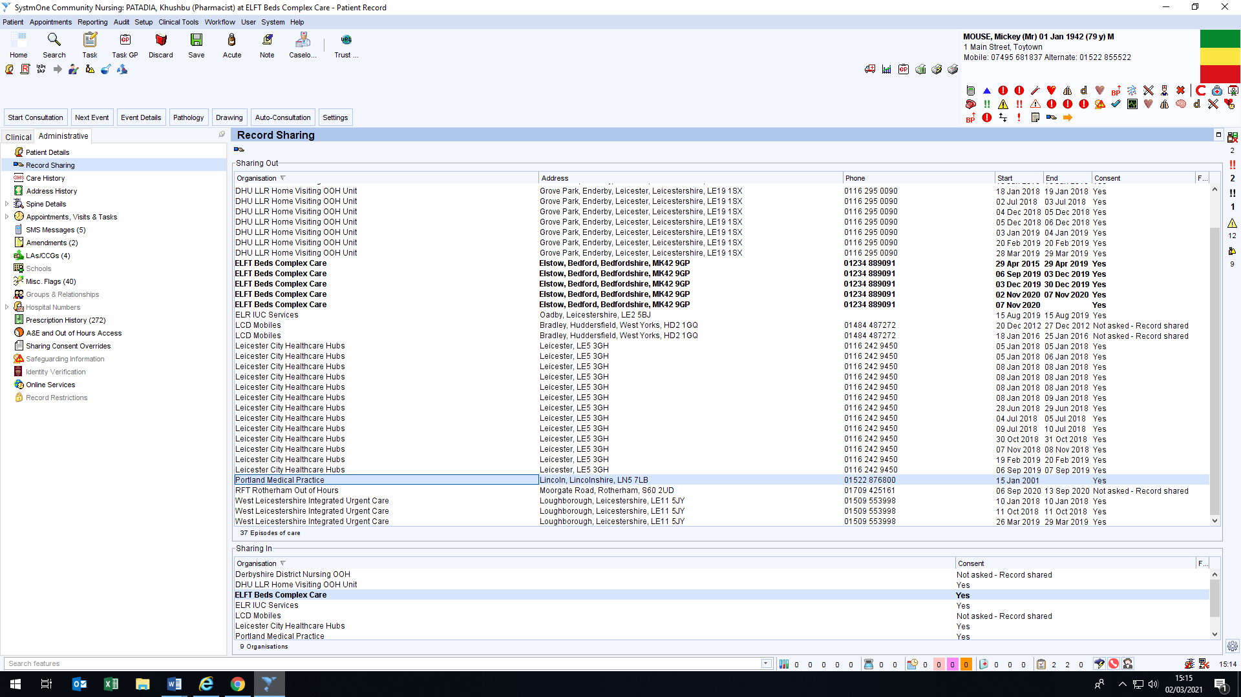

Sharing out: Locate the surgery that the patient is currently registered with (usually the one with a ‘start date’ but no ‘end date’) and check if records are being shared. If a record is being shared, it should say ‘yes’ or ‘not asked- record shared’.
Sharing in: Locate ELFT Beds Complex Care and check if the CCT is sharing in. If not shared then please request directly with the surgery – please ask them to put our team onto the white list.
If satisfied that the reason for referral is appropriate and full record sharing is available, then the referral can be moved from the ‘referral’ folder to the ‘consented’ folder on the main caseload screen. The image below demonstrates how referrals can be moved from one folder to another.
Consenting to Referrals
To move a patient from the Pharmacist Referral Bedford, Ivel, WMB and South folder, click on the patient and then on ‘Reassign Caseload Holder’. A pop-up will appear, click on the respective case load ‘Consented’ folder that the referral needs to be moved to and press ‘OK’ as demonstrated by the diagram below.
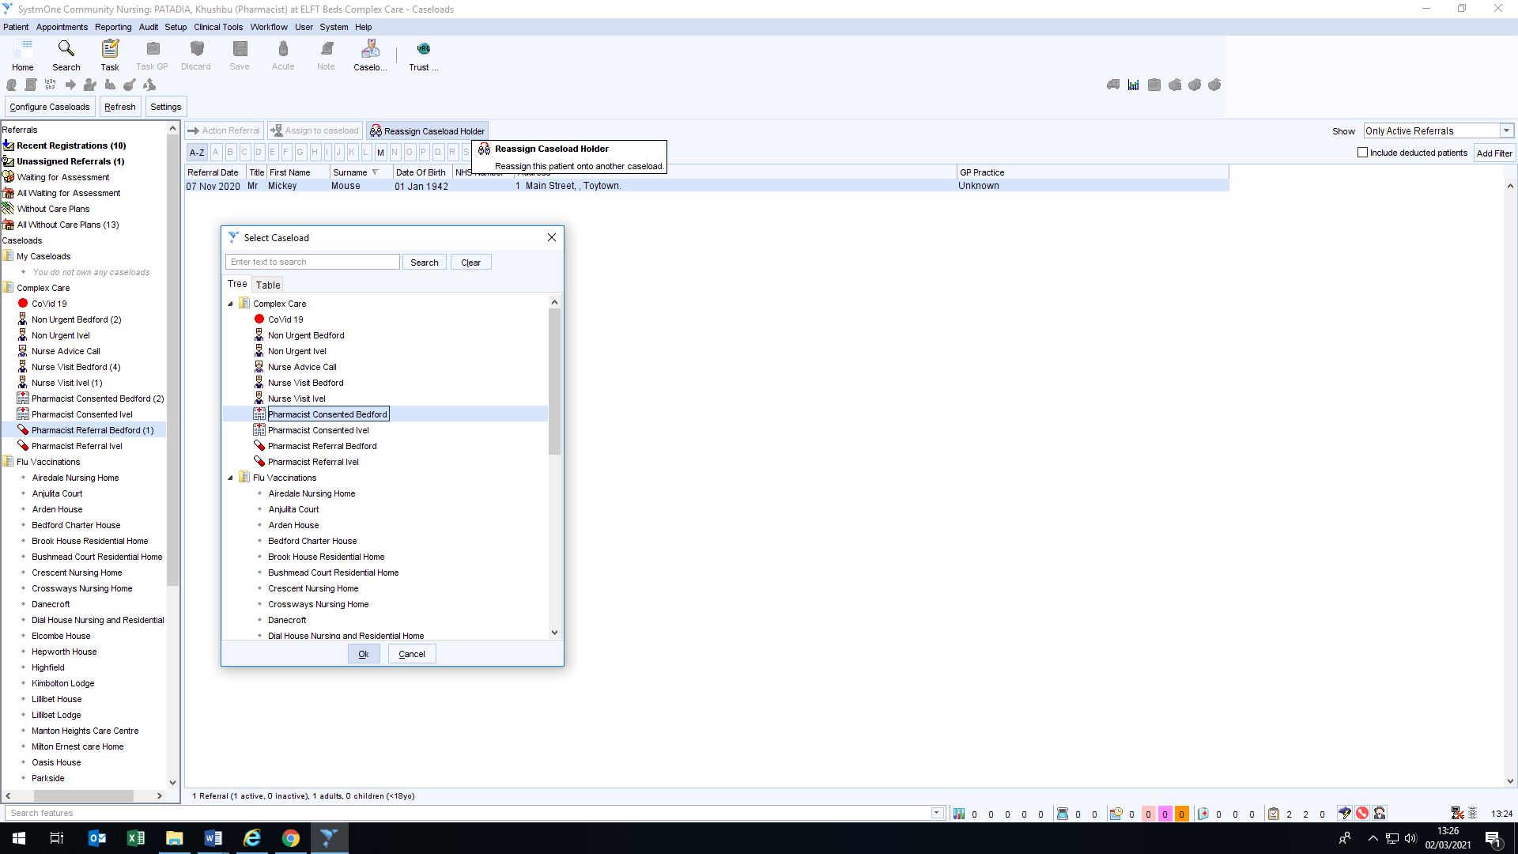

Navigating around a patients’ record
- Patient home mode: this displays a range of messages regarding the patient. These include; Patient Record open elsewhere message, Reminders, Status Alerts, Sensitivities and Allergies, Scan to File, Tasks, visits etc. Clicking on them will take you to either that Node or open up an additional window to view the information.
- Demographic box:
- This displays the name, date of birth, age, gender, address, telephone numbers, NHS number etc.
- Hovering over the demographic box with your mouse will display additional information such as GP details.
- There are symbols /alerts displayed at the bottom of the box. Each icon can be hovered over to view the description. The box may have a red box around it (as shown) if you have more than one patient record open (up to four records can be opened at the same time). To switch between records that are open, right click on the demographics list, this will give you a list of open records, select the one you need (Although it would be recommended that only one record is opened at a time, to prevent data being entered in the wrong patient record).
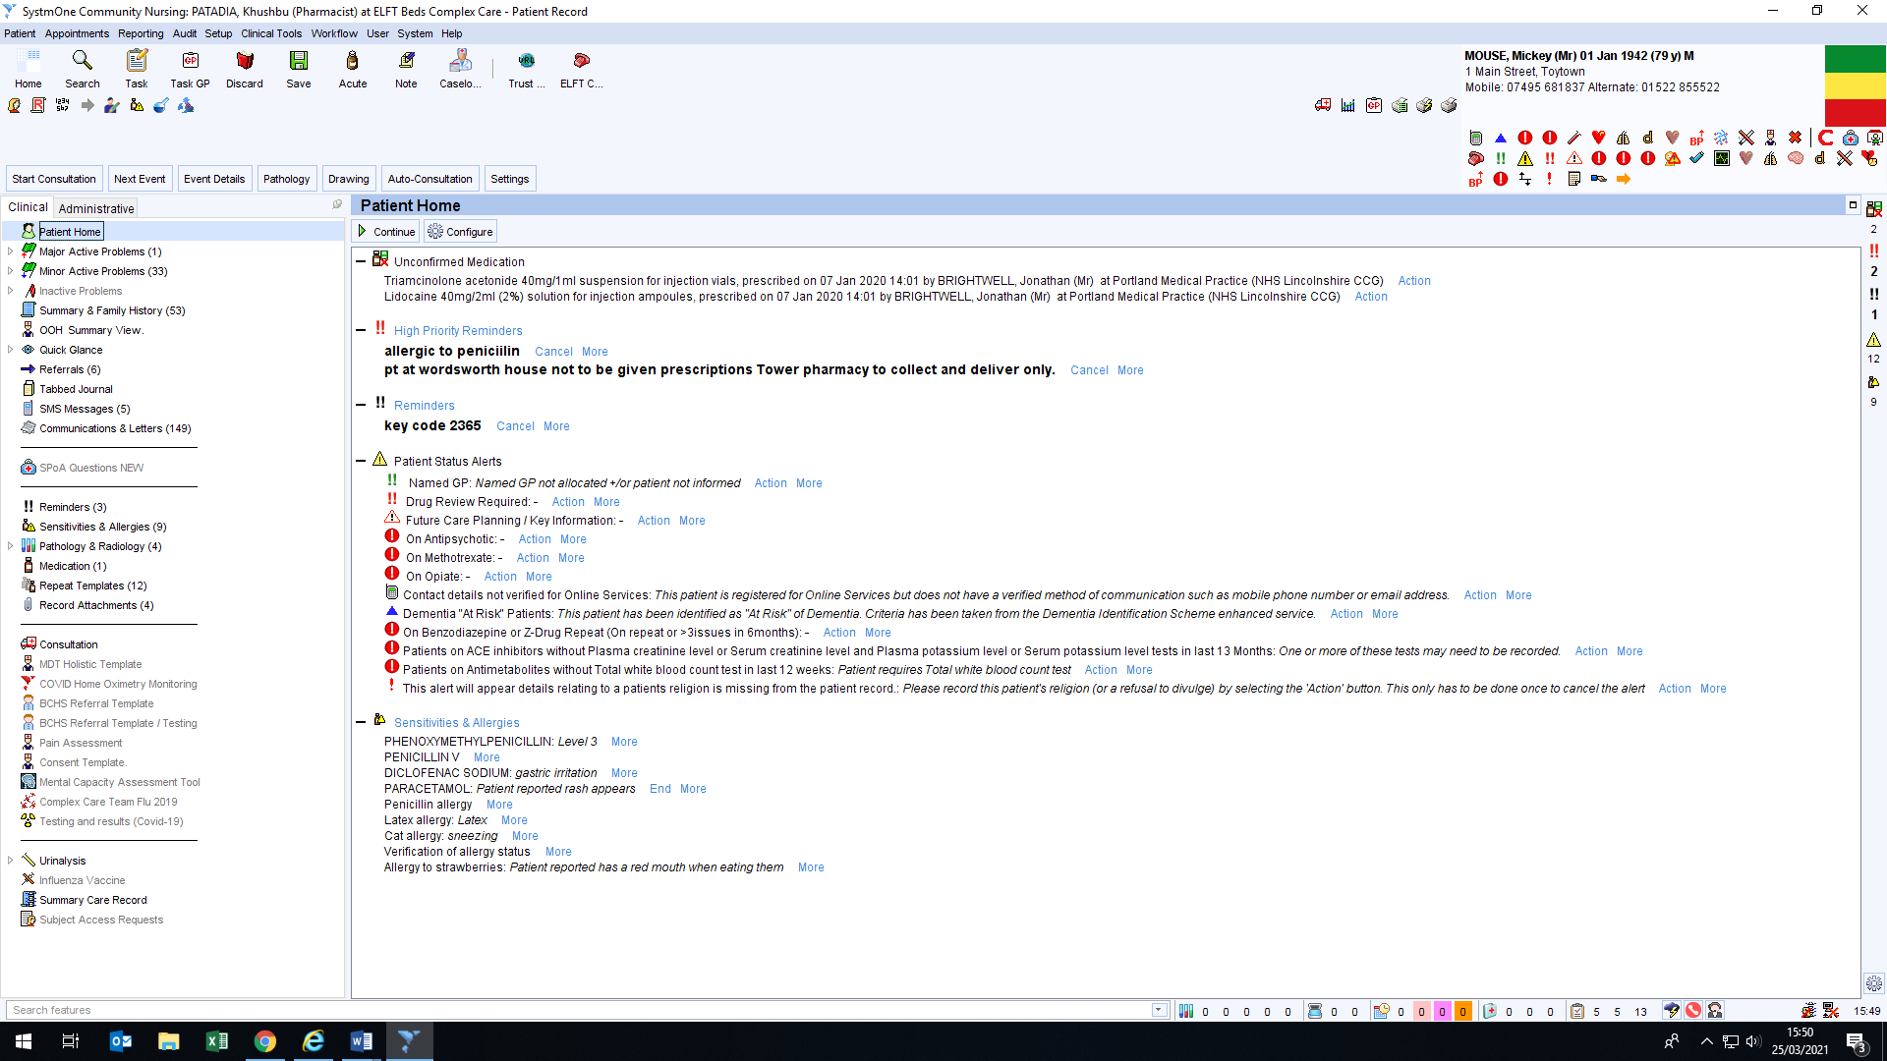
1
2

The Clinical Tree
There are many nodes on the clinical tree. Clicking on individual nodes provides you with a wide range of vital information.
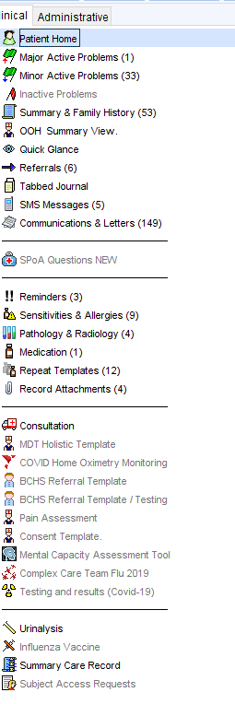
- Patient home node: This displays a range of messages regarding the patient. These include Patient Record open elsewhere message, Reminders, Status Alerts, Sensitivities and Allergies, Scan to File, Tasks, visits etc. Clicking on them will take you to either that Node or open up an additional window to view the information.
- Major and Minor active problems: As the name suggests, these provide information with regards to the patients’ co-morbidities/medical conditions.
- Summary & Family history: details the family history for the patient
- Quick Glance: Provides a brief overall summary of the patient. This includes; BP, Pulse, Weight/Height, BMI, Allergies, Current repeat medication, any blood test results and the last three consultations recorded.
- Tabbed Journal: This is a journal that contains all entries with information created by different healthcare professionals caring for the patients.
- Communications & letters: Displays all the documents that are uploaded onto the patient’s record, this included; Hospital discharge letters, clinic letters, letters from patient/family and letters from other healthcare staff (CH/NH, dietician, physiotherapists etc).
- Sensitivities & Allergies: Lists all the allergies recorded on the patient’s record. You can further right click on individually listed allergies and click on ‘Show journal entry’ to see further information recorded about the allergy.
- Medication: This shows all issues of the patient’s medication. Icons along the top allow entry of new medications, reissue, re-authorise, printing, etc. a filter field at the top right allows you to show all medication, current or in a specific time scale. Right clicking on individual medications also displays the actions with text. Recorded sensitivities and allergies are outlined in red at the bottom of the screen.
- Repeat Medication: Shows all the medication that are on repeat. Also shows how many repeats are left in each batch.
- Consultation: Allows you to record consultation for the patient.
- Summary Care Record: A GP summary care record that can be printed for the patient.

Record of Consultation
Once all the relevant information has been gathered about the patient, it should all be recorded on the relevant ardens template on S1. There are separate templates for each healthcare professional. To access the relevant ardens template. Follow these steps:
- Click on ‘Auto-consultation’.
- Select ‘ardens other professional
- Then select ‘Pharmacy technician’
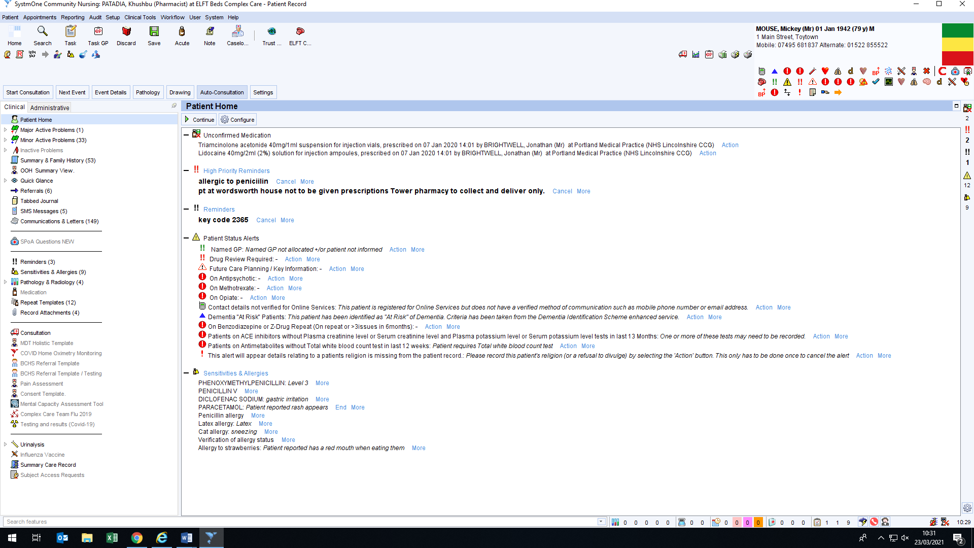
1
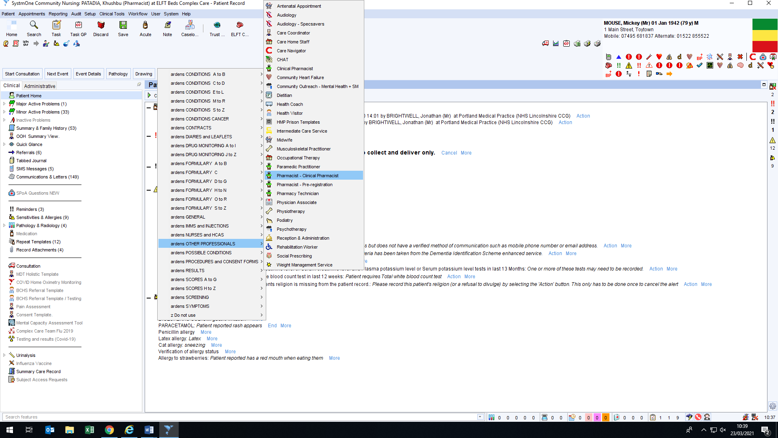
2
3
This should bring up the relevant ardens template where the information for the patient can be recorded. Please see appendix 1 for breakdown of stages and relevant codes.
Hospital avoidance – admission template to be used next
Right click the consultation tab on the tree and click on consultation
- In the new window, fill in the presenting complaint.
- This could include; Medication review post hospital discharge or New resident at CH/NH – Medication review.
- If an ardens template has been completed, then note that down too.
- Fill in the ‘advice and treatment’ section: briefly document what the advice/plan is.
- Click on ‘Pharmacist Avoidance with Stratify’ if patient over 75 years of age.
- Once a new window opens, fill in number 2 and 3 (Transfer and Mobility, respectively) only and click on ‘Save Final Version’
- Click on the medication review tab at the top and click on carer present and advice about side effects.
- Fill in the compliance of the patient
- If they are on inhalers ask the care home staff if they are compliant and taking inhalers correctly.
- Close this tab with OK at the bottom of the screen.

How to Task a GP
GP’s may need to be contacted for several reasons; for a follow-up of a clinical review, to update a repeat template, for bloods for a patients’ as requested by the hospital, to request a referral to another service, to query medication information etc.
To task a GP:
- Click on Task GP at the top of the screen on the intended patient’s record.
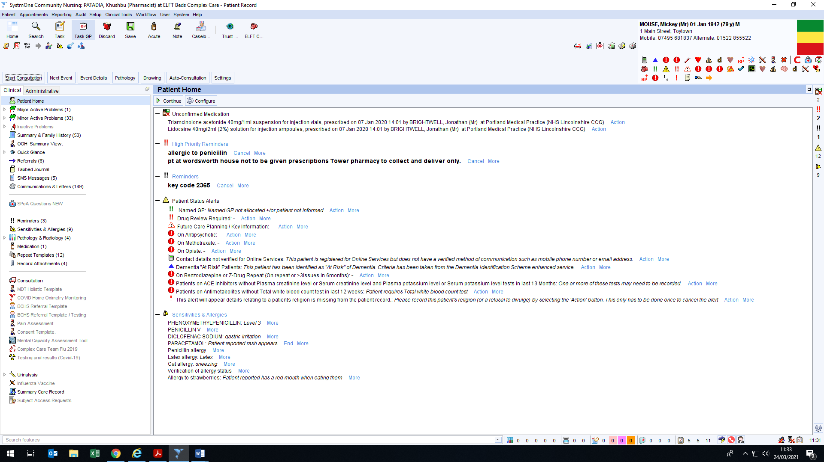
1

This should open up a new dialogue box (demonstrated below).
- For: This states the registered surgery for the patient.
- Staff member: It will usually have the named GP from the surgery for the patient. However, the information may not always be up to date. So ensure the correct GP is selected from the drop-down menu (other staff members can also be selected from the list, it is not limited to GPs)
- Name of the patient: Ensure the correct patient has been selected.
- Reason for task: This is important; it enables GPs to prioritise their tasks. From the drop-down menu, select the relevant heading for the task, these include; Miscellaneous, discharge, pharmacist, for action, for urgent action and for information.
- Task: Enter the information/query for the GP. Include all the relevant and supporting information in this box.
- Due by: This drop-down menu opens a calendar to select a date by which the task needs to be completed by the GP. Always include a date, as if not added & the recipient has a long list of tasks to complete, then your new task will remain at the bottom of their task list and may not be seen for a while. The date should usually be today’s date (if urgent) but can be a date in the future (if not urgent).
- Once all the necessary sections have been completed and the important information typed up, press ‘Ok’ to send the task.

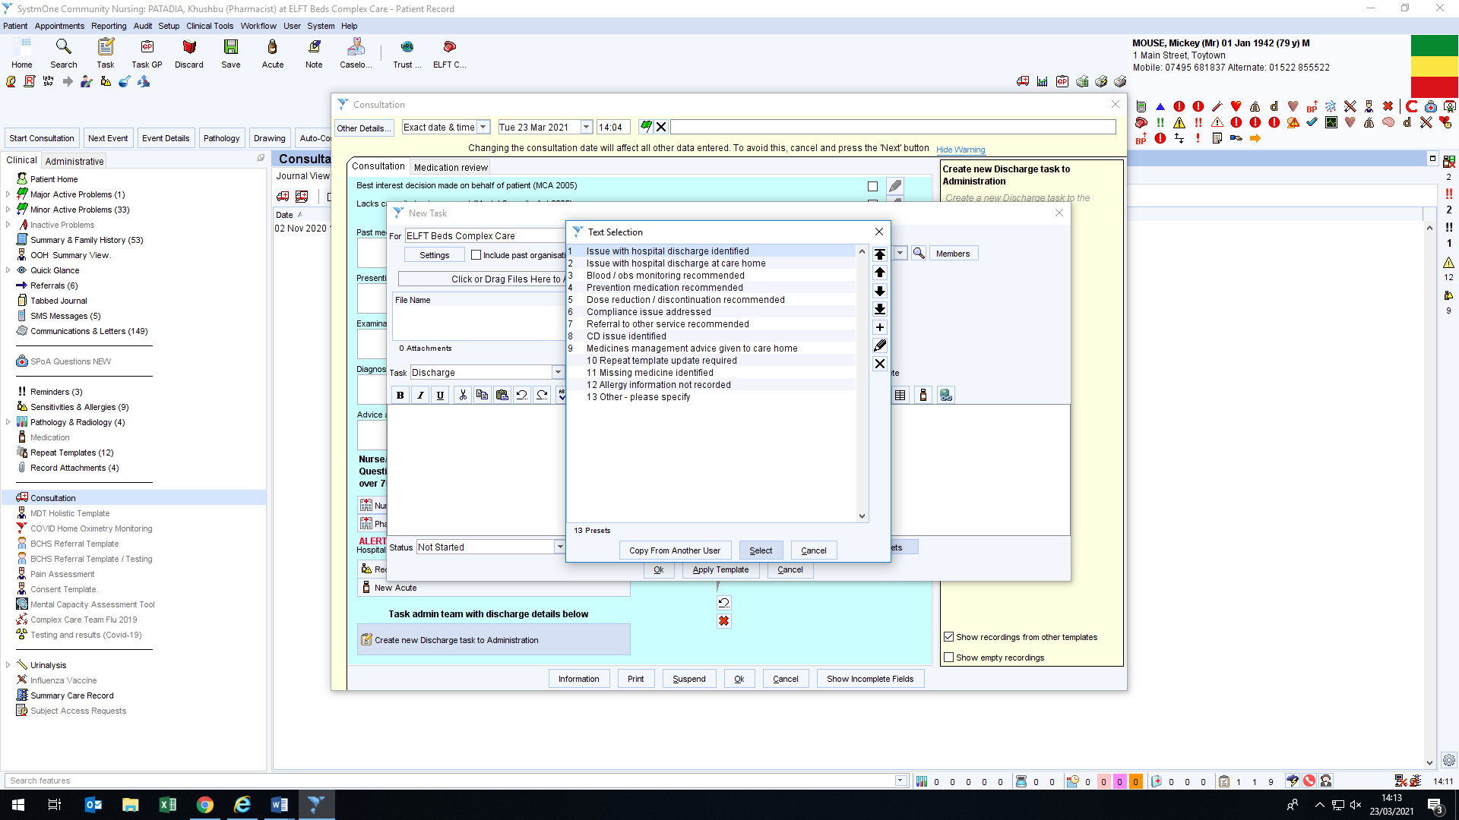
9

Check for ‘Pharmacist’ task group e.g. De Parys Group (ALL pharmacists).
Task individual surgery pharmacists where possible (see CCG published list) unless urgent then send unassigned task & telephone surgery to ensure it is allocated (GP Pharmacist may be on leave).
Where a general task/urgent task is needed and there is no Pharmacist contact send the task ‘unassigned’ – as per CCT Protocol agreed with CCG – always telephone surgery to ensure that the staff are alerted to the task and it will be passed on to appropriate person.

Saving Consultations
Once Auto-consultation (using ardens template), consultation and any tasks have been completed, it is highly important to save all the inputted data you have made in the patient record. If the patient profile gets discarded, all entered data will be lost. To save:
- Click on ‘Save’ at the top pf the screen.

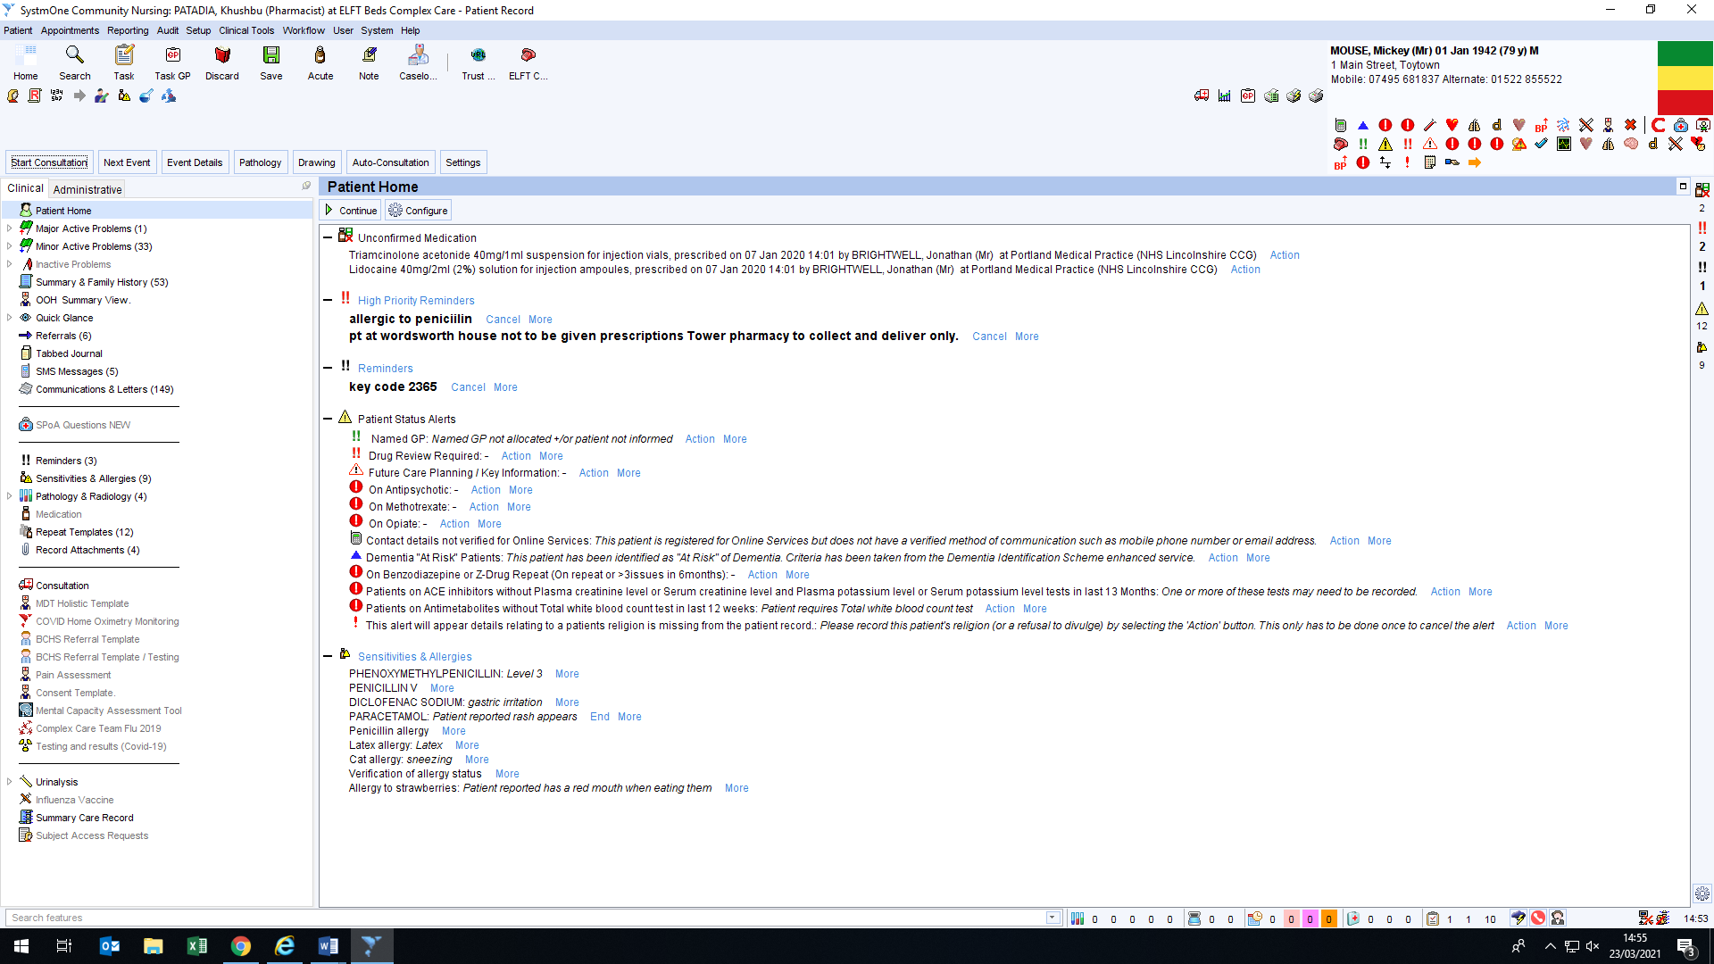
1

The following dialogue box will open. Both the left hand side and the right hand side sections need to be filled in.
- Template: Select the relevant template from the drop down menu.
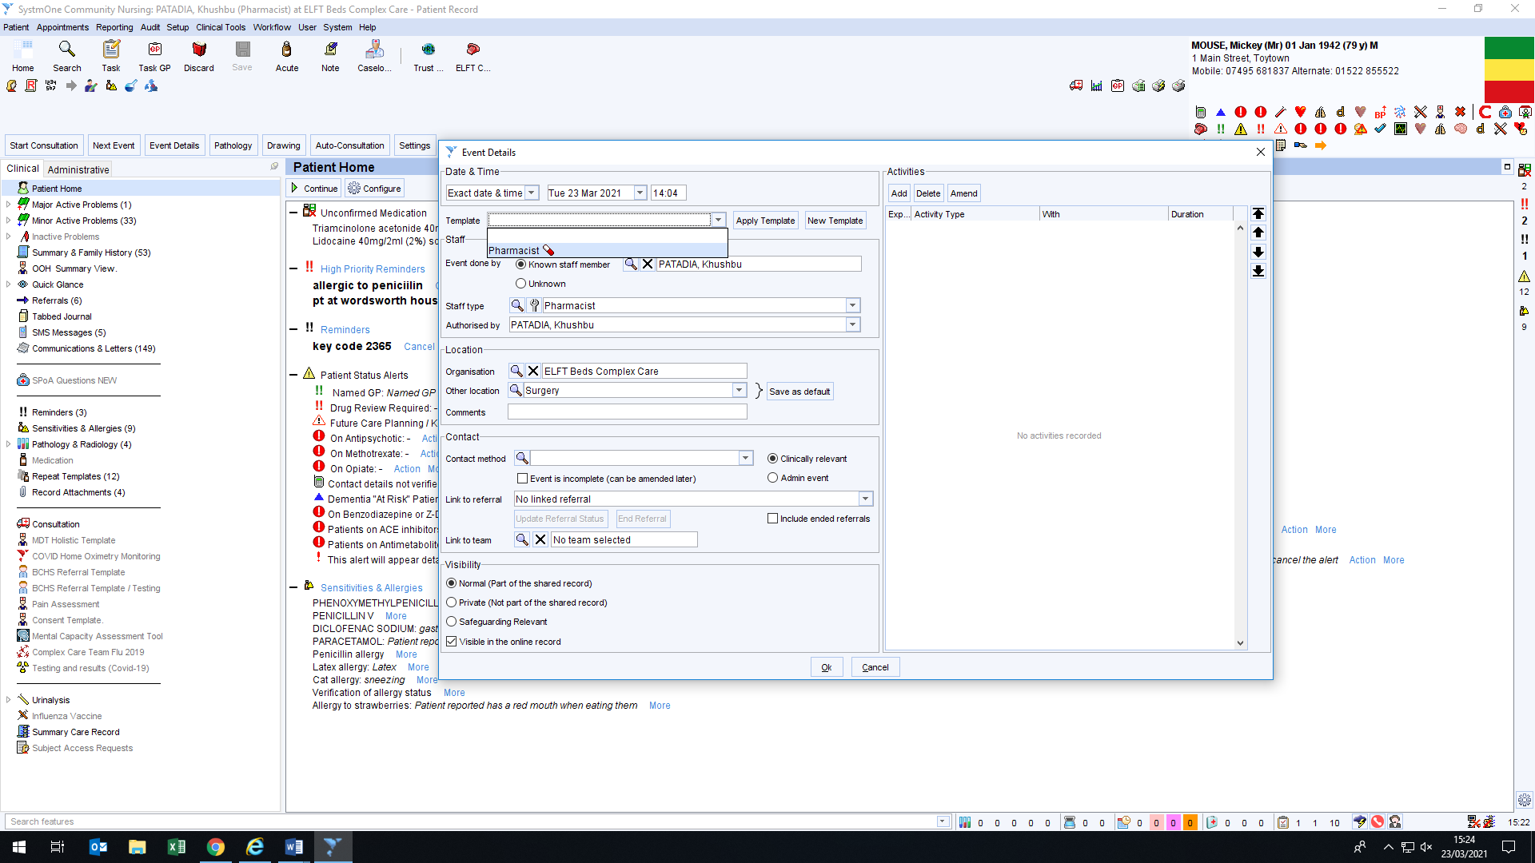
2

- Contact method: Select from the drop down menu the contact method used. Admin can be selected if no contact was made and only information had been entered on S1.
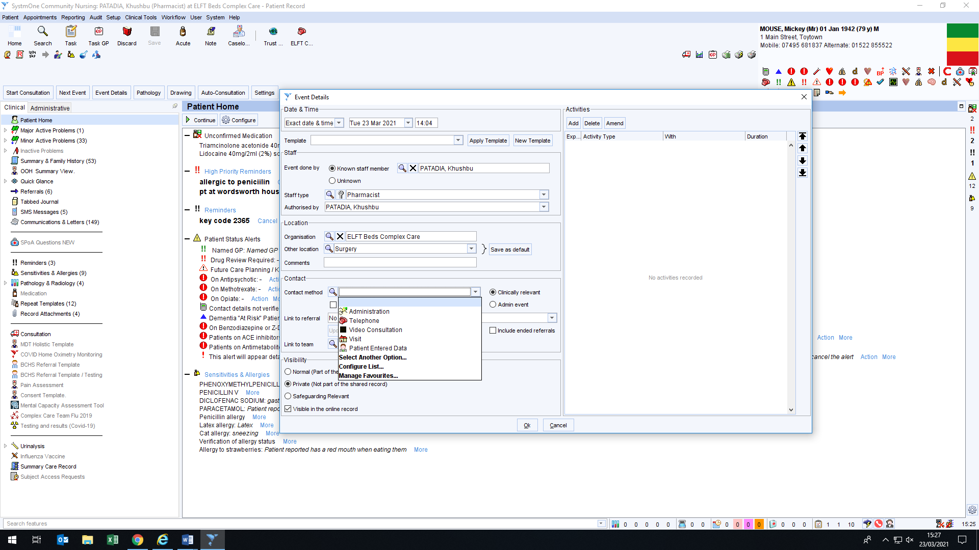
3

- Link to referral: A patient may have several open referrals with different teams. Thus, it is important to select the referral that is being completed. Click on the drop-down menu and select the referral made to the CCT pharmacy team for a medication review (post discharge/new home) or for advice.
- Visibility: Ensure that the visibility is set to normal, this will mean that is being shared and information entered is made visible to other healthcare staff.
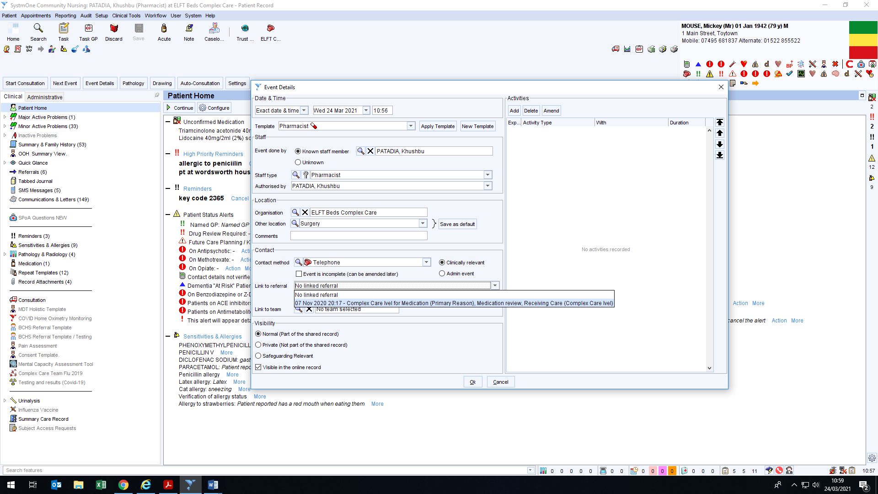
4
5

- Activities: Next all the activities that were carried out on the patients’ record need to be recorded. This includes admin work and any calls made to GP, CH, NH, Hospital, Community pharmacy or any other healthcare staff. To add an activity, click on ‘Add’.
- This should open a new window called ‘Consultation Activity’. Click on ‘Template’ first; this will automatically fill in all the other details (Contact with, activity, method and duration). Usually once the template has been selected, the only field that needs to be changed is the duration. Type in the duration taken to complete the activity.

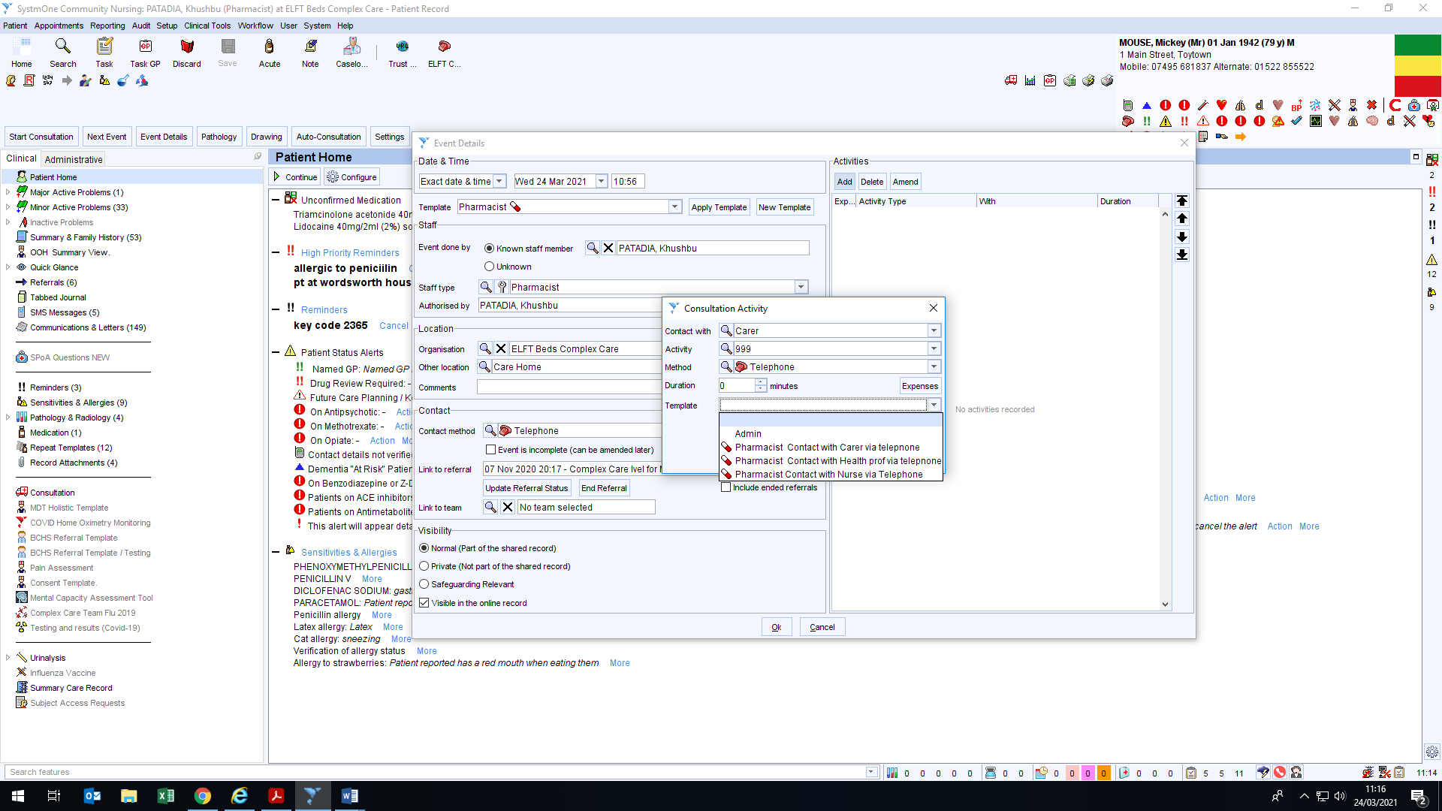
6
7

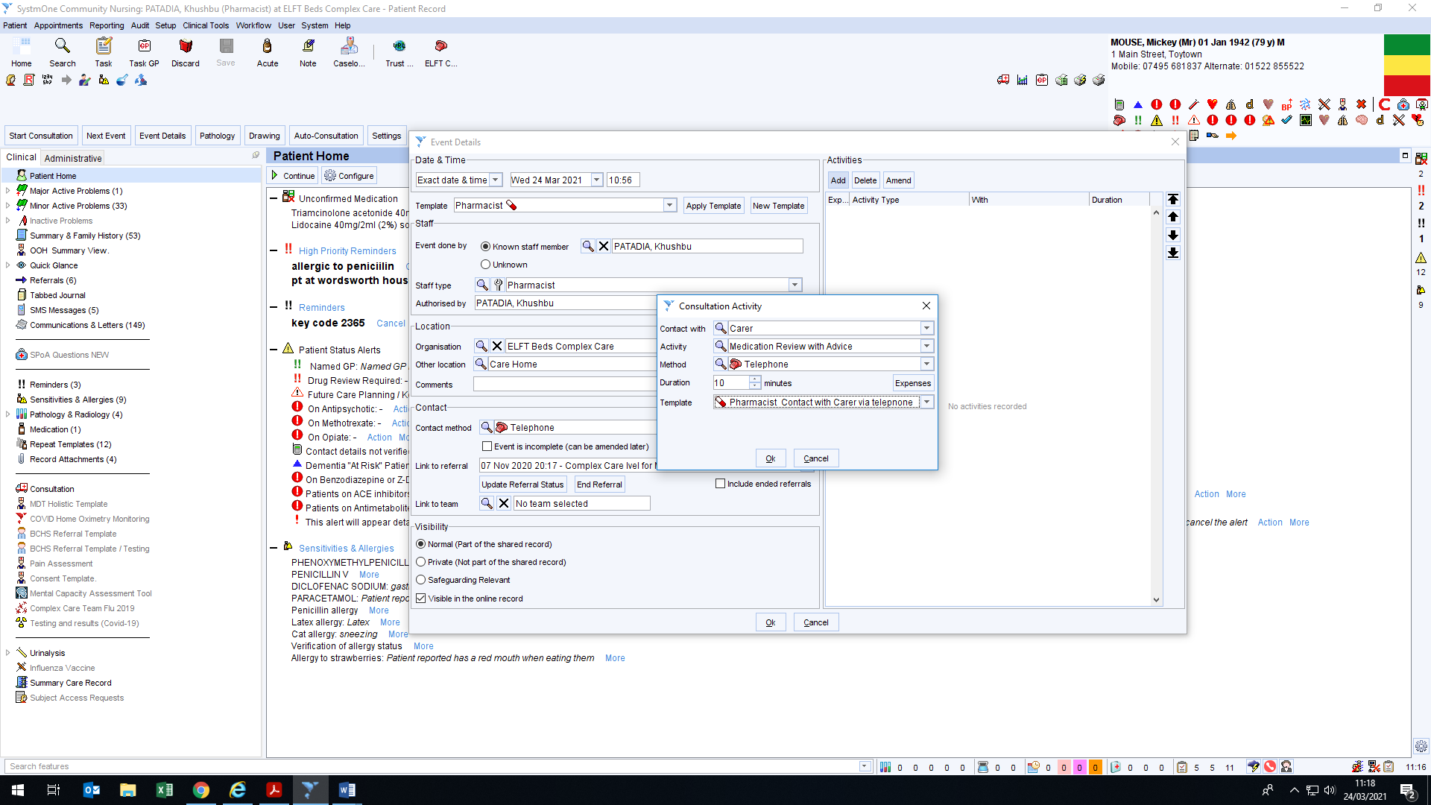
- Press ‘Ok’
8

- The activity will then be shown in the dialogue box as demonstrated below. This activity can be amended or deleted by clicking on the respective buttons. Depending all the work that was carried out, several activities can be added on to this screen by repeating steps 6 to 8. Ensure the time taken to browse through the patient’s record and the time taken to make the entries is recorded by selecting ‘admin’.

Once all the activities have been entered, click on ‘End referral’ to end the referral or click on ‘Ok’ to just save (note: this will only save the record, the referral will still remain open). Clicking ‘Ok’ will save the information and close the patient record. If however, ‘end referral’ has been clicked, follow steps 10 and 11.

- Press ‘Ok’ when the warning shows up (the tick-box can be un-ticked, so the message does not appear each time).
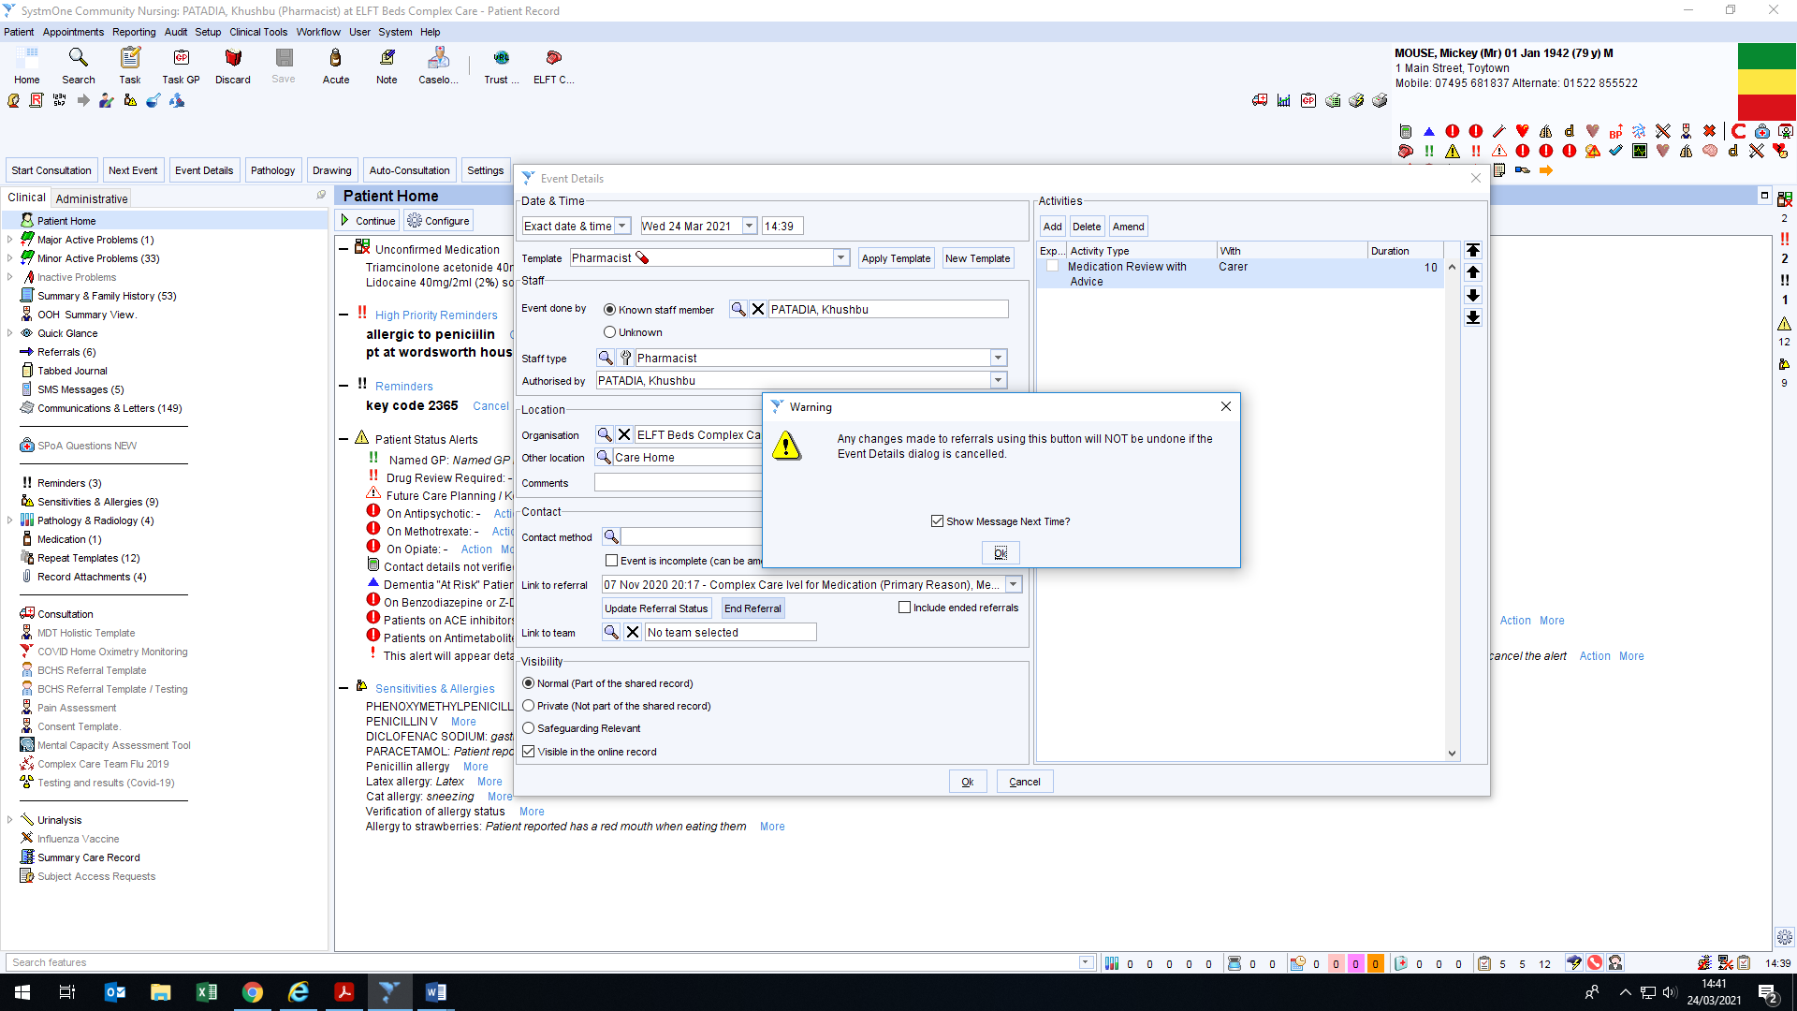
10

- End Referral: A new window should open as shown below. Ensure that the reason for ending referral is discharge (even if death is the cause). Ensure the date of discharge is correct. Next select the location after discharge from the drop-down menu; usually Residential/Care home.
- Select the intervention and click OK and then OK again.
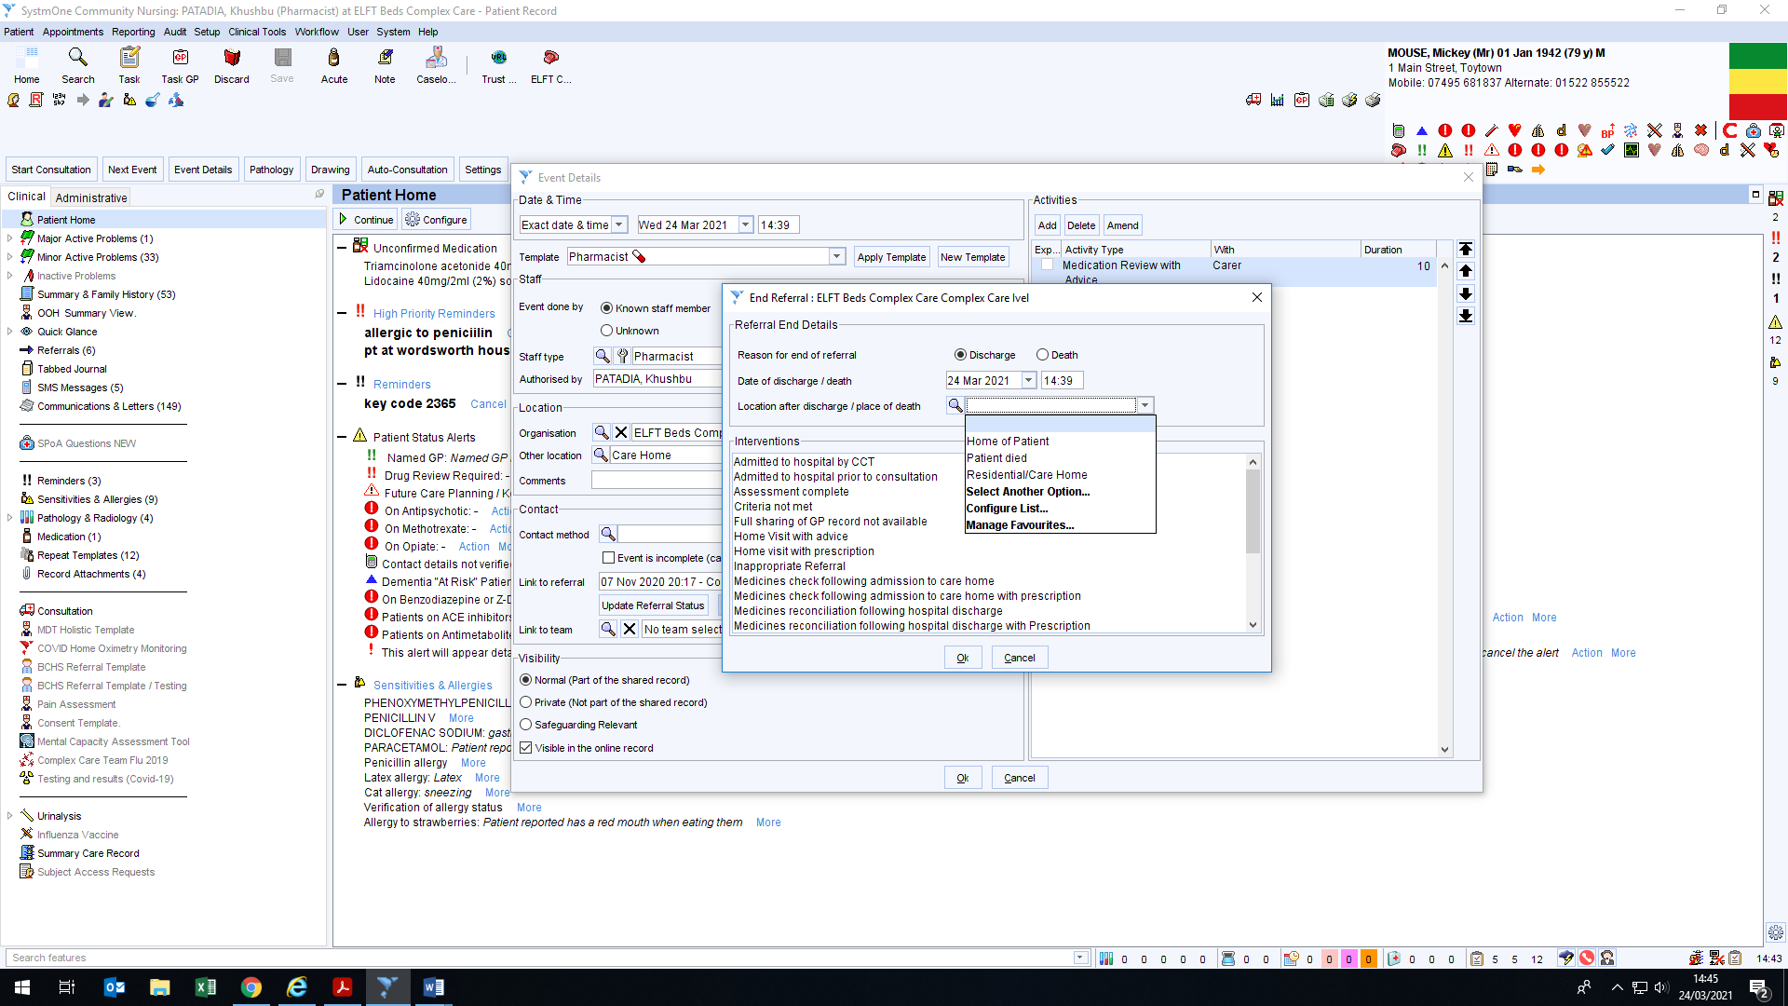
11
12

Other Important information/ Resources

Safeguarding Lead
Tony Alston – Named Professional for Adult Safeguarding ELFT BCHS
tony.alston@nhsnet 07920 075744

BCCG Prescribing Formularies and JPC Information & Care Home information
www.gpref.bedfordshire.nhs.uk/referrals/bccg-primary-care-formulary.aspx

Communication
Discharge discrepancies
Bedford Hospital: Always speak to pharmacist (ward staff less able to help) Tel: 01234 355122 Pharmacy Ext. 2476 (however automated service will state ‘putting you through to Serena Anshaw!’) request to speak to discharging ward pharmacist. They can use NHS email to send through updated/missing discharge letters.
Lister Hospital Medicines Information: 01438 284969
Luton & Dunstable Hospital Switchboard: 01582 491166
Milton Keynes Hospital Medicines Information: 01908 995733
Addenbrookes Hospital: email responses only gpdischargequery@nhs.net

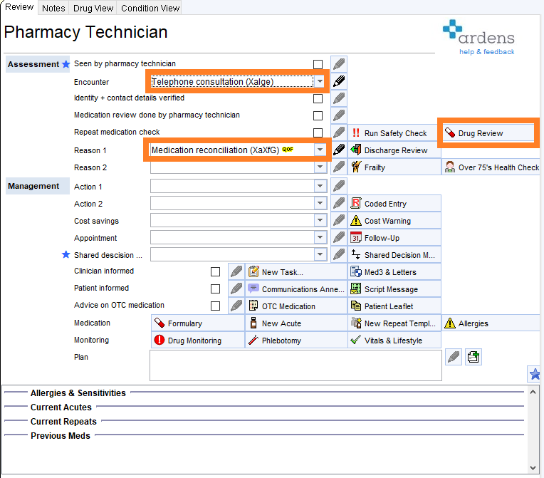
How to document a failed telephone encounter.

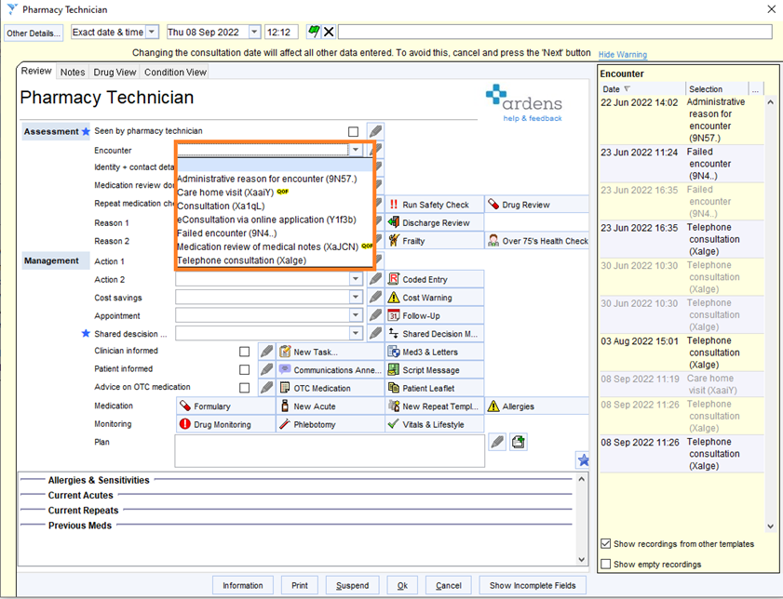

How to document vital signs and holistic issues
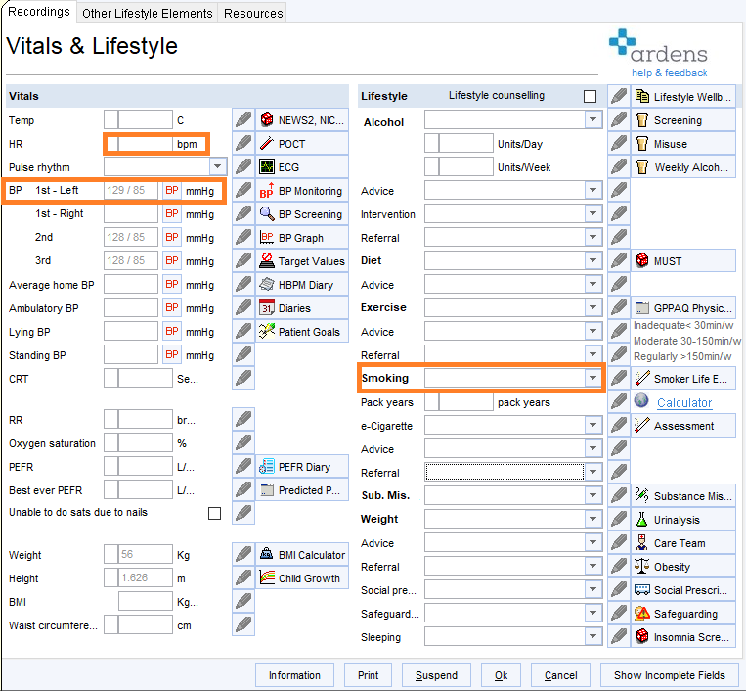
v

