Continuing Healthcare Team’s Standard Operating Procedure

Version number : | 3.2
Consultation Groups | CHCT team members.
Approved by (Sponsor Group) | Lead Nurses
Date approved | 17th March 2025
Ratified by: | Lead Therapist
Date ratified: | 23rd April 2025
Name of originator/author: | Service Manager  Tower Hamlets and Newham Continuing Healthcare Team
Executive Director lead : | Deputy Director of Tower Hamlets CHS
Implementation Date : | April 2025
Last Review Date | March 2024
Next Review date: | March 2026

Services | Applicable
Trust wide
Mental Health and LD
Community Health Services | X

Version Control Summary

Version | Date | Author | Status | Comment
2.0 | 03/09/2021 | Paulette Douglas-Obobi | Final | All changes to be authorised by Clinical Team Manager for CHCT.
3.0 | 26/06/2023 | Paulette Douglas-Obobi | Update | All changes to be authorised by Clinical Team Manager for CHCT.
3.1 | 04.03.2024 | Paulette Douglas-Obobi | Update | All changes to be authorised by Clinical Team Service Manager for CHCT.
3.2 | 12/03/2025 | Patricia Hopwood-Samuels | Update | All changes to be authorised by Clinical Team Service Manager for CHCT

Contents:
Content | Page
Introduction | 2
Vision | 3
Values | 3
Aims | 3
Responsibilities | 4-6
Service Overview | 7-13
Staffing | 14
Service Systems | 15-18
Quality Standards and Improvements: | 19

Introduction
Background:
NEL Integrated Care Board commissions ELFT’s NHS Continuing Healthcare service for people registered with a Newham /Tower Hamlets GP.
The Continuing Healthcare Team provides intensive community-based support to patients 18 years and over with complex/continuing healthcare needs who are in their own homes or care home facility. These cases meet the criteria for NHS Continuing Healthcare or NHS Funded Nursing care contribution and Fast Track palliative care patients who are at the end of their life and through choice want to go home or to a care home to die.

NHS Funded Nursing Care

The Continuing Healthcare team carry out independent nursing assessments for patients that are in nursing homes to determine eligibility for Continuing Healthcare assessments.

The service provides NHS continuing healthcare assessments and reviews for adult patients who are in the community and registered with a GP in Newham/Tower Hamlets.

The service provides case management support to Newham/Tower Hamlets residents meeting the eligibility criteria for NHS Continuing Healthcare; this will include arranging suitable care packages according to the wishes of the client and their family; ensuring that placements are clinically safe through both visiting and reviewing regulatory reports. The service ensures that packages of care and care home placements for people who are eligible for fully funded NHS Continuing Healthcare are appropriately assessed, managed, monitored and reviewed.

The service offers support and training to health and social care professionals to complete continuing Healthcare assessments in line with the National Framework for NHS CHC. Develop and deliver a training programme in relation to processes and policies for NHS CHC and NHS Funded Nursing Care.

The service also co-ordinates referrals for NHS Funded Nursing Care contribution, ensuring that the eligibility and funding criteria is identified accurately, and best practice guidelines are adhered to.

The service provides representation on the Single Eligibility Health Panel.

The service works in partnership with patients, families, their carers and other health professionals to ensure the patients are supported at the end of life in their preferred place of care

Contact details
Tower Hamlets and Newham Continuing Health Care Team
Address: Room 6, 2nd Floor

Newby Place Health and Wellbeing Centre

21 Newby Place,
London
E14 0EY
Tel: 020 7909 3805
Team Email: elft.chcnewham@nhs.net (Newham)
: elft.thchc@nhs.net( Tower Hamlets)
Clinical Team Service Manager: Patricia Hopwood-Samuels
CHC Lead Therapist: Alex Hadayah

Opening Times:
Mondays to Fridays: 9:00am-5:00pm.

Our Vision:
We make a positive difference to people’s lives.
Our values:
We care.
We respect.
We are inclusive.
Also
We work together.
We strive for continuous improvement.
We discover and share our knowledge.

Our Aims:
To promote independent and safe living of patients in the community with complex health problems by ensuring that they are in receipt of a fully funded NHS CHC care package if eligible and provide effective case management.
To promote palliative care in the community by setting up care packages for patients who have an eligible Fast Track assessment and provision of Marie Curie night sitting service for the last 2 weeks of life in the community.
To facilitate timely discharge from hospitals for patients who are fully funded Fast Track referrals.
To promote and share the expertise of CHC assessments and reviews with other health and social care professionals.

Our responsibilities:

- To carry out timely NHS Continuing Healthcare/Funded Nursing Care assessments and reviews in care homes/community.

- To provide case management support to fully funded NHS CHC patients in the community.

- To provide training around NHS Continuing Healthcare (NHS CHC) processes to health and social care professionals in Newham / Tower Hamlets.

- To provide support to our Local Authority colleagues when a safeguarding concern has been raised for fully funded CHC patients in Newham / Tower Hamlets. By undertaking urgent reviews and welfare visits. Reporting back to LBN/ LBTH &, ELFT and ICB safeguarding teams.

- Provide Personal Health Budget information to patients and their families for patients being assessed for NHS CHC.

- Promote the uptake of Personal Health Budgets for patients found eligible for NHS CHC.

- Facilitation of the CHC process for NEL ICB including ensuring documentation submitted to NEL (North East London) ICB for approval/ratification is complete and of sufficient quality to enable the NEL Health Eligibility Panel to verify a patient’s eligibility for NHS CHC funding.

- Facilitation of the CHC assessment process end to end from referral to the implementation of a package of care for the patient, maintaining all patient records and activities in an internal patient management system.

- Receive and review all Checklists and Fast Track Tools to ensure the standards required are met according to the NHS continuing healthcare framework and that they indicate eligibility for receipt of service or further assessment for eligibility.

- Developing or facilitating the development of a care plan for CHC patients that meets the patients’ needs identified through the assessment, liaising with the referring/appropriate clinician(s) where clarification is required to complete the care plan.

- Arranging care packages and placements for patients, ensuring that packages of care are value for money, using AQP providers where possible.
- Updating EMIS with dates that patients are referred for assessment and assessed, uploading accompanying evidence.
- Facilitate and where necessary, undertake the MDT assessment of the patient with other practitioners, coordinating the assessment to ensure that all areas of the DST are completed and are sufficiently evidenced.
- Facilitate the process to ensure the MDT reach an agreement on CHC eligibility.
- Write up the DST following the MDT assessment, ensuring that all evidence is captured, and DST does not have any areas of contradiction. Send the completed DST to the deputy team managers for quality assurance 2 days after completion.
- Ensure appropriate professionals are in attendance at the MDT/DST assessment.
- Arrange for the CHC paperwork to be presented to the Newham/ Tower Hamlets CHC Health Eligibility Panel by sending it to the ICB CHC panel coordinator.
- Represent health on the Newham/ Tower Hamlets CHC Health Eligibility Panel as required.
- If the panel are unable to verify the MDT recommendation, then review the panel minutes, following up with the panel chair if necessary, and remedy the issues flagged by the panel members, resubmitting the DST to panel within 1 week of the original panel date. The allocated case manager will review panel minutes and ensure that the information and action within a week.
- If the eligibility panel verifies the recommendation for 100% CHC, arrange the package of care based on the needs of the individual, as identified in the DST, and provide costings of the package of care, along with the supporting care plan for approval by the ICB within 1 week of the panel decision.
- Ensure that when arranging the package of care, a discussion is held with the patient about the type of funding package they would like, promoting the use of PHB’s in line with NHSE’s strategy to increase the use of Personal Health Budget’s.
- Record all panel decisions in individual’s case records on EMIS and ensure all communication of panel decisions to MDT participants is undertaken in a timely and professional manner.
- Ensure reviews are undertaken in line with National Framework and at other times as required. The National Framework guidelines state:
- All new CHC patient’s needs should be reviewed 3 months following their initial eligibility ratification. The review can be completed using the shortened Review Template.
- All existing CHC patient’s needs must be reviewed every 12 months. The review can be completed using the shortened Review Template.
- Patients with a PHB care plan, should use the PHB care plan template to complete the reviews.
- Notifying the ICB when a review has been completed and uploading the evidence of the review on to EMIS.
- Ensure the ICB is alerted to issues with Care providers, which may compromise quality of care.
- Facilitate placement/care packages for CHC patients.
- Ensure that ICB approves the care package and costs, providing documentation and costings for package before putting package in place.
- Ensure that ICB approves any changes to packages of care as they occur.
- Set up Fast Track care packages.
- Ensure that the ICB approves the Fast-Track care package and costs, providing documentation and costings for package before putting package in place.
- Ensure that ICB approves any changes to Fast Track packages of care as they occur, providing an updated care plan and funding request form detailing the change in need and the accompanying change in cost.
- Confirm prices and terms and conditions for services offered by providers on the ICB’s provider list, using providers on AQP should be the priority.
- Where the placement is for Nursing Care select a range of 3 providers from accredited AQP list suitable to patient’s needs, wishes and availability.
- Ensure that selected providers are acceptable to patient and/or family.
- Ensure that all packages of care provide value for money and in the first instance utilise providers off the accredited provider list.
- Ensure that an appropriate selection of packages including PHB, are offered to each client/patient based on their individual care plan.
- Single point of access for all CHC referrals.

Service overview
The following pathways make up Newham and Tower Hamlet’s CHC Service:

NHS CHC
CHC is a package of care provided outside of hospital that is arranged and funded solely by the NHS for individuals who have significant ongoing healthcare needs. Those assessed as eligible for CHC have their health and social care costs paid for by their Integrated Care Board. For those assessed as not eligible, their needs will be met by other services (universal services, Local Authority, etc).
The NHS CHC Service is commissioned by NEL ICB, and is delivered by a number of organisations including North East London Integrated Care Board, East London Foundation Trust, and Bart’s Health NHS Trust.

Fast Track
The Fast Track pathway is used by appropriate clinicians to expedite the implementation of a care package in the community for patients who have a rapidly deteriorating condition that may be entering a terminal phase, into their preferred place of care.

FNC
NHS-funded nursing care (FNC) is care provided by a registered nurse for people who live in a care home. The NHS will pay a flat rate contribution directly to the care home towards the cost of this registered nursing care. In order to be eligible for NHS-funded nursing care a patient must first be deemed ineligible for NHS Continuing healthcare but have been assessed as requiring care from a registered nurse, and the patient lives in a care home.

Joint Care
There will be some individuals who, although they are not entitled to NHS Continuing Healthcare (CHC) because taken as a whole their needs are not beyond the powers of a local authority to meet, but nonetheless have some specific health needs identified through the Decision Support Tool that are not of a nature that an LA can solely meet or are beyond the powers of an LA to solely meet. ICB’s should work in partnership with their LA colleagues to agree their respective responsibilities in a joint package of care. Case management for this patient group, remains with the LA.
D2A Pathway -Discharge to assess
Acute hospitals no longer complete CHC assessments or Checklists, for patients who are discharged to a nursing home or their own homes. A checklist is completed in the community by the Social worker and submitted to the CHC team, if the Checklist is positive a DST will be completed within 28 days.

Continuing Healthcare

Principles
Continuing Healthcare means care provided over an extended period of time to a person aged 18 or over to meet physical and mental health needs which have arisen as a result of disability, accident or illness. NHS Continuing Healthcare means a package of continuing care arranged and funded solely by the NHS (National Framework for NHS Continuing Healthcare & NHS funded nursing care – DH 2012).
An individual who needs ‘continuing care’ may require services from NHS bodies and/or Local Authorities. Integrated Care Boards have a responsibility to ensure that the assessment for eligibility for continuing healthcare takes place within 28 days from the receipt of the continuing healthcare Checklist in a timely and consistent fashion.
Checklists for NHS CHC can only be completed by appropriately trained professionals.
Note: The 28-day clock starts on date of receipt of the completed Checklist – this can be late in the afternoon on that day.
The 28-day clock can be stopped or put on hold, if the patient in the community is admitted to an acute hospital.
NEL ICB and the London Borough of Newham/Tower Hamlets, Adults Social Care Division are committed to working in partnership to achieve these time frames, together with local provider services.
The principles underlying this policy are that the residents of Newham/Tower Hamlets have fair and equitable access to NHS funded continuing healthcare. These principles are:
  - The individual’s informed consent will be obtained before starting the process to determine eligibility for NHS continuing healthcare.
  - If the individual lacks the mental capacity either to refuse or consent, a ‘best interest’ decision should be taken and recorded in line with the Mental Capacity Act 2005 as to whether to proceed with assessment for eligibility for NHS continuing healthcare. A third party cannot give or refuse consent for an assessment of eligibility for NHS continuing healthcare on behalf of a person who lacks capacity, unless they have valid and applicable Lasting Power of Attorney for Health and Welfare or have been appointed as a Deputy by the Court of Protection for Welfare only. NEL ICB will act in the best interest of the individual and convene a best interest meeting if there is a dispute and no one has power of attorney.
  - Health, and where appropriate, social care professionals will work in partnership with individual patients/clients and their families throughout the process.
  - All individual patients and their families will be provided with information to allow them to participate in the process.
  - NEL Integrated Care Board will support the use of advocacy for individuals through the process of application for NHS continuing healthcare, as in other services where advocacy is required.
  - The process for decisions about eligibility for NHS Continuing Healthcare will be transparent for individual patients and their families and for partner agencies.
  - Once an individual has been referred for a full assessment for NHS continuing healthcare, following the completion of a Checklist, all assessments will be undertaken by the multi-disciplinary team involved using the Decision support tool form, ensuring a comprehensive multi-disciplinary assessment of an individual’s health and social care needs.
  - Assessments and decision making about eligibility for NHS continuing healthcare will be undertaken within 28 calendar days of the completion of the continuing healthcare Checklist to ensure that individuals receive the care they require in the appropriate environment and without unreasonable delays.
- Eligibility decisions will be made by the Newham/ Tower Hamlets CHC Eligibility Panel. This panel is made up of a senior health and senior social care representative. The panel is chaired by the NELICB. The Terms of Reference for this panel can be found on the N-drive.
- All patients found eligible for NHS funded CHC must be offered a Personal Health Budget, and at a minimum be put on a notional Personal Health Budget, further details on Personal Health Budgets can be found in the Personal Health Budgets Policy.
- Any reassessment that takes place which has the recommendation to remove NHS CHC funding must involve social care as part of the MDT undertaking the assessment.
- When a person is found eligible for NHS CHC funding and are currently in receipt of a social care package, there is a two week trim point – i.e. the local authority will provide notice to the ICB that they will fund two weeks of care before cancelling the care package, during which time the ICB must pick up the package of care.
- When a person who is currently in receipt of NHS CHC funding, and is found ineligible for further CHC funding, there is a two week trim point – i.e. the ICB will provide notice to the local authority that they will fund two weeks of care before cancelling the care package, during which time the local authority must pick up the package of care.

Our Goals for 2025-2028 | Reality | Way Forward
Safety | Continuing Healthcare Service is currently fully staffed.  Areas of concern:  - Lack of responsiveness from Social Services which delay our patient assessments and consequently may leave vulnerable patients without adequate care package.  - New members to the team are inexperienced in managing adult safeguarding concerns. | - The clinical team manager and their Line manager to work closely with Social Services and Integrated Care Board to ensure that the Continuing Healthcare Service has allocated social workers to work with the team.  - All team members to have Level 3 Adult safeguarding training.  - The team has access to monthly adult safeguarding supervision/training by the trust’s adult safeguarding leads.
Health Promotion and recovery (Caring and responsive) | The Continuing Healthcare Service case manages the most vulnerable groups of adults in the community and there is a huge potential to promote healthier lifestyles for patients and carers.  Areas of concerns:  - NHS Continuing Care funded patients and carers may be at risk of social isolation.  - NHS Continuing Care funded patients may have unequal access to services. | - The Continuing Healthcare Service to produce ‘You said we did’ leaflets to improve patient’s experience  - Monthly welfare calls to the most vulnerable patients, living in their own homes.  - Ensure that the patients where possible have representation at CHC assessments and reviews.
Innovation (effective). | The CHC service is working with the D2A process. No CHC assessments are completed in hospital.  Areas of concern:  - The CHC assessments must be completed within 28 days, from receipt of checklist to presentation at Panel. | The Checklist is completed in the community by a social worker or Case worker. This can also be completed by other professionals who have received Checklist training. On receipt of the Checklist, the CHC team will arrange with the LA to complete the CHC assessment.
Leadership (well led). | The Continuing Healthcare Service now has a team structure and has one nurse specialist vacancy.  Areas of concerns:  - All staff to attend CHC training provided by NHSE.  - All staff to maintain their safeguarding competencies and skills.  - All staff to be competent at record keeping. | - Service Manager to share NHSE training information with the wider team.  - Safeguarding referrals are discussed in team meetings. Staff to attend external safeguarding training. Whilst maintaining their statutory and mandatory safeguarding training.  - Audit of CHC record commencing May 2021.

Our Patient Journey:

Continuing Healthcare Team: From Referral to Completion of CHC Assessments:
New referral via team email.
18 years old and above.
Registered with a GP in Newham/Tower Hamlets.

Duty Nurse completes the duty tracker.
Allocate to a CHC Nurse specialist to complete a DST within 28 days from receipt of completed CHC checklist to CHC team.
DST submitted to Single Eligibility Panel.
Referral is closed on EMIS.
Referrer and client are informed of discharge.
Admin staff creates a new referral on EMIS
Duty Nurse approves a CHC checklist.
Duty Nurse accepts a CHC Fast Track and Checklist
ICB approves the fast track Duty nurse triages the checklist & informs referrer & patient.
Duty Nurse rejects Fast Track or Checklist and informs referrer & Patient
Single Eligibility Panel decision
No CHC funding.
ICB informs client.
FNC funding agreed for 3 months.
CHC Nurse Handover to social services.
Duty Nurse decides on Checklist and Fast Tracks
Continues on next page.

100% CHC funding for 3 months.
A CHC case manager is allocated

Continuing Healthcare Team: From CHC or FNC Funding to Reviews:

CHC funding or FNC funding approved.
CHC Case manager seeks approval of care package & risk assessment and ensures that care package is in place in 10 working days.
CHC Case manager records on EMIS.

Duty Nurse approves FNC request
Duty Nurse records on EMIS.
Duty Nurse sets up a Fast Track Care Package within 4 working days of referral.
Duty Nurse records on EMIS.
CHC Case Manager reviews care package at 3 and then 12 monthly.
CHC Case Manager records on EMIS.
CHC Case Manager completes a CHC checklist at 3 months which triggers for a full assessment and a DST to be completed within 28 days.
CHC Case Manager records on EMIS
CHC Nurse reviews FNC at 3 months. A copy of the review is sent to the ICB for filing.
CHC Nurse records on EMIS
CHC Case Manager completes a CHC checklist at 12 months. This is sent to the ICB for filing.
CHC Case Manager records on EMIS.
Single Eligibility Panel decision.
100% CHC Funding for 12 months.
CHC case manager records on EMIS.
No CHC funding.
CHC case manager’s records in EMIS.
CHC Case manager handover to social services.
FNC funding.
CHC case manager records on EMIS.
CHC Case Manager Handover to social services
Client dies.
CHC Case Manager informs ICB within 1 working day. And discharges patient on EMIS. Inphase to be completed

CHC Case Manager closes referral on EMIS.
ICB informs client.

Newham Staff Complement
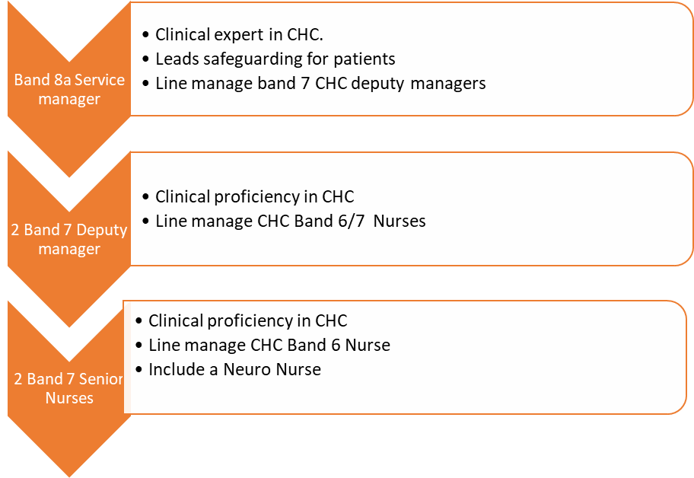

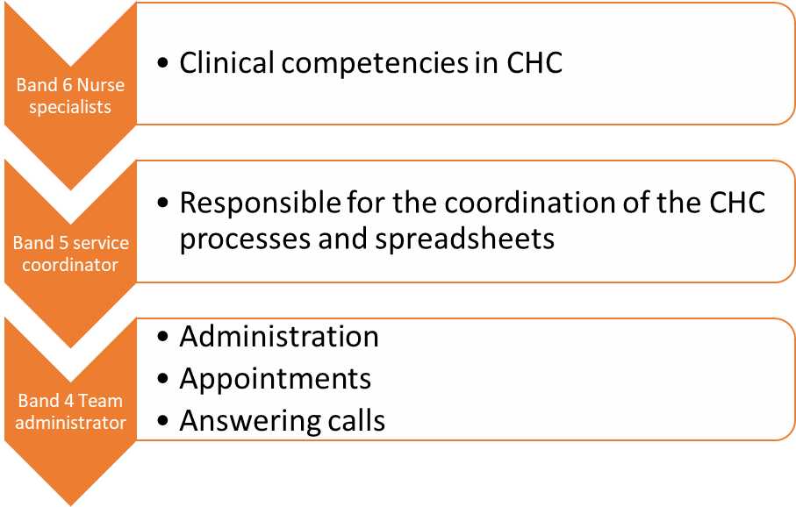

Tower Hamlets Staff complement
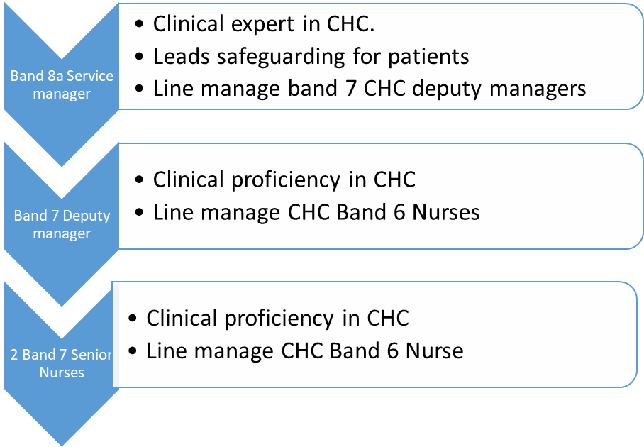
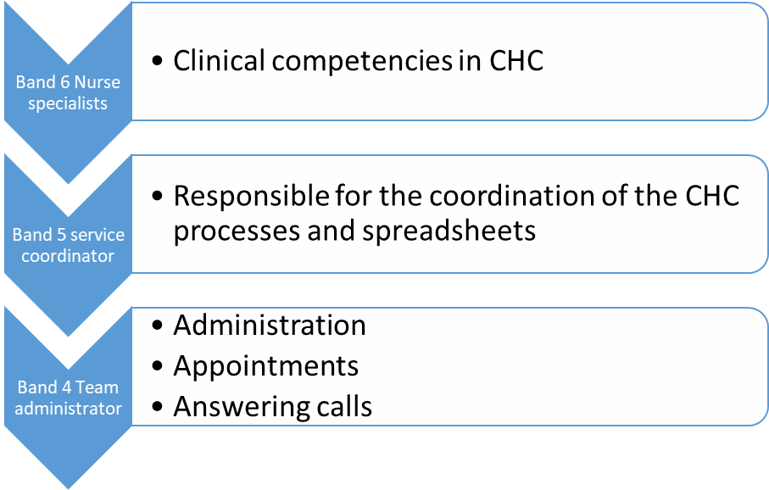

CHC Service Systems:
Advocacy services:
Language Shop for help with translation.
IMCA for DOLS.
IMHA for Mental Health Act.
Appraisals and personal development plan:
All staff has an annual appraisal and a personal development plan which due in March on an annual basis or within 3 months of start date.
All staff to have a 6 months review of their appraisal and a personal development plan in September.
Appraisal compliance rate is monitored on a monthly basis.
Audit:
There are three monthly departmental audits.
Budget:
Budget is reported via an electronic link on a month basis to the budget holder.
Care Quality Commission:
There is a ‘Care Quality Commission’ folder on the N-Drive accessed from the ‘Adult Bed N Days’ folder. Access to this folder is obtained by sending IThelpdesk@nhs.net an email.
The ‘Care Quality Commission’ folder is a central place where all the important documents are kept for easy access.
Complaints:
For advice and help:
- Staff to offer Patient Advice and Liaison Service (PALS) contact number: 0800 783 4839. elft.pals@nhs.net
- Staff to offer our complaint contact number: 0800 085 8354 or email: or by post:
Freepost RTKB-ESXB-HYYX,
Trust Headquarters, 9Alie Street, E1 8DE.
- Team to display our ‘How to make a comment, compliment or a complaint’ poster and leaflet.
Staff in receipt of a complaint will need to carry out the following actions:
- Inform line manager.
- Submit the complaint to the complaints team and save the copy under the ‘Care Quality Folder’ on N-drive.
- Create an incident form for the complaint.
- Support and reassure the complainant.
- Get involved in an After Action Review (AAR) with the team and apply any lessons learnt quickly.
Staff in receipt of compliment will need to carry out the followings:
- Inform line manager.
- Submit a copy to elft.pals@nhs.net and save a copy under the ‘Care Quality Commission’ folder on the N-drive.
Follow up:
The Complaints team will advise the line manager how the complaint will be investigated:
- Local resolution which involve the local team to find a resolution with the complainant.
- Or a formal investigation by the staff member outside the department and a formal response to the complainant.
Clinical record keeping:
EMIS is the electronic clinical record keeping.
Mycare Bank to be implemented

Communications:
- Telephone and emails
- Once a week team meeting.

Emergency response:
- Call 999 for all emergencies.
- Call duty senior manager.
- 24 hours emergency response team for fire emergency.
- Call duty manager on call.
Electronic Systems:
All staff will need access to the following:
- Electronic roster- please speak to your line manager.

- N-Drive- Ask your employer to complete a form on the IT portal for permission for access to ‘Adult Bed N Days’ folder.
- Line managers will need addition access to; ‘Staff Supervision’ folder on N-drive; Oracle; Budget; Electronic Rosters- please liaise with your line manager to set you up as needed.
- All folders are placed on Teams for easy access to staff.
Estates and maintenance:
Staff to report repairs and maintenance to the centre manager who will submit a request for repairs and maintenance.
Incident reporting:
All incidents (complaints, errors, safeguarding concerns) are reported via an electronic reporting system which is known as Inphase.
Infection Control:
- Hand washing facilities, access to gloves and aprons and clinical waste and sharps disposal systems.
- All staffs are trained in infection control.
- Infection control nurse available for advice and carries out timely audits.
- We test all our facilities for Legionnaire disease.
Information Governance:
- All information that we hold are compliant with Data Protection Act 1998.
- Information will be shared as per Caldicott Principles (1997).
- All staff needs to undertake the mandatory training in Information Governance.
Key performance Indicators:
KPIs are reported on a monthly basis.
The Performance team will send the nurse in charge a reminder at the beginning of the month and any manual update will need to be submitted by the 6th day of the month.
Mandatory training and compliance:
- Mandatory trainings are available in face to face training and via online via a system ELA which all staff has access.
Mandatory training compliance is reported once a month via the training department
Patient feedbacks:
- All patients are offered to complete a feedback following an assessment or review via an electronic tablet and results are updated once a month.

Risk and risk management:
- Risks are recorded on a team risk register which is discussed at the team meetings and at departmental level via the Improvement safety and quality meeting at least once a month. This is available on the N-drive.
Referral Process:
- There are two referral documents, the Checklist and Fast Track. Referrals are received from Health and Social care professionals.
Sickness reporting:
- Staffs needs to inform to the most senior staff in the team in person when they are off sick and when they are fit to return back to work.
- Senior staff to inform line manager promptly of staff sickness and progress who will report the episode of sickness online.
- Senior staff & line manager will ensure that staff sickness is managed as per ELFT sickness management policy.
- There is a monthly email from the People and Culture department that provides the detailed sickness level.
Staff, rotas and levels:
- Staff rotas are approved 6 weeks in advance via an electronic roster which is available to all staff.
- Shortage of staff will need to be reported to the line manager and further escalation to the Team Manager.

Stock orders:
1. Supplies- via Oracle.
2. Claire’s

Supervision and compliance:
- All staff has access to monthly one to one management supervision.
- Supervision compliance rate is monitored on a monthly basis.

Quality Standards and Improvements:
Local quality standards and improvement. | Professional quality standards | Care Quality Commission standards. | National Guidelines. | Law
Specialist Nursing Policies.  Community Health Newham Policies.  ELFT policies. | Allied Health Care policies and standards.  Nursing and Midwifery Council policies and standards.  General Medical Council policies and standards. | - Person Centred Care  - Dignity and Respect  - Need for Consent  - Safe and Appropriate Care and Treatment  - Safeguarding Service Users from Abuse.  - Meeting Nutritional Needs.  - Cleanliness, safety and suitability of premises and equipment.  - Receiving and acting on complaints.  - Staffing  - Fit & Proper persons employed.  - Good Governance  - Duty of candour. | National Framework for Continuing Healthcare Framework.  National Institute of Clinical Excellence guidelines.  National Service Framework for older adults. | Mental Health Act 2007.  Mental Capacity act 2005 and Deprivation of Liberty Safeguards.

