Title | Medicines Safety Officer Report March 2025
Authors | Rajesh Jethwa/Indreet Anand - Medicines Safety Officers (MSO’s)
Presented to | Medicines Committee
Date | 12th March 2025

Purpose of the Report:
This report provides a summary of medicines safety data that is collected in the Trust and is presented to the Medicines Committee for information. The committee is asked to consider the level of assurance provided by the report and decide whether further action is needed.

Strategic priorities this paper supports (Please check box including brief statement)
Improving service user satisfaction | ☒ | Improve service user-related outcomes by ensuring that they receive safe pharmaceutical care.
Improving staff satisfaction | ☒
Maintaining financial viability | ☐

Committees/Meetings where this item has been considered:
Date | Committee/Meeting
N/A | This report has not been considered in any other committees or meetings

Equality Analysis | This report has no direct impact on equalities
Contents
Section | Page | Source of information
Medication incident reporting and deep dive | 2 - 5 | Inphase Dashboard & observations
PSIRF & examples  - After Action reviews  - PSI’s | 6-8 | MSO’s & Inphase
Trust Medicines Safety Group | 9 | Medicines Safety Group Minutes & Action log.
Local Medication Safety Update | 10 | MSO,s NEL/BLMK system wide work extracts
MHRA Drug Safety Updates | 10-11 | MHRA drug safety update
Trustwide Audit programme Key actions | 12 | Inphase data

Key Medicines Safety Messages
- High medication incident reporting culture noted within trustwide community health services. Key areas include; medication discharge processes & tasks related to insulin administration. Dedicated workstreams top mitigate future risk
- Internal medication errors related to dispensing process on the rise. Themes picked out include preperation of dosette boxes & label and dispensing of individual items. MSO’s to support central dispensing team once a month to highlight errors and provide dedicated safety training.
- A rise in prescribing errors related to external agencies serving tower hamlets CHS. Incidents are discussed and solutions are put forward as part of learning together collaborative work
- PSI report that identified gaps in prescribing practices within Bedford and Luton MH community services. SEIPS approach taken to identify effective and sustainable actions
- Active engagement with people participation on medicine safety related workstreams. Supported by Irum Reela our Patient Safety Partner.
- Valproate MHRA update February 2025 - Review by TWO specialists remains in place for patients initiating valproate under 55 years of age but the commission on human medicines has advised that it will not be required for males currently taking valproate

External errors related to prescribing process within tower hamlets CHS

Trust Wide Medication Incident Reporting

Figure 1 & 2 Total number of medication incidents reported per month (12 and 24 months)
General upward trajectory in medication incident reporting over the last 24 months, however within the last 12 months there is a downward trajectory in medication incident reporting potentially compounded by transition from datix to inphase. Despite this medication incident reporting remains within the upper and lower control limits and important to continually monitor. Our community health services in Tower Hamlets and Bedfordshire have a high reporting culture. A high proportion of these errors relate to transfer of care from the hospitals in the area with a particular focus on medication discharges and errors related to the insulin adminsitration.

TH CHS – Collabrative working with Royal London Hospital working together on learning from medication safety incidents. Events organised with primary care to support learning following incidents with insulin.
SPS national webinar hosted by our very own Dr Alex Harbourne and the CHS team discussing safety strategies to support safer use of insulin across community health
- Optimisation of diabetic medicines within community
- SOP to be shared system wide for how to make changes to insulin doses and prescribing responsibilites within primary care
- Work around promotion of diabetes self management reducing dependency on district nurse visits where appropriate. Work undertaken to add function on EMIS GP system to identify where self management is an option for the patient
BCHS – Registered QI project looking at inappropriate discharges from local acute hospitals into community setting (care home/ domicilliary)
December 24 – February 25 – Medication Incident reporting by directorate and subcategory (Internal errors)
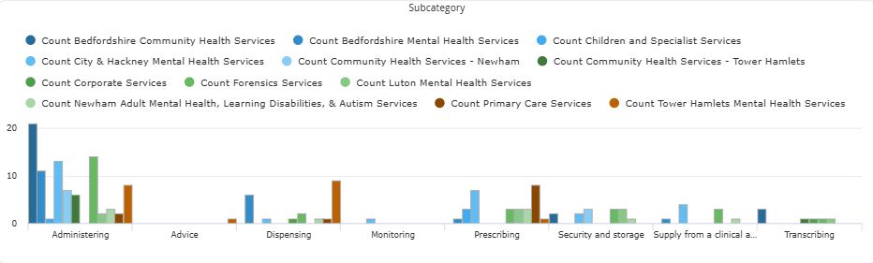
Figure 3- Incident reporting by directorate and subcategory (Internal)
Focus areas
- High proportion of medication errors related to administration as a process. Higher reporting within BCHS. Again related to insulin administration, MAR chart discrepancies and documentation on visits.
- Dispensing incidents – Increased reporting within the Tower Hamlets directorate. Themes picked out include timely supply of TTA’s, Clozapine dispensing (Dosette box errors), Labelling & dispensing errors
- Prescribing incidents in Primary care – Incidents related to authorisation/resupply of medicines via repeats leading to increased prescription turnaround times and some incidents related to medicines continued when no longer clinically appropriate

December 24 – February 25 – Medication Incident reporting by directorate and subcategory (External errors)
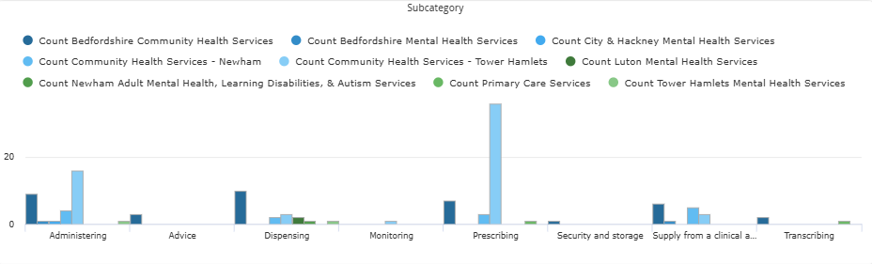
Figure 4 - Incident reporting by directorate and subcategory (External)
Focus areas
- Prescribing errors in THCHS
  - Examples of incorrect device, doses and type of insulin chosen and not being updated on GP prescribing systems leading to old doses being given
  - Difficulties noted with use of PAN london MAR chart to support end of life care. Not always written up correctly
  - Stop dates with patients being discharged with Low Molecular Weight Heparins from Royal London hospital
  - Incidents related to the the prescribing of appropriate doses of anticipatory end of life medications
Physical Harm (December 24 – February 25)
Physical Harm | Count | % of total harm
No Harm | 118 | 79
Low Harm | 27 | 16
Moderate  Harm | 8 | 5
Severe
Harm
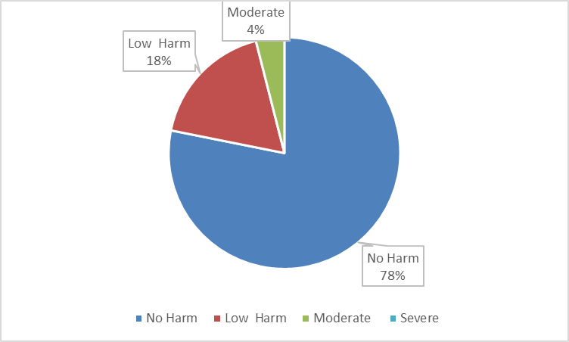
50 % of the medication incidents that were graded as moderate harm were due to external agencies.
Moderate Harm Incidents (December 24 to February 2025)
*Incident descriptions and immediate actions taken directly from inphase*
Key points
- Timely authorisation of medicines by GP practices to ensure medicines are not omitted
- Maximum dosing with Haloperidol
- Paliperidone dosing schedule at initiation
- B12 monitoring for patients receiving IM therapy and treatment continuation
- Illegibility’s and discrepancies with PAN london MAAR chart leading to delays with end of life care.

72 hour Medication Incident reports Commissioned (December – February 25)
A 72-hour report is designed to support staff in providing critical and relevant information related to a patient safety incident to help executive team understand what happened. This is done to support incident-grading panel with deciding on most appropriate form of learning.
Note: Incidents may have initially requested a 72 hour but then later de-escalated after formal review of the incident
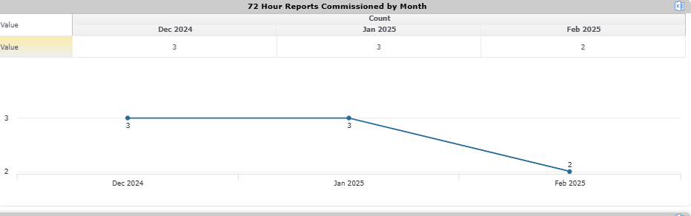
Example 1 Patient X was reported to have received FOUR tablets of 400mg lithium instead 2 tablets prescribed. Medical review to determine if any toxicity. Through learning, it was likely that the patient received the prescribed dose using a smaller strength, which would then equate to FOUR tablets. No signs of toxicity and lithium levels came back within range
Actions (frame using SEIPS)
- If there is a deviation from the prescribed strength, it is good practice to inform the patient about what they are being given and why there is a variation.
- -Document the reason for the variation and the patient's acknowledgment on RIO or EPMA.
- -During working hours, consult with the pharmacy to ensure the required supply is available.
- If a long-term supply issue is anticipated, pharmacists or doctors can support by adjusting the prescription to a different strength, ensuring accurate documentation of administration.

PSIRF Learning Examples
- After Action Reviews (AAR)
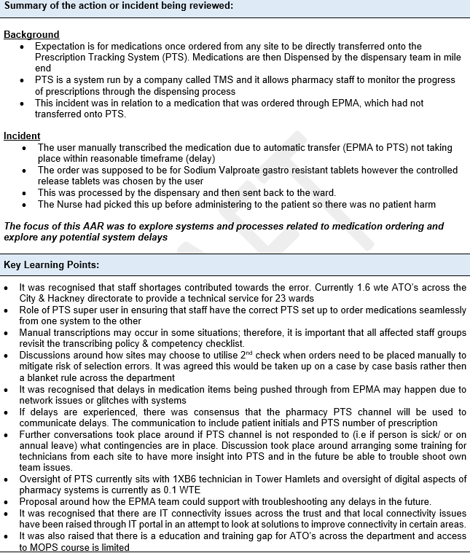
Planned After Action reviews:
- Incident ID – 28192 (Tower Hamlets Directorate) – Rajesh to facilitate alongside Dr Nicole Eady & Helen Moseley. AAR oversight and support from Dalila Magdu
- Incident ID – 28898 (CHS Newham) – Indreet to facilitate with CHS team in Newham (Sally Sherman ward). Request to have an AAR submitted by Dawn Mcmahon (Clinical Lead Pharmacist)
2. Patient Safety Incident Investigation (PSII) report
- PSI 10117 – Prescribing Incident Dementia Intensive Support services + Bedford older people CMHT + Cauldwell GP
PSI lead reviewer: Aroon Jeeneea
Contributions to PSI Dr Gavin Watt, Dr Stuart Banham, Rajesh Jethwa, Gogo Abbey

  - Patient developed serotonin syndrome as a result of cumulative medication interactions. Medication involved; Rasagiline, sertraline, phenalzine and lithium
  - The PSI explored communication around medication prescribing practices across different settings
    - Holistic review of patient’s medications when starting a new medication. Review to be undertaken by members of staff authorising the medication
    - Exploration of systems and processes related to medication correspondences
    - Awareness of resources available to support safe and effective prescribing.
    - Exploration of Alert fatigue on GP prescribing systems

SEIPS ACTION MAPPING | Safety action description  (SMART) | Target date for implementation | Date Implemented | Responsibility for monitoring/ oversight | Planned review date  (e.g. annually)
Action 1: Mapped to ‘Enhanced Documentation and communication’ | ELFT Community MH services must ensure all medicines both newly started and existing are communicated with primary care to aid continuity of care and safer prescribing | February 2025 | February 2025 | Medicines Committee/Medicines Safety Group
Action 2: Mapped to Training and standardised processes | Prescribers in BCHS to be mapped to the safe prescribing e-learning module that exists on the ELFT learning academy | June 2025 |  | BCHS Quality Assurance group
Action 3: mapped to introducing changes to original error prone system. i.e Taken for value that those checks have already been done by the specialist. | Medicines will be verified for clinical appropriateness by prescribers in ELFT primary care services. This will include querying any medicines that they are unfamiliar with, making contact with specialist prescriber for additional safety netting. | February 2025 | February 2025 | Medicines Committee/Medicines Safety Group
Action 4: Mapped to policy and system redesign | Only registered staff as per local sop/policy have final oversight of any correspondence that is sent to primary care in relation to medicine use | February 2025 | February 2025 | BCHS Quality Assurance group

Trust Medicines Safety group – Highlights
It has almost been a year since the Trust Medicines Safety Group has been set up. Some of the key highlights we would like to share are as below
Log of ongoing and completed actions of the group
Involving service users and carers in safety learning and improvement work
- We have a number of service users/carers who have joined our group and we have started to establish PP into key medicine safety related workstreams. This has been supported by our Patient Safety Partner Irum Rela.
  - Understanding of the medication complaints data the organisation receives. Using the data and other forms of intelligence to build change ideas to improve patient safety
  - Understanding the medication incident data related to high risk medicines such as clozapine and working with PP to generate ideas to improve the safety profile with systems and proccesses related to this medication
  - Medication incidents related to discharge processes are a clear priority of this group. The PP group have stories and experiences to share which has provided some steer on what we do next to improve discharge process related to medicines.
  - PP will be supporting the group with implementation of a dedicated CHS medicines management programme.
  - Collaboration with PP to develop a medicines safety resource pack for group members- this will be a key resource to support members and those that handle medication with key medicine safety information.
Supporting those affected by Incidents.
- The Medicines Safety Group provides a platform for staff to discuss and share incidents that they have been involved in. The group is set up to listen attentively to staff experiences, give staff the time to reflect on what happened, identify learning and then think about how this will be shared more widely. It is a supportive group and members come ready to present their incidents and share how this had affected them The group works to provide support to staff through listening to medication safety concerns, develop solutions and signposting to relevant trustwide resources
Future direction
- Application and routine use of SEIPS into medication incident learning responses, which will help to identify stronger actions.
- Forum to test out and share experience with new PSIRF learning methods.
- Continue to identify risks and work collaboratively to identify effective solutions to improve patient safety

LOCAL MEDICINES SAFETY UPDATES
- Trust wide Medicines Safety Group (MSG)
  - Good engagement across all disciplines
  - Work streams underway to improve safety across the organisation.
  - Feedback MS forms survey sent to group – analysis of responses and implement findings

- Valproate Policy
- Trust-wide policy now live on the intranet
- February 2025 – Review by TWO specialists remain in place for patients initiated on valproate under 55 years of age. Those men already on valproate will not be required to be reviewed by TWO specialists. This cohort of patient are still required to have the counselling related to the risks associated with valproate use.

- Forensic Nurse Training
  - Webinar providing information on the safe use of medicines
  - Sharing of incidents and best practice.

- Doctors Induction/Training
  - Sessions continue to be delivered at learning academic sessions
  - Safe prescribing of medicines e-learning module live on the intranet.

- CD e-learning package
  - Tested and reviewed by pharmacy and nursing staff
  - Presented at Medicines safety group for ratification
  - To be launched in April 25 alongside revised CD policy

- System Wide Working
  - MSO’s co-leading on NEL wide workstream on learning from medicines related patient safety events
  - Key stakeholder of high risk/teratogenic medicines sub group of the MSQG.
  - BLMK Medicines Safety Group

- Review of Medicines audit programme
  - MSO’s working with services to review medicines audit programme. This includes revision of existing audits and implementation of new audits onto inphase module.

MHRA DRUG SAFETY UPDATES
January 2025
- GLP-1 and dual GIP/glp-1 receptor agonists: potential risk of pulmonary aspiration during general anaesthesia/deep sedation
  - Healthcare professionals should be aware of the potential risk of pulmonary aspiration in patients using GLP-1 or dual GIP/GLP-1 receptor agonists who undergo surgery or procedures with general anaesthesia or deep sedation.
February 2025
- Review by TWO specialists remains in place for patients initiating valproate under 55 years of age but the commission on human medicines has advised that it will not be required for males currently taking valproate
- Males currently taking valproate should be counselled as below
  - as a precaution, recommend that male patients and their female sexual partner use effective contraception (condoms, plus effective contraception used by female sexual partner) throughout the valproate treatment period and for 3 months after stopping valproate, to allow for one completed sperm cycle not exposed to valproate
  - at their next regular treatment review, discuss with men on oral valproate treatment whether they are planning to father a child in the next year and if they are, refer to a specialist to discuss most appropriate treatment options
  - advise men not to donate sperm during valproate treatment and for 3 months after stopping valproate
  - if a female reports they are pregnant or planning a pregnancy with a man on valproate, refer them for prenatal counselling

Trust Wide Medicines Audit Programme 2025 – Actions
Note: Directorate teams have access to inphase audit data results and are expected to; review data/trend analysis for their individual directorates, identify address areas of concern and action plan for improvement.
Focus areas | Action | Progress | Status
HDAT prescribing in forensics | To benchmark HDAT prescribing to other NHS forensic services. | IA/MA – Liasing with other NHS trusts that have a forensic service to understand if we are an outlier.
HDAT prescribing in forensics | To present recent local audit data at the forensics quality committee | MA – assigned to present the data at tnext meeting and collabaratiuvely iudentify next steps.
HDAT prescribing in forensics | Benchmarking HDAT Prescribing to national POMH-UK audit. | IA/RJ - To review against last set of trust data
HDAT prescribing in forensics | HDAT prescribing standards to be reflected in trustwide junior doctors induction programme. | RJ – reflected in induction for new doctors joining the trust
Rapid Tranqulisation monitoring | To present national benchmarking POMH-UK audit data at Quality Committee | IA – Presented POMH uk data at quality committee
Rapid Tranqulisation monitoring | Decide on implementation plan of actions via T&F group | IA/EM/RJ – ongoing conversations to decide on best strategy to move forward with identified actions
Valproate | Identification of newly prescribed male patients | RJ/IA Patients will be tracked through NEL ICB valproate dashboard. To understand how this information will be available to us in BLMK
Valproate | Monthly snapshot report sent to MSO’s to identify admitted patients on valproate with/without completed RAF form | Monthly snapshot report sent to MSO’s to identify admitted patients on valproate with/without completed RAF form. Produced by informatics and soon to be mapped to pharmacy powerbi dashboard so that data is readily available to all staff

