STANDARD OPERATING PROCEDURE (SOP)

Department: | All Departments
SOP Ref No:
SOP Title: | Raising and Monitoring Call-off Orders

 | NAME | TITLE | SIGNATURE | DATE
Author/  Reviewer: | Raymond Chan | NHS Shared Business Services |  | April 2025
Approved by:
Issued to:

Effective Date:
Review Date:

Change/amendment History:
Record of changes: (latest version number to be listed first)

Version No | Effective Date | Brief Summary of Changes | Author
V1 | April 2025 | Original document | Raymond Chan

Introduction

This Standard Operating Procedure (SOP) is for Trust users to raise and monitor a ‘Call-off Order’ in the NHS Shared Service (NHS SBS) Oracle system. The use of ‘Call-off Orders’ is intended to replace the approval of non-PO invoices.

The Purpose of this SOP is to support:

Consistency: Ensures that call-off orders are raised and monitored correctly to ensure that delays in raising and paying call-off requisitions are minimised.
Compliance: Ensures that staff only request goods and services from approved suppliers, and by using purchase orders (POs), spend is better controlled.
Efficiency: Streamlines the process, making it quicker and easier for staff to raise and monitor call-off purchase orders.
Training: Provides a clear guide for new staff members, ensuring they understand the correct procedures.
Accountability: Establishes clear roles and responsibilities, making it easier to track who did what and when.

Roles and Responsibilities

Call-Off Requisitioner: Individuals requesting a call-off purchase to be raised (e.g. ward staff, administrative staff)
Budget Holder: Individuals with permission to approve requisition requests.
Procurement: The Trusts central procurement team.

Standard Operating Procedures

This Standard Operating Procedure document includes the following separate processes:

SOP Reference | Description | Page
- Raising a Call-Off Order | The process to follow when a ‘Call-Off Order’ needs to be raised in Oracle. | 4
- Monitoring Call-Off Orders | The process to follow when periodically monitoring the balance left on a ‘Call-Off Order’. | 6
- Requesting a Call-Off Order ‘Top Up’ | The process to follow when the balance of a ‘Call-Off Order’ is insufficient to receipt the total value invoices expected from a supplier in the remaining months of the financial year. | 7

Raising a Call-Off Order

Call-off orders are a way of raising purchase orders (POs) where:

- Exact items and quantities of goods or services to order are unknown, and/or;
- Exact total cost of goods or services are unknown, and/or;
- Expecting multiple invoices to be received for a single purchase order
Each time an invoice is received and receipted against a call-off PO then the value of the PO is reduced by the invoice amount. Requisitioners can continue ordering and receipting goods or services against the call-off PO until the balance of the PO is reduced to nil.

For more details on monitoring the balance of PO’s please refer to the ‘2. Monitoring a Call-Off Order’ section.

Step | Description | Role
1 | Complete the ‘Call-Off Purchase Order’ excel template, which can be found on the procurement intranet page, and send to the procurement team. Multiple call-off purchase order requests can be added to the template.  Step-by-step instructions are contained within the excel template.  Best practice when requesting call-off purchase orders:  - Ensure that relevant signoffs are included in the template.  - The start and end date for each call-off purchase order should cover a maximum of one financial year (April to March).  - A new call of purchase order should be raised each financial year.  - Annual call-off purchase orders should be requested via the excel template by the last working day of February each year to allow sufficient time for the new purchase order to be created.  - Do not use prior year call-off purchase orders to requisition current year goods or services. (e.g. 23/24 financial year call-off purchase orders should not be used to requisition goods or services in the 24/25 financial year).  - Call-off purchase orders do not have to be fully used. Call-off purchase orders with a balance left at the end of a financial year will automatically be closed as per the end date input when created. | Requisitioner
2 | The Trust procurement team will review the template to ensure that fields are fully completed. Which include:  - ‘Start’ and ‘End’ date – The start and end date range should span a maximum of one financial year.  - Description – The description of the order is complete with best practice to include a description of goods or services to be ordered; and the start and end date of the purchase order  e.g. Call off Order – Changing Rooms Cleaning – Apr 2024 to Mar 2025.  - Amount – Total value of the PO, before VAT.  If there are missing details or the request does not follow best practice e.g. start and end dates, then the Trust procurement team will contact the ‘Requisitioner’ to provide missing details or revise the form.  If the details are correct and in line with best practice then the Trust procurement team will send the template to the ‘NHS SBS’ team for review and creation of call-off purchase orders. | Trust Procurement Team
3 | The SBS procurement team will check the call-off purchase order template details for before processing to ensure that the correct information is included and will notify the procurement team if additional information is required.  If the details are correct and complete, then the SBS procurement team will create the call-off purchase order and notify the requisitioner of the purchase order number. | SBS Procurement Team

Monitoring a Call-Off Order

Each time an invoice is received and receipted against a call-off purchase order (PO) then the value of the PO is reduced by the invoice amount. Requisitioners can continue ordering and receipting goods or services against the call-off PO until the balance of the PO is reduced to nil.

The PO value can be increased (‘topped up’) if the balance left is lower than the total value invoices that are expected to be received in the remaining months of the financial year (April to March). Call-off PO’s can take time to be created in Oracle therefore, best practice is to monitor the balance of the call-off PO periodically and request a top up once 80% of the PO value has been used and the total value of additional invoices expected from the supplier in the remaining months of the year are larger than the total PO value. This ensures that there is always a call-off PO that can be used to receipt invoices from suppliers and reduces the risk of non-PO spend.

The frequency of monitoring required will depend on how often invoices are received for a particular supplier however, best practice is to monitor the PO balance each quarter (3-months). If it is expected that there will be a high frequency of invoices received during the year monitoring should be performed on a more frequence basis e.g. each month.

Step | Description | Role
1 | Log on to the system and navigate to the ‘Requisitions’ tab found in the ‘NHS_RWK_IPROC’ responsibility.  This screen will display a list of requisitions and the purchase orders numbers that have been created, in the ‘Order’ field.  Click on the purchase order number that relates to a call-off purchase order you have raised to view more details. | Requisitioner
2 | The purchase order details page will display a summary in the top right corner which will show the total value of the purchase order and the value of invoices that have been receipted against it.  When the total invoiced amount is nearing 80% of the total PO value and additional invoices are expected in the remaining months of the financial year, then a request should be raised to ‘Top-Up’ the call-off purchase order.  Please see the ‘3. Requesting a Call-Off Order Top Up’ section for further details. | Requisitioner

Requesting a Call-Off Order ‘Top Up’

A call-off purchase order will require a ‘top up’ if the balance is lower than the total value of supplier invoices expected for the remaining months of the year.

For a step-by-step guide, please see the Reference Materials section below.

Step | Description | Role
1 | Log on the Oracle system and navigate to ‘Non-Catalogue Request’ under the ‘Shop’ tab found within the ‘NHS_RWK_IPROC’ responsibility. | Requisitioner
2 | Input the relevant information into the form and add to the cart.  This will include:  - Item Type, for call-off purchase orders this will be ‘Goods or services billed by amount’.  - Item Description, a description of goods or services to be ordered; and the start and end date of the purchase order to be topped up.  e.g. Call off Order – Changing Rooms Cleaning – Apr 2024 to Mar 2025.  - Category, the relevant category that the good or service relates to.  - Supplier Details, as per the purchase order to be topped up.  - Amount, the revised total call-off purchase order value | Requisitioner
3 | Review and amend the requisition details summary and submit to proceed.  Requisitioners can input, or amend defaults for the following details contained in the requisition summary:  - Requisition header description.  - Need by date.  - Deliver to location.  Please note that the system will use these details and the e-class code of the product to determine which charge account the requisition will be charged to. If the code generated presents an error the requisitioner will need to contact the finance team to find the appropriate charge code and enter manually. | Requisitioner
4 | The system will generate and display the approval hierarchy for the requisitioner to approve.  Here, the requisitioner can add any notes and/or attachments such as a note to the buyer or a justification explanation for the approver. The inclusion of notes or attachments will help to reduce any delays in the approval or buying process.  For top-ups the requisitioner should add a note to buyer to indicate that the request is related to a call-off purchase order top-up and the original call-off purchase order number. For example, “Top up of PO 555 555”.  If the requisitioner knows that the default approver is away, then they can change the first approver to an alternative, known, approver. This will help reduce any delays in the requisition approval processes and ultimately receiving the goods or services.  If the requisitioner does not know that the approver is away, then the approvals will be forwarded to a nominated approver as long as out of office rules have been applied by the default approver that is away.  Review the system generated approval hierarchy and add any notes and/or attachments to support the requisition. | Requisitioner
5 | Review the requisition summary and submit to issue the requisition through the approval chain. | Requisitioner
6 | The requisition is reviewed by approver(s).  Best practice when approving requisitions:  - Are the goods or services being requisitioned appropriate?  - Is the requestion with a Trust approved supplier?  - Has the correct cost centre / e-class coding been used?  - Does the budget holder have the authority to approve the requisition?  If approved, NHS SBS will process the requisition request.  If rejected or further information is requested by the approver, a notification will be sent to the requisitioner with the reason for the rejection. | Budget Holder
7 | NHS SBS check the requisition details before processing to ensure that the correct information is included and will notify the requisitioner if additional information is required to raise a PO.  Please note, if the additional information required is not provided within a timely manner, it will be chased, and requisition will be returned if no response is received after a period of time. | NHS SBS/ Requisitioner
8 | If no additional information is required and the requisition passes validation checks then PO will be created by NHS SBS. The user will be notified of the PO creation, and the PO will be issued to the supplier. | NHS SBS

Reference Material

Quick Reference Guides from the NHS SBS Training Zone:

How to find the Quick Reference Guides from the NHS SBS Training Zone.

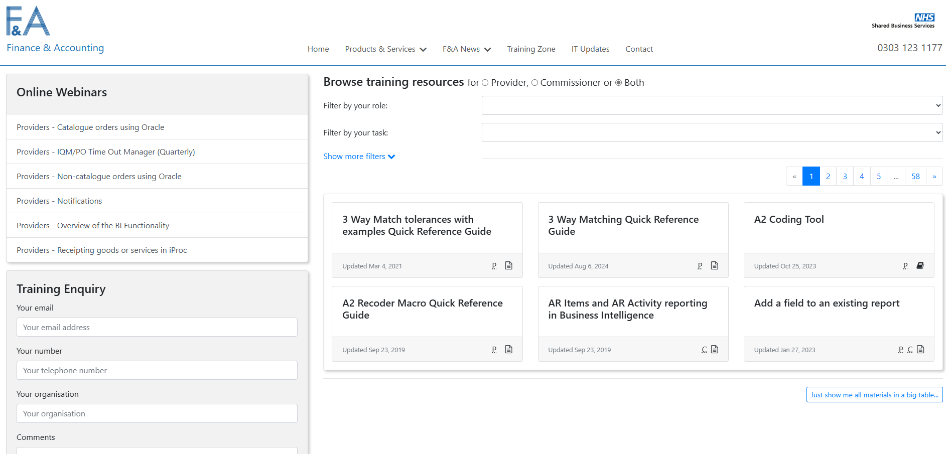

Click on the expand more filters and type into the field Filter by resource name. The below are the corresponding resource names:

Link | Resource Name
R12 Non-Catalog Request QRG | “R12 Non-Catalog Request QRG”
Training Zone :: NHS Shared Business Services | “How to view purchase orders, invoices and receipts on Oracle iProc”

