STANDARD OPERATING PROCEDURE (SOP)

Department: | Individual Wards
SOP Ref No:
SOP Title: | Call-Off Purchase Order Receipting

 | NAME | TITLE | SIGNATURE | DATE
Author/  Reviewer: | Raymond Chan | NHS Shared Business Services |  | April 2025
Approved by:
Issued to:

Effective Date:
Review Date:

Change/amendment History:
Record of changes: (latest version number to be listed first)

Version No | Effective Date | Brief Summary of Changes | Author
V1 | April 2025 | Original document | Raymond Chan

Introduction

This Standard Operating Procedure (SOP) is for receipting goods or services in Oracle against a call-off purchase order (PO) and the correcting of receipts.

The Purpose of this SOP is to support:

Consistency: Ensures that no steps are missed, this is important for audit trails and dispute resolutions.
Compliance: Receipts are required for checking that the invoices received relate to the Purchase Order that has been quoted on the invoice. This process is called a ‘match-to-receipt’ and differs to the normal goods receipting process where the quantities of goods or services are known when ordering. The process checks the two documents (Good Receipts and Invoice) match. If they do not match, or the goods receipt is missing, the invoice will not be paid. This can lead to suppliers putting the account on stop/ hold until payment has been received.
Efficiency: Streamlines the process, making it quicker and easier for staff to receipt goods.
Training: Provides a clear guide for new staff members, ensuring they understand the correct procedures.
Accountability: Establishes clear roles and responsibilities, making it easier to track who did what and when.

Roles and Responsibilities

Call-Off Requisitioner: These individuals have raised a call-off purchase order and place orders directly with suppliers. When a supplier invoice relates to a call-off PO they will be responsible for receipting the invoice in Oracle.
Nominated Receiptor: An individual in the same team as the call-off requisitioner requestor, who raises a receipt when the original requisitioner is not available.

Standard Operating Procedures

This Standard Operating Procedure document includes the following separate processes:

SOP Reference | Description | Page
- Receipting a Call-Off Order | The process to follow when a notification is received from the NHS SBS notifications team that there is an unmatched invoice relating to a call-off purchase order. | 4
- Receipt Corrections | The process to follow should receipt information need to be corrected. | 7

Standard operating procedure: Receipting a Call-Off Order

Where a call-off purchase order has been raised, requisitioners can order directly with suppliers, who will need to include the call-off purchase order number in the invoice sent to the Trust.

Once an invoice is received then it must be receipted on the system for the invoice to be paid, otherwise the invoice will remain unpaid.

Step | Description | Role
1 | Each week NHS SBS’ notifications team will email call-off requisitioners where an invoice is sitting against a call-off purchase order. These invoices cannot be paid because there is no goods receipt referencing the invoice number and therefore no match between a goods receipt and the invoice.  The call-off requisitioner will need to review the emails received and validate whether the invoice relates to the purchase order quoted and that the value of the invoice is correct.  If the invoice does relate to the call-off purchase order, then a goods receipt will need to be created to match the invoice to the call-off purchase order (PO). This will allow the invoice to be paid. Proceed to step 2a for further details.  If the invoice does not relate to the purchase order, then the call-off requisitioner will need to inform NHS SBS’ notifications team by replying to the email. As no goods receipt is created the invoice will remain unpaid. | Call-Off Requisitioner
2a. | If you are the original call-off requisitioner, create a receipt in the Oracle system.  For step-by-step guide, please see the Reference Materials section below.  To ensure that the goods receipt is matched to the call-off purchase order and passes through to payment, the invoice number must be included in the ‘Packing Slip’ field of the goods receipt.  The invoice number must follow the following formatting conventions when input in to the ‘Packing Slip’ field in the goods receipt to reduce any delays in the matching process:  - Include All Zeros – if the invoice number has leading zeros these must also be included (e.g. 0000INV123)  - Do NOT Include Symbols and Dashes – (e.g. 0000-INV123% = 0000INV123)  Note that when receipting a call off purchase order, no quantity needs to be entered as the call-off purchase order is raised for a value only. | Call-Off Requisitioner
3. | When the call-off requisitioner is planning to be away they should enable out of office notifications which will send notifications to a nominated receiptor.  When NHS SBS’ notification team send notifications to the call-off requisitioner these will be forwarded to the nominated receiptor who can raise goods receipts as per steps 1 to 2. | Call-Off Requisitioner  Nominated Receiptor

Receipt Corrections

Occasionally, it may be required to correct the receipting of an order in the Oracle system. This may be due to incorrect information being input by either end receiver or Goods In staff upon initial receipt.

Please note it is important that any errors in this receipting information are corrected as quickly as possible to ensure that there are no delays to the payment of the invoice. As mentioned above in the “Purpose of this SOP” section, if the invoice and good receipt do not match, the payment will not be made.

Step | Description | Role
1 | Original receipting individual receives notification from SBS that a receipt correction is required. | Call-Off Requisitioner
2 | Log on to the Oracle system and locate the receipt through the query function on the receiving tab in Oracle. For screen shots, please see the below link to the quick reference guide.  For step-by-step guide, please see the Reference Materials section below. | Call-Off Requisitioner
3 | Amend the receipt.  Go into the relevant fields that need correcting and input the correct information. Save the newly input receipt information. | Call-Off Requisitioner
4 | Confirm the receipt has been corrected by locating the receipt through the query function on the receiving tab in Oracle.  For step-by-step guide, please see the Reference Materials section below.  For automatic invoices the system will automatically be updated. | Call-Off Requisitioner

Reference Material

Quick Reference Guides from the NHS SBS Training Zone:

How to find the Quick Reference Guides from the NHS SBS Training Zone
Training Zone :: NHS Shared Business Services

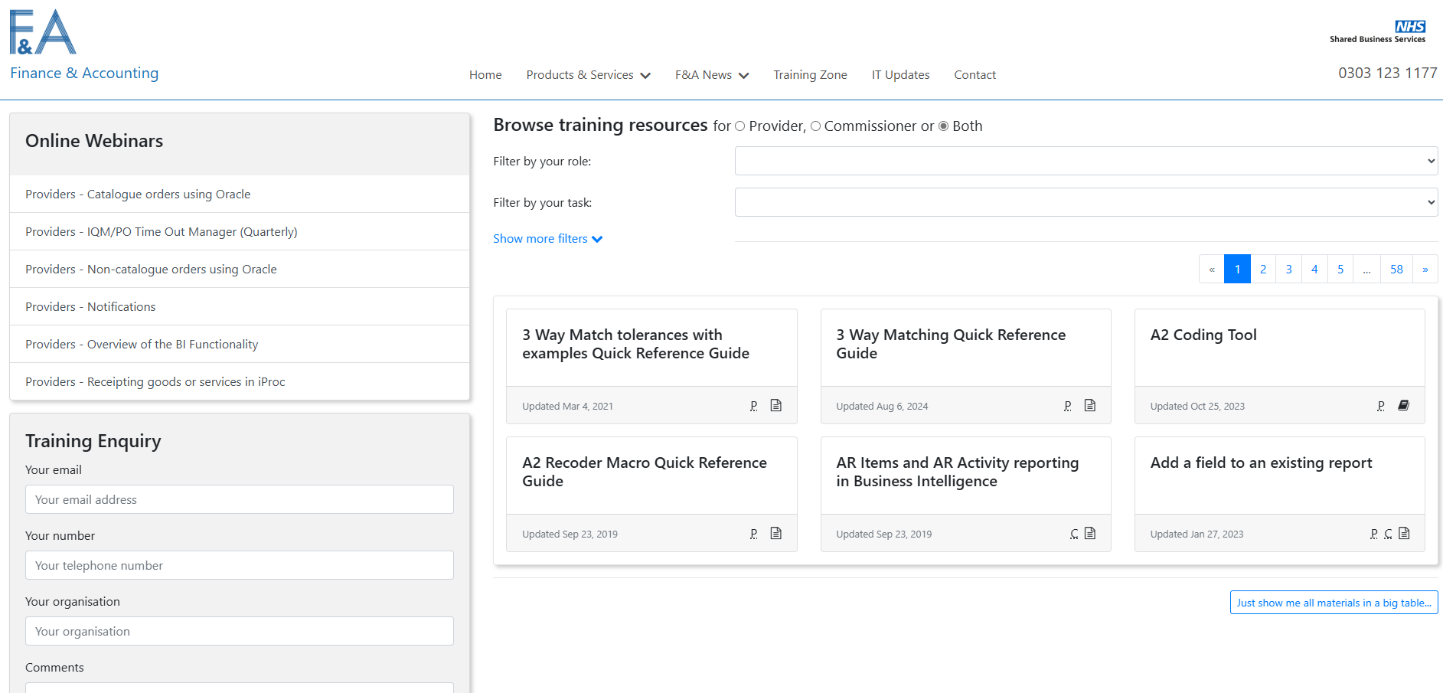

Click on the expand more filters and type into the field Filter by resource name. The below are the corresponding resource names:

Link | Resource Name
Goods In: Self-Serve raising a receipt in Oracle. | “EP2P ICS Enter a Receipt – End User V2”
Receipting on behalf of others | “EP2P ICS Enter a Receipt on Behalf of Others V2”
Correcting a receipt in Oracle. | EP2P ICS Correcting a Receipt V2
NHS-SBS-How-to-search-for-Requisitions-and-Purchase-Orders-and-Receipts-in-EP2P-QRG.pdf | “EP2P ICS How to search for Requisitions and Purchase Orders and Receipts V2”

