Recording Intended Activities in RiO – April 2025

Purpose
This guide outlines the new process for recording meaningful activities in RiO, designed to support Community Mental Health Teams and contribute to the Trust’s waiting time initiative. Early Intervention Services can also use these intended activities to help capture some of the evidence needed for the National Clinical Audit of Psychosis (NCAP).

Traditionally, services have mainly recorded basic information about appointments, like the type (face-to-face, phone or video), the time and duration, who was involved, and whether the patient was seen. While this information is useful for understanding aspects of patient safety and wellbeing, it does not tell us what actually took place during the appointment or the impact of the care and that is something we now need to capture more clearly.

Recording what happens during appointments gives a fuller picture of the care provided. It helps improve the quality of support for service users, increases visibility across teams, and ensures we meet national reporting requirements. Over time, this information can also support better planning of resources and services based on actual needs and activity.

How the Activity List Was Developed
Based on national guidelines, the East London Performance Team worked closely with local services to develop a manageable list of meaningful activities. These activities are intended for use by teams participating in the new waiting time initiative. While we recognise that some services may prefer more granular detail, this list offers a practical and helpful starting point to support the cultural change needed. It can always be refined as the process evolves.

There are currently 52 different intended activities available in RiO. To make selection easier and more structured for clinicians, each activity has been grouped using a prefix. These prefixes help users quickly identify relevant activities without having to scroll through the full list.

The following prefixes group activities by service type or function
- AX – Assessment; Clinical, functional, or psychosocial assessments (initial or review).
- ED – Eating Disorder Team; Specialist interventions delivered by the Eating Disorder service.
- EIS – Early Intervention Service; Interventions specific to EIP teams.
- GEN – General Interventions; Non-specialist or routine clinical interventions.
- PHARM – Pharmacy Team Interventions; including medication reviews and monitoring.
- PSY – Psychological Therapies Services; such as CBT, formulation, or trauma-informed therapy.
- SoC – Social Care and Support; related to housing, benefits, safeguarding, or social inclusion.

Full Intended Activity List
Below is the full list of intended activities currently available in RiO across East London services, grouped by prefix. These can be selected from the appointment diary when booking or recording a session with a service user.

Group Category | Activities available on RiO for all East London services
AX – Assessments | AX - Diagnostic Assessment
AX – Assessments | AX - Emergency mental health assessment (procedure)
AX – Assessments | AX - Full needs assessment
AX – Assessments | AX - Initial assessment
AX – Assessments | AX - Medical assessment
AX – Assessments | AX - Medical Review
ED –  Eating Disorders Interventions | ED - Cognitive behavioural therapy for eating disorders (regime/therapy)
ED –  Eating Disorders Interventions | ED - Dietetic Intervention
ED –  Eating Disorders Interventions | ED - FREED Intervention
ED –  Eating Disorders Interventions | ED - Hub Intervention
ED –  Eating Disorders Interventions | ED - PCN ED Intervention
EIS –  Early Intervention | EIS - CBT for Psychosis
EIS –  Early Intervention | EIS - FI for psychosis
GEN –  General Interventions and Procedures | GEN - ABT
GEN –  General Interventions and Procedures | GEN - ADOS Assessment
GEN –  General Interventions and Procedures | GEN - Consultation (Procedure)
GEN –  General Interventions and Procedures | GEN - Feedback meeting
GEN –  General Interventions and Procedures | GEN - Leisure activities input
GEN –  General Interventions and Procedures | GEN - Liaison with other agencies
GEN –  General Interventions and Procedures | GEN - Occupational Therapy Intervention
GEN –  General Interventions and Procedures | GEN - Physical health review/observation
GEN –  General Interventions and Procedures | GEN - Placement review
GEN –  General Interventions and Procedures | GEN - Pre-Conception Advice
GEN –  General Interventions and Procedures | GEN - Signposted to appropriate service (intervention)
GEN –  General Interventions and Procedures | GEN - Signposting (procedure)
PHARM – Pharmacy Interventions | PHARM - Depot
PHARM – Pharmacy Interventions | PHARM - De-prescribing
PHARM – Pharmacy Interventions | PHARM - Medication administration
PHARM – Pharmacy Interventions | PHARM - Medication review
PHARM – Pharmacy Interventions | PHARM - Medicines Information/Advice
PHARM – Pharmacy Interventions | PHARM - Pharmacy assessment
PHARM – Pharmacy Interventions | PHARM - Transfer of care
PSY – Psychological Therapies | PSY - Art Therapy
PSY – Psychological Therapies | PSY - CBT/Integrative group
PSY – Psychological Therapies | PSY - CBT/Integrative Individual
PSY – Psychological Therapies | PSY - Focal psychodynamic therapy (regime/therapy)
PSY – Psychological Therapies | PSY - Guided self-help cognitive behavioural therapy (regime/therapy)
PSY – Psychological Therapies | PSY - Psychodynamic group
PSY – Psychological Therapies | PSY - Psychodynamic Individual
PSY – Psychological Therapies | PSY - Psychological Assessment
PSY – Psychological Therapies | PSY - Psychological review
PSY – Psychological Therapies | PSY - Psychological Treatment
SoC –  Social Care and Support | SoC - Care Act assessment
SoC –  Social Care and Support | SoC - Care Act review
SoC –  Social Care and Support | SoC - Care Act Support
SoC –  Social Care and Support | SoC - Carer Support/Training
SoC –  Social Care and Support | SoC - Child Social Care Referral
SoC –  Social Care and Support | SoC - Employment Support (non IPS)
SoC –  Social Care and Support | SoC - Family Intervention
SoC –  Social Care and Support | SoC - Housing support
SoC –  Social Care and Support | SoC - Individual Placement and Support (regime/therapy)
SoC –  Social Care and Support | SoC - Safeguarding

Accessing Intended Activities in RiO
All meaningful activities are now available through the appointment booking screen in RiO. For detailed steps on how to add or update intended activities when booking or outcoming an appointment, please refer to the following guide. This includes instructions on expanding the activities section, selecting multiple activities, and saving them properly in RiO.

Step 1 – How to Access Intended Activities When Booking an Appointment
Follow the usual steps to access the appointment booking screen, as shown in the screenshot below. Then click on ‘Intended Activities’ to expand the section and view the list of available activities you can select from.
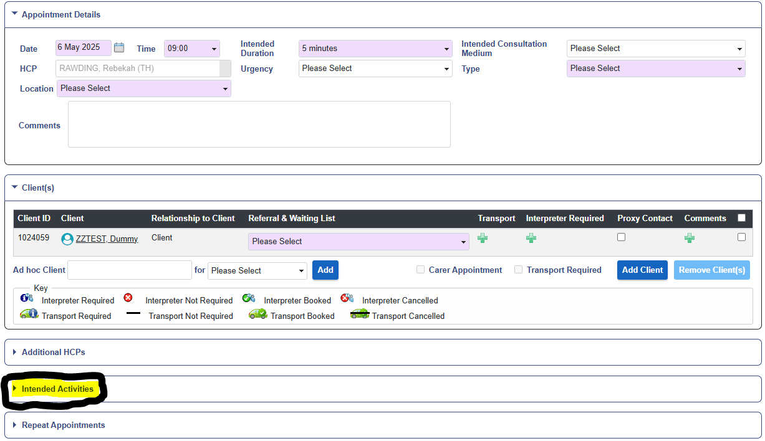
Click to expand Intended Activities section

Step 2 – Select from the list and click on Add Activities
Once the activities section is expanded, you will see a list of all available options. Select the activities you plan to deliver during the appointment, then click the ‘Add Activities’ button to confirm your choices. Use the scroll bar to view and select additional activities further down the list.

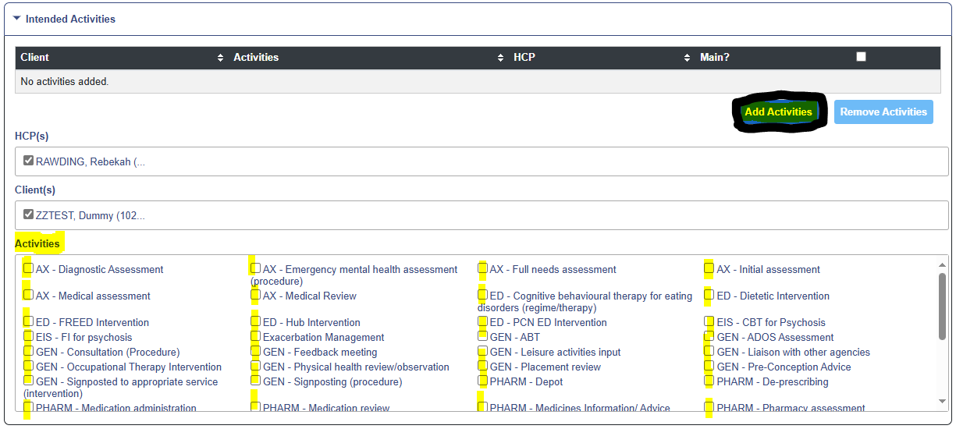
Select all activities you foresee being part of the appointment. Ensure you click Add Activities to save them to the appointment

Step 3 – How to Access Intended Activities When Outcoming an Appointment
Clinicians can select the 'Intended Activities' either when booking the appointment or when recording the outcome. However, it’s important to ensure these activities are finalised by confirming which ones were actually delivered, this should be done by selecting the 'Actual' activities on the outcome screen.

On the outcome screen, click on ‘Activities’ to expand the section. If any activities were selected during appointment booking, they will appear here. Confirm which activities were actually delivered by ticking the ‘Actual’ box for each one, then click ‘Save’. You can also add more activities at this stage by selecting from the activity list and use the scroll bar to view additional options further down. Remember to tick the ‘Actual’ box for each activity that was delivered.

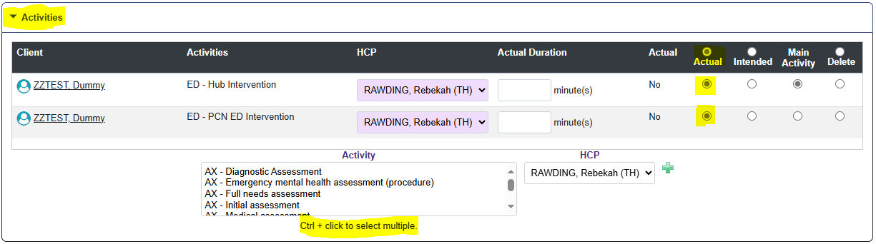

This guide was developed by the East London Quality & Performance Team to support the training and rollout of Intended Activities in RiO. If you have any questions or feedback, please contact your local Performance Manager.

