Title | MSO report May 2025
Authors | Indreet Anand Trust & Rajesh Jethwa - Medicines Safety Officers (MSO’s)
Presented to | Medicines Committee
Date | 14th May 2025

Purpose of the Report:
This report provides a summary of medicines safety data that is collected in the Trust and is presented to the Medicines Committee for information. The committee is asked to consider the level of assurance provided by the report and decide whether further action is needed.

Strategic priorities this paper supports (Please check box including brief statement)
Improving service user satisfaction | ☒ | Improve service user-related outcomes by ensuring that they receive safe pharmaceutical care.
Improving staff satisfaction | ☒
Maintaining financial viability | ☐

Committees/Meetings where this item has been considered:
Date | Committee/Meeting
N/A | This report has not been considered in any other committees or meetings

Equality Analysis | This report has no direct impact on equalities
Contents
Section | Page | Source of information
Medication incident reporting | 2 - 3 | Inphase Dashboard
Moderate/Severe Harm Incidents | 3 | Inphase + MSO
72 Hour medication incident reports | 3-4 | Inphase + MSO
PSIRF Learning – After Action Review | 5 | MSO
Local Medication Safety Update | 6 | MSO
MHRA Safety Round Up | 7 | MHRA
Trust Wide Medicines Audit Programme 2024/2025 | 8-15 | Inphase Dashboard + MSO analysis
Valproate Audit | 16 | Informatics Team

Trust Wide Medication Incident Reporting

Figure 1 & 2 Total number of medication incidents reported per month (12 and 24 months)
Medication incident reporting fluctuates within control limits. For the last year reporting has stabilised since the embedment of INPHASE in November 2023 (Figure 1). Relative to two years ago, the trajectory shows gradual increase in reporting, reflecting greater awareness of reporting medication incidents and work undertaken to increase awareness amongst the trust, including the period leading up to the inphase launch (significant communications to train/increase awareness of reporting).

Past 12 months (April 24 to March 25)
A significant proportion of medication incidents reported are attributed to external errors; approx. 40% (annual is similar to per month reporting). Of these external errors, 89% are reported by our ELFT CHS services in particular Bedfordshire Community Health services (BCHS) and Tower Hamlets Community Health Services (THCHS), which is reflective of their strong reporting culture. External errors are always fed back to the external organisation. CHS Pharmacy Leads review such errors and follow up with external system partner organisations to address any wider themes/recurring errors e.g. LMWH start/stop dates not being stipulated by secondary care hospitals has been a recent issue (being followed up) with the external trust.

Physical Harm – Internal errors (external organisation errors excluded)
Physical Harm | Count | % of total harm
Blank | 74 | n/a
No Harm | 598 | 79
Low Harm | 132 | 18
Moderate  Harm | 18 | 2
Severe  Harm | 4 | <1%  (0.5%)

Figure 4 Internal medication incidents broken down by type of physical harm
(April 24 to March 25 YTD )

Data above provides re-assurance with respect to internally attributed ELFT incidents. The majority of internal medication incidents are deemed no harm (79%) to low harm (18%). A small proportion (2%) deemed moderate to severe harm (0.5%).

Moderate/Severe Harm Incidents (March 2025)
*Incident descriptions and immediate actions taken directly from inphase* ( Dec 24 to Feb 25 covered in last report )
- 3 of the moderate harm incidents were external errors reported by ELFT staff – all external incidents were followed up.
- 1 severe harm incident related to patient overdose and was followed up with a comprehensive 72 hour report given the severity of harms associated with the incident.
72 hour Medication Incident reports Commissioned
A 72-hour report is designed to support staff in providing critical and relevant information related to a patient safety incident to help executive team understand what happened. This is done to support incident-grading panel with deciding on most appropriate form of learning.
Note: Incidents may have initially requested a 72 hour but then later de-escalated after formal review of the incident
*Incident descriptions taken directly from inphase* - 72 hour reports available via inphase. Dec 24 to Feb 25 covered in last report

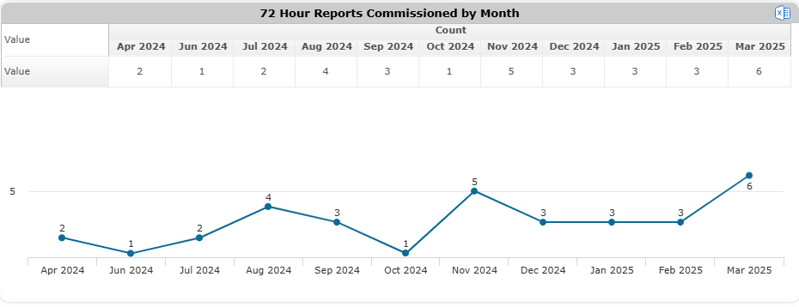
December to Feb 25 covered in previous report. 6 x 72 hour reports requested in the month of March; higher than usually, but fluctuations are to be expected. Will continue to monitor. Although, it is important to monitor the trend, this shouldn’t be a deterrent in escalating an incident as a 72 hour report if deemed appropriate for a more comprehensive follow up.
Example 1
–Depot in the community
Patient X attended for depot at CMHT however informed by patient that he is receiving a different long acting antipsychotic injection by the GP.
Injection @ CMHT = Risperidone DEPOT
Injection @ GP = Paliperidone DEPOT

Learning/Actions
- Baseline audit to be completed to gain better understanding of risks with medicine provision in the community
- Awareness that stable patients may well have ongoing antipsychotic treatment via the GP. This is when the patient is stable usually after 1 year of treatment
- GP responsibility to ensure they confirm with patient that they have been adequately stabalised on antipsychotic
- GP to ensure a written communication has been received by MH team to aid transfer of care
- GP to ensure patient receives appropriate monitoring at agreed intervals

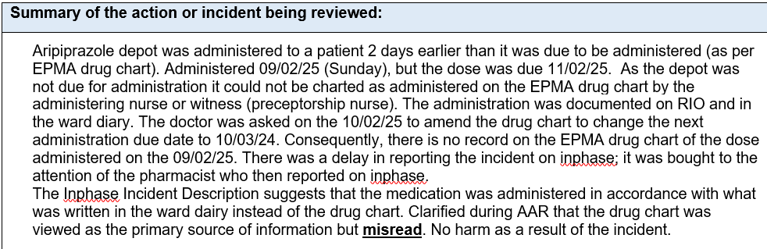
PSIRF Learning Examples - After Action Reviews (AAR)
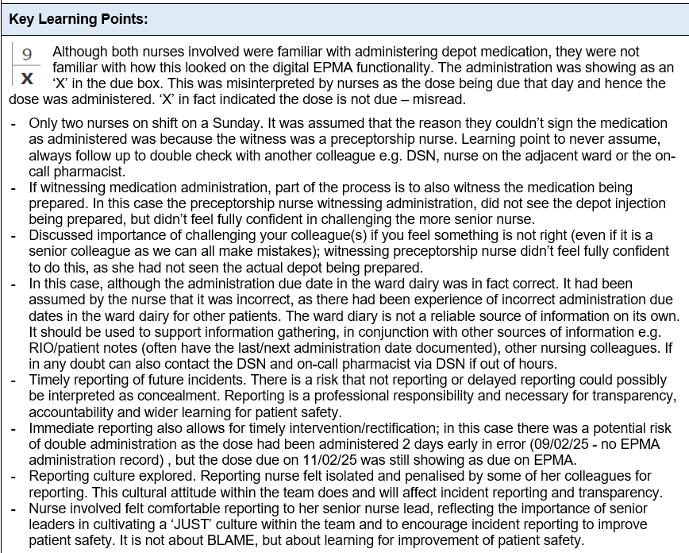
Full AAR attached

LOCAL MEDICINES SAFETY UPDATES
- Trust wide Medicines Safety Group (MSG)
  - CD E-learning package developed –Live on learning academy.
  - Discharge medicine Checklist – Electronic form to be reviewed at digital Board before implementation
  - Digital media within Pharmacy – options/proposals to be discussed with CAMHS service users

- Valproate Policy
- Trust-wide policy now live on the intranet
- Updated policy (version 3.0) to be released soon – major change is inclusion of infographics/flowcharts provided by the MHRA Feb 2025 Drug safety update.
- NEL Teratogenic Medicines Webinar (03/04/25) presented NEL wide Valproate system metrics dashboard to support organisation with compliance to national regulations.

- Doctors Induction/Training
  - Safer Prescribing mandatory e-learning training module
  - Feedback from clinicians undertaking the module has raised concerns regarding length and content suitability for the majority of prescribers
  - Initial meeting to discuss review of this module is scheduled for 28th April 2025.

- Review of Medicines audit programme
  - MSO’s working with services to review medicines audit programme. This includes revision of existing audits and implementation of new audits onto inphase module – current audit work streams; FP10, CHS transcribing, CHS Controlled Drugs in Domiciliary setting.

- Medicines Bulletin
  - Circulated trust wide w/c 14th April 2025.

- Pharmacy Audit Dashboard Demonstration
  - Audit results dashboard demonstrated to pharmacy colleague during monthly CPD session.
  - Directorate leads asked to co-ordinate/delegate review of results within their team for onwards discussion with the directorate.

MHRA Safety Round Up
UPDATE: Monthly MHRA Drug Safety Update Publications have been withdrawn as of March 25
- Drug Safety Updates are now being published throughout the month via the Drug Safety Update page (https://www.gov.uk/drug-safety-update)
- MHRA Safety Roundup bulletins will include all safety communication including Drug Safety Updates
MHRA Safety Roundup: March 2025
Accessible via clicking here
Prolonged-release opioids: Removal of indication for relief of post-operative pain
‘’The indication for the treatment of post-operative pain has been removed from the licences of all prolonged release opioids due to the increased risk of persistent post-operative opioid use (PPOU) and opioid-induced ventilatory impairment (OIVI).’’
It is also not recommended to use transdermal patches for post operative pain. At discharge from GENERAL hospitals: services should only be supplying patients with immediate release opioids to treat acute post operative pain to minimise risk of PPOU, dependence, stock piling of unused opioids and potential for diversion. This has been communicated across the system
Note: Although this alert is directly applicable (with defined actions) to those trusts where surgery is undertaken. As a trust it is important for our services to have an awareness, as patients may come into our service prescribed opioids for post-operative pain and hence it may be appropriate to refer back to the discharging hospital for review of post-operative opioid medication if appropriate (in accordance with the alert).

Trust Wide Medicines Audit Programme 2025 – Actions
Note: Directorate teams have access to inphase audit data results and are expected to; review data/trend analysis for their individual directorates, identify address areas of concern and action plan for improvement. COMPLETE ACTION FROM LAST REPORT CLOSED/REMOVED.
Focus areas | Action | Progress | Update | Status
HDAT prescribing in forensics | To benchmark FORENSIC HDAT prescribing to other NHS forensic services. | IA/MA – Liasing with other NHS trusts that have a forensic service to understand if we are an outlier. (contacted Feb 2025 and chased) | North London  – no response  West London awaiting reponse
HDAT prescribing in forensics | Benchmarking HDAT Prescribing to national POMH-UK audit. | IA - Complete | Complete
HDAT prescribing in forensics | Forensics directorate to internally audit/explore HDAT prescribing and sample existing patients | MA – Lead Forensic Pharmacist assigned | Pending
Rapid Tranqulisation monitoring | To present national benchmarking POMH-UK RT at the restrictive pratices meeting | AO/RJ – Presented POMH uk data at restrictive practices meeting - (27.03.25) | Complete
Rapid Tranqulisation monitoring | Decide on implementation plan of actions via T&F group | PM– following on from restrcitive practices meeting, T&F group to be set up to focus on RT monitoring improvement
Valproate | Identification/Audit compliance of NEWLY prescribed male patients with RAF completion | RJ/IA Patients will be tracked through NEL ICB valproate dashboard (June 25). To understand how this information will be available to us in BLMK | NEL dashboard to be released June 2025

Trust Wide Medicines Audit Programme 2025 –
Controlled Drug Audit (Quaterly) – Jan 2025 (Q4) Note: Directorate teams have access to inphase audit data results and are expected to; review data/trend analysis for their individual directorates, identify address areas of concern and action plan for improvement.
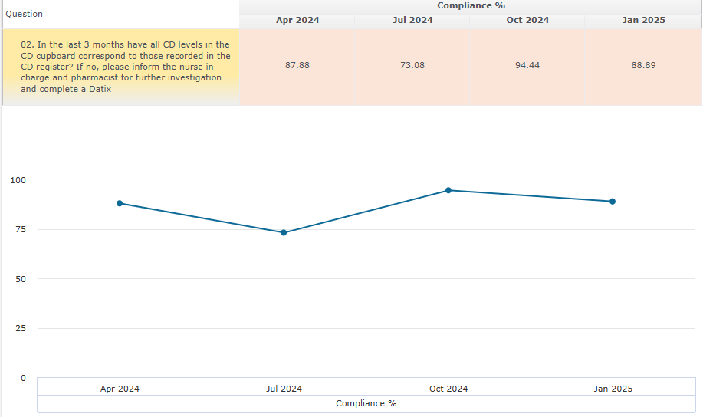 | 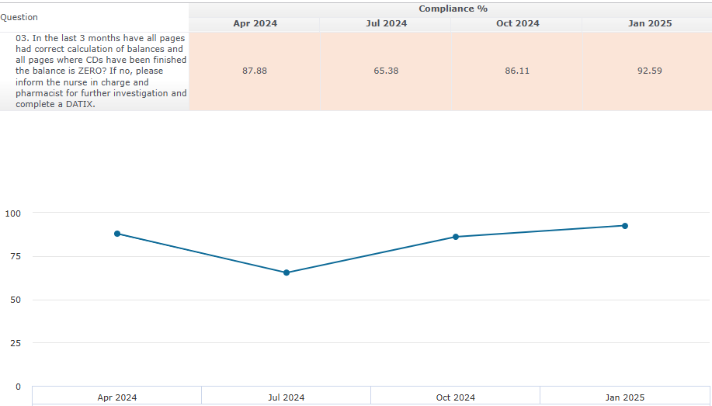 | 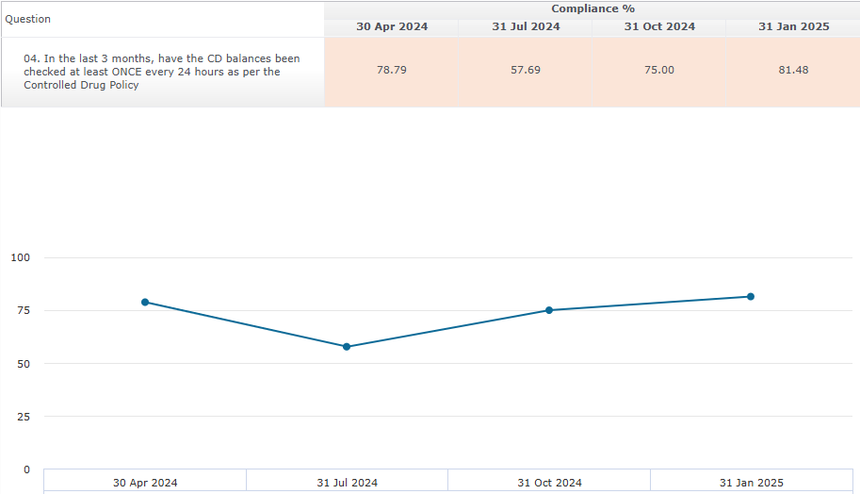
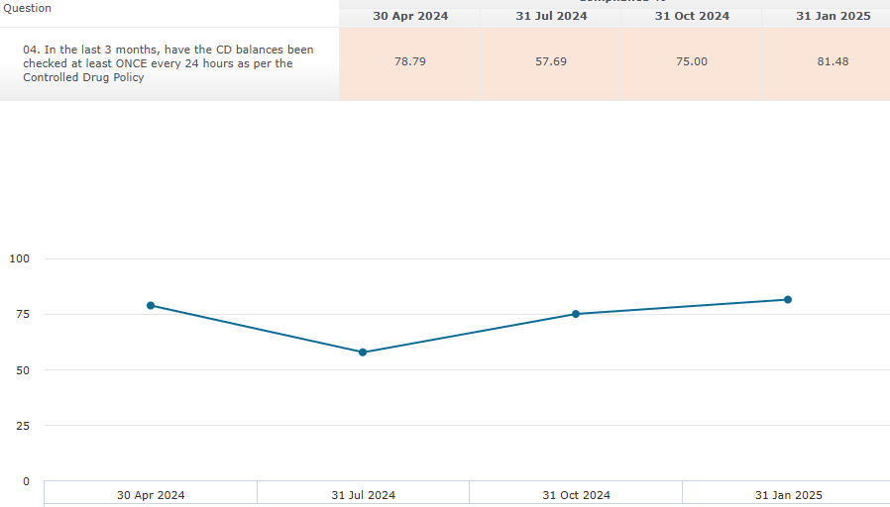 | 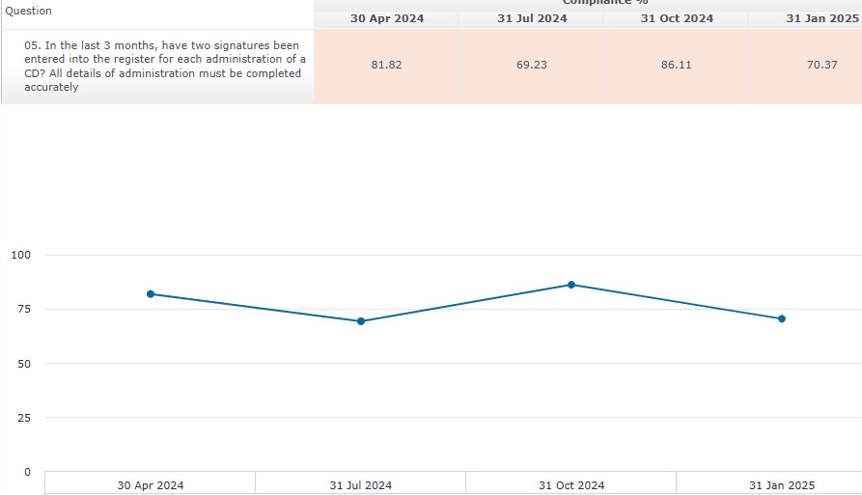 | 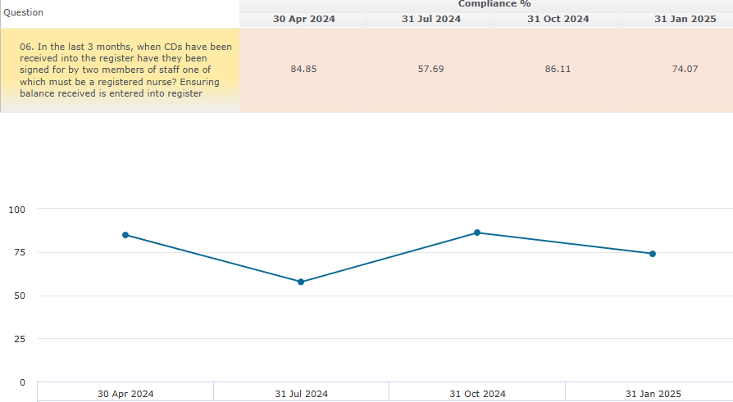
Controlled Drugs Audit (Jan25, Q4) Feeback

- Every Cycle, directorate leads including lead pharmacists are expected to review the break down of wards which are non-compliant with CD audit standards and directly address with the non-compliant wards
- Total of 11 audit standards
- 2 audit standards scored 100%
- 3 audit standards scored 85-90%
- 3 audit standards scored 80-85%

- 3 audit standards scored 70-80%

- 70.3% - In the last 3 months, have two signatures been entered into the register for each administration of a controlled drug? All details of administration must be completed accurately 70.3% (8 wards across the trust)

- 70.4% - In the last 3 months, when controlled drugs have been received into the register have they been signed for by two members of staff one of which must be a registered nurse? Ensuring balance received is entered into register (7 wards across the trust)

- 70.6% - When a controlled drug has been transferred from another ward/team, or to another page in the same controlled drug register, has the number of the new page that the controlled drug has been transferred to, been written on the container? (5 wards across the trust)

Ongoing Work
- CD e-learning package complete and available on ELA. Wards teams should be encouraged to complete the course to support safe use of CDs on the wards
- CD policy under review/for update.

Action:
- To follow up with governance facilitators for each directorate to support with generating actions from audits directly onto inphase.

Clinical Use of Meds Audit - HDAT – High Dose Antoipsychotic Treatment and Monitoring
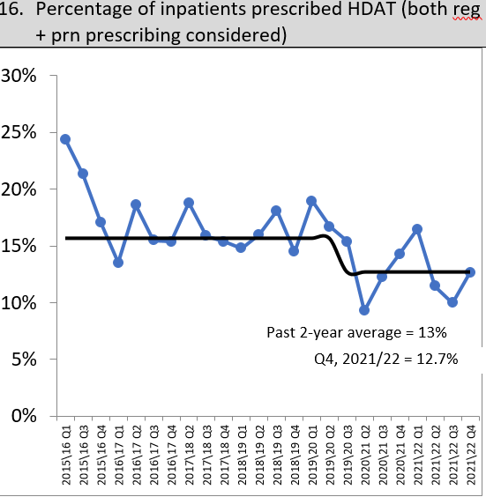
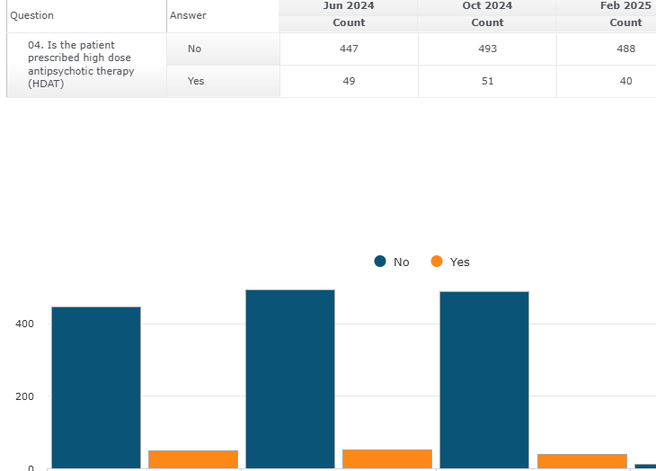
Figure 5: Current Trust wide HDAT prescribing levels 2024 Figure 6 Trust wide HDAT prescribing levels – Historic (pre inphase)

Cycle 1: 10% | Cycle 2: 9% | Cycle 3: 7.6%

Trustwide HDAT prescribing remains at an all time low (historic data also provided for context) .

FORENSIC UPDATE: January 2025 report highlighted significantly higher levels of HDAT prescribing within Forensics: C1: 17%, C2: 20% C3: 17% versus trust average of 9%
ACTION: Medicines Committee had requested further exploration including
1) escalation to the Forensics Quality Committee - complete
2) bench marking against other trust’s forsensics directorates (no reponse) and POMH UK data – complete (see below)
3) Forensic to conduct internal audits re HDAT prescribing – pending – forensics lead pharmacist (MA) to update

POMH-UK HDAT Benhcmarking | Trust HDAT Monitoring | Forensics HDAT Monitoring
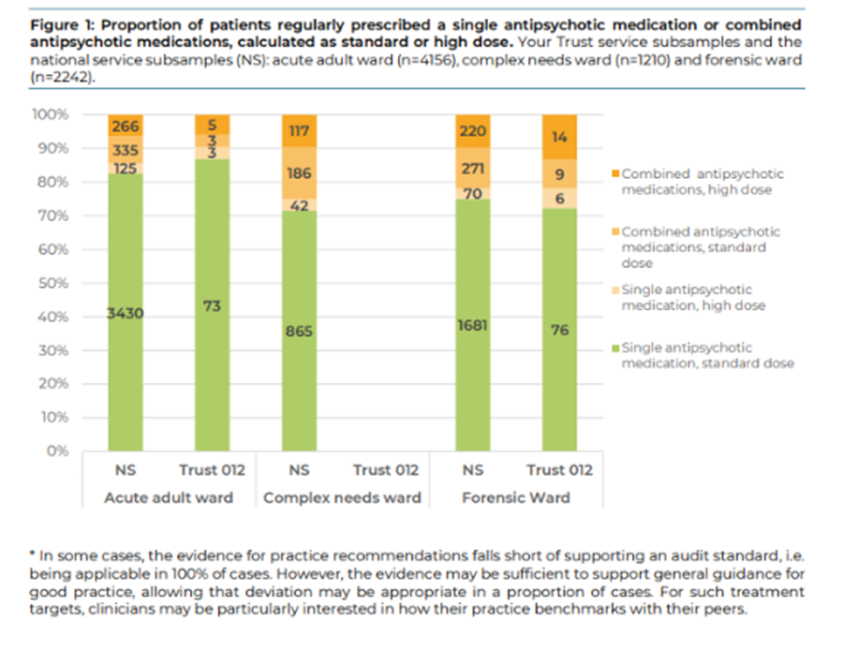 | 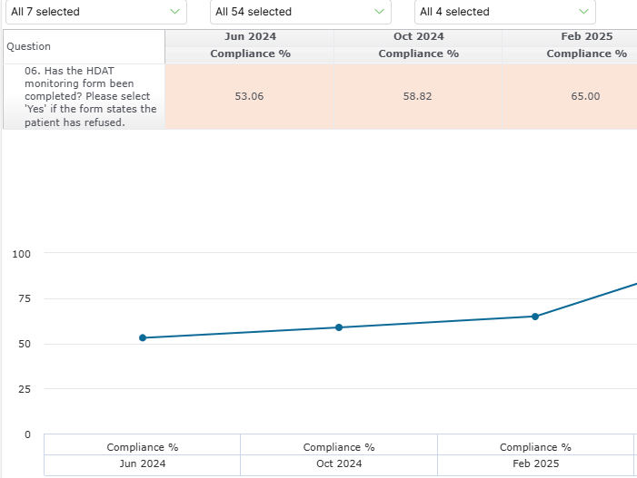 | 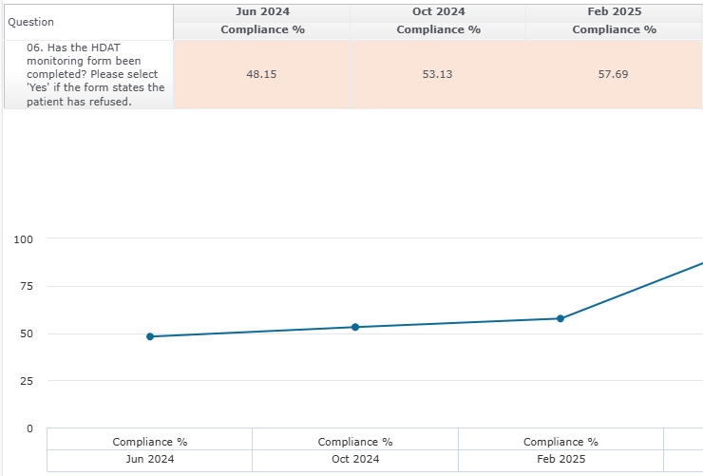
POMH UK Audit 2022 - Prescribing of antipsychotic medication in adult mental health services, including high dose, combined, and PRN QI programme 1h&3e supplementary audit  Acute adult wards  National: HDAT prescribing 9.40% [(125+266)/ 4156]  ELFT: HDAT prescribing 9.5% [(3+5)/84]  Forensics Wards  National: HDAT prescribing 13% [(70+20)/2242]  ELFT: HDAT prescribing 19% [(6+14)/105]  HDAT prescribing with ELFT Forensics benchmarks higher than the national average; POMH UK audit shows ELFT prescribing at 19% which is similar to our current trust audit levels of 17-20% vs national HDAT prescribing levels of 13% | HDAT Monitoring  - Trust HDAT monitoring is remains low 53-65% (C1 –C3).  - However, the priority focus is Forensics; highest levels of HDAT prescribing within the Trust with greatest absolute numbers of patients prescribed HDAT (17-20%, 26-32 patients) and it’s HDAT monitoring sits at approx 50%.  - By comparison other directorates will have 3-8 patients prescribed HDAT per audit cycle.  - With respect to all other directorates , lead pharmacists are asked to review ward breakdown data re monitoring compliance and address directly with the clinical teams on the wards.

Trust Rapid Tranquilisation Usage | Trust – Post RT monitoring compliance | Post Monitoring non-compliant wards
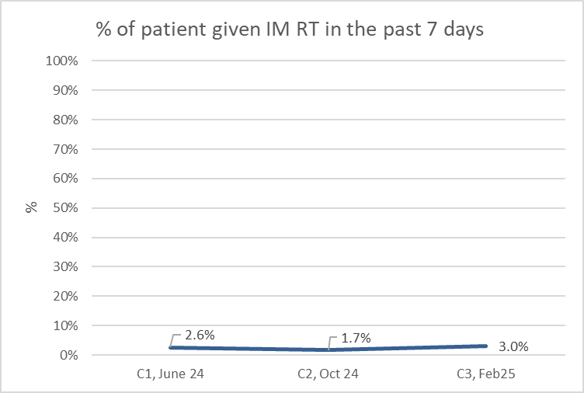 | 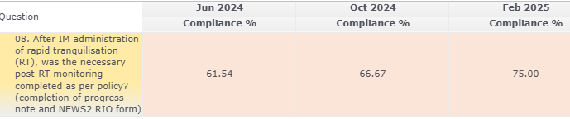  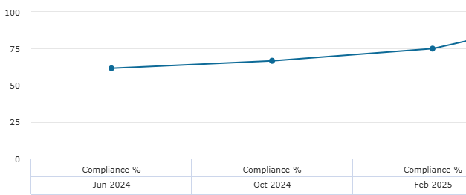
  Post Monitoring non-compliant wards
  C1 (06/24) | C2  (10/24) | C3  (02/25)
  Newham  Ivory  Ruby Triage | Forensic  Bow  Stratford  T.Hamlets  Roman | Forensic  Westferry  T.Hamlets  Millharbour  Rosebank  C&H  Bevan
- Overall, the prescribing of RT within the Trust remains low (1.7-3.0 %). Average cycle trust sample size: approx 500 patients.
- Post RT monitoring remains poor across the trust; deep dive of non-compliant wards doesn’t indicate in particular recurring problem wards.

POMH-UK Audit: Rapid tranquillisation in the context of the pharmacological management of acutely-disturbed behaviour (November 2024)
- POMH UK Audit result are also aligned to our own internal audit results; reflective of poor post monitoring.
- POMH – UK audit results presented to Quality Committee and the Trust Restrictive Practices Forum/meeting
- Restrictived Practices Forum asked to set up a Task and Finish Group re Improvement of RT Post Moniotring;being led by P.McLaughlin.
Clinical Use of Meds Audit - Rapid Tranquilisation

Clinical Use of Meds Audit – Antimicrobials
-2024/25 - Cycle 3 (Feb 25):
- No concerns. 6 audit parameters. All scores >87.50% across all parameters. No concerns re previous cycle scores; all relatively high.
- 4 audit standards scored 100%
- 2 audit standards scored 85-95%
- Is the allergy section of the patient's drug chart completed?
- Is the indication of the selected antimicrobial appropriate and in accordance with guidelines/microbiology advice?
- Is the indication for the antimicrobial stated either in the RIO patient’s notes or on their medication chart?
Trust sample size 528
16% of patients prescribed a benzodiazepine
Positively, 78% have had a review in the last 7 days (similar result to previous cycles)
Dr Bushra is currently scoping patient safety imrovement work related to high dose Benzodiazepine prescribing, so could potentially link in this work – for further exploration.

- Is the dose prescribed as per guidelines?
- Is the course length in accordance with guidelines/microbiology advice?
- Has a stop/review date been recorded on their medication chart?
Clinical Use of Meds Audit – Benzodiazepine

Clinical Use of Meds Audit – Medicines Discharge Checklist
Compliance: C1 30%, C2 41%, C3 34%
Poor completion of mandatory Medicines Discharge Checklist (as per Medicines Policy).
Working Group established via Medicines Safety Group – work in progress to digitalise this as RIO e form.

Clinical Use of Meds Audit – Lithium
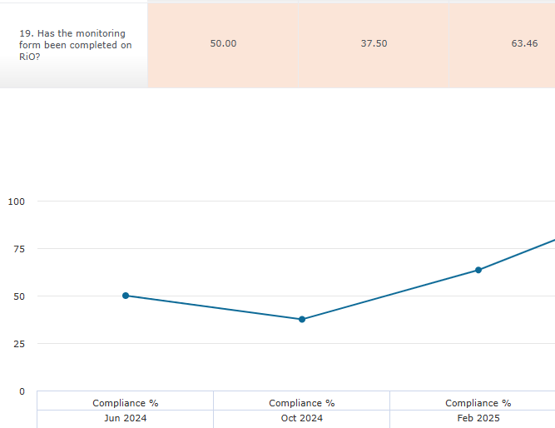 | 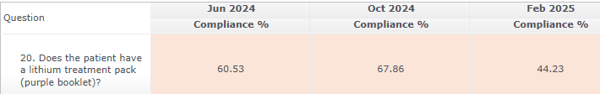  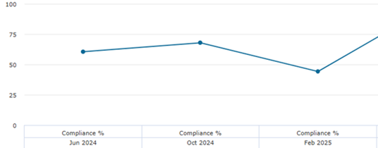
- Compliance with completion of lithium monitoring form has had some improvement this cycle .
- Compliance re patients having a lithium booklet remains low.
- Pharmacy teams have been asked to actively highlight patients prescribed lithium to the clinical teams for monitoring

Valproate Audit

The Valproate audit questions have been removed from the cyclical audits. As agreed by the Valproate Implementation Group, Instead a monthly snapshot report is sent to the MSOs for review re compliance with the national Risk Acknowledgement Form (RAF). Work is in progress to display compliance with respect to completion of the RAF for applicable patients on the live power BI dashboard.
The national RAF form is to be completed by two specialists to independently document that there is no other effective or tolerated treatment for:
- ALL patients (male and female) under 55 years of age NEWLY inititated Valproate.
- For existing female patients of child bearing potential (the new RAF must be completed with a second specialist signature to authorise continuation of treatment, but subsequent annual reviews require only ONE SPECIALIST signature unless the patient’s situation changes.

Inpatient Snapshot report generated 1st April 2025. Criteria selected: a) under 55 b) last administered Valproate in the months of Feb/March 2025

Trust wide report generated 01.04.25 |  | Valid RAF available
Males <55 | 68 | Y=12, No = 56
Females <55 | 5 | Y=4 NO=1  No:  1 no form – 50 year old patient – escalted to pharmacy for follow up

Females <55: Pharmacy teams are expected to follow up non compliant patients with the clinical team as per policy and as per policy shouldn’t be supplying Valproate unless the patient’s RAF has been completed.
Male <55: Unable to comprehensively audit male patients; the data extracted cannot differentiate between NEWLY initiated males and those males who have an existing Valproate prescription (only mandatory to complete the RAF for NEWLY initiated males). Positively, data is showing the form is being completed for male patients, which provides some assurance forms are being completed for males in line with the new regulations. Further re-assurance in relation to males is that pharmacists are well aware of the new regulatory requirements and do gate keep medication, ensuring compliance with regulation as part of their clinical screening and supply function.
ACTIONS: for discussion at Medicines Safety Group; discussion of implemenation of RCODES to support counselling has been provided to male patients
NOTE: Updated policy to be launched April/May 2025 – minor amendments e.g. February MHRA Drug Safety Update Flowchart/Inforgraphics.

