STANDARD OPERATING PROCEDURE (SOP)

Department: | All Departments
SOP Ref No:
SOP Title: | Requisitions (Patient Transport Services)

 | NAME | TITLE | SIGNATURE | DATE
Author/  Reviewer: | Raymond Chan | NHS Shared Business Services |  | April 2025
Approved by:
Issued to:

Effective Date:
Review Date:

Change/amendment History:
Record of changes: (latest version number to be listed first)

Version No | Effective Date | Brief Summary of Changes | Author
V1 | April 2025 | Original document | Raymond Chan

Introduction

This Standard Operating Procedure (SOP) is for Trust users to raise a requisition for ‘Patient Transport Services’, ambulance or secure transport, (via ‘Smart form’) in the NHS Shared Business Services (NHS SBS) Oracle system.

The Purpose of this SOP is to support:

Consistency: Ensures that no steps are missed, this is important to reduce delays in requisitioning ‘Patient Transport Services’.
Compliance: Ensures that only approved suppliers of ‘Patient Transport Services’ are requisitioned by staff; and that appropriate controls such as purchase orders are used in line with trust policy.
Efficiency: Streamlines the process, making it quicker and easier for staff to requisition ‘Patient Transport Services’.
Training: Provides a clear guide for new staff members, ensuring they understand the correct procedures.
Accountability: Establishes clear roles and responsibilities, making it easier to track who did what and when.

Roles and Responsibilities

Requisitioner: Individuals requesting or the administrative staff that manage the requisition ‘Patient Transport Services’. (e.g. ward staff, administrative staff)
Budget Holder: Individuals with permission to approve ‘Patient Transport Service’ requisition requests.
Procurement: The Trusts central procurement team.
Finance: The trusts finance team which is responsible for managing patient transport supplier invoicing centrally.
SBS Procurement Team: The NHS Shared Business Services team that will attach additional information to the patient transport call-off purchase order.

Standard Operating Procedures

This Standard Operating Procedure document includes the following separate processes:

SOP Reference | Description | Page
- Raising a Call-Off Order | The process to follow when a ‘Call-Off Order’ needs to be raised in Oracle for ‘Patient Transport’ suppliers. | 4
- Monitoring Call-Off Orders | The process to follow when periodically monitoring the balance left on a ‘Call-Off Order’. | 6
- Requesting a Call-Off Order ‘Top Up’ | The process to follow when the balance of a ‘Call-Off Order’ is insufficient to receipt the total value invoices expected from a ‘Patient Transport’ suppliers in the remaining months of the financial year. | 7
- Recording Patient Journeys (Smart form) | When a patient journey is ordered with ‘Patient Transport’ suppliers and details are to be recorded against the supplier ‘Call-Off Order’. | 4

Raising a Call-Off Order

Call-off orders are a way of raising purchase orders (POs) where:

- Exact items and quantities of goods or services to order are unknown, and/or;
- Exact total cost of goods or services are unknown, and/or;
- Expecting multiple invoices to be received for a single purchase order, and/or;
- Goods or services are required immediately and there is not time wait for a purchase order to be raised.
As per Trust Policy only ambulance or secure patient travel services from approved suppliers should be used. The approved ‘Patient Transport Service’ suppliers are:

- PATIENT TRANSPORT (UK) LTD
- VKL HEALTHCARE LTD
Each time an invoice is received and receipted against a call-off PO then the value of the PO is reduced by the invoice amount. Requisitioners can continue ordering and receipting goods or services against the call-off PO until the balance of the PO is reduced to nil.

For more details on monitoring the balance of PO’s please refer to the ‘2. Monitoring a Call-Off Order’ section.

Consolidated invoices are received for the above approved patient transport suppliers. These invoices are for all the journeys ordered across all directorates in the trust and are managed centrally by the finance team.

Step | Description | Role
1 | Complete the ‘Call-Off Purchase Order’ excel template and send to the procurement team. Multiple call-off purchase order requests can be added to the template.  Step-by-step instructions are contained within the excel template.  Best practice when requesting call-off purchase orders:  - Ensure that relevant signoffs are included in the template.  - The start and end date for each call-off purchase order should cover a maximum of one financial year (April to March).  - A new call of purchase order should be raised each financial year.  - Annual call-off purchase orders should be requested via the excel template by the last working day of February each year to allow sufficient time for the new purchase order to be created.  - Do not use prior year call-off purchase orders to requisition current year goods or services. (e.g. 23/24 financial year call-off purchase orders should not be used to requisition goods or services in the 24/25 financial year).  - Call-off purchase orders do not have to be fully used. Call-off purchase orders with a balance left at the end of a financial year will automatically be closed as per the end date input when created. | Finance
2 | The Trust procurement team will review the template to ensure that fields are fully completed. Which include:  - ‘Start’ and ‘End’ date – The start and end date range should span a maximum of one financial year.  - Description – The description of the order is complete with best practice to include a description of goods or services to be ordered; and the start and end date of the purchase order.  e.g. Call off Order – Changing Rooms Cleaning – Apr 2024 to Mar 2025.  - Amount – Total value of the PO, before VAT.  If there are missing details or the request does not follow best practice e.g. start and end dates, then the Trust procurement team will contact the ‘Requisitioner’ to provide missing details or revise the form.  If the details are correct and in line with best practice, then the Trust procurement team will send the template to the ‘NHS SBS’ team for review and creation of call-off purchase orders. | Trust Procurement Team
3 | The SBS procurement team will check the call-off purchase order template details for before processing to ensure that the correct information is included and will notify the procurement team if additional information is required.  If the details are correct and complete, then the SBS procurement team will create the call-off purchase order and notify the requisitioner of the purchase order number. | SBS Procurement Team

Monitoring a Call-Off Order

Each time an invoice is received and receipted against a call-off purchase order (PO) then the value of the PO is reduced by the invoice amount. Requisitioners can continue ordering and receipting goods or services against the call-off PO until the balance of the PO is reduced to nil.

The PO value can be increased (‘topped up’) if the balance left is lower than the total value invoices that are expected to be received in the remaining months of the financial year (April to March). Call-off PO’s can take time to be created in Oracle therefore, best practice is to monitor the balance of the call-off PO periodically and request a top up once 80% of the PO value has been used and the total value of additional invoices expected from the supplier in the remaining months of the year are larger than the total PO value. This ensures that there is always a call-off PO that can be used to receipt invoices from suppliers and reduces the risk of non-PO spend.

The frequency of monitoring required will depend on how often invoices are received for a particular supplier however, best practice is to monitor the PO balance each quarter (3-months). If it is expected that there will be a high frequency of invoices received during the year monitoring should be performed on a more frequence basis e.g. each month.

Step | Description | Role
1 | Log on to the system and navigate to the ‘Requisitions’ tab found in the ‘NHS_RWK_IPROC’ responsibility.  This screen will display a list of requisitions and the purchase orders numbers that have been created, in the ‘Order’ field.  Click on the purchase order number that relates to a call-off purchase order you have raised to view more details. | Finance
2 | The purchase order details page will display a summary in the top right corner which will show the total value of the purchase order and the value of invoices that have been receipted against it.  When the total invoiced amount is nearing 80% of the total PO value and additional invoices are expected in the remaining months of the financial year, then a request should be raised to ‘Top-Up’ the call-off purchase order.  Please see the ‘3. Requesting a Call-Off Order Top Up’ section for further details. | Finance

Requesting a Call-Off Order ‘Top Up’

A call-off purchase order will require a ‘top up’ if the balance is lower than the total value of supplier invoices expected for the remaining months of the year.

For a step-by-step guide, please see the Reference Materials section below.

Step | Description | Role
1 | Log on the Oracle system and navigate to ‘Non-Catalogue Request’ under the ‘Shop’ tab found within the ‘NHS_RWK_IPROC’ responsibility. | Finance
2 | Input the relevant information into the form and add to the cart.  This will include:  - Item Type, for call-off purchase orders this will be ‘Goods or services billed by amount’.  - Item Description, a description of goods or services to be ordered; and the start and end date of the purchase order to be topped up.  e.g. Call off Order – Changing Rooms Cleaning – Apr 2024 to Mar 2025.  - Category, the relevant category that the good or service relates to.  - Supplier Details, as per the purchase order to be topped up.  - Amount, the revised total call-off purchase order value | Finance
3 | Review and amend the requisition details summary and submit to proceed.  Requisitioners can then input, or amend defaults for the following details contained in the requisition summary:  - Requisition header description.  - Need by date.  - Deliver to location.  Please note that the system will use these details and the e-class code of the product to determine which charge account the requisition will be charged to. If the code generated presents an error the requisitioner will need to contact the finance team to find the appropriate charge code and enter manually. | Finance

Recording Patient Journeys (Smart Form)

When patient travel is ordered for a patient, details of the patient journey should be recorded in Oracle using a ‘smart form’ and attached to a patient travel supplier ‘Call-Off Purchase Order’.

Patient journey details can be used by budget holders during the approval process to compare journeys ordered with journeys invoiced by suppliers.

Patient journeys can be recorded either when they are ordered individual or multiple journeys on a weekly basis.

Step | Description | Role
1 | Log on the Oracle system and navigate to ‘Stores’ under the ‘Shop’ tab found within the ‘NHS_RWK_IPROC’ responsibility. | Requisitioner
2 | At the top of the page under the ‘Stores’ heading, select the smart form group ‘RWK Transport’ then select the smart form appropriate to the approved supplier used for the patient journey.  For Patient Transport UK Ltd select :  ‘Patient Transport Journey (PATIENT TRANPORT UK LTD)’  For VKL HEALTHCARE LTD select:  ‘Patient Transport Journey (VKL HEALTHCARE LTD)’ | Requisitioner
3 | Input the relevant journey information into the form and add to the cart.  Note, where journeys are transfer between wards in the Trust only the ward where the patient is travelling from should record the journey. This is to avoid any duplication in recording journeys.  For example, if a patient is travelling from Ward A to Ward B, only Ward A should record the journey.  This will include:  - Item Description, this field has been prepopulated so no additional input is required.  - Item Cateogry, this field has been prepopulated so no additional input is required.  - Supplier Details, the supplier name has been prepopulated and no other details are required.  - Quantity, the default is 1, there is does not need to be amended.  - Unit Price, enter the total value of the quote from the supplier. If none is available then enter a 0 in this field.  - PO Number, this is the PO number for the supplier, this number will be provided to you. Please note that for each financial year a new PO will be available to use. PO numbers from pervious financial years are inactive so please use the latest PO number for the current financial year.  - Booking Reference, the booking reference quoted by the supplier when ordering the patient travel journey or the initials of the patient for which travel has been ordered. Do not include full patient names in this field.  - Date of Travel, the date of the patient journey.  - Directorate, the directorate of the ward / location that the patient is travelling from. Select from the drop down list.  - Ward/Team, the team or the ward that the patient is travelling from  - Budget Code / Cost Centre, relating to the ward / location the patient is travelling from.  - Name of Booker, the staff member who has booked the patient travel journey.  - Journey Start Location, details of where the patient journey is starting from.  - Journey End Location, details of where the patient is travelling to.  - Transport Type, the transport type being ordered e.g. ambulance, secure transport. If available.  - Was the Journey Aborted? yes or no flag to indicate whether the journey had to be aborted once the transport had arrived, due to the status of the patient.  - Reason for Travel, a short description of why the patient journey and transport type was ordered.  - Authorised? was appropriate authorisation given for the patient journey to be ordered? Select from the drop down list.  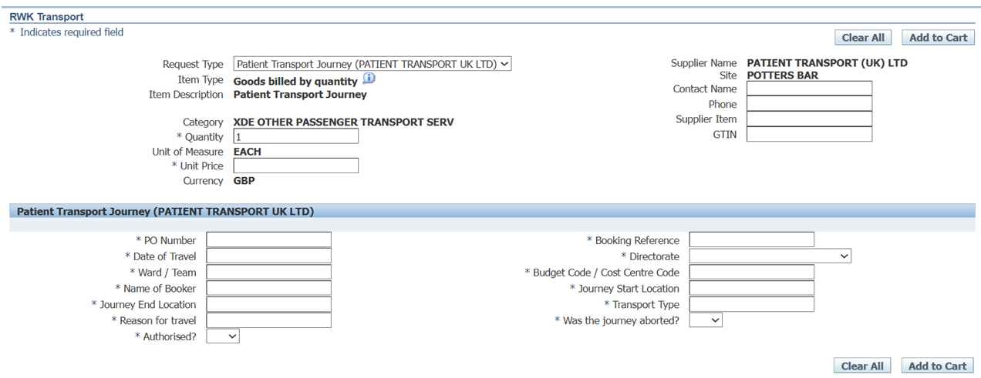  Below is a example of the patient transport smart form to record patient journeys: | Requisitioner
4 | Review details entered into the smart form and select ‘Add to Cart’  At this point additional journeys can be added by repeating steps 1-3 above.  Once all journeys have been added then select ‘View Cart and Checkout’, then ‘Checkout’ to proceed.  then ‘View Cart and Checkout’ and finally ‘Checkout’ to proceed. | Requisitioner
5 | Requisitioners can then input, or amend defaults for the following details contained in the requisition summary:  - Requisition header description.  - Need by date.  - Deliver to location.  Requisitioners do not need to change any of the defaults populated on this page, as the smart form is for information purposes only.  Select ‘Submit’ to proceed. | Requisitioner
5 | The system will generate and display the approval hierarchy for the requisitioner to approve.  In the ‘Notes to Buyer’ field enter the comment: “Attach to PO”  No other notes need to be added on this page.  Select ‘Submit’ to issue the recorded journey through the approval chain. | Requisitioner
6 | The requisition is reviewed by approver(s).  Best practice when approving requisitions:  - Are the goods or services being requisitioned appropriate?  - Is the requestion with an Trust approved supplier?  - Has the correct cost centre / e-class coding been used?  - Does the budget holder have the authority to approve the requisition  If approved, NHS SBS will process the requisition request.  If rejected or further information is requested by the approver, a notification will be sent to the requisitioner with the reason for the rejection. | Budget Holder
7 | The details entered will now be attached to the supplier PO by the SBS procurement team and the details will be available to view on the ‘Purchase Order Details’ page.  Please see the ‘2. Monitoring a Call-Off Orders’ section for further details. | SBS Procurement Team

Reference Material

Quick Reference Guides from the NHS SBS Training Zone:

How to find the Quick Reference Guides from the NHS SBS Training Zone.

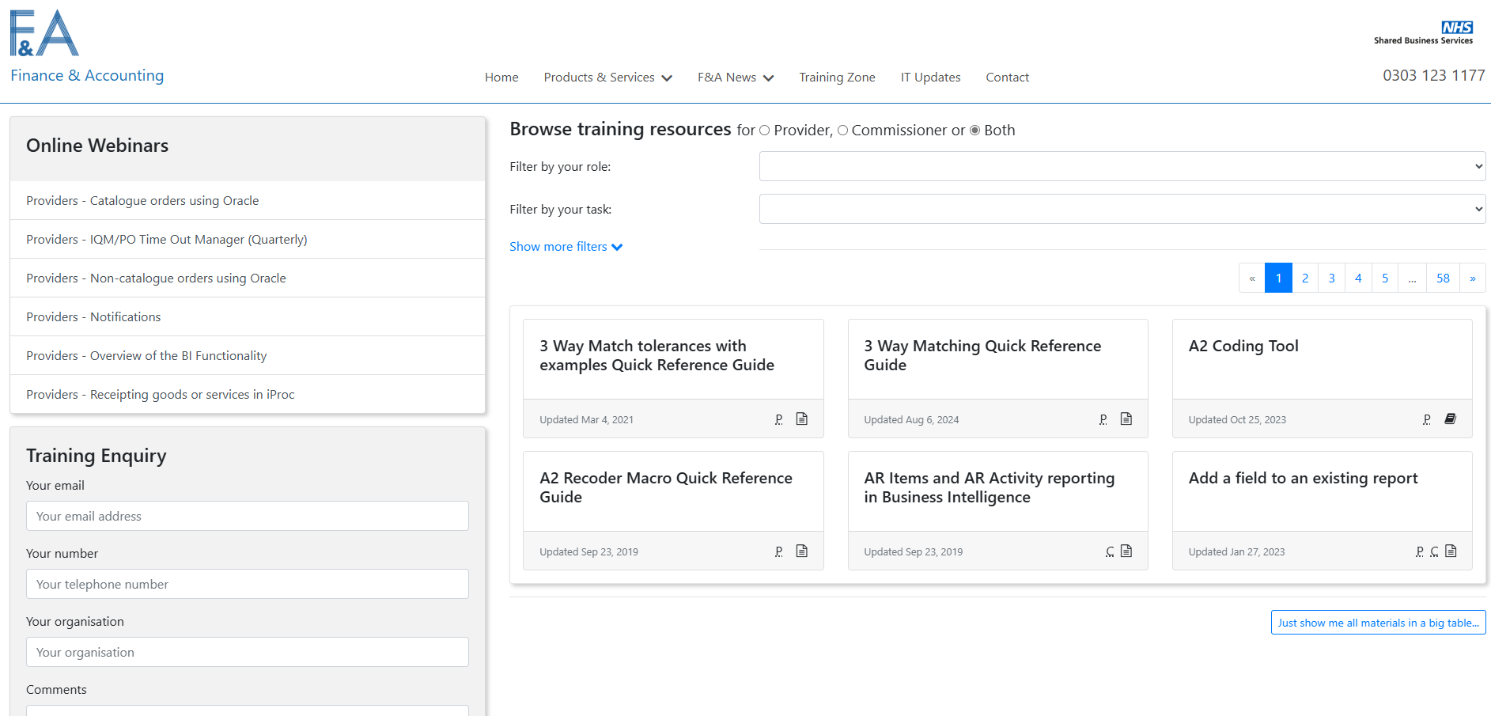

Click on the expand more filters and type into the field Filter by resource name. The below are the corresponding resource names:

Link | Resource Name
NHS-SBS-How-to-search-for-Requisitions-and-Purchase-Orders-and-Receipts-in-EP2P-QRG.pdf | “EP2P ICS How to search for Requisitions and Purchase Orders and Receipts V2”

Alternatively, filtering by task to “EP2P” will select all relevant videos and additional information needed.

