Hybrid Mail Frequently Asked Questions
& Hybrid Mail How To’s
Frequently Asked Questions
- Following the Hybrid Mail Upgrade on 2 July (application version from 4.5.7.8 to 5.0.6.8), how would my machine (laptop/PC) receive the upgrade?
The upgrade will take place gradually as users come online to receive the upgrade. To enable this, users are advised to keep their machine (laptop/PC) switched on, connected to the broadband/Wi-Fi (and the VPN network / Any Connect if working remotely). We advise to keep machines in the working mode (not sleep).
- How can I check if my machine (laptop/PC) have the latest version of Hybrid Mail installed?
Users can look up under Settings > Apps > Installed Apps. The latest Print Client and Printer Driver will be listed as HybridMail Print Client and HybridMail Printer Driver. See below screenshot.
Users will see the new printer listed under Printers when sending a Word document to Print.
- Can I continue using Hybrid Mail if upgrade has not come through?
Yes, the old version will be diverted to the new version.
- Do I need to come to the base (The Green) to receive the upgrade?

No, upgrade will be delivered remotely. To enable this, users are advised to keep their machine (laptop/PC) switched on, connected to the broadband/Wi-Fi (and the VPN network / Any Connect if working remotely). We advise to keep machines in the working mode (not sleep).

- What is the difference between the old and the new version of Hybrid Mail?
There are no changes to the Hybrid Mail apart from a new enhanced feature called “Quick Post”.
The “Quick Post” is a new feature which improves user experience by enabling users to upload letters in Word/PDF faster, giving a user an ability to split letters when uploading a batch, check and correct positioning of postal addresses, add attachments.
Letters can easily be dragged and dropped into a virtual Royal Mail post box.
It is displayed on the right side of the portal, see below screenshots
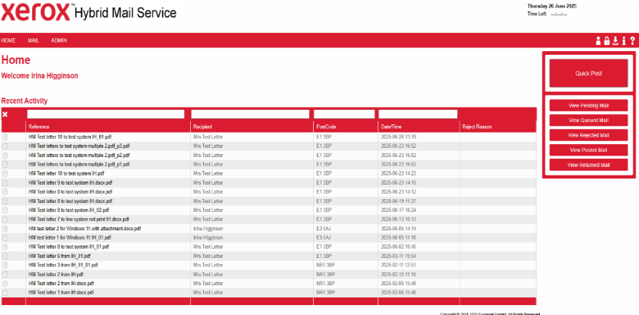 |  | 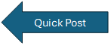
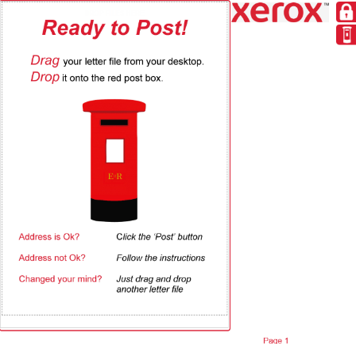
A full Quick Post User guide is available [insert hyperlink to the intranet page]
How Quick Post works (YouTube video from Hybrid Mail) https://www.youtube.com/watch?v=V31zgijPNTs&t=3s
- When is the cut off time for sending post?
6pm for second class post
- What if I send a letter and need to stop it being sent?
You can log into the web portal and select the letter and push delete.
The new url for the portal is https://svr-hybridmail/
- How much does it cost to send a letter by email?
£0.1p for email and SMS with a pin code
- How much does it cost to send a letter by 2nd class post?
The price for the 2nd Class Mail depends on the type of envelope, the size of the paper and type of printing. The standard delivery is the C5 Second Mono at £0.760.
- Can I send carbon copies and how much does it cost?
Carbon copies are sent as regular letters (C5 Second Mono) and yes, it will be the same cost as a letter being posted via 2nd class (see question 9). If electronic delivery has been enabled, it will cost cheaper (£0.1p for email and SMS with a pin code).
When sending carbon copies, address must follow the CC: as a string of text OR line by line. See below examples:

CC: Name (and Job title if applicable), Organisation (if applicable), Street, City, Post code.

OR

CC:
Name (and Job Title if applicable)
Organisation (if applicable)
Street
City
Post code

- What is the maximum size of attachment can be included?
20GB, 130 pages
- Who to contact with a technical issue about Hybrid Mail?
Contact Hybrid Mail Help Desk gbr.sdc-helpdesk@xerox.com and request a ticket to be raised. It is important to provide clear description when raising a technical query.
- Subject line of the email – please add (ELFT, name of your service, locality and issue).
- Have Hybrid Mail letter ID numbers ready to provide with the query to be investigated. This is a seven-digit number generated for each letter. To locate the Hybrid Mail ID number, simply put a cursor over the title of the letter which will bring up a Hybrid Mail letter ID number, as per below example.
Letters listed under Recent Activity | Hybrid Mail ID displayed in square brackets [4303492]
- Where can I access available resources?
A full user guide for Quick Post is available on the intranet [insert hyperlink]
How Quick Post works YouTube video from Hybrid Mail
https://www.youtube.com/watch?v=V31zgijPNTs&t=3s

How to use Hybrid Mail
- The Hybrid Mail Print Driver has been upgraded and is now listed as HybridMail printer on machines (laptop/PC). Once a letter is created in Word, RiO, EMIS, IAPTUS or SystmOne, the user clicks on File, Print and selects HybridMail printer
- To use Hybrid Mail, a user must be on the network (VPN Any Connect) if working remotely.
- Hybrid Mail will open and log a user in automatically as account gets authenticated.
- Hybrid Mail How to videos can be accessed on YouTube https://www.youtube.com/channel/UC9qnEdDW7d4xepVKIiQNO8w
Hybrid Mail Web Portal
The web portal is where users can see what letters they have posted when and what their status is. Users can quality check their letters to ensure they are happy with what has been sent. If users have sent something and need to stop it being sent they can log in and delete it from the queue if it has not been sent. Managers can view what their staff have sent.
Click on the link to access the web portal https://svr-hybridmail/

