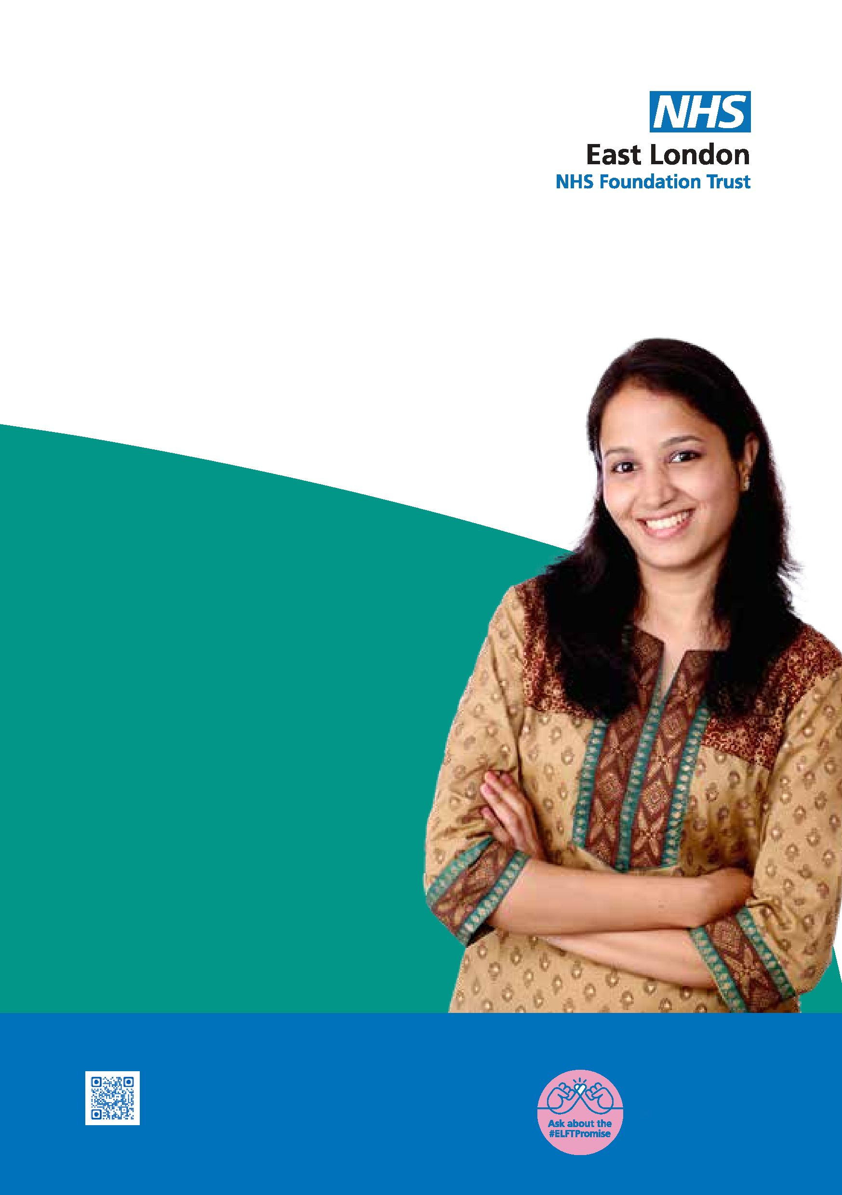
Newham
Autism
Diagnostic
Service
A diagnostic service for adults (over the age of 18) who are residing in Newham
Take the first step contact us today!
We care
We respect
We are inclusive

What is Autism
Autism influences how people experience and interact with the world. It is a lifelong neurodivergence and disability. Autistic people are different from each other, but for a diagnosis they must share differences from non-autistic people in how they think, feel and communicate.

The main areas of difficulty include:
Social communication and interaction differences
Restricted and repetitive behaviours or interests, and difficulty coping with change and unpredictability.

Benefits of getting a diagnosis
- Help you understand why you experience certain difficulties and how to cope with them.
- Help you access the appropriate services that suit your needs and certain benefits.
- Help you access reasonable adjustments in your employment or education.

Making a referral
- The service accepts self-referrals, and
- Referrals from GPs and other agencies

Referral criteria
- Adults age 18 and over.
- Residents of Newham
- Consent to the referral.
- No existing diagnosis of Autism Spectrum Conditions.

What to expect after the referral is received
- New referrals will be screened by the clinicians.
- We will ask you to complete some questionnaires.
- We will require information from your parents or someone who knew you as child.
- If accepted, we will add you to the waiting list.
- You will be invited for your initial assessment.

How the service operates
The Autism Diagnostic Service operates on a multi-disciplinary model as part of the health team. Following diagnosis, the service can provide brief post diagnostic support, such as signposting to local support services and sharing resources. The team will develop protocols and care-pathways, working closely with Mental Health services, Local Authorities and voluntary services.



Contact us

Service information
Address:
Newham Adults Autism Diagnostic Service
Lord Lister Health Centre (1st Floor)
121 Woodgrange Rd,
London
E7 0EP
Tel: 07984463314
E-mail: elft.NewhamAutismDiagnosticService@nhs.net
Website: https://www.elft.nhs.uk/adult-autism-diagnostic-services
We promise to work together creatively to: learn "what matters" to everyone, achieve a better quality of life and continuously improve our services.
We care. We respect. We are inclusive.

