

Policy for the Safe Use of Insulin

Version number: | 3.0
Consultation Groups | CHS Clinical Policies Alignment Committee  Nursing Development Steering Group,  Team / Service Leads  Representatives of Nursing teams across the Trust
Approved by (Sponsor Group) | Medicines Committee
Date approved | 14th May 2025
Ratified by: | Medicine Committee
Date ratified: | 14th May 2025
Name of originator/author: | Clinical Lead, Tower Hamlets EPCT  Diabetes Nurse Specialist, Newham  Professional Development Lead Nurse
Executive Director lead: | Chief Nurse
Implementation Date: | May 2025
Last Review Date | May 2025
Next Review date: | May 2028

Services | Applicable
Trust wide | X
Mental Health and LD
Community Health Services
Primary care

Version Control Summary

Version | Date | Author | Status | Comment
1.0 | Jan 2019 | Grace Njoku  Georgina Amparado Molina Chantal Riviere
2.0 | Feb 2021 | Caroline Ogunsola,  Charity Okoli &  Vikramsingh Totaram |  | Minor amendments made to incorporate Mental Health settings usage and reflect a Trust wide policy. The Insulin passport added as appendix 7. Information on Infection Control in view of Covid-19 pandemic added appendix 8. Hyperlinked some policies such as the “Self-Administration of Medicines policy”, to ensure staff read this before delegation of administration to patient. References to the document updated
3.0 | May 2025 | Georgina Amparado Molina Michael Asuma, Caroline Ogunsola |  | An amended policy with  13.8 Use of Freestyle Libre  16.7 Insulin medications  17.5 Use of BD Autoshield  20.4 EPR reconciliation notification for GP and DSN

Members of the Community Services Clinical Polices Alignment Group are:

- Caroline Ogunsola, QN– Professional Development Nurse for Community Services - Convener
- Dupe Fagbenro – Deputy Chief Pharmacist – Bedford & Luton
- Nike Bademosi QN– Lead Nurse– Tower Hamlets Community Health Services
- Emma Robinson QN – Deputy Lead Nurse, Tower Hamlets Community Health Services
- Charity Okoli – Lead Pharmacist Tower Hamlets Community Health Services
- Marlene Soares – Clinical Lead Newham Community Health Services
- Ade Adeosun - Clinical Lead Newham Community Health Services
- Sola Bello - Clinical Lead Newham Community Health Services
- Fatima Hafesji - Lead Pharmacist Tower Hamlets Community Health Services
- Saema Arain- Lead Pharmacist Bedfordshire Community Health Services
- Victoria Stone – Locality Manager - Bedfordshire
- Sarah O’Hare QN – Locality Manager, Bedfordshire
- Rashida Goswami – Clinical Nurse, OPAT
- Leander Webb QN - Clinical Service Manager Beds
- Lucy Kwatia - Clinical Lead Newham Community Health Services
- Laura Pisaneschi - Advanced Clinical Practitioner & Senior Lead Clinician Primary Care
- Lara Lawson - Clinical Lead Newham Community Health Services (RR)
- Georgina Amparado – Molina – Clinical Lead Tower hamlets Community Health Services
- Dawn McMahon–Lead Pharmacist – Newham CHS
- Sharon Eplett QN – Head of Quality & Performance Bedfordshire
- Megan Collins – Bedfordshire Community Health Services
- Carole Taylor – Trust Lead Nurse for Tissue Viability
- Chinny Ejiogu QN – Continence Lead for Tower Hamlets
- Emma Stoneman – Deputy Therapy Lead (Beds) & Trust Podiatry Lead
- Caroline White QN – Deputy Lead Nurse, Beds
- Michael Asumah – Diabetes Nurse Specialist, Newham

Contents
  - Executive Summary 5
  - Definitions/Explanation of Terms 6
- Introduction 7
- Purpose of the Policy 8
- Scope 8
6. Responsibilities 9
- Initiation of Treatment 11
- Training 11
- Continuation of Treatment on In-patient Units / Wards 12
- Safe Prescribing and Transcribing of Insulin 12
- Administration of Insulin 13
- Self-Administration of Insulin 14
- Monitoring Blood Glucose Levels 14
- Safe Storage of Insulin 15
- Insulin Administration Devices 16
- Timing of Insulin Doses 17
- Injecting Insulin 18
- GLP-1 Receptor Agonist Injection Safety 19
  - Administration 19
  - Safety Guidelines 19
  - Common GLP-1RA Medications 19
  - GLP-1RA Storage Guidelines 20
- Safe Disposal of Sharps 20
- Discharge from In Patients Units / Wards 20
- Monitoring Compliance and Effectiveness 22
References 23
Appendix 1- Management of Hypoglycemia 25
Appendix 2. Algorithm for the management of Hypoglycemia in the community setting 28
Appendix 3: Management of Hyperglycemia 29
Appendix 6: Injecting Insulin with a Pen 32
Appendix 8. Advanced Preparation of Insulin for Later Administration in Highly Exceptional Circumstances:
. 37
Appendix 10: types of insulin and action 39

Executive Summary

The policy provides guidance to all clinical staff in the Trust nursing on the safe prescribing, dispensing, administration and monitoring of insulin to adults in the Trust. The policy aligns with the National Institute of Health and Care Excellence (NICE) NG17- Type 1 and 2 Diabetes in adults: Diagnosis and Management; the Royal College of Nursing Guidance on the Advanced Preparation of Insulin and the NHS England 2018 Never Event list: Overdose of Insulin due to abbreviations or incorrect device.

Summary and Key Points

  - The policy should be applied in practice in conjunction with the following ELFT guidelines and polices:

    - ELFT Medicines Policy
    - Policy for the Delegated administration of Insulin in Adults in Community Health Services and Competency framework
    - Policy for the Administration of Medicines by staff in Community Health Services
    - Transcribing Policy
    - Infection Prevention and Control Policy
    - Incident reporting policy
    - ELFT Medicines Reconciliation Policy
  - Insulin must only be given via an insulin syringe or pen device.
  - Insulin should only be prescribed as “Units”, abbreviations such as “U” or “IU” are not acceptable.
  - Health Care Practitioners should ensure the correct insulin pen with a safety retractable needle or an insulin syringe with a retractable needle is used when administering insulin.
  - Health Care Practitioners must check that the monitoring requirements are being followed according to the patient’s care plan.
  - Blood glucose should always be checked before giving insulin.

  - Where assessed as safe, patients should be encouraged to self-administer their insulin. The multidisciplinary and community teams should use their clinical and professional judgment to assess the suitability of self-administration on an individual patient basis and this may include a mental capacity assessment where required.

  - Health Care Practitioners administering insulin should have completed the Safer Use of Insulin (SUI) training on ELFT Education Learning Academy (ELA) and should maintain their knowledge and skills to enable them to administer medication effectively and safely.
  - Only Health Care Practitioners that have successfully completed specific training and been assessed as competent can administer insulin except for registered nurses and doctors.
  - Medicines reconciliation should be conducted on admission or transfer to verify that the correct insulin product and dose is prescribed. Where available the patient-held record i.e. Insulin Passport/Card’ should be checked as part of this process.
  - Whenever insulin is prescribed for In-Patients, a hypo emergency kit should be available.
1.12. Patients using insulin pumps must be under the care of a trained specialist team and may only continue using a pump device if all necessary equipment is available and the patient can manage the pump therapy. If it is not suitable to continue with the pump an alternative method for insulin administration should be agreed upon with the patient.

Definitions/Explanation of Terms

    - Insulin Passport/Card: A patient held information record book detailing the insulin prescribed for the patient's use.
    - Hypoglycaemia: is defined as blood glucose less than 4mmol/L with or without symptoms, however, the absolute blood glucose level at which signs and symptoms begin to occur can vary. Impaired awareness of hypoglycaemia can occur when the ability to recognise usual symptoms is lost, or when the symptoms are blunted or no longer present. An increase in the frequency of hypoglycaemic episodes may reduce the warning symptoms experienced by the patient. Impaired awareness of symptoms below 3 mmol/litre is associated with a significantly increased risk of severe hypoglycaemia.
    - Hyperglycaemia: is defined as high blood glucose levels outside recommended levels. Unless otherwise stated in patient’s care plan, hyperglycaemia is regarded as blood glucose levels above 7mmol/l before a meal and above 8.5mmol/l two hours after a meal.
    - Diabetic Keto Acidosis (DKA): Consistently high blood glucose levels can lead to a condition called diabetic ketoacidosis (DKA). This happens when a severe lack of insulin means the body cannot use glucose for energy, and the body starts to break down other body tissues as an alternative energy source. Ketones are the by-product of this process. Ketones are poisonous chemicals which build up and, if left unchecked, will cause the body

to become acidic – hence the name 'acidosis'. DKA is a life-threatening emergency.
    - Hyperosmolar Hyperglycaemic State (HHS) – severe dehydration caused by the body trying to get rid of excess sugar; this tends to affect people with type 2 diabetes.
    - Never Events: Are serious incidents that has the potential to cause serious patient harm or death defined as ‘wholly preventable, where guidance or safety recommendations that provide strong systemic protective barriers are available at the national level, and should have been implemented by all healthcare providers.
    - GLP-1RA: Glucagon-like peptide-1 receptor agonists e.g. Semaglutide, Tirzepatide, Exenatide, Liraglutide, Dulaglutide (Refer to BNF for comprehensive list of medicines that fall into this category)
    - Continuous glucose monitors (CGM) are used to check your glucose levels. They let you see patterns in your levels and check if your glucose is too high or low. They can help you control your blood glucose levels, as you'll be able to act on patterns before they go too high or low.

Introduction

Potentially fatal outcomes can occur if incorrect types, doses, or devices of insulin are used or doses omitted.

This policy relates to the administration of insulin and has been prepared in response to the NPSA alerts RRR013 ‘Safer Administration of Insulin’ (NPSA 2010), NPSA alert PSA003 ‘The adult patient’s passport to safer use of insulin’ (NPSA 2011) and ‘Risk of severe harm and death due to withdrawing insulin from pen devices’ (NPSA 2016) together with NHS Improvement Never Events (2018), and has considered locally reported incidents and changes to practice. Potentially fatal outcomes can occur if incorrect types, doses, or devices of insulin are used, or doses are omitted. The Medicines and Healthcare products Regulatory Agency (MHRA,2024) encourages patients and healthcare professionals to report any safety concerns or adverse incidents related to insulin pumps and continuous glucose monitoring equipment through the Yellow Card scheme. Timely reporting aids in the identification and mitigation of potential safety issues.
In the UK the number of people with diabetes who are on insulin is growing. There are a growing number of people who, for reasons of poor dexterity, vision, mental capacity or lack of carer support, are unable to administer their own insulin and/or undertake their blood glucose monitoring who come under the care of Community Health Services (CHS) and inpatient services of East London Foundation Trust (ELFT).
Insulin is a naturally secreted hormone which the body needs for correct function and plays a

key role in the regulation of protein, fat, and carbohydrate metabolism. It facilitates glucose circulating in blood to be absorbed by cells. Injecting insulin is an essential part of the daily regimen for many people with diabetes. In the UK, diabetes affects approximately 4.8 million people.

There are over 30 different types of insulin, these fall into four main types which are categorised by their speed of action:
- Rapid acting
- Short acting
- Intermediate acting
- Long acting
In addition, there is mixed insulin which is a mixture of short and long-acting insulins

Purpose of the Policy
    - The aim of this policy is to ensure safe practice in the administration of insulin by Registered Nurses and Nursing Associates, Band 3 Healthcare Support Workers within the in-patient and community setting, and across the Trust. It incorporates recommendations outlined by the NPSA and ELFT Medicines Policy.
    - It provides guidance to all clinical staff on the safe prescribing, dispensing, administration and monitoring of insulin and GLP-1RA in adults in ELFT to ensure that the right patient receives the right insulin/GLP-1RA, at the right dose and at the right time.
    - It defines the responsibilities of Health Care Practitioners involved in the care of patients on insulin.

Scope
The scope of this policy covers:

    - The management of Type1 and Type 2 diabetes in adults in In Patient and Community settings.
    - It applies to all health care practitioners (HCPs) involved in prescribing, dispensing, administration and monitoring of Insulin to adults in ELFT.
    - Administration of Glucagon-like peptide-1(GLP-1) receptor agonists e.g. Semaglutide, Tirzepatide, exenatide, liraglutide, lixisenatide and dulaglutide, are also given by subcutaneous injections that have the same storage and administration requirements as Insulin.

Exclusion Criteria
    - HbA1c/IFCC (Glycated haemoglobin) is a common test which indicates blood glucose levels for the previous two to three months. Blood glucose monitoring using HbA1c/IFCC levels are not discussed in this policy. Practitioners should refer to national (NICE guidelines) and local guidelines on the management of diabetes for information. Individualized HbA1c/IFCC targets are agreed with a patient based on their needs and circumstances. A clinician with experience in managing patients with diabetes should be contacted for advice if a patient’s HbA1c/IFCC level is outside the patient’s agreed target.
    - Continuous glucose monitoring is an alternative to self-monitoring using capillary blood glucose (SMBG) in individuals with diabetes. CGM is a sensor based technology that reduces the need for finger-prick testing and provides additional information about trends in glucose levels ie Dexcom G7, Medtronic Guardian Connect 4, Freestyle Libre® 2 (incorporates optional alarms) and Freestyle Libre® 3 (a full rtCGM system which incorporates alarms and allows for automatic streaming of real time glucose readings by Health Information and Quality Authority (HIQA, 2023).

Responsibilities

Prescribers

    - On admission or transfer confirm the insulin type and dose through medicines reconciliation before prescribing.
    - Check monitoring requirements required, clearly document instructions for monitoring in the patient’s notes and where applicable on the medicines chart /home notes/ care plan.
    - Write/ generate prescriptions legibly and clearly using brand names for insulin as well as for insulin pen devices.
    - Write all doses in “Units”. Abbreviations such “U” or “IU” are not acceptable.
    - The discharge notification form/letter should clearly state any changes made to the insulin prescription during the inpatient stay.

6.2. Registered Nurse and other Trained Health Care Practitioners.

- Check that the insulin name and dose on prescription or Medicines Administration Record chart is legible and ensure dose has been written in Units. Abbreviations such “U” or “IU” are not acceptable and should be referred to the prescriber/transcriber where clarification is required.
- Clarify any queries on the insulin prescription with the prescriber or a senior nurse or pharmacist on duty before administration.

- Ensure administration is in accordance with the prescription and make an accurate record of administration.
- Check monitoring requirements/ instructions and carry out monitoring (i.e. blood glucose monitoring) in accordance with the care plan.
- Ensure that a retractable needle is used with the appropriate prefilled pen or insulin syringe.
- Be aware of the signs of hypo/hyper glycaemia and know what actions to take if patients exhibit these signs and symptoms. Must be aware of when to use quick-acting oral glucose e.g. 4 – 5 dextrol or glucose tablets, pure fruit juice (200mls), GlucoGel®, Dextrogel® and Glucagon injection ® for hypoglycaemia if required and available.

6.3 All Clinical Staff
- All clinical staff qualified to prescribe/dispense/ administer medicines should operate within this policy and professional competency.
- Clinical staff should familiarise themselves with this policy and should be suitably trained and competent to carry out their professional duties.
- Healthcare support workers (HCSWs) or Health care Assistants (HCAs) can only work under the delegated administration of Insulin policy. Please see the intranet for this policy
- All ELFT staff involved in the prescribing, dispensing or administration of insulin should complete the Safe Use of Insulin e-learning programme available on ELA (ELFT Learning Academy).
- It is the responsibility of all staff involved in any aspect of this policy to inform their manager of any variation in practice or inability to follow the processes defined.

6.4 Diabetes Specialist Nurses
- Provide Specialist advice, guidance and support in assessing and reviewing patients
- Support healthcare practitioners in the safe use of insulin including the provision of education and training.
- Review this policy regularly in conjunction with Directorate pharmacists to ensure it is fit for purposes.
- Lead and provide training as and when identified by service leads and sign off competencies in conjunction with practice development nurses.
- Carry out regular audits to establish compliance with this policy.

Initiation of Treatment

    - Insulin should only be initiated by a Diabetes Specialist Nurse/ a GP / Practice nurse (who is an insulin initiator) or at an acute Trust.
    - Following initiation, only prescribe insulin in the context of a written protocol and/ treatment plan including guidance on monitoring.
    - The treatment plan must be documented clearly in the patient’s electronic record and state the type and dose of insulin, device, timing of administration and monitoring requirements.
    - Patients / Carers should be fully informed and receive verbal and up-to-date written information about their therapy.
    - The prescriber will obtain confirmation of the patients’ understanding and consent. If the patient lacks capacity to consent, then a decision should be made in line with the Mental Capacity Act (2010).
    - In the event that the patient’s capacity to consent is in doubt, clinical staff must ensure that a formal mental capacity assessment is completed and recorded and then a best interest decision reached. Patients with an impairment of or a disturbance in the functioning of the mind or brain is thought to lack the mental capacity to give informed consent if they cannot do one of the following:
      - Understand information about the decision
      - Remember that information
      - Use the information to make the decision
      - Communicate the decision

Training
    - All staff that prescribe, dispense and administer insulin must complete the Safe Use of Insulin E-Learning which is available on the ELFT Learning Academy (ELA).
    - Staff must be competent in using insulin pen devices and insulin safety needles as assessed by the senior nurses.
    - In addition, District Nurses and other trained HCPs who administer insulin should contact their Community Diabetes Team for information on local training provided.
Further E-learning is also available as follows:
    - Diabetes in healthcare - a free RCN-accredited introductory course for healthcare professionals who are not specialists in diabetes but want to know more about the condition. www.diabetesinhealthcare.co.uk/
    - The six steps to insulin safety - a free essential module for all those prescribing, managing or administering insulin, with the overall aim of reducing insulin errors in clinical practice available from www.cpd.diabetesonthenet.com/

- The FIT forum for injection techniques www.fit4diabetes.com/united- kingdom/fit recommendations.

Continuation of Treatment on In-patient Units / Wards

    - Non specialist doctors/ non-medical prescribers who prescribe on-going insulin should have ready access to Trust policies including guidance on monitoring and the treatment of hyper/hypo glycaemia.
    - Where patients are admitted and on insulin, the preparation, dose, frequency, monitoring and administration requirements must be clarified by checking at least two reliable and current sources as per the ELFT Medicines Reconciliation Policy. Every effort should be made to check the patient’s treatment plan from the GP or initiating service and review.
    - If the patient is seen “out-of-hours”, and it is not possible to access the GP or summary care records then at least two other sources should be used to verify the insulin prescription e.g. patient’s own drugs (PODs), patient/carer, and community pharmacy. The insulin details should be clarified as soon as possible to avoid missed doses.
    - Where possible, prescribers should prescribe quick-acting oral glucose e.g. GlucoGel®, Dextrogel® as well as Glucagon®, with appropriate advice of when to use it, for all in patients requiring insulin therapy.
    - Where appropriate, nurses should continue to promote self-management after a risk assessment has been carried out in a community setting. On an Inpatient setting, where possible, the policy for the self-administration of medicines should be followed.

Safe Prescribing and Transcribing of Insulin

    - Prescribing and transcribing insulin should be in line with the ELFT policies governing transcribing and prescribing, and only by nurses that have been deemed competent to do so.
    - The insulin type, device, dose and frequency must be clearly written.
    - The term ‘Units’ should be used in all contexts when prescribing insulin. Abbreviations such as ‘U’ or ‘IU’ should never be used.
    - The device required to administer the insulin preparation should be stated on the Medicines Administration Record Chart.
    - If the insulin dose changes then the whole insulin prescription should be crossed off and rewritten.
    - Should the preparation of insulin change or be discontinued by the manufacturer, the

prescriber should seek advice from the specialist service or a pharmacist to confirm a suitable alternative preparation and dose.
    - The prescriber is responsible for clinically reviewing the patient’s insulin requirements and prescription.

Administration of Insulin

    - Insulin is a “high risk” Medicine and should be administered according to the patient’s care plan.
    - Insulin is a Critical Medicine and administration must not be delayed. A supply of insulin must be sourced as soon as possible to avoid missed doses and to ensure the dose is administered at the prescribed time.
    - Use necessary Personal Protective Equipment e.g. gloves for blood glucose
    - checks and administration
    - Check the blood glucose levels, record results and act on them guided by the patient’s target level and care plan.
    - Check with the patient, when the last dose of insulin was administered.
- Ensure the dose, and insulin types are correct for the patient.
- For Inpatient setting, ensure, where possible, that the insulin dose is checked with a second registered nurse immediately before administration.
- Check the correct insulin is available
- Check that the dose is legible and ensure the dose has been written in units. Abbreviations such as “U or IU” are not acceptable and should be referred back to the prescriber as the dose must be clarified and re-written.
- Check expiry date and/or use by date.
    - Record /label start date of insulin vial/pens.
    - Discard Insulin pens according to manufacturer recommendation or expiration. Although many Insulins have a four-week expiry there are many Insulin preparations that have a longer expiry of between four to eight weeks. Staff are encouraged to check the manufacturer’s guidance to ascertain this information.
- In community setting, patients’ own insulin should only be used if it has been stored correctly.
- Prior to use, check characteristics of insulin i.e. if fast acting or long-acting analogues; they should be clear prior to use. For Premixed insulin/ intermediate acting insulin gently shake / rotate 10 - 20 times to obtain a uniform cloudy characteristic. If lumps / clumps are present, then do not use them. This applies to both insulin pens and vials.

    - If in exceptional circumstances where risk assessment has been completed, and it is clinically appropriate to draw up from an Insulin vial; use an insulin syringe with 6mm retractable needle and for an insulin pen device use a 5mm retractable pen needle. This should be clearly documented in patients’ clinical records.
    - Insulin should never be drawn with a syringe from a pen device.
    - Use a sharps bin to dispose of used needles, lancets or sharps on administration.
    - Used needles must not be bent or broken before disposal, never try to recap a needle.
    - Refer to Appendix 5, 6 and 7 for how to Inject Insulin.

Self-Administration of Insulin

    - The Trust’s policy on self-administration of medicines applies in this regard. Training is usually led by the Diabetes Specialist Nurse covering the service.
    - Where assessed as safe, patients should be encouraged to self-administer their insulin. The multidisciplinary teams should use their clinical and professional judgment to assess the suitability of self-administration on an individual patient basis and this may include a mental capacity assessment where required.
      - If the patient is new to the team/has transferred wards, and can self - administer their insulin, the patient should be assessed to ensure the use of correct technique and that they are not injecting into areas of lipohypertrophy (lumpy injection sites) as this can affect insulin absorption.
    - Refer to the Self Administration of Medicine policy and a senior healthcare practitioner for support on self-administration.

Monitoring Blood Glucose Levels

    - All capillary blood glucose monitoring systems must meet the 2013 ISO standards.
    - Blood glucose level check should be carried out by the nurse pre-insulin administration.
    - Frequency of testing should be decided on an Individual patient basis and recorded in the care plan.
    - Staff must check that the monitoring requirements are being followed; this includes completing a blood glucose monitoring chart.
    - Staff must be familiar with the risk factors for hypo/hyperglycaemia and the potential causes. Staff must have an awareness of the symptoms of hypo/hyperglycaemia and how to manage this complication and if further action or review/advice is required by specialist service (see Appendices 2 and 3).
    - Prescribers and Diabetes Specialist Nurses are responsible for clinically reviewing patients

    - and adjusting the dose of insulin according to the patient’s blood glucose level as per locally agreed procedures.
    - For Frail Elderly, the pre-meal glucose target is usually 5-15 mmol/L unless otherwise stated in the patient’s treatment plan.
      - If above 5mmol/L and the patient does not have symptoms of hypoglycaemia proceed to administer insulin.
      - If below 5mmol/L and the patient has a symptom of hypoglycaemia, treat hypoglycaemia before giving insulin.
      - If below 5mmol/L and no symptoms - re-check blood glucose levels (BGL) immediately. If still below 5mmol/L treat for hypoglycaemia.
      - If above patient’s target blood glucose level or above 15mmol/L (if target is not stated or known) for 3 consecutive reading s, contact the Diabetes Specialist Team, duty doctor or GP.
    - If the patient has Type 1 diabetes mellitus and develops ketones, record vital signs and contact the doctor or GP immediately. Ketoacidosis is life-threatening and immediate treatment is required.
    - If the patient is provided with a Continuous Glucose Monitors e.g. Freestyle Libre device by the GP as an alternative to routine blood glucose monitoring in people with type 1 and 2 diabetes who use insulin injections. Capillary blood glucose measurements are required when a patient is ill, when sensor reading does not match patient’s symptoms or to meet the requirements of the Driver and Vehicle Licensing Agency in assessing fitness to drive. (NICE 2023).
    - If the Capillary Blood Glucose Monitoring (CGMS) reading indicates hypoglycemia and the patient does not have any symptoms, confirm blood glucose level with capillary glucose monitoring.

Safe Storage of Insulin

    - Unopened vials /Cartridges /prefilled pens should be stored in a medical grade fridge in inpatient settings at 2 - 8° C, to ensure potency and maintenance of physical characteristics. If insulin products are unopened and kept at these temperatures, efficacy is maintained until the expiry date.
- Insulin in use can be stored at room temperature (below 25° C) according to the manufacturer’s recommendation as this varies with the insulin prescribed. The date and time of opening should be documented. Keep it under room temperature before administration.

- Ensure Insulin is discarded according to manufacturer’s recommendation.
- Do not place insulin in or close to the freezer compartment as it should not be frozen.
- Do not expose vials, cartridges or prefilled pens to sunlight or high temperatures above 30° C.
  - Do not use insulin if it has expired
  - For storage of insulin prepared in advance refer to Appendix 9.

Insulin Administration Devices

    - There are over thirty types of insulin and many different devices for insulin administration including:
      - Insulin Syringes
      - Insulin Pens
      - Prefilled pens which are disposed of when empty
      - Pens where insulin is given via a cartridge, the pen is reusable and not discarded
- If insulin is administered by ELFT staff from a pen, then 5mm retractable pen needles must be used to prevent needle stick injury.
- Where retractable pen needles are not available, the prescriber should be contacted to prescribe them or prescribe the insulin as a vial. An insulin syringe and retractable needle will then be used to administer from the vial.
  - ELFT supplies retractable needles if ELFT staff are administering insulin. Insulin syringe comes with a needle and does not require a retractable needle.
  - Pen needles are a single-use item and must be removed from the pen device after each injection and disposed of in a sharps bin. NB. Only 5mm (or 4mm in patient self- administering) pen needles should be used to prevent the risk of intramuscular injections.
  - On no occasion should ELFT staff use an insulin syringe and needle to extract insulin from pen devices or refill cartridges. Insulin syringes have graduations only suitable for calculating doses of standard 100units/mL. If insulin is extracted from a pen or cartridge of a higher strength, and that is not considered in determining the volume required, it can lead to a significant and potentially fatal overdose. Additionally, this can damage the device’s mechanism and is not covered by the manufacturer’s warranty.
  - If syringes are to be used by nurses to administer insulin from a vial, a retractable safety needle must be used. The preferred needle size for an insulin syringe is 6 mm. Insulin syringes are available in the following sizes:
    - 1ml = 100 unit maximum capacity (2 unit divisions)
    - 0.5 ml = 50 unit maximum capacity (1 unit division)

  - The smallest syringe that's big enough to hold the largest dose should be chosen. The smaller the syringe, the easier it is to read the markings and draw up an accurate insulin dose.
  - Insulin pumps are used for patients with Type 1 diabetes mellitus.
  - Patients admitted to an ELFT bedded unit with an insulin pump must be assessed by the diabetes nurse specialist and or an experienced practitioner as capable of using the pump and are expected to have a supply of all necessary equipment (including a change of infusion set). If a patient does not have the required equipment or is not fully able to use the pump independently, specialist advice must be sought from the patient’s diabetes specialist team.

Timing of Insulin Doses
- Healthcare professionals should discuss with the patient when they need to take their insulin. With insulin, timing is essential to ensure peak effectiveness. Where possible, HCP should coordinate visit /administration of insulin time in line with the insulin treatment regime.
      - Rapid-acting analogues are injected just before, with or soon after food and have a peak action at 0–1 hour. They tend to last 4–5 hours and only last long enough for the meal at which they are taken. They are clear in appearance. No need to shake pre use. Examples: Novo Rapid ® , Humalog ® , Apidra ®
      - Long-acting insulins are often used with rapid or short insulins but can also be used alone. Should be given at the same time each day. Do not need shaking before use. Starts Working within 1 hour and duration of 18 - 24 hours. Examples are Levemir ® , Lantus ®, Abasaglar ®.
      - Ultra-long-acting insulin is often used with short-acting insulin but can also be used alone. Should be given same time every day. They are clear insulins and do not need to be rotated prior to administration e.g. Toujeo®.
      - Short-acting insulins should normally be taken before meals. They are also known as 'regular' or 'neutral' insulin. E.g. Human: Humulin S ®, Insuman Rapid
®; Porcine: Hypurin Porcine Neutra ®; Bovine: Hypurin, Bovine Neutral®, Actrapid ® (Actrapid can last up to 8 hours increasing the risk of hypoglycaemia).
      - Intermediate-acting insulins should be injected at the same time each day. It can be administered before meals (ensure that the patient has meals after insulin injection). Intermediate-acting insulins are often taken alongside short-acting

insulin but can be given alone. They MUST be rotated gently 10 - 20 times before use. Examples: Human: Insulatard ®; Humulin I ®; In sumanBasal ®; Porcine: Hypurin Porcine Isophane ®; Bovine: Hypurin Bovine Isophane ®.
      - Mixed Insulins: Biphasic ® (premixed insulin) should be tailored to the individual, taking into account lifestyle, preferences and personal patterns of glycaemic control.

Injecting Insulin

    - Insulin is given subcutaneously into the tissue of the abdomen, buttocks, upper outer thigh or the upper arms. Insulin is absorbed fastest from the abdomen and slowest from the thighs.
    - If using a 4 or 5-mm insulin pen needle, inject at a 90-degree angle. If the patient is underweight, then use a gentle pinch up of the skin and subcutaneous tissue to ensure a subcutaneous injection.
      - Injection sites should be rotated on a daily basis. This prevents the development of lipohypertrophy which can cause erratic insulin absorption.

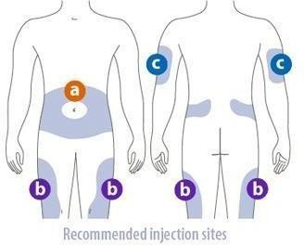
      - Refer to Appendix 7 – Good Injection technique

If nurses are administering insulin using the BD Autoshield Duo Safety Pen needle, inject vertically into the skin (at a 90° angle) without a skin fold to prevent injecting too deep and into the muscle tissue. Injection with a skin fold at a 90° angle.

GLP-1 Receptor Agonist Injection Safety

Administration

GLP-1RA injections must be administered via the subcutaneous route, following prescribed frequency—either daily or weekly—depending on the specific medication.

Safety Guidelines

To ensure the safe use and administration of GLP-1RA injections, the following guidelines must be adhered to:

    - Storage Requirements: Unopened GLP-1RA Injection must be refrigerated at a temperature between 2°C and 8°C (36°F to 46°F). Once opened, follow specific product instructions for room-temperature storage.
    - Injection Technique: Correct injection techniques are essential to prevent complications such as lipohypertrophy (lumpy fat deposits) and to ensure effective medication delivery. Injection sites must be rotated regularly to minimize tissue damage.
    - Monitoring for Side Effects: Patients must be monitored for potential adverse effects, including gastrointestinal disturbances, signs of pancreatitis, and severe allergic reactions.
    - Adherence to Injection Schedule: Ensure GLP-1RA injections are administered as per the prescribed schedule to maintain therapeutic effectiveness.
    - Recognition and Management of Hypoglycaemia: Clinical staff must be able to recognise signs of hypoglycaemia and follow established policy to provide appropriate management.
    - Sharps Safety: Adhere to sharp safety policy to prevent needlestick injuries. Safety devices should be used, and needles and syringes must be disposed of according to policy guidelines.

Common GLP-1RA Medications

Commonly used GLP-1RA medications include:

    - Liraglutide
    - Dulaglutide
    - Semaglutide
    - Tirzepatide
    - Lixisenatide

GLP-1RA Storage Guidelines
- GLP-1RA should be stored according to manufacturer guidelines.

Safe Disposal of Sharps
    - All sharps (pen needles / syringes) must be disposed of in sharps bins under the Trust’s Waste Management Policy.
    - If patients have been using a pen device already and can continue with self-administration this should continue, where possible, with supervision from staff. A patient may use an insulin pen and a non-retractable pen needle with staff supervision. This will involve the patient using the outer plastic cap to re-sheath the needle after use and using it to unscrew the needle from the pen. This is then disposed of in the sharps bin directly. Under no circumstances must the inner needle sheath be used to remove the needle as this involves re-sheathing the needle and carries a significant risk of needle stick injury.
    - Any needle stick injury sustained must be made to bleed and rinsed vigorously under running water. Occupational Health should always be informed following a sharps injury.
    - Nurses who fail to use recommended safety devices such as auto shields are putting themselves unnecessarily at risk of needle stick injury.

Discharge from In Patients Units / Wards

    - For In Patients settings, approaching discharge the prescriber and pharmacist should ensure appropriate arrangements are in place post-discharge for follow-up such as with the specialist hospital or GP. These arrangements should be documented clearly in the clinical record and on the discharge notification form.
Discharge information should include:
      - The date at which current medication should be reviewed.
      - Details of where further supplies of insulin will be prescribed and supplied from.
      - The amount to be provided and the preparation.
      - Any changes made in the insulin prescription.
      - If the insulin patient information care plan has been supplied as this would also require a review.
- If the patient requires District Nurses to administer insulin post-discharge, a referral MUST be made ideally 24 hours prior to discharge, including information on the name, dose and timing of administration of insulin, if they can self-administer. Check local referral criteria before referring.
- General Practitioner (GP) and Diabetes Nurse Specialist should be notified to amend changes in electronic patient record (EPR) to reflect any changes in insulin medication.

Monitoring Compliance and Effectiveness

    - Line Managers should monitor the completion of insulin e-learning and maintenance of competence through the clinical supervision process.
    - All medication incidents involving the prescribing, dispensing or administration of insulin preparations should be reported on Inphase. These should be reviewed by the Governance and Risk Management Team and recurrent themes identified and shared with Directorates and Trust-wide as a way of learning from incidents.
    - Audit should be carried out quarterly for compliance and assurance.

References
    - Diabetes UK, https://www.diabetes.org.uk/

Diabetes UK. https://www.diabetes.co.uk/Diabetes-and-Hypoglycaemia.html. UK Diabetes. Accessed on 3 July 2024
Diabetes NHS. www.diabetes.nhs.uk/safe use of insulin.Accessed on 3 July 2024
Drug Safety Update volume 17, issue 4: November 2023: 1.: https://www.gov.uk/drug- safety-update/ozempicv-semaglutide-and-saxenda-liraglutide-vigilance-required-due- to-potentially-harmful-falsified-products ↩. https://www.mkuh.nhs.uk/wp- content/uploads/2020/03/Injection-technique-matters.pdf
MDA safety notice MDA2005/009 available from http://www.mhra.gov.uk/Publications/Safetywarnings/MedicalDeviceAlerts/CO N008453

NHS Improvement, Patient Safety Alert: Risk of severe harm and death due to withdrawing insulin from pen devices (NHS/PSA/W/2016/11) British National Formulary

NICE (NG17) Type 1 Diabetes in adults: Diagnosis and Management: (August 2015). www.nice.org.uk
(17 August 2024)

NICE (NG28) Type 2 diabetes in adults: management. ( 9 June 2022) www.nice.org.uk

NICE 2023. Freestyle Libre for Glucose Monitoring. https://www.nice.org.uk/advice/mib110/resources/freestyle-libre-for-glucose-monitoring-pdf- 2285963268047557. Accessed 1 November 2024.
NPSA Rapid response Report: safer administration of insulin NPSA/2010/RRR013 http://www.nrls.npsa.nhs.uk/alerts/?entryid45=74287

NMC 2016 Standard for Medicines Management. NMC 2021 Code of Conduct.
Never Events Policy and Framework, March 2015. NHS England, Patient Safety Domain. https://www.england.nhs.uk/wp- content/uploads/2015/04/never-evnts-pol-framwrk-apr.pdf.

National Patient Safety Agency (2011) Rapid Response Report NPSA/2011/PSA003: The adult patients passport for the safe use of insulin.

The Balance guide to testing and treating diabetes 2010 from www.diabetes.org.uk

TREND UK Hypoglycaemia in Adults in the Community: Recognition, Management and Prevention (for Healthcare Professionals). Available at: https://trenddiabetes.online/portfolio/hypoglycaemia-in-adults-in-the-community-recognition- management-and-prevention/. Accessed 3 July 2024
TREND UK: Blood Glucose Monitoring Guidelines – Consensus Document. Jan 2017. Available at :http://trend-uk.org/wp-content/uploads/2017/05/170131- TREND_BG_ONLINE.pdf. Accessed 3 July 2024.
TREND UK : For Healthcare Professionals: Insulin Adjustment Guideline (2023). https://trenddiabetes.online/wp- content/uploads/2023/02/Insulin_Adjustment_TREND_2023.pdf. Accessed 3 July 2024.
RCN 2018: Advance preparation for insulin syringes for patients to administer at home. http://www.rcn.org.uk/data/assets/pdf_file/0010/619804/RCNguide_insulinSyringes_WEB.pd f

Appendix 1- Management of Hypoglycaemia

Definition: Hypoglycaemia is defined as blood glucose less than 4mmol/L. Patients can be hypoglycaemic but be unaware of it, especially if having recurrent hypoglycaemia or if blood glucose is too tightly controlled (i.e. Blood Glucose Levels are between 4-5mmol/L). If patient’s blood glucose levels have been running high, it is important to consider that bringing them back into range too quickly can cause symptoms of hypoglycaemia, even with blood sugars of 5-6 mmol/L.
In vulnerable patients who cannot identify or manage hypoglycemia independently, blood sugar level should be 5-12mmol (fasting). In cases, where they can manage hypoglycemia, a blood sugar level 4mmol and above; insulin can be administered with food.
Recommended Blood Glucose (BGL) levels: Unless otherwise stated (check with Specialist or Diabetes Specialist Nurse for alternate targets):
- 5-12mmol/L (before food)
- 6-15 mmol/L (2 hours after food)

Causes Include:

- Side effects of medication e.g. sulphonylureas
- missing or delaying a meal or snack
- not having enough carbohydrates at the last meal
- doing a lot of exercise without having extra carbohydrates or without reducing the insulin dose (if you take insulin)
- taking more insulin (or certain diabetes medication) than you needed
- Drinking alcohol on an empty stomach.

Symptoms:

Classic symptoms: sweating, shaking, anxiety, slurred speech, change in behaviour - irritable /aggressiveness, going pale, tingling sensation around the mouth, trembling and shaking, and unconsciousness. Some patients may have other individual symptoms.
NB: Hypoglycaemia should be considered if behavioural changes are observed in mental health patients with diabetes.

Treatment:
- Give 15 – 20g of fast acting carbohydrate such as:
- 60mls Gluco juice
- 200ml (a small carton) of smooth orange juice or other pure fruit juice
- 5 or 6 dextrose tablets
- Two tubes of 40% glucose gel inserted slowly into the buccal cavity if the

person is unable or unwilling to take other oral treatments - This treatment cannot be given if the person is unable to swallow.Two tubes of 40% glucose gel inserted slowly into the buccal cavity if the person is unable or unwilling to take other oral treatments - This treatment cannot be given if the person is unable to swallow
If the person does not feel better (or if the blood glucose level is still less than 4 mmol/l) after 15 minutes, repeat one of these treatments to a maximum of three treatments. If after three treatments the blood glucose is still low, seek urgent medical advice.
When the individual feels better and if they are not due to eat a meal (which should contain carbohydrate), they should eat a small starchy snack such as a banana, a slice of bread or 2 plain biscuits, and be monitored afterwards.

Severe hypoglycemia (requiring 3rd party assistance)-The unconscious person

- Call 999 and seek urgent medical assistance

- If breathing the individual should be placed in the recovery position (on their side with their head tilted back)
- Check if the individual is breathing if not commence cardio pulmonary resuscitation
- Glucose treatment should not be put in their mouth
- Glucagon can be injected if someone is present who is trained to do so

- Once the individual is conscious and able to eat give 20g of quick acting carbohydrate as above followed by a 20g starch carbohydrate snack
Patients on Humulin M3 or night Isophane insulin – Humulin I or Insulatard should have a bedtime snack (If BGL levels are less than 10mmol before bed).
The patient may have a high BGL several hours later do not give extra insulin to counteract this; the BGL will come down with the next normal dose of medication (if not seek advice).
NB: Glucagon – will not be effective in patients with liver disease, glucocorticoid deficiency or who have been malnourished or starved.
If having more than 2 hypoglycaemic episodes in a week without explanation (e.g.

missed meals) inform the Diabetes Nurse Specialist/ward doctor / GP and ask to review the patient as insulin may require 10 – 20% insulin reduction.

APPENDIX 2. ALGORITHM FOR THE MANAGEMENT OF HYPOGLYCAEMIA IN THE COMMUNITY SETTING
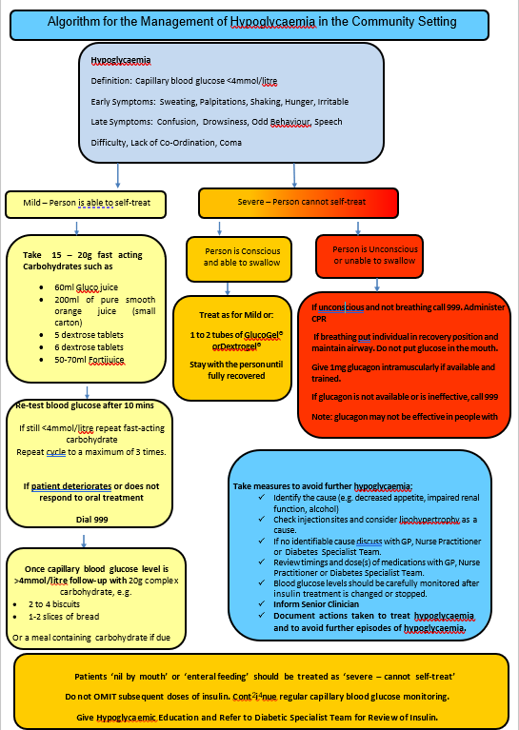

Appendix 3: Management of Hyperglycaemia
Hyperglycaemia is defined as high blood glucose levels outside recommended levels. Unless otherwise stated in patient’s care plan, hyperglycaemia is regarded as blood glucose levels above 7mmol/l before a meal and above 8.5mmol/L two hours after a meal.
Although blood sugar levels exceeding 7mmol/L for extended periods of time can start to cause damage to internal organs, symptoms may not develop until blood glucose levels exceed 11mmol/L.
Patients are at risk of diabetic ketoacidosis if blood glucose levels stay high especially patient with type 1 diabetes. Diabetic ketoacidosis is a medical emergency and it requires urgent treatment in hospital.
Hyperosmolar, hyperglycaemic state (HHS) can occur in people with Type 2 diabetes who may be experiencing very high blood glucose levels (often over 40mmol/l). It can develop over a course of weeks through a combination of illness, dehydration and being unable to take usual diabetes medication due to the effect of the illness. It is a potentially life threatening emergency requiring hospital treatment. Ketones are usually not present.Symptoms of Hyperglycaemia and possible diabetic ketoacidosis:
- Early stages include thirst, polyuria, vomiting, abdominal pain and tiredness.

- Advanced symptoms Include confusion, drowsiness, and ketones in urine/blood, hyperventilation and tachycardia.

Treatment:
Treatment will depend on the cause of the hyperglycaemia. Possible causes include missing a dose of medication, stress, infection, consumption of more carbohydrate than usual or over treating hypoglycaemia.
If levels are high for just one reading, no treatment is required. However, consider possible causes and make necessary adjustments where possible. Continue to monitor levels.
If levels are high, follow flow diagram below.
  - Type 1 diabetes patients for two consecutive readings
  - Type 2 diabetes patients for two consecutive days

APPENDIX 4. Flow Diagram for the Management of Hyperglycaemia

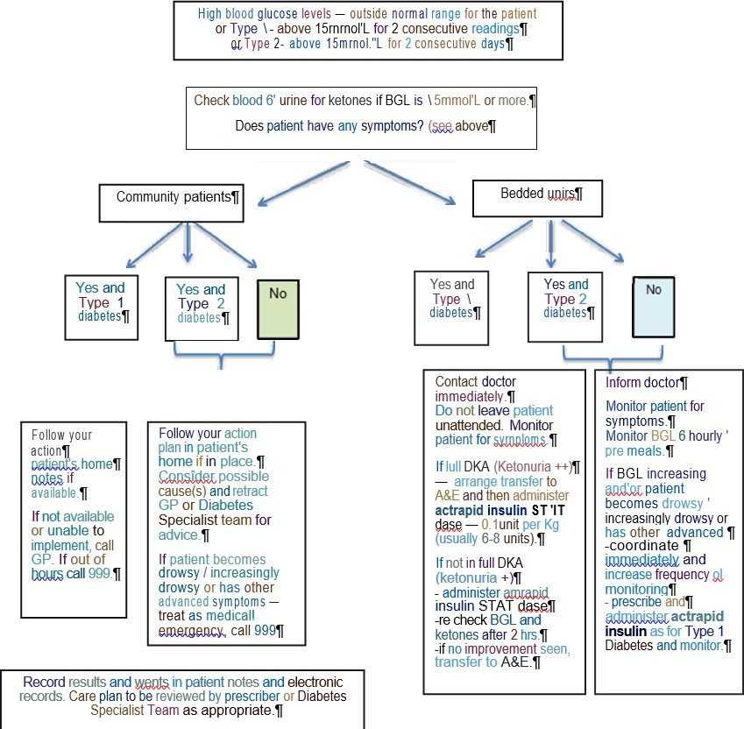

Appendix 5: Injecting Insulin with a Syringe

It is important to know how to draw up and inject insulin safely. By learning to use the correct injection technique, insulin can be given accurately and with a minimum of discomfort and inconvenience to the patient. These are guidelines on how to inject insulin with a syringe. Please ensure you follow the principles of ANTT (Aseptic Non Touch Technique as per Trust Policy) and good hand hygiene (Infection Prevention and Control Goods Practice Policy). Please note a syringe should be used only once and disposed of safely.
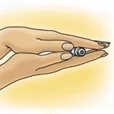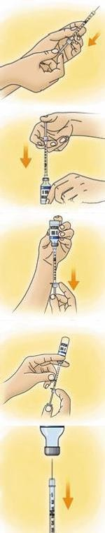
Always check the label on the insulin vial to confirm the correct insulin as prescribed, the expiry date and for any special instructions. Wear gloves and using a large alcohol wipe (2% chlorhexidine &70% alcohol) to wipe the insulin vials as per ANTT.
If the insulin is cloudy, roll the vial gently between your hands several
times in order to mix it completely
Remove the white cap covering the plunger. Carefully remove the orange needle cap. Pull back the plunger to measure an amount of air
equivalent to the amount of insulin required
With the vial standing upright, insert the needle through the centre of the rubber cap of the insulin vial and push the plunger down. This expels the air into the vial, making it easier to draw out the insulin.
Turn the vial upside down. Make sure the point of the needle inside the vial is well beneath the surface of the insulin. Pull back the plunger gently until you have measured slightly more than your correct dose of
insulin.
If any air bubbles are in your syringe, remove them. Flick or tap the syringe at the bubbles with your finger. When the air bubbles go to the top, push the plunger back to the desired dose expelling the bubbles into
the vial.
Remove the needle from the vial and perform the injection as prescribed. A sharps bin must be taken with you to the point of patients care (As per Infection Prevention and control Good Practices Policy).
The sharp must be disposed of immediately after use.

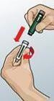
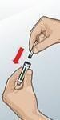
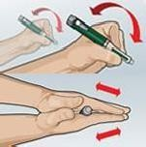
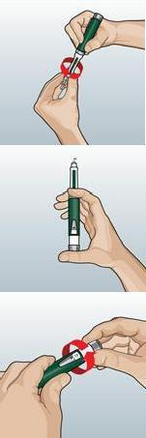
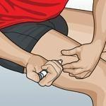
Appendix 6: Injecting Insulin with a Pen

These are general guidelines common to most insulin pen devices. It is important to read the manufactures instructions. Pens are designed for patient use. The prescriber must be mindful of the potential risk for a needle stick injury. If the patient is unable to use a pen device, the prescriber should explore the option of prescribing insulin that is available in a VIAL (which can be administered by the nurse using an insulin syringe).
If the prescribed insulin is not available in a vial do not draw up insulin from pen fill cartridges, please refer to the appendix -administration of insulin via a pen device

Pull the cap off the pen and remove the cartridge holder from the pen body. Put an insulin cartridge into the holder. Reattach the holder to the pen body.
Preparing prefilled pens and cartridge pens for administration of insulin
If the insulin is cloudy, gently tip the pen 10 times and roll it between the palms of your hands 10 times to mix it.
Screw on a new needle before each injection. Remove the outer cap of the needle, then the inner cap.
Before each injection, check the pen is working by priming the pen. Set the dial to 2 units. With the pen pointing upwards slowly press the button. A tiny bead of insulin should appear at the needle tip, if not, repeat this step until you see a tiny bead of insulin at the needle tip.
Check the dial is a zero and dial up the dose as prescribed Please check prescription for:
- name of insulin
- dosage in units
- time of administration
- subcutaneous administration
With the pen prepared for the injection, push the needle all the way into the skin and inject the insulin by depressing the plunger. Hold down the button for at least 10 seconds after the dial has returned
to zero to assist absorption. Withdraw the needle slowly.

Appendix 7: Good Injection Technique

A good insulin injection technique can contribute to maintaining good glycaemic control.

Injecting Correctly
Insulin needs to be absorbed steadily to work properly, and this is why insulin is injected into subcutaneous tissue. Injecting into subcutaneous tissue ensures that the insulin is released smoothly, and this helps to regulate glycaemic control.
If the needle goes deeper, the injection may go into the muscle tissue. Muscle tissue absorbs insulin more rapidly than subcutaneous tissue, and this could contribute to hypoglycaemia. For most people, using a short (e.g. 5mm to 8mm) needle is ideal to make sure the end of the needle is in the subcutaneous layer and doesn't go deeper reaching into the muscle layer.
Remember: when injecting, to leave the needle in the subcutaneous tissue for at least 10 seconds (after you have pressing the plunger) to make sure that all of the insulin is injected properly.

Lift a fold of skin (A gentle pinch)



Make a lifted skin fold as indicated below if appropriate (lifted skin folds will only be required if a patient has extremely slim limbs or abdomen) exhibiting caution to avoid a needle stick injury and taking care to ensure that the skin is not squeezed so tightly that it causes kin blanching or pain.

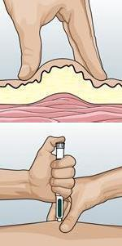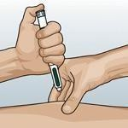
With the pen (or syringe) correctly prepared for the injection, push the needle fully into the skin at the peak of the fold. Administer insulin in a quick smooth movement through the skin. The injection should be administered slowly ensuring that either the plunger (syringe) or button (pen) has been fully depressed. Leave the needle in the skin for at least
10 seconds after the thumb button plunger is fully depressed.
Withdraw needle from skin. Release lifted skin fold.

Ensure safe needle disposal to avoid cross infection/needle stick injury (See local infection control guidelines). A sharps bin must be taken to the point of patient care.

- Rotation.
Three areas generally could be used for injecting: thighs, abdomen and buttocks.
Note: Injecting into the arms should be avoided unless advised by the diabetes team (there



is an increased risk of hypoglycaemia when injecting into the arms as these injections might become intra- muscular rather than subcutaneous).

The main reason for rotating between and within sites is to make sure injections are not repeatedly given into the same site area each time. The reasons are:

- The speed of insulin absorption varies from site to site. It is important to develop a pattern where injection sites are rotated. Rotating injection sites can help control blood glucose levels.
- If insulin injections are given regularly into the same site, the tissue beneath may harden or become lumpy - a condition known as lipohypertrophy (or lipo’s as they are often called).

Absorption Rates
  - The thigh and buttocks are the preferred injection sites for the administration of long- acting basal analogues and medium and long-acting insulins as absorption is slowest from these sites.
  - The abdomen is the preferred site for rapid-acting analogues and short-acting neutral insulin since absorption is fastest there.
  - Massaging the site before or after injection may speed up absorption and is not generally recommended.
  - All insulins should be injected subcutaneously except short-acting neutral insulin (Actrapid and Humulin S) in a rate-controlled device for sliding scale purposes only.

Premixed Insulin
  - Premixed insulins (human or analogue) injections should be rotated around abdominal injection sites (as illustrated above) or thigh (upper-outer) site areas.

Basal bolus insulin regime
  - Rapid or short acting insulins should be administered into the abdominal injection site
  - Intermediate/Long-acting insulin should be injected into the thigh (upper- outer) or buttocks

Appendix 8. Advanced Preparation of Insulin for Later Administration in Highly Exceptional Circumstances:

The act of pre-loading an insulin syringe is considered a form of secondary dispensing which is not covered by the terms of the Medicines Act (1968). In essence, the act of pre -loading an insulin syringe creates an unlicensed product.
There are other risks associated with the practice such as the lapse of time between the preparation of the syringe and its administration by an individual with diabetes
The Royal College of Nursing 2021 document Advance Preparation of Insulin Syringes for Patients to administer at Home therefore recommends the following:
- Ensuring that there is an organisation-wide policy in place covering the use of pre- loaded insulin syringes;
    - Patients must be assessed and have full capacity for this practice to be considered and patient capacity must be routinely and frequently re-assessed as per local policy
    - A Senior Community nurse must be involved in the initial patient assessment; this risk assessment should be updated regularly (as per local policy).
    - Comprehensive training on pre-drawn insulin for self-administration must have been undertaken by the nurse.
- A patient care plan must be in place and reviewed at regular intervals.

  - The patient’s GP is aware, understands and is in agreement that prescribing pre- loaded insulin syringes has associated medical-legal issues, and that there is a guidance in place to support this process
  - The practice of preparing Insulin for administration in advance must therefore only be carried out as a last resort, where all other alternatives have failed or are impracticable, and in accordance with locally agreed procedures which meet the standards set out in the RCN document Advanced Preparation of Insulin Syringes for Adult Patients to Administer at Home - RCN guidance for nurses.

Appendix 9: Guide using BD Autoshield Duo Safety Pen Needle
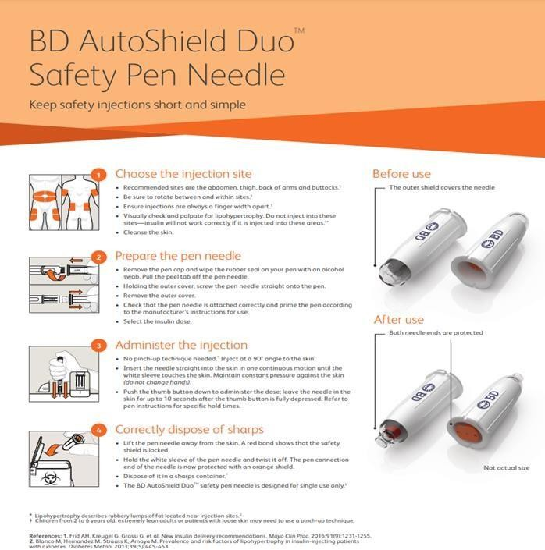

Appendix 10: Types Of Insulin and Action

TIMING OF INSULIN ACTION
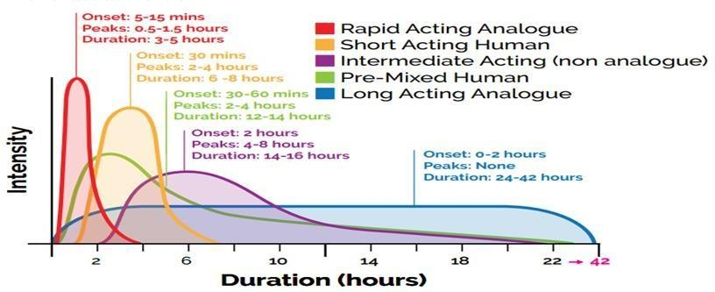
Insulin can be given in a variety of regimens depending on the clinical need and preferences of the individuals:
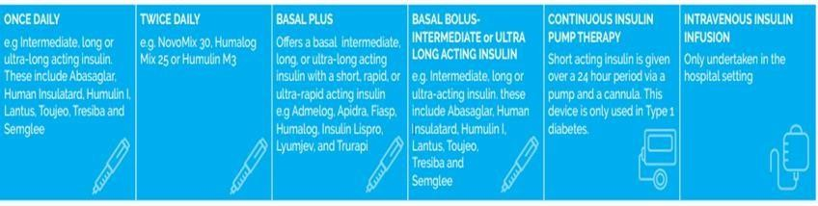

The Right Insulin:

