

Policy for the Use of Injectable Medicines in ELFT Adult Community Health Services

(Including Intravenous Medicines)

Version number : | 3.0
Consultation Groups | CHS Clinical Policy Alignment Group  CHS Practice Development Nurses  Nursing Development Steering Group
Approved by (Sponsor Group) | Medicines Committee
Date approved | 9th July 2025
Ratified by: | Medicines Committee
Date ratified: | 9th July 2025
Name of originator/author: | Clinical Lead Pharmacist CHS Newham
Executive Director lead : | Chief Nurse
Implementation Date : | July 2025
Last Review Date | June 2025
Next Review date: | July 2028

Services | Applicable
Trustwide
Mental Health and LD
Community Health Services

Version Control Summary

Version | Date | Author | Comment
1.0 | October 2018 | Kikelomo Pinheiro  Ed Phillips
2.0 | July 2022 | Charity Okoli  Ed Phillips  Rozi Hamilton | - The link for UK Injectable Medicines-Medusa website updated  - Appendix 1: Competency framework for the administration of intravenous medicines, added  - Drug calculations added as Appendix 2  Appendix 3: Visual infusion phlebitis score, added.  - Audit tool added on Appendix 4  - On section 11 and 12, different types of access devices and their pictorial explanation added.  - The importance of aseptic technique, added on section 13.1  - Lifted and combined useful practice materials on IV documents from Newham CHS and BCHS to update this policy.
3.0 | June 2025 | Dawn McMahon | - Changes to wording and formatting throughout, including references to Datix updated to Inphase.  - Title and Section 2 updated to specify that policy covers adults only.  - Section 4: Practice Development Teams added to Responsibilities section.  - Section 5.2: Removed the requirement to complete risk assessment for each new injectable medication (previous NPSA requirement); replaced with reference to Medusa risk assessments. Relevant appendices also removed.  - Section 5.4: Advice added regarding not using open systems.  - Section 5.6.1: New subsection covering nursing students.  - Section 5.6 and 7.8.2: additional detail added for frequency of NEWS2 completion.  - Section 5.8: administration by patient/carer limited to subcutaneous route only.  - Section 7: detail of vascular access devices and related procedures streamlined, with references added to RMM for further information.  - Section 7: NHS England audit of High Impact Interventions removed as current HIIs do not include IV line care. Related appendices also removed.  - Section 7.8.1 and appendix 6: ANTT competency assessment added.  - Section 7.8.7: new section added on taking bloods from central lines, further details to be obtained from Venepuncture policy.  - Section 7.8.8: practical details of procedures removed from policy, new section added referencing RMM.  - Section 7.10: new section on extravasation and infiltration.  - Previous appendix 5 removed: information in main text or covered by referral to RMM.  - IV competency framework removed from appendices, directs to PDNs for latest version.  - New appendices added: appendix 2 on NEWS2 scoring, appendix 4 on sepsis, appendix 5 on extravasation, appendix 6 on ANTT.

Members of the Community Services Clinical Polices Alignment Group are:

- Caroline Ogunsola, QN– Professional Development Nurse for Community Services - Convener
- Dupe Fagbenro – Deputy Chief Pharmacist – Bedford & Luton
- Nike Bademosi QN– Lead Nurse– Tower Hamlets Community Health Services
- Emma Robinson QN – Deputy Lead Nurse, Tower Hamlets Community Health Services
- Charity Okoli – Lead Pharmacist Tower Hamlets Community Health Services
- Marlene Soares – Clinical Lead Newham Community Health Services
- Ade Adeosun - Clinical Lead Newham Community Health Services
- Sola Bello - Clinical Lead Newham Community Health Services
- Fatima Hafesji - Lead Pharmacist Tower Hamlets Community Health Services
- Saema Arain- Lead Pharmacist Bedfordshire Community Health Services
- Victoria Stone – Locality Manager - Bedfordshire
- Sarah O’Hare QN – Locality Manager, Bedfordshire
- Rashida Goswami – Clinical Nurse, OPAT
- Leander Webb QN - Clinical Service Manager Beds
- Lucy Kwatia - Clinical Lead Newham Community Health Services
- Laura Pisaneschi - Advanced Clinical Practitioner & Senior Lead Clinician Primary Care
- Lara Lawson - Clinical Lead Newham Community Health Services (RR)
- Georgina Amparado – Molina – Clinical Lead Tower hamlets Community Health Services
- Dawn McMahon–Lead Pharmacist – Newham CHS
- Sharon Eplett QN – Head of Quality & Performance Bedfordshire
- Megan Collins – Bedfordshire Community Health Services
- Carole Taylor – Trust Lead Nurse for Tissue Viability
- Chinny Ejiogu QN – Continence Lead for Tower Hamlets
- Emma Stoneman – Deputy Therapy Lead (Beds) & Trust Podiatry Lead
- Caroline White QN – Deputy Lead Nurse, Beds
- Michael Asumah – Diabetes Nurse Specialist, Newham

Table of Contents
Executive Summary 6
1.0 Introduction 6
2.0 Purpose and Scope 7
3.0 Related Policies 7
4.0 Duties and Responsibilities 8
4.1 All Staff 8
4.2 Registered Healthcare Practitioners 8
4.3 Team Leads 9
4.4 Community Health Services Pharmacy Leads 9
4.5 Prescriber (this includes all clinicians who can prescribe) 9
4.6 CHS Practice Development Teams 10
5.0 Standards for Safe Practice 10
5.1 Provision and use of essential technical information 10
5.2 Risk awareness 10
5.3 Prescribing 11
5.4 Preparation 11
5.5 Supply and Storage 13
5.6 Administration 14
5.6.1 Nursing students 14
5.7 Requirements for second checking of preparation and administration 15
5.8 Administration of Injectable Medicines by Patients, Carers or Relatives 15
5.9 Monitoring 17
5.10 Documentation 18
5.11 Disposal 18
6.0 Anaphylaxis 18
7.0 Intravenous Therapy 19
7.1 Introduction 19
7.2 Vascular Access Devices (VADs) 19
7.3 Types of Vascular Access Device 20
7.4 Referral and Assessment of Patients under Community Nursing teams 21
7.5 Criteria for acceptance for community based IV treatment 22
7.5.1 Checklist of criteria for community based IV treatment 23
7.6 Supplies of IV medicines 24
7.6.1 Inpatient supplies / transfer between hospital Trusts 24
7.6.2 Supplies for use in patient’s homes or community settings 24
7.7 Equipment 24
7.8 Administration of IV Medication 25
7.8.1 Aseptic Non Touch Technique 25
7.8.2 Clinical Observations 26
7.8.3 Training Specifically for IV Administration 27
7.8.4 Permitted methods of administration 27
7.8.5 Flushes 28
7.8.6 Flushing technique 28
7.8.7 Taking blood from central lines 29
7.8.8 Procedures for intravenous drug administration, insertion and removal of port needles, and insertion and removal of peripheral cannulas 29
7.9 Adverse Effects / Complications of IV therapy 29
7.10 Infiltration and extravasation 30
7.11 Potential complications of central venous catheters 30
7.12 Line and insertion site care 32
7.13 Intravenous Cytotoxic Medicines 33
8.0 Intramuscular and Subcutaneous Administration 33
Appendix 1: Drug calculations 34
Appendix 2: NEWS2 scoring and response 35
Appendix 3: Visual Infusion Phlebitis Score (VIP) 37
Appendix 4: Sepsis Screening Tool for Community Care 38
Appendix 5: NIVAS (National Infusion and Vascular Access Society) extravasation resources 39
Appendix 6a: ANTT Competency Assessment Tool 40
Appendix 6b: ANTT Competency Assessment Tool answers 42
References 43

Executive Summary
The use of injectable medicines has many benefits for patients; however, evidence indicates that the incidence of errors is higher than other forms of medicine^{1,2}. The complexities associated with prescribing, preparation, administration, and monitoring of injectable medicines means that there are greater potential risks for patients than with other routes of administration. To decrease risk, it is essential that policies and procedures for managing injectable medicines safely and effectively are in place. These must be based on legislation, current evidence and best practice; as well as being in line with professional standards.
This document outlines the standards required for the safe preparation, administration, prescribing and monitoring of injectable medicines. It defines the responsibilities of registered practitioners in relation to the treatment of patients with medicines administered via the injectable route.

1.0 Introduction

An injectable medicine may be given by one of the following methods:
    - Intramuscular injection
    - Direct subcutaneous injection
    - Subcutaneous infusion
    - Intradermal injection
    - Intravenously by
      - Direct injection (bolus) into a vein
      - Direct injection into infusion line tubing (bolus)
      - Intravenous infusion – either continuous or intermittent

Other injectable routes that are not covered in this policy include intra-arterial, intraventricular, intravitreal, intrapleural, intrathecal and intraocular.

2.0 Purpose and Scope
- The aim of this policy is to ensure consistency of practice by defining the standards and responsibilities for the safe prescription, administration and handling of injectable medicines in ELFT Adult Community Health Services.
- This policy covers the intravenous (IV), intramuscular (IM), subcutaneous (SC) and intradermal routes.
- This policy excludes the administration of blood or blood products.
- Patients on parenteral nutrition should be managed according to the care plan from the prescribing tertiary centre as agreed locally.
- This policy applies to all healthcare practitioners employed by the Trust, on a substantive or temporary basis, who are involved in the prescribing, supply, storage, preparation, administration and monitoring of injectable medicines.

3.0 Related Policies
This policy is linked and can be cross referenced to other ELFT Trust policies, including:
- Medicines Policy
- Policy for the Administration of Medicines by Staff in Community Health Services
- Guidelines for the Safe Administration of Low Molecular Weight Heparins in Adults Transferred to ELFT Community Health Services
- Policy for the Delegated Administration of Low Molecular Weight Heparins in ELFT Adult CHS
- Policy for the delegated administration of Insulin in Adults in Community Health Services
- Infection Prevention and Control policy
- Incident Policy
- Anaphylaxis Recognition & Treatment Policy
- Policy for the management of Syringe Pumps / Drivers in Palliative and End of Life Care
- Carer Administration of Subcutaneous Injections at End of Life Policy

This list is not exhaustive.

Duties and Responsibilities

4.1 All Staff
- All staff should be aware that practice may change to improve patient care due to changes in legislation or best practice guidance.
- It is the responsibility of individual healthcare professionals to keep up to date with current practice, maintain and update their knowledge and skills and keep their own record of continuing professional development in accordance with their professional and registration bodies.
- Adhere to Trust Policies and Procedures.
- Each practitioner is responsible for their own action and omission.

4.2 Registered Healthcare Practitioners
Registered healthcare practitioners should ensure:
- They adhere to their Professional Codes of Conduct.
- They understand they are accountable for their practice and work within their competencies.
- They have received the necessary training, including in the use of up to date devices and equipment.
- They maintain and update their knowledge, skills and competencies.
- Medicines are administered in accordance with an appropriately written prescription.
- The patient is monitored appropriately during treatment and be aware of the necessary action and escalation process to take if a problem arises.
- The required records are maintained of administration and monitoring.
- Incidents and near misses are reported using the Trust Incident Reporting system (InPhase).
- They avoid any delegation that increases the risk of drug errors and compromises the interests, wellbeing or safety of patients.
- They know the therapeutic uses of the medicine to be administered, its normal dosage, side effects, precautions and contraindications.
- They are aware of risks associated with and receive specific training and competency assessment prior to using any particular device e.g. syringe driver.
- They are familiar with the Trust Anaphylaxis Policy and training; and up to date with Basic life support training with access to adrenaline 1 in 1000 injection when administering injectable medication.

4.3 Team Leads
Team leads need to ensure that:
- Local arrangements are in place to comply with medicines management requirements.
- Staff have read and understood the policy.
- Staff have the required training and competencies needed to apply this policy in practice and that records of these are maintained.
- Incidents and near misses involving injectable medicines are reported on InPhase, investigated and learning used to inform future practice.
- Any suspected adverse drug reactions are reported to the prescriber and to the MHRA using the Yellow Card scheme.

4.4 Community Health Services Pharmacy Leads
The CHS Lead Pharmacists will:
- Ensure that this policy is current and updated with legislation, national and local frameworks and good practice.
- Share National Alerts related to injectable medicines with teams
- Liaise with clinicians on issues relating to supply issues with injectables.
- Support the nursing team with investigations related to medicine incidents.
- Respond to queries related to administration, dosage and timings from other clinicians within ELFT as and when raised.

4.5 Prescriber (this includes all clinicians who can prescribe)
The prescriber must:
- Retain clinical responsibility for treatment with injectable medicines.
- Prescribe all medicines clearly and safely in accordance with legislation and the Medicines Policy, in a manner that can be readily understood by those dispensing and administering the medication.
- Only prescribe to patients within the scope of their professional role and competence.
- Ensure that the patient/carer is informed of any changes in therapy; including aims and side effects; and ensure that they have written information and understand the reason for use and give consent.
- Ensure the patient’s condition and clinical response to medication is monitored and reviewed.
- Ensure that the medicines prescribed are appropriate for the injectable routes and for the vehicle of administration, taking account of stability and incompatibility information.
- Provide a legal, legible, signed prescription to enable the drug to be administered safely and correctly.
- Ensure that the patient has appropriate intravenous access for intravenous medicines prescribed so that they can be administered.

4.6 CHS Practice Development Teams
- Provide training and assess competence as required.

Standards for Safe Practice

5.1 Provision and use of essential technical information
- Essential technical information shall be available in all areas where iinjectable medicines are prescribed, prepared, administered or monitored.
- Sources of essential technical information are:
- NHS Injectable Medicines Guide (Medusa) - accessed through the Trust intranet;
- Summary of Product Characteristics – available online via Electronic Medicines Compendium;
- BNF;
- Please note this list is not exhaustive.
- If a specific monograph is not included in the NHS Injectable Medicines Guide (Medusa), then the prescriber or person administering should notify the Community Health Services Pharmacy Lead who should assist in obtaining a copy of the manufacturer’s technical information, which shall then be made available in the clinical area/ team.

5.2 Risk awareness
- When administering via the injectable route, the practitioner must be familiar with the risks associated with the route of administration.
- Healthcare professionals responsible for prescribing, administering and monitoring injectable medicines are expected to have an understanding of risks associated with injectable therapy and be available to advise on problems that may arise from its use.
- Practitioners should consult risk assessments on individual monographs of the NHS Injectable Medicines Guide (Medusa) to understand risks for the specific injectable preparation.

5.3 Prescribing
- Medicines should be given by injection only when the use of other routes is clinically inappropriate, practically impossible or unacceptable to the patient.
- The necessity for repeated injections/infusions should be regularly reviewed in favour of switching to oral administration as soon as clinically appropriate.
- All prescriptions for injectable medicines must adhere to requirements in the Medicines Policy.
- Where injectable medicines require diluents and/or flushes, it is essential that these are prescribed.
- IV fluid therapy must be prescribed and monitored in line with the most recent NICE Guidelines on Intravenous Fluid Therapy (CG174).

5.4 Preparation
- Injectable medicines should be prepared only by registered practitioners trained in safe procedures, aware of the risks involved and who have demonstrated their competence in administration of injectable medicines.
- Before beginning preparation, practitioners must have a prescription or other written instruction such as a Patient Specific Direction (PSD) or Patient Group Direction (PGD).
- Essential technical information about the injectable preparation(s) and processes needed for safe preparation and administration should be available, as described under section 5.1.
- Injectable medicines shall be prepared in accordance with the essential technical information, and where relevant procedural guidelines in the Royal Marsden Manual of Clinical and Cancer Nursing Procedures.
- The area in which the medicine is to be prepared should be clean, uncluttered and as free from distraction and interruption as possible. Ideally, preparation within ward or clinical area should take place in an area dedicated to this process.
- Within a home environment the practitioner preparing injectable medicines shall use their clinical judgement to determine the most suitable area within the home in which to prepare the medicine(s). All reasonable steps will be taken to create a sterile field (e.g. through use of trays or sterile dressing packs). However if these efforts fail and there is no safe area to prepare the medicine(s), then consideration shall be given to alternative healthcare provision (e.g. dressing clinics, practice nurses, or send back to referrer). This should be discussed with practitioner/team responsible for the patient’s care as soon as possible and documented in their notes.
- Aseptic Non Touch Technique (ANTT) must be used during preparation and administration (https://antt.org) – see section 7.8.1 for more detail. Use necessary Personal Protective Equipment (PPE) in line with the Trust’s Infection Prevention and Control Policy.
- Prepared injectable medicines should be administered immediately (within 30 minutes) after preparation by the healthcare professional who has prepared the medicine (or in their presence if administration is by a student nurse); they must not be stored before use due to inadvertent administration risks. Administration should be complete in less than 24 hours.
- The only exception to this is the preparation of insulin in advance within a patient’s home, which occurs as a last resort where all other alternatives have failed or are impracticable. This should be strictly in accordance with agreed procedures, see Policy for the Safe Use of Insulin for further details.
- Insulin should be measured and administered using an insulin syringe or commercial insulin pen device. Intravenous syringes must never be used for insulin administration. See Policy for the Safe Use of Insulin for further details.
- Before preparing the injectable medicines, checks should be made to confirm that the medicine and its container do not have obvious defects or contamination; e.g. particles, discolouration, the product is not expired; the medicines were stored as recommended by the manufacturer (e.g. in the refrigerator), the patient has no allergy to the medicine, device or latex, and that the prescribed medicine, dose, concentration, diluent and infusion fluid comply with the specific monograph.
- All syringes, including flushes and infusions, must be labelled immediately after preparation by the person who prepared them.
- The only exception to this is in situations where preparation and bolus (push) administration is one uninterrupted process and the unlabeled product does not leave the hands of the person who prepared it.
- Labels used on injectable medicines prepared in clinical areas should contain the following information:
- Name of the medicine;
- Strength, concentration or total quantity of medicine in the final infusion container or syringe;
- Route of administration;
- Diluent and final volume;
- Patient’s name;
- Expiry date and time;
- Name of the practitioner preparing the medicine.
- ‘Flag labelling’ should be used to ensure that volume graduations on small syringes are not obscured. (‘Flag labelling’ is a method used by pharmacies where a label is folded back on itself so as to take up less space on the packaging, or the label is applied to a clear ‘flag’ which itself has an adhesive strip attached to one corner which wraps around the container.)
- Under no circumstances should a practitioner be in possession of more than one unlabeled syringe at any one time, nor must an unlabeled syringe be fitted to a syringe driver or similar device.
- Only medical devices, e.g. syringes and lines with luer connections, shall be used for preparation and administration of injections.
- ‘Open systems’ must not be used as a container for injectable medication, due to risks associated with this practice (e.g. misidentification of the substance, bacterial contamination). Open systems include gallipots or other types of open container such as moulded plastic procedure trays.
- Place the final syringe or infusion and the empty ampoule(s)/vials(s) in a clean plastic tray or sterile dressing pack with the prescription for taking to the patient for administration.
- Staff administering injectable medicines are expected to know the therapeutic uses of the medicine to be administered, its normal dosage, side effects, precautions and contraindications referring to the appropriate reference sources as required.
- Calculations must be undertaken independently. If in doubt, check the results with another qualified healthcare practitioner. Refer to appendix 1 for guidance on conducting drug calculations.

5.5 Supply and Storage
- Risk assessments on the Injectable Medicines Guide (Medusa) should be used to inform the safest presentation to be used, and appropriate location for storage and preparation.
- Ready-to-administer or ready-to-use products should be used in preference to those needing preparation before use, or those which are classified as high-risk (red risk rating) as per Injectable Medicines Guide.
- Concentrates should only be supplied where safer alternatives are not available.
- Multiple use of an unpreserved injectable medicine should be eliminated. Most injectable medicines are licensed for ‘once-only’ use. Unless the manufacturer’s label specifically indicates the injection is licensed for multi-dose use, the container should only be used to prepare a single dose for a single patient on one occasion.

5.6 Administration
- Injections should be administered only by healthcare staff or patients/carers who understand the risks involved, have been trained to use safe procedures, who have demonstrated their competence for the task.
- All practitioners should act only within their scope of professional practice. They are accountable for their practice including acts and omissions regardless of advice or direction received from another professional.
- The patient's identity and allergy status should be confirmed prior to administration.
- Consent to treatment should be obtained before administration.
- Before administration, the following should be available:
- A current prescription, a Patient Group Direction (PGD) or other written instructions for example a Patient Specific Direction (PSD);
- Essential technical information, including information on any medical devices to be used to administer the injection;
- A prepared and labelled injectable medicine (unless a bolus administration which is exempt from labelling as per section 5.4).
- The practitioner must ensure that all injectable medicines are administered in strict accordance with the manufacturer’s recommendations or in accordance with an approved guidance document e.g. Injectable Medicines Guide (Medusa) monograph.
- While administering injectable medicines, the nurse must monitor the patient’s condition constantly, observing for any adverse reactions and the response to treatment. If at any time during or following treatment, the patient’s condition has not improved or has worsened; the nurse must arrange a medical review.
- For IV infusions a registered nurse must monitor the patient at regular intervals for the duration of the infusion in order to check the flow rate and observe the patient. NEWS2 (see appendix 2) should be completed prior to starting the medication, and repeated as needed based on patient’s clinical status.
- The person administering the medicine should personally make a record of administration as soon as possible after the event.

5.6.1 Nursing students
  - Student nurses should only participate in administration or preparation of any injectable medicine in line with their e-PAD (Practice Assessment Document), which will list what they can and cannot do.

5.7 Requirements for second checking of preparation and administration
- In in-patient units the preparation and administration of all Injectable medicines should be second checked as per Medicines Policy.
- In patient’s homes, it is accepted that medicines may be administered by one person only without being checked by a second person. Where a second person is available, it is good practice for them to provide a check, especially when it is the first time community teams have administered the medicine to the patient.
- The second checker should check for the 10 Rights of the Safe Administration of Medicines, as per Medicines Policy:
  - Right Patient
  - Right Consent
  - Right Time
  - Right Medication
  - Right Dose
  - Right Route
  - Right Expiry
  - Right Documentation
  - Right Effect
  - Right Education
- The second checker shall act independently of the person preparing or administering the medicine.
- A second check can be carried out by registered nurses, pharmacists and doctors. A second checker does not need to have been assessed as competent to administer injectable medicines, but do need to have up-to-date medicines knowledge.
- The second checker is accountable for checking correctly and accurately. They should sign the drug chart (EPMA/paper drug chart/MAR/MAAR) to confirm that they have provided a second check. On inpatient units with EPMA it may not be possible for the second checker to sign if they are not a registered nurse; in this case a record should be made in patient electronic notes (Rio).
- The person administering the injection retains overall responsibility for the accurate preparation and administration of the injectable.

5.8 Administration of Injectable Medicines by Patients, Carers or Relatives
- Patients, carers or relatives may administer injectable medicines via the subcutaneous route only. This is provided they are able and willing, and that the following criteria are met:
  - The registered nurse assesses administration by patient/carer.
  - The patient is assessed to be stable by a registered nurse who has been assessed as competent to administer and monitor the medication.
  - The medicine dose remains the same.
  - The person administering the medicine has received training and supervision and has been assessed as capable based on the clinical judgement of a registered nurse.
  - It is documented in the patient’s notes who is to continue administration, and that their competence has been assessed.
  - Training and assessment may be carried out prior to discharge in the inpatient or clinical setting or at home by the community nursing team.
  - Training must cover the steps of hand washing, preparing the injectable medicine, aseptic non-touch technique, infection control, disposal of sharps and equipment, and recognition of potential complications.
  - The patient/carer administering the medication must be given a copy of the care plan and a set of verbal and written step-by-step instructions to follow which are tailored to the individual’s ability.
  - The person administering the medication must be aware of, and observe for side effects and complications of treatment, know what to do in an emergency and who to contact at any time for advice.
  - The patient/carer administering the medication must be taught how to recognise symptoms of anaphylaxis and be aware of the need to report any allergic reaction regardless of the severity, and when to call 999.
  - It is not considered necessary for patients/carers to have a supply of adrenaline, except in individually identified circumstances.
  - Where administration is jointly carried out with community teams, the registered nurse must establish who will be administering the medication at which times of day and ensure this is clearly documented in patient notes and on MAR/MAAR chart.
  - A complete record of administration must be maintained.
  - The registered nurse must continue to monitor the patient at regular intervals determined by the patient’s clinical need and the needs of the person administering the medicine. Regular re-assessment and support must be provided by the community team. The exception to this is if the patient has been able to be discharged as they have no need for continuing CHS input; in this case the GP should be alerted that they will need to monitor patient.
- Specific arrangements apply for symptom control in end of life patients; refer to the Carer Administration of Subcutaneous Injections at End of Life Policy.

5.9 Monitoring
- During a course of injectable therapy the patient must be monitored by the healthcare practitioner during the administration of the medication to its completion as per prescription. The exception to this is in a domiciliary setting where the medication is being administered by the patient /carer who has undergone training and has been deemed competent to carry out the procedure, and the patient has been discharged under the care of the GP.
- The following must be monitored:
  - Response to treatment
  - Relevant observations i.e. complete NEWS2 scoring (appendix 2). Observe for signs of infection and undertake phlebitis score (appendix 3) where relevant as indicated by the prescriber, and essential technical information
  - Patency of intravenous device (for intravenous therapy) i.e. checking the ability of the IV line to freely and easily allow fluid to flow through it and to aspirate blood without resistance
  - Adverse effects/complications
- If any checks indicate a problem appropriate action must be taken and documented in the patient’s notes and a InPhase report completed.
- If the patient develops a reaction to the injectable, stop administration, assess the patient’s condition, inform the prescriber and give appropriate treatment. Adverse reactions should be reported to the MHRA via the Yellow Card scheme.
- In an inpatient setting, if a patient develops an anaphylactic reaction or the patient reports an adverse event, the nurse shall administer adrenaline from the ward’s emergency drug kit (if anaphylaxis), then inform the prescriber or on-call team immediately and take appropriate action. An InPhase report should be completed, and the reaction should be noted on the patient’s record.
- If a patient develops an anaphylactic reaction while at home, the healthcare professional should use their anaphylaxis kit, then call 999 (even if the patient appears to have improved following adrenaline administration). They should also alert their team lead. An InPhase report should be completed, and the reaction should be noted on the patient’s record.
- Therapeutic blood level monitoring (where indicated) must be carried out in accordance with instructions of the prescriber.
- Routine blood tests should be carried out as specified by the prescriber.
- Monitor the patient for symptoms of sepsis and escalate immediately (as per appendix 4).

5.10 Documentation
A clear, accurate and immediate record as per Trust policy must be made on Trust-approved charts and in the patient’s notes of:
- Patient consent
- Medicines, diluents and flushes administered, intentionally withheld or refused by the patient
- Date and time of administration
- Where relevant, details of insertion and removal of the venous access device (VAD) including; date, time, site, reason for insertion/removal, attempts, type and size of device
- Monitoring and care undertaken in accordance with the care plan, e.g. temperature, pulse, respirations, blood pressure, patency of cannula, signs of infection, phlebitis score and dressing changes
- Any adverse reactions and complications
- Details of any medical reviews of the treatment plan
- Any additional monitoring undertaken at the request of the prescriber (e.g. blood levels) must be documented
All entries must be signed and should be legible.

5.11 Disposal
Medication and equipment must be disposed of safely in accordance with the Medicines Policy, Waste Management Policy, and Infection Prevention and Control Policy.

Anaphylaxis
- Anaphylaxis is a severe and potential life threatening event that requires immediate medical attention. It is a systemic response following the administration of a medicine or substance that the body is allergic to.
- The body can rapidly go into shock and this can lead to respiratory and cardiac arrest if delay in treatment occurs.
- Every healthcare professional in the Trust authorised to give medication is also authorised to give adrenaline intramuscularly in an emergency situation without the need for a prescription or Patient Group Direction.
- See further details in the Policy for the Administration of Medicines by Staff in Community Health Services.

Intravenous Therapy

7.1 Introduction
Benefits of intravenous therapy include:
- A more rapid response is usually obtained
- Higher serum concentrations are possible
- A constant therapeutic effect can be maintained by continuous infusion
- Some drugs are ineffective by other routes
Risks associated with intravenous therapy include:
- Higher risk of toxicity
- Microbial contamination
- Damage to veins
- Damage to surrounding tissue
- Local reactions/toxicity where medicine is insufficiently diluted, given too rapidly, or not flushed
- Due to greater and more rapid absorption than other routes, risks associated with preparation or administration errors are higher and errors are more difficult to rectify

7.2 Vascular Access Devices (VADs)
- All Vascular Access Devices (VADs) should be managed in accordance with the latest version of the Royal Marsden Manual of Clinical and Cancer Nursing Procedures – current edition available through Trust intranet. See section 7.3 for types of VAD.
- Care of the VAD should be documented using the appropriate care bundle.
- The Registered Nurse has a responsibility to ensure they are aware of potential complications of the VAD used, and has received theoretical and practical training in the care of such devices before administering medications via them.
- Utilise the UK Vessel Health and Preservation 2020: Right Line Decision Tool, to assess whether route of administration and type of VAD is appropriate based on the nature of the therapy, the expected duration and the status of the venous anatomy.

7.3 Types of Vascular Access Device
Type of device | Possible materials | Features | Common insertion site (veins) | Recommended indwelling life and common uses
Peripheral intravenous cannula (PIVC) | Teflon (PTFE)  Polyurethane  Vialon | Winged or non‐winged  Ported or non‐ported  Closed system, single ported or dual ported | Cephalic or basilic  Dorsal venous network | Removed when clinically indicated for short‐term access
Midline catheter | Silicone  Polyurethane | Single lumen  Dual lumen | Basilic  Median cubital Cephalic | Used for 1–6 weeks for short‐ to intermediate‐term access
Peripherally inserted central catheter (PICC) | Polyurethane  Silicone | Triple lumen  Dual lumen  Single lumen  Valved or non‐valved | Basilic  Cephalic  Brachial | Used primarily for patients requiring several weeks or months of intravenous access
Short‐term percutaneous central venous catheter (non‐tunnelled) | Polyurethane  Silicone | Heparin, antibiotic and antiseptic coatings; multiple lumen | Jugular  Subclavian  Femoral | Intended for days to weeks of intravenous access
Skin‐tunnelled catheter (STC) | Polyurethane  Silicone | Valved or non‐valved  Antimicrobial/silver cuff  Multiple lumen  Computed tomography compatible | Jugular  Axillary  Subclavian  Femoral | Indefinite: used for long‐term intermittent, continuous or daily intravenous access; may be appropriate for short‐term use if reliable access needed
Implanted ports | Catheter: silicone or polyurethane  Port: titanium or plastic | Single or dual ports  Peripheral or chest ports  Valved or non‐valved  Low profile  Computed tomography compatible | Veins of the upper arm (basilic, brachial)  Jugular  Axillary  Subclavian  Femoral | Indefinite: used for long‐term access  Intermittent, continuous or daily intravenous access
Table taken from Royal Marsden Manual of Clinical & Cancer Nursing Procedures, 10th edition, chapter 17.

7.4 Referral and Assessment of Patients under Community Nursing teams
Patients may be:
- Commenced on IV therapy whilst an inpatient and referred for continuation in the community on discharge;
- Referred for initiation of IV therapy in the community.
Referrals should be made according to the local referral processes.

The minimum data provided (in addition to patient details) by the referrer should include:
- Medicine name, dose, frequency and duration (including date and time started)
- Review date
- Patient’s body weight (where relevant)
- Diagnosis
- Rationale for prescribing IV therapy rather than oral
- Known allergies or sensitivities and nature of reaction
- Details of and arrangements for any monitoring required
- Type of venous access device
- Type of dressing
- Confirmation that all necessary medicines, equipment and consumables have/will be provided upon discharge
- IV monograph where necessary
- Signature, registration number and contact details of the prescriber

- The referrer retains clinical responsibility for the patient whilst in the care of the community nursing team for IV administration.
- The referring clinician is responsible for clinical care of the patient including making the diagnosis, assessment, monitoring, follow up and management of clinical outcomes in liaison with the Community Nurse caring for the patient in the community.
- It is the responsibility of the clinician referring to issue the prescription for the IV medicine, including flushes, diluents and any specialist equipment required that is not normally available in the community.
- A thorough assessment must be undertaken by the receiving service, who must liaise directly with the referrer prior to accepting the referral, to ensure that the criteria for access to the service are met and all considerations in the checklist (check local procedures and section 7.5.1 below) are addressed. The treatment plan must be agreed between the referring clinician and the receiving service before accepting the patient.
- All referrals, assessments and discussions must be documented in the patient’s notes.

7.5 Criteria for acceptance for community based IV treatment
The following criteria must be met before accepting a patient for community based IV treatment. Outcome of the assessment should be documented in the patient’s notes.
- The medicine can be administered safely in the relevant setting.
- The patient’s safety can be maintained during administration of the required medicine.
- Staff have the competence and skills required to administer the medicine.
- The level of nursing input and supplies of medicine are sustainable for the duration of treatment.
- The patient must have a clearly stated clinical diagnosis requiring intravenous therapy.
- The patient must be medically stable with minimal risk of developing complications assessed using the checklist (see section 7.5.1).
- The patient or carer are able to safely identify complications and seek help in an emergency.
- Clear arrangements must be in place for prescribing, monitoring and reviewing treatment and the clinician responsible is clearly identified.
- There must be a completion date and/or review date.
- The IV regimen and any specific monitoring requirements must be agreed with the accepting team. Information and advice can be obtained from pharmacy or microbiology departments (where relevant).
- Any known allergies must be documented and the risk of anaphylaxis considered.
- In addition, for patients receiving IV therapy in their own home the home situation must be suitable.
- The patient must be able to call for help if unwell.
- There must be electricity, running water and access to a telephone.
- Where there is a history of drug or alcohol abuse a risk assessment must be completed to assess suitability for acceptance of referral.
- The patient must have appropriate venous access device inserted.
- The patient must have a discharge letter/ TTA available.
- Patients and their families must be able to understand and comply with the IV treatment regimen, for example, elevation of limb, time off work for resting, attending appointments etc.
- Patients and their families must be able to give consent in accordance with the Trust Consent Policy. The following issues should be discussed with the patient/carer:
- The prescribed treatment
- The venous access device
- How to recognise complications / infections / anaphylaxis / common adverse effects
- Who to contact throughout the day or night

If the above criteria are not met, a more suitable community healthcare setting should be considered e.g. outpatient or assessment unit in hospital or clinic setting.

7.5.1 Checklist of criteria for community based IV treatment

Criteria |  |  | Comments
Has the patient had a previous reaction to this proposed medication? | No | Yes | Continue with IV therapy  Not suitable for IV therapy in the community
Is the prescribed medication appropriate for the patient taking into consideration any contraindications or interactions with current medication? | No | Yes | Check with microbiologist or prescriber for further alternative medicine  Continue with medication
Is there a start and review/complete date of treatment? | No | Yes | To check with the prescriber before starting the procedure  Continue with the medication
Is the IV therapy likely to exceed two weeks? | No | Yes | To continue with peripheral cannula  The IV therapy should be given via a central line, discuss with the referrer and prescriber if central line not in situ
Is the community nursing team able to support the proposed treatment?  Issues to consider; timing of medication, the number of times it needs to be given in 24hrs, can treatment be supported over the weekend or bank holidays? | No | Yes | Not suitable for IV therapy in the community.  Continue with the medication
Has the patient consented or has the mental capacity to consent to home IV therapy? | No | Yes | If not consented – no IV therapy  If does not have the mental capacity- check if a mental capacity form completed and discuss with next of kin  If there is a consent – continue with the medication

7.6 Supplies of IV medicines

7.6.1 Inpatient supplies / transfer between hospital Trusts
- Supplies of IV medicines for routine inpatient use will be in accordance with local procedures within the unit.
- For inpatient transfers from other hospitals, the referring Trust must supply 14 days which should be sent with the patient. A discharge summary including details of the patient’s medicines must be shared, and ongoing availability should be established before the patient is accepted for transfer.

7.6.2 Supplies for use in patient’s homes or community settings
- On discharge from hospital all IV medicines, including diluents and flushes are provided by the discharging hospital to the patient unless there are local agreements in place regarding the holding of certain stock by the receiving service.
- Where IV therapy is initiated in a patient’s home by the GP or non- medical prescriber, the medicine, diluents and flushes must be obtained from a community pharmacy using an FP10 prescription written by the prescriber. Other arrangements such as obtaining via an out patient prescription from the hospital pharmacy may also apply.
- Community pharmacies do not routinely stock IV medicines therefore it is advisable to check with the community pharmacy to ensure the required medicine is available, or how quickly it can be supplied.
- If immediate treatment is required and the medicine is not immediately available in the community, consider admission to clinical setting or hospital.
- Medicines obtained on FP10 are the property of the patient they were prescribed for and must not be used for any other patient or be incorporated into ‘stock’.

7.7 Equipment
Specialist equipment and all consumables required for safe administration of IV therapy must be available. In inpatient settings these will be stocked. In patient home/community settings, District Nurses will hold sterile dressing packs; any additional items required should be provided by the referring authority/prescribing clinician.

7.8 Administration of IV Medication
- Registered nurses must adhere to the Trust Policy for the Administration of Medicines by Staff in Community Health Services, which includes ensuring accurate records are kept.
- Registered nurses must ensure they have the required authority to administer the intravenous medicine and flushes, for example, a valid prescription. For patients discharged from a hospital setting, the registered nurse must administer the IV medicines and flushes in accordance with the hospital discharge prescription/letter/dedicated IV paperwork. It is vitally important to ensure that the right type of access device (i.e. central or peripheral) is used for the specific medicine being administered. Guidance is available in essential technical information as referenced in section 5.1 of this policy. This includes advice on recommended type of line, as well as pH of the medication. Medications at extremes of pH have a higher risk of tissue damage.
- Administration of IV medication via peripheral and central lines uses the same technique, there are differences in the management of the lines but the practical procedure for administering medication is the same.
- Sodium chloride 0.9% is recommended as a flush and lock solution for any type of non-dialysis CVAD.

7.8.1 Aseptic Non Touch Technique

IV medications carry an associated risk of infection because of the potential for direct microbial entry to the bloodstream. Health Care Acquired Infections (HCAI) in relation to IV medications have the potential to cause major health complications for the patient and in some cases can be a cause of death.

Definitions
- Sterile – free from microorganisms, this is only achievable in controlled environments such as Laminar flow or operating theatres.
- Asepsis – prevention of microbial contamination, achieved through excluding or removing microorganisms in order to prevent infection.

What is Aseptic Non Touch Technique (ANTT)?
- Aseptic non-touch technique (ANTT) is the practice of avoiding contamination by not touching key elements, such as the tip of a needle, the seal of an intravenous connector after it has been decontaminated, or the inside surface of a sterile dressing where it will be in contact with the wound.
- This is the underpinning management principle for all IV nursing care. Please refer to the Royal Marsden Manual of Clinical and Cancer Nursing Procedures (available via ELFT intranet) for practical details.
- All staff administering intravenous medication should complete the ANTT competency assessment tool at appendix 6a. Answers to the questions are available in appendix 6b; these should be used by team leads/Practice Development Nurses to assess nurse’s understanding.
- Sterile dressing packs and sterile gloves are recommended in domiciliary settings to ensure maintenance of asepsis.
- The injection port or vascular access device catheter hub should be decontaminated before and after accessing the system using chlorhexidine gluconate in 70% alcohol.
    - If the manufacturer’s recommendations prohibit the use of alcohol with their catheter, an aqueous solution of chlorhexidine gluconate is a suitable alternative.
    - If the patient has a sensitivity to chlorhexidine, single use povidone iodine solution or water-based skin cleansing swabs should be used.

7.8.2 Clinical Observations
- In inpatient settings, the nurse administering the IV medication should record the patient’s National Early Warning Score (NEWS) 2, a minimum of once daily.
- In the domiciliary setting, NEWS2 must be undertaken every time IV medication is administered.
- This is to detect early signs of systemic infection from a blood borne infection, and if IV medication is for infection to monitor the efficacy of treatment. If any observations trigger the NEWS2 algorithm then medical advice must be sought. See appendix 2 for further details.
- A visual inspection of the site should be undertaken at every administration, using the Visual Infusion Phlebitis Score (VIP) (appendix 3).

7.8.3 Training Specifically for IV Administration
- All healthcare professionals including new starters administering intravenous therapy must take part in the Trust approved training course to administer IV medications.
- New starters to the Trust may provide documented evidence that approved training has been completed within the preceding year. These documents must be presented to the clinical line manager/ or the Practice Development Nurse.
- Training and assessment should comprise of both a theoretical component and practical procedures (assessment in clinical practice) and include legal and professional issues, pharmacology, medicine administration, local and systemic complications, infection prevention and control, use of equipment, risk management and drug calculations.
- Assessment in clinical practice requires direct observation and a signed declaration by the Assessor indicating that the Nurse has achieved the required level of competence in accordance with Trust Policy. At least 3 direct observation sessions should be completed before a Nurse is assessed as competent.
- All healthcare professionals, including those who have received their training elsewhere, are expected to complete the ELFT Competency Framework for the Administration of Intravenous Medicines within the Trust before undertaking administration of IV therapy. This is managed through Practice Development Nurses.
- A record of IV therapy training and completed competency assessments should be kept by the individual’s line manager and team Leader.
Healthcare professionals must attend an IV therapy update and competence re-assessment every three years to maintain their IV therapy competencies.

7.8.4 Permitted methods of administration
The Registered Nurse in the community (inpatient and community-based settings) may only administer IV therapy in the following ways.
- Intravenous Bolus Injection - direct injection of a small volume of fluid / medicine (max 20mls) contained within a syringe administered directly into the injection bung/needle free device.
- Intravenous Intermittent infusion - infusion of a volume of fluid / medicine (max 100mls) over a set period of time at prescribed intervals and stopped until next dose is required.
- For bolus and intermittent infusions, the nurse must stay with the patient for the duration of the infusion in order to monitor the flow rate.

7.8.5 Flushes
- During regular use, the IV access device should be flushed with the prescribed flushing solution e.g. Sodium Chloride 0.9% injection, to maintain the patency of the line before and after administration of a medicine, or in between each administration if more than one medicine is administered consecutively. All flushes must be prescribed and the volume administered must be documented.
- Guidance from the referring Trust will be followed regarding the different flushing intervals and solutions to be used for ports, Hickman lines, non- tunnelled long lines and PICC lines.
- Central lines and PICC lines that are not in regular use should be flushed weekly or in accordance with the patient’s prescription. Research has shown that Sodium Chloride 0.9% injection is as effective at maintaining catheter patency as Heparinised Saline.

7.8.6 Flushing technique
- Syringes smaller than 10ml should not be used for infusion into the IV access device. This is to prevent excessive pressure being exerted on the lumen which might cause it to rupture. Smaller syringes exert greater pressure, however please note that syringe size alone is not sufficient to prevent rupture. When resistance is felt, if more pressure is applied to overcome it, catheter fracture could result regardless of the syringe size.
- A brisk 'push-pause' flushing technique should be routinely used when flushing the catheter i.e. flush briskly, pausing briefly after approximately each ml of fluid. The 'push-pause' technique causes turbulence within the catheter, which helps to flush away any debris and prevent occlusion of the lumen
- If the catheter possesses a clamp, the line should be clamped while the final millilitre of the flush is being injected. If there is no clamp a “positive pressure finish” can be achieved by removing the syringe from the Clave (or similar) while injecting the last millilitre, being careful to avoid any spray from the syringe. Maintaining positive pressure helps prevent blood entering the catheter after flushing, which might lead to occlusion or thrombus formation. Specially designed positive pressure needle free devices are available.
- Do not routinely withdraw and discard blood from the catheter before flushing in an attempt to avoid flushing bacteria and clots into the patient. There is no evidence that withdrawing prior to flushing reduces infection or embolism. Note that if the catheter is to be used for administering drugs or fluids, checking for “flashback” should be a routine part of catheter assessment.

7.8.7 Taking blood from central lines
Bloods samples may be taken from central lines. For full details please refer to the Trust Venepuncture Policy.

7.8.8 Procedures for intravenous drug administration, insertion and removal of port needles, and insertion and removal of peripheral cannulas
The Royal Marsden Manual of Clinical and Cancer Nursing Procedures should be used to guide the detail of these procedures. Local competency frameworks should also be adhered to.
Note: Central lines should not be removed in the community.

7.9 Adverse Effects / Complications of IV therapy
- Potential hazards and risks of intravenous therapy include anaphylaxis, phlebitis, infiltration, extravasation (see section 7.10), haematoma, occlusion, speed-shock, infection and air embolus.
- For details refer to the current edition of the Royal Marsden Manual of Clinical & Cancer Nursing Procedures available on the intranet.
- During IV administration the nurse must monitor the patient’s condition and observe for any adverse effects (see section 7.8.2).
- If there are signs of an adverse reaction the nurse must act immediately and stop the injection / infusion.
- The patient / carer should be reassured and their condition assessed and appropriate observations documented.
- Any adverse or suspected adverse reaction must be reported to the prescriber or responsible clinician as soon as possible to ensure the patient receives the appropriate treatment.
- If there are serious concerns, emergency medical attention should be sought immediately; an ambulance may be required by dialling 999.
- Details of any adverse events and any action taken must be documented in the patient’s notes and reported on the Trust incident reporting system (InPhase), and if applicable, reported to the MHRA using the yellow card system which can be found in BNF (paper copies) or online (https://yellowcard.mhra.gov.uk/).
- All registered nurses must be familiar with the Anaphylaxis Policy and be up to date with their Basic Life Support and Anaphylaxis training. Nurses must have adrenaline injection 1 in 1000 available at all times.

7.10 Infiltration and extravasation
Infiltration is the inadvertent leakage of intravenous fluid or medication into extravascular tissue from an intravenous vascular access device. The resulting injury is likely to be minor. If the fluid or medication is a vesicant, the injury would be classed as an extravasation as the risk of tissue damage and serious, often life changing injury is high.
Vesicants are drugs or solutions with the potential to cause serious skin or tissue damage including blistering, ulceration and necrosis. There are 4 main groups of vesicant drugs commonly used:
- Chemotherapy agents
- Drugs with non-physiological pH (acidic pH <5 or alkaline pH >9)
- Vasopressors (e.g. adrenaline, noradrenaline, dopamine)
- Hyperosmolar solutions (above 600mOsm/L)
Non-chemotherapy drugs have been reported as having a greater risk of serious complications. The most serious extravasation injuries are associated with peripherally administered vesicant drugs such as antibiotics, antiepileptics and anaesthetics.
NIVAS (National Infusion and Vascular Access Society) advise a 5 step process for the management of extravasation: Prevention, Recognition, Treatment, Follow-Up, Reporting. See appendix 5 for further information and link.
Refer to the Royal Marsden Manual of Clinical & Cancer Nursing Procedures for detailed information on recognition and management.

7.11 Potential complications of central venous catheters
ProblP Problem | Possible Cause | Recommended Action
Dyspnoea,  tachypnoea, chest  pain, cyanosis,  respiratory arrest. | Air embolism | Clamp the catheter and then check for damage, rupture or disconnections. If damage or rupture found, clamp the line immediately, above (toward patient) damaged part.  Monitor the patient.  Ring emergency services if patient at home. Inform responsible clinician.  Lay patient in Trendelenburg position - head down 45 degrees if possible.  Administer oxygen if available.  Commence CPR if necessary.  Ensure all observations and actions are recorded.
Oedema, pain,  swelling and/or  tenderness of arm,  neck and/or chest.  Engorged peripheral  veins. Peripheral  neuropathy. Skin  colour and/or  temperature  changes.  Blocked catheter. | Thrombosis | Report to responsible clinician and call emergency services if severe.  Venogram may be performed.  Possible anti-coagulant therapy.  Possible catheter removal.
Pain, redness,  inflammation,  exudate at wound  site | Local infection of  the tunnel or exit  site | Swab wound and clean and redress site.  Report to responsible clinician and call emergency services if severe.  Blood cultures may be required peripherally and from each lumen.  Possible antibiotics - oral or potentially I.V.  Possible catheter removal.
Mechanical phlebitis  (Peripherally inserted  central catheters) | Maybe related to  movement of the  line | Apply warm compresses to the elevated extremity 4 times daily for 72 hours. Contact responsible clinicianregarding potential removal of line.
Pyrexia, tachycardia,  rigors | Systemic infection | Report to responsible clinician and call emergency services if severe.  Blood cultures may be required peripherally and from each lumen.  Possible I.V. antibiotics.  Possible catheter removal.
Unable to obtain  Blood/flash back  Inability to flush  catheter | Occlusion/blockage  Catheter tip against  vessel wall | Try gentle pressure and aspiration with sodium chloride 0.9% in syringe. NB. Use a syringe of 10ml or above ONLY to avoid excessive pressure.  DO NOT use excessive force.  Check clamps are open and the catheter is not kinked.  Move clamp and massage catheter where the clamp was.  Ask patient to:- cough, deep breathe, raise arms, change position.  If unsuccessful, Seek advice from prescriber or specialist unit.  Instillation of Urokinase maybe needed to dissolve any thrombi and restore patency.  Potential for catheter removal.

7.12 Line and insertion site care
An important additional aspect of the prevention of IV associated infections is line and insertion site care. EPIC3 (National evidence-based guidelines for preventing healthcare associated infections in NHS hospitals in England) should be followed:
- Use a sterile, transparent, semipermeable polyurethane dressing to cover the intravascular insertion site.
- Transparent, semi-permeable polyurethane dressings should be changed every 7 days, or sooner, if they are no longer intact or if moisture collects under the dressing.
- Use a sterile gauze dressing if a patient has profuse perspiration or if the insertion site is bleeding or leaking, and change when inspection of the insertion site is necessary or when the dressing becomes damp, loosened or soiled. Replace with a transparent semi-permeable dressing as soon as possible.
- Consider the use of a chlorhexidine-impregnated sponge dressing in adult patients with a central venous catheter as a strategy to reduce catheter-related bloodstream infection.
- Consider the use of daily cleansing with chlorhexidine in adult patients with a central venous catheter as a strategy to reduce catheter-related bloodstream infection.
- Dressings used on tunnelled or implanted catheter insertion sites should be replaced every 7 days until the insertion site has healed unless there is an indication to change them sooner. A dressing may no longer be required once the insertion site has healed.
- Use a single-use application of 2% chlorhexidine gluconate in 70% isopropyl alcohol (or povidone iodine in alcohol for patients with sensitivity to chlorhexidine) to clean the central catheter insertion site during dressing changes, and allow to air dry.
- Use a single-use application of 2% chlorhexidine gluconate in 70% isopropyl alcohol (or povidone iodine in alcohol for patients with sensitivity to chlorhexidine) to clean the peripheral venous catheter insertion site during dressing changes, and allow to air dry.
- Do not apply antimicrobial ointment to catheter insertion sites as part of routine catheter site care.
During bathing and showering, the patient should be advised to take care to keep the exit site dry.

7.13 Intravenous Cytotoxic Medicines
- Only those healthcare professionals who have undergone and successfully completed relevant additional training and assessment may administer intravenous cytotoxic therapy.
- Registered nurses may however disconnect intravenous cytotoxic medicines on completion of administration, if the required equipment for disposal is available e.g. PPE and cytotoxic bins and they have undergone and successfully completed relevant additional training. Any local procedures should be followed.

Intramuscular and Subcutaneous Administration

Registered Nurses have achieved the competences for administering intramuscular and subcutaneous injections as part of preceptorship training. A record of this training shall be maintained by Clinical Lead and Team Lead.

Appendix 1: Drug calculations

1. To calculate the amount of medicine to give from a solution:

Dose to be given x Volume of Solution
Strength available

Or

What you want x what it’s in
What you’ve got

Example:

If a patient is prescribed 200mg of a medicine that comes as 250mg in 5ml - the calculation will be:

200 x 5ml = 4ml
250

2. To calculate the flow rate of an infusion in drops per minute:

Vol of solution to be given (mls) x Number of drops per ml = Flow rate (drops/min)
Duration of infusion (mins)

NB. Always check the individual packaging of the giving set to be used before calculating the flow rate, as the number of drops per ml may vary with different manufacturers.

Example:

The patient needs to be given 100mls of Metronidazole over 30 minutes, the giving set delivers 20 drops per ml - the calculation would be:

100(mls) x 20(drops) = 66.6 drops per minute
30(mins)

Appendix 2: NEWS2 scoring and response
(Taken from Royal College of Physicians website: https://www.rcp.ac.uk/improving-care/resources/national-early-warning-score-news-2/)
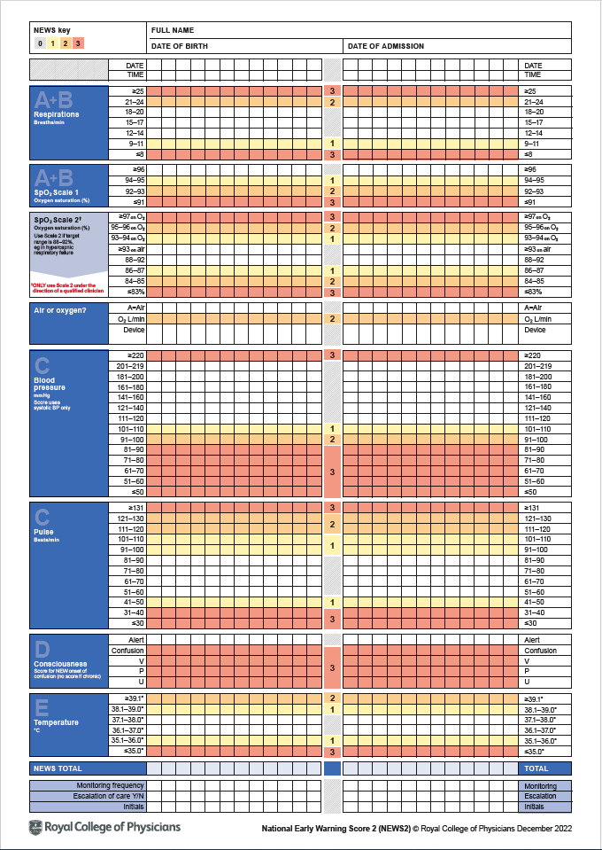
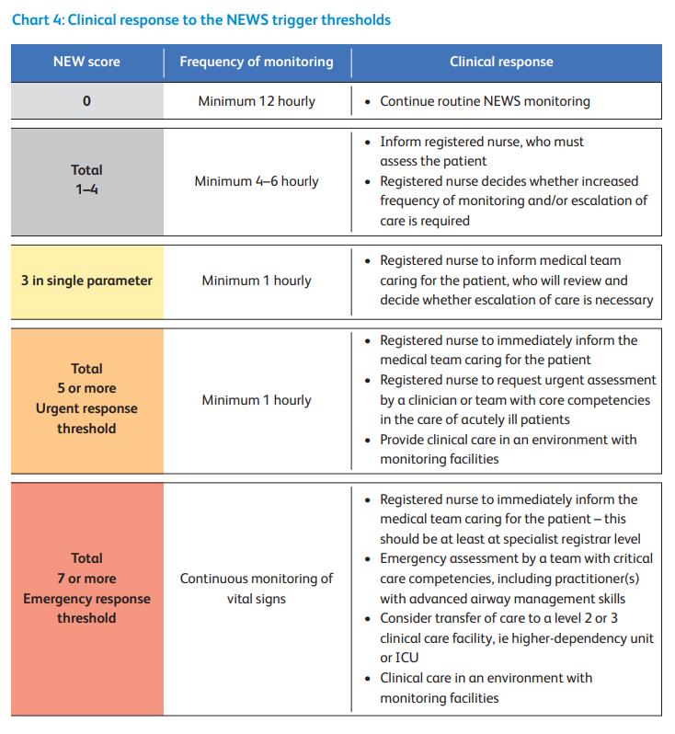
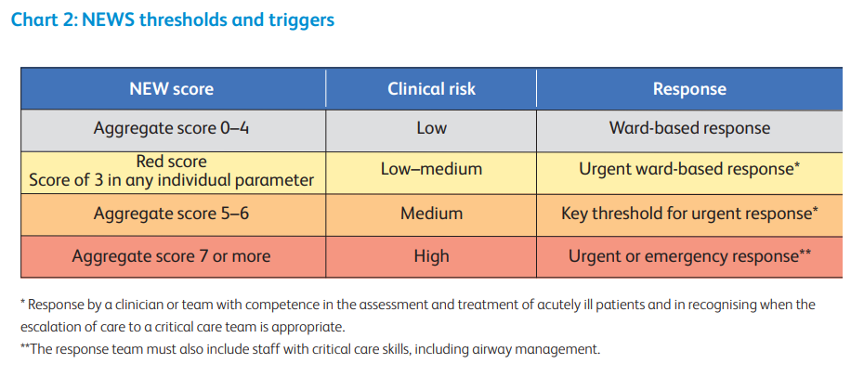

Appendix 3: Visual Infusion Phlebitis Score (VIP)
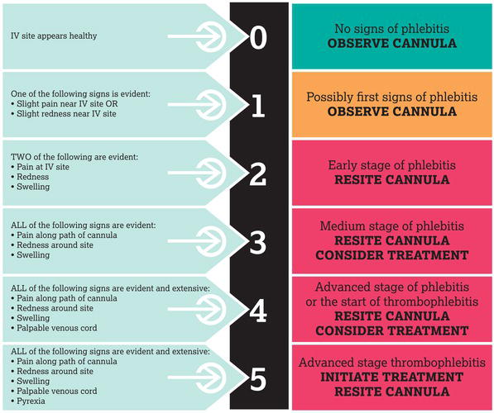

Appendix 4: Sepsis Screening Tool for Community Care
(Taken from UK Sepsis Trust website: https://sepsistrust.org/healthcare-professionals/clinical-tools/)
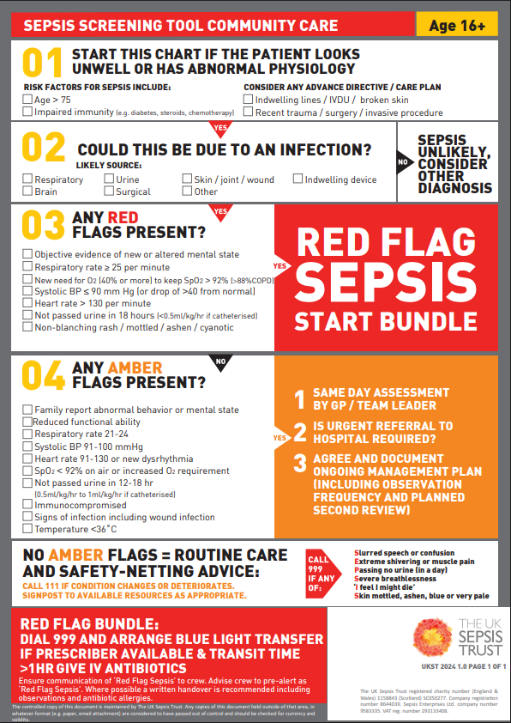

Appendix 5: NIVAS (National Infusion and Vascular Access Society) extravasation resources
(Taken from https://nivas.org.uk/)
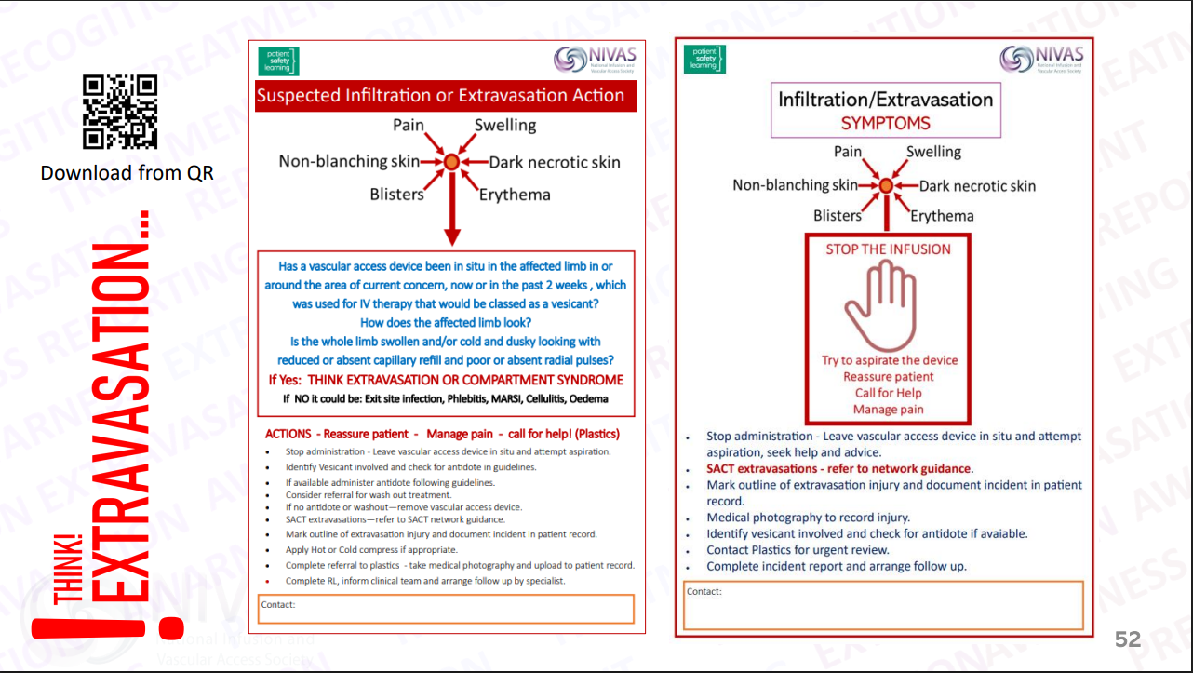
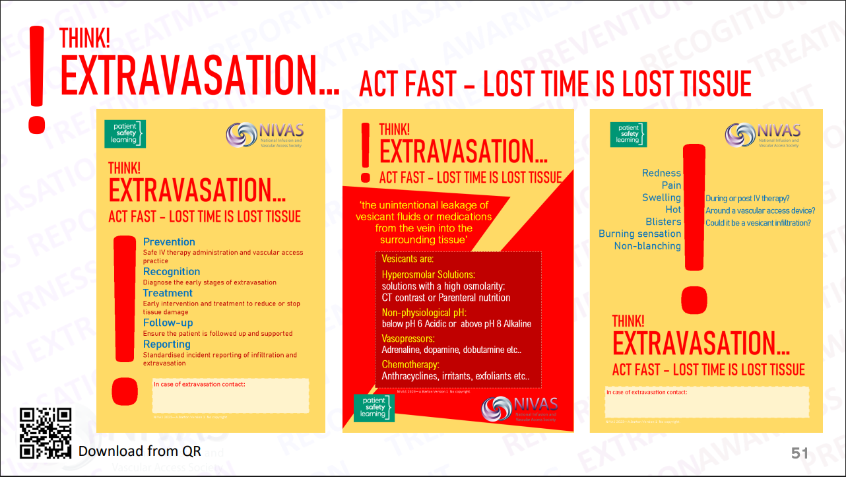

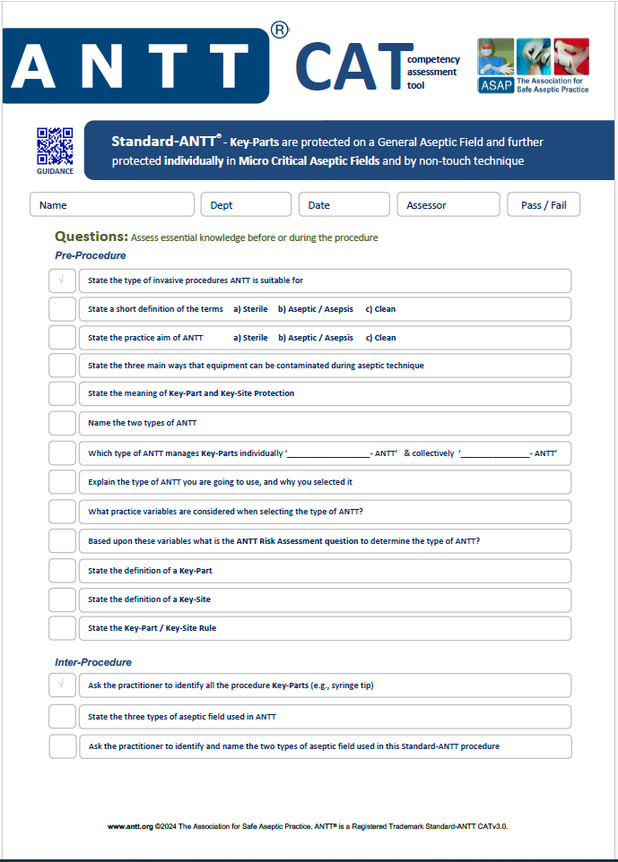
Appendix 6a: ANTT Competency Assessment Tool
(Taken from https://www.antt.org/downloads.html, May 2025)
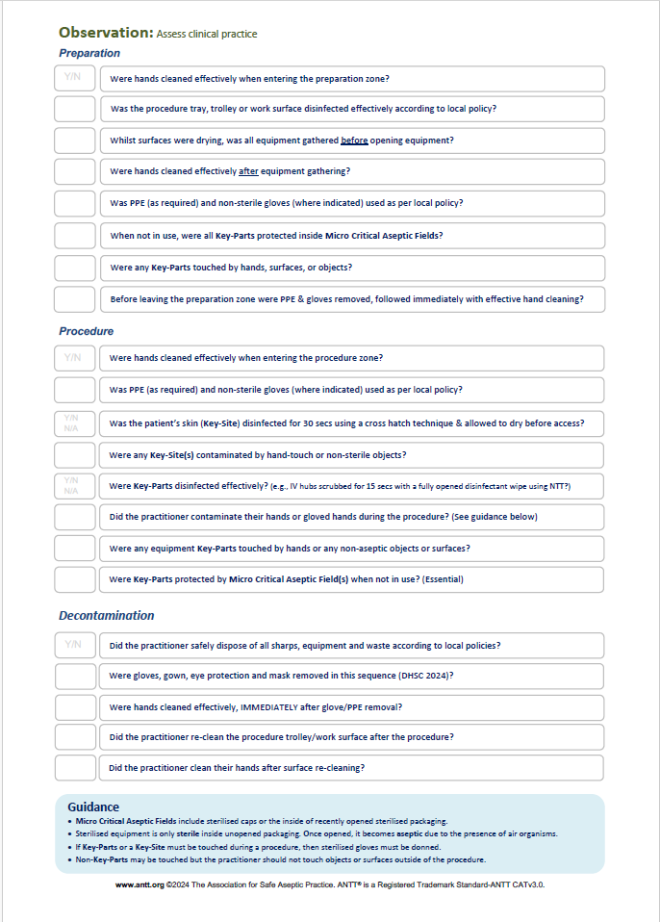

Appendix 6b: ANTT Competency Assessment Tool answers
(Taken from https://www.antt.org/downloads.html , May 2025)
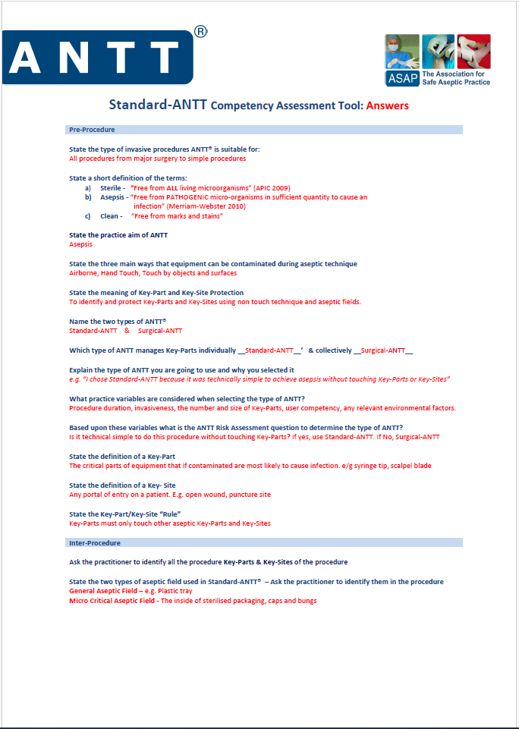

References
- National Patient Safety Agency alert 20: “Promoting safer use of Injectable Medicines” (2007). https://webarchive.nationalarchives.gov.uk/ukgwa/20171030131058/http://www.nrls.npsa.nhs.uk/resources/type/alerts/?entryid45=59812&p=3 [accessed April 2025]
- Cousins DH, Otero MJ, Schmitt E. Time to review how injectable medicines are prepared and administered in European hospitals. Farm Hosp. 2021;45(4):204-9.
- Royal College of Nursing: Standards for Infusion Therapy (4th edition, 2016). https://www.rcn.org.uk/clinical-topics/Infection-prevention-and-control-advice/Standards-for-infusion-therapy [accessed April 2025]
- Royal Pharmaceutical Society: Professional Guidance on the Safe and Secure Handling of Medicines (December 2018) https://www.rpharms.com/recognition/setting-professional-standards/safe-and-secure-handling-of-medicines/professional-guidance-on-the-safe-and-secure-handling-of-medicines?welcome=true [accessed April 2025]
- Professional Guidance on the Administration of Medicines in Healthcare Settings. Co-produced by Royal Pharmaceutical Society (RPS) and Royal College of Nursing (RCN) (2019). https://www.rpharms.com/Portals/0/RPS%20document%20library/Open%20access/Professional%20standards/SSHM%20and%20Admin/Admin%20of%20Meds%20prof%20guidance.pdf?ver=2019-01-23-145026-567 [accessed April 2025]
- NHS Improvement Patient Safety Alert: Restricted use of open systems for injectable medication (2016). https://www.england.nhs.uk/wp-content/uploads/2019/12/NHSI_Patient_Safety_Alert_-_Restricted_use_of_open_systems.pdf [accessed April 2025]
- Department of Health: Mixing of medicines prior to administration in clinical practice: medical and non-medical prescribing (2010). https://www.gov.uk/government/publications/mixing-of-medicines-prior-to-administration-in-clinical-practice-medical-and-non-medical-prescribing [accessed April 2025]
- Human Medicines Regulations 2012. http://www.legislation.gov.uk/uksi/2012/1916/contents/made [accessed April 2025]
- The Misuse of Drugs Act 1971 (Amendment) Order 2012. https://www.legislation.gov.uk/uksi/2012/1390/contents/made [accessed April 2025]
- National Patient Safety Agency: Rapid Response Report NPSA/2008/RRR05: Reducing Dosing Errors with Opioid Medicines (2008). https://webarchive.nationalarchives.gov.uk/ukgwa/20171030131053/http://www.nrls.npsa.nhs.uk/resources/type/alerts/?entryid45=59888%26p=3 [accessed April 2025]
- National Patient Safety Agency: Rapid Response Report NPSA/2010/RRR013: Safer Administration of Insulin (2010). https://webarchive.nationalarchives.gov.uk/ukgwa/20171030124154/http:/www.nrls.npsa.nhs.uk/resources/?entryid45=74287&p=7 [accessed April 2025]
- The Royal Marsden Manual of Clinical and Cancer Nursing Procedures (10th Edition, 2021)
- National Patient Safety Agency Rapid Response Report RRR02: Risks with intravenous heparin flush solutions (2008). https://webarchive.nationalarchives.gov.uk/ukgwa/20180501163616/http://www.nrls.npsa.nhs.uk/resources/type/alerts/?entryid45=59892%26p=3 [accessed April 2025]
- NICE Clinical Guideline: Intravenous fluid therapy in adults in hospital. https://www.nice.org.uk/guidance/cg174 [accessed April 2025]
- Specialist Pharmacy Service: Multiple Use of Injectable Medicines in Clinical Areas. Published February 2020. https://www.sps.nhs.uk/wp-content/uploads/2019/12/Multiple-Use-of-Injectable-Medicines-in-Clinical-Areas-V2-February-2020.pdf [accessed April 2025]
- Infection Prevention Society: Vessel Health and Preservation Framework 2020. https://www.ips.uk.net/vessel-health-and-preservation-framework-2020 [accessed May 2025]
- NICE Clinical Guideline: Healthcare-associated infections: prevention and control in primary and community care. https://www.nice.org.uk/guidance/cg139 [accessed April 2025]
- EPIC3: National Evidence-Based Guidelines for Preventing Healthcare-Associated Infections in NHS Hospitals in England. https://www.journalofhospitalinfection.com/action/showPdf?pii=S0195-6701%2813%2960012-2 [accessed April 2025]
- NIVAS (National Infusion and Vascular Access Society), Infiltration and Extravasation: A toolkit to improve practice, version 1 February 2024. https://nivas.org.uk/ [accessed May 2025]

