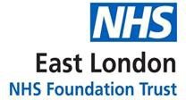

Standard Operating Procedure for Conservative Sharp Debridement of Wounds Applicable to Specialist Nurse(s) in Tissue Viability only

September 2025

Tissue Viability Service



Conservative Sharp Debridement of Wounds / Standard Procedural Document

Version number: | 2.0
Consultation Groups | Tissue Viability Teams London & Bedfordshire  Pressure Ulcer Team Newham & Tower Hamlets  Infection Prevention & Control Team
Approved by (Sponsor Group) | Nursing Development Steering Group & Infection Prevention & Control Team  Clinical Policy Alignment Group
Date approved | 5th September 2025
Ratified by: | Nursing Development Steering Group
Date ratified: | 9th September 2025
Name and Job Title of author: | Lead Nurse Tissue Viability
Executive Director lead: | Director of Nursing
Implementation Date: | September 2025
Last Review Date | September 2025
Next Review date: | September 2028

Services | Applicable to
Tissue Viability Services Trust wide | Yes
Pressure Ulcer Improvement Facilitators | Yes

Version Control Summary

Version | Date | Author | Status | Comment
V 1.0 | Aug 2022 | Carole Taylor | Implementation | Approved
V 2.0 | Sept 2025 | Carole Taylor | Reviewed amended and updated | Debridement pathway added

CONTENTS TABLE
Section Number | Section heading | Page Number
1.0 | Policy Summary | 5
2.0 | Overriding Duty of Care Statement | 5
3.0 | To whom this guideline applies | 5
4.0 | Background & Scope | 5
5.0 | Aims & Objectives | 6
6.0 | Quality Assurance & Audit | 6
7.0 | Dissemination | 7
8.0 | Educational Requirements | 7
9.0 | Assessment | 7
9.1 | Environment | 7
9.2 | Demographic | 7
9.3 | investigations | 7
9.4 | Medical History | 7
9.5 | Pain assessment | 7
9.6 | Wound History | 7
9.7 | Wound assessment & Surrounding skin | 7
9.8 | Identifying tissue that requires Conservative Sharp Wound Debridement | 9
9.9 | Investigations Ankle Brachial Pressure Index | 9
9.10 | Photography | 9
10.0 | Contraindications | 10
10.1 | Cautions | 10
11.0 | Procedure | 10
11.1 | Equipment | 10
11.2 | Practical procedure | 11
12.0 | Complications | 12
13.0 | References | 13
 | APPENDICES
1 | Wound Cleansing & Debridement Pathway | 15
2 | Tissue types encountered during conservative sharp wound debridement | 18

1.0 Policy Summary

This document has been written by the Tissue Viability Service (TVS) and contains guidance for Tissue Viability nurses and Pressure ulcer improvement Facilitators (PUIF) in Conservative Sharp Debridement (CSD) These guidelines should be read in conjunction with National Guidance _{8,10,11,12,13,} other literature relevant to the procedure _{1,2,3,4,5,6,7,9,14,16} the Clinical Practice Guidelines in the TVS Portfolio and the Infection Prevention & Control Policy, The Royal Marsden Hospital Manual of Clinical Nursing Practice, and the Trust Wound Dressing Formulary for London & Bedfordshire community services.

2.0 Overriding Duty of Care Statement

Should the content or operation of these guidelines be challenged on any grounds whatsoever then the impact on the past, present or future duty of care to patients will be taken to be a primary factor in deciding the outcome of that challenge.

3.0 To whom this Guideline applies Duties & Responsibilities

This document is aimed at Specialist Tissue Viability Nurses and the Pressure ulcer improvement facilitators who have successfully completed a validated educational programme in wound debridement, including assessment of competency in practice

4.0 Background & Scope

In order for wounds to progress towards healing wound bed cleansing and wound bed preparation is essential. Conservative Sharp debridement is carried out when there has been no improvement to the removal of the devitalised tissue such as necrosis or slough in the wound bed after following the Wound Cleansing and Debridement pathway (Appendix 1), or there is presence of biofilm which can delay healing and increase the risk of infection. Debridement describes any method which removes devitalised tissue types or biofilm to reveal tissue which will promote wound healing. Debridement can be achieved either through the use of wound care products or by conservative sharp debridement. This guideline will focus on the removal of devitalised tissue by Conservative Sharp Debridement (CSD).

This procedure will only be undertaken by Specialist Nurse(s) in Tissue Viability or by the pressure ulcer improvement facilitators who have successfully completed a validated educational programme in wound debridement, including assessment of competency in practice. Conservative sharp debridement is an extended role for the specialist tissue viability nurse/PUIF.

The NMC Professional standards of practice and behaviour for nurses, midwives and nursing associates (2018), recognises the dynamic nature of nursing and supports the development and advancement of nursing roles. Advanced nursing roles can be undertaken only where the nurse has completed the necessary training and is competent before carrying out the new role and is satisfied that the procedure is in the patient’s best interest.

This document is intended to provide a practical guide for the safe procedure of the conservative sharp debridement of wounds.

Wound preparation, which encompasses cleaning and the removal of devitalised tissue, involves preparing the surrounding skin and all areas of the wound for healing. Debridement is an accepted principle of good wound care, especially when debris is acting as a focus for infection.” The purpose of debridement is to:

- Determine the extent of the wound and identify any undermining
- Remove non-viable tissue
- Reduce the bacterial load and minimise risk of local and systemic infection
- Removal of Biofilm
- Allow wound drainage
- Reduce odour
- Promote healing
- To remove foreign material from tissue

Debridement is complete when 100% of the wound bed consists of healthy granulation Tissue.
When clinically indicated CSD provides a fast and effective method of wound debridement, however, nurses should be aware of the other methods of debridement available (Appendix1). The Tissue Viability Specialist Nurse/PUIF must have the knowledge and ability to select the appropriate method of debridement for each wound and apply it correctly. Often a combination of methods will be required to achieve rapid safe debridement. CSD may form part of an on-going program of debridement.

Methods of Debridement

The main methods of debridement are:
- Autolytic – Hydrating dressing
- Chemical/Enzymatic - Soloution
- Mechanical – Monofilament/Debridement pads
- Sharp (only by trained specialist nurses)
- Biosurgery - Larvae
- Hydosurgery
- Surgical (hospital settings)

.
5.0 Aims & Objectives

- To provide a reference guide for assessing and managing the wound bed prior to CSD
- To ensure an evidence-based, standardised approach to CSD.
- To provide a framework to ensure that the quality of care for patients who receive CSD can be monitored and improved in line with the Trusts quality improvement strategy.

6.0 Quality Assurance & Audit

The principles upon which this document is based are:

- An individualised holistic assessment should be undertaken and evidence-based treatment plans commenced, which take into account the underlying aetiology, patient’s circumstances and wishes, the overall goals of intervention, the practitioners clinical judgement, available resources and knowledge of more recent research findings.
- Those who undertake CSD should have successfully completed a validated educational programme in wound debridement, including assessment of competency in practice.
- The patient and their carers should be fully informed, given consent and share in the decision making process.
- The process should be clearly documented in the patient’s electronic records and made accessible to all those caring for the patient to ensure continuity of care.
- A collaborative, multi-disciplinary, inter agency approach is taken to meet the needs of patients.
- Patients, staff and carers should have access to the equipment and resources necessary to deliver quality care.
- Monitoring of healing rates and as an indicator of quality care should be undertaken regularly after each episode of CSD.

7.0 Dissemination

This document is available to all Tissue Viability Specialist Nurses and the Pressure Ulcer Improvement Facilitator on the Trust Intranet site.

8.0 Educational requirements:

Tissue Viability Specialist Nurses carrying out this procedure will:

- Be employed by East London Foundation Trust in the role of Specialist Tissue Viability Nurse/ PUIF
- Have completed an education programme in wound debridement, to include conservative sharp debridement, by a recognised Educational establishment and or endorsed, accredited and approved by the European Wound Management Association or Royal College of Nursing
- All specialist nurses wishing to undertake this technique must do so in line with the Nursing and Midwifery Code of Professional Conduct (NMC 2018)
- Be anatomically aware of the underlying structures within the area to be debrided (Appendix 2)
- Stop if they become uncomfortable, uneasy or uncertain at any time during the procedure
- Have approval from their employers to perform the extended role
- Do so as part of a treatment plan agreed with the multi-disciplinary team managing the patients care
- Be aware of local policies and guidelines related to wound management (e.g. Infection Control, Moving and Handling, Wound management Guidelines, Pressure ulcer Guidelines and Lower Limb Guidelines)

9.0 Assessment
Prior to CSD an holistic assessment will be completed and documented on the patients electronic records and will include:
  - Environment - If Home setting check
- Space available is suitable and not cramped/crowded
- Home Environment is clean and free of clutter in the area the procedure will be performed
- Lighting of good quality
- Pets must be secured away from the area the procedure will be undertaken
- Children must be supervised during the procedure

9.2 Demographic Details
- Date and time of initial assessment
- Name, address, NHS number, contact telephone number, date of birth
- District/Community/ Clinic nurses name, contact details
- GP's name, address, telephone number

9.3 Investigations
- Include any pathology test results
- Results of investigations; Vital signs, BMI, recent blood results, Scan reports, X-Ray reports, MRI reports, Ankle Brachial Pressure Index results following a Doppler ultrasound

9.4 Medical History
Past & Current medical history: e.g.
- Diabetes mellitus.
- Anaemia
- Deep vein thrombosis (DVT)
- Phlebitis of the affected leg
- Obesity
- Past surgery
- Any prolonged periods of bed rest i.e. more than 4 days
- Smoking & alcohol history
- Nutritional and hydration level
- Blood clotting problems
- Medications prescribed, over the counter and recreational drugs
- Allergies and skin sensitivities
- Functional ability

9.5 Pain
- Patient reported pain using a 1-10 scale with 10 being the most pain.
- Constant or intermittent
- Day or night
- At dressing change
- What helps the pain
- Impact of the wound pain on the patients quality of life

  - Wound History
- Cause of the wound
- Duration of wound
- Number of episodes
- Time to healing in previous episodes
- Ankle movement (leg ulcers)
- Measurement of ankle circumference (leg ulcers)

  - Assessment of wound and surrounding skin
- Record Site of wound(s) - position on the body and exact location. For example: medial, lateral, anterior, posterior, etc.
- Size of wound(s) – record maximum length by maximum width in centimetres. This should be recorded on the Wound Assessment Form/template in the patient’s electronic notes and should be repeated and compared with previous measurements every 4 weeks.
- Measure the depth of the wound where possible using a wound probe
- Assess and record the presence or absence of odour and exudate including colour, viscosity, and volume.
- Assess and record the appearance of wound bed to include colour i.e black/grey/green/yellow/red/pink.
- Assess and record the type of tissue i.e. necrotic, sloughy, granulating, epithealialising and estimate the depth and percentage of the tissue
- Assess and record exudate amount and type e.g. purulent, serous
- Note proximity to structures or anatomical features e.g. grafts, prosthesis, bone, tendon , ligaments etc
- Assess and record Peri wound skin and skin condition
- Assess for signs of infection and record findings.
- Clinical observations and changes to the wound bed and edges should be documented at each dressing change.

  - Identifying tissue that requires Conservative Sharp Wound Debridement
- Moist necrotic tissue – green, yellow, or grey appearance
- Dry necrotic tissue – dry and leathery, it appears as hard black/brown eschar.
- Slough – stringy moist necrotic tissue grey or yellow that adheres to the wound bed
- Haematoma- a collection of blood following trauma/ surgery.
- Hyperkeratosis of peri wound skin.
- Malodour is also an indication to provide conservative sharp wound debridement

9.9 Investigations: Ankle Brachial Pressure Index (ABPI)

Measurement ABPI using MESI or a hand held Doppler ultrasound should be taken during the initial assessment for all wounds present on the legs or foot.
ABPI assessment is not intended for the diagnosis of venous disease, but rather for exclusion of significant arterial disease and therefore confirmation of safe practice (i.e. to confirm that use of compression treatment is safe or it is safe to carry out CSD). Measuring ABPI provides an assessment of the patient’s peripheral arterial system. Please also refer to the Trusts Lower Limb Guidelines (2024)

The ankle brachial pressure index (ABPI) provides an index of vessel competency by measuring the ratio of systolic blood pressure at the ankle to that in the arm, with a value of 1 being normal. Measurement of the ABPI should be undertaken by an experienced operator using validated equipment

- ABPI less than 0.5 suggests significant arterial disease and an urgent referral should be made to vascular services. CSD should not be performed
- ABPI greater than 0.5 to less than 0.8 suggests the presence of arterial disease or mixed/venous disease. Refer the person for vascular assessment. CSD should not be performed
- ABPI between 0.8 and 1.3 suggests no evidence of arterial disease.
- For people with cardiac failure, consider seeking specialist advice as there may be a risk of fluid overload if not closely monitored.
- ABPI greater than 1.3 may suggest the presence of arterial calcification, such as in some people with diabetes, rheumatoid arthritis, systemic vasculitis, atherosclerotic diseases, and advanced chronic renal failure. Please seek advice from specialist services. CSD should not be performed
- ABPI values should always be interpreted in the context of signs and symptoms, for example, if it is within the normal range but the person has symptoms of peripheral arterial disease (such as intermittent claudication or rest pain), consider vascular referral and CSD should not be performed

9.10 Photography
- Photographs should be taken using a Trust camera/Trust mobile device on initial assessment and every four weeks with the patient's consent.
- Verbal consent can be obtained for photographs used for wound monitoring
and evaluation, triage and for providing information to the Tissue viability team for virtual advice
- Written consent must be obtained if the photographs are to be used for publication. Please use the Trusts consent form and upload the consent to the patient electronic records
- Photographs should be uploaded to the patient’s electronic records as soon as the clinician has access to the records and deleted from the camera/Trust mobile device.
- Refer to wound management guidelines (2022) for more information.

10.0 Contraindications to CSD

- wounds on ischaemic digits
- Gangrenous digits which should be kept dry and allowed to auto amputate as creation of a moist environment may precipitate wet, infected gangrene, which is potentially limb and /or life threatening _{(17,18)}
- Where ABPI result is outside of the safe range of 0.8 – 1.3
- Patients with blood clotting disorders
- Wounds that are fungating or malignant wounds
- Wounds on the foot (excluding heel region)
- Wounds on the hands and face
- Autoimmune ulcers
- Anatomical structures that cannot be identified
- Neonates and paediatrics
- Specialist Nurses should not undertake sharp debridement of wounds that are near the following structures:
  - Arterial structures
  - Vascular grafts
  - Prosthesis
  - Dialysis fistula
  - These should be referred to the appropriate Consultant Surgeon

10.1 Cautions for conservative sharp debridement
- lower limb wounds in the presence of ischaemia should be referred to the podiatrist and CSD should not be carried out by the specialist nurses alone
- Patients on long term anti-coagulant therapy e.g. Warfarin, Aspirin
- Patients on short term anti-coagulant therapy e.g subcutaneous Enoxoparin
- Wounds on heels and where there is a history of diabetes or PVD should be managed Jointly with Podiatry
- Wounds on the Achilles tendon area should be joint management with podiatry
- CSD in the presence of clinical infection may require systemic antibiotic cover

Decisions with regard to whether or not the debridement of ischaemic lower limbs is appropriate should be made by the by the Vascular team and not by the Tissue Viability Nurse Specialist or PUIF

11.0 Conservative sharp debridement procedure

  - Equipment
- Single use Scalpel with size 10, 11 or 15 blade
- Single use Sharp sterile scissors with a curved blade
- Single use Sterile metal toothed forceps
- Single use Curette
- Sterile dressing pack
- Haemostatic dressing
- Camera/Trust Mobile Device
- Sharps bin and container for safe disposal of clinical waste
- Post procedural wound dressing
- Bright Light
- Body Block to support lower limbs
- Personal protective equipment (PPE)
- Apron
- Gloves

11.2 Practical Procedure
Explain CSD procedure to the patient and ensure informed consent has been obtained. Consent may be verbal and documented fully in the Health Records.
if the patient lacks capacity to consent then consent must be written and obtained from the next of kin or those holding lasting power of attorney for health

Ensure that the patient is comfortable and in a position where the wound can be accessed and viewed easily.

The nurse carrying out this procedure should have access to good lighting and be in an appropriate and comfortable position to allow access to the area for debridement

Check pain level and If required apply EMLA anaesthetic cream according to manufacturer instructions and cover with film dressing. For non-prescribers this should be requested from GP

Prepare a sterile field and ensure all equipment and resources are in place.
Nurse to wear Personal Protective Equipment (PPE) throughout the procedure
An aseptic non touch technique (ANTT) should be applied for the purpose of
Conservative sharp debridement. The Four principles of an ANTT are:

- Always wash hands effectively following the hand hygiene policy
- Never contaminate key parts
- Touch non-key parts with confidence
- Take appropriate infective precautions

Cleanse the areas to be debrided with an appropriate cleansing solution

Lift the necrotic/sloughy tissue with suitable grasping forceps and cut it carefully with a scalpel or curved tissue scissors. The angle of the scalpel or scissors should be parallel to or angled away from the wound bed. Necrotic/sloughy tissue should be removed in layers.

Some wounds may require the use of a curette to debride the wound bed and disrupt a biofilm

The Specialist nurse should stop the procedure if either they or the patient becomes uncomfortable, uneasy or uncertain at any time during the procedure.

On completion of the CSD procedure, reassess the wound bed including photographing.

Redress according to Trust Wound Management Formulary

Dispose of the single use equipment, sharps and debrided tissue as per Trust
Clinical Waste Policy

Clean the camera, mobile device and body block using a disinfectant wipe such as
Clinell

Document the outcome of the procedure in the patient’s clinical record

12.0 Complications

The specialist nurse must be aware of the availability of medical support in the event
Of unforeseen or unexpected problems during CSD
- If any complications arise i.e. pain, damage to underlying structures and / or excessive bleeding the procedure should be stopped immediately.
- The patient should be reassured and appropriate action taken which may involve seeking medical assistance.
- The complications and subsequent action should be documented in the patient’s health records
- inform line manager, service lead and other health professionals caring for the patients
- Complete an incident form on the Trust Inphase reporting system.

REFERENCES

- Ashworth, J. (2002) Conservative sharp debridement: the professional and legal issues. Nursing Times accessed 17.06.25 from https://www.nursingtimes.net/archive/conservative-sharp-debridement-the-professional-and-legal-issues-01-06-2002/

- Bentley J, Bishai P, Foster A, Preece J (2005) Clinical competence in sharp debridement: an innovative course. British Journal of Community Nursing, Wound Care supplement. 10 (3) S6-13. Accessed 17.06.25 from https://www.researchgate.net/publication/7911666_Clinical_competence_in_sharp_debridement_an_innovative_course

- Benbow, M. (2007) Clinical governance & accountability in wound care management. Journal of Community Nursing accessed 17.06.25 from https://www.jcn.co.uk/journals/issue/02-2007/article/clinical-governance-accountability-in-wound-care-management .

- Benbow, M. (2008) Debridement and the removal of devitalised tissue. Journal of Community Nursing accessed 17.06.25 from https://www.researchgate.net/publication/288674096_Debridement_and_the_removal_of_devitalised_tissue

- Dowsett, C. (2002) The role of the nurse in wound bed preparation. Nursing Standard. 16 (44) p 69 – 76. Accessed 17.06.25 from https://www.researchgate.net/publication/11168969_The_role_of_the_nurse_in_wound_bed_preparation

- Edwards J. (2000) Sharp Debridement of Wounds. Journal of Community Nursing. 14: 1 Accessed 17.06.25 from https://www.jcn.co.uk/journals/issue/01-2000/article/sharp-debridement-of-wounds

- Fairburn K et al. (2002) A Sharp Debridement Procedure Devised by Specialist Nurses. Journal of Wound Care. 11:10, 371 – 375.

- Falanga V. (2004) Wound Bed Preparation: ~Science Applied to Practice. European Wound Management Association Position Document. London: Medical Education Partnership.

- Fulbrook, S. (2007). The duty of care 1: compliance with directives and protocols. British Journal of Nursing, 16 (1), 386 – 387.

- Health Service Circular (2001) Good Practice in Consent. NHS Executive. HSC 2001/023. Leaper, D. (2003) Sharp technique for wound debridement. World Wide Wounds accessed 14.07.25 from http://www.worldwidewounds.com/2002/december/Leaper/Sharp-Debridement.html

- National Institute of Clinical Excellence (NICE) (2020) Surgical site infections: prevention and Treatment: Technology Appraisal Guidance. 24. NICE. London. Accessed 14.07.25 from https://www.nice.org.uk/guidance/ng125

- National Institute of Clinical Excellence (NICE) (2019) Diabetic foot problems; prevention and management. Clinical Guideline NG19. NICE. London. Accessed 14.07.25 from https://www.nice.org.uk/guidance/ng19

- NMC (2018) The Code: Professional standards of practice and behaviour for nurses, midwives and nursing associates accessed 14.07.25 from https://www.nmc.org.uk/globalassets/sitedocuments/nmc-publications/nmc-code.pdf

- O’Brien, M. (2003) Debridement: ethical, legal and practical considerations. British Journal of Community Nursing wound care supplement. March 2003 8 (3suppl) page 23 – 25.

- G. Agrifoglio, M. Domanin, E. Baggio. (2000) EMLA Anaesthetic Cream for Sharp Debridement of Venous Leg Ulcers: A Double-Masked, Placebo-Controlled Study accessed 14.07.25 from https://journals.sagepub.com/doi/10.1177/026835550001500208

- Barrwtt,S., Dark.J., Dowestt,C. et al (2022). Best Practice Recommendations: Wound Preparation by cleansing and Debridement using Alprep Pad. Wounds UK, London. Accessed 14.07.25 from https://wounds-uk.com/best-practice-statements/wound-preparation-by-cleansing-and-debridement-using-alprep-pad/

- Leaper D. (2002) Sharp technique for wound debridement. World Wide Wounds accessed 14.08.2025 from http://www.worldwidewounds.com/2002/december/Leaper/SharpDebridement.html

- Vowden, KR and Vowden, P (1999) Wound Debridement, Part 2: Sharp techniques. Journal of Wound Care , 8 (6) 291-294

APPENDIX 1

Wound Cleansing & Debridement Pathway

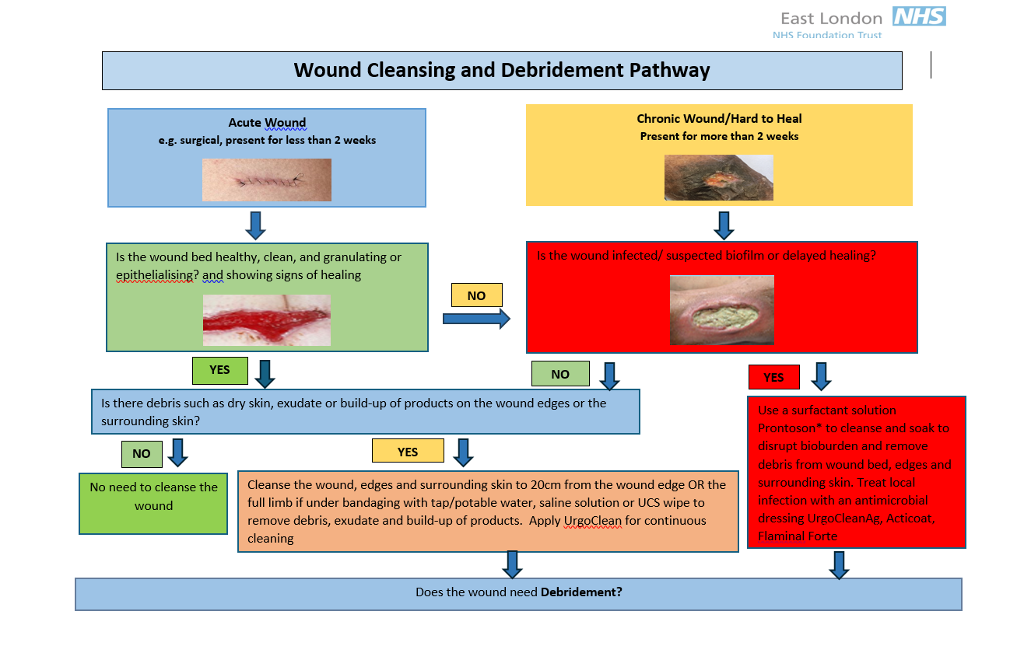
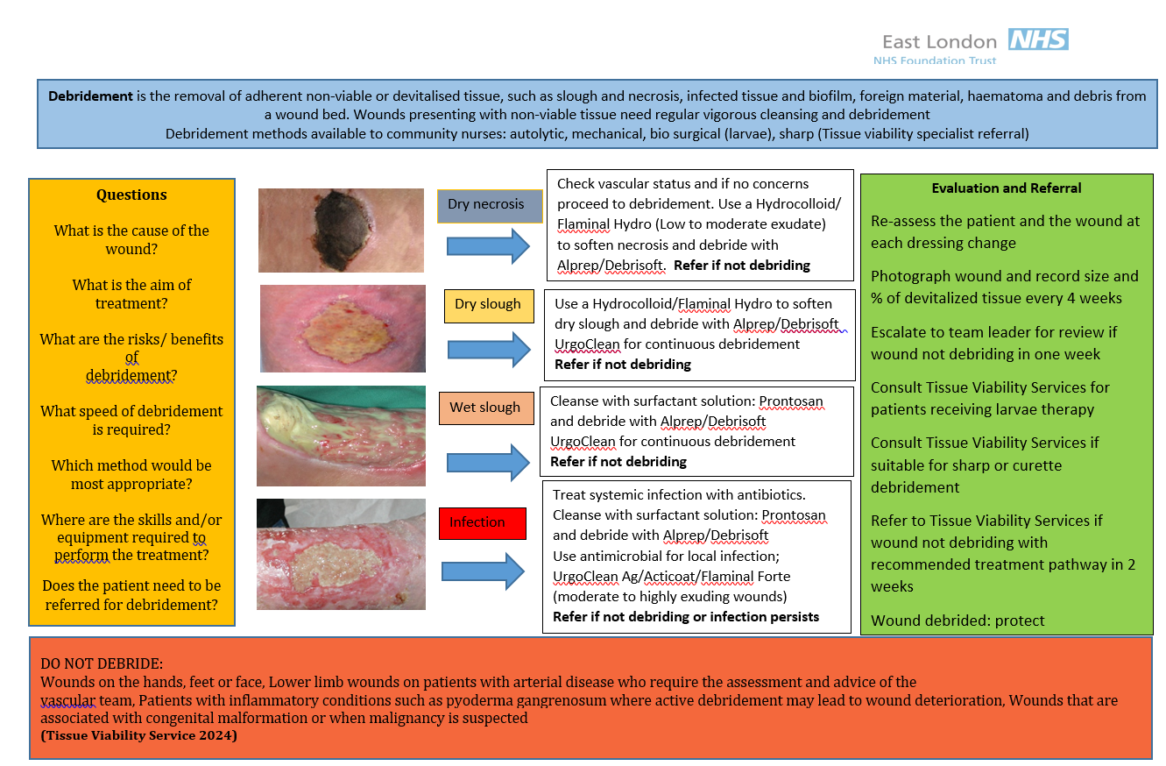

APPENDIX 2

Tissue types encountered during conservative sharp wound debridement

Tissue | Description
Subcutaneous | Mostly yellow fat: generally, there is  poor vascularity
Fascia | Shiny gleaming white. It is “tough” covering the muscles. Infection can spread along the plane (necrotising fasciitis)
Muscle | Dull red in colour, highly vascular and tears easily. Protects bones,  joints, nerves and vessels
Bone | Hard, bright and white. Desiccates rapidly if exposed and turns yellow
Cartilage | Connective tissue with poor vascularity. Covers the bone at the joint
Ligaments type 1 | White, fibrous, inelastic
Ligaments type 2 | Yellow elastic tissue
Tendons | Strong, gleaming white, shiny elastic fibrous tissue. Attach muscle to  bone, poor vascularity
Dead tissue | Necrotic Tissue  Dead tissue presents in a variety of forms  Necrotic tissue varies in appearance dependent on moisture content.  When dry necrotic tissue presents as hard, black eschar (leather like).  When moisture content rises the necrotic tissue changes to brown, then  yellow before breaking down into slough, which can be yellow/grey  fibrous tissue with a gelatinous surface attached to the wound bed  (NICE, 2005)

Adapted from Edwards, 2000

