REPORT TO THE QUALITY ASSURANCE COMMITTEE TRUST BOARD IN PUBLIC

June 2025

Title | Associate Director of Safeguarding
Author | Dinh Padicala
Accountable Executive Director  Delegated Executive Lead | Claire McKenna  Eileen Bryant

Purpose of the report

This is a combined adult and children Safeguarding Annual Report that has been adopted in line with the Trust’s shared safeguarding strategy. Its purpose is to inform Trust Board members of the progress regarding its responsibilities for safeguarding adults and children’s activity as part of its regulated and statutory responsibilities, and to ensure that patients, service users and carers know that safeguarding of adults and children is a Trust priority. The report outlines the work the Trust has done to strengthen safeguarding governance through better alignment of the safeguarding priorities. This report also includes the achievements, priorities and challenges for safeguarding during 2024-2025.

Committees/meetings where this item has been considered

Date | Committee/Meeting
09/05/2025 | Trust Safeguarding Committee

Key messages

The Executive team, the Corporate Safeguarding team and all staff across the Trust remain committed to ensuring that the safety and protection of our patients/service users and staff remains a key Trust priority.
This year has brought both challenge and reflection, prompting us to draw critical learning from national safeguarding failures, including the ongoing inquiries into Southport and Nottingham attacks. These events serve as powerful reminders of the serious consequences that can arise when concerns are overlooked, and systems fail to respond effectively.
At ELFT, we are proud to uphold a strong safeguarding culture, underpinned by high levels of training and supervision compliance, and driven by a shared commitment to professional accountability, compassionate care, and continuous improvement. These principles are central to our safeguarding approach and shape the way we respond across services.We recognise that ongoing financial pressures across the Trust present real challenges to safeguarding delivery. Workforce shortages, funding constraints, and rising demand place pressure on our teams and systems. We remain firmly committed to a whole family approach, recognising that safeguarding cannot be separated from holistic, person-centred care. Whether working in mental health, community services, or corporate teams, our staff collaborate across disciplines to ensure that children, adults, and families receive the right support at the right time.
This year marked key leadership milestones with the appointment of Lorraine Sunduza OBE as the Chief Executive Officer of ELFT and Claire McKenna as Chief Nurse and Executive Director of Safeguarding. Lorraine and Claire previously led the Corporate Safeguarding Team with clarity, compassion, and a deep-rooted dedication to protecting those most at risk. Their transition into this strategic role reflects both the outstanding leadership and the Trust’s commitment to safeguarding at the highest level. The safeguarding team has embraced new structures and worked through staffing pressures including vacancies and secondments with remarkable resilience and professionalism.
Among the team’s notable achievements is the launch of a new Quality Improvement project on Routine Enquiry into Domestic Abuse. This initiative aims to strengthen early identification of domestic abuse, enhance support pathways for service users, and ensure staff are equipped to respond sensitively and confidently to disclosures.
I extend our sincere thanks to the Corporate Safeguarding Team, our frontline staff, partner agencies, and Local Authority colleagues. Your vigilance, collaboration, and compassion form the bedrock of our safeguarding system. Together, we have responded to emerging risks, adapted to complex challenges, and continued to build a culture that places safety, dignity, and wellbeing at its core.
As we look ahead, we reaffirm our commitment to fostering a culture where safeguarding is everyone’s responsibility — where all voices are heard, concerns are acted upon, and people feel safe and supported. With continued partnership and an unwavering focus on our values — We Care, We Respect, and We Are Inclusive — we will remain a Trust where safeguarding is not only embedded in practice, but led from the heart.

Strategic priorities this paper supports

Improved population health outcomes | ☒ | By using safeguarding to identify and address abuse, neglect, and exploitation early, preventing long –term harm. Embed safeguarding within wider health and social care systems to reduce health inequalities and protect the most vulnerable.
Improved experience of care | ☒ | By ensuring safeguarding process are person –centred, trauma –informed, and respectful of individuals’ rights and dignity. Strengthen multi-agency collaboration to provide timely, coordinated support that builds trust and empowers those at risk.
Improved staff experience | ☒ | By providing clear safeguarding procedures, supportive supervision, and regular training to build confidence and reduce anxiety in managing concerns. Foster a culture of psychological safety where staff feel valued, heard, and supported when raising or responding to safeguarding issues.
Improved value | ☒ | By embedding safeguarding into all levels of care, leading to earlier intervention, reduce harm, and more efficient use of resources. This enhances outcomes for service users, supports staff confidence and retention, and strengthens the organisation’s reputation and accountability.

Implications

Equality Analysis | This report provides an overview of actions the safeguarding team have taken to identify inequalities that can contribute to vulnerabilities of service users and strategies to address these.
Risk and Assurance | The report provides assurance of the monitoring and understanding the occurrence of safeguarding practices and incidents with learning lessons.
Service User/ Carer/Staff | Positive service user impact
Financial | Review of team from external review resulting in increase of resources.
Quality | Increase in quality displayed through audits.

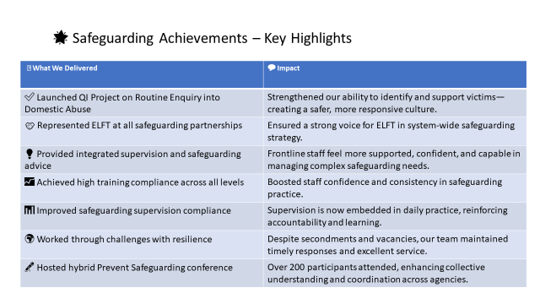

Introduction and background
This annual report provides a comprehensive overview of safeguarding activity across East London NHS Foundation Trust (ELFT), for the financial year 2024-25. It demonstrates the Trust's adherence to statutory duties under key legislation, including:

      - Children Act 2004
      - Mental Capacity Act 2005
      - Care Act 2014
      - Modern Slavery Act 2015
      - Equality Act 2010
      - Domestic Abuse Act 2021
The report aligns with the Safeguarding Accountability and Assurance Framework (2022), providing assurance to the Trust Board and external partners that effective safeguarding systems are in place to protect children, young people, and adults at risk.
The report outlines ELFT’s safeguarding performance, key achievements, and forward priorities. Safeguarding practice is underpinned by the Trust’s values—We Care, We Respect, We Are Inclusive—and reflects a commitment to proportionate, partnership-based responses to risk.
ELFT operates across East London, Luton and Bedfordshire, serving a highly diverse population with a workforce of 7,786 permanent staff. Safeguarding arrangements are delivered in close collaboration with multi-agency partners and are fully compliant with CQC Regulation 13: Safeguarding service users from abuse and improper treatment
- Governance and Accountability arrangements for Safeguarding
ELFT maintains a robust safeguarding governance framework, ensuring effective leadership, accountability, and multi-agency collaboration across all services and boroughs. Safeguarding is a core responsibility embedded at all organisational levels, reflecting the Trust's values.
Strategic Leadership and Internal Governance:
- The Chief Nurse serves as the Executive Director for Safeguarding, providing Board-level oversight and leadership.
- The Director of Nursing is the delegated executive lead responsible for delivering the Trust’s safeguarding strategy.
- The Associate Director of Safeguarding holds strategic and operational responsibility, ensuring the Trust meets its statutory safeguarding duties for children, young people, and adults at risk.
- Lead Professionals for Safeguarding Adults and Children provide operational leadership, oversee the corporate safeguarding team, and coordinate complex case management, training, and supervision.
- Named Safeguarding Professionals offer expert advice, training, and assurance, embedding safeguarding into everyday clinical practice.
- The Corporate Safeguarding Team operates under a 'Think Family' approach, supported by a unified Safeguarding Committee with integrated work plans.
Partnership Working and External Governance:
ELFT is committed to multi-agency collaboration, maintaining representation on five Safeguarding Adult Boards (SABs) and six Safeguarding Children Partnerships (SCPs) across its operational footprint.
The Trust contributes strategically and operationally through participation in various safeguarding partnership boards, subgroups, and local assurance meetings. This includes engagement in local audits, multi-agency training, and strategic reviews such as Safeguarding Adult Reviews (SARs), Child Safeguarding Practice Reviews (CSPRs), Domestic Abuse Related Death Reviews (DARDR), Channel Panels, and PREVENT/CONTEST Boards.
Direct contributions to local safeguarding reports and the implementation of actions are monitored by the Trust Safeguarding Committee. These arrangements ensure a cohesive safeguarding leadership, assurance, and accountability framework from frontline services to the Board, supporting the delivery of safe, inclusive, and responsive care.
- Reporting of Safeguarding activity
The Trust Safeguarding Committee meets quarterly to provide challenge and assurance regarding safeguarding arrangements and monitors compliance. Quarterly reports are submitted, providing assurance against responsibilities outlined in CQC Regulation 13, Contractual Safeguarding requirements, the Children Act (1989/2004), and the Care Act 2014.

4.0 Risk Register
During 2024/25, the Trust Safeguarding Committee maintained close oversight of safeguarding risks through quarterly reviews and active mitigation. The summary below outlines key risks, mitigation actions, and status.

Risk Area | Risk Description | Mitigation | Current Status
Safeguarding Referrals | Variability in staff recording practices led to underreporting in some boroughs. | Policy changes requiring all children’s safeguarding referrals via incident system. | Risk remains under monitoring
Prevent Training Compliance | National changes to Prevent Level 3 requirements caused a temporary dip in compliance. | Focused recovery plans implemented to restore compliance. | Risk removed from register
Non-Compliance with Mandatory Training | Low uptake of Level 2 and 3 safeguarding training for adults and children increased risk of unrecognised abuse or neglect. | Action plan introduced and monitored. Compliance improved. | Risk removed from register
Lack of Professional Curiosity | Failure to routinely exercise professional curiosity may result in missed safeguarding concerns. | Safeguarding supervision was strengthened across the Trust. | Risk removed from register
Impact of Team Restructure | Restructure led to increased staff responsibility, risking delays in support to services. | Digital changes and new leadership absorbed added responsibilities. | Risk removed from register
Workforce Shortages | Vacancies among Named Professionals paused non-urgent activities, affecting delivery capacity. | New staff members recruited to restore team capacity. | Risk remains under monitoring

5.0 Section 42 Responsibilities (Care Act, 2014)
The Trust continues to see growth in the number of section 42 enquiries being undertaken in all of its areas. In 2024-25 the Trust completed 863 enquiries compared to 643 the previous year. This was a 34.2% increase in enquiries compared to 2023-24 and a 102% increase from 2022–23.
The Trust has seen a much higher increase in section 42 enquiries compared to 2% record in 2023-24 nationally (national data from 2024-25 is not yet available). There are a number of reasons for the increased number of enquiries being undertaken by ELFT, namely:
- Changes adopted by some local authorities in how they record enquiries and adoption three level section 42 enquiry framework.
- Higher conversion rate of concern to enquiry following improvement work undertaken with mental health directorates to improve both the quality of referral and s.42 threshold decision making.
- Improved identification of safeguarding concerns following improvement work undertaken by the safeguarding team through training, safeguarding supervision and monitoring of InPhase alerts. This also tallies with the substantial increase seen in InPhase incidents with safeguarding adult implications.
- Within London directorates, increased focus on timeliness of completion of s.42 decision, resulting in higher conversion rate to full enquiries.
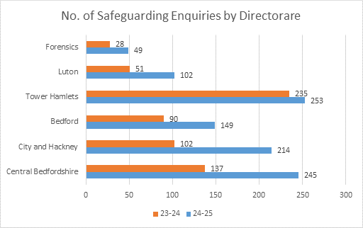

The most common location of risk for our patients is their own homes at 68%, but it should be noted a small but significant proportion is ELFT premises at 5% and highlights the necessity for close scrutiny and oversight of enquiries where adult are at risk or have experienced harm while in the Trust’s care. Similarly, in 7% of enquiries source of risk was an ELFT member of staff (mostly allegations of neglect or acts of omission).
The most common source of risk were adults at risk themselves and this reflects the high number of enquiries where self-neglect is a concern. Members of the adult at risk’s family, 12%, or their partner, 17%, account for the source of risk in 29% of ELFT enquiries. This is reflective of the higher proportion of enquires conducted by ELFT where there are concerns of domestic abuse.
The type of abuse of neglect in enquiries undertaken by ELFT, differs significantly from the national picture and reflects that 83% of ELFT safeguarding enquiries are undertaken with working age adults whereas the national average is the reverse with over 85% of enquiries conducted with adults over 65 years of age.
In ELFT, the most frequent type of abuse in enquiries is self-neglect at 22% compared to 8% nationally while neglect and acts of omission and organisational abuse are significantly less frequent then the national average. As a mental health Trust primarily working with working age adults the types of abuse and risks these adults encounter is different from adults in older age. Our patients are younger likely more physically well than older adults are and less likely to be receiving domiciliary, residential or nursing care. However, they have different sets of vulnerabilities and this is accounted in the higher proportion of enquiries where self-neglect, domestic abuse and sexual abuse are identified compared to the national averages. These differences in the risks faced by our patients informs our work plans, training and safeguarding supervision.

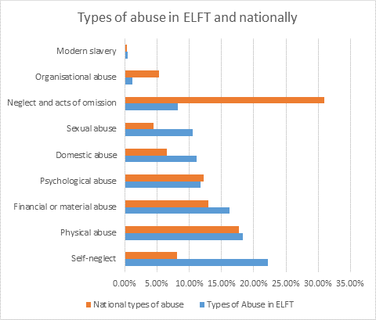
Service Directors hold bi-monthly Section 75 meetings with Local Authorities, providing updates on delegated safeguarding and social care activities, attended by the Trust safeguarding team.

5.1 Children’s Social Care Referrals (CSC) based on InPhase reporting
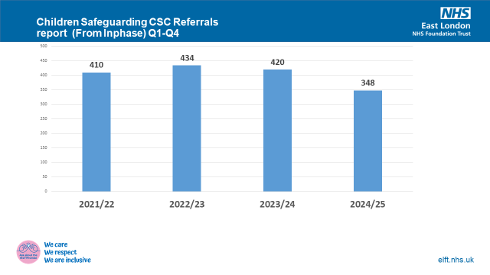

ELFT data indicates a 17% reduction in referrals to Children’s Social Care (CSC) in 2024-25 (348 referrals) compared to the previous financial year (420 referrals in 2023-24). This decline is partly attributed to challenges in accurately recording and capturing referral data within ELFT’s electronic systems, particularly when submissions are made directly via Local Authority portals and not consistently recorded on RiO. The use of multiple electronic patient record systems further complicates data collection.

To address these issues and enhance accountability, the Trust has implemented an improved reporting process for CSC referrals. From 1 April 2025, all staff are mandated to complete an InPhase incident report form concurrently with any child protection referral to CSC. This measure will enable timely and accurate data capture, effective oversight by the safeguarding team and prompt, effective intervention.

6.0 Looked After Children (Children in Care)
The Children in Care (CIC) health team is responsible for assessing and meeting the health needs of all looked after children and young people from Newham, whether residing within the borough or placed out of area. The team also assesses the health needs of children from other authorities placed in Newham upon request. A child ceases to be "Looked After" upon adoption, returning home, or reaching 18 years of age. Social care also maintains responsibility for Care Leavers up to 25 years, irrespective of educational status. The Newham CIC team continues to support 18–25 year-olds through the Leaving Care Nurse.
Children in Care often enter the care system with poorer health outcomes due to factors such as poverty, inadequate parenting, abuse, and neglect. These young people frequently originate from chaotic home environments or via the criminal justice system.
As of March 2025, Newham looked after 706 children, representing a 38% increase from March 2024. For children living outside Newham, the CIC team sees those within a 20-mile boundary, beyond which care is requested from the host Local Authority and health provider. In specific cases, the Newham CIC team conducts home visits. In 2024-2025, 236 children newly entered care in Newham, consistent with the previous year's figures.
Health Assessments and Reviews:
- Initial Health Assessments (IHAs): 63.5% of IHAs were completed within the 20-working-day timeframe in 2024-2025, a 13.1% increase from the previous year. The national average target for IHA completion is 85%. Breaches of the statutory timeframe and 'did not attends' are reported weekly to NEL ICB. Main reasons for breaches include late receipt of paperwork, clinic slot unavailability, and young person refusal.
- Under 5yr Review Health Assessments (RHAs): 75.1% of under 5s RHAs were completed within the set timeframe in 2024-2025, an 8% increase from the previous year. The national average target for under 5yr RHAs is 90%.
- 5yr - 18yr Review Health Assessments: 73% of over 5s RHAs were completed within the set timeframe, a 5.8% increase from the previous year. The national average is 90%. Reasons for non-completion include appointments cancelled by carers, young person refusal, and lack of consent from social worker. All cases of incomplete reviews are escalated to the child/young person’s social worker.
- ELFT CIC ensures all children and young people leaving care at 18 years have a completed Care Leaver’s health summary. In 2024-2025, 74% of care leavers had a completed health summary.
Unaccompanied Asylum-Seeking Young People (UASC):
33 UASC were seen in the integrated health care pathway in 2024-2025, a slight decrease from 34 in the previous year.
Children from Other Local Authorities:
By March 2025, the Newham Children in Care Health Team saw 116 children from other local authorities for IHAs and RHAs. This represents a decrease of 110 appointments from the previous year, primarily due to capacity constraints within the Newham CIC team.
Adoption Medicals:
Our medical advisor for adoption and fostering conducted medical assessments for 34 children in 2024-2025 prior to proposed adoptions, a 50% increase from the previous year.
CIC Governance and Reporting Arrangements:
The CIC health team actively participates in various governance and reporting forums:
- Attends Newham Joint Health Sub Group.
- Named Nurse attends the Newham Corporate Parenting Board, Corporate Parenting Board Operational Group, joint CIC and LBN meeting, and quarterly Foster Panel.
- Named Nurse attends the Clinical Governance meeting for Specialist Children’s and Young Peoples Services (SCYPS).
- Named Nurse submits monthly KPI data to NEL ICB.
- The clinical team undertakes quarterly essential audits in record keeping and infection control.
- The Named Nurse conducts an annual RHA audit with the Designated Nurse for CIC on behalf of NEL ICB.
- The Named and Designate Doctors conduct an annual IHA audit on behalf of NEL ICB.

7.0 Safeguarding Audits
In 2024-25, the safeguarding team conducted several multi-agency and Trust-wide audits. Findings, learnings, and recommendations were reported to individual staff members, managers, and the Trust Safeguarding Committee. These audits were initiated in response to learning from local and/or national case reviews or internal reviews. Audit outcomes are presented to the Safeguarding Committee for assurance and to ensure relevant learning is disseminated across directorates to improve or change practice.

The table below shows the audits undertaken in 2024/25 by the safeguarding team:

No | Audit Type | Audit Findings | Actions Taken | Progress
1 | Think Family Approach | - Good examples of family-inclusive practice identified.  - Gaps remain in recording the child’s lived experience, particularly where domestic abuse is a concern.  - Inconsistent recording of family members, especially non-resident or ‘invisible’ males. | - Safeguarding supervision now includes prompts to review family demographics and ensure accurate referral data.  - Practitioners reminded to use the Safeguarding Alert system and tools such as “Day in the Life”, Domestic Abuse Stalking, Harassment and Honour Based Violence Assessment (DASH), and the Pan-Beds Neglect Toolkit.  - The safeguarding children policy has been updated.  - A follow-up audit is scheduled for 2025–26 to include a larger sample across both adult and child records. | Ongoing. Policy review completed; re-audit planned. Staff engagement continues through supervision and newsletter updates.
2 | Voice of the Child in Adult Services | - Limited evidence of the child’s voice or safeguarding concerns being recorded in adult inpatient records.  - Discharge planning did not always reflect safeguarding action or parental responsibility arrangements. | - Audit tool updated to include child-focused prompts.  - Inpatient teams engaged via away days and supervision to promote correct safeguarding referrals.  - Operational leads reminded to update family demographics.  - Signposting to neglect tools, threshold documents, and escalation policy reinforced. | Partially implemented. Training and operational reminders in progress. Full impact expected following actions planned for 2025–26.
3 | Domestic Abuse (DA) Practice and Reporting | - DA concerns not consistently logged on InPhase.  - Discrepancies between DA data recorded in incidents and formal safeguarding reporting. | - InPhase entries reviewed and reclassified to improve DA categorisation.  - Targeted training sessions underway to address recording inconsistencies.  - Domestic Abuse newsletter and safeguarding intranet launched to improve staff awareness.  - Structured risk assessments promoted to support earlier identification of concerns. | Actions ongoing. Training and communication activities in place; formal review of impact scheduled for 2025–26.
4 | Child Neglect | - Neglect concerns were under-recorded or misclassified.  - Application of the Think Family approach inconsistent across services. | - Safeguarding reporting forms updated to reduce misclassification.  - Neglect screening tools standardised and shared via supervision.  - Annual audits planned with findings disseminated to teams.  - Staff encouraged to document lived experience and inter-agency activity. | Improved clarity in documentation and reporting. Further system updates scheduled for Q2–Q3 2025–26.
5 | Self-Neglect – City & Hackney | - Self-neglect safeguarding referrals have reduced, but the rationale is unclear.  - Further quality assurance of enquiry practice was required. | - Bespoke training developed and delivered on self-neglect, including use of the clutter scale.  - Training compliance checks for Safeguarding Adult Managers (SAMs) and enquiry officers introduced.  - Modular training package added to ELFT Learning Academy (ELA) platform.  - Audit findings shared during safeguarding supervision. | Majority of actions complete. Training and compliance monitoring continue to support sustained improvement.
6 | Forensic Services – Safeguarding Deep Dive | - Safeguarding practice had improved since the previous audit, though sustainability of improvements needed validation.  - Some inconsistency remained in enquiry recording and training compliance. | - Deep dive completed to assess impact of previous recommendations.  - Monthly safeguarding audits introduced at Directorate Management Team (DMT) level.  - SAM and enquiry officer training compliance tracked monthly.  - Bespoke training delivered, including guidance on RIO form completion and PIPOT.  - Audit findings embedded into supervision and monitored via forensic social work leadership. | Sustained improvement evident. Ongoing collaboration with forensic leadership. Monitoring and reporting now embedded into governance structures.

Key Themes Identified Across Audits
- Training & Supervision: Targeted efforts across all directorates to increase safeguarding competence and compliance.
- Data Quality: Enhanced InPhase reporting and audit tools introduced to improve accuracy and clarity.
- Child-Centred Practice: Renewed emphasis on capturing the voice and lived experience of children.
- Policy Alignment: Updated safeguarding policies to reflect Think Family and Domestic Abuse guidance.
- Continuous Learning: Use of repeat audits, supervision, and newsletters to drive quality improvement
- Safeguarding Training Compliance
The Trust operates under a Safeguarding Training Strategy and Training Needs Analysis, based on the Intercollegiate Document, Safeguarding Children and Young People: Roles and Competencies for Health Care Staff. Fourth edition (2019) and Adult Safeguarding: Roles and Competencies for Health care Staff. Second edition: July 2024

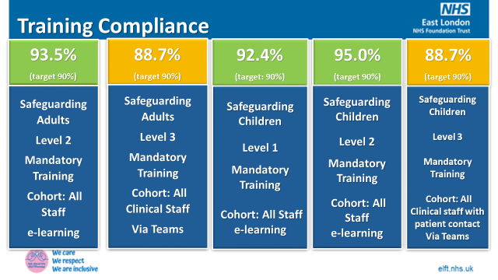

Safeguarding Training Compliance and Delivery
- The Trust has demonstrated strong improvement in safeguarding training compliance across both children and adult safeguarding in 2024/25:
- Level 3 Safeguarding Children training compliance rose to 89%, up from 83% in 2023/24 – a 6.7% increase year-on-year.
- Level 3 Adult Safeguarding training compliance saw a substantial rise from 62.3% to 89%, reflecting a 26.7% improvement over the reporting period.
The Safeguarding Team delivered 45 Level 3 training sessions for both adult and children’s safeguarding, training 2,763 staff members in 2024/25. While this is a 21% decrease in attendance compared to 3,485 staff in 2023/24, overall compliance improved due to more targeted training delivery aligned to strategic priorities.

Combined safeguarding training compliance for adults and children exceeded 88%, evidencing a well-coordinated and effective training approach that supports the Trust’s statutory obligations and quality standards.
Training Feedback
- 96% of staff rated their confidence and knowledge as 4 or 5 out of 5 after attending Level 3 training.

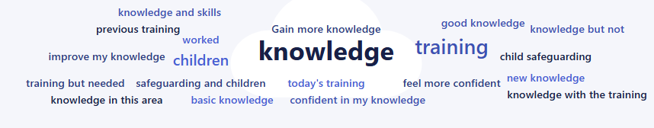

Prevent Training (Basic Awareness Prevent – BAP)
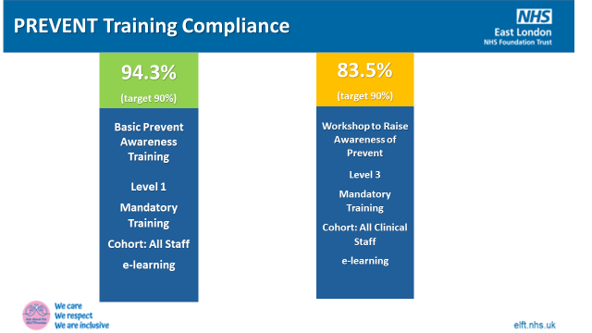
BAP Level 1 compliance remained consistently above the 90% target throughout 2024/25.
BAP Level 3 experienced a temporary decline due to a national change requiring refresher
training every three years. This adjustment led to a drop in compliance from 94% to 54% between Q4 2023/24 and Q1 2024/25. Recovery efforts have been effective, with compliance now at 83% and on track to reach the 90% target in Q1 2025/26.
- Safeguarding Supervision
Safeguarding supervision for both adults and children continues to be delivered in line with Trust policies, reinforcing our commitment to high-quality safeguarding practice. Supervision remains a key mechanism for assurance, reflective practice, and professional development. It provides a structured forum for learning, supports practitioners in managing emotional demands, and enables critical analysis of complex safeguarding concerns.
In 2024–25, there was a marked increase in both planned and ad hoc supervision activity across the Trust. Several services achieved 100% compliance, reflecting sustained engagement with the safeguarding supervision framework. Supervision is now well-integrated across service lines, delivered through face-to-face sessions, group work, 1:1 meetings, and telephone consultations.
The safeguarding supervision platform has evolved into a multi-functional tool for:
    - Delivering bespoke training by Named Professionals
    - Disseminating learning from local and national reviews
    - Sharing findings from audit activity and thematic analysis
Named Professionals played a key role in multidisciplinary forums such as High-Risk Panels, Complex Case Panels, MARAC, and Channel Panel, offering expert safeguarding advice and co-developing safety plans for complex cases.
The safeguarding team was contacted 2240 times for ad hoc supervision, and provided 958 planned supervision sessions, demonstrating a high level of demand. A data improvement project is underway to better capture the volume and complexity of supervision contacts, as current metrics underreport activity (one advice form per case, despite multiple interactions).
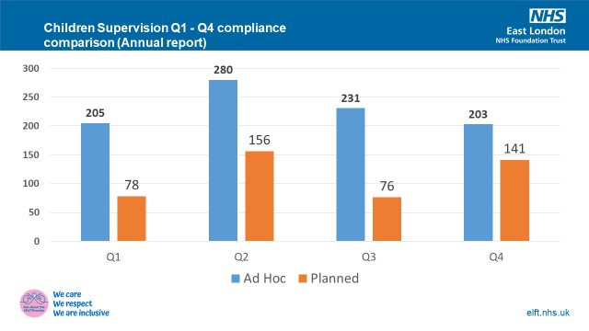
Children’s Safeguarding Supervision

- Ad hoc contacts: 919 in 2024–25 (up from 873 in 2023–24) — 5.3% increase
- Planned supervision sessions: 451 teams supported (up from 395) — 14% increase
- Top themes: parenting capacity & mental illness, domestic abuse — consistent with previous year

Adult Safeguarding Supervision
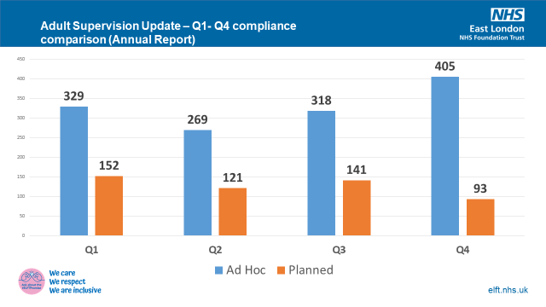
- Ad hoc contacts: 1321 in 2024–25 (up from 789) — 40% increase
- Planned supervision sessions: 507 delivered (up from 461) — 10% increase
- Some sessions were postponed due to staffing constraints
- Top themes: domestic abuse, self-neglect, and neglect/acts of omission — consistent across years
Supervision remains central to embedding a “Think Family” approach. Integrated safeguarding conversations ensure staff consider the broader familial impact of presenting issues, especially where parental needs affect child or adult safety. The development of new data tools will enhance insight into emerging supervision themes, driving proactive safeguarding across all services.

The most common themes discussed during safeguarding supervision are as follows:
Safeguarding Adults | Safeguarding Children
Section 42 cases | Parenting Capacity with mental health issues
Complex cases involving safeguarding, mental capacity and potential criminal allegations. | Domestic Abuse
Domestic Abuse and responding to high level risk | Neglect
Self-Neglect and hoarding issues | Non-recent abuse
Non-recent abuse and information sharing | Children mental health, sexual abuse risk
Person in position of trust (PiPOT) – how to report and respond | LADO (Local Authority Designated Officer) issues
Mental Capacity and DoL’s related practice issues.

- Safeguarding Reviews
The safeguarding team have contributed to several statutory reviews within the time frame of the annual report. This includes providing reports based on agreed terms of reference regarding children and adults in the family home and their contact with Trust services. There is also a requirement to attend panel meetings, practitioner learning events, provide feedback to draft reports, sign off panel to agree final reports and meetings about publication and publicity arrangements.
Safeguarding Adults Review (SARs)
Safeguarding Adult Reviews 2024–25

Identifier | Review Type | Link
Joe - Bedfordshire | SAR | Published September 2024 - Click here
Steve - City and Hackney | SAR | Published November 2024 - Click here
JL- City and Hackney | SAR | Published September 2024 - Click here
Thematic Self-Neglect- Luton | SAR | Published: Final LSAB Thematic SAR Self-Neglect alongside an Executive Summary Thematic SAR Self Neglect.
Family T | Integrated Safeguarding Review | Published: Click here
Lilian - Newham | SAR | Published April 2024 – Click here
Tower Hamlets |  | No published SARs this financial year.

Safeguarding Children Practice Reviews (CSPRs) - 2024–25
Identifier | Type of Review |  | Link
Isabella - Central Bedfordshire, Suffolk and Norfolk | Published CSPR |  | Click Here
Child A - City and Hackney | Published CSPR |  | Click Here
Extra Familiar Harm and intra familiar abuse thematic review- Newham | Published CSPR |  | Concerns of serious youth violence - Click here
Child H - Newham | Published CSPR | Concerns of neglect, Concerns of neglect, parental and carer responsibility  Click Here

Domestic Abuse Related Death Reviews (DARDRs) - 2024-25
Identifier | Type of Review | Link
Jane - Central Bedfordshire | DARDR | Click Here

The safeguarding committee receives updates and learning from these reviews and monitors any actions put in place to address any systems gaps or issues identified from the reviews.
- PREVENT Duty

The Trust responded to 30 Prevent related concerns in 2024-25. These range from general enquiries to request by Channel Panel from assessments of people’s mental health.

In 2024-25 the Trust made 7 Prevent referrals which is a slight increase compared to three Prevent referrals in 2023-24 which is consistent with the national picture.

The Trust’s Safeguarding team and operational teams attend Channel Panel meeting every month and contributes to the discussions for the panel to make informed decision on cases.

The Trust continues to attend and participate in Prevent workshops and events in East of England and London.

The Associate Director of Safeguarding and the Lead Professionals for Safeguarding attend the PREVENT and CONTEST boards to update them of the work done by the trust and provide inputs to their work plan

On 26th March 2025, the Trust hosted the Safeguarding Prevent Conference in partnership with Tower Hamlets Prevent team to raise awareness of Prevent. The training was open to other partners across the East London and Luton landscape, and was attended by 202 people.

- Domestic Abuse
There continues to be Trust representation at the local Multi Agency Risk Assessment Conference meetings (MARAC), at the respective Community Safety Partnerships and at the Domestic Abuse Strategic Leaders group.
The Trust has seen a sharp increase in the number of Domestic Abuse Related Death Reviews (DARDR’s) and the Safeguarding team have been involved in about 22 ongoing DARDR’s across the Trust.
The Corporate Safeguarding team has developed and rolled out a number of Domestic Abuse training sessions throughout the year for the staff to raise awareness and to ensure early identification of domestic abuse among patients and staff members.
The Corporate Safeguarding team is doing a Routine Enquiry QI project. This project seeks to strengthen the trust’s approach to routine enquiry for domestic abuse by embedding a robust, proactive, and patient-centred framework. The objectives are to improve identification of domestic abuse experienced by our patients and optimise response to provide a more compassionate, effective and trauma-informed approach for patients experiencing domestic abuse. The project is in its early stages and is receiving positive feedback where staff have introduced routine enquiry process.
The Trust “Domestic Abuse Steering” group meets bi-monthly to plan and identify areas of work that needs strengthening within the organisation to appropriately respond to concerns of domestic abuse. The meeting is chaired by the Associate Director of Safeguarding and is attended by the Corporate Safeguarding team, the Named doctors and the Public Health team. The group has a DA action plan to support the work, and reports into the Trust Safeguarding Committee.
The Safeguarding team organised 16 days of action to raise awareness of Domestic Abuse and also shared learnings from published DHRs.
To support the victims of Domestic Abuse, Trust has acquired organisational membership with Respect, a Domestic Abuse charity.
- InPhase reported incidents (2024-25)

All patient safety incidents reported via InPhase are reviewed by the Corporate Safeguarding team to identify indicators of abuse, neglect, or poor care. This process supports frontline decision-making and strengthens safeguarding vigilance across the Trust.

In 2024–25, the Trust saw a substantial rise in reported safeguarding incidents, underlining improved awareness and reporting but also highlighting key thematic challenges.

Adult Safeguarding: Volume and Patterns
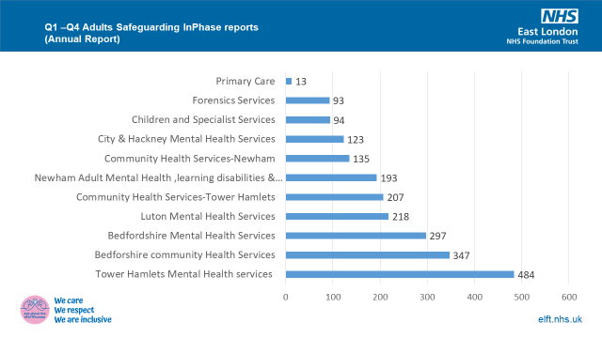

- A total of 2,204 Adult safeguarding incidents were reported in 2024–25, up from 1,115 in 2023–24—an increase of 97%.
- The majority were reported by Mental Health services (1,408 incidents), followed by Community Health services (689 incidents).
- Highest reporting came from:
- Tower Hamlets Mental Health: 484 incidents
- Bedfordshire Mental Health: 297 incidents
- Luton Mental Health: 218 incidents
- Bedfordshire CHS: 347 incidents

Types of Abuse
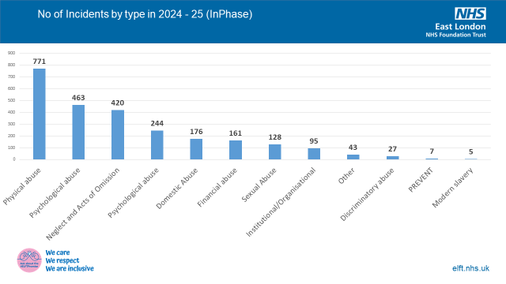

- Physical Abuse was the most reported category, primarily due to patient-on-patient violence in inpatient units, reflecting the Trust’s significant inpatient mental health footprint.
- Neglect and Acts of Omission and Self-Neglect followed closely. Community Health Services raised most Neglect-related concerns, while Community Mental Health Teams reported the most Self-Neglect cases.
- Benchmarking suggests similar trends in other NHS mental health trusts, where physical abuse is frequently the most reported type due to inpatient settings.
Domestic Abuse Reporting
- 176 Domestic Abuse incidents were reported in 2024–25, excluding those categorised under physical, emotional, sexual, or financial abuse.
- This number is likely under representative, as incidents involving physical injury are often misclassified solely under physical abuse.
- The Corporate Safeguarding Team is proactively reviewing incident classifications to improve the visibility of Domestic Abuse within the dataset.
Other Notable Issues
- Financial Abuse showed an increase in Q3 and Q4.
- Organisational Abuse remains stable but low.
- Discriminatory Abuse is still underreported, suggesting further training is needed to support recognition and reporting.

- Children’s Safeguarding: Volume and Themes
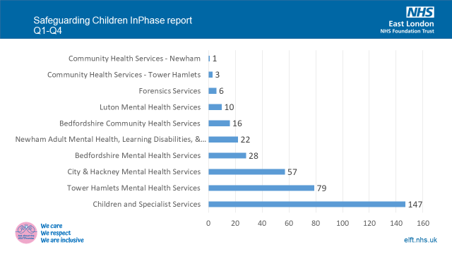
- 369 Safeguarding Children’s incidents were recorded in 2024–25, compared to 420 the previous year.
- Specialist Children’s Services reported the most incidents (147), followed by:
- Tower Hamlets: 79
- City and Hackney: 57
- Neglect remains the leading category, followed by Emotional and Physical abuse.
14.1 Referral Activity
Although only 369 incidents were recorded in InPhase, 984 referrals were submitted by ELFT staff to local authorities based on partial data from Hackney, Newham, and Bedford.
This discrepancy highlights a known challenge—duplicate recording across multiple systems (InPhase, Rio, Emis, System One Care Path and LA portals) is often bypassed by frontline staff due to time constraints.
14.2 Systemic Improvements
To address underreporting and data fragmentation:
- A new policy now mandates an InPhase entry for all CSC referrals.
- The Safeguarding Team has operational policies and providing staff guidance to standardise children’s safeguarding incident reporting and improve visibility.
- The rise in reported safeguarding incidents via InPhase demonstrates a growing organisational awareness and staff engagement in safeguarding responsibilities. While this is encouraging, improvements in recording accuracy, category recognition, and system integration are crucial to understand the themes, trends and risks in the organisation.

- Modern Slavery Declaration

The Trust is compliant with the responsibilities to have a statement regarding its commitment to ending Modern Slavery, through its support and oversight of the Modern Slavery Act 2015. This is available on the Trust website - modern-slavery-and-human-trafficking-statement-2023.

Modern Slavery and trafficking is included in the Level 2 and 3 training package offered to Trust staff.

- Allegations against staff

Despite all efforts to introduce safety mechanisms there will be occasions when allegations are made. All staff have a responsibility for safeguarding and promoting the welfare of adults and children and a duty to report any concerns they may have about service users, members of staff (including bank, agency and honorary, unpaid, volunteers, contractors and those seconded from other services) and visitors.

Within the reporting period, a total of twenty-two cases of staff allegation were managed by the Human Resources team which remains consistent with the previous year. Seven of the cases were closed and did not require any further escalations or DBS referrals. Thirteen case met the Local Authority Designated Officer (LADO) threshold, however were closed after the review meeting with no further action.
- Workforce

Statutory guidance requires the Trust to have robust arrangements for safe recruitment practices including identity and DBS checks for all new and existing every three years. At the end of the financial year the percentage of staff with a valid Disclosure and Barring Scheme (DBS) check was 98.77%. This was due to a number of staffs members being off sick, on maternity leave and career break.

The Trust made a total of 8 DBS referrals in 2024-25 after the completion of the staff disciplinary process.
- Safeguarding Challenges

- Rising Complexity of Need across Age Groups. There has been a notable increase in cases involving individuals, both children and adults presenting with intersecting risks. In children, this includes a convergence of mental health concerns, school exclusion, exploitation, and neglect. For adults, self-neglect, hoarding, with co-existing mental health conditions have been increasingly reported. These complex presentations often require prolonged safeguarding input, multi –agency coordination, and multiple interventional responses from the safeguarding team that go beyond initial intervention.
- Mental Health Pressures and Perplexing Presentations- Children and young people are experiencing a sustained rise in emotional distress, self-harm, and suicidal ideation, particularly impacting schools and CAMHS services. Similarly, adults are presenting with complex and often undiagnosed mental health conditions that underpin safeguarding risks such as self-neglect and resistance to care. The Trust continues to prioritise early identification and trauma-informed responses, supported by safeguarding supervision and on-going support from the safeguarding team.

Domestic Abuse and Coercive Control - Domestic abuse remains a persistent safeguarding concern across all demographics, including older adults, carers, and neuro-divergent populations. Despite progress, the routine enquiry QI is not yet embedded across all services, and remains a key area for improvement in 2025–26. The Trust’s ongoing QI project aims to normalise and strengthen routine enquiry into domestic abuse, ensuring staff are confident in identification of, and response to Domestic Abuse.

Exploitation and Online Harm - Nationally Child sexual and criminal exploitation, including county lines activity and intra-familial abuse, continues to affect all age groups, often compounded by online grooming and digital risk. For adults, increasing cases of modern slavery, trafficking, and exploitation are linked with homelessness, poverty, and substance misuse. Intelligence sharing across agencies remains a challenge, necessitating improvements in joint working and timely information exchange.

Impact of the Cost-of-Living Crisis -The continued impact of economic hardship is evident in safeguarding referrals across all age groups. Families and individuals are facing heightened stress, hidden neglect, food insecurity, and housing instability. Higher thresholds for statutory intervention are reported across local systems, placing additional demand on safeguarding teams to offer sustained and holistic support.
- Systemic Pressures and Workforce Resilience -The safeguarding team experienced significant staffing shortages for much of the financial year. Despite this, the team demonstrated resilience and professionalism by absorbing additional responsibilities to maintain service delivery. Named Professionals fulfil highly specialist and demanding roles that require advanced expertise, emotional resilience, and regular opportunities for reflection and development. In recognition of this, the Trust provides monthly restorative supervision to support their wellbeing, enhance practice, and promote staff retention.
- Improve data visibility and reduce duplication- Currently, duplicate safeguarding reporting across some areas of the Trust undermines the ability to gain a coherent, accurate view of safeguarding activity and risk. The absence of consistent local data or centralised entries in the Trust’s recording system limits the organisation’s visibility and inhibits effective risk governance.

- Key Priorities for 2025-26

Priorities | Actions
Domestic Abuse | - Implementing Routine Enquiry in services embedding a trauma informed approach to responding to domestic abuse.  - Introducing Domestic Abuse Ambassadors across the Trust to raise awareness of Domestic Abuse and the use of Routine Enquiry
Trainings | - Self-Neglect and hoarding - In Progress  - Legal Framework - In Progress  - Responding to Allegations - In Progress  - LADO/Pipot - In Progress  - Neglect - In Progress  - Domestic Abuse - Intergenerational and Intersectional training- In Progress  - Integrated Level 3 refresher training  - Safeguarding and Anti-racist practice
Co-production | - Developing training package and leaflets with support from experts by experience
Learning from reviews | - Offering staff bi-annual training to cascade learnings from reviews.  - Introducing “Let’s Change Practice” Newsletter when SAR’s, DARDR’s, CSPR’s, Section 42 enquiries and complex safeguarding cases.
Improved Data Visibility | - To reduce duplication in safeguarding reporting to enhance oversight of risk and progress across all services.
Safeguarding Quality Assurance | - To develop a new quality management framework that integrates quality planning, quality control, quality assurance, and quality improvement across all safeguarding processes within ELFT

- Conclusion:

- During 2024-25, the safeguarding team had some staffing challenges which impacted on progressing with some of the safeguarding priorities and the safeguarding work plan.

- Despite the challenges, some of the objectives were achieved. Areas such as training, reporting, and auditing has improved and embedded in staffs practice as evidenced in this report.

- The current work plan will be reviewed and updated for the next 3 years. It will incorporate some of the ongoing work started in 2024/25 and will be reviewed by the Corporate Safeguarding team based on the priorities of the Boards and Partnerships. Progress will be monitored by the Safeguarding Committee

- Finally, this report seeks to acknowledge and provide focus to the numerous excellent safeguarding achievements which have occurred during 2024/25 There are a great number of committed staff who work impeccably to support and serve our service users and their families, and the Safeguarding team would like to acknowledge them all.

- The Board/Committee is asked to:

- RECEIVE and NOTE the report
- NOTE the assurance provided and CONSIDER if further sources of assurance are required

ELFT Strategic Objective |  | No. Safeguarding Objective | Action Required |  | Lead | Evidence  Measures | Time scale and Progress Update |  | RAG
Improved Population Health Outcomes |  | 1. Promote Preventative and Early Intervention Safeguarding Across ELFT  The Corporate Safeguarding Team will lead on embedding a preventative safeguarding culture across the Trust by strengthening early intervention, equipping staff with the knowledge, skills and confidence to recognise and respond to safeguarding concerns affecting service users of all ages. |  |  | - The Named Professionals and Lead Professionals are responsible for the operational delivery of the actions in the work plan.  - The Associate Director is primarily accountable for delivering the safeguarding strategy and coordinating the implementation of the work plan.  - The Trust Safeguarding Committee provides the strategic governance and assurance |  | Quarterly performance report to safeguarding committee evidencing the following areas of work :  - Training Compliance  - Planned Supervision compliance  - Ad hoc advice compliance  - Audit Reports  - Inphase analysis reports  - Action Plan progress of safeguarding reviews.  - Training feedback  Safeguarding Adults and Children’s dashboards |  | Qtr 1
  - Deliver level 3 Safeguarding training
  - Deliver targeted training on early safeguarding indicators, including Routine Enquiry into Domestic Abuse (REDA)
  - Provide quarterly safeguarding supervision across services with a focus on prevention
  - Monitor and report local safeguarding trends through InPhase
  - Ensure updated policies and protocols reflect preventative safeguarding best practice
  - Undertake monthly audits to identify learnings and good practice
  - Cascade learnings from safeguarding reviews via Safeguarding Newsletters and “Let’s Change Practice” messages
  - Percentage of staff trained (target ≥90%)
  - Pre/post training evaluation
  - Attendance records
  - Supervision logs
  - Staff feedback surveys
  - Audit of supervision compliance (≥85%)
  - Quarterly reports- Examples of actions taken from trend analysis
  - Log of policy reviews- Version-controlled documents- Staff awareness checks
  - Safeguarding Annual Report
 |  |  |  |  |  |  |  |  | Qtr 2
 |  |  |  |  |  |  |  |  | Qtr3
 |  |  |  |  |  |  |  |  | Qtr 4
ELFT Strategic Objective |  | No. Safeguarding Objective | Action Required |  | Lead | Evidence Measures | Time scale and Progress Update |  | RAG
Improved staff experience |  | 2. Enhance Learning from Safeguarding Reviews and Enquiries  The Corporate Safeguarding Team will ensure that learning from statutory and non-statutory safeguarding reviews—including SARs, CSPRs, DHRs, PFDs, and LeDeR reviews—is actively shared across the organisation and used to influence practice, policies, and system-wide improvement. |  |  | - The Named Professionals and Lead Professionals are responsible for the operational delivery of the actions in the work plan.  - The Associate Director is primarily accountable for delivering the safeguarding strategy and coordinating the implementation of the work plan.  - The Trust Safeguarding Committee provides the strategic governance and assurance |  | - Corporate Safeguarding team to attend all boards/partnerships and subgroups  - Corporate Safeguarding team to engage in the safeguarding review process.  - Corporate safeguarding team to cascade learnings from reviews via newsletter, supervision, training and attendance at strategic trust meetings.  - Corporate Safeguarding Team to monitor how much impact learning lessons are having on changing practice and embedding learning.  - Attendance of service user at Trust Safeguarding Committee and interview panel. |  | Qtr 1
  - Ensure Named Professionals contribute to all SAR/DHR/CSPR/PFD/LeDeR reviews
  - Share learning through newsletters, workshops, training and supervision
  - Monitor application of learning through practice audits
  - Ensure lessons learnt are cascaded at borough DMT and Quality Forums
  - Record of IMRs/chronologies submitted- QA logs by Lead Professional/Associate Director
  - Copies of safeguarding newsletters
  - Staff training logs- Feedback from training sessions
  - Audit reports demonstrating practice change
  - Case studies shared at Safeguarding Committee
  - Meeting minutes and slide decks- Action logs with local team commitments
 |  |  |  |  |  |  |  |  | Qtr 2
 |  |  |  |  |  |  |  |  | Qtr 3
 |  |  |  |  |  |  |  |  | Qtr 4
ELFT Strategic Objective |  | No. Safeguarding Objective | Action Required |  | Lead | Evidence  Measures | Time scale and Progress Update |  | RAG
Improved Experience of care |  | 3.Ensure Making Safeguarding Personal and Voice of the Child are Central to Practice  The Corporate Safeguarding Team will ensure that all safeguarding interventions are person-led, outcome-focused, and aligned with the principles of Making Safeguarding Personal (MSP), with clear consideration of the views, wishes and lived experience of service users, including children. |  |  | - The Named Professionals and Lead Professionals are responsible for the operational delivery of the actions in the work plan.  - The Associate Director is primarily accountable for delivering the safeguarding strategy and coordinating the implementation of the work plan.  - The Trust Safeguarding Committee provides the strategic governance and assurance |  | Quarterly performance report to safeguarding committee evidencing the following areas of work:  - Training Compliance  - Planned Supervision compliance  - Ad hoc advice compliance  - Audit Reports  - Inphase analysis reports  - Action Plan progress of safeguarding reviews.  - Training feedback  Safeguarding Adults and Children’s dashboards |  | Qtr 1
  - Audit safeguarding documentation for evidence of MSP/Voice of the Child
  - Co-produce safeguarding feedback form in partnership with people with lived experience
  - Deliver staff training focused on applying MSP principles in complex cases
  - Audit case files to ensure the Voice of the Child is central to all decision making
  - Embed TIC principles into all safeguarding training, supervision and advice
  - Provide quarterly reflective safeguarding supervision sessions with TIC emphasis to cascade the practice
  - Collect safeguarding feedback from service users when enquiries are completed
  - Deliver integrated safeguarding training
  -
  - Service user attendance at safeguarding committee and interview panel
  - Training evaluations
  - Case studies presented at Trust Safeguarding Committee
  - Audit reports demonstrating practice change
  - Service user experience to be incorporated in safeguarding training
 |  |  |  |  |  |  |  |  | Qtr 2
 |  |  |  |  |  |  |  |  | Qtr 3
 |  |  |  |  |  |  |  |  | Qtr 4
ELFT Strategic Objective |  | No. Safeguarding Objective | Action Required |  | Lead | Evidence Measures | Time scale and Progress Update |  | RAG
Improved Population Health Outcomes | 4. Domestic Abuse and Routine Enquiry  Corporate Safeguarding team to implement routine enquiry into domestic abuse across ELFT services using the QI methodology, underpinned by a trauma-informed approach, and supported by the introduction of Domestic Abuse Ambassadors to promote awareness, consistency, and staff confidence in responding to disclosures. |  |  |  | - The Named Professionals and Lead Professionals are responsible for the operational delivery of the actions in the work plan.  - The Associate Director is primarily accountable for delivering the safeguarding strategy and coordinating the implementation of the work plan.  - The Trust Safeguarding Committee provides the strategic governance and assurance |  | Quarterly performance report to safeguarding committee evidencing the following areas of work :  - Training Compliance  - Progress of the Routine Enquiry QI project  - Planned Supervision compliance  - Ad hoc advice compliance  - Audit Reports  - Inphase analysis reports  - Training feedback  - Feedback from the Domestic Abuse Steering group |  | Qtr 1
  - NP’s to roll out REDA training across priority services
  - Embed REDA prompts into assessment documentation and electronic patient records (e.g. RiO)
  - Identify and train Domestic Abuse Ambassadors in each borough/service
  - Deliver quarterly REDA reflective forums for Ambassadors
  - Monitor the implementation and outcomes of REDA through supervision, audits and safeguarding reporting
  - Percentage staff trained
  - Pre/post knowledge evaluation
  - Updated templates approved
  - Audit of completed REDA documentation
  - Ambassador list and role descriptions- Training logs and ongoing support arrangements
  - Forum attendance records- Summary reports on challenges and impact
  - Staff feedback and REDA case study examples
 |  |  |  |  |  |  |  |  | Qtr 2
 |  |  |  |  |  |  |  |  | Qtr 3
 |  |  |  |  |  |  |  |  | Qtr 4
ELFT Strategic Objective | No. Safeguarding Objective |  | Action Required | Lead |  | Evidence Measures |  | Time scale and Progress Update | RAG
Improved Value | 5. Quality Assurance  Corporate Safeguarding team to design and implement a safeguarding quality management framework to strengthen accountability and assurance by embedding quality indicators that aligns with safeguarding activity with broader governance and quality priorities. |  |  | - The Named Professionals and Lead Professionals are responsible for the operational delivery of the actions in the work plan.  - The Associate Director is primarily accountable for delivering the safeguarding strategy and coordinating the implementation of the work plan.  - The Trust Safeguarding Committee provides the strategic governance and assurance |  |  |  | Quarterly performance report to safeguarding committee evidencing the following areas of work :  - Changes introduced to improve the quality of safeguarding reporting  - Utilising PowerBi reporting for safeguarding  - Reducing recording duplication  - Real time progress of the safeguarding activity across the Trust | Qtr 1
  - Co-produce a safeguarding quality management framework aligned with CQC regulation 13 and ELFT standards
  - Define measurable safeguarding quality indicators in line with statutory reporting
  - Integrate quality control mechanisms into supervision, audits and training
  - Implement quarterly quality assurance safeguarding audit cycle
  - To develop and published framework document
  - Agreed set of indicators across children and adults safeguarding-
  - Percentage of improvement in compliance or outcomes over time
  - Evidence of actions tracked to service improvement
 |  |  |  |  |  |  |  |  | Qtr 2
 |  |  |  |  |  |  |  |  | Qtr 3
 |  |  |  |  |  |  |  |  | Qtr 4
ELFT Strategic Objective | No. Safeguarding Objective |  | Action Required | Lead |  | Evidence Measures |  | Time scale and Progress Update
Improved Value | 6. Improve data visibility and reduce duplication  Currently, duplicate safeguarding reporting across some areas of the Trust undermines the ability to gain a coherent, accurate view of safeguarding activity and risk. The absence of consistent local data or centralised entries in the Trust’s recording system limits the organisation’s visibility and inhibits effective risk governance. |  | - Map current safeguarding reporting pathways  - Standardise safeguarding data entry protocols  - Integrate unrecorded local safeguarding activity into corporate reporting  - Define minimum safeguarding data requirements for local teams  - Audit data quality and duplication | - The Named Professionals and Lead Professionals are responsible for the operational delivery of the actions in the work plan.  - The Associate Director is primarily accountable for delivering the safeguarding strategy and coordinating the implementation of the work plan.  - The Trust Safeguarding Committee provides the strategic governance and assurance |  | - To identify where duplication occurs and where local data is missing.  - To ensure all safeguarding activity is consistently captured in the Trust system  - To develop plans for integration or local data retention.  - Establish minimum data requirements for local teams to hold and report  - Audit to see improvement in data completeness. |  | - Monitor and audit data entries quarterly to track reduction in duplication and improvement in data completeness.  - Report quarterly to the Safeguarding Committee on progress towards reducing duplication and improving data visibility. | Qtr 1
 |  |  |  |  |  |  |  |  | Qtr 2
 |  |  |  |  |  |  |  |  | Qtr 3
 |  |  |  |  |  |  |  |  | Qtr 4

Appendix- 2 Organisational Chart

