

MS Teams

User’s Guide for ELFT Corporate users.

Table of Contents.
Contents
Table of Contents. 1
Accessing MS Teams. 3
MS Teams Overview. 3
Joining MS Teams As an External Participants. 5
Scheduling a Meeting on MS Teams 6
Meeting access: 7
Roles 8
Adding Participants and Co-Organiser During a Meeting. 9
Participation 10
Recording and Transcription 11
Guest Access to Recording 11
Advanced Protection 11
Production tools/Anonymity 12
Joining MS Teams Meeting as an ELFT Staff 13
External Participants Joining MS teams Meeting. 14
Universal Meeting Link 15
Attendance Reporting 16
Breakout Rooms 17
Breakout Room Features. 18
Hosts Broadcasting Text messages Within Breakout Rooms. 20
MS Teams Meeting Chat 20
Pop Out Chat Manually When Messaging Participants Directly. 21
Chat Messaging Features 23
Moderate Q & A with Anonymity 27
Screen Sharing MS Teams 28
See Participants and Chats Simultaneously. 29
29
Sharing from a Dual Monitor on Teams 30
Splitting Windows in MS Teams Meeting 30
MS Teams White Board Feature 33
MS Teams Gallery View 34
34
Hiding, Pin, Spotlight, Remove Participant from Gallery View 35
MS Teams Webinar 36
Add Co-Organiser and Presenter 37
Saving Webinar Information Before Publishing 37
Event Access 38
Event Capacity; Host Registering Participants 39
Webinar Meeting Options 40
Inflight of Webinar Meeting - Meeting Option Changes 41
Anonymise Participants in Webinar Meetings 41
Participants Joining MS Teams Webinar internally (ELFT) & Externally 42
Sending Webinar online link to participants /Attendees to join. 42
Sending Webinar to participants /Attendees to join via MS Outlook Email. 43
MS TEAMS FAQ 45

Accessing MS Teams.
To access MS Teams as an ELFT staff you need to have an ELFT work account created by ELFT IT technical team. You can access MS Teams via your laptop, desktop, tablet, and mobile phone.
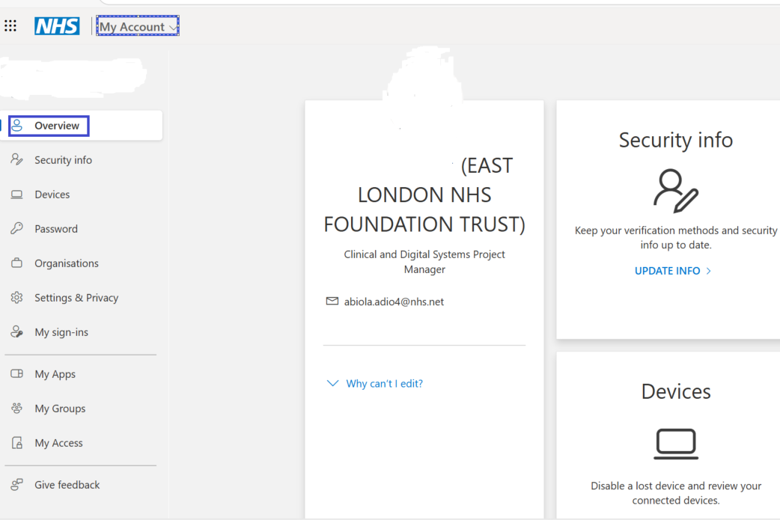
Fig 1.MS Teams account

MS Teams Overview.
MS Teams navigation icons
- Chat
- Teams
- Calendar
- Call
- One Drive
- NHS mail
- Activity
- Planner
- …

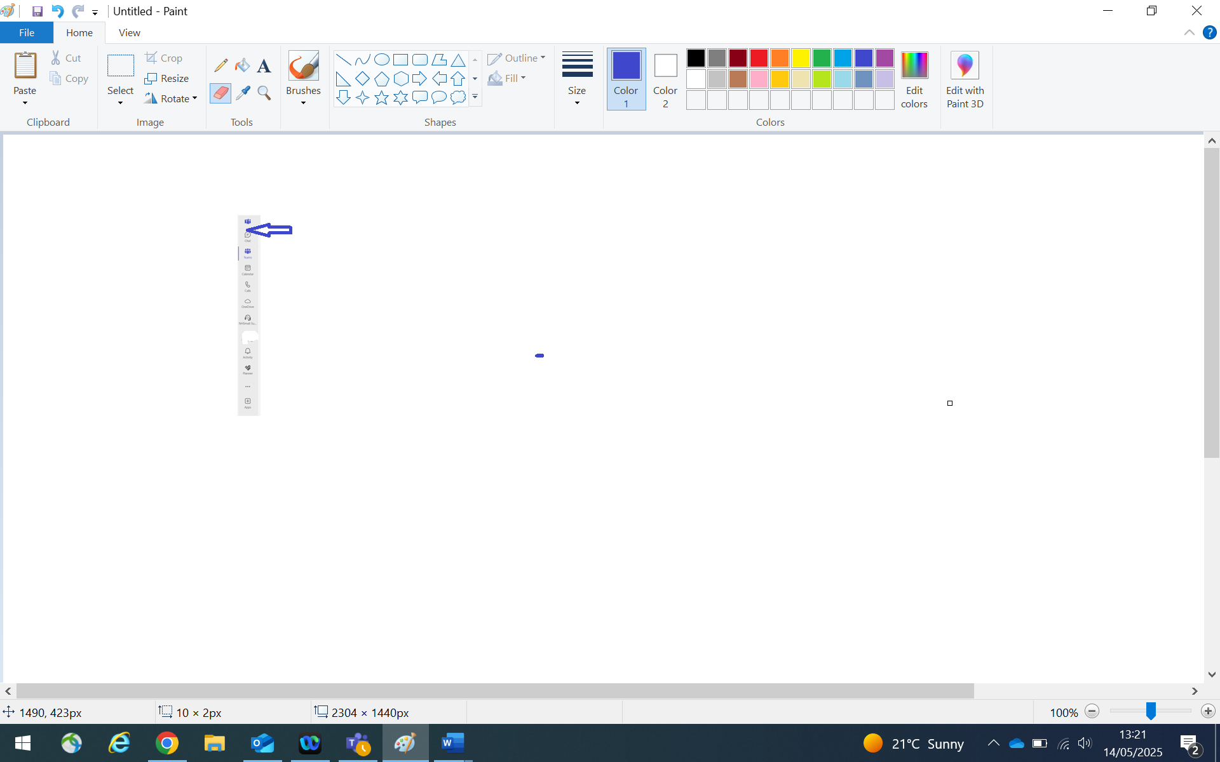
Fig 1.2 MS Teams icon only icons needed would be visited later in this guide.

Joining MS Teams As an External Participants.
External participants can join MS teams via a web browser either on a laptop, desktop and mobile by downloading MS Teams. You only need to download MS Teams once and if you are an existing user, you would not need to download MS teams.
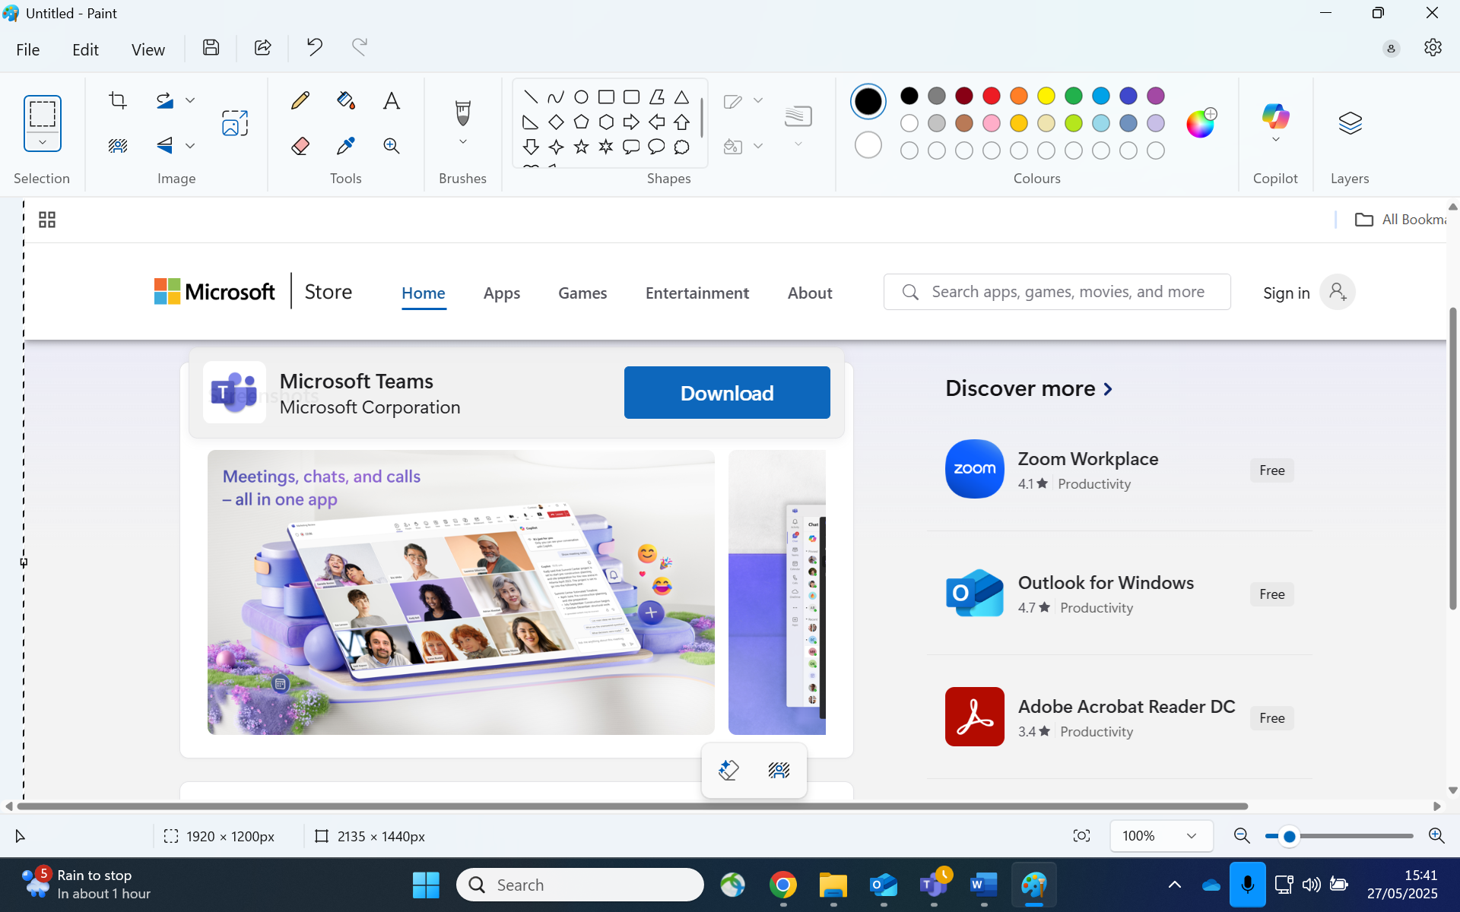
Fig1.3 Joining MS Teams on a web browser.

External participants can join MS Teams via an App store if the participants have an iPhone mobile or an iPad. If using and Android phone, you can download MS Teams via the play store.
You only need to download MS Teams App once and if you are an existing user of MS teams you would not need to download MS Teams.
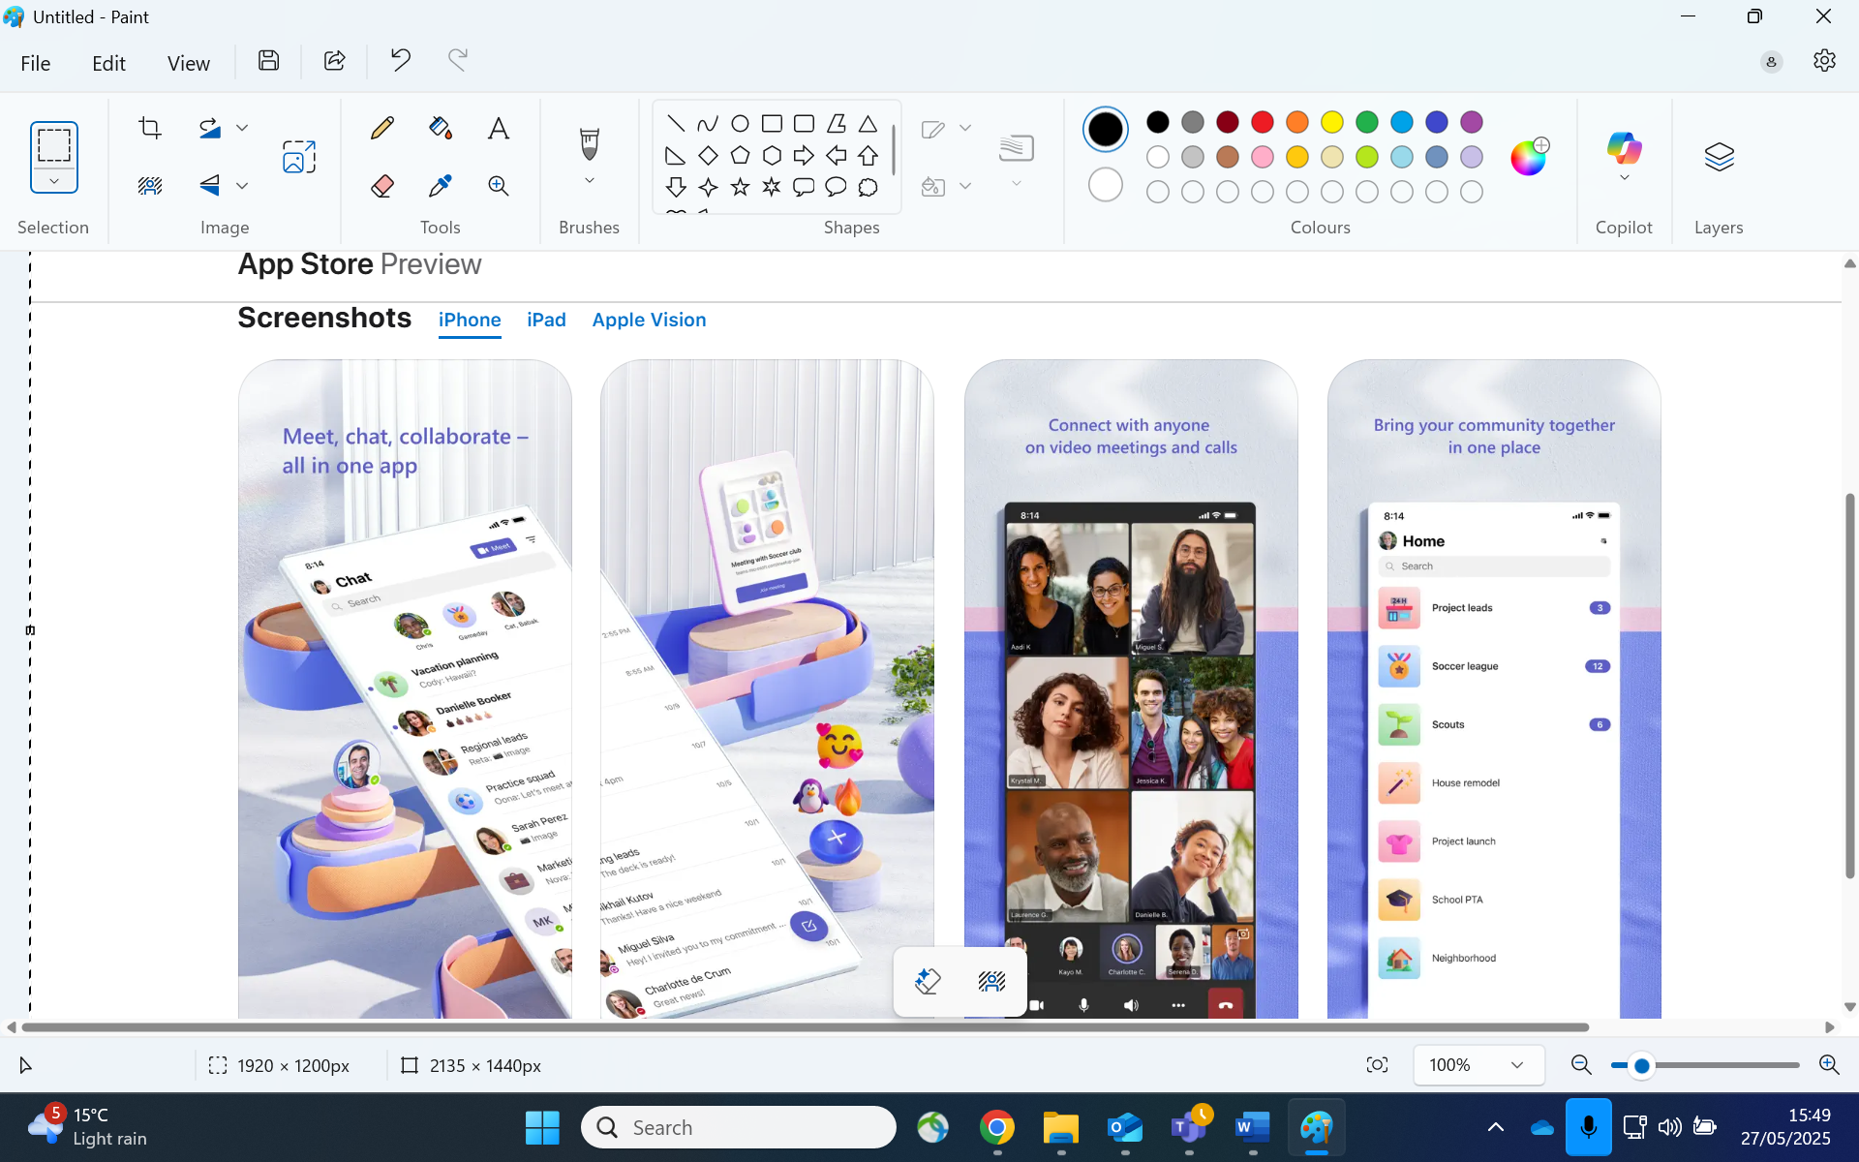
Fig 1.4 Joining MS Teams via an Appstore

Scheduling a Meeting on MS Teams
To schedule a meeting on MS Teams, navigate to:
- Click on the calendar icon and the calendar page opens.
- Click on a meeting date.
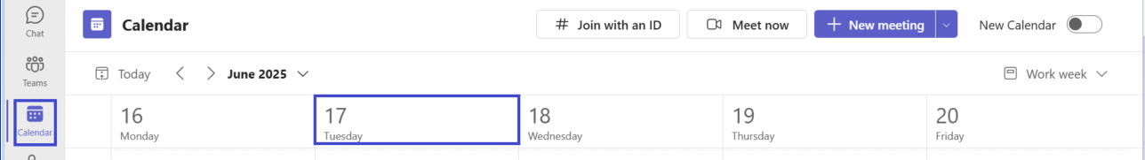
Fig 2.1 MS Teams calendar

Upon clicking on the calendar page, the window below opens:
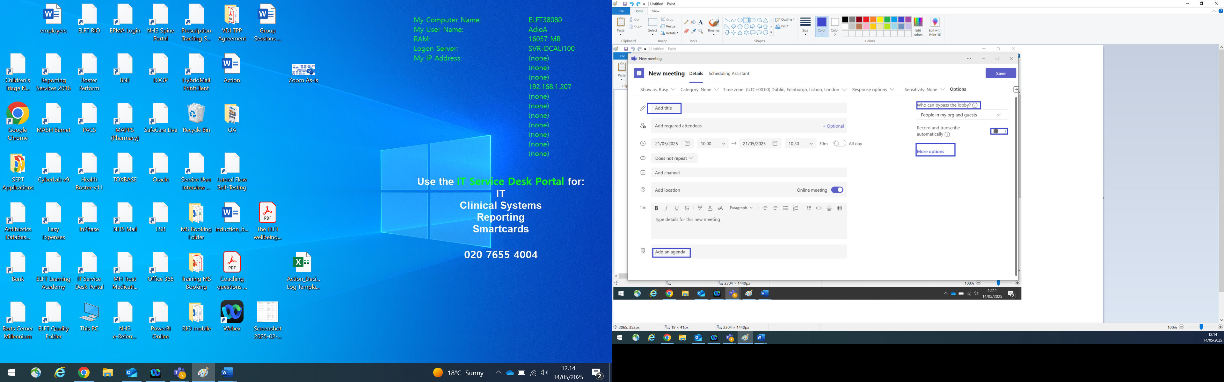
Fig 2.3 MS Teams New meeting page.

Complete the details on the page as follow:
- Meeting title
- Date and time.
- Add an agenda.
- Click on who can bypass the lobby to choose who can bypass the lobby.
- Click on record and transcribe if recording and transcribing the meeting.
- Click on save.

Upon clicking on more options, the meeting options window opens which enables:
- Meeting access
- Advanced Protection
- Roles
- Production Tools
- Participation
- Recording transcription
- Copilot and other AI.

Meeting access: Hosting/Organising a meeting and Lobby Access
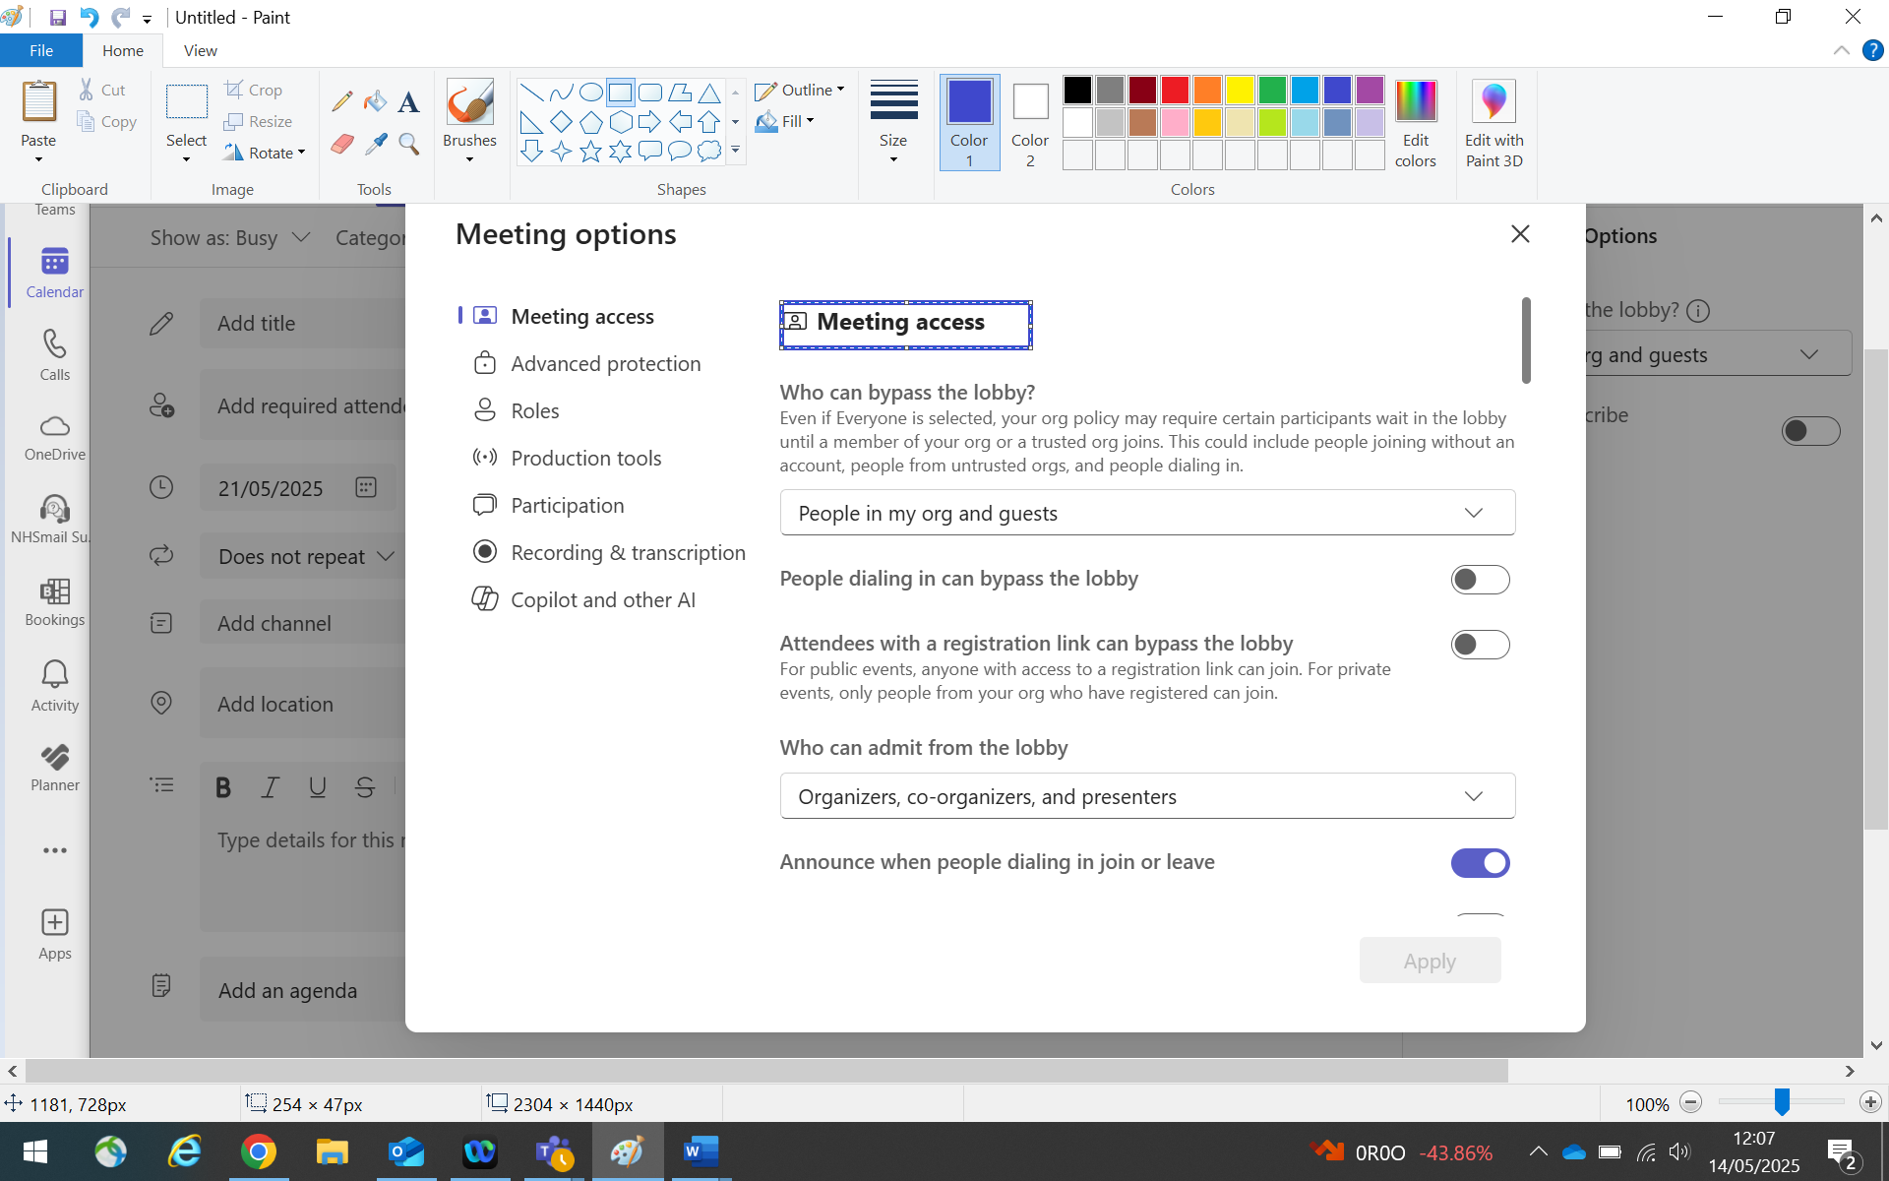
Fig 2.4 Meeting access page.

Organiser: When hosting a meeting you can:
- Choose who can bypass the lobby from the drop-down menu.
- Choose if people dialling in can bypass the lobby.
- Choose if attendees with a registration link can bypass the lobby.
- Choos e who can admit from the lobby.
- Choose to announce when people dialling in join or leave.

Roles: Co-organisers and Presenters.
Navigate to the roles icon to choose:
- Co-organisers: Who is Co-organising with you.
- Presenter/Who can Present: Everyone participating.
People in my org and guests
Specific people.
Only organisers and co- organisers.

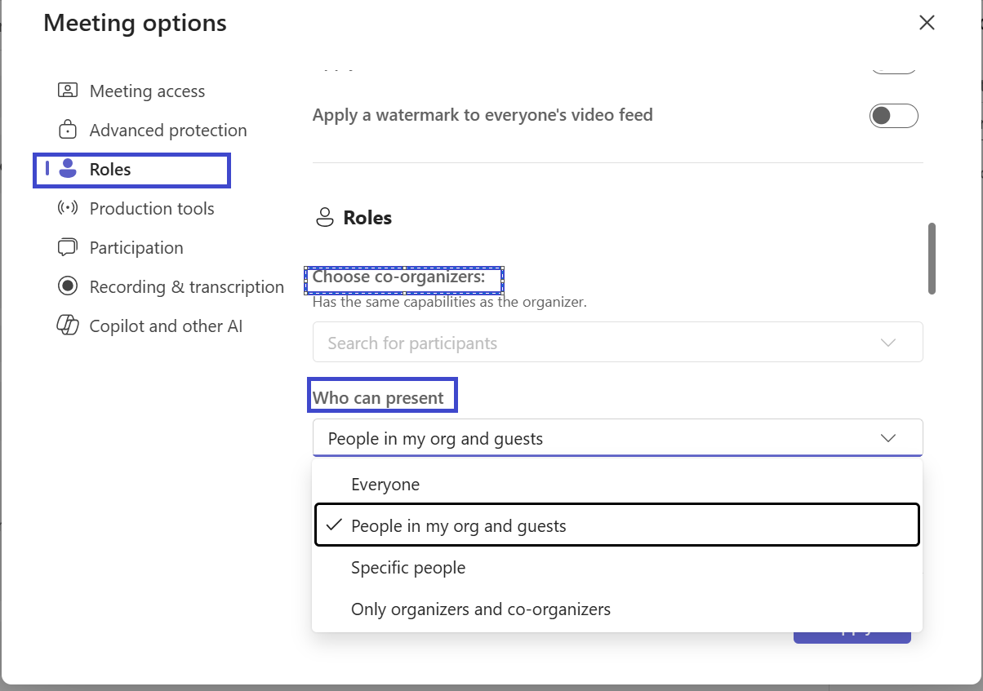
Fig 2.5(0) Roles

Adding Participants and Co-Organiser During a Meeting.
During a meeting call you can choose to add:
- A Participant
- Co-organiser
Whist on a meeting call as the host/organiser. Navigate to:
- More and click.
- From the drop-down option click on settings.
- From the drop-down option click on Meeting options.
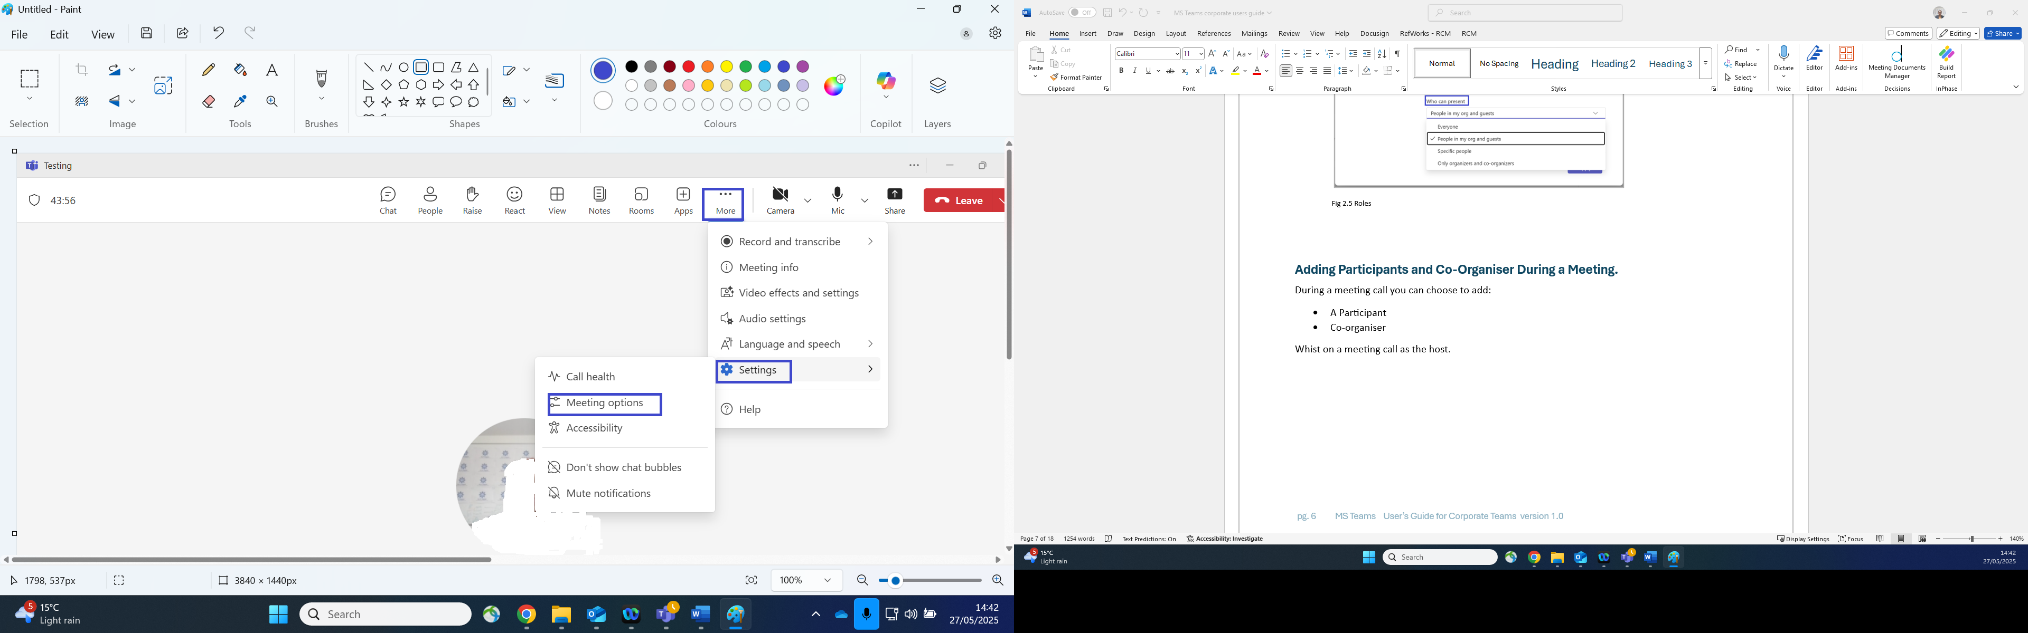
Fig 2.5(1) Meeting options
The meeting option window open, navigate to
- Click on roles.
- Navigate to choose co organisers and search for participants to be added.
- Navigate to who can present and select your requested option from the drop-down list.
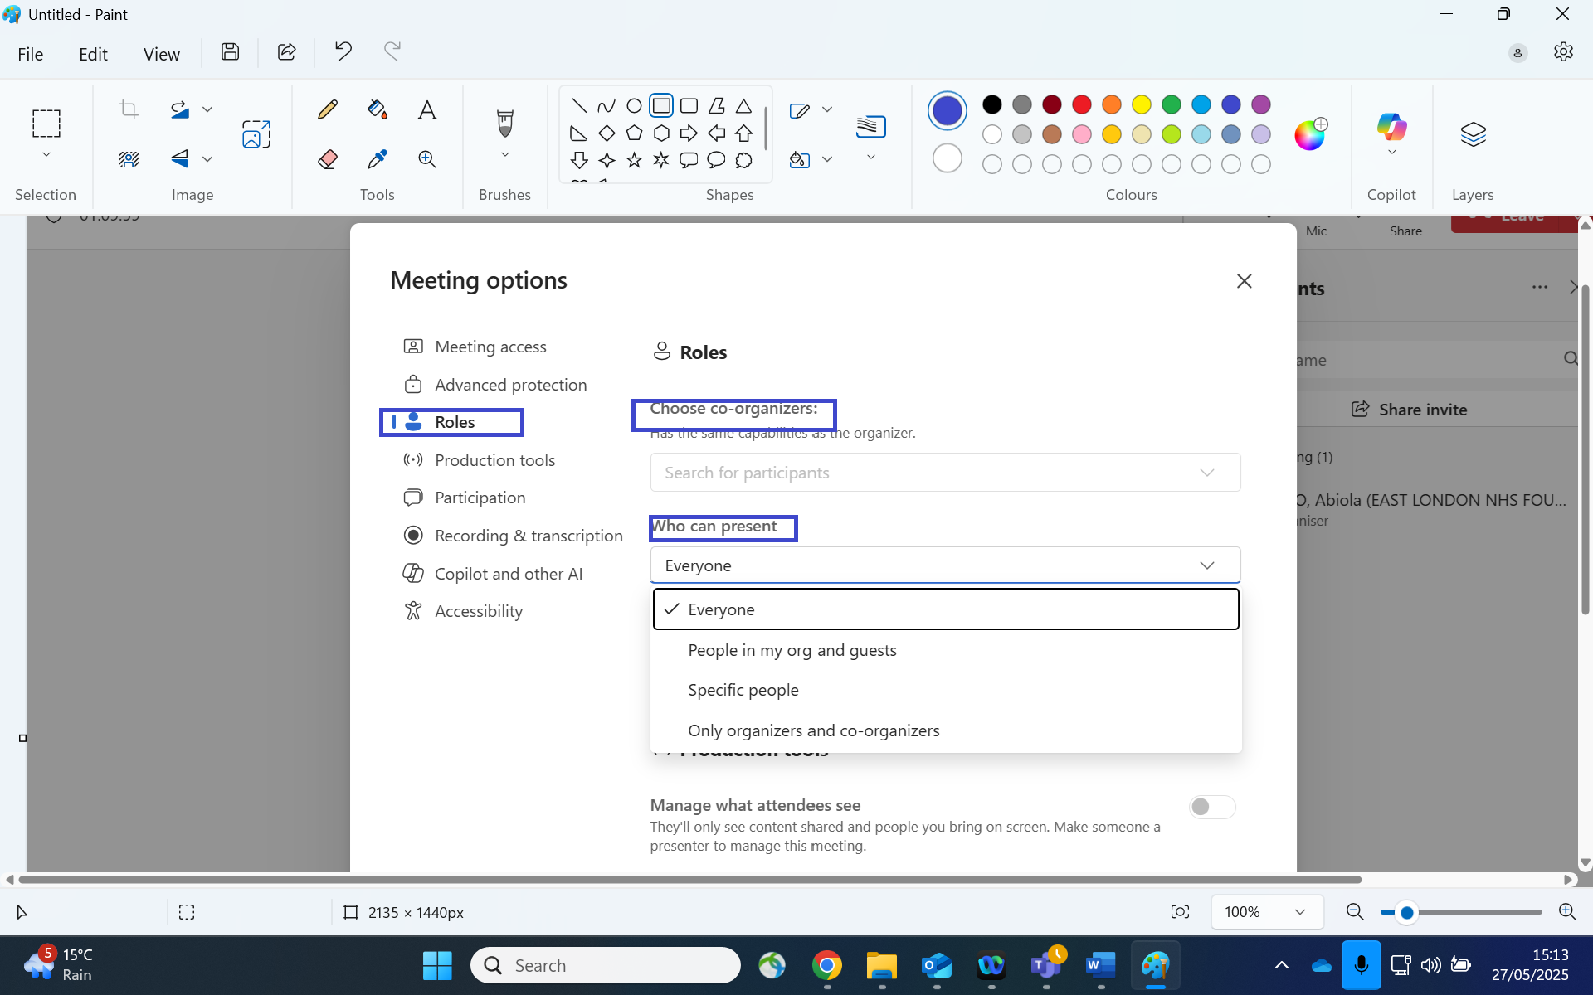
Fig 2.5(2) Role during a meeting call
Participation enables you choose to:
- Allow mic(microphone) for attendees. /Participants.
- Allow camera for attendees.
- Meeting chat: can be on, off or in meeting only chat for participants.
- Customise questions and answers.
- Allow reactions.
- Hide attendee names.
- Allow attendance report.
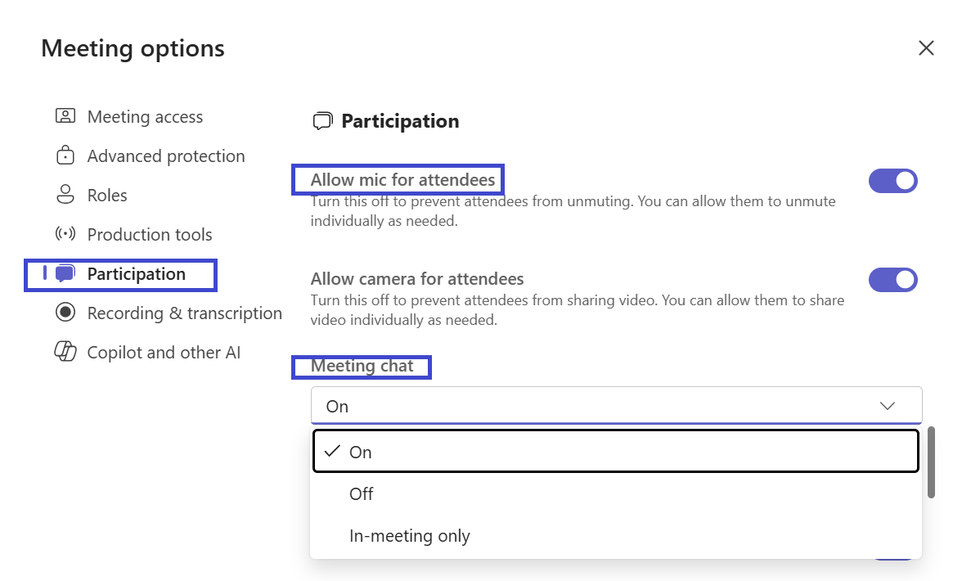
Fig 2.6 Participation (1)
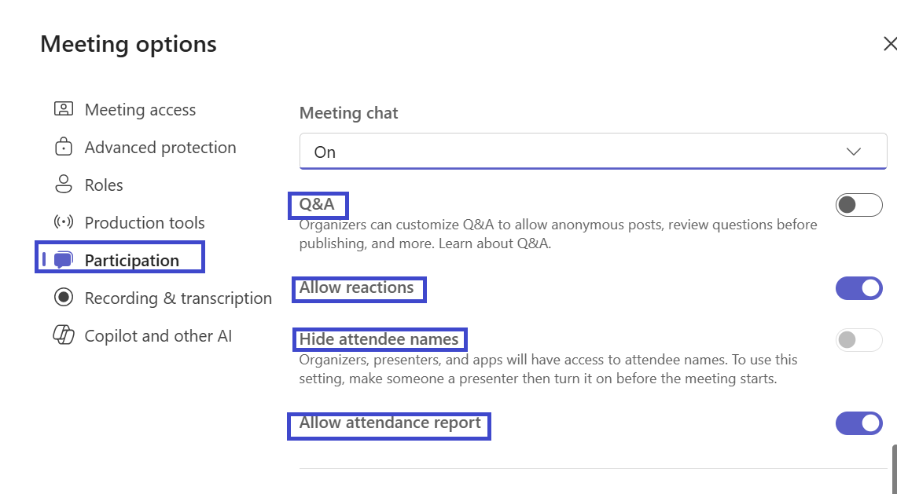
Fig 2.7 Participation (2)

Recording and Transcription enables the host to choose:
- If to Record and transcribe automatically
- Who can record and transcribe?
- Who has access to the recording and transcript?

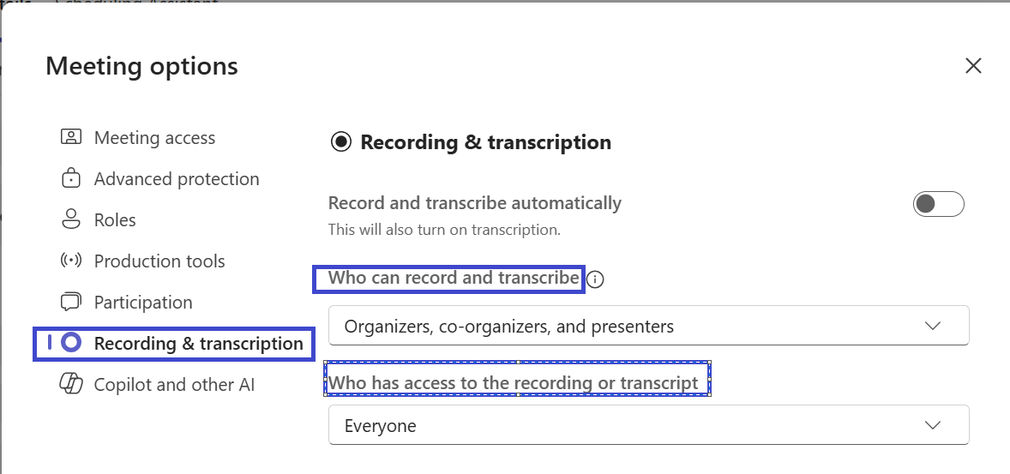
Fig 2.8 Recording & Transcription

Guest Access to Recording
If everyone is selected as above from the screenshot by the host this also enables external participants to have access to the video recording.

Advanced Protection enables the host of the meeting to set privacy and restriction for the participants as follow:
- Turn off copying and forwarding of meeting chat, captions, and live transcripts.
- End to end encryption.
- Apply watermark to shared content for document privacy.
- Apply watermark to everyone’s video feed for privacy.
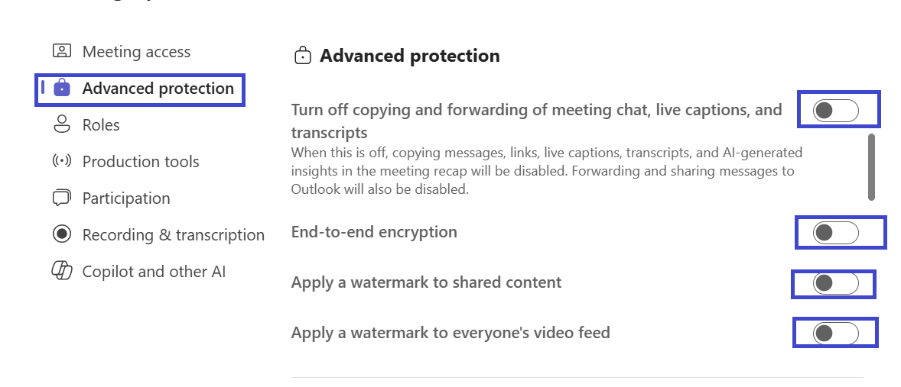
Fig 2.9 Advanced Protection
Production tools/Anonymity enables host privacy to:
- Manage what attendees/participants can see.
- RTMP (Real Time Information protocol) of live media videos if needed.
RTMP is used to stream live broadcast and mainly used for large meetings like Town Hall. You will receive a weblink and code to steam into another software once enabled.
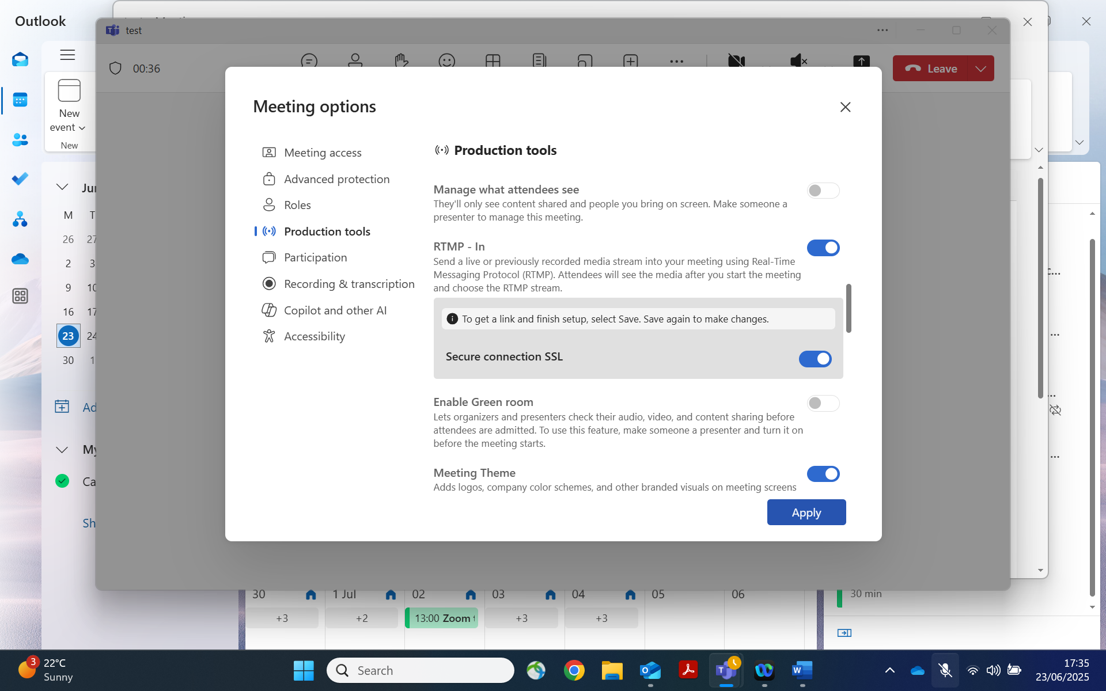
- Enable green room allows organisers and presenters check audio, video, and content before admitting participants.
- Meeting theme is automatically configured in ELFT.
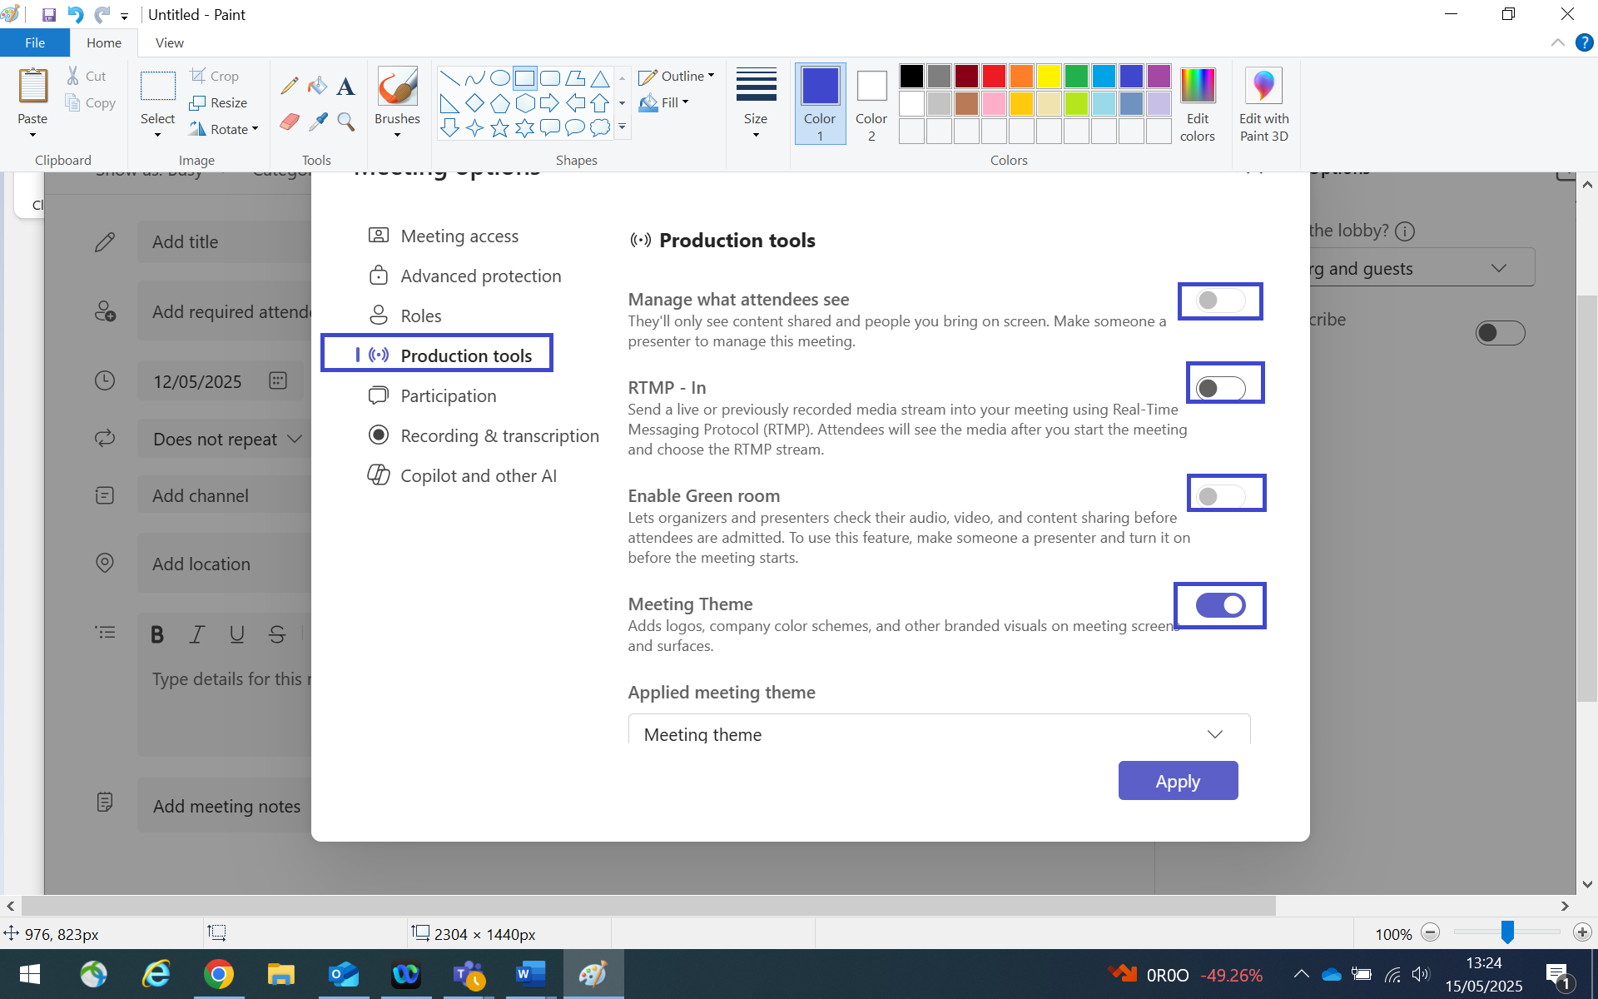
Fig 3.0 Production tools

Joining MS Teams Meeting as an ELFT Staff
Participants within ELFT with an nhs.net account would receive an invite for a meeting organised by the host via outlook calendar and MS Teams calendar.
On outlook calendar you can join a meeting by:
- Clicking on the calendar date for the meeting
- A window opens with the meeting name.
- Click on join to join the meeting.

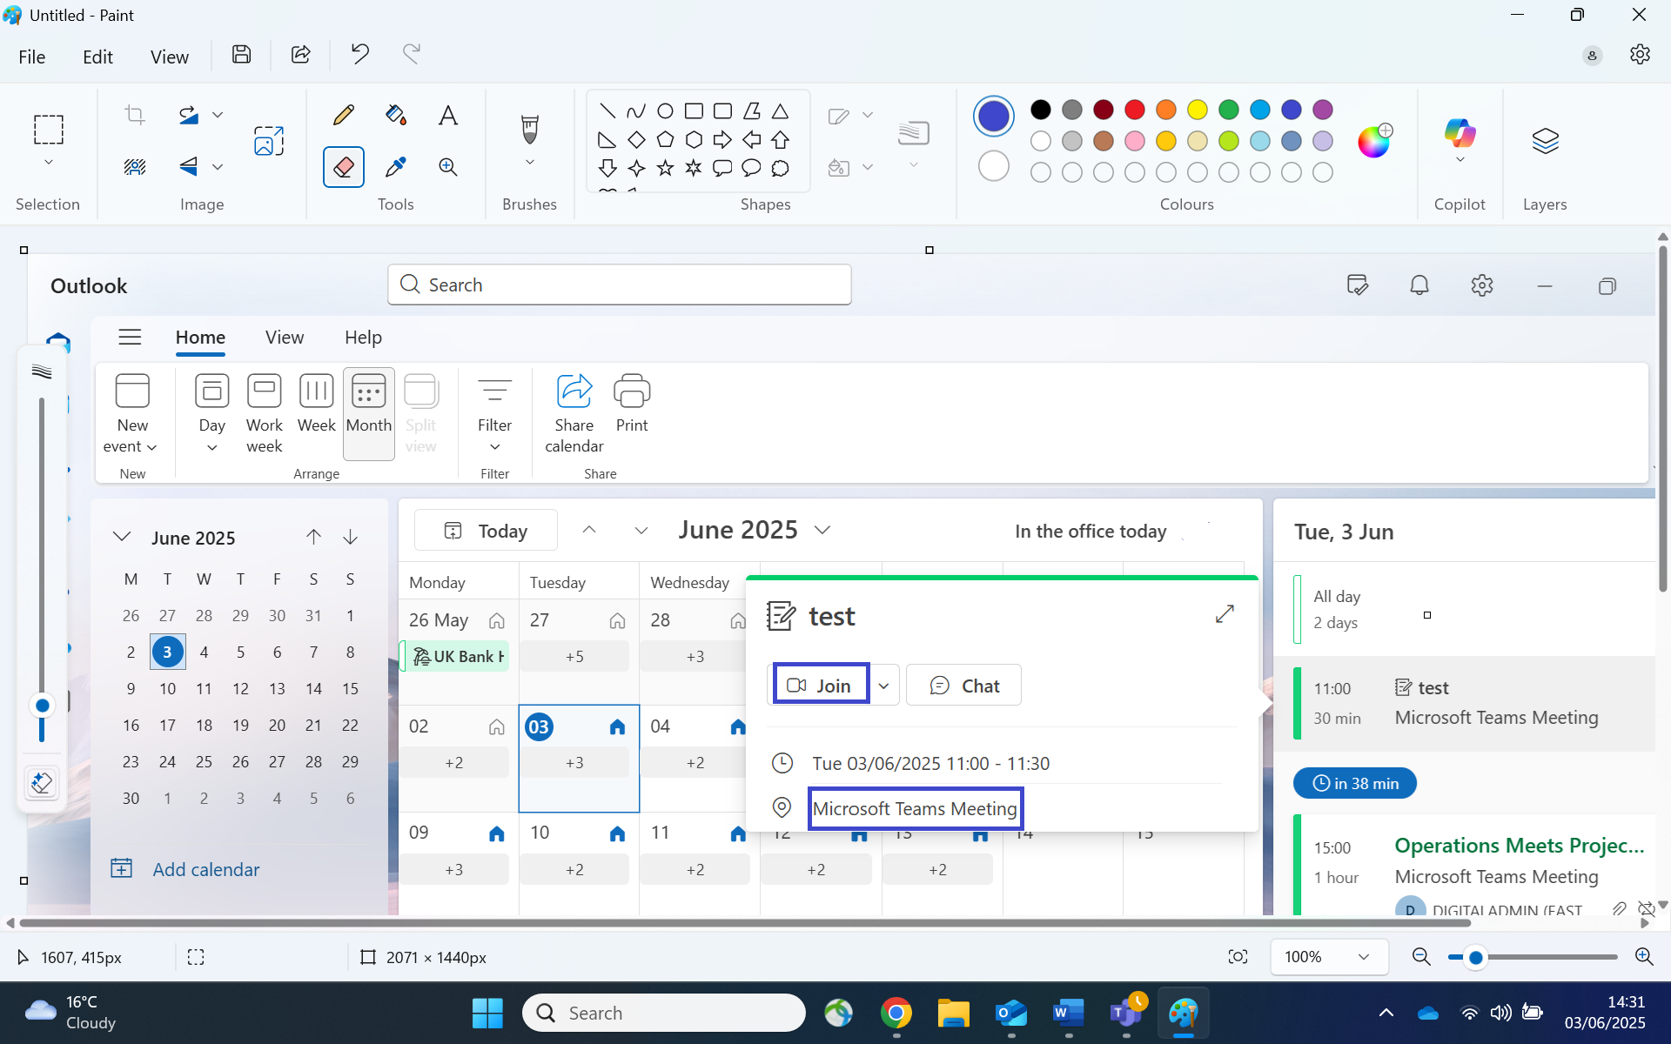
Fig 3.1 Joining MS Teams via outlook calendar.

To join from MS Teams calendar in ELFT you must have an MS Teams account.

- Click on the date of the meeting.
- A window opens with the meeting name.
- Click on join to join the meeting.

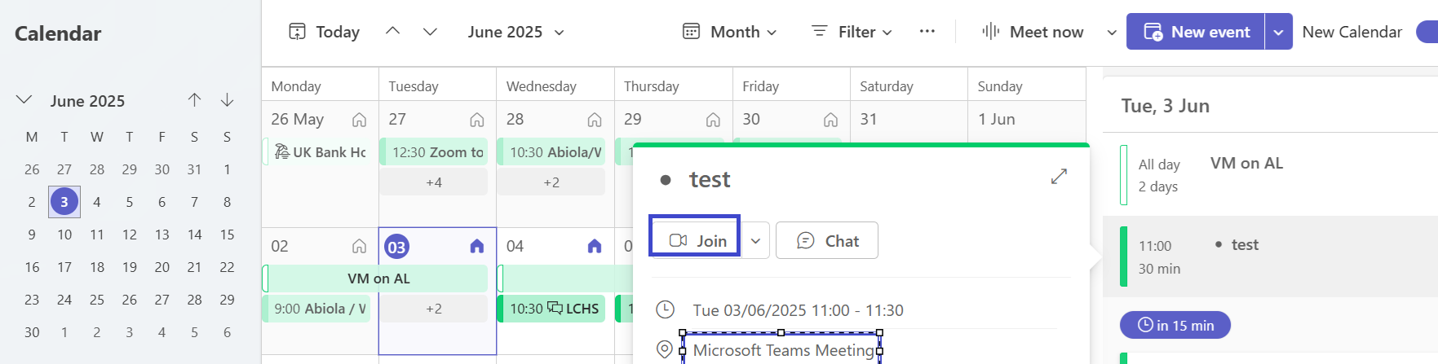
Fig 3.2 MS Teams Calendar

External Participants Joining MS teams Meeting.
The external participant would receive an online invite link sent to an email address provided to join MS Teams meeting via an internet web browser. Click on join to join the meeting upon receiving the MS Teams invite.

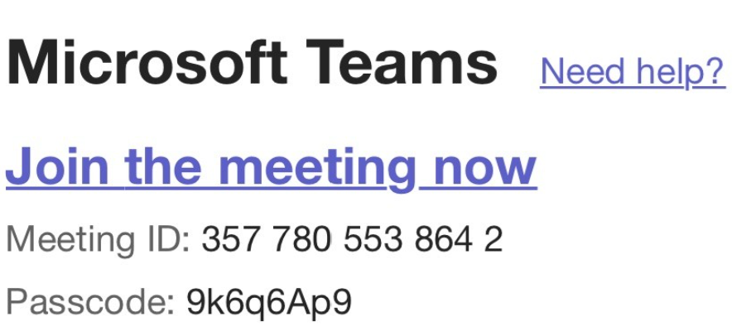

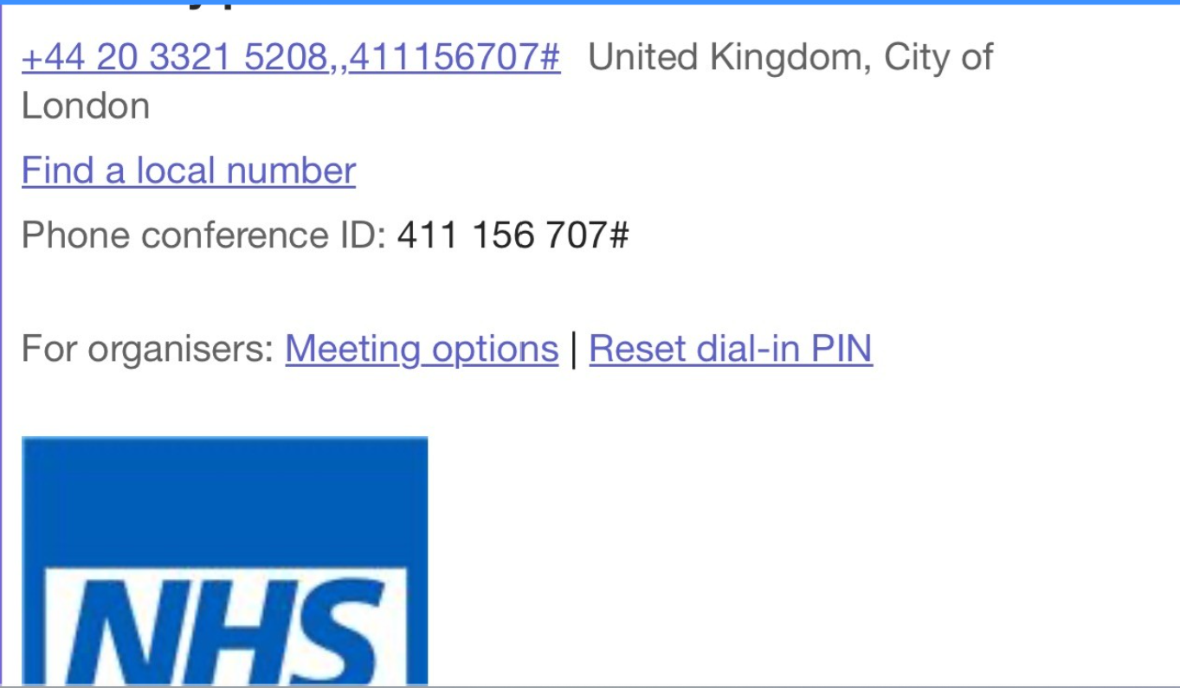
Fig 3.3 Joining MS Teams via eternal email.

Universal Meeting Link
A meeting link on MS Teams can be shared with other software like Eventbrite notifying participants of the meeting.
- Navigate to meet now and click
A window opens with the meeting name
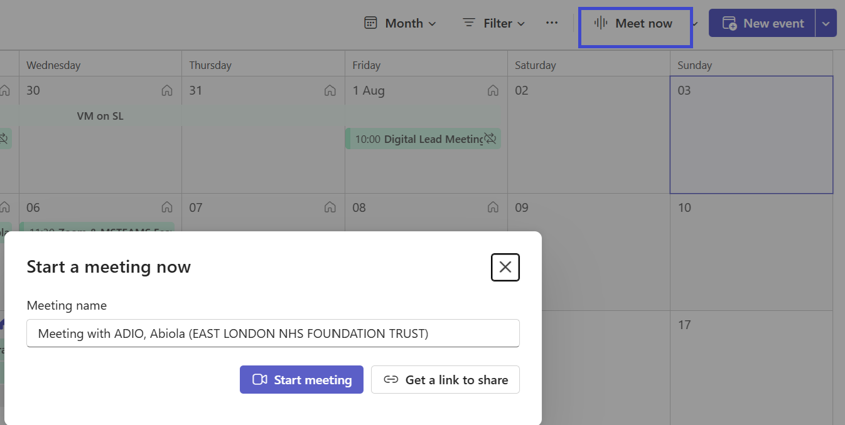
Fig 3.4

- Click on link to share
- A window opens up
- Click on
- Click on the copy icon to share the meeting link.
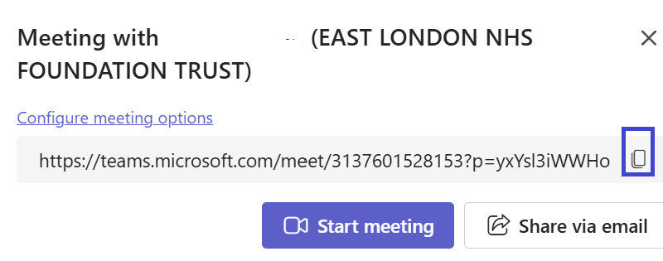
Fig 3.5

Attendance Reporting
You can see who has attended an MS Teams meeting as the host after the meeting has taken place by:
- Navigating to meeting chats
- Click on the meeting
- On the menu bar click on Attendance
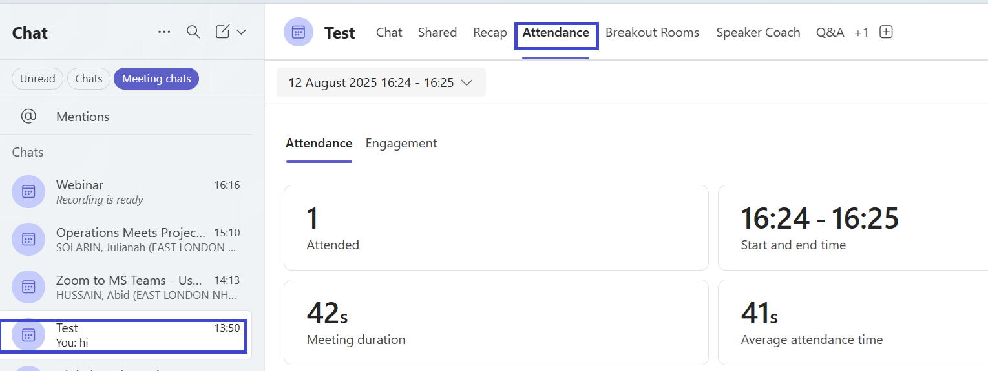
Fig 3.6

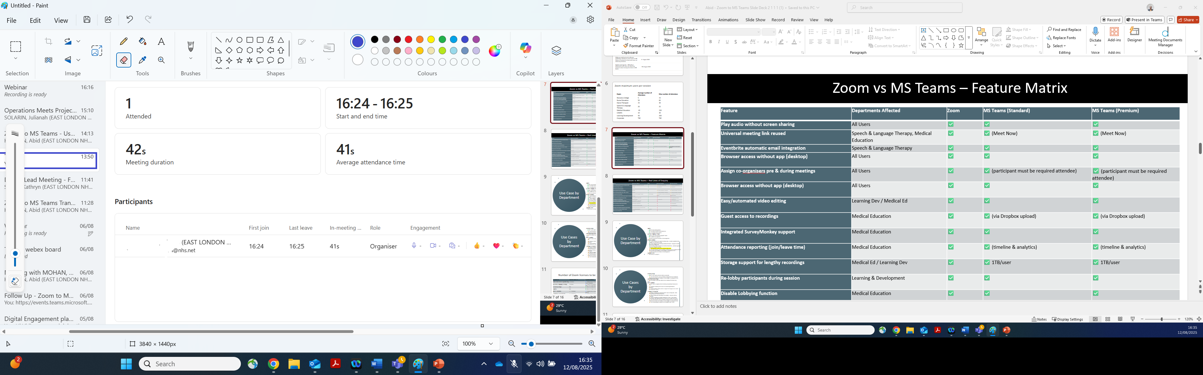
Fig 3.7

Breakout Rooms
In MS Teams breakout rooms can be created by the host/organisers for participants to have:
- Interactive discussion session
- Presentation as a team within a breakout group
- When you join a meeting via MS Teams calendar by clicking on the date and time you are presented with the window below:
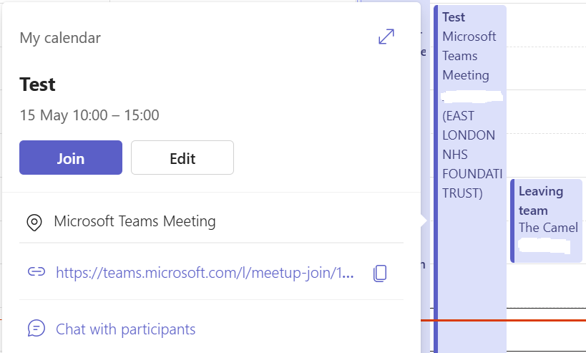
Fig 4.0 Join a MS Teams meeting calendar.

When you click on join you are taken to another window which enables you to:
- Turn your camera on if it is not disabled by the host/organisers.
- Adjust the volume of your microphone or mute yourself if it is not disabled by the host /organisers.
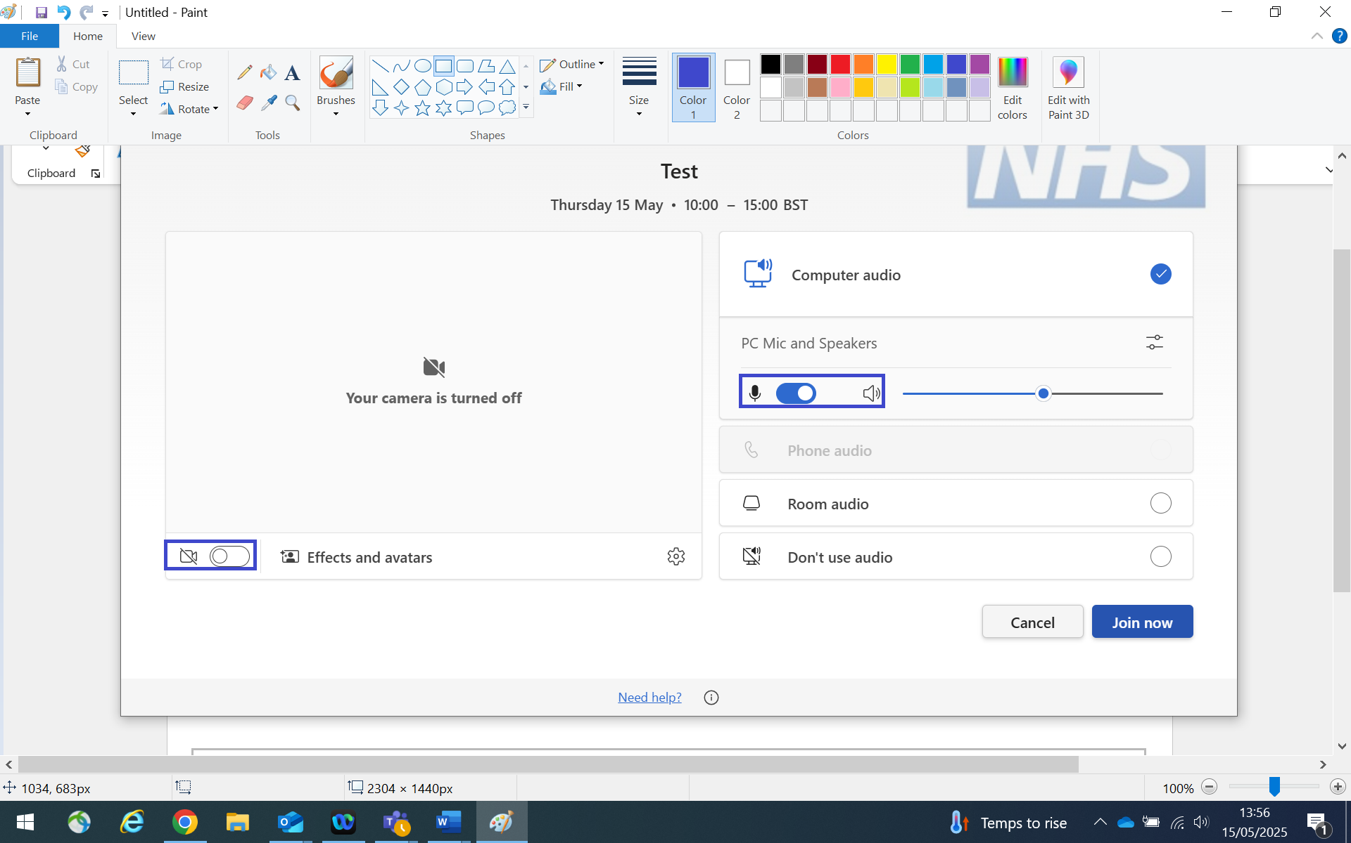
Fig 4.1 MS Teams meeting page.

Click on Join to enter your meeting and you are presented with the window below:

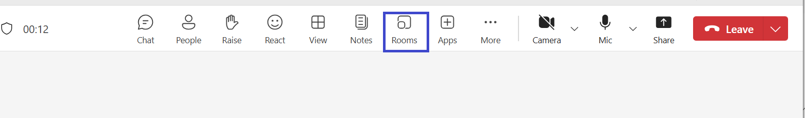
Fig 4.2 MS Teams Rooms icon
- Navigate to Rooms as the host/organiser and click on rooms.
- Click on assign participants and assign participants manually or MS Teams can shuffle to rooms for you.
- Click on save.

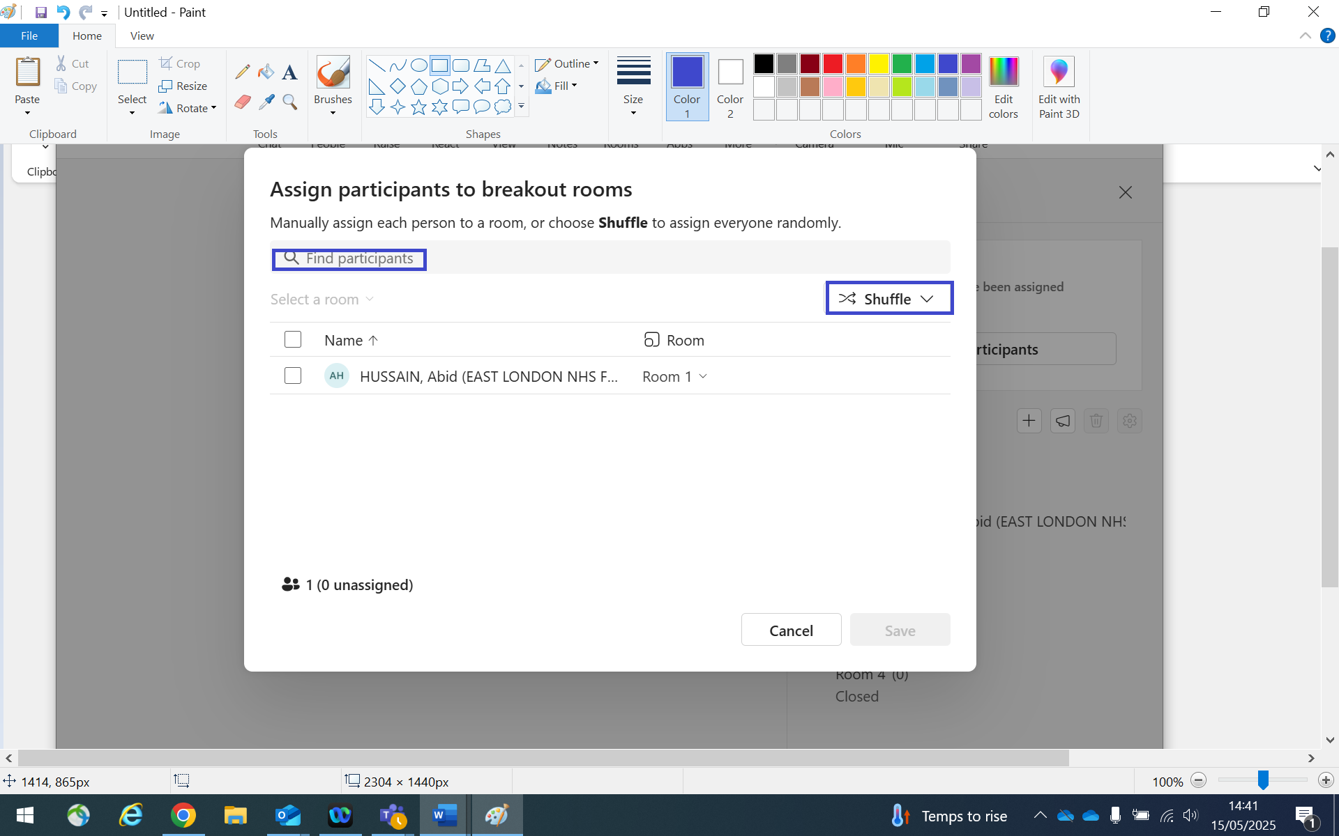
Fig 4.3 Assign participants

Breakout Room Features.

- Click on the + plus icon to add number of breakout rooms.
- Click on open for participants to enter their rooms.
- Click on the 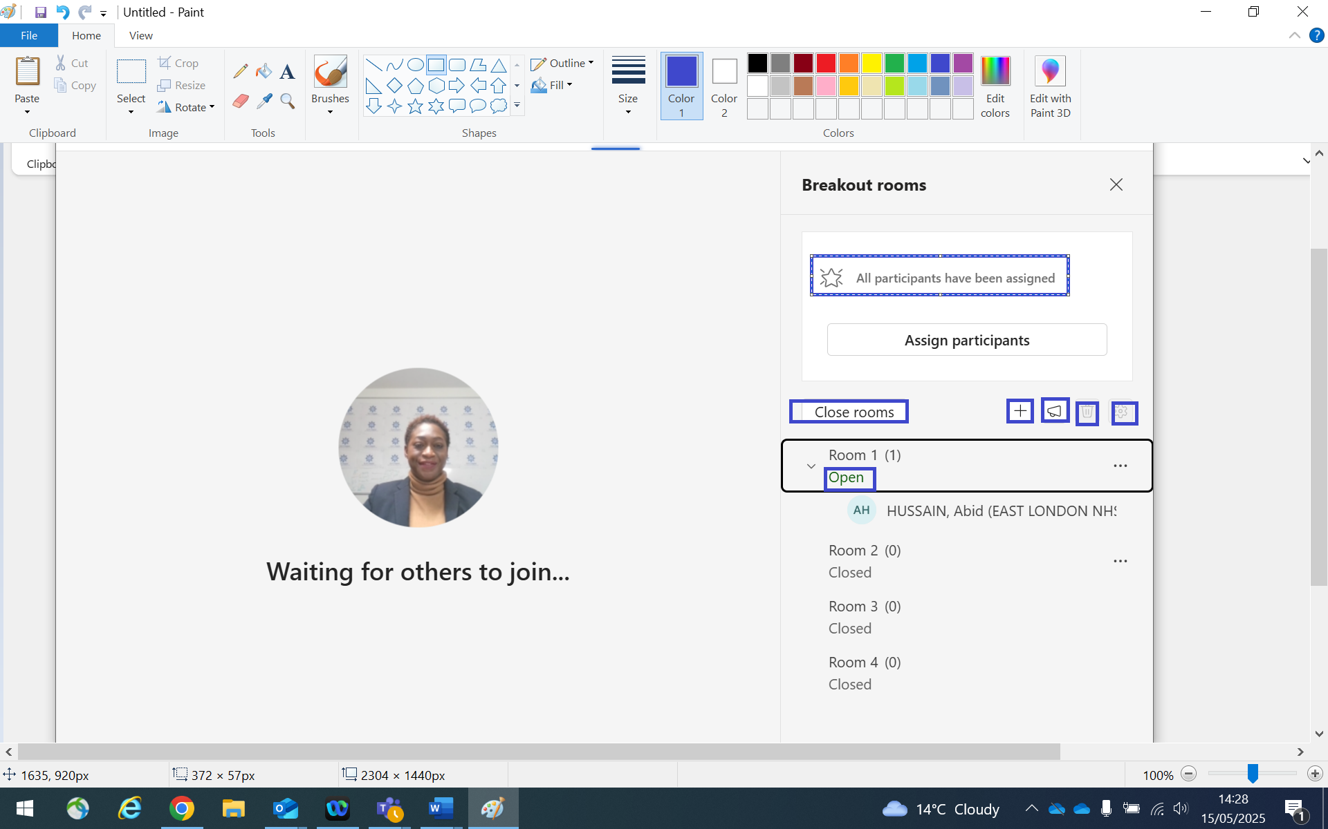icon to make an announcement.
- Click on the icon to delete room not needed.
- Click on close rooms to move participants back to the main meeting.

Fig 4.5 Breakout room features.

Hosts Broadcasting Text messages Within Breakout Rooms.
Text messages can only be sent within a breakout room by the organisers

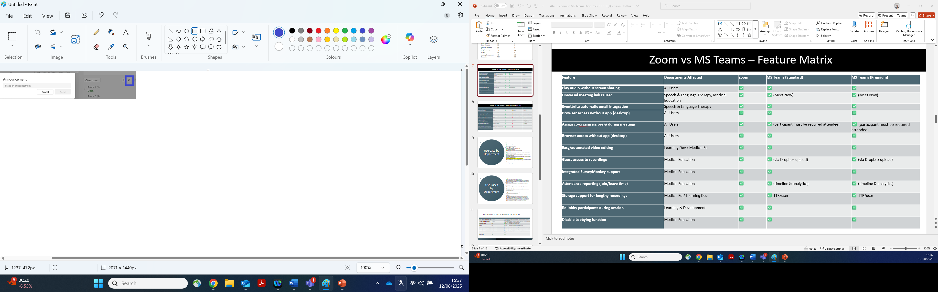
Fig 4.6

MS Teams Meeting Chat
Whilst in a meeting as the host, co-organiser and participant navigate to the chat icon.
- Click on the chat icon and type conversation to communicate in the meeting.
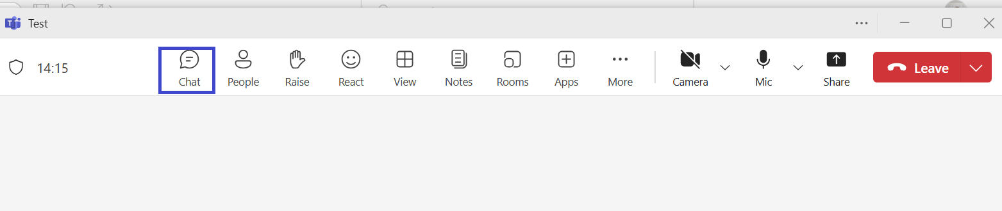
Fig 5.0 meeting chat icon
Meeting chat window opens.
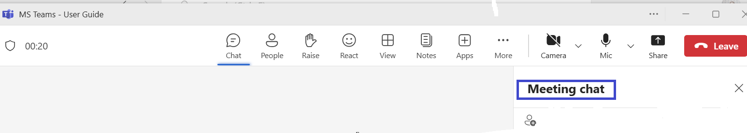
Fig 5.1 meeting chat.

Pop Out Chat Manually When Messaging Participants Directly.
To pop out chat manually:
- Select “people” icon
- Hover over the participant in the people section list
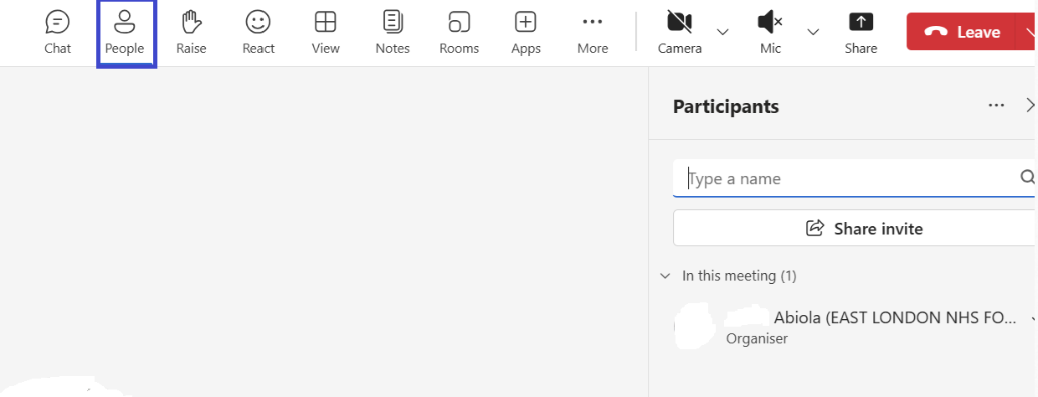
Fig 5.2(1) selects people.
- A pop-up window opens with the profile details of the participant
- Click on the chat symbol

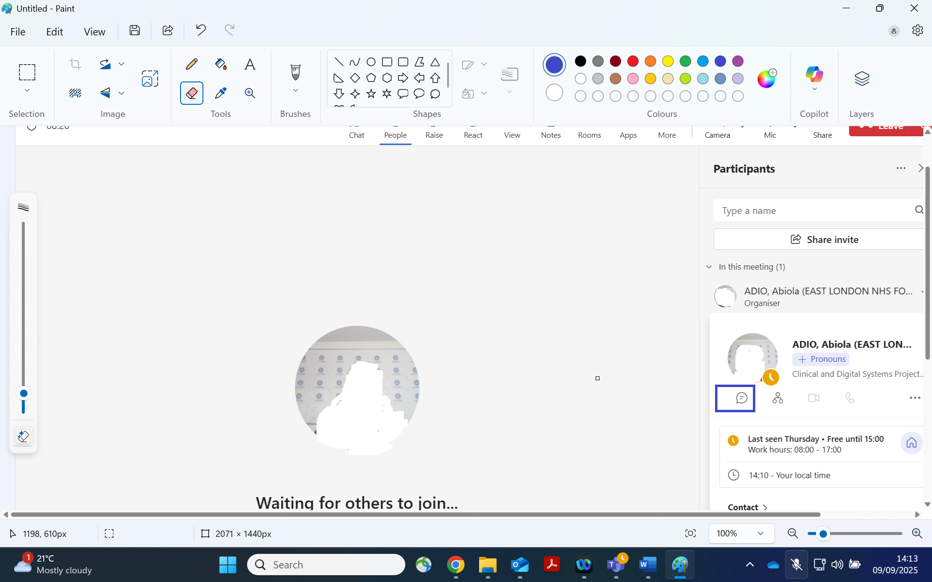
Fig 5.2(2) pop out chat icon.
A new Pop out chat window opens.
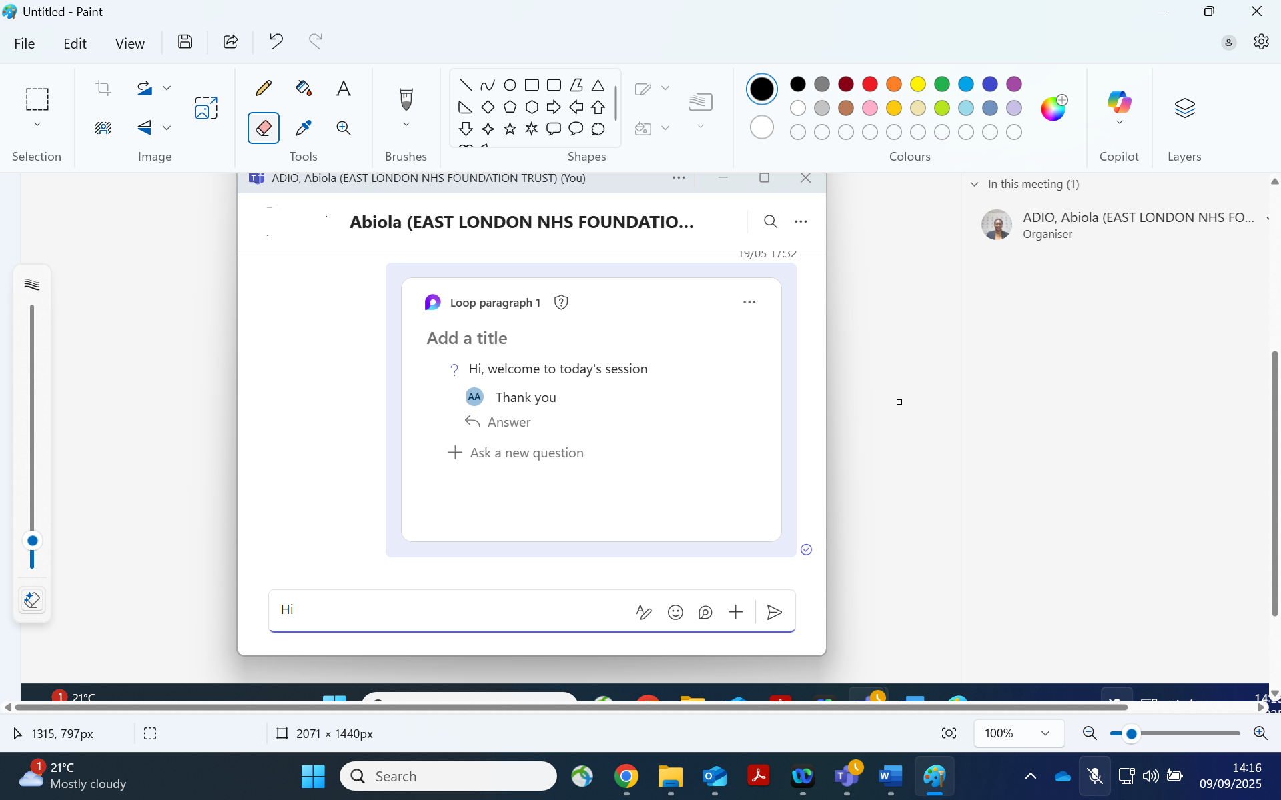

Fig 5.2(3) pop out chat window

Chat Messaging Features
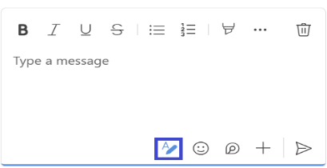
Chat messaging enables you to:
- Format your message by clicking on the formatting icon.

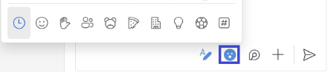
- Click on the emoji for reactions.

- Multiple Participants Reactions
Participants reactions on MS Teams are limited to five (5).

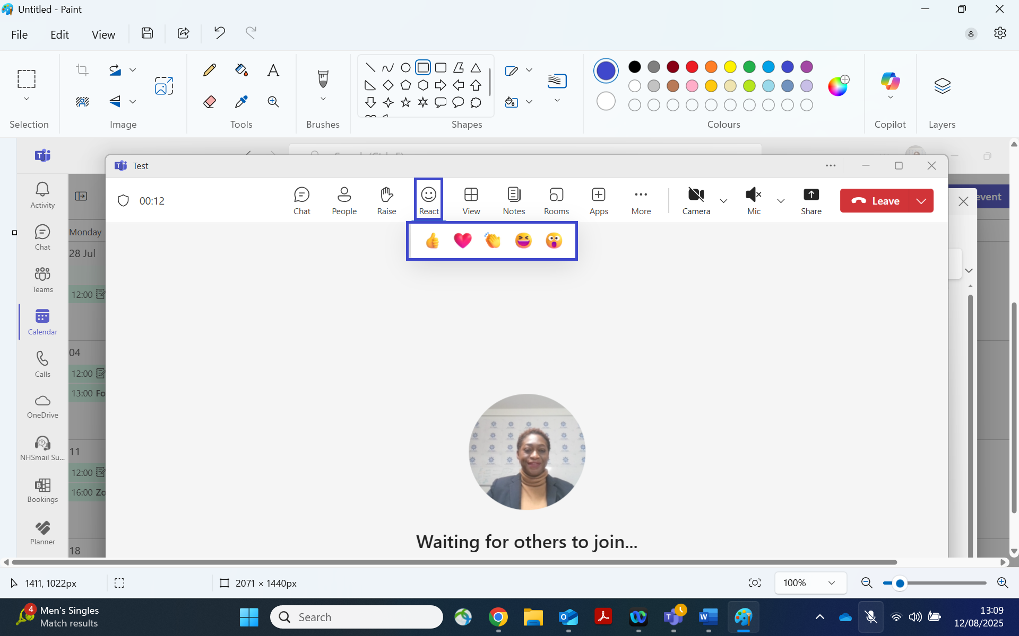

- Click on the + (Plus) App menu bar icon to create polls for participants to vote in a meeting.

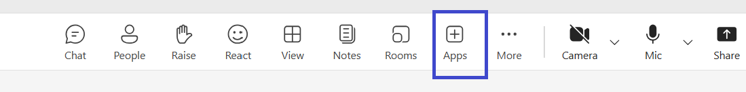
- Click on Polls on the open window.
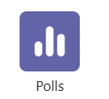
- The poll icon is now added to the menu bar.
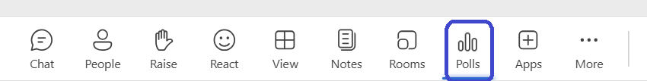

- Click on new Poll.
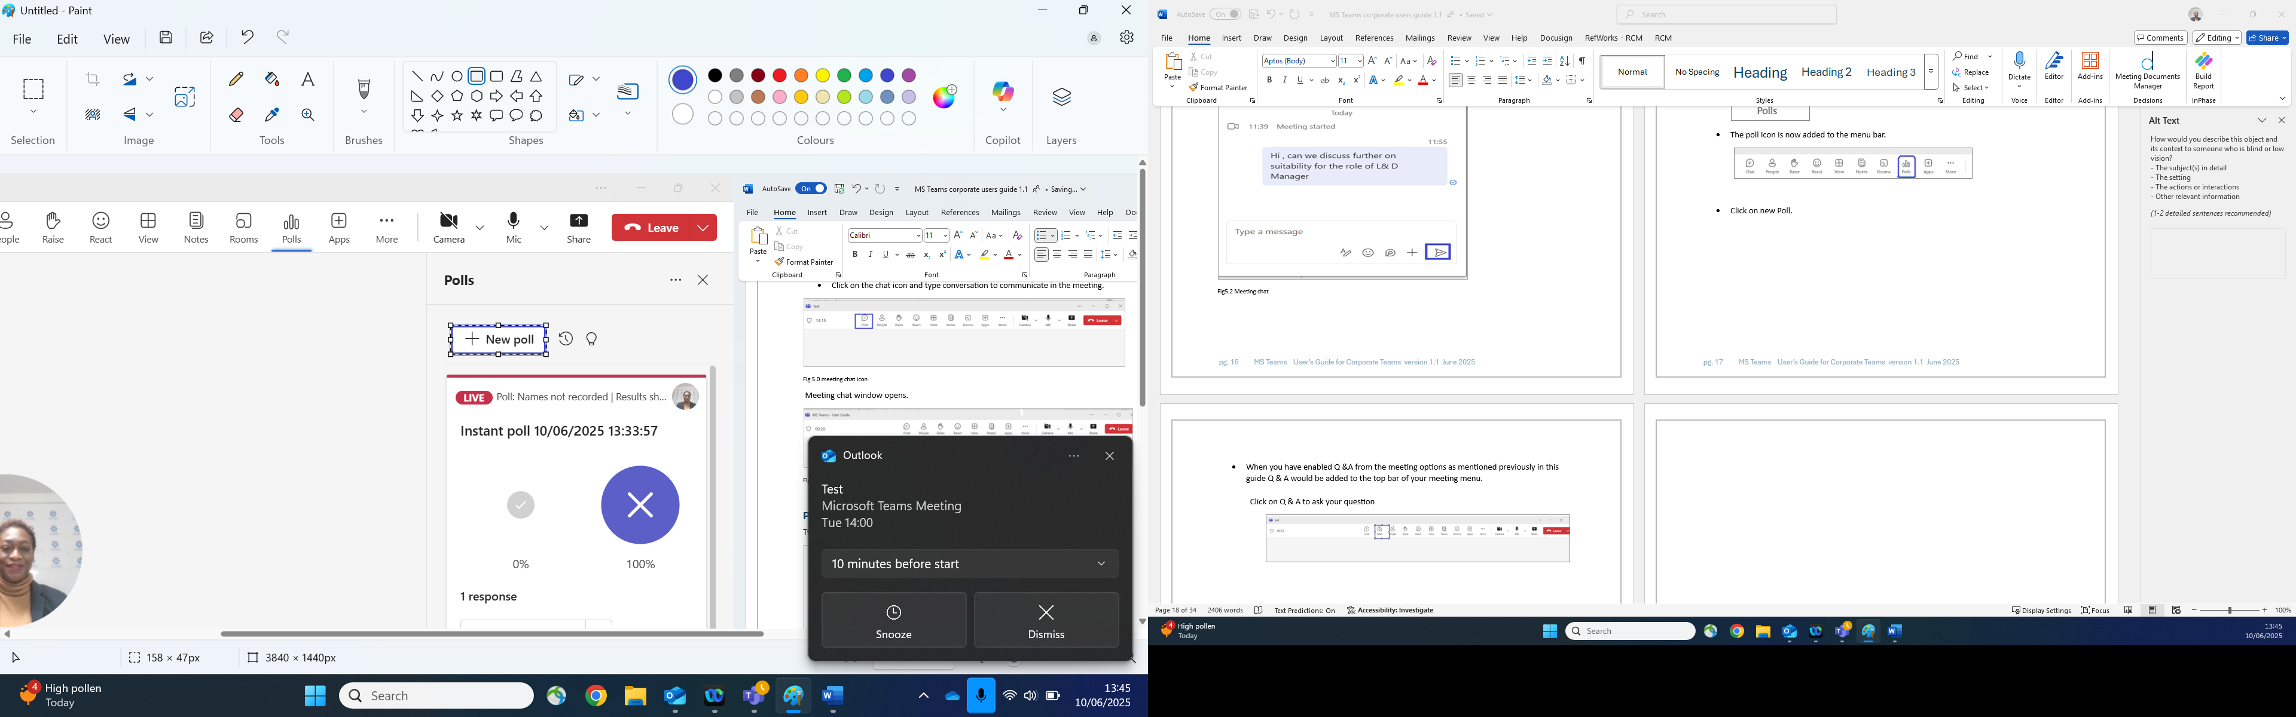

- Select the poll you want to use.

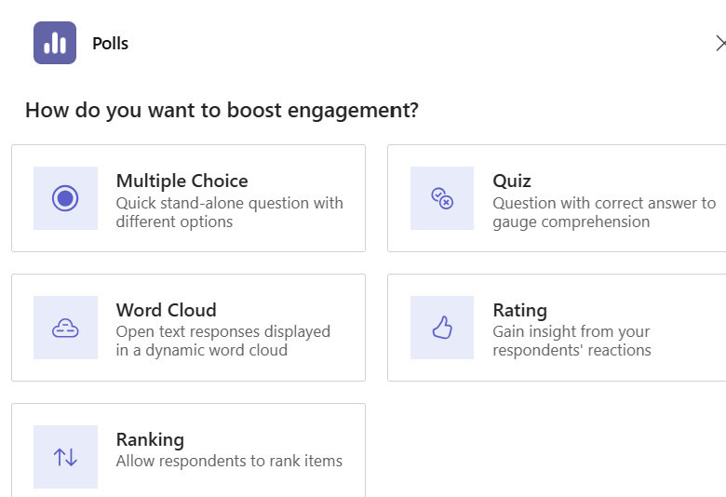

- Type your questions and click on launch poll.
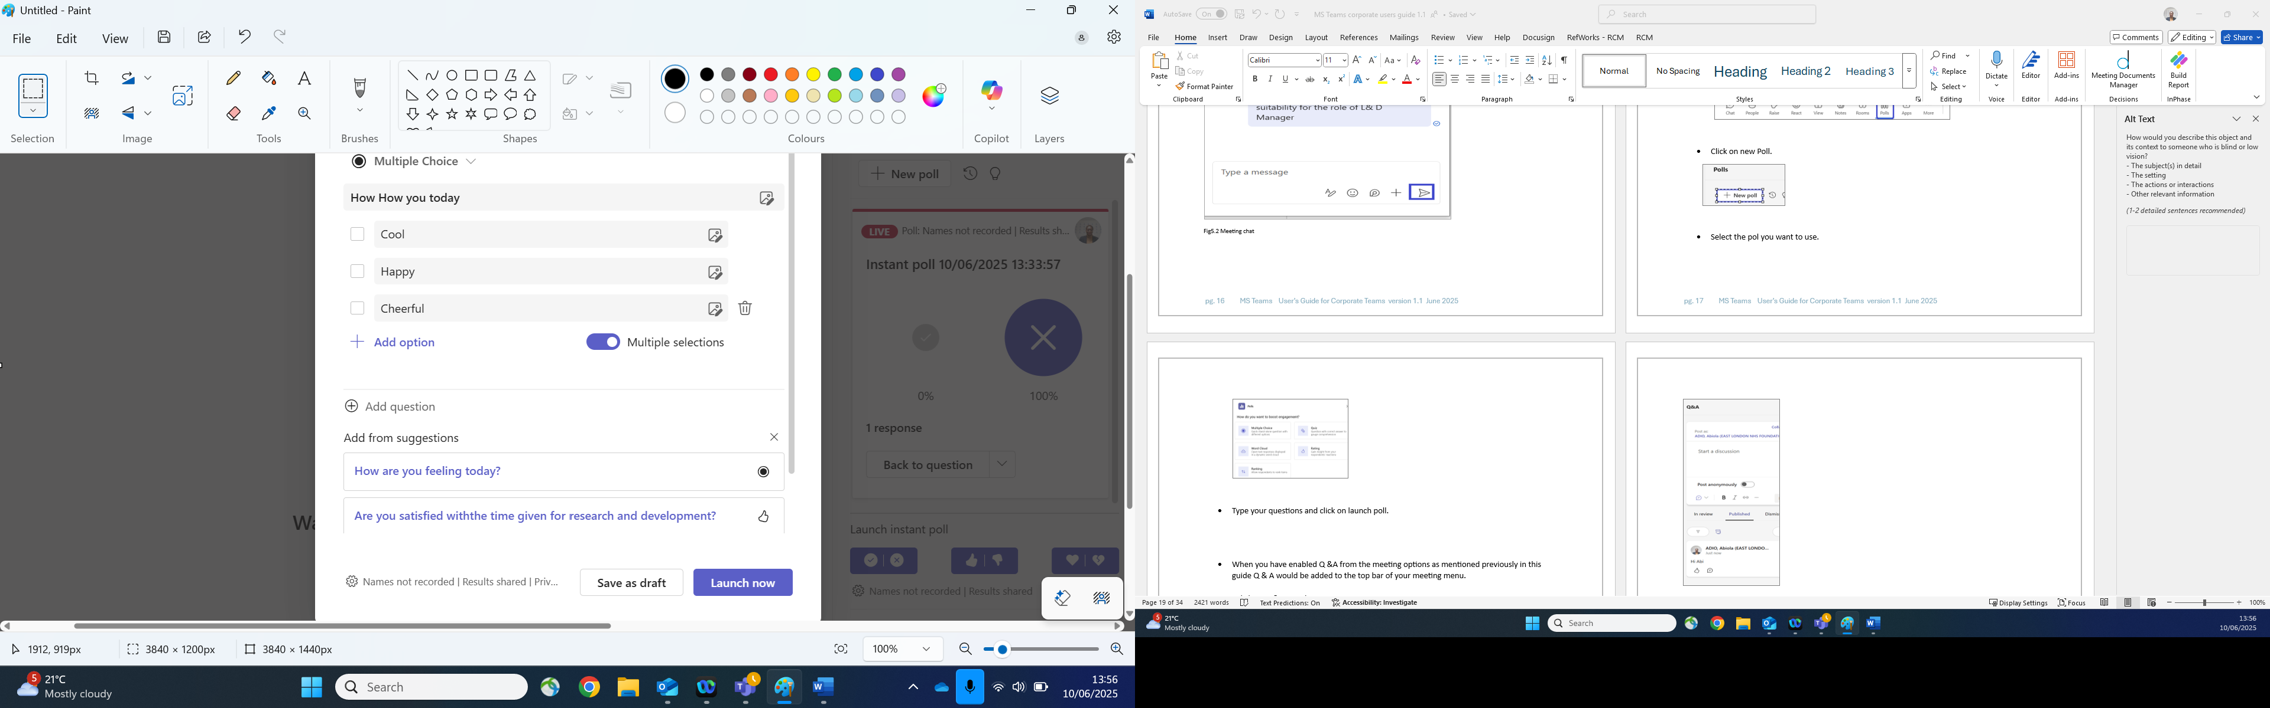

- The poll is received by the meeting participants in the chat to vote.
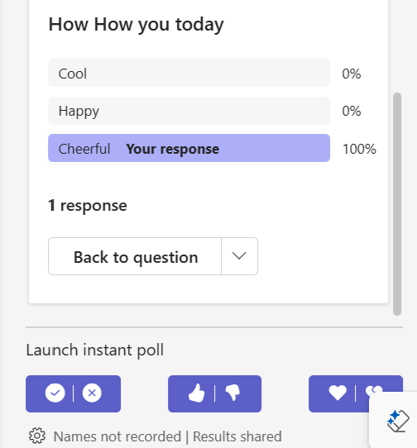

- Question and Answer. When you have enabled Q &A from the meeting options as mentioned previously in this guide Q & A would be added to the top bar of your meeting menu.

Click on Q & A to ask your question.
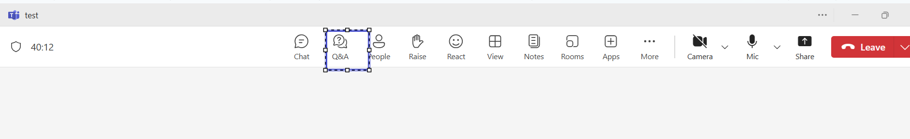

Type your message in the Q & A box and click post for participants to see your question.
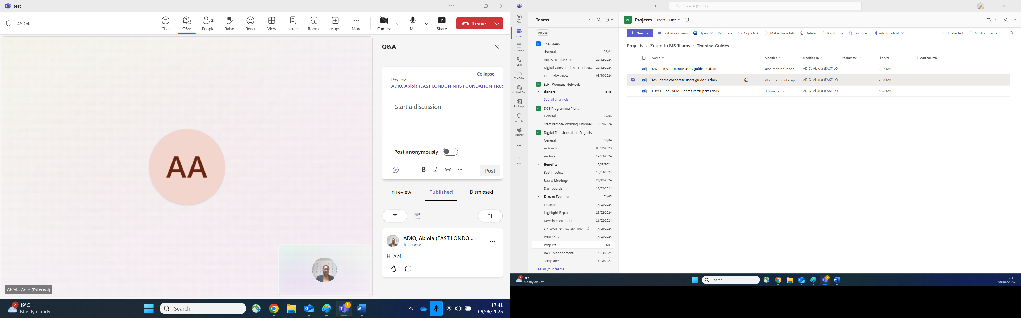

- Click on the + Plus symbol: To attach a file.
Schedule a message to be delivered at a particular time.
Set delivery options if it is standard, important, or urgent.
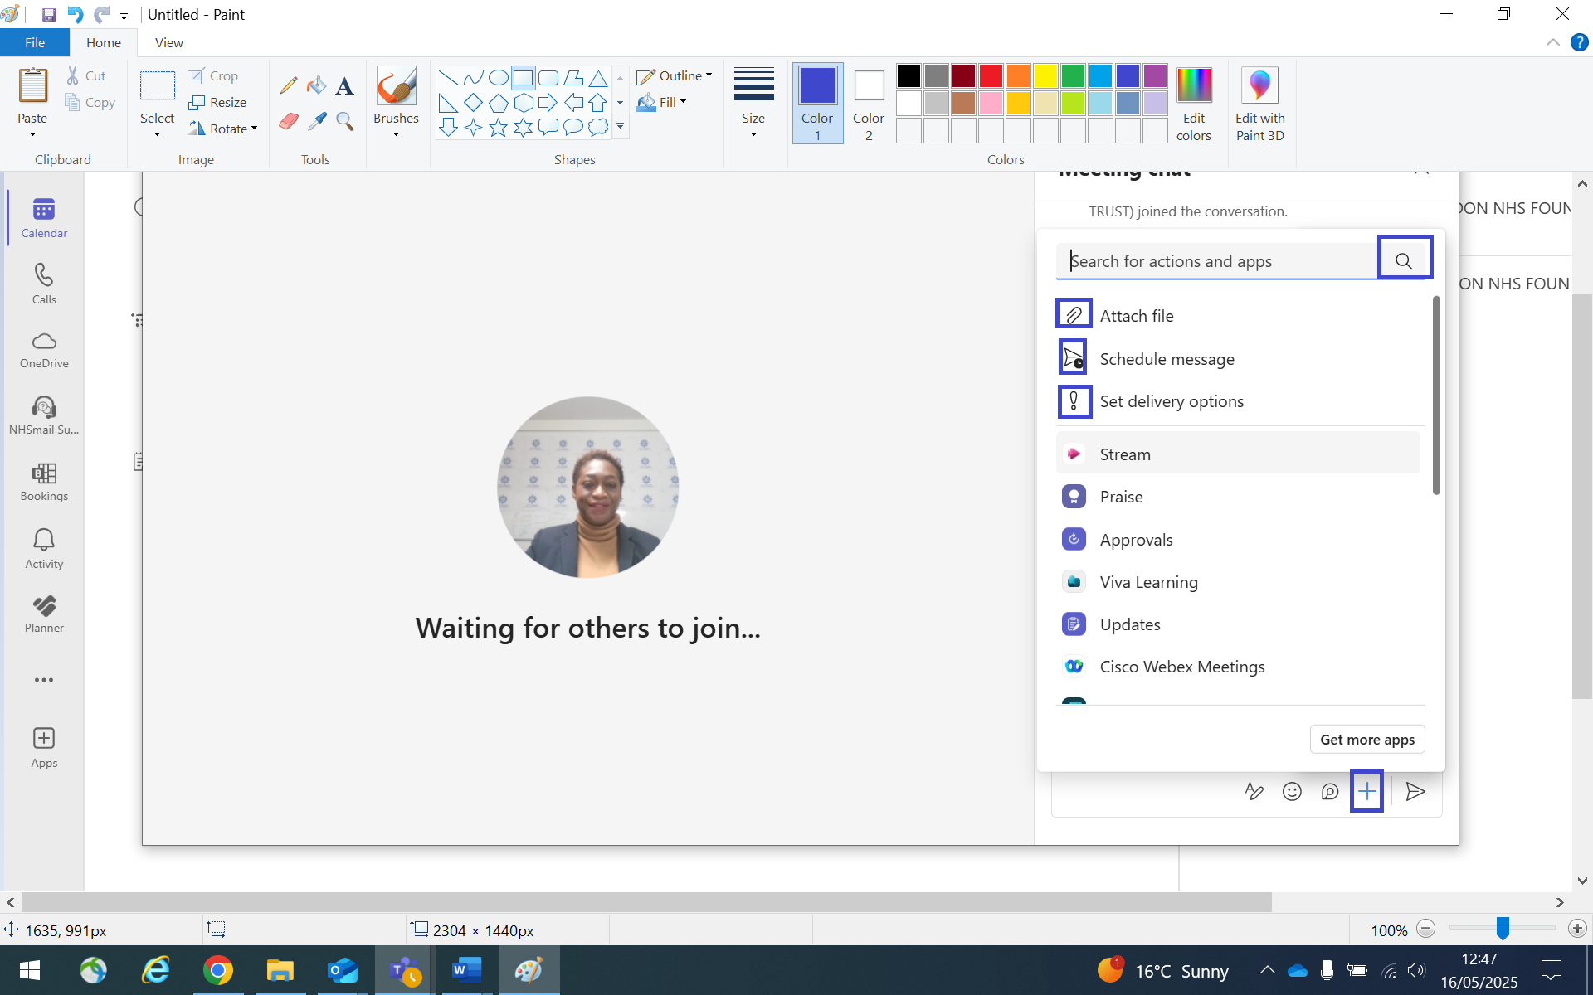
Search for apps if needed.

Moderate Q & A with Anonymity
As the organiser you can choose to anonymise participants response by navigating to:
- Q & A settings.
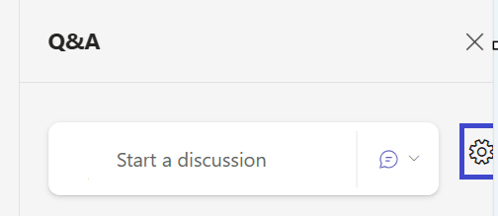
Fig 5.3
- Click on Anonymise posts or replies if required.
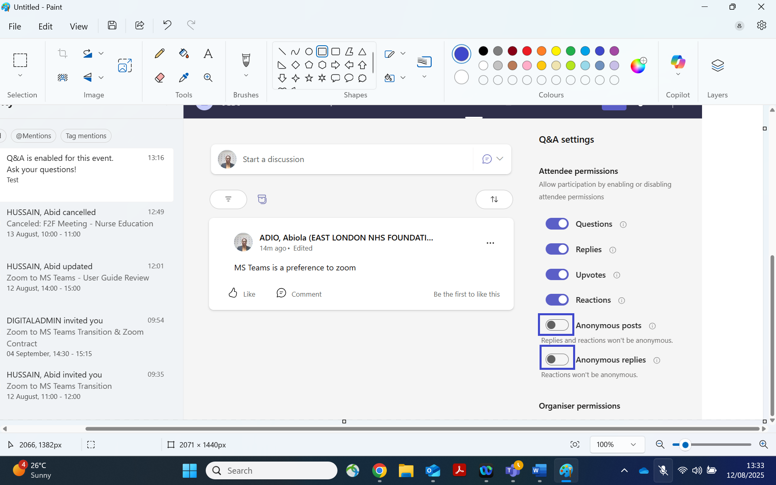
Fig 5.4

Screen Sharing MS Teams
You can share your screen from a single monitor or from a dual monitor.
Sharing from a single monitor
- Click on the share icon.
- Click on the windows picture to select document to share.
- You can also click on the Screen picture if you have the document open in the background.
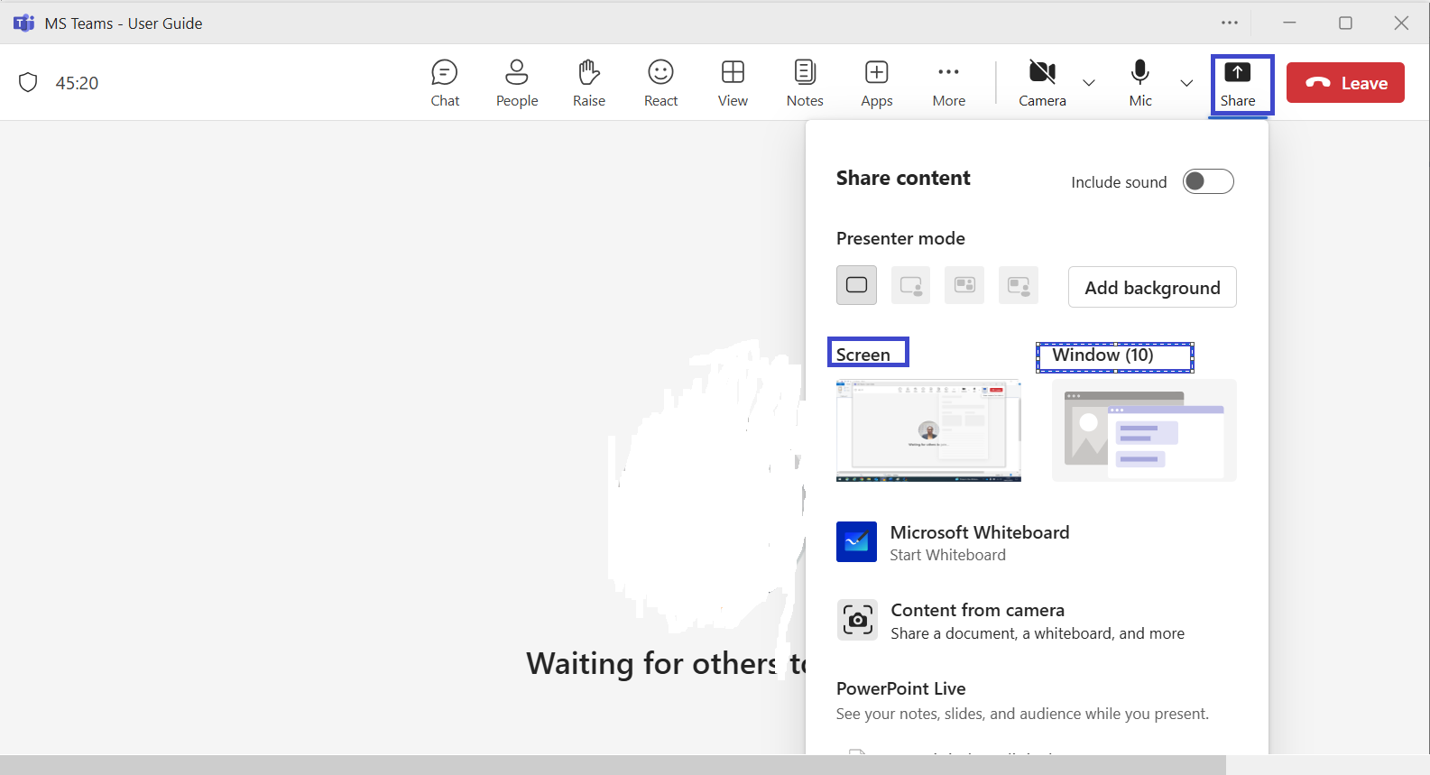
Fig 6.1 sharing on a single monitor

See Participants and Chats Simultaneously.
Viewing Participants and Chat in Microsoft Teams
- In a meeting chat, select the People icon to display the list of participants.
- If you want to view the participant list and meeting chat at the same time, switch to the Microsoft Teams app (desktop version).
- In the Teams app, search for the meeting chat, this will show all your chat history.
- You can then:
  - Resize windows to arrange the chat and participant list side by side, or
  - Use the Windows 11 Snap/Tiling feature to organise the windows into your preferred layout.

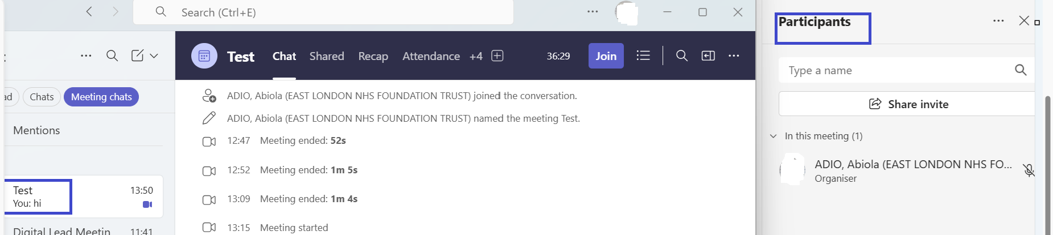
Fig 6.1(2)

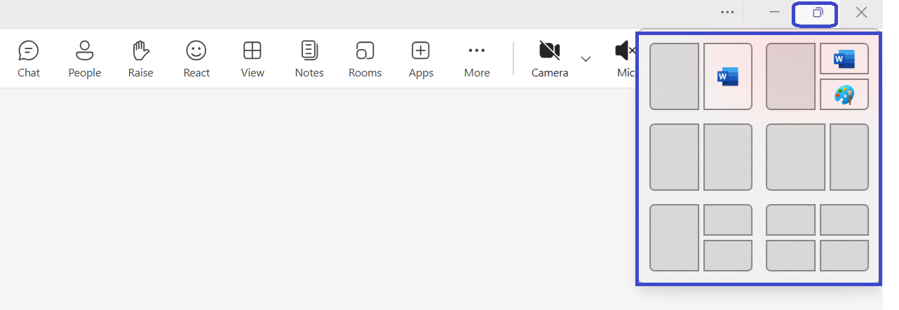
Fig 6.1(3) windows 1 tiling tool

Sharing from a Dual Monitor on Teams
To share documentation, video presentation on a dual monitor:
- Have your document, video to share open on the second monitor.
- Click on the share icon.
- Select the screen/ document you would like to share. A red border will appear around the shared content.
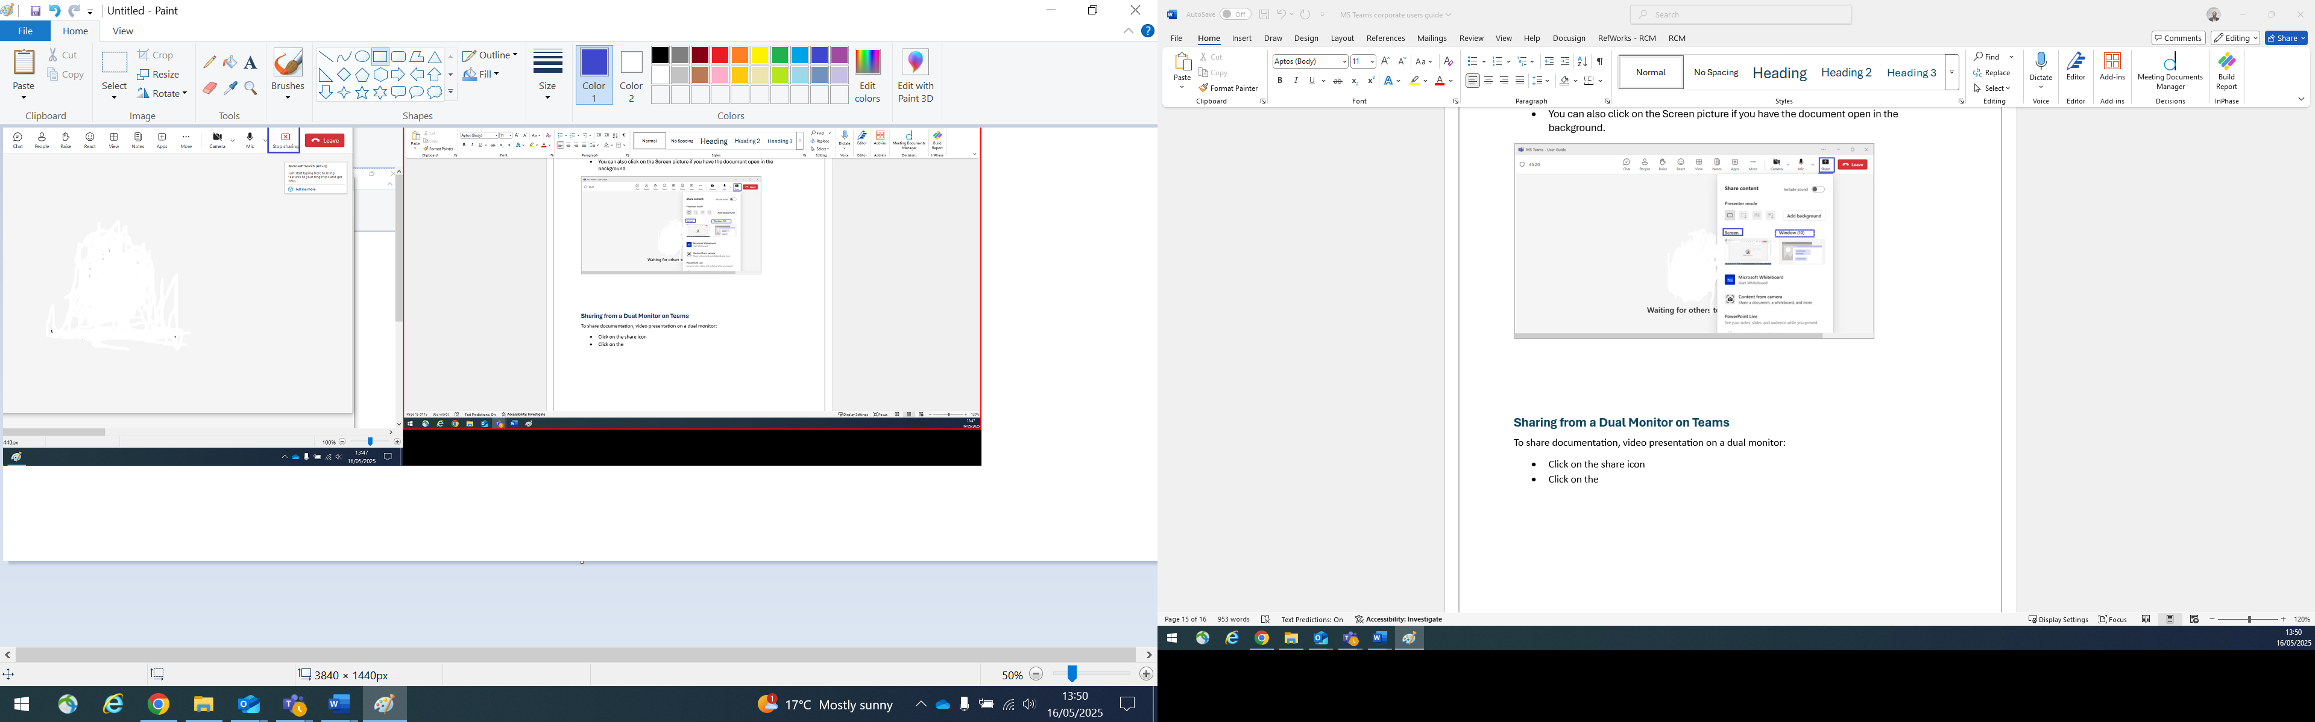
Fig 6.2 sharing on a dual monitor.

Splitting Windows in MS Teams Meeting
In MS Teams meeting you can have your shared document, chat and participants window open by splitting your screen. To do this whilst on a meeting call:
- Navigate to your menu bar and click on people to have your participants window open on the left-hand side of your screen.
- Open the document you want to share with participants
- Click on the share icon then select to share the contents window.
- Navigate to your windows start icon and click to open other Teams App and click on the meeting chat.

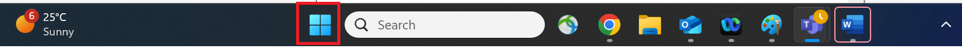
Fig 6.8(0) Windows start icon

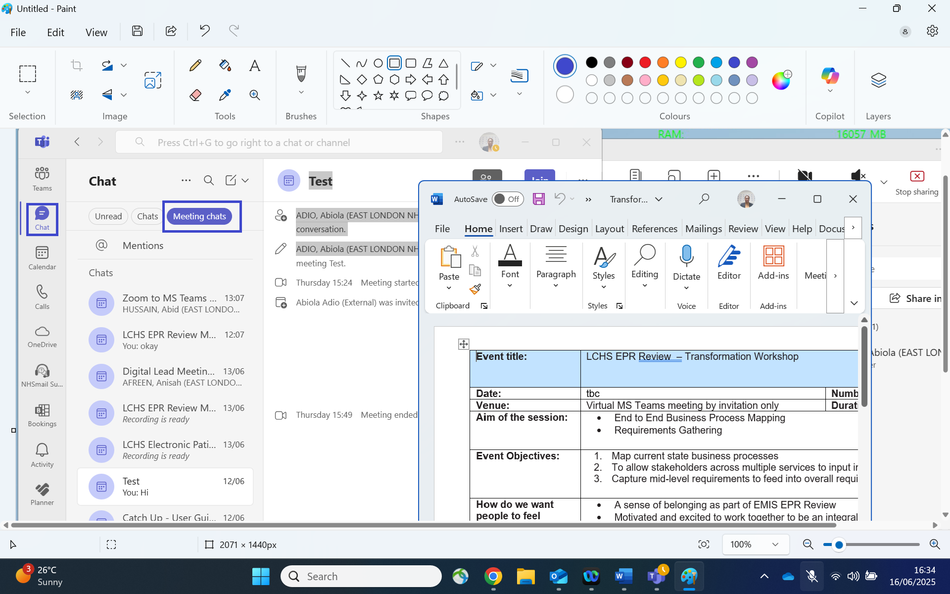
Fig 6.8(1) meeting chat

- Select your meeting chat accordingly from the meeting chat option.
- Tile your windows by resizing the meeting chat window open on the right-hand side of your screen.
Fig 6.8(2) Tiling your window

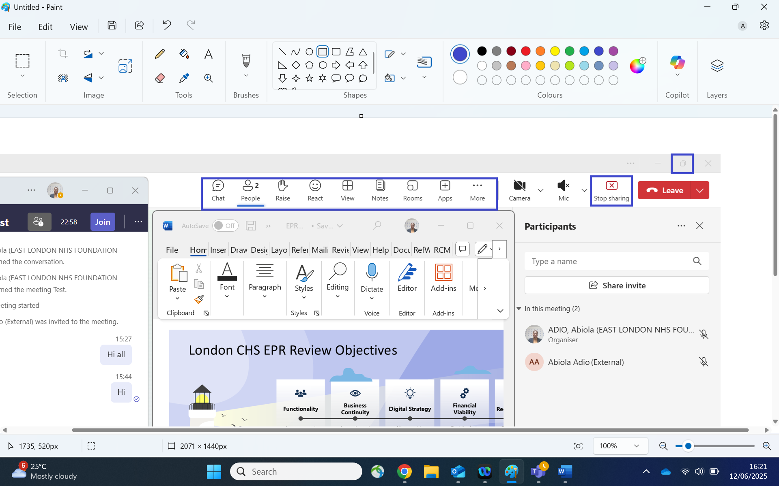
Fig 6.8(3) maximises and minimise bar
- Use maximise and minimise to resize your windows.

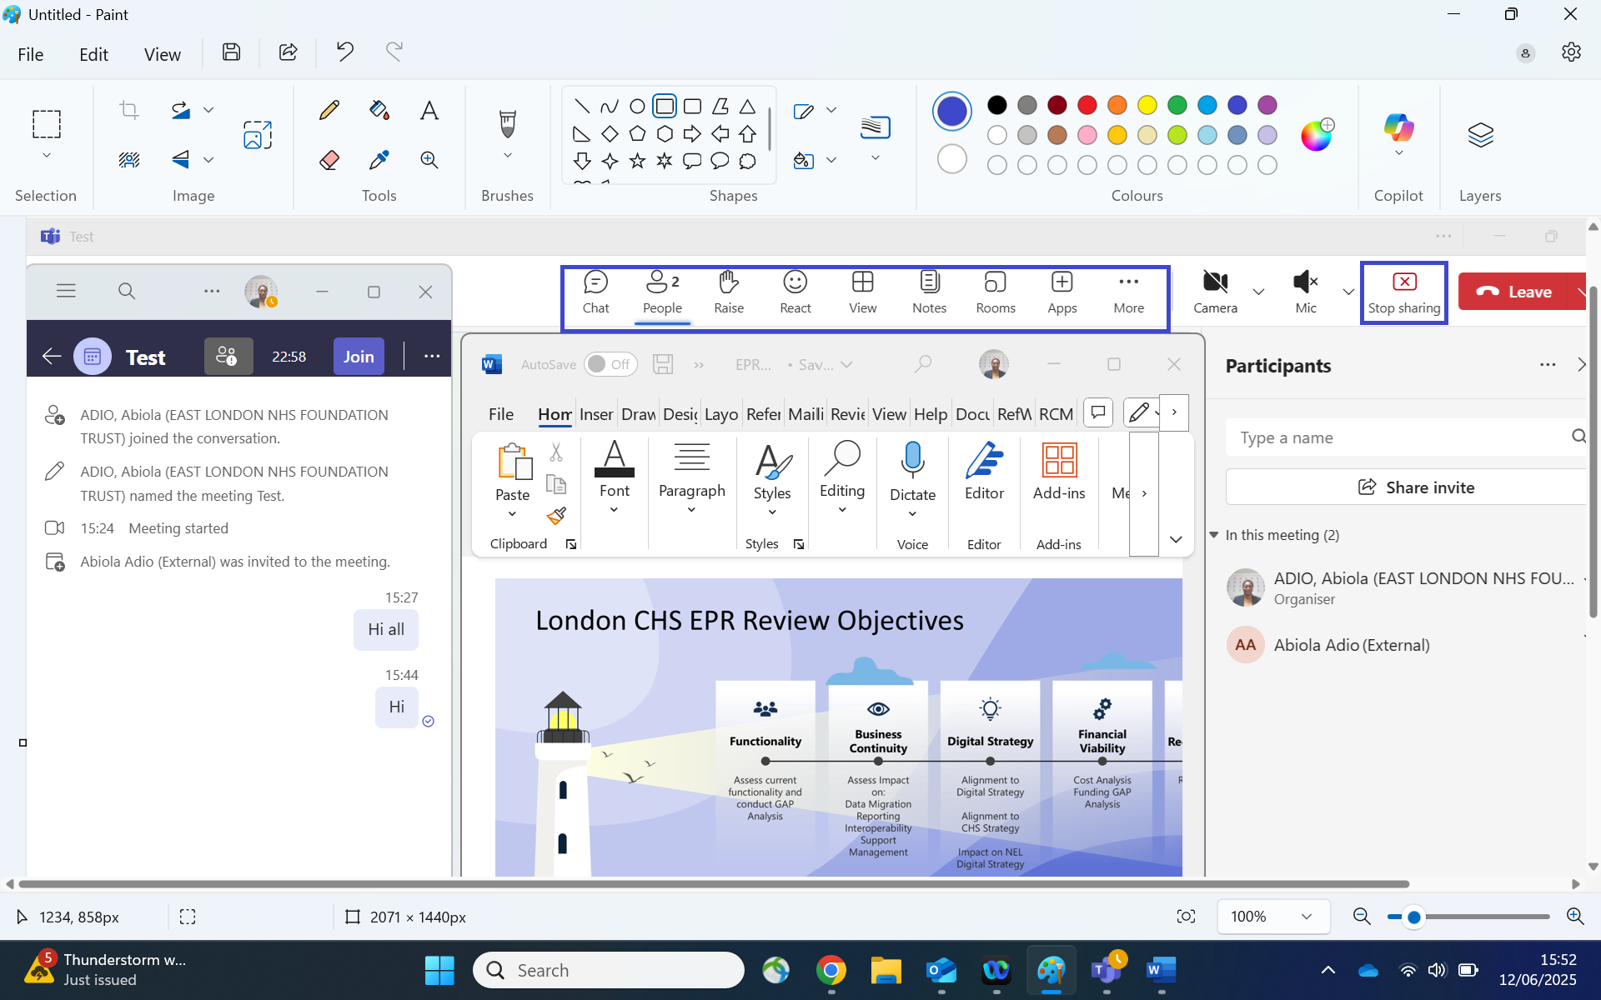
Fig 6.8 (4) Splitting window

MS Teams White Board Feature
To add MS Teams White board:
- Navigate to Share and click.
- From the drop-down window click on Microsoft whiteboard to open it
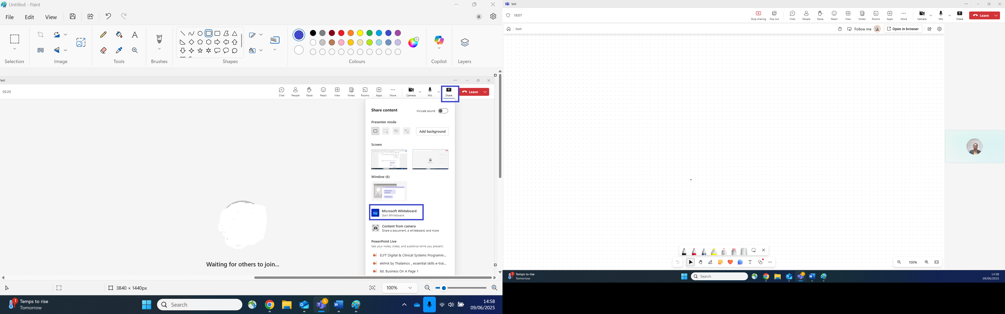
Fig 6.9(1) Sharing whiteboard
- The white board opens, and it is shared with participants if on an MS Teams meeting or webinar.
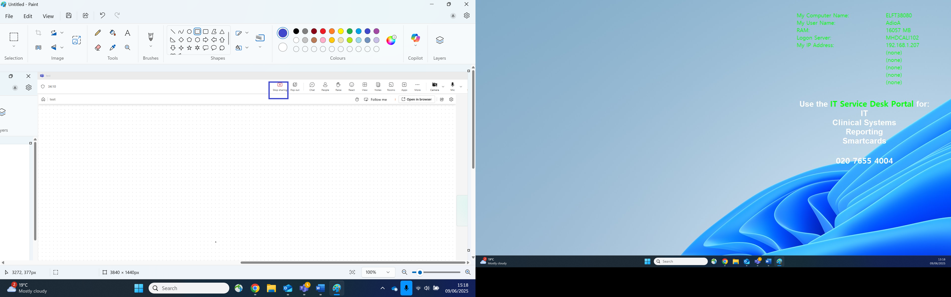
Fig 6.9(2) whiteboard page
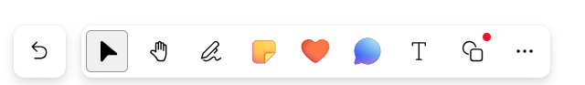
Fig 6.9(3) whiteboard icons use the whiteboard icons to add notes, type text by navigating and clicking on each icon.

MS Teams Gallery View
MS Teams gallery view enables you to know the number of participants you can view whilst on an MS Teams or Webinar meeting.
- Navigate to view and click.
- From the drop-down list hover your mouse on max gallery size
- You can either select 4,9,16 or 49 people.
- Select your requested number.

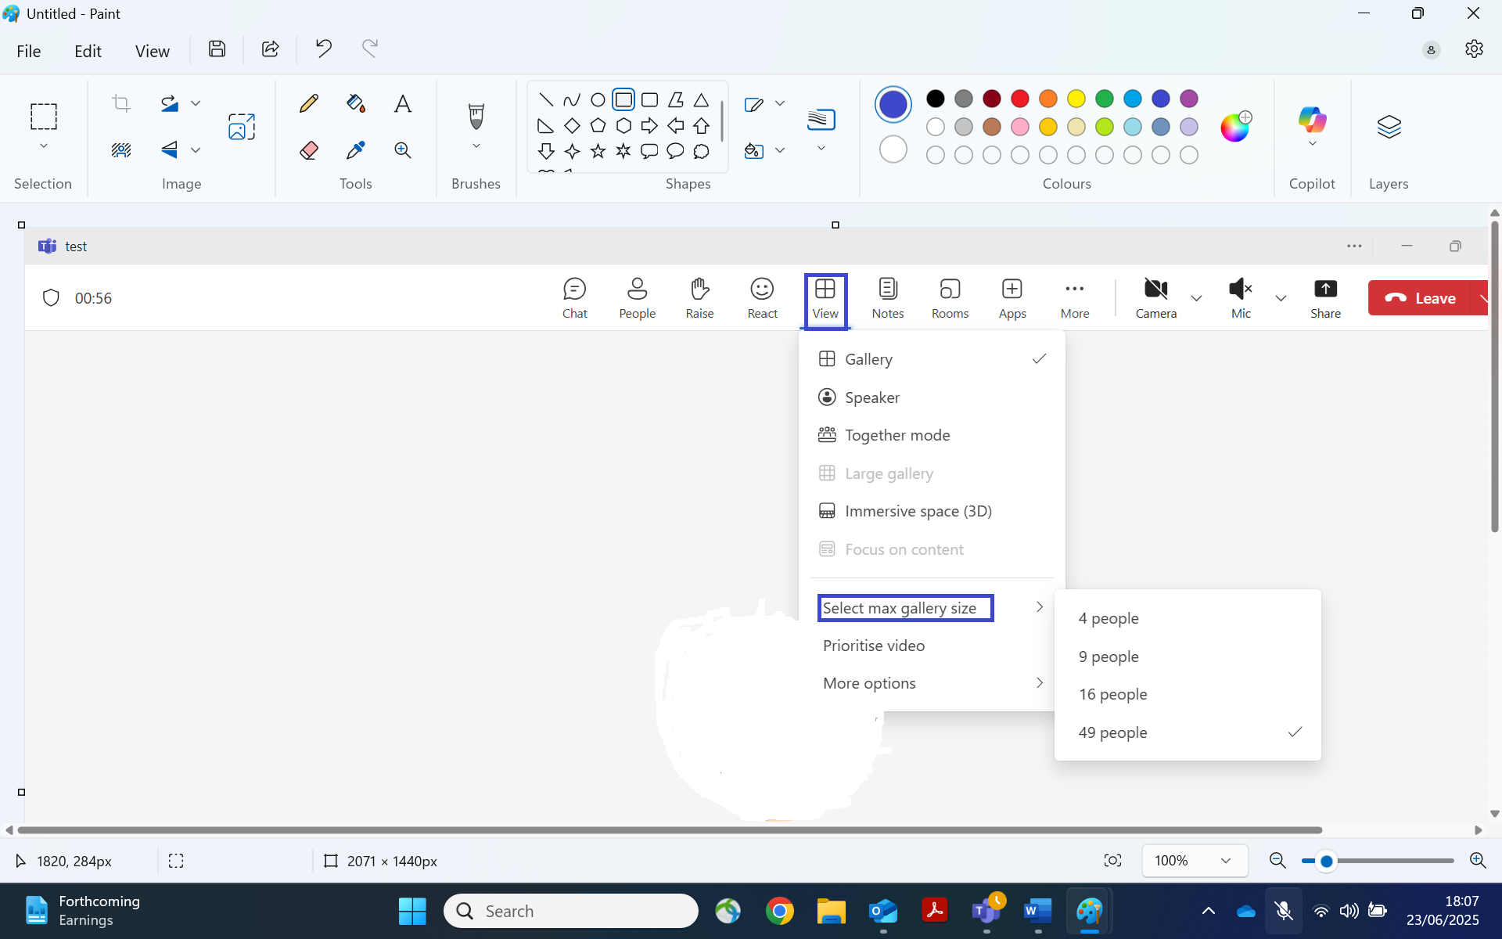
Fig 6.10 Gallery view

Hiding, Pin, Spotlight, Remove Participant from Gallery View
In the gallery view you can:
- Hide Participant
- Pin participant
- Spotlight participant
- Remove from gallery.
You can do this by navigating to:
- Click on the people icon
- Participants window open
- Click on the … (dots)
- Select your option from the drop-down list.

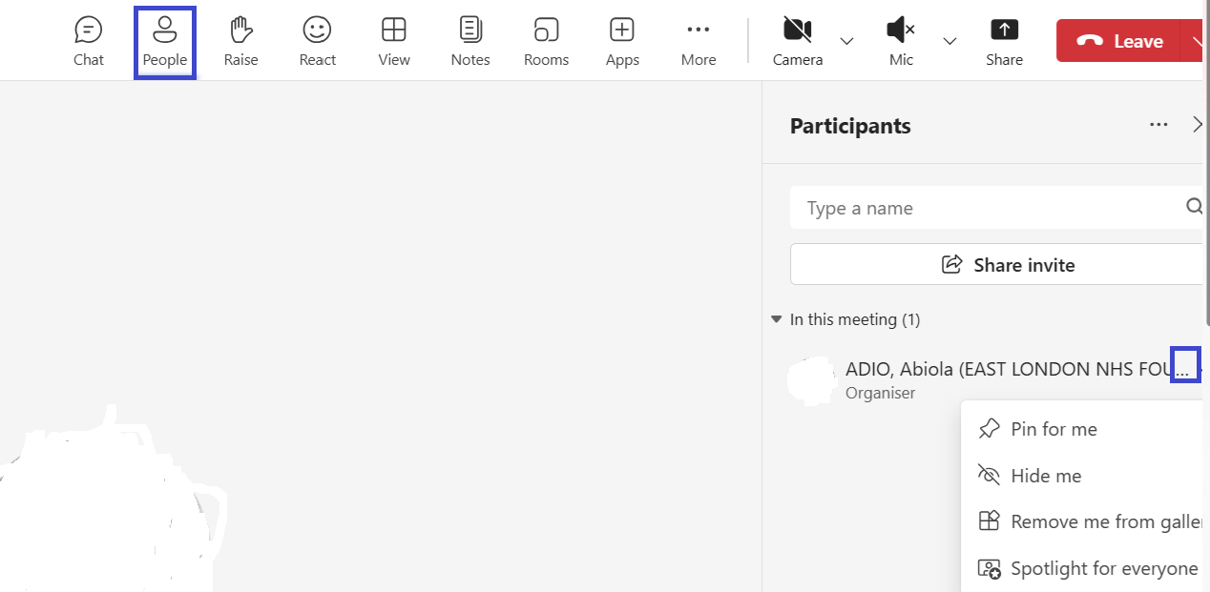
Fig 6.11 Gallery view options

MS Teams Webinar
MS Teams online webinar is an interactive session that requires participants to register to join.
To schedule a webinar, navigate to.
- Calendar on MS teams
- Click on the drop down for new event 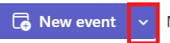
- Click on webinar.
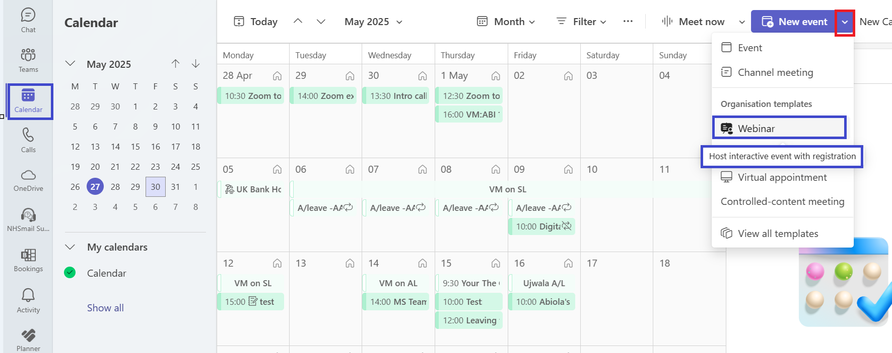
Fig 7.0 scheduling a webinar.

The webinar window opens.
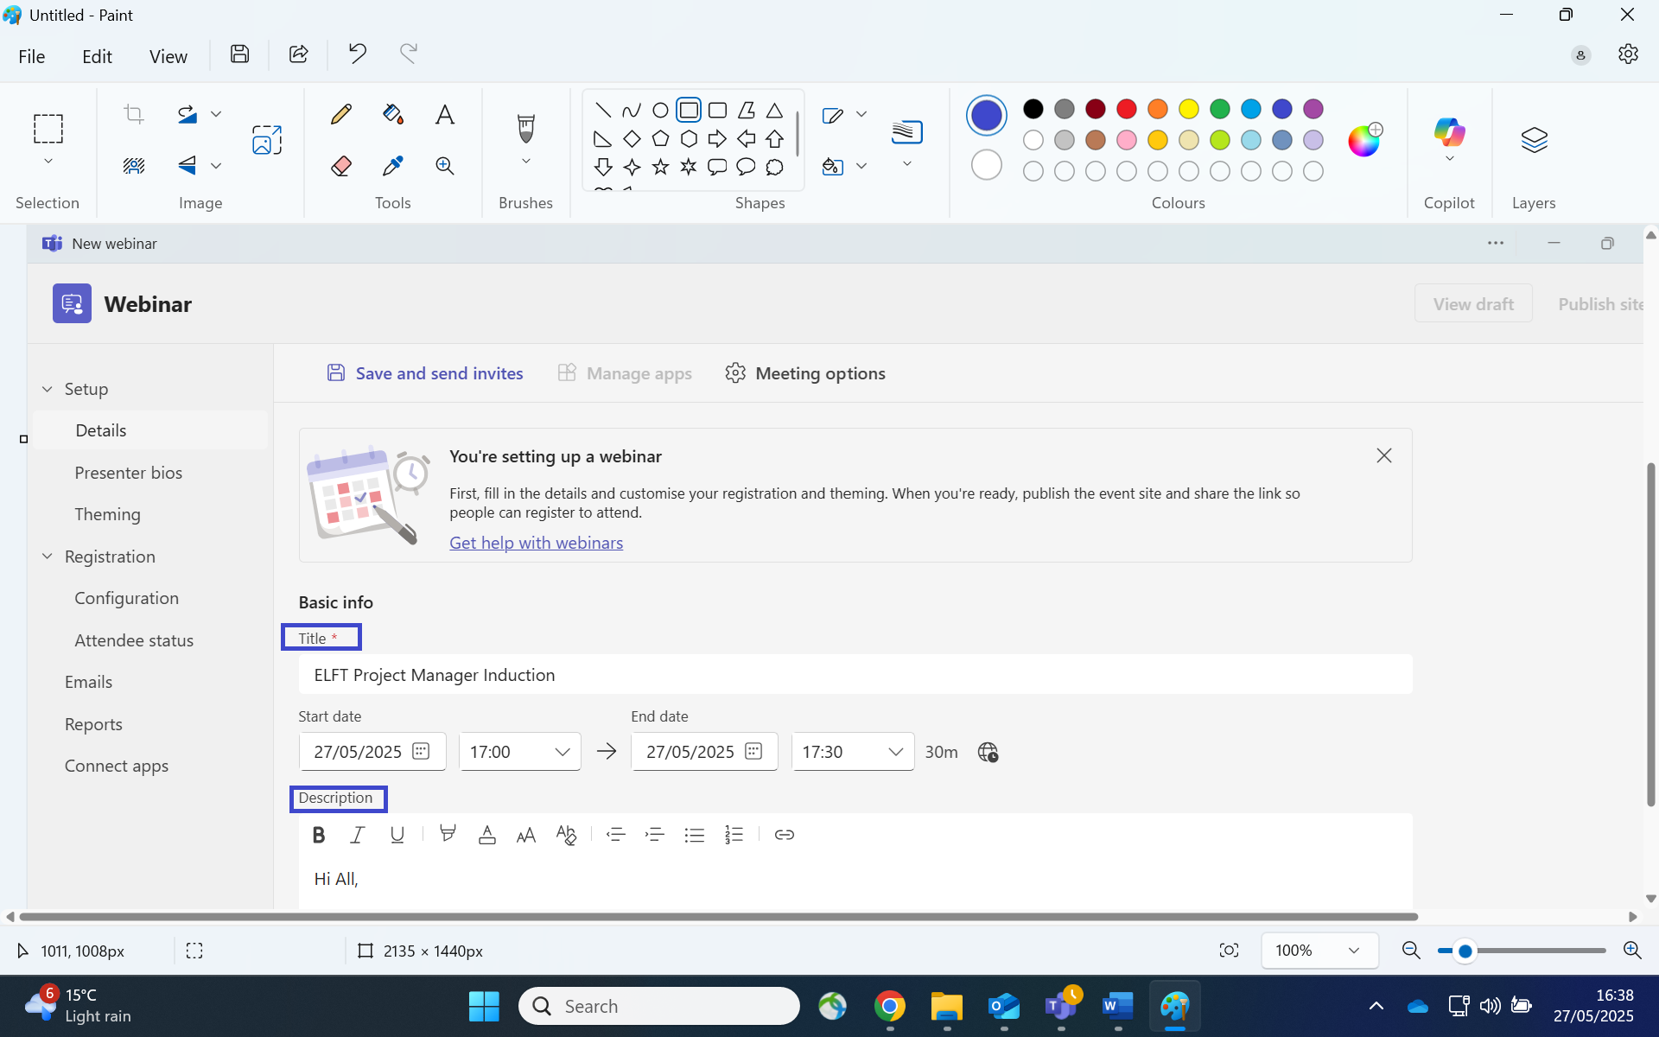
Fig 7.1 completing webinar details.

Add Co-Organiser and Presenter
You can choose to add co-organiser to the event by navigating to the event section:
- Adding a co-organiser
- Adding presenters from ELFT
- Adding external presenter by typing their emails
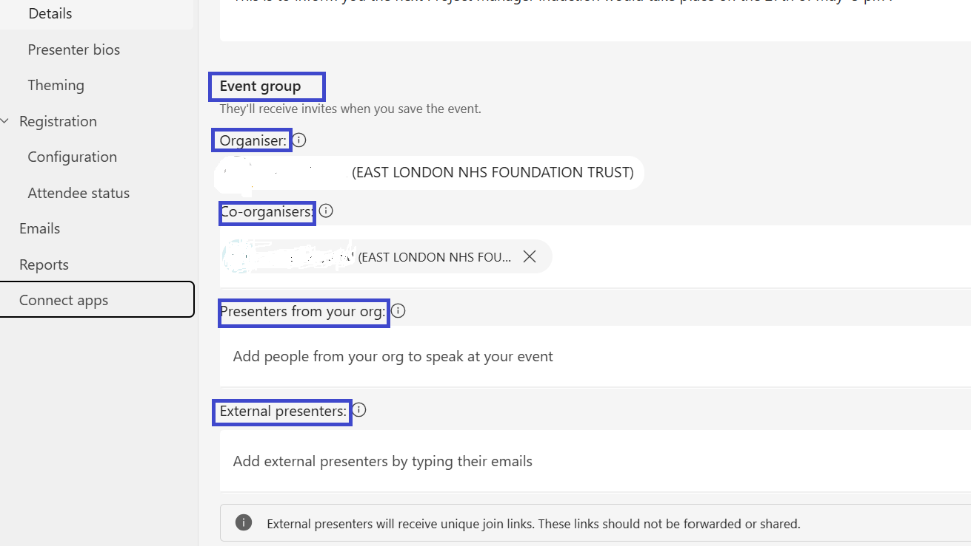
Fig 7.2 Adding co-organiser/Presenter.

Saving Webinar Information Before Publishing
You need to save your webinar before adding registration details and before publishing the webinar page.
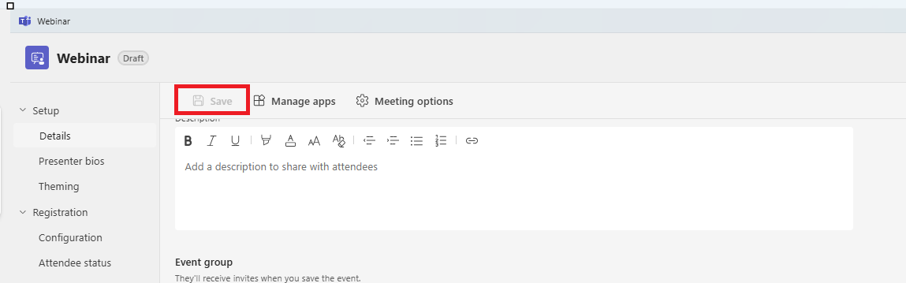
Fig 7.3 Saving webinar

Event Access
Event access enables the webinar host to:
- Choose if participants would be Public or within your organisation.
Attendee /Participant experience in which the webinar host:
- Manage what attendee (Participants) see.
- Allow mic/Camera.
- Customise questions and answers (Q&A)
- Enable Green groom (organisers/host can check audio and content before webinar starts)
- Hide attendees (participants)names.
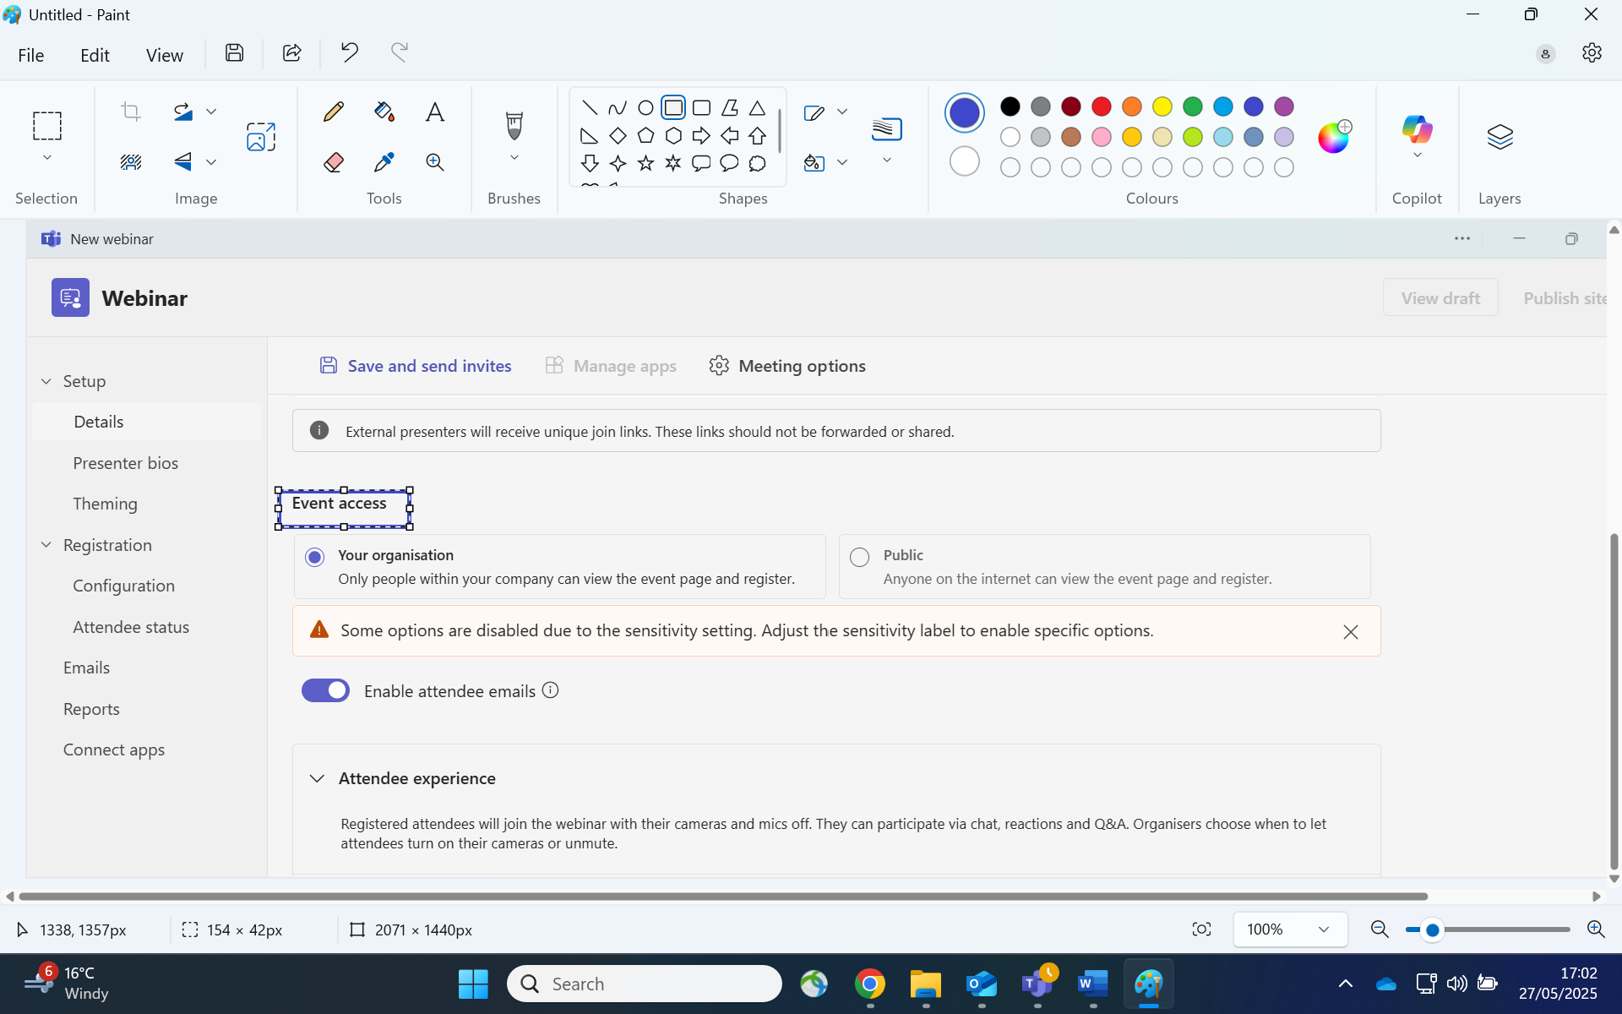
Fig 7.4 Event access
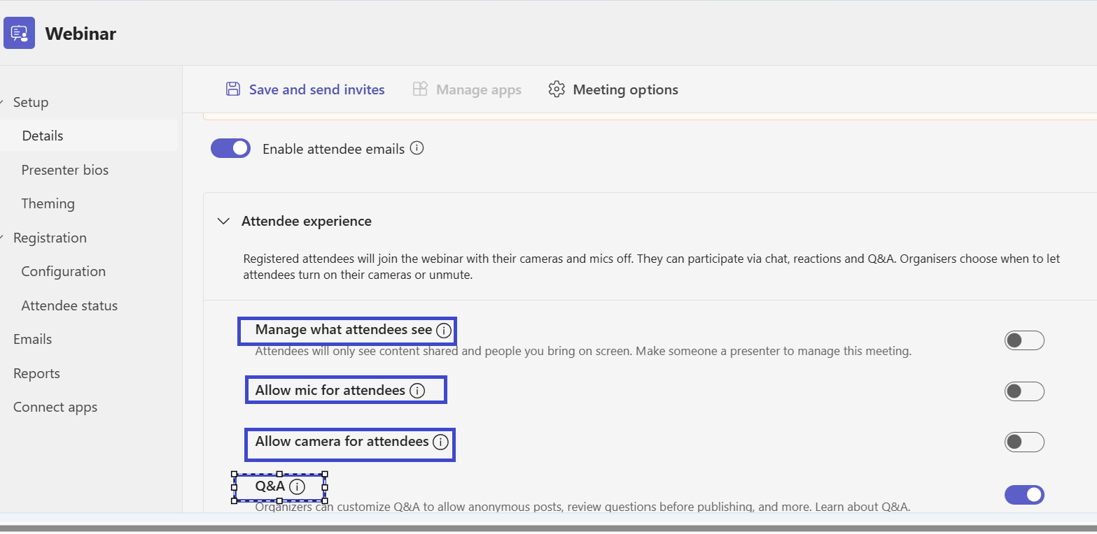
Fig 7.5 Event access

Once you have completed your meeting information save before publishing your webinar to add further information

Event Capacity; Host Registering Participants
To add the number of participants required to attend the webinar navigate to:
- Registration and select configuration.
- Event Capacity and add the number of participants.
- Complete the form to add name, address, email of participants.
From the registration you can view participants emails, status, reports.
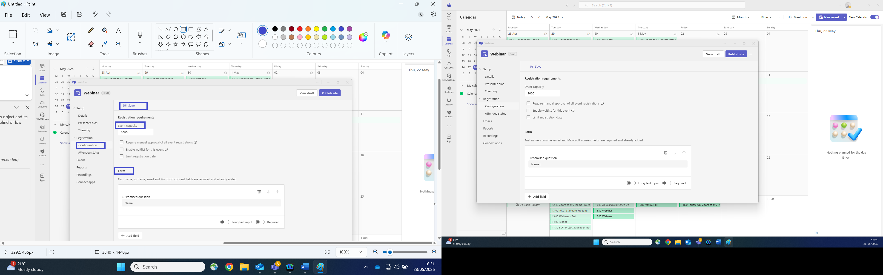
Fig 7.6 Event capacity

Webinar Meeting Options
As a webinar host /organiser navigate to meeting options to add:
- Meeting Access
- Advanced Protection
- Roles
- Production Tools
- Participation
- Recording and Transcription
- Co Pilot and AI
- Accessibility
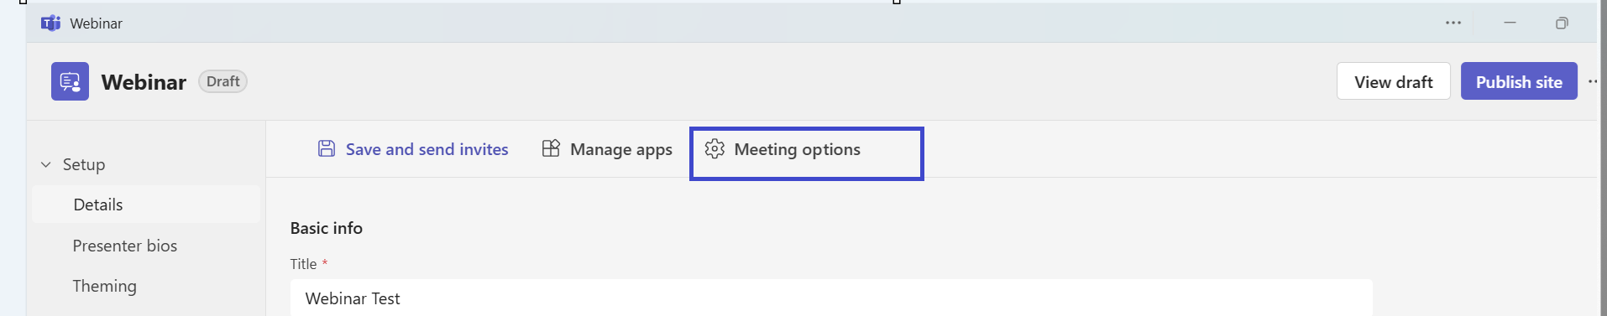
Fig 8.1 Meeting options (1)

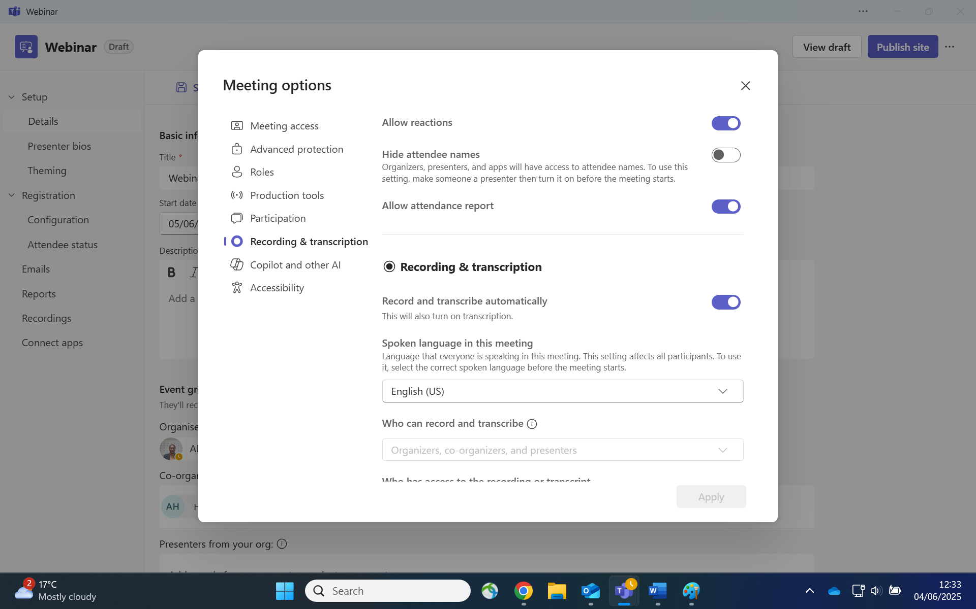
Fig 8.2 meeting options (2)

Inflight of Webinar Meeting - Meeting Option Changes
As the host/organiser when a webinar has started or you are in a webinar session you can navigate to meeting options to make changes if required.
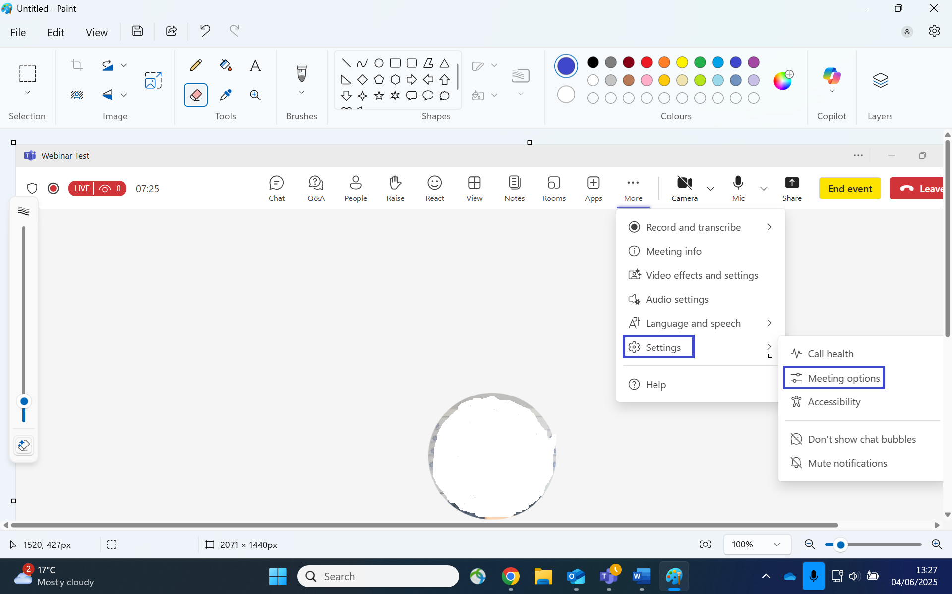
Fig 8.3

Anonymise Participants in Webinar Meetings
This is only available before a meeting starts.
Participants can be hidden during a webinar meeting.
- Navigate to meeting options as above
- Click on participation
- Click on hide attendee names to hide participants
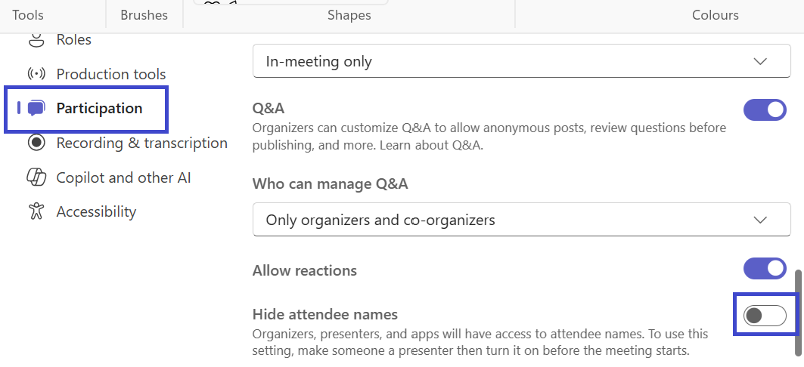

Take Note
- Anonymity in MS Teams webinar is only available before meeting starts.
- The same steps for meeting options in MS Teams meeting is applicable to MS Teams Webinar event.

Participants Joining MS Teams Webinar internally (ELFT) & Externally
When the webinar is published attendee/participants can view the webinar on the internet and can register.
- You can either send a web link of the published webinar for participants/attendee to register or
- You can send an invite via your MS Outlook email to both internal and external participants.

Sending Webinar online link to participants /Attendees to join.
An example of an online webinar link below
Microsoft Virtual Events Powered by Teams

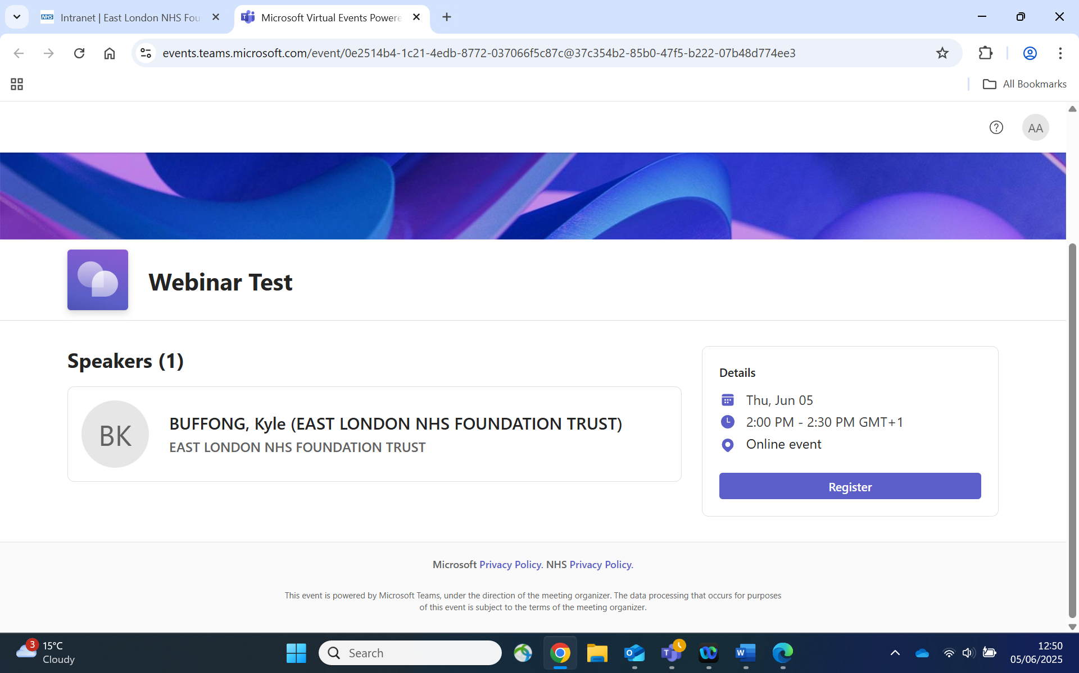
Fig 9.0 webinar published page.
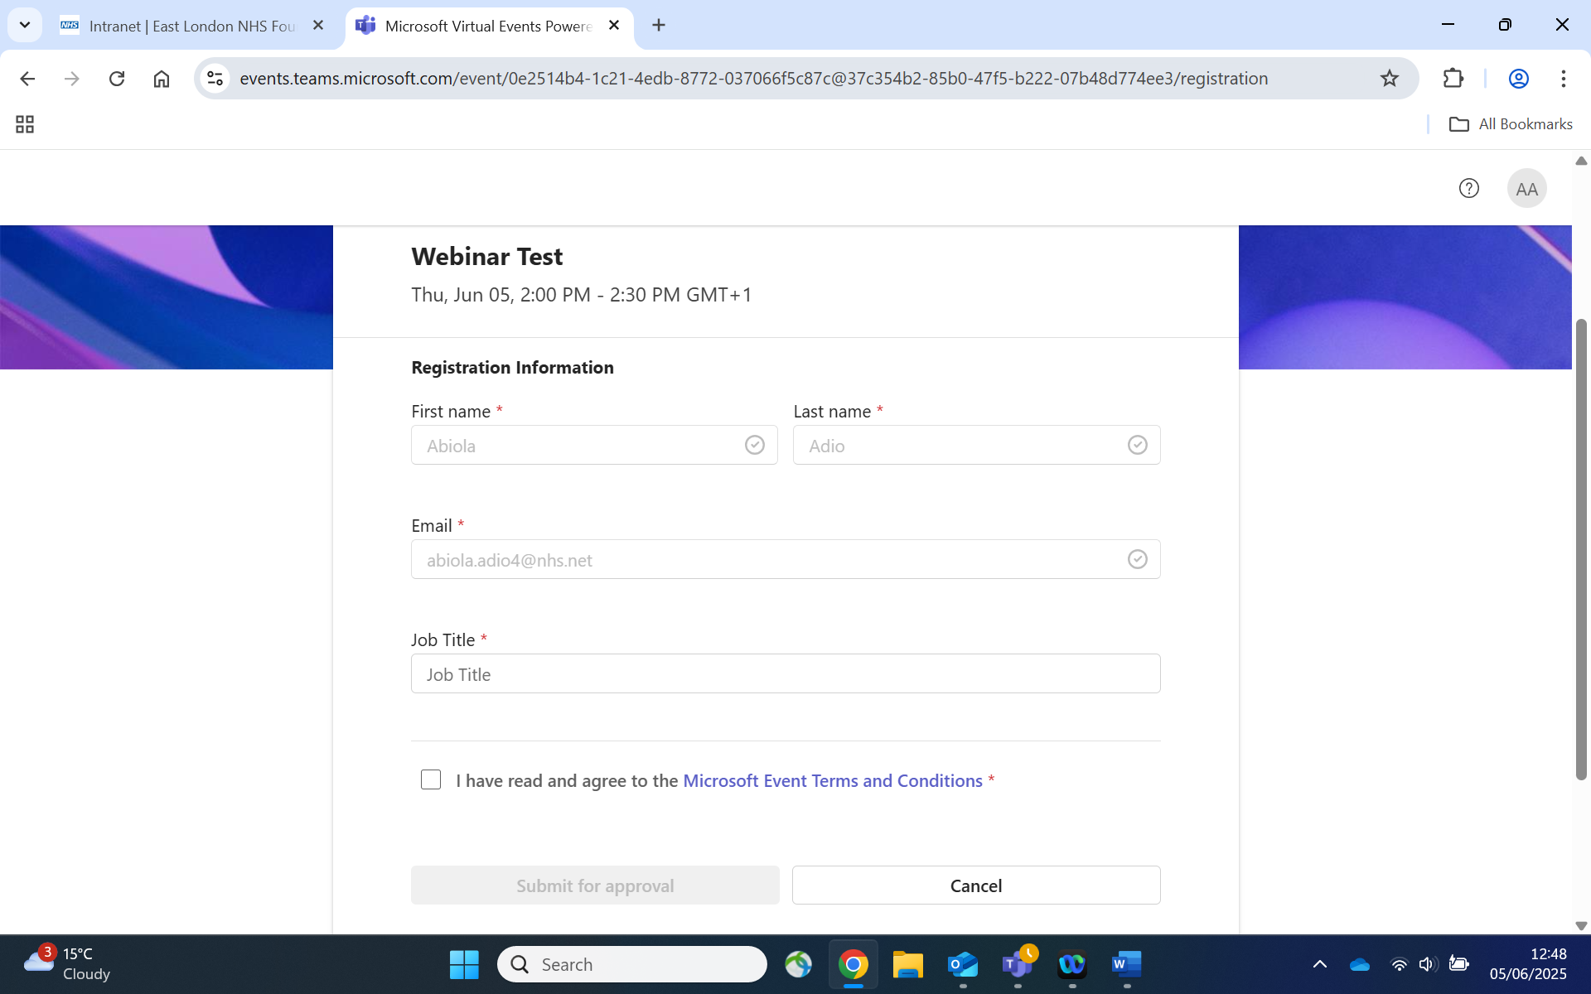
Fig 9.1 Webinar registration page.

Sending Webinar to participants /Attendees to join via MS Outlook Email.
Click on your outlook calendar and the date of the webinar page.
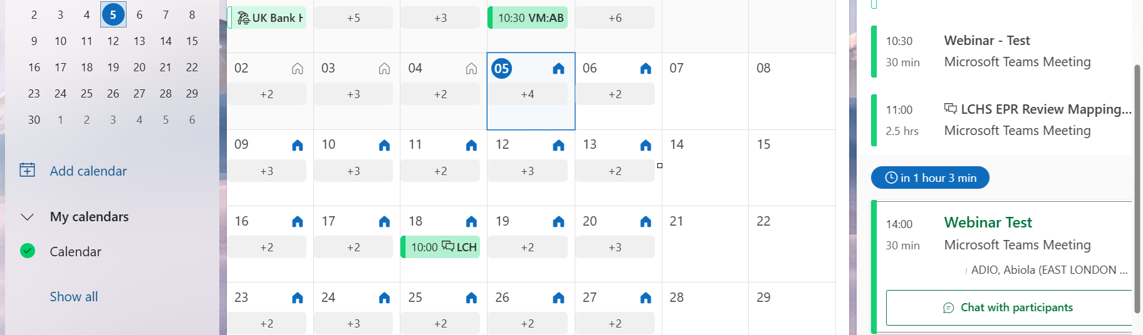
Fig 9.2 webinar outlook calendar
- Click on forward.
- Type the participant/attendee email.
- Click on send.
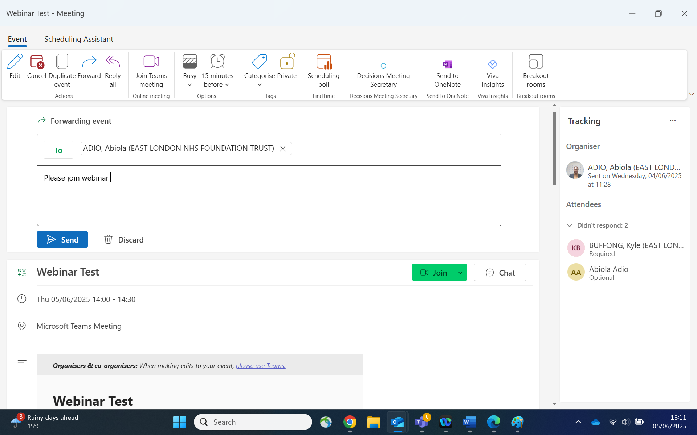
Fig 9.3 sending webinar via outlook email.
The participant upon receiving the email will click on Join to join the meeting.
Fig 9.4 Join webinar via email received via outlook.
Upon clicking on join the participant /attendee will be requested to join and register for the webinar.
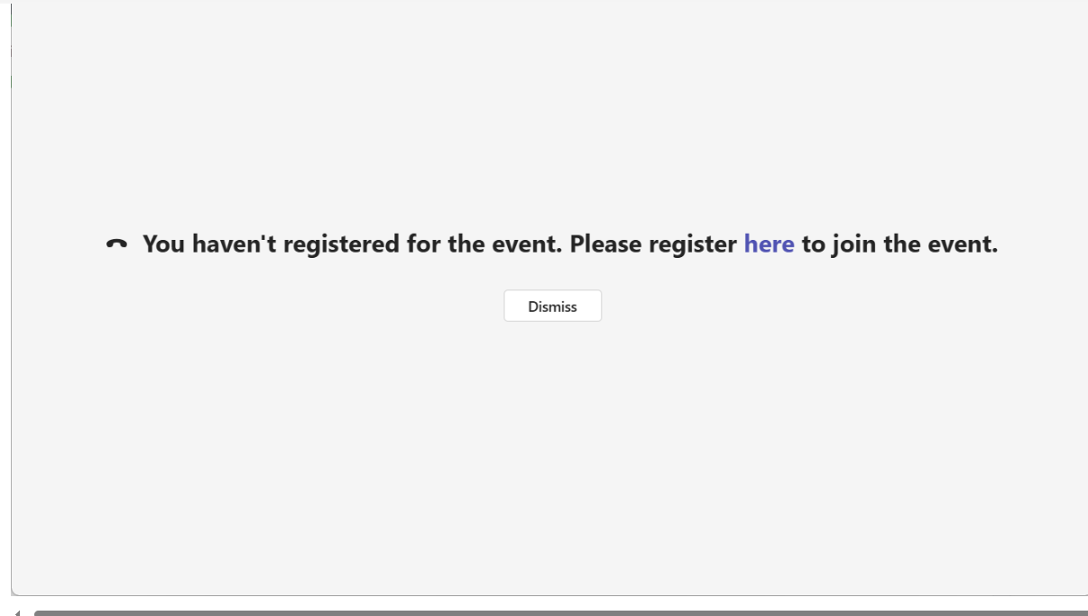
Fig 9.5 participant register and join

MS TEAMS FAQ
As the host can I monitor participants whilst on an MS Teams meeting call | This can be done via the people icon on the screen you are not presenting from, for ease.  Ref: MS Teams Gallery View
As the host can I monitor Participants whilst screen sharing documents, video in a meeting call. | This can be done via the people icon on the screen you are not presenting from for ease, you can mute, hide camera, and see if the participant is still in the call.  Ref: Splitting windows in MS Teams
How many participants are visible on an MS Teams meeting call. | 49 participants are visible on a meeting call  Ref: MS Teams Gallery View
Can participants chat with the host or co-organiser in an MS Teams meeting call. | Participants can chat via the chat icon window.  Ref: MS Teams Meeting Chat
As the host can I remove a participant from an MS Teams meeting call. | This can be done from the meeting options.  Ref: Participants
Can you have all functions running in one screen | Yes, you can with the split function you can share your content, have your chat open and monitor participants attendance whilst on a meeting call.  Ref: Splitting windows in MS Teams.
Is dual Computer needed during a meeting call | Not necessary as you can have all your windows open on a single monitor by minimising and maximising your windows on by splitting your windows on your screen.  Ref: Splitting Windows MS Teams
Can external participants download MS Teams easily | MS Teams can be downloaded on an internet web browser and via mobile phone App, Tablet and iPad.  Ref: Joining MS Teams As an External Participant
Training Participants on MS Teams
Does the participants need a TEAMS Account to join a training session in MSTEAMS? | The participants don’t need a MS TEAMS account to join the training. However, they would be expected to register for webinars using their personal details.
Communication reactions on MS Teams call | There is Emoji in which the trainer and participants can use to react whilst on an MS Teams meeting call.  Ref: Chat messaging features.
MS connectivity with external participants | ELFT has a good internet connection and any further queries regarding connectivity can be directed to ELFT IT service desk.
Adding Participant and Co-organiser during a meeting. | Whist on a meeting call as the host/organiser. Navigate to:  More and click. From the drop-down option click on settings.  From the drop-down option click on Meeting options.
Universal meeting link reused for all meetings, workshops | A meeting link can be shared with other software such as Eventbrite which notifies participants of meeting event.
Eventbrite Automatic Email Integration | Refer to universal meeting link to schedule Eventbrite meetings.
Play Audio without Screen Sharing | Audio cannot be solely shared on MS Teams
Breakout out rooms with Visibility of main chat & screen share in one window | You cannot share the main screen in breakout room. This is not present but workaround of using the split screen functionality
Multiple participants reactions | This is limited to 5. Ref: Chat reactions
Co organisation unlimited | Co organisers limited to only 10 on MS Teams.
Browse Access without APP | You can join MS teams via an internet web browser.
Integrated survey monkey support | This can be added via MS Teams Apps for participants to take part in a survey. Ref Survey Monkey
MS Teams does not allow you to share your screen and make your meeting chat invisible
Host Broadcasting Text messaging within Breakout rooms | Text messages can only be sent within a breakout room by the organisers
Does Microsoft Teams integrate with Survey Monkey like zoom does? | No, Microsoft Teams does not offer native integration with SurveyMonkey in the same way Zoom does. However, you can still use SurveyMonkey effectively during Teams meetings.
How Can I use Survey Monkey in a Teams meeting | You can create your survey in SurveyMonkey beforehand and then share the survey link in the Teams meeting chat. Participants can click the link and complete the survey during or after the meeting.  Tip: To ensure engagement, let participants know when and how you’d like them to respond to the survey, and consider following up after the meeting if needed.

