NON RECENT ABUSE

What happens when a disclosure of non-recent child abuse is shared with the police or social care?
This leaflet is to support clinicians with what happens next, after a decision has been made following discussion with your supervisor, manager or safeguarding team to take forward a disclosure of non-recent child sexual abuse with the police or social care.
This information should be referred to in conjunction with the London Child Protection Procedures, Pan Beds child protection procedures ELFT safeguarding Children Policy and British Psychological Guidance on responding to disclosures of non-recent (historic) child sexual abuse: Safeguarding and support implications-

https://explore.bps.org.uk/content/report-guideline/bpsrep.2023.inf258b/chapter/bpsrep.2023.inf258b.6#ch03lev1sec1
Practitioners should always ensure that the limits to confidentiality are explained at the beginning of contact with a client, and ideally this should be reiterated in writing (for example in the form of an information leaflet). It may need to be reiterated later, as information processing and retention can be significantly impaired by distress. The nature of identifying information may need to be defined, so that the client is clear what information would be the focus of disclosure. Whilst it may be very frightening for clients, data from IICSA’s Truth project indicate that many people do not want other children to suffer the same experiences as they did, and that they are prepared to consider passing on concerns in order

to be protective of others (especially when they understand that there are options for making allegations that do not necessarily involve going to court).

If a client discloses non-recent sexual abuse, practitioner can powerfully communicate that they have heard the client, they take their disclosure seriously, that the client is not to blame and that the responsibility always lies with the perpetrator. Practitioner psychologists can also demonstrate that it is the perpetrator’s behaviour that was unacceptable and that it is the perpetrator’s behaviour which needs to be addressed. It may also be necessary to say either immediately, or at a later point, that in order to ensure that the alleged perpetrator is not harming other children or young people, it may be necessary to pass on what has been disclosed. It needs to be clearly conveyed to the client that this can be done anonymously, does not have to involve the person being identified, and that their safety and survival is of equal importance to the need to protect other potential victims
(British Psychological Society, 2023)

What if a child is identified as being currently at risk?
If a child is identified as being currently at risk this should be referred by the clinician to Children's Social Care following normal local safeguarding procedures. If a child is in immediate danger call 999. If a child is currently at risk, and you believe there may be important forensic evidence, report at the earliest opportunity to the Police, as timeframes are crucial for their investigation. The following table provides the contact details for the different children’s social care teams across the trust are as follows-

Central Bedfordshire Access and Referral Team 0300 300 8585
Bedford Borough Integrated Front Door 01234 718700
Luton Multi Agency Safeguarding Hub (MASH) 01582 547 653
Newham Multi Agency Safeguarding Hub (MASH) 020 3373 4600
Tower Hamlets Multi Agency Safeguarding Hub (MASH) Tel: 020 7364 5006 opt 3
Hackney Multi Agency Safeguarding Hub (MASH) 020 8356 5500
City of London Multi Agency Safeguarding Hub (MASH) 020 7332 3621

What if it is not clear that a child is currently at risk?
A call should be made to 101 the non-emergency police number. Alternatively can report online https://www.met.police.uk/ro/report/ocr/af/how-to-report-a-crime/
What should I expect when I call 101 the non-emergency police number?
When you call 101 the system will determine your location and connect you to the police force covering that area. You will hear a recorded message announcing the police force you are being connected to.
Calls to 101 are answered by trained police officers and staff in the control room of the local police force. The call handler will log the call and refer it to the relevant team within the force.
The police will allocate a crime report number called a unique reference number (URN) on reporting the information. This should be referred to in any communication with the police and recorded in the client’s clinical record along with the name of the officer you speak with.
If it is a clinician making a call on behalf of the client, this number should be given to the client and recorded in the client’s clinical record.
You should be prepared to provide the call handler with the following information:
- Your details (including name, contact details and times when you will be available to be called back)
- Your role
- Place of work
- Details of client, perpetrator and disclosure

What happens if the client wants to report to the police themselves?
There are different ways in which a client may wish to report their experience of child abuse to the police.
This can be done: - directly by phone or at a local police station or anonymously – via crime stoppers or NSPCC
What will happen after the disclosure is shared with the police?
Police and other agencies will need to enable an effective response that incorporates the need to protect children and investigate a crime, balanced against the need to protect the well-being of the person who is a survivor of child abuse.
Where there are current child safeguarding concerns, a strategy meeting involving a police supervisor, social care colleagues and any other relevant professionals should take place and be formally minuted before any further action is taken. The clinician involved or member of the Safeguarding Children Team is likely to be part of such a meeting.
The outcome will be fed back to the clinician and, where appropriate, the client.
Police will make contact with the client/patient within days to discuss what took place and explain the next steps, including making a statement.
Balancing the Needs of the Client versus Needs Of Potential Other Victims
- If a client discloses that they were sexually abused in childhood, the practitioner concerns about risk should be heightened if:
- the alleged abuse has not been previously reported or there has not been previous professional intervention from the police, medical or social services;
- the alleged perpetrator is a family member with ongoing contact with children;
- the alleged perpetrator holds a position of trust (paid or voluntary) which is likely to bring them into contact with children and young people;
- the client is aware (though they may not be) that other young people were victimised;
- it is clear that there was organised or ritual abuse; or
- the adult client is continuing to be abused by the perpetrator.

These factors are likely to be present in the rare and exceptional instances where practitioners may have to take action without the client’s consent.
The absence of any or all of these factors cannot be assumed to mean there is no ongoing risk. Perpetrators with no known access to children either through familial, social or occupational context will still live as part of communities and may well have access to children in their daily lives. The survivor may be unaware of other victims and may feel that they were uniquely singled out or to blame, when in fact the perpetrator may have abused other children extensively.
In any case of disclosed abuse, it is crucial to include the survivor’s reasons for not telling as part of risk assessment, and to be clear with colleagues that these risks may present real threats to the person’s ongoing safety. Silence can be induced by specific threats of harm to the victim or to people close to that person. If clients are from shame/so-called ‘honour’ based cultures, then this can place them at particular risk of severe reprisals. Clients may have genuine and real fears that they might be killed for speaking out. In any case of disclosed abuse, it is crucial to include the victim’s reasons for not telling as part of risk assessment, and to be clear with colleagues that these risks may present real threats to the person’s ongoing safety.
Risk assessments need to be extended to consider potential safeguarding issues raised by non-recent abuse allegations, the impact on the client, and the risks associated with placing them on a waiting list during any potential investigation. Practitioners are advised to consider additional factors which can make reporting more complex. These should be considered as potential vulnerabilities and inform a risk assessment and formulation.
The client may also be a parent themselves, and the impact of distress upon their parenting capacity should also be considered.

Breaching Confidentiality
There may be circumstances when a practitioner needs to breach confidentiality in order to safeguard the client and/or others. It is important that the rules around confidentiality are established at the outset ensuring clients understand that confidentiality may need to be breached in certain circumstances without their consent. Clients also need to understand the extent of information-sharing between professionals bound by the same rules. The fundamental obligation is that a client ought to know in advance of disclosing anything to any professional that the professional may not be permitted to keep secret the information the client has disclosed. Honesty about this issue is crucial and avoids risks of clients’ later feeling let down or that they misplaced their trust in the professional.
What do I do if a disclosure has to be taken forward without the knowledge or consent of the client?
In some cases the consent and knowledge of the client may not be possible. This could be because of an increase in risk to a child, the client, clinician or others, or because they may then seek to inform an alleged perpetrator or undermine any further investigation.
If information is to be shared without knowledge of the client, it is recommended to seek advice from the Safeguarding Team.
What should I do if the client wants the disclosure shared with the police, but wants me to report?
The clinician can make a call to 101 on behalf of the client. The clinician should state that they are making the call on their behalf, and it is a third party report.
The clinician needs to be clear how the client wishes to proceed.
What if the client wants to share information as intelligence, but does not want to pursue a criminal complaint or want the perpetrator arrested?
The client can call 101 the police non-emergency number and state; this happened to them as a child, they do not want to make a criminal complaint or want the perpetrator arrested. It is unlikely that the police would go against victim’s wishes, but 100% guarantee cannot be given.
If police checks identify a child may be currently at risk then a discussion would take place with children’s social care.
By reporting the disclosure a crime will be recorded against the client and a crime number given. If the client should change their mind and wish to take forward as a criminal complaint at a later date, the crime number can be referred to and this would show that the client has been consistent in their disclosure.
Can the client report informally/anonymously to the police?
The client can call 101 the non-emergency police number or Crime stoppers 0800 555 111.
This can also be carried out by a friend, family member or support worker on their behalf.
Advise the client it is better to give their own name, as this will help to identify or confirm anyone else at risk. This does not mean they will be contacted.
Documentation
A clear recording of the disclosure of the client, details of actions taken, including discussions with supervisors/ managers/Safeguarding Team and outcomes should be recorded in the clinical record as per Trust policies.
If checks on police systems have taken place without the client’s knowledge, ensure that this is clearly recorded in the clients clinical record, handed over in transition to other services and included in discharge summaries to partner agencies e.g. GPs.
A clear rationale for the decision not to inform the client should be included.
What if my client reported the abuse in the past but is not happy how it was investigated and/or has new information that was not known during the investigation?
The police will respond to your client's concerns and/or new information.
Your client, a friend, family member or support worker can call the non-emergency police number 101 and discuss how this can be taken forward.
Where can my client get support?
Specific support for survivors of child sexual abuse is currently provided by adult psychological services within ELFT.
In other circumstances clients should be encouraged to seek advice from their GP.
Below are listed a number of organisations that can be contacted.
However, these organisations are non-NHS and therefore ELFT cannot vouch for the quality of their services:
NSPCC
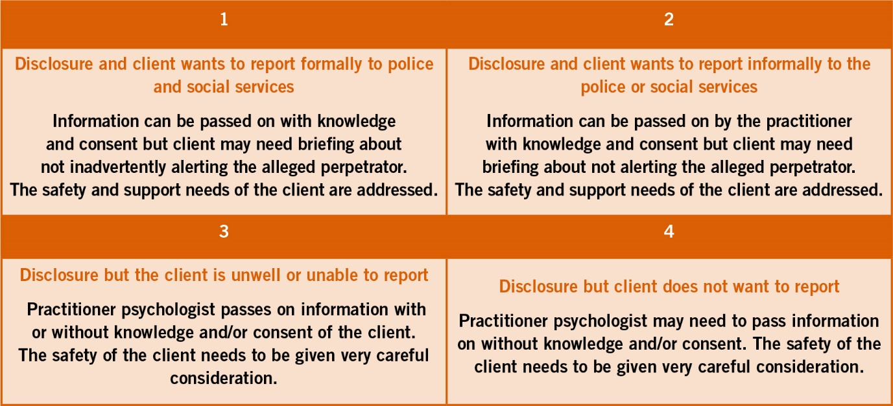
The NSPCC give support to those who have experienced child abuse in the past, or for those who are concerned about a child in the present. • Helpline: 0808 800 5000 • Email: help@nspcc.org.uk • Make a report online at www.nspcc.org.uk
NAPAC
NAPAC is the National Association for People Abused in Childhood, providing a helpline and support to people who experienced past abuse. • Support line 0808 801 0331 • www.napac.org.uk
MOSAC
This charity aims to provide a unique and specialist service, offering practical and emotional support to non-abusing parents, carers and families. • Helpline: 0800 980 1958 • Freephone: 0800 783 6294 • Email: enquiries@mosac.org.uk
The Survivors Trust
The Survivors Trust is a UK-wide national umbrella agency for 141 specialist organisations for support for the impact of rape, sexual violence and childhood sexual abuse throughout the UK and Ireland. • www.thesurvivorstrust.org • Freephone: 08088 010 818 • Email info@thesurvivorstrust.org
Stop It Now!
Stop It Now! is an organisation run by Lucy Faithful House that is at the forefront of activity to prevent child sexual abuse. • www.stopitnow.org.uk • Freephone: 0808 1000 900
Likely scenarios when a client discloses non recent abuse

