

User Guide For

MS Teams Participants

Table of Contents
Contents
Table of Contents 1
Joining MS Teams As an External Participant 2
Joining MS Teams Meeting Via Computer Laptop /Desktop 3
Joining MS Teams Meeting Via Mobile Phone 4
Joining MS Teams Webinar via Laptop and Mobile Phone 6
MS Team White Board Feature 10
MS Teams Gallery View 11
Q & A Session (Questions and Answers) 11
Participating in a Poll 12
MS TEAMS FAQ 13

Joining MS Teams As an External Participant
As an external participant you can join MS Teams via a web browser either on a laptop, desktop and mobile by downloading MS Teams.
To join MS Teams on a laptop, you need to download via an internet web browser. As first-time user only download once afterwards you can join many times password is not needed.
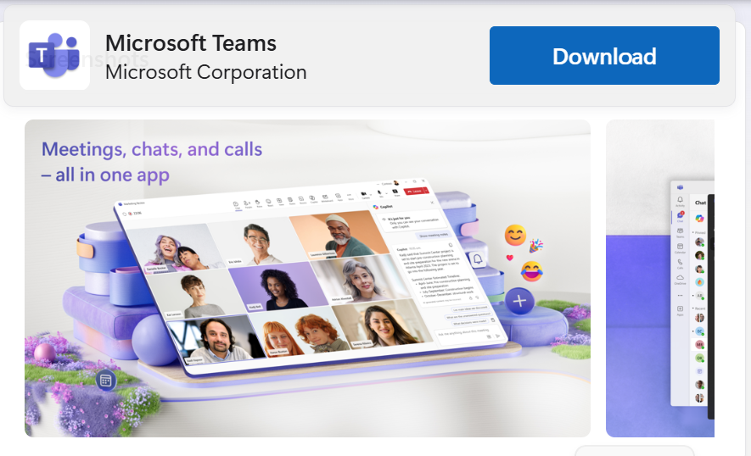
Fig 1.0 Download MS Teams for laptop/Desktop
You can join MS Teams via an App store if you have an iPhone mobile or an iPad, iPhone and on Android play store. And first-time users only download and done once they can join as many times as they can they do not need a username and password.

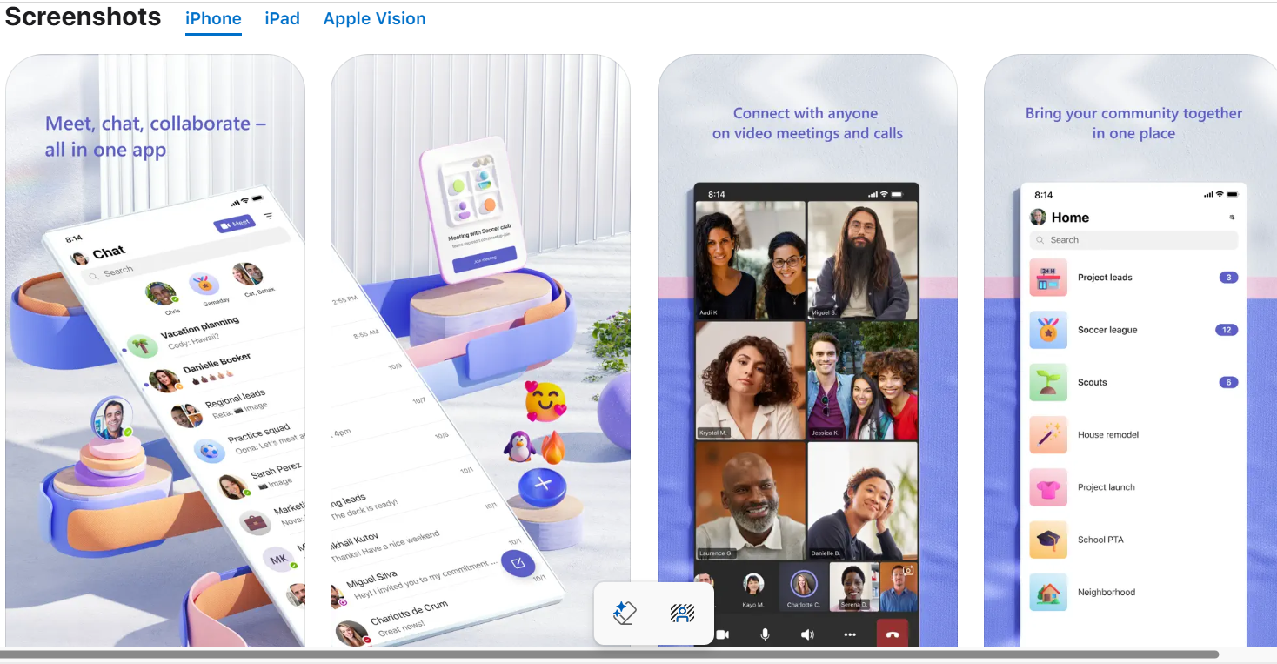
Fig 1.1 Download MS Teams from the App store

Joining MS Teams Meeting Via Computer Laptop /Desktop
To join MS Teams Meeting and Webinar you must have access to an internet web browser and have an email address where you can receive notification of an MS Team meeting and webinar invite.
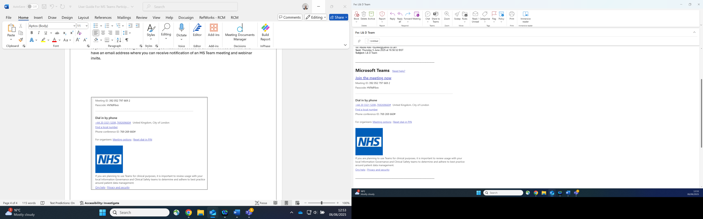
Fig 2.1 MS Teams email invite
Upon clicking on join to enter the meeting room, you will be presented with the window below:
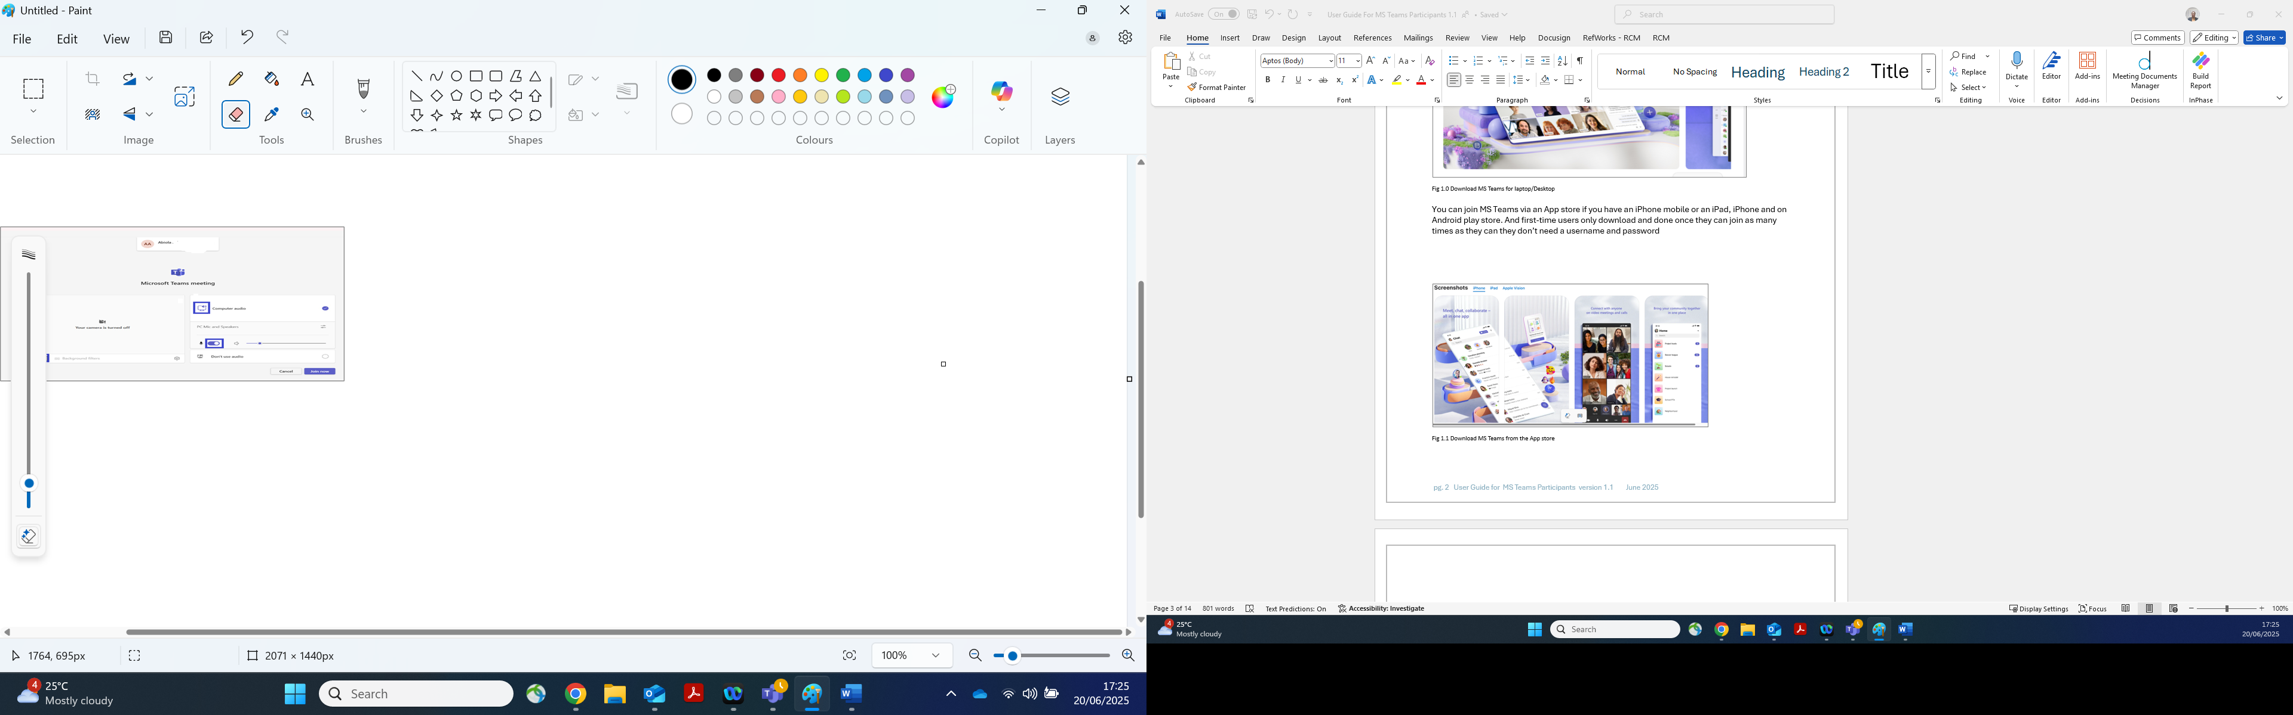
Fig 2.2 Joining MS teams meeting.

- Ensure your computer audio is on
- Adjust the volume of your speaker.
- Click on camera to show your face.

Joining MS Teams Meeting Via Mobile Phone
From the email invite received click on join and you will be presented with the window below:
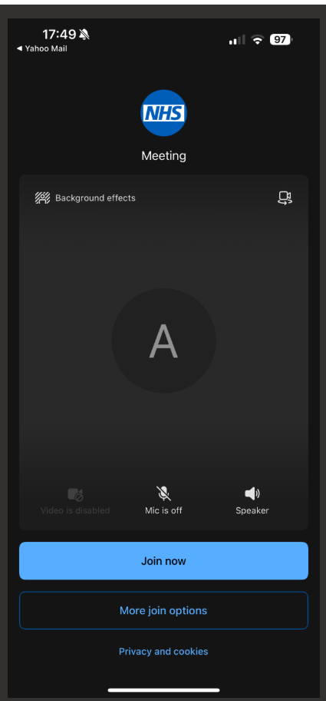
Fig 3.0 Joining on MS Teams mobile.
- Type your name.

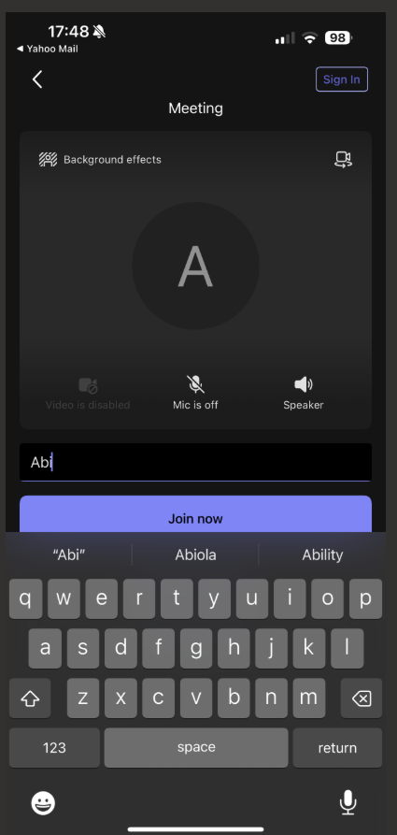
Fig 3.1 Type your name.

You will be directed to the lobby where you will.
- Adjust your speaker volume.
- Enable your camera to show your face.
- The meeting host admit you into the meeting.
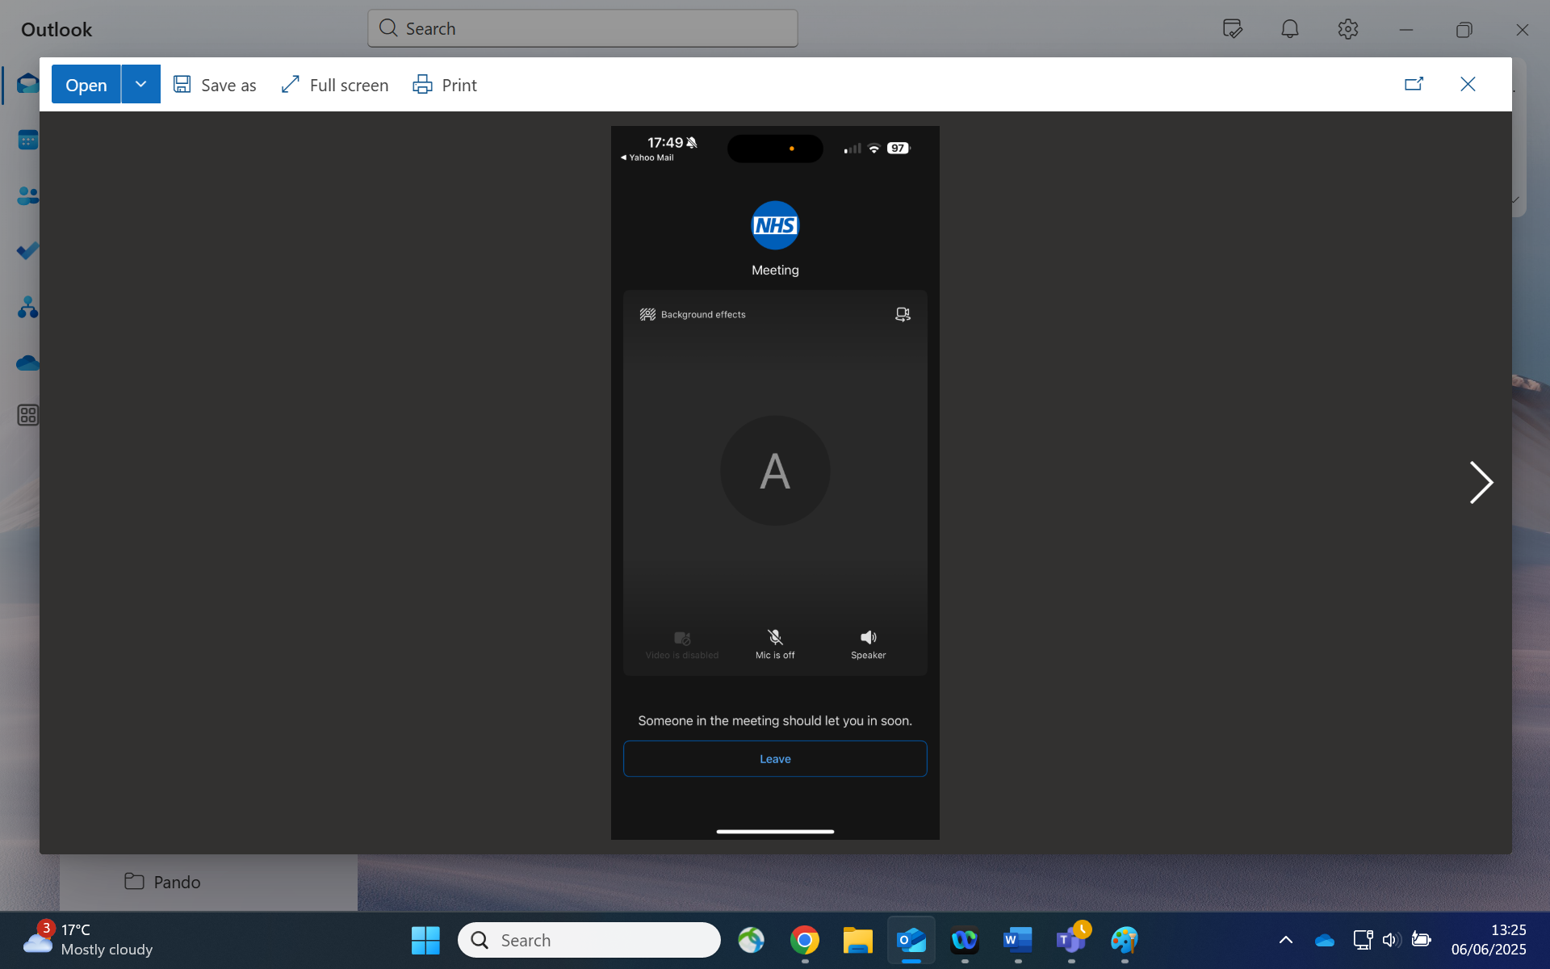
Fig 3.2 Lobby waiting to enter meeting room.

Joining MS Teams Webinar via Laptop and Mobile Phone
You will receive an email with the webinar link.

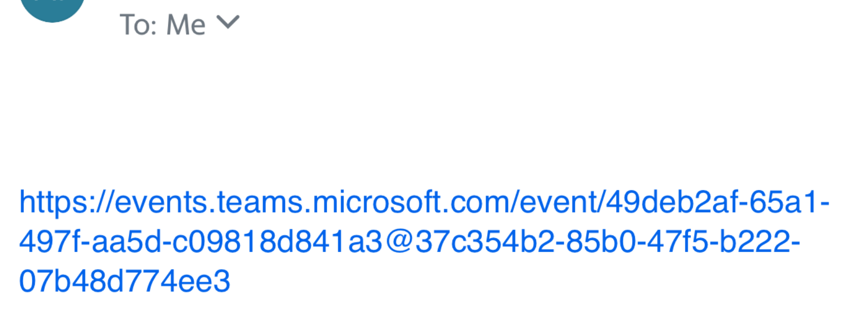
Fig 4.0 Webinar invite link.

Click on the web link and you will be taken to the published webinar test page.
- Click on Register to register your attendance at the webinar.
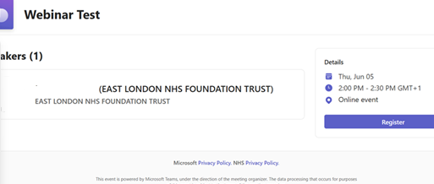
Fig 4.1 Register for webinar

You will be directed to another window to complete the field for:
- First Name
- Surname
- Email
- Tick the box for I have read and agreed to the Microsoft terms and condition.
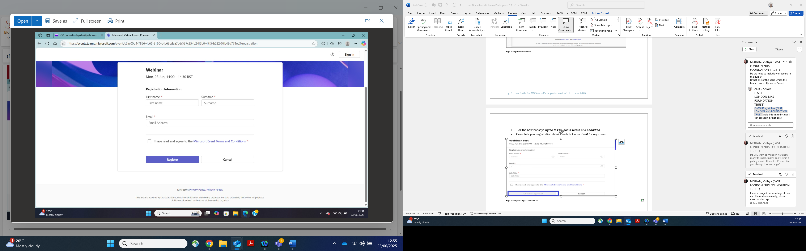
Fig 4.2 completing fields window.

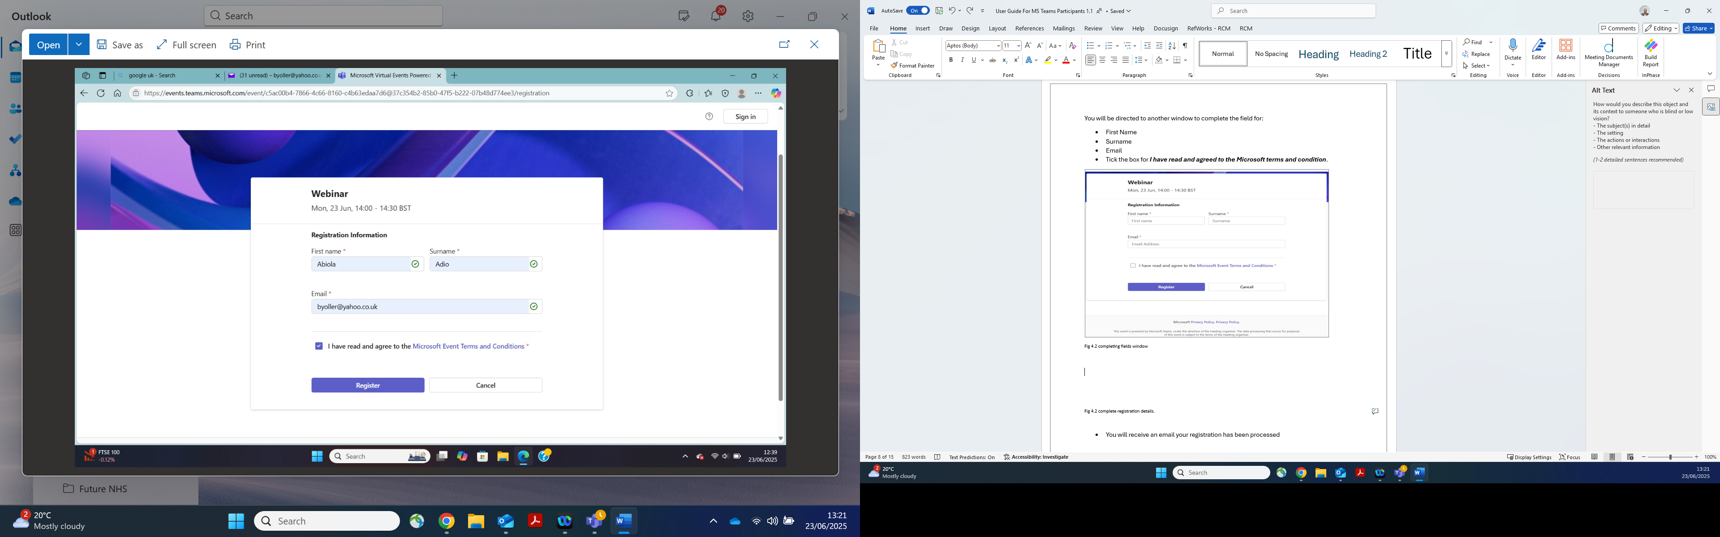
Fig 4.2 complete registration details.

- Click on Register to submit your completed fields.
- You will receive an email your registration has been processed.

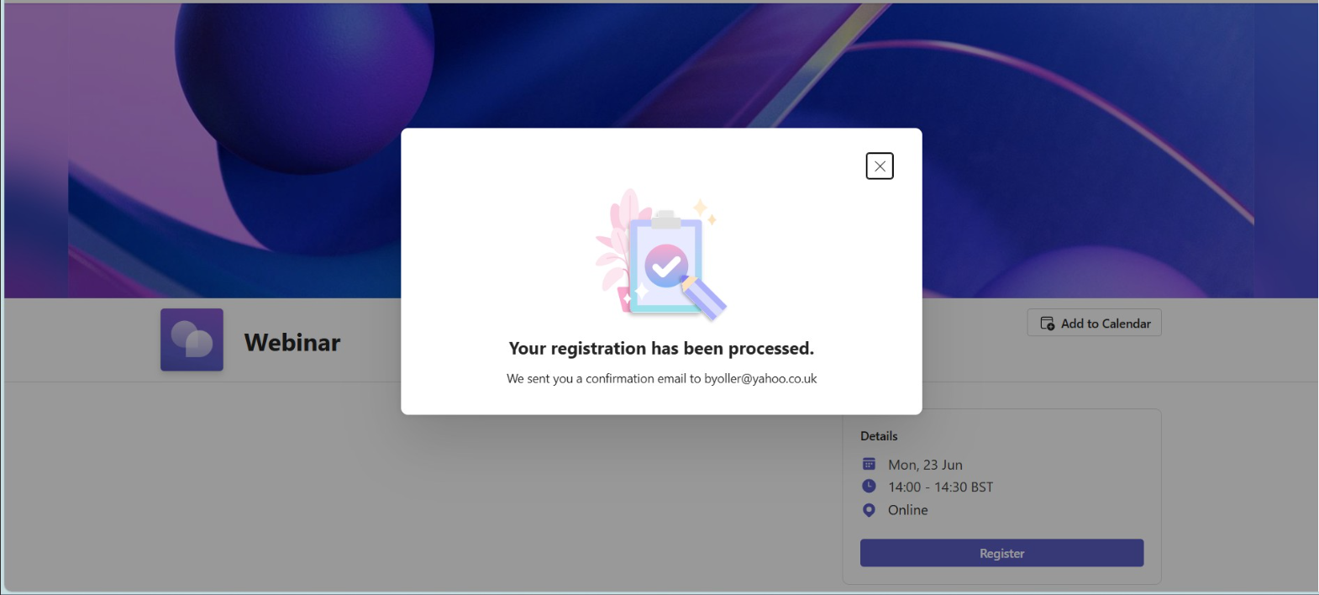
Fig 4.3 Processed registration

- You will receive a confirmation email your registration has been processed.

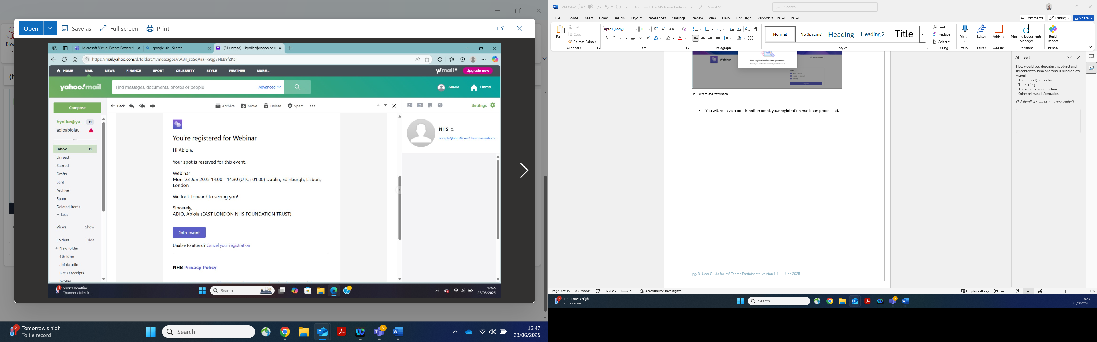
Fig 4.4 webinar registration

Click on Join the event.

- Adjust your speaker volume.
- Enable your camera to show your face.
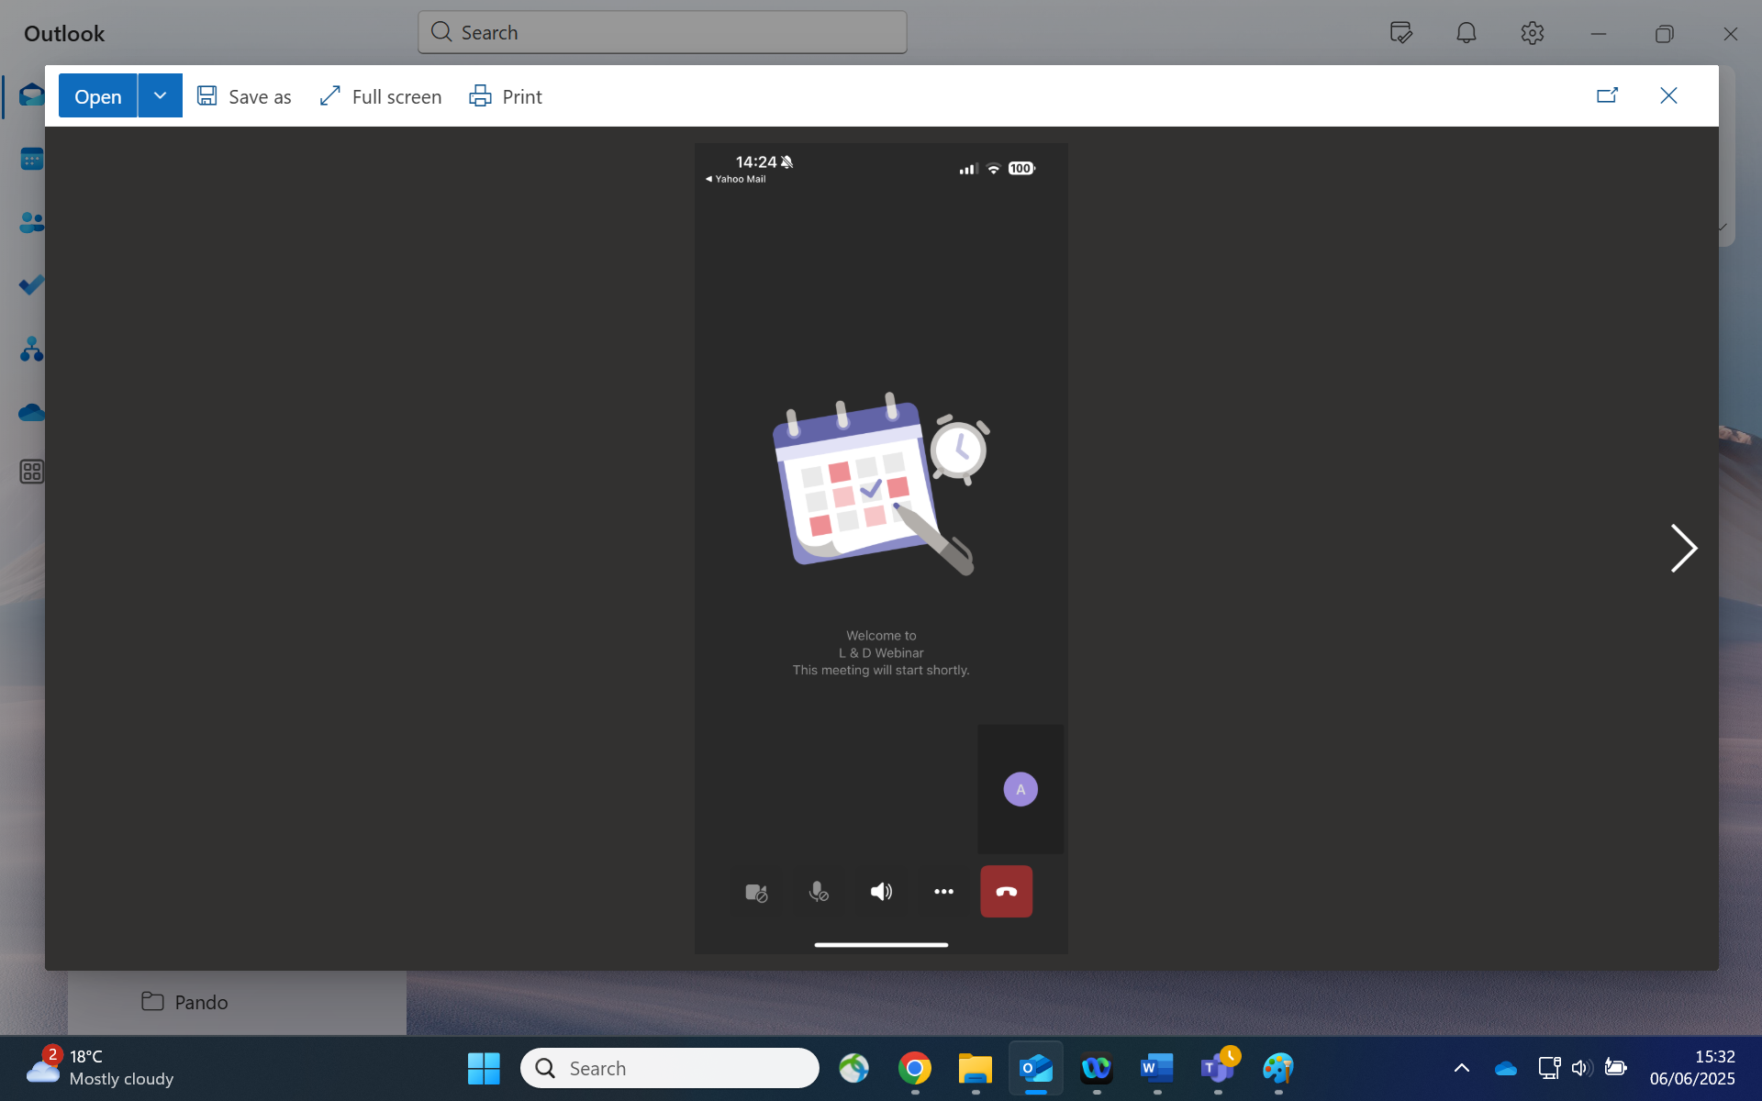
Fig 4.5 webinar welcome page

MS Team White Board Feature
An internal ELFT participant with MS teams account can view the whiteboard easily.
The white board would be shared by the meeting host so it can be viewed.
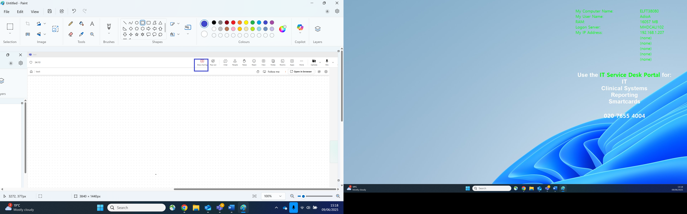
Fig 5.0 whiteboard.

External participants with Hotmail, Yahoo or other accounts cannot view the whiteboard.
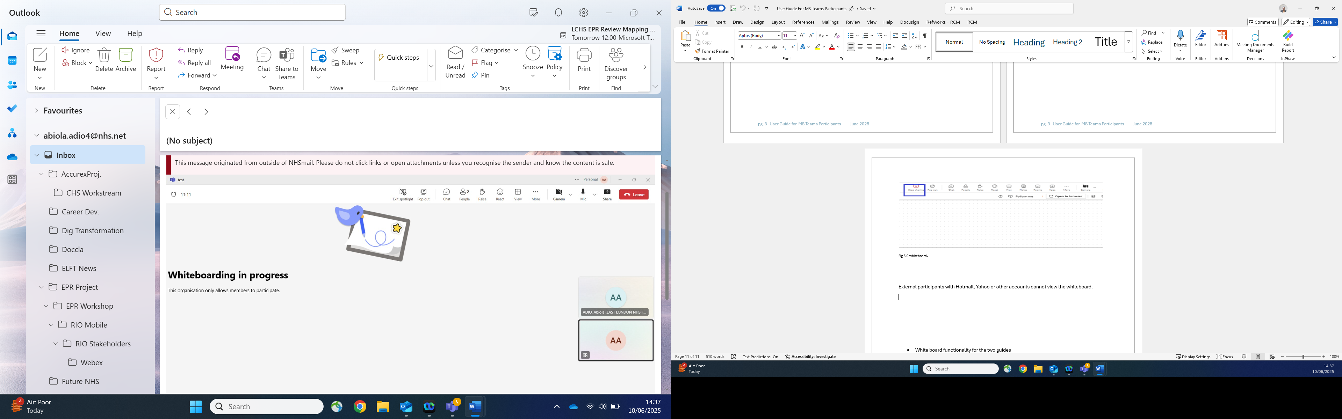
Fig 5.1 External participants unable to view whiteboard.

MS Teams Gallery View
As participants joining MS teams meeting or Webinar as a family and career you have numbers below that your host can view. You can view 4,9,16 and 49 as the maximum.
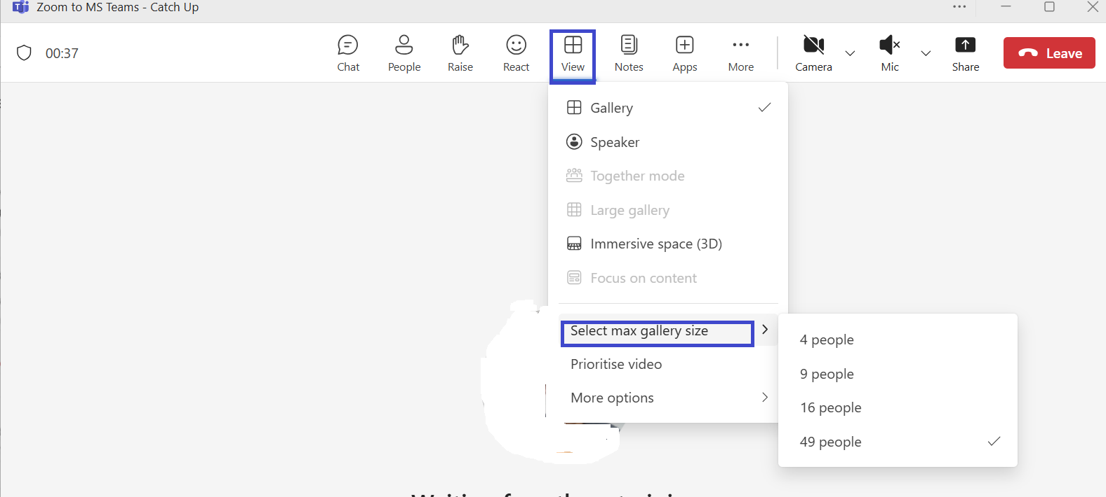
Fig 5.2 Gallery view

Q & A Session (Questions and Answers)
Q & A can be viewed by the participants to answer and comment.
- When you have answered the question click on post.

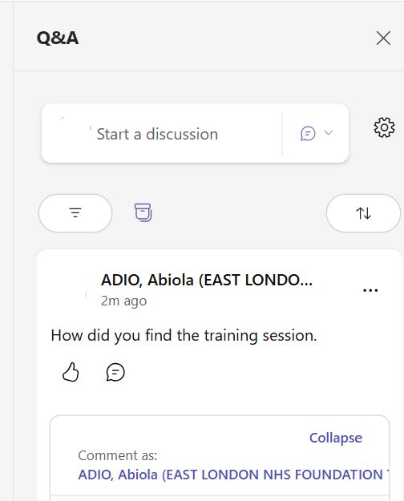
Fig 5.3 Q & A window.

Participating in a Poll
As a participant you can view the poll in the chat section.

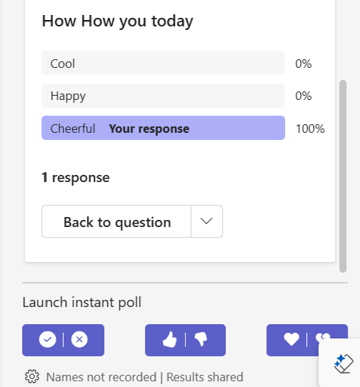
Fig 5.4 poll participation.

MS TEAMS FAQ

MS Teams
Can I join a meeting call via MS Teams mobile APP. | Yes, you can. For the first time, you will be asked to download MS Team’s app if your mobile does not have the app already downloaded. You are not required need to register into the app though. Ref: Pg 4
Do I need to download MS Teams for Desktop | No. You can join via web browser by launching the meeting. Ref: Pg3.
Can I join 10minute before my meeting call | Yes, you can, you would be in the lobby, and your host will be notified that you are in the waiting lobby as soon as the meeting starts your host will admit you from the Lobby.  Ref Pg 5,6
Can I request for my meeting not to be recorded | The meeting host would advise you on this
Can I request anonymity when on a group call | Yes, you can inform your meeting host prior to your meeting so necessary arrangements can be made.

