

Venepuncture Policy

Version number: | 4.0
Consultation Groups | Nursing Development Steering Group
Approved by (Sponsor Group) | Nursing Development Steering group
Date approved | 10th July 2025
Ratified by: | Quality Committee
Date ratified: | 24th September 2025
Name of originator/author: | CHS London & Bedford (BCHS) Education Team
Executive Director lead: | Director of Nursing
Implementation Date: | September 2025
Last Review Date | February 2025
Next Review date: | February 2028

Services | Applicable
Trust wide | X
Mental Health and LD
Community Health Services

Version Control Summary

Version | Date | Author | Status | Comment
1.0 | April 2012 | Yvonne Fenn and  Rozi Hamilton |  | Venepuncture Policy
2.0 | June 2017 | Rozi Hamilton |  | Replaces the previous  policy
3.0 | October 2021 | Rozi Hamilton |  | Replaces the previous  policy
4.0 | February 2025 | Stephanie Aidoo  Karen Griffiths  Rahma Abdalla  Edward Phillips  Dawn Didwell |  | Replacing previous policy

Document Revision Record

Description of Change(s) | Reason for  change | Author &  Group(s) | Date
Paragraph added on taking blood under  mental capacity/ best interest decision | Absent from last  policy | Rozi Hamilton | 16/06/2016
Name changed to specify this is an  Adult policy | Absent from last  policy | Rozi Hamilton | 17/07/2016
Section included for taking blood from a CVAD. | Absent from last policy | Stephanie Aidoo | 10/04/2025
Section included regarding students and their scope of practice. | Absent from last policy | Stephanie Aidoo | 09/09/2025

Executive Summary

Venepuncture is the procedure of puncturing a superficial vein in the upper limb with a needle, in order to obtain a blood sample for diagnostic purposes or to monitor a service user’s condition and/ or levels of blood components (Lister, Hofland and Grafton, 2020)

Team leads must ensure that the policy is shared with all new members of the team including bank & agency staff to enhance their awareness of ELFT policy and procedures. They must also ensure that all of their staff who are required to undertake venepuncture receive the appropriate training, updates and have the met the competencies and have evidence of this in employment records and competency documents.

Staff carrying out venepuncture must always follow this policy and must ensure that they maintain their competence through regular practice and three yearly updates. It is their responsibility to recognise the limits of their competence and refer to a more experienced practitioner if they have difficulty in carrying out the procedure. No more than two venepuncture attempts from a single practitioner should be made on a patient (Ford and Skarparis, 2024).

This policy only applies to taking blood from adult patients

Staff are required to undertake a recognised training programme that incorporates theory, simulated practice and a period of supervised practice- under direct supervision of a competent practitioner.
Formal assessment of 5 successful venepuncture attempts must be done under direct supervision and
Recorded on the supervised practice form (appendix 2). The member of staff must sign and date the declaration on the form. It is the responsibility of the staff member to seek an update or retraining if they feel their competence has decreased. Should issues arise in regard to a member of staff’s competency, senior clinicians must include within their action plan to signpost the staff to retrain in venepuncture theory and practical again. These guidelines are from the RCN guidelines for infusion therapy (RCN, 2010). The guidelines are currently being reviewed and are due to be published in 2022 so any change required will be updated once published.

Practitioners must explain the venepuncture procedure, this should include the purpose of the blood test; what the procedure involves, potential risks and side effects, when the results will be available and what potential consequences and treatments may be required as a result of the findings of the blood test.

Once the above has been achieved informed consent, either verbal or implied by the service user prior to venepuncture being carried out. The patient has the right to refuse to have the procedure carried out at any point and should not be put under pressure by the practitioner or the family if they refuse.

It is vital that the practitioner positively identifies the patient prior to undertaking the procedure by asking them to state their full name and date of birth. These details should be checked against the request form.

In exceptional circumstances it may be deemed necessary to use physical restraint in order to obtain a blood sample where Mental Capacity is lacking and the individual is at dire risk of harm should the procedure not be done. In these circumstances a Mental Capacity assessment must be completed by a multi-disciplinary team and family members, followed by the best interest decision. For guidance, please refer to the Trust Mental Capacity and Best Interest form on the intranet.

A single use tourniquet is used to identify an appropriate vein and make the procedure easier. The tourniquet must be applied 5-10cm above the chosen entry site and must be applied with enough pressure to compress the veins but not obstruct arterial circulation.
The pulse must be palpable below the tourniquet. Once blood flow is achieved onto the bottle the tourniquet must be released. The tourniquet must not be left on for more than a minute as this will cause haemo-concentration which will cause erroneous test results leading to the test having to be repeated.

Before performing venepuncture both upper limbs should be inspected to select the most appropriate site for venepuncture. Appropriate veins should be identified in the following order; at the bend of the elbow of each arm (Antecubital Fossa) then on the back of each hand.

Veins within limbs that have been operated on and had axillary lymph nodes removed, those that have arteriovenous fistulae, phlebitis, and lymphedema or are affected by amputation, fracture or cerebrovascular accident are contraindicated for the purpose of venepuncture.
There are a number of potential complications of venepuncture. Use of veins in lower extremities is not routinely advised due to the higher risk of complications, particularly in service users with diabetes and coagulation disorders. This policy does not cover practitioners to take blood from feet and covers only venepuncture of the upper limbs (antecubital fossa, and hand).

Complications of venepuncture

Complication | Prevention
Nerve damage and arterial puncture | Avoided by keeping the angle of entry of the needle to below 30°.
Pain | Avoid using veins in sensitive areas  Ensure skin cleansing agent is dry before puncturing the skin
Haematoma | Avoided by choice of an appropriately sized needle for the vein avoiding over advancement of the needle.  Releasing the tourniquet as soon as blood flow is achieved  Pressing on the site as soon as the needle is removed for up to 1 minute to secure haemostasis.
Fainting | Check previous history and be alert for signs and symptoms during the procedure

Infection Control

Clean the puncture site with 2% Chlorhexidine and 70% Isopropyl Alcohol for a minimum of 30 seconds prior to venepuncture and allow to completely dry before puncturing the skin (Lister, Hofland and Grafton, 2020) .

Hands must be washed before and after the procedure using the NSPA 8 stage technique (appendix 3).
Disposable latex free gloves and aprons (in inpatient areas) must be used and discarded between patients (DOH, 2007, Loveday et al, 2014)
Vascular access equipment should have sharps injury protection. The mechanism must be activated immediately after use prior to disposal. Used disposable sharp objects must be disposed of in a sharps bin which complies with UN 3921 and BS7320 standards which should be placed near the patient and if required the patient’s home. Handling of sharps must be kept to a minimum. Needles must never be bent, re-sheathed or taken apart prior to disposal (Lister, Hofland and Grafton, 2020).

This policy includes guidelines for the order of draw of the blood bottles (from and a
Blood Bottles and Order of Draw (as suggested by BD vacutainer guidelines) and the insertion procedure from the latest Marsden Manual of Clinical Nursing Procedures (Lister et al 2020)

Any untoward incident relating to the practice of venepuncture will be reported via the Inphase reporting process. Managers will monitor Inphase incident forms relating to venepuncture practice and will investigate and send staff for retraining if deemed necessary.

Contents

- Introduction 6
- Definitions 6
- Purpose 6
- Duties 7
- Training 8
- Pre-Reg students 8
- Consent 9
- Mental Capacity 9
- Tourniquet use 10
- Site Selection 10
- High risk areas for Venepuncture 11
- Complications 12
- Guidelines for Fasting Blood Specimens 12
- Equipment 13
- Safe use and disposal of sharps 13
- Infection Control 13
- Monitoring 14
- Blood Bottles and Order of Draw 15
- Obtaining blood sample from CVAD 16
- Procedure of CVAD Blood samples 16- 17
- Complications of CVAD Blood sampling 18
- Associated Documents 19
- Insertion Procedure 20-25
- References 26-27

Appendices
- Practical Assessment Guidelines 28-29
- Formal assessment (practice) form 30-31
- Hand washing technique and ANTT 32
- CVAD Blood sampling 33
- Information on Sharps Procedure 34
- Venepuncture Operational Policy for Phlebotomists 35- 36
- Equality Analysis 37-41

Introduction

East London Foundation Trust herein after referred to as ‘ELFT’ has a statutory duty to have in place appropriate policies to enable staff to fulfil the requirements of their role safely and competently.
This document sets out the venepuncture standards for practitioners including registered and non-registered staff employed by the Trust whose role involves venepuncture.
Venepuncture is the introduction of a needle into a vein to obtain blood for hematological, biochemical or bacteriological analysis Lister, Hofland and Grafton, 2020). It is also one of the most routinely performed invasive procedures in healthcare and developing skills in venepuncture can facilitate holistic and timely treatment.

Definitions
Venepuncture or phlebotomy is the term used to describe the insertion of a needle into a vein in order to withdraw blood.

Venepuncture is a practical skill that can be used by a range of health professionals including registered nurses, registered nursing associates, midwives, phlebotomists, doctors and more recently health care assistants, SHINE staff and receptionists

To perform venepuncture safely and effectively staff must achieve competence in theoretical and practical aspects of the skill, to provide a high-quality service to patients and clients in the community that is accessible in a timely manner.

This is provided locally with a programme devised by the ELFT Practice Education Team.

Purpose

The aim of this policy is to provide staff with the framework to enable them to undertake venepuncture competently and confidently to a high standard that underpins the trust values.

Duties Clinical Leads
All staff must work in accordance with all aspects of this policy. Policy should be shared with all new
Members of the team including bank & agency staff to enhance their awareness of ELFT policy and procedures.

To ensure staff who are required to perform venepuncture receive the appropriate level of training and support to meet venepuncture competencies. To also identify through IPR where staff may require updates including infection control.

To ensure relevant staff have achieved the competencies required for their work role with regards to venepuncture. (See attached appendix 1).
To maintain evidence of training and competency assessments within personal files and through IPR,

All Staff
To adhere to the standards set out in this policy.
To undertake or demonstrate evidence of theoretical and practical training and competence before undertaking venepuncture for ELFT services autonomously.

All healthcare professionals must report to line manager of any identified training needs in relation to venepuncture through clinical supervision. It is the healthcare professional’s responsibility to ensure their mandatory training needs are kept up to date in accordance with their contract of employment.

Healthcare professionals must recognise the limits of their competence and seek the help of experienced practitioners should they require further clinical supervision. If an incident occurs during or after the procedure this should be highlighted through the trust reporting mechanism of ‘In-Phase’.

Should Venepuncture be unsuccessful after two attempts, the practitioner must request assistance from a more experienced colleague to undertake the next attempt, which should be carried out on another day. There must be a MAXIMUM OF TWO ATTEMPTS of obtaining blood a day, multiple unsuccessful attempts are distressing for the patient and limit future vascular access

Where blood is required to be taken from children, specific pediatrics practice should only be considered once the practitioner is experienced with adults. Additional competencies are required when taking blood from this client group.

This policy does not cover pediatrics venepuncture, please refer to this policy.

Training

The healthcare professional must undertake a recognised training programme, which incorporates theory, simulated practice and supervised clinical practice.
Following successful completion of the theory and simulated practice component of the training programme, the nurse may only practice venepuncture under the direct supervision of a colleague who is experienced and competent in the procedure. When the healthcare professional feels confident, he/she must seek to be formally assessed.
Formal assessment and achievement of 5 successful venepuncture attempts must be undertaken within six months of attending the theoretical and simulated practice training programme (see appendix 1 for assessment record). If formal assessment and achievement are not successfully completed within the sixth month period, the healthcare professional should not undertake any further attempts at venepuncture. They must rebook onto theoretical and practical training and be formally reassessed.
Formal assessment may only be undertaken once theoretical training and classroom simulated practice has been undertaken. Supervised practice must be supervised by a member of staff experienced and competent in venepuncture. Assessment must be in line with the criteria found in appendix 1 and the assessment signed and dated on the supervised practice form (appendix 2) accordingly. Having successfully completed the formal assessments, the staff member must sign the declaration on the reverse of the assessment form. Then a certificate will be issued to the healthcare professional certifying venepuncture training completion. A three yearly update is required to be undertaken for all competent healthcare professionals to ensure clinical practice is up to date and evidence based.

A copy of the completed assessment form and declaration must be given to the Practice Education team and line manager of the service and (if relevant) to the Locality Manager for inclusion in the staff member's personal record/file. The original training certificate and supervised practice assessment record should be retained by the staff member as evidence of completion.

Students

Pre-registration nursing students must adhere to their defined scope of practice when performing blood collection procedures. If venepuncture is a required component of their clinical training, it may be undertaken; however, it must be conducted under direct supervision at all times.

Student nurses are encouraged to participate in venepuncture training sessions. For further guidance, please consult the relevant policies and procedures outlined by your university.

Detailed Venepuncture Procedure

Consent

A healthcare professional that carries out a clinical procedure or treatment without first obtaining informed consent from the patient is at risk of legal action by the patient and action by their professional body. Consent must be given voluntarily by the patient who has capacity to give consent and has been fully informed as to the nature and purpose of the treatment (DOH 2010), ELFT Consent to treatment policy (2025). Consent may be given verbally or non-verbally and may be the act of the patient holding out their arm for the nurse to carry out a procedure, providing the patient has received appropriate information as to the purpose and risks of the procedure prior to this (DOH 2010).

A patient has the right to withdraw consent at any time and should not be put under undue pressure by their family or the professional to give consent. The decision to withdraw or refuse consent must be respected (DOH 2010).
Some tests require the patient to fast or blood sample to be obtained prior to medication. It is important to check that the patient has been concordant with the advice so that test results are interpreted correctly by the clinician requesting the sample. (Scales, 2008).
The patient should be encouraged to drink plenty of water before the blood is taken as dehydration will affect superficial peripheral access. Drinking enhances venous filling and will make the procedure easier and more likely to be successful (Lister et al 2020).
Prior to performing venepuncture the practitioner must positively identify the patient by asking them to state their full name and date of birth and address checking these against the details on the request form, in line with the Trust policy for the Identification of Patients.

Mental capacity
In exceptional circumstances it may be deemed necessary to use physical restraint to obtain a blood sample where mental capacity is lacking and the individual is at dire risk of harm should the procedure not be done. If there is doubt about a person’s capacity to consent, a capacity assessment should be carried out by the person ultimately responsible for the procedure. This should be recorded on the appropriate electronic form (available in RiO, Systm1 and EMIS systems). If the outcome of the assessment is that the person lacks capacity to consent to venepuncture, then a decision in the best interest needs to be made, the process of which must follow the guidance set out in in the Trust's MCA policy and section 4 of the Act. The Mental Capacity Act Policy can be found via the Trust Internet.

Use of a Tourniquet

To locate a vein for blood sampling it is imperative to use a single use tourniquet. The tourniquet should be applied 5 – 10cms above the intended venepuncture site and should be tight enough to compress the veins. However, the tourniquet must not obstruct the arterial circulation of the limb, and the pulse should be palpable below it. Should the tourniquet over constrict, arterial circulation can be compromised and obstruct the flow of blood into the specimen tube.

In the event of the patient’s arm becoming cyanosed, this may indicate that the tourniquet has been on for a prolonged period, and it should be immediately loosened and removed. The arm should be observed until it has regained normal colour and sensation.

The tourniquet must be removed as soon as blood flow is achieved or after a maximum of 1 minute,

In the event of having trouble locating a vein, the tourniquet must be removed within one minute. Should the tourniquet be left for longer than one minute this may lead to abnormal results.

Abnormal results may consist of increased electrolytes (Ernst, 2019). This will lead to the blood test having to be repeated.

Vein selection (With tourniquet in place).

Before performing venepuncture both upper limbs should be inspected to select the most appropriate site for venepuncture. (Please refer to the table below)

It is important to obtain as much information as possible before selecting the site as some patients may have difficulty bleeding due to their pre-existing medical condition, therefore a thorough history taking must be undertaken.

Inspection and palpation of the arm will identify the position of the veins and their size and other physical features. The vein should be straight and feel soft, cylindrical in shape and ‘bouncy’ when lightly pressed (Scales, 2008).

When taking blood from veins at the elbow, the patient’s arm must be kept straight with the wrist extended and arm supported.

These are the areas where accessible veins can be located beginning with the Antecubital Fossa.

At the bend of the elbow of each arm (Antecubital Fossa)
- Median Vein
- Basilic Vein
- Cephalic Vein

In the forearm
- Cephalic Vein

On the back of each hand
- Dorsal Vein
- Cephalic Vein
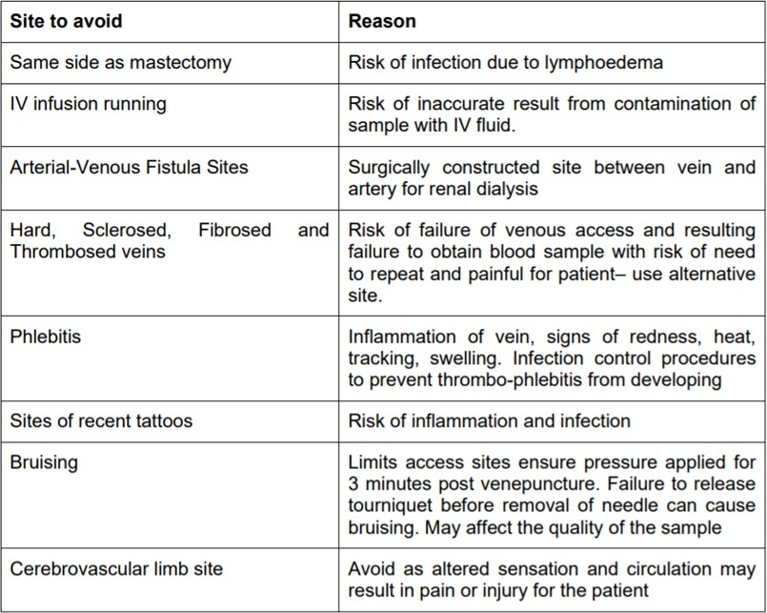

High Risk areas for Venepuncture

High risk areas such as the wrist must not be used for venepuncture due to the risk of puncturing the radial, ulnar, nerve or artery. This can cause temporary or permanent nerve damage and inability of the patient to open and close their hand (Beutel et al 2024).

Axillary Lymph Node Dissection (ALND) arteriovenous fistulae, phlebitis, lymphedema, amputation, fracture or Cerebrovascular Attack (CVA) are all contraindicated for the purpose of venepuncture (Lister et al 2020).

Use of veins in lower extremities is not routinely advised due to the higher risk of complications, particularly in patients with diabetes and coagulation disorders (Lister et al 2020). This policy does not cover practitioners to take blood from feet and covers only venepuncture of the upper limbs (antecubital fossa, and hand).
On occasions when practitioners are unable to obtain blood from these sights - for instance patients who are Intravenous Drug Users- a risk assessment should be undertaken, and a local policy must be in place to guide the practitioner through the process. This policy pertains only to venepuncture of the upper limbs.

Complications

Nerve damage and arterial puncture caused by:
  - Entering the vein at too steep an angle
  - Poor vein selection (check for a pulse prior to insertion)

Pain caused by:
  - Hitting a nerve or valve in the vein
  - Poor technique
  - Failure to allow skin cleanser to dry before venepuncture
  - Use of large gauge venepuncture device
  - Use of veins in sensitive areas

Haematoma and bruising caused by:
  - Entering vein at too steep an angle or over-advancement of the needle
  - Needle too large for the vein
  - Failure to release the tourniquet early enough
  - Failure to secure haemostasis after needle removal

Fainting
  - Check if patient has fainted before as this increases risk
  - Keep alert during procedure for signs- pallor, sweating and light headedness
  - If present remove needle, apply pressure to entry site and ask patient to lower their head (if possible) below their heart.
  - Taking blood from patient with Autonomic Dysreflexia (AD) – Follow patients care plan on (AD)
Infection
  - Inadequate cleansing of the entry site
  - Not allowing cleansed area to dry prior to procedure
  - Reusing the same needle after first attempt
  - Not following Aseptic Non-Touch Technique (ANTT)

Guidelines for Fasting Blood Specimens

- All fasting bloods must be taken before 11am unless otherwise directed by the patients GP
- Diabetic patients should have Dextrose Tablets to hand in case of hypo-glycemic attack.
- Before obtaining the specimen, the member of staff must check that the patient has fasted correctly.
- If not, the fasting procedure must be explained clearly by the member of staff carrying out the venepuncture and the patient is asked to return to clinic at the earliest available appointment or home visit to be rescheduled.
- The patient should be encouraged to drink plenty of water before the blood is taken as dehydration will affect superficial peripheral access

Equipment

  - Single use Tourniquet
  - Cleansing wipe containing 2% Chlorhexidine gluconate in 70% Isopropyl alcohol
  - Non-sterile latex free gloves
  - Request forms
  - Blood bottles (Check expiry date)
  - Specimen bag
  - Local anaesthetic cream (if required)
  - Safety sterile needle of appropriate size for the vein
  - Blood collection system
  - Cotton ball or gauze swab
  - Tape or adhesive plaster
  - Sharps container
  - Needle Holder or (Blood Collection Set including Needle & Holder)
  - Clinical waste bag (for gloves, wipes, etc.)

Safe use and disposal of sharps

The use of Vacuum blood collection systems (E.G. Vacutainer) requires the use of a Vacutainer holder to protect staff from sharps injury and to ensure that blood bottles are punctured correctly and supported during filling. These are single use items and should be disposed of immediately after use.
Vascular access equipment should have sharps injury protection which must be activated immediately after use prior to disposal. Used disposable sharp objects must be disposed of in a sharps bin which complies with UN 3921 and BS7320 standards which should be placed near the patient and if necessary, in the patient’s home. Handling of sharps must be kept to a minimum (Lister, Hofland and Grafton, 2020).

Sharps Injury

For details on what to do in the event of a sharps injury please see appendix 5 for more information.

Infection Control
Venepuncture, however quickly completed, is a breach of the circulatory system, providing a means of entry for bacteria. An aseptic non touch technique (ANTT) must therefore be applied throughout the procedure (see infection control policy for more details). Details of ANTT procedure in the community can be found in Appendix 3. Any cuts or abrasions on the hands or arms must be covered up in advance of starting the procedure (Department of Health and Social Care, 2024).

Hands must be washed before and after the procedure using the NSPA hand cleaning technique (appendix 3). Disposable gloves must be used for the procedure. Providing the practitioners hands are free from contaminants and visibly clean this may be done in the community with alcohol hand gel instead of soap and water. The venepuncture site must be cleaned with 2% Chlorhexidine gluconate in 70% Isopropyl alcohol for 30 seconds and allowed to dry completely (Lister, Hofland and Grafton, 2020).

The infection control policy which contains more information can be found via the trust intranet.

Monitoring

Any untoward incident relating to the practice of venepuncture will be reported via the Inphase reporting process. The types of incidents that should be reported are as follows:
- The patient suffers any of the following complications:
- Heavy bleeding
- Arterial puncture
- Nerve damage
- Fainting
- Any of the sterile single use equipment is damaged or not fit for purpose
- The practitioner receives a needle stick injury
- Bloods are not labelled correctly
- Blood is collected in the wrong bottle
- Blood taken from wrong patient

Managers will monitor Inphase incidents relating to venepuncture practice and will investigate and send staff for retraining if deemed necessary. Managers will also discuss in one-to-one supervisions whether a member of staff requires retraining due to decreased competence and confidence and also ensure that staff attend their three yearly update

Blood Bottles and Order of Draw

The following order of draw of specimens and mixing guidelines recommended by BD Vacutainer must be followed when drawing multiple tubes to avoid possible test error due to cross contamination from tube additives.

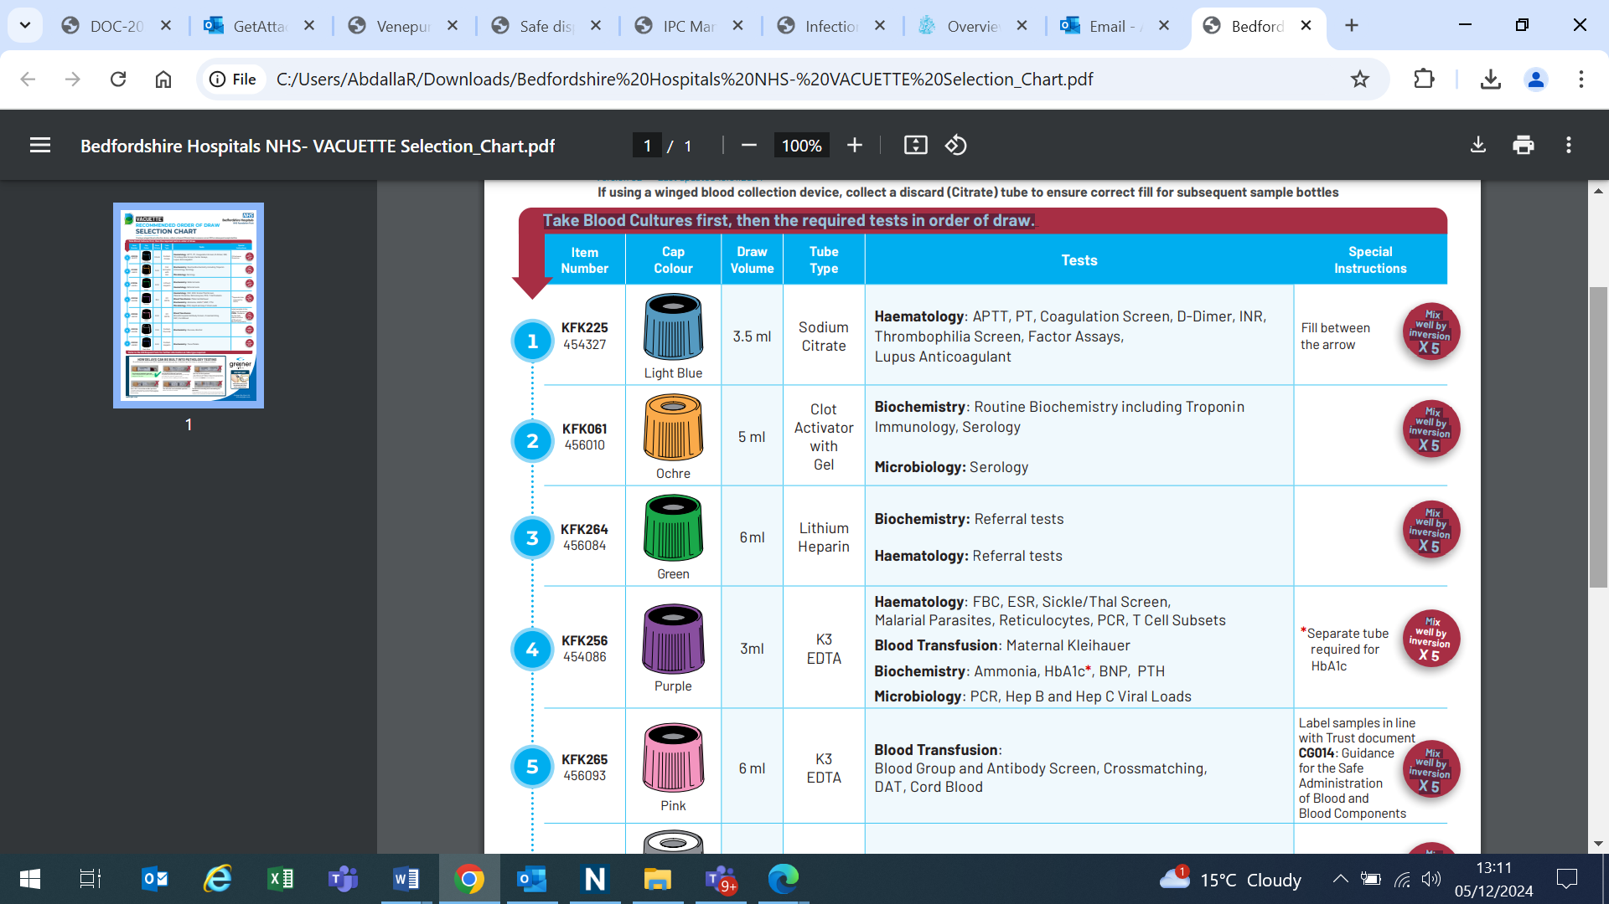
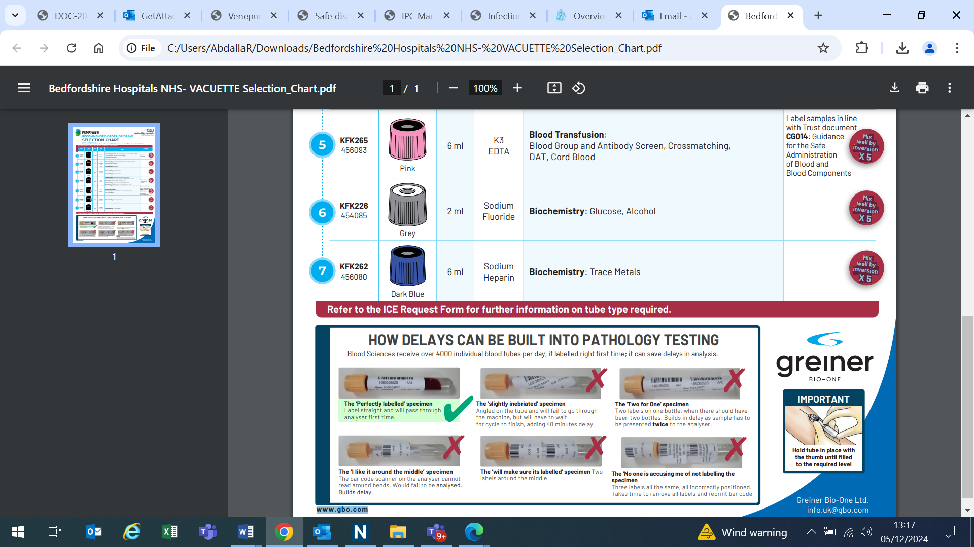

Obtaining blood from a Central Venous Access Device (CVAD).

Patients with long-term conditions may have a central venous access device (CVAD) in place to support the administration of intravenous therapies. CVADs are surgically inserted and provide an external access point for the delivery of prescribed medication. They may also be utilised for blood sampling, thereby reducing the need for repeated direct venepuncture attempts (Lister, Hofland and Grafton, 2020).

Types of CVAD’s
- Peripherally Inserted Central Catheters (PICCs)
- Skin-Tunnelled Catheters (Hickman, Broviac, and Groshong catheters)
- Implanted Ports (Port-a-Cath)
- Non-Tunnelled Central Venous Catheters
Access to and management of CVADs must only be undertaken by registered healthcare professionals who have successfully completed training in intravenous (IV) therapy, demonstrated competence in the required procedures, and have been formally signed off in accordance with the Policy for the Use of Injectable Medicines in ELFT Adult Community Health Services policy, which can be found on the ELFT Intranet
Training in the management of CVADs is included within the Intravenous (IV) Therapy Training programme.”
This procedure applies to all registered healthcare professionals who have completed Intravenous (IV) Therapy Training, demonstrated competence, and have been formally signed off to access CVADs.

Responsibilities
- Only trained and competent staff may undertake blood sampling from CVADs.
- Staff must comply with ELFT Trust infection control prevention and control policies, CVAD management protocols.
Equipment Required
- Sterile gloves and apron
- PPE as per Trust guidance
- Cleansing wipe containing 2% Chlorhexidine gluconate in 70% Isopropyl alcohol
- Sterile syringes (DO NOT use syringe smaller than 10mls;pressure from smaller syringe can damage line) and/or blood collection system
- Appropriate blood sample tubes
- 0.9% sodium chloride flush
- Sharps container and clinical waste disposal

Procedure (See Appendix 4 for diagram)
Confirm Indication and Patients details (NMC. 2015 The Code)
- Verify blood sampling is required and appropriate via CVAD.
- Check type of CVAD and confirm patency.

Prepare the Environment
- Perform hand hygiene and apply PPE.
- Assemble equipment on a clean surface or sterile tray
Aseptic Technique
- Clean the CVAD access hub with an Cleansing wipe containing 2% Chlorhexidine gluconate in 70% Isopropyl alcohol as per trust (Infection Prevention and Control Policy Manual)
- Allow to dry fully before proceeding.
Waste Aspirate
- Attach a sterile syringe above 10mls.
- Aspirate and discard the initial blood volume 5–10 ml to remove flush solution and obtain an undiluted sample.
Blood Sampling
- Attach a new sterile syringe or vacutainer system.
- Collect the required blood volume into appropriate tubes.
- Label samples whilst patient is present or in the patient’s home in accordance with Trust policy.
Flush the Line
- Following blood collection, flush the CVAD with 10ml 0.9% sodium chloride
- Administer locking solution if required by prescribing consultant (e.g., heparin, citrate), in accordance with device type and Trust guidelines.
- Secure line with disinfectant IV Cap/ Port protector.
Completion
- Dispose of sharps and clinical waste safely.
- Remove PPE and perform hand hygiene.
- Document the procedure in the patient’s records i.e. on EMIS/RIO/SystemOne including:
- Type of sample obtained
- Volume discarded
- Line patency
- Any complications or concerns, report any issues via Inphase.

Complications with CVAD

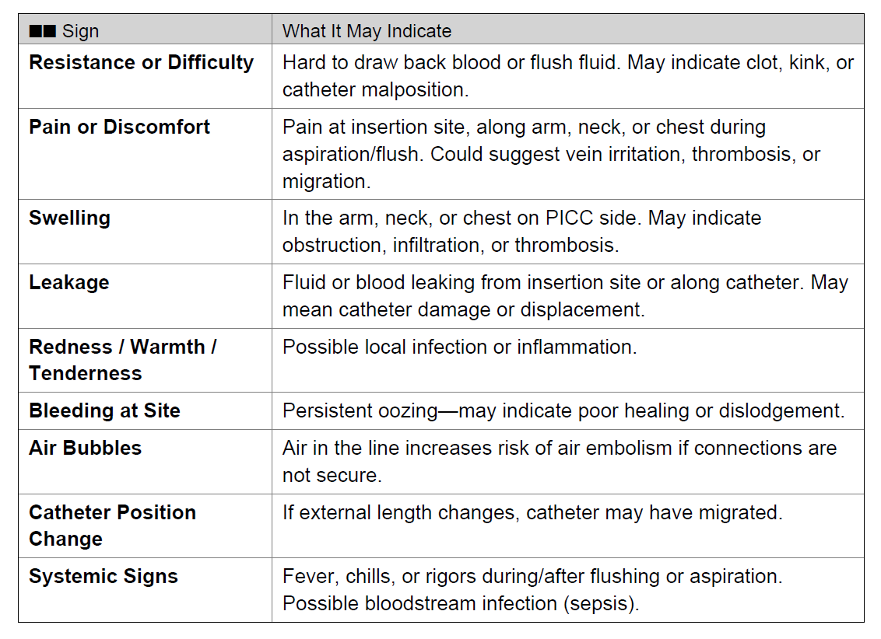
If any of the above occur, Stop the procedure, do NOT force flush/aspiration, seek advice from senior clinician or contact emergency services for advice (Lister, Hofland and Grafton, 2020).

Associated Documents

The following documents are required to be used alongside this procedure:
  - Practical assessment for Venepuncture (appendix 1)
  - Formal Assessment for venepuncture

Venepuncture Action Rationale Insertion Procedure (Adult)

Action | Rationale
Approach patient, introduce yourself and check patient identity- forename, surname, date of birth against blood form and obtains  information regarding allergies (E.G. latex)  Give explanation and rationale for venepuncture to patient including reason for blood test.  Information given must include post- procedure care including the requirement to report pain, swelling, discomfort. | To ensure that you have the correct patient and the correct blood form  Explain venepuncture procedure in detail and obtain  Inform consent from the patient (Royal Marsden NHS Foundation Trust, 2020).  Venepuncture may be daunting for some patients, therefore it is important to reassure and ensure they understand their care needs and how/ when to report problems  (Royal Marsden NHS Foundation Trust, 2020)
Ask patient about previous history with  Venepuncture, including any fainting, allergies or possible contraindications to using either limb.  Check for preferences, previous problems and allow the patient to ask questions | To involve patient in choices about the  procedure and check for any history that may predispose the patient to complications or prevent the use of either limb, E.G mastectomy (Lister et al 2020)  Ensuring the patient is relaxed will prevent anxiety, which can cause vasoconstriction (Lister et al, 2020)
Ensure work area is clean. If necessary  Clean surfaces with soap and warm water or a detergent surface wipe.  Wash hands using soap and water or alcohol hand gel, following National patient safety  agency ‘clean your hands campaign’ 6 stage technique (appendix 3) | To prevent cross infection and contamination  Hands must be washed before and after patient contact and before carrying out any clinical procedure to prevent infection (Royal Marsden NHS Foundation Trust, 2020).
Prepare equipment to be used safely,  Applying the principles of aseptic and checking sterility and use by date.  Take into account size of needle or butterfly required with regard to the condition of veins. | To prevent cross-contamination, sharps  Injury, reduce risk of contamination.  To prevent complications and increase chances of venepuncture being successful.

Action | Rationale
Adjust environment to comfortable  working height and ensure adequate lighting- wherever possible | To prevent back strain and ensure that healthcare practitioner  can see adequately to facilitate the procedure
Ensure patient is comfortable and consents  to procedure | Patient comfort will prevent movement and  so facilitate the procedure. Consent to treatment is a legal requirement as outlined by the Department of Health and Social Care (2019).
Select non-dominant arm wherever possible.  Rest the arm on a pillow if possible | If dominant arm is selected there is greater  risk of bleeding post procedure  To increase comfort and facilitate venous access (Lister et al 2020)
Avoid veins that are inflamed, infected or  sclerosed | Inflamed and sclerosed veins are difficult to  Obtain blood from.
Explain to the patient that they need to have  A tourniquet applied. Use a single patient use tourniquet and select an appropriate vein in the ante cubital fossa area.  Apply the tourniquet 7-8cm above the venepuncture site, ensuring it is not tight enough to obstruct arterial supply. The radial pulse must be still palpable | To inform the patient and prevent  unnecessary distress.  Reusable tourniquets have been known to be contaminated with blood and carry staphylococcus aureus and MRSA (Mehmood, Z., et al, (2014).  To obstruct venous return to dilate the veins and make them more prominent. (Lister et al 2020)  Obstruction of arterial flow will cause the veins to collapse and distress the patient (RCN 2010)
If the tourniquet does not increase venous  distention you can ask the patient to lower their limb below the level of the heart, clench their fist and you can gently palpate and stroke the vein | To improve venous access (Lister et al,2020)
Palpate the chosen vein to assess the size  Depth and condition. | To avoid inserting the needle into anatomical  structures such as arteries, nerves and valves (Lister et al 2020)

Action | Rationale
Remove the tourniquet. | To ensure patient is comfortable and prevent  Haemo-concentration leading to inaccurate results (Lister et al 2020).
If it is not possible to confidently identify an  Appropriate vein the attempt to take blood must be discontinued and the patient referred to a more experienced colleague.  The reasons why the venepuncture was not attempted must be clearly documented in the patient notes and reported to the GP/ team  leader or nurse in charge (whichever is appropriate) | To prevent the patient distress and the risk of  Limiting further venepuncture attempts.  To ensure that the patient is appropriately referred on to have the procedure.
Select the appropriate venepuncture device  For the size depth, amount of blood to be taken and site of the vein to be used. For a  Metacarpal vein a butterfly device should be considered. | To prevent trauma and damage to the vein  and hemolysis (Lister et al 2020).
Cleanse hands again with alcohol hand gel  using NPSA clean your hands campaign 6 stage hand washing technique | To maintain asepsis. Hands have been  Contaminated during vein selection.
Don well-fitting latex free gloves. | Personal protective equipment is required for this procedure as the exposure to blood is  High risk (Loveday et al, 2014).
Re-apply the tourniquet above the vein entry site to be used. | To impede venous return to increase their prominence (Lister et al 2020).
Clean the skin in a circular motion outwards  From the intended entry site for 30 seconds using 2% chlorhexidine gluconate in 70% isopropyl alcohol and allow to dry completely. Do not palpate again or touch the skin.  In patients who are sensitive to chlorhexidine gluconate and/ or isopropyl alcohol use providone - iodine application  Do not blow or fan the area dry. | To reduce prevent recontamination of the  entry site and reduce the risk of infection (Loveday et al 2014).  This will contaminate the area and lead to increased risk of infection (Lister et al, 2020).

Action | Rationale
Assemble vacutainer needle and needle  Holder as per manufacturer’s instructions Remove the needle from packaging and inspect for defects. | To ensure that all equipment is to hand to  Facilitate ease of procedure and to prevent contamination/ infection from out-of- date stock.  To detect faulty equipment. If the needle is bent or damaged return to manufacturer with information regarding batch details (Lister et al 2020).
Manually stabilise the vein by anchoring the  Skin a few cm’s below the chosen entry site without contaminating the cleaned area. | To prevent movement of the vein and  increase the likelihood of success (Lister et al 2020).
Remove the needle shield and, with the  bevel of the needle pointing upwards insert the needle into the vein at an angle of 30° or less depending on the size of the vein.  Reduce the angle of the needle as soon as you feel the resistance change or flash back is seen along the tubing of the venepuncture device | The bevel needs to be upwards to facilitate  smooth transition through the skin and vein. Keeping the angle low will reduce the risk of nerve damage (Arbique and Arbique, 2007)  To prevent advancing the needle too far into the vein wall (Bowden 2010).
Slightly advance the needle into the vein. | To secure the device and prevent  displacement (Bowden 2010).
Firmly connect the blood container to the hub  of the vacutainer and allow the bottle to fill with blood to the required level.  As soon as blood is flowing the tourniquet can be loosened. | Prolonged tourniquet usage may lead to inaccurate blood test results (Çuhadar, 2013).
Hold the vacutainer holder securely while  collecting the blood and changing the bottles | To prevent the equipment from becoming  dislodged (Bowden 2010).
Use correct order of draw with the blood  bottles (see blood bottles and order of draw section on p12) | To prevent contamination of tubes without  additives from the tubes that contain additives (Bowden, 2010).
While each tube is filling the previous tubes  should be gently inverted. Those with dry additives require 5 inversions. Those containing liquid additives need to be  inverted 6-9 times. Invert as per manufacturers guidelines | To ensure that the additives are properly  mixed in with the blood to ensure their efficacy.
Action | Rationale
Do not apply pressure on the site until the needle has been removed. | To prevent occurrence of bleeding and  Haematoma (Lister et al 2020).
It may be necessary to remove the  tourniquet as soon as blood is flowing to | Calcium levels and other results can be  affected by haemostasis and prolonged

avoid inaccurate results arising due to  haemostasis | tourniquet pressure (Lister et al, 2020) NICE  2019
Immediately engage the sharp safety  Mechanism and discard the needle in the sharps bin. | To meet health and safety requirements by  Preventing sharps injuries.
Apply digital pressure to the puncture site  Until bleeding has stopped. In patients with clotting disorders or who are on anticoagulant medication haemostasis can take over 1 minute.  If appropriate you can advise patient to do this and to avoid bending their arm if the antecubital fossa has been used | To stop bleeding and prevent Haematoma  Formation (Lister et al 2020).
Gently invert the blood tube for the number  of times appropriate for the bottle (see table on p12) | To mix the additives into the blood without  Damaging the blood cells (Lister et al, 2020).
Carefully label the bottles and place in the plastic bag/container for laboratory samples. | To ensure the bloods are correctly labelled and prevent identification errors.  Laboratories have a zero tolerance to labelling errors and sample bottles that do not have a minimum of three identifiers. illegible or misspelt information on blood tubes and request forms lead to patients receiving incompatible blood and treatment (Davidson & Bolton-Maggs (2014).
Inspect the venepuncture site before  covering it with a dressing.  Ensure patient is not allergic to adhesive plaster before applying. | To ensure the site has stopped bleeding.  To prevent allergic reaction and prevent  further bleeding from the site. (Lister et al 2020).
Ensure the patient is comfortable and does  not have any symptoms or questions. Explain to the patient how to recognise infection and other complications.  Dispose of any waste products appropriately. | To be able to recognise and/ or treat  problems before leaving the patient.  Patients are usually the first to notice any side effects and this will lead to prompt  Treatment.
Remove gloves and wash hands again using  NPSA clean your hands campaign 6 stage hand washing technique | Handwashing is required following removing  gloves (Loveday et al 2014).
If two venepuncture attempts are  unsuccessful the attempt must be discontinued and the patient referred to a colleague more experienced in  venepuncture to take over the procedure on another allocated day.  With exceptional circumstances if patient urgently requires bloods taken due to clinical condition deteriorating, please seek agreement from referring clinician. | To prevent the patient distress and the risk of  limiting further venepuncture attempts.  To prevent a worsening condition which may result in poor health outcomes.

References

Arbique J. Arbique D. (2007) I.V. Rounds: Reducing the risk of nerve injuries. Nursing 37(11) p20- 21
Bowden T. (2010) Venepuncture: A practical guide. British Journal of Cardiac Nursing. 5 (2) p66-71

Beutel BG, Worley C, Disquiet J, et al. Allen Test. [Updated 2024 Oct 14]. In: Stat Pearls [Internet]. Treasure Island (FL): Stat Pearls Publishing; 2024 Jan-. Available from:
https://www.ncbi.nlm.nih.gov/books/NBK507816 (accessed 20-11-2024)

Davidson A. Bolton-Maggs P (2014) Nursing Times 110 (11) Patient identification in blood sampling.

Department of Health (2024) Infection prevention and control : resource for adult social care https://www.gov.uk/government/publications/infection-prevention-and-control-in-adult-social-care-settings/infection-prevention-and-control-resource-for-adult-social-care Accessed on 20th August 2025

Department of Health (2010). Reference guide to consent for examination or treatment.
London: HMSO

Department of Health (2007). Saving lives: reducing infection, delivering clean and safe care : London: HMSO
Department of Health (1995). The Patient’s Charter. London: HMSO

Dougherty L, Lister S. The Royal Marsden Manual of Clinical Nursing Procedures.
10th edition. Wiley-Blackwell; 2020.

East London NHS Foundation Trust Consent to Treatment Policy (2025)

East London NHS Foundation Trust Infection Prevention and Control Policy (2025)
East London NHS Foundation Trust. Detailed pathway for management of blood and body fluids; exposure sustained by staff employed for staff working within; Newham and Community Health Newham Directorates
Lavery (2003). Peripheral intravenous cannulation and patient consent. Nursing Standard.
17(28) p40-42

Lavery I. Smith E. (2008) Venepuncture practice and the 2008 Nursing and Midwifery Council Code. British Journal of Nursing. 17(13) p824-828

Lister S. Hoffland J. Grafton H. (2020) The Royal Marsden Manual of Clinical Nursing Procedures, (Professional), 10th Ed. P662-670
Loveday HP. Wilson JA. Pratt RJ. Golsorkhi M. Tingle A. Bak A. Browne J. Prieto J. Wilcox M. (2014) epic 3: National Evidence- Based Guidelines for Preventing Healthcare Associated Infections in NHS Hospitals in England Journal of Hospital Infection 86S1 pS1 S70
NICE (2019) How to diagnose Hypercalcemia. (Accessed 21 -10-21) https://cks.nice.org.uk/topics/hypercalcaemia/diagnosis/confirmation/

Rourke C, Bates C, Read RD. (2001). Poor hospital infection control practice in Venepuncture and use of tourniquets. Journal of Hospital Infection. 49 p59-61

Royal College of Nursing (2010). Standards for infusion therapy 3rd Ed. RCN: London

Royal Marsden NHS Foundation Trust (2020) the Royal Marsden Hospital Manual of Clinical and Cancer Nursing Procedures 10th Edition

Scales K. (2008) a practical guide to Venepuncture and blood sampling. Nursing Standard.
22 (29) p29-36

Appendix 1

Practical Assessment for Venepuncture

CORRECTLY DEMONSTRATE THE FOLLOWING ON 5 SEPARATE OCCASIONS | TICK  BOX
Has attended approved recognised theoretical training including simulated practice
using the use of medical devices used in venepuncture
- Certificate provided as evidence
Demonstrates adequate knowledge by correctly answering questions on:
- Relevant anatomy and physiology, site selection-including contraindications and how to select an appropriate vein
- Consent, mental capacity and patient information giving
- Side effects and complications
- How to deal with complications- fainting, arterial and nerve puncture
- Infection control
- Sharp safety and what to do in the event of needle stick injury
Demonstrate how to prepare the single use equipment for venepuncture
- Choose appropriate venepuncture equipment for patient needs.
- Assemble appropriate equipment on a clean trolley i.e. vacutainer and needle attachment, butterfly, sharps bin, tourniquet, gloves, blood bottles, skin cleaning
Prep, cotton wool and adhesive tape.
Describe how to prepare a patient for venepuncture
- Explain the procedure in simple terms and position the patient comfortably
- Explains the reason and purpose for the blood test
- Obtain informed consent
- Check for any known allergies
- Checks the identity of the patient
Describe how the practitioner should prepare for the procedure
- Hand washing technique
- Wear clean gloves and apron
- Ensure adequate lighting and posture of the patient and self
Select appropriate vein for venepuncture
- Apply tourniquet 5-10cms from the intended puncture site applying enough pressure to obstruct venous but not arterial flow
- Encourage venous filling by: ask patient to open and close fist, lower arm below the level of the heart, massage site, apply warm compress (if necessary)
- Palpates the vein.
Demonstrate the preparation of the puncture site
- Ensure the area is clean and dry.
- Use 2% chlorhexidine gluconate in 70% isopropyl alcohol to clean the skin around the entry site for 30 seconds
Demonstrate how the venepuncture equipment is appropriately assembled for use
And how it should be handled.
- Ensure package and contents are intact
- Check expiry date
- Fold down wing of butterfly if used
- Check bevel of needle is uppermost
- Ensure the needle is not contaminated before use
Demonstrate needle insertion
- Immobilise limb and apply traction to skin in order to anchor vein
- With bevel uppermost insert needle at an angle of 30 degrees (depending on depth of vein)

- Avoid touch contamination of the insertion site and aseptic non touch technique
- Attach the blood bottle to vacutainer to obtain blood sample, in the correct order of draw
- Once all samples are collected release the tourniquet and cover needle site with cotton wool.
- Apply pressure once the needle is withdrawn for 30-60 seconds to prevent bruising.
- Check the site (if clotted, apply tape over cotton wool)
DEMONSTRATE SHARPS DISPOSAL
- Able to engage safety mechanism if present
- Dispose of sharps immediately into appropriate sized sharps bin
DEMONSTRATE CORRECT HANDLING OF BLOOD SAMPLE BOTTLES
- Correct order of draw
- Agitate bottles as required
- Correctly label, date and time the bottles
- Send the bottles appropriately package for transport to the pathology lab
Demonstrate correct disposal & decontamination of equipment
- Demonstrate correct disposal of equipment
- Demonstrate safe clearing of blood spillages
- Demonstrate correct decontamination of hands following procedure

Name of Candidate:…………………………………………………………….. Signature of candidate…………………………………………………………. Date:……………………………………………..
Name of Assessor:………………………………………………………………

Signature of assessor………………………………………………………….. Achieved Not Achieved
Recommendations

Appendix 2

Venepuncture (Adult) FORMAL ASSESSMENT

Name …………………………………………………… Date training programme attended…………………..

1) Date:
I certify that the above named competently & unaided performed venepuncture in line with the criteria specified in the Trust Policy Signed

Name and Title (Block Letters)
2) Date:
I certify that the above named competently & unaided performed venepuncture in line with the criteria specified in the Trust Policy Signed
Name and Title(Block Letters)
3) Date:
I certify that the above named competently & unaided performed venepuncture in line with the criteria specified in the Trust Policy Signed

Name and Title (Block Letters)
4) Date:
I certify that the above named competently & unaided performed venepuncture in line with the criteria specified in the Trust Policy Signed
Name and Title (Block Letters)
5) Date:
I certify that the above named competently & unaided performed venepuncture in line with the criteria specified in the Trust Policy

Signed
Name and Title (Block Letters)

Declaration
To be filled out by practical assessor:
Five competent adult intravenous peripheral cannulations have been performed

Signature ………………………………. Print ……………………………….
Designation ……………………………. Date ………………………………..
To be filled out by staff member:
I confirm that I am competent and have the requisite knowledge to carry out venepuncture and will seek retraining and supervised practice if my competence level is not maintained
Signature ………………………………. Print ……………………………….
Date ………………………………..

To be filled out by practical assessor:
Five competent adult intravenous peripheral cannulations have been performed

Signature ………………………………. Print ……………………………….
Designation ……………………………. Date ………………………………..

To be filled out by staff member:
I confirm that I am competent and have the requisite knowledge to carry out venepuncture and will seek retraining and supervised practice if my competence level is not maintained
Signature ………………………………. Print ……………………………….
Date ………………………………..

Appendix 3

NHSPA hand Cleaning Technique and community ANTT
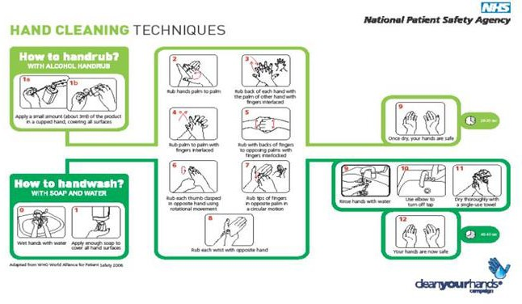
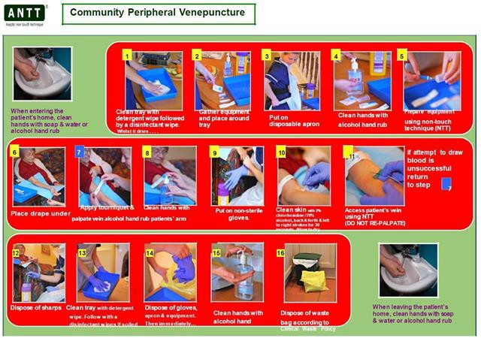

Appendix 4

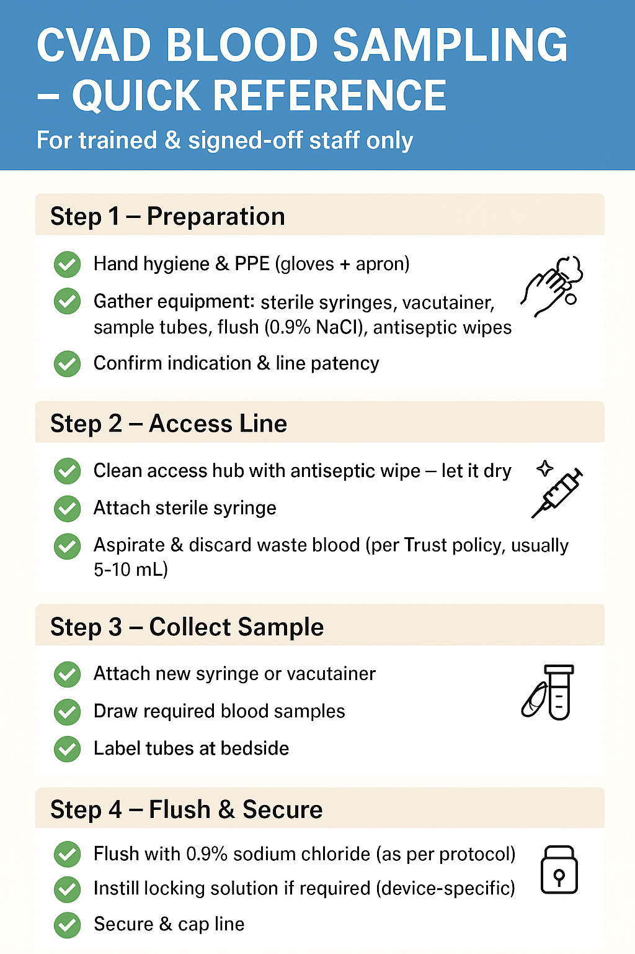

Appendix 5

For details of specific details based on your directorate please visit the intranet:
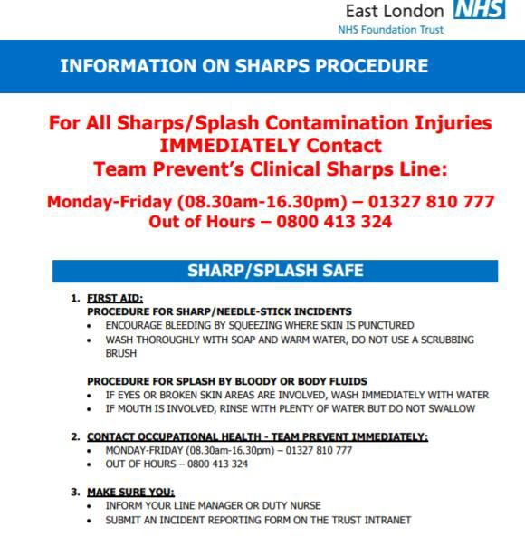
https://www.elft.nhs.uk/sites/default/files/2022-03/Sharps%20Poster%20for%20ELFT%20Staff%20-%20CHN%20%26%20Newham%20Directorate%20%281%29.pdf

Appendix 6

Venepuncture operational policy for phlebotomists

Band 4 Lead Phlebotomist to ensure all sites are adequately staffed, maintaining accurate records of all annual leave & Sickness. Reporting any difficulties directly to the General Manager.

To ensure that e-roster reflects staffing levels at all times. Or managers need to ensure that staffing levels and skills are available to provide the service to clients/ patients
To be able to communicate effectively with clients at all times, maintaining a professional approach at all times. Any arising issues should always be referred to the ‘Centre Manager’ of that site and if necessary elevated up to the General Manager of that service.

ENVIRONMENT
Venepuncture should take place in the designated non-carpeted clinical rooms with facilities for hand washing and sharps and clinical waste disposal.

All patients arriving for a blood test at health center are directed to the ticket machine either by reception staff or by adequate signage within the reception area.
Patients booked for a GTT will have an appointment time. Reception staff will advise the Phlebotomist that the patient has arrived. These patients should be given priority on arrival. Other waiting patients should be informed of any other priority.

All patients sent to phlebotomy and are known to have been diagnosed or suspected of carrying in infectious deceases such as chicken pox, shingles etc.

Paediatrics
1. | Venepuncture should only be offered in clinics to children over 4, and undertaken by  adequately experienced phlebotomists.
2. | All children under the age of 4 should be referred to Newham University Hospital.
3. | Explanations should always be given to the parent/carer in advance of any  conversations with the child.
4. | The phlebotomist’s should aim to establish a rapport with the child, in order to gain  the child’s confidence and to give necessary reassurances before carrying out such a procedure, and should allow sufficient time to do so, using diversional therapy wher e  possible.
5. | For very young children (under 12) a butterfly needle should be used, in order to limit  the risk of venous collapse/unexpected movement causing damage.
6. | For children over 12 only the Vacutainer system or syringe and needle may be used  when taking blood, if thought necessary a butterfly needle may be used.

END OF SESSION RESPONSIBILITIES:


To ensure all samples are dispatched correctly to lab
To clear away and lock up all equipment and dispose of clinical waste as per Infection Co ntrol policy.
 To leave room tidy and furniture as required by clinic.

ELECTRONIC BLOOD TEST REQUEST (EPR)
Only these Phlebotomists that have been trained in the use of the EPR system and have the appropriate personal code will have access to the system. Agency and temporary staff will not. Patients attending for blood tests at sites that are being temporarily ‘covered’ by agency staff only will need to be directed to one of the other sites.
Please refer patient to Clinical Administrator who will deal appropriately.
Log onto system and retrieve label from printer. Peel label from printer 1 label down to ensure that there is no blocking of the printer Read label carefully.
Check identification with patient.
Do not take sample if unsure of identification.
Place the label on the appropriate bottle, ensuring in correct place. Write name on bottle for audit purposes. Take blood.
Continue following venepuncture procedures as above.

CHECKING OF BLOOD SAMPLES
Two people to check bloods are labelled and bar coded correctly and tally with paperwork (count number of bottles) – either 2 phlebotomists or a phlebotomist and administrator for independent verification.
When bloods are packed into large bio hazard bag, please tape bag closed and sign on tape by the w people checking bloods.
Two people (Phlebotomist and admin staff) to sign as bloods put into red box Phlebotomist to sign blood handed over to driver, copy to be kept on site.
Blood boxes to be double checked to ensure blood samples are in the box to be transported back to Path Lab.
Driver to sign he accepted the blood (Number of boxes) before he leaves the building.

Appendix 7

Equality Analysis Template

Part 1: Equality Analysis Details
Title of ‘Proposal’  (The term proposal covers activities such as such as policy development, policy review, service redesign and internal reorganisation or restructuring processes). | Venepuncture Policy
Name of directorate | Community Health Newham Directorate
Name of manager undertaking the Equality Analysis | Stephanie Aidoo
Consultation date/s with staff | Not Applicable
Consultation date/s with service users | Not Applicable
Date Equality Analysis Completed | 10th April 2025

Review date  (Review at least once every three years) | 10th April 2028

Part 2: Proposal Details
1) What are the aims of the proposal? Indicate if this is a new proposal or the review of an existing one?
(The term ‘proposal’ covers activities such as such as policy development, policy review, service redesign and internal reorganisation or restructuring processes)

To provide evidence based policy to guide phlebotomists, nursing staff and care support workers to safely and competently carry out venepuncture on patients and clients in the trust

2) Provide a summary of the current activity to which the proposal relates e.g. policy or service structure and provision and the
reasons for the changes being proposed? (State if the proposal involves relocating a service to another site; extended service hours; puts staff at risk or involves significant change)
New policy to guide venepuncture practice

Part 3: Equality Analysis of Staff
Protected Groups  - Identify the impact or potential impact on each of the following protected groups, with due regard to the three aims of the  PSED (public sector equality duty). | Impact Positive or negative?  or no impact? | Please describe the process of your analysis with reference to the following:  - Results of consultation  - Data or research on the protected groups that you have considered  - Implications for the protected groups
Age: different age groups | No Impact
Disability: (Consider a range of  impairments, including - sensory, mental, physical and learning disability ) | No impact
Sex: men and women | No impact | Nothing required
Religion or Belief: (including no belief) | No impact | Nothing required
Sexual Orientation: people who are gay,  lesbian, bisexual or heterosexual | No impact | Nothing required
Race: including ethnicity and nationality | No impact | Nothing required
Gender Reassignment transgender people | No Impact | Nothing required
Pregnancy and Maternity | No impact | Nothing required
Marriage and Civil Partnership | No impact | Nothing required

Part 4: Equality Analysis of Service Users / Patients
Protected Groups  (Equality Strands)  - Identify the impact or potential impact on each of the following protected groups, with due regard to the three aims of the  PSED (public sector equality duty). | Impact  Positive or negative? or  no impact? | Please describe the process of your analysis with reference to the following:  - Results of consultation  - Data or research on the protected groups that you have considered  - Implications for the protected groups
Age: different age groups | Negative | Only covers those aged over 16 years for safety purposes
Disability: (Consider a range of  impairments, including - sensory, mental, physical and learning disability ) | Positive | Sensory and circulatory impairment is considered in the policy
Sex: men and women | No Impact | Nothing required
Religion or Belief: (including no belief) | No Impact | Nothing required
Sexual Orientation: people who are gay, lesbian, bisexual or heterosexual | No Impact | Nothing required
Race: including ethnicity and nationality | No Impact | Nothing required
Gender Reassignment: transgender  people | No Impact | Nothing required
Pregnancy and Maternity | No Impact | Nothing required
Marriage and Civil Partnership | No Impact | Nothing required

Part 5: Findings from the Equality Analysis
Use this space provided below to elaborate on your decision based on the findings of the equality analysis
1. Accept the proposal - no evidence of discrimination and appropriate opportunities have been taken to advance equality and foster good
relations
2. Continue the proposal - despite adverse effects or taking opportunities to advance equality provided the proposals do not unlawfully
discriminate and can be objectively justified. (To identify whether a proposal may unlawfully discriminate due regard should be given to discrimination on the basis of the protected characteristics)

Part 6: Equality Analysis Action Plan
Adverse Impact – Staff | Please describe the actions that will be taken to mitigate this impact
None Identified | Non required
Adverse Impact – Service Users | Please describe the actions that will be taken to mitigate this impact
None identified | None required

