
Services for People who have a Learning Disability (SPLD)
Physical Health Strategy 2025 – 2028



Introduction
Within Services for People who have a Learning Disability (SPLD) we are constantly committed to developing models of care, designed around local population needs. We understand that there are substantial benefits in aligning approaches to physical and mental health across wider health care systems.

The NHS Five Year Forward document sets out a vision for the future of the NHS and how we would like it to be. It recognizes that people’s physical and mental health needs are closely linked and that one impacts on the other. We need to be mindful of this to better ensure that health and well-being are more effectively managed for people who have a learning disability.

Within SPLD, we plan to work closely with health and social care partners to give people more control over their own care.

We will support people with multiple health conditions, not just single diseases, and deliver care as locally and conveniently as possible for people.

We will develop our current and future workforce and introduce innovative ways to use technology.

We hope that this will enable us to make more dynamic progress in addressing physical health risks and reducing premature death for people who have learning disabilities.

One of our key areas of focus will be to support people who have a learning disability to move towards a healthier lifestyle. Alongside this we will also need staff across all systems to recognise the importance of this strategy and embed it as part of their role.

We want everyone to adopt the principles of “Making Every Contact Count.” This is about informing and educating people, whilst working with staff to empower healthier lifestyle choices.
https://www.england.nhs.uk/wp-content/uploads/2014/06/mecc-guid-booklet.pdf

We know that if we are to do this well, the process requires investment from all SPLD staff as well as organisational commitments from wider stakeholders to deliver both primary and secondary preventative approaches.

One of the main drivers for developing this strategy was the Learning Disabilities Mortality Review (LeDeR) programme which was established in May 2015. LeDeR reviews show us that there is a need for more scrutiny on earlier identification of the deteriorating person and ensuring that staff have the right skills and support to deliver the right response to medical conditions.

We see the same recurrent themes arising within both local and national LeDeR reviews, including ineffective Annual Health Checks, constipation, lack of appropriate diabetes management, issues with epilepsy, higher levels of infections and aspiration pneumonia as well as other serious physical healthcare needs.

This needs to stop and serves to emphasise that there is a need for us all to have a greater understanding of supporting roles within the healthcare system, so we can work more collaboratively to continue safe care and treatment for people once discharged from our care.

Why do we need an SPLD Physical Health Strategy?

People who have learning disabilities die at a much younger age than the general population. They are dying of preventable physical health conditions. Some die without receiving care and treatment that should be accessible on the NHS.

People who have a learning disability encounter many barriers to accessing healthcare. They often have multiple comorbidities in their physical health conditions which see them being admitted to hospital on a more frequent basis.

LeDeR aims to improve health care, reduce health inequalities and prevent premature deaths amongst people with a learning disability. In 2019 The NHS England LeDeR report highlighted that the average age of death is 23 years younger than the general population for men with a learning disability and 27 years younger for women.

These figures make for stark and difficult reading and emphasise why there needs to be an increased focus on physical health for people who have a learning disability.

More needs to be done to focus on preventing admission to hospital and keeping people fit and well in the community. SPLD acknowledges that there is a huge amount of work to do to ensure both equity of access to physical healthcare, and physical health outcomes.

By having a dedicated physical health strategy, this will enable us to deliver more focused interventions, targeted health promotion work and provide better outcome measures for people who have a learning disability.

What do we need to change?
 | People with a learning disability often experience higher levels of poor physical health.
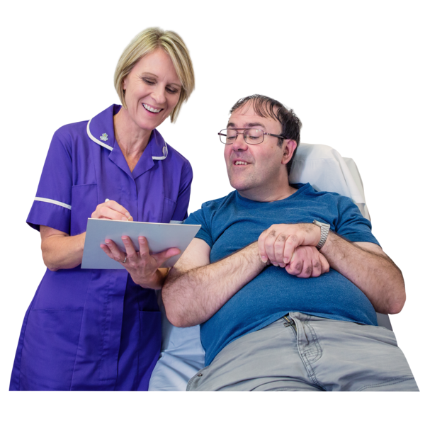 | Many of these people do not get their health problems treated.
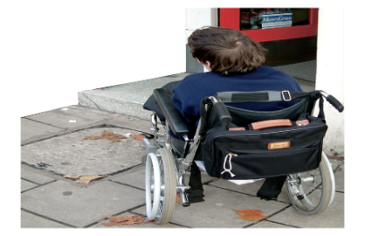 | Access to health in some areas is a big problem.  This can affect people’s quality of life.
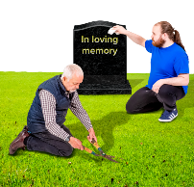   | In some cases, it leads to illness.  It can also lead to early death.

What are the reasons for this?

  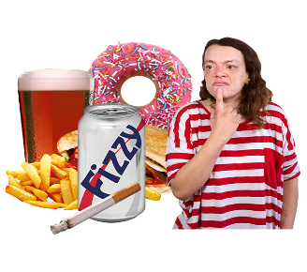 | Unhealthy behaviours lead to health problems  - Eating unhealthy food  - Lack of exercise  - Not enough sleep  - Too much alcohol  - Smoking
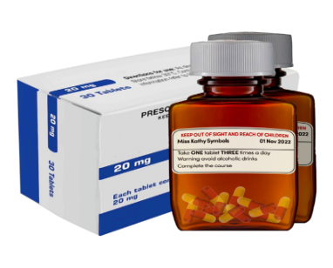 | Some medications have side effects.  These can make the body unwell if taken for a long time.
 | Poverty can make it harder to afford healthy choices.  This may mean we cannot buy healthy choices like fruit and vegetables.
 | Feeling isolated or not having family and friends to help can make us feel sad.  Feeling sad can affect our physical health.
What can we do to help?
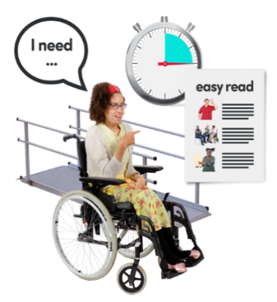 | Support people to get the physical health care they need.  Support Healthcare professionals to make reasonable adjustments.  Support people to get the right care at the right time.
 | At each point of contact, professionals will ask about physical health.  Every health contact will count.  Physical health will be seen as important for all.
 | People will work together to develop new and better ways of improving people’s physical health in BLMK.  Carers can also get involved.
 | SPLD will work together with partner organisations to make sure that opportunities to improve physical health are a part of everyone’s plans.  This is across health, social services, private and voluntary sector.

Initiatives to support improved physical health for people who have a learning disability
4: People with Complex Medical / Health and Care Needs and Community Services
3: Long Term Conditions (Asthma, Diabetes, Epilepsy) and Chronic Health Conditions (Obesity/ Constipation)
2: Interdependencies across Mental Health, LDA and Physical Health
1: Transforming Whole System Models of Care

Partnership working for innovation, integration, and improvement
System-wide partnerships should underpin the development of innovative approaches and integrated models of care, workforce, and commissioning.
Addressing fragmented care through integrated delivery and promoting holistic approaches for the best start in life and optimising health outcomes for all.
Addressing health inequalities and ensuring accessible services for people with complex needs is a priority focus
Strengthening joint commissioning across the ICB and Local Authorities for LDA pathways.
This priority includes End of Life Care and Advance Care Planning.
A focus is also hospital admission avoidance with effective community-based care and support.
Focus to improve quality of care and quality of life.
Lead on quality improvement in care pathways for chronic health conditions based on best practice and working across all settings.
Be informed by patient experience/ feedback.
Support collaborative working.
Promote digital solutions to support improved outcomes.
Joining up expertise and delivery for improved outcomes
Physical health is equally as important as mental health.
We know that physical outcomes for people with a Learning Disability with an additional mental health condition are poorer.
To close these gaps and improve outcomes we need to develop and ensure joint training, approaches and delivery across physical, mental and Learning Disability health.

Main areas for focus within SPLD Physical Health Strategy

Annual Health Checks
Improving the quality of annual health checks to avoid these being a tick box exercise within Primary Care.
Improving the content and communication of health action plans to strengthen the ability to monitoring care.
Ensure that all people who have a Learning Disability are supported to access regular physical health checks.
Review medication on a regular basis.
Cancer screening
Effective communication between people, their families and carers.
Mechanism for best interest decisions when individuals do not want to participate in cancer screening programmes.
Identify alternative ways of monitoring for potential changes/ signs and symptoms caused by cancer.
Provision of easy read information to support understanding of cancer screening programmes.
Identifying why people chose not to engage with screening programmes.
Constipation
Working to reduce the root cause of constipation including poor dietary and fluid intake.
Promote the benefits of exercise and health lifestyles.
Educate people and carers about medication which can contribute to constipation.
Encourage the use of bowel management plans within the community.
Prevention of Obesity and Weight Management
Improved access to health lifestyle information.
Improved access to Learning Disability specific weight management programmes based within the community.
Earlier support provided to avoid obesity becoming an issue in adulthood.
Early Diagnosis
Ensure onwards referrals are made to appropriate professionals following health checks.
Support attendance at Annual Health Checks where conditions can be identified sooner.
Support carers to be aware of changes in people’s condition so that more timely action can be taken.
Aspiration Pneumonia
Review alternatives to PEG insertion.
Referrals from acute services to community SLT services to take place in a timely manner.
Support to complete timely SLT assessments to take place considering cases of rapid deterioration.
Care staff to be trained to be aware of the soft signs of illness and deterioration.
Robust management plans to be collaborated on to reduce the risk of repeat admission with community-based support to be considered.

Developed by Simone Mingay, Clinical Nurse Manager, ELFT

