

Services for People who have a Learning Disability (SPLD)




Physical Health Strategy 2025 – 2028

Introduction
 | About Us  We are the Services for People who have a Learning Disability (SPLD).  We want people with learning disabilities to be treated fairly and equally.
 | Our New Strategy  We are happy to tell you about our new plan.  It is called the SPLD Learning Disability Strategy.  It is for the years 2025 to 2028.
 | What the Strategy is About  This plan is about helping people with learning disabilities to have better physical health.  It is for people who live in Bedfordshire and Luton.  We will work hard over the next 3 years to make things better.
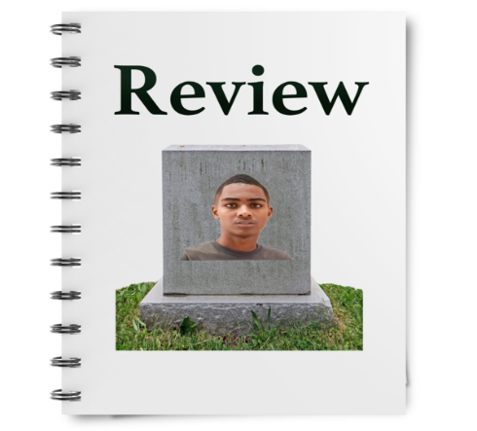 | Why We Are Doing This  Some of our work comes from LeDeR reviews. LeDeR means:  Learning from Lives and Deaths – People with a Learning Disability and Autistic People.  These reviews tell us how we can make services better.  They show us where people have had problems with healthcare. We want to fix these problems.
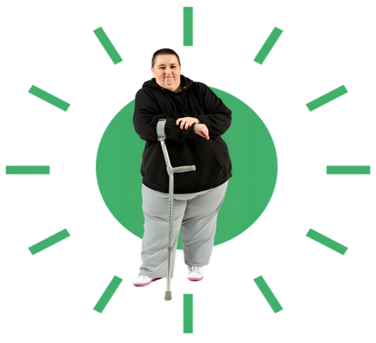 | What We Want to Do  We want people to:  ✔ Feel healthy and well  ✔ Be happy and safe  ✔ Get the right care at the right time  We want to put people at the centre of their care.  This means you help to make decisions about your health.
 | Listening and Working Together  We will:  ✔ Listen to people with learning disabilities  ✔ Talk with families and carers  ✔ Work together to make things better
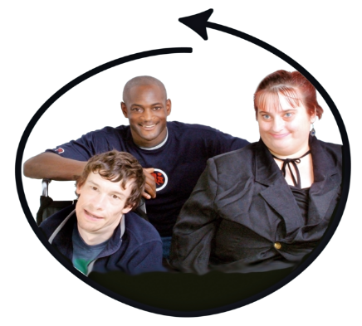 | What is Important to Us  It is very important that:  ✔ People with learning disabilities can use our services easily  ✔ Everyone gets the help they need  ✔ People feel included and respected

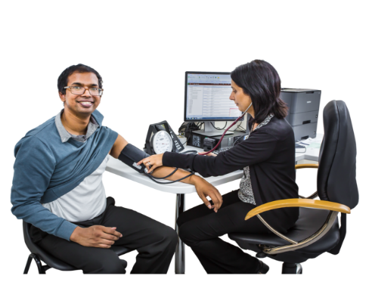
What do we need to change?
 | People with a learning disability often experience higher levels of poor physical health.
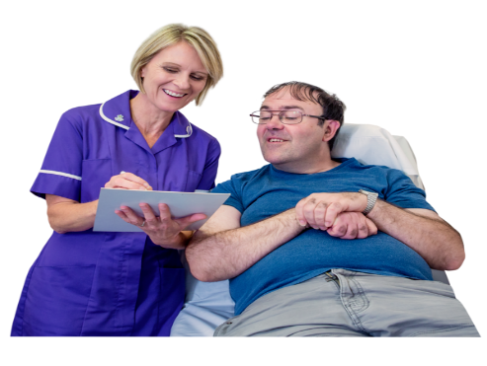 | Many of these people do not get their health problems treated.
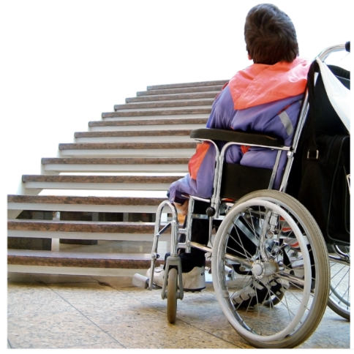 | Access to health in some areas is a big problem.  This can affect people’s quality of life.
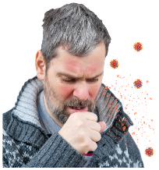  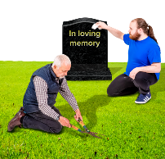 | In some cases, it leads to illness.  It can also lead to early death.

What are the reasons for this?
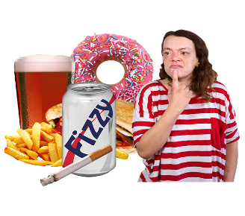  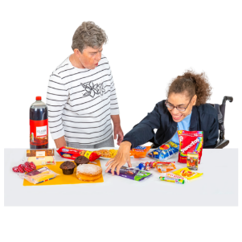 | Unhealthy behaviours lead to health problems  - Eating unhealthy food  - Lack of exercise  - Not enough sleep  - Too much alcohol  - Smoking
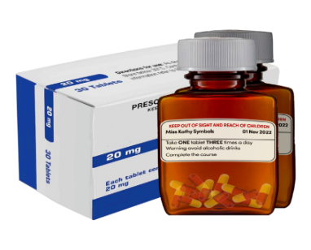 | Some medications have side effects.  These can make the body unwell if taken for a long time.
 | Poverty can make it harder to afford healthy choices.  This may mean we cannot buy healthy choices like fruit and vegetables.
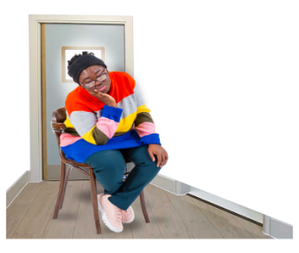 | Feeling isolated or not having family and friends to help can make us feel sad.  Feeling sad can affect our physical health.
What can we do to help?
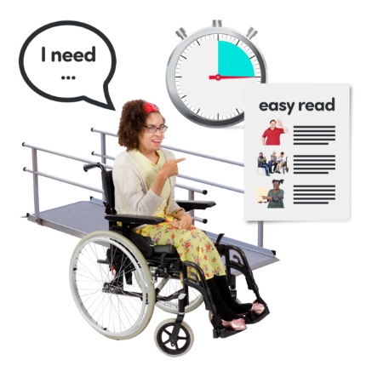 | Support people to get the physical health care they need.  Support Healthcare professionals to make reasonable adjustments.  Support people to get the right care at the right time.
 | At each point of contact, professionals will ask about physical health.  Every health contact will count.  Physical health will be seen as important for all.
 | People will work together to develop new and better ways of improving people’s physical health in Bedfordshire and Luton.  Carers can also get involved.
 | SPLD will work together with partner organisations to make sure that opportunities to improve physical health are a part of everyone’s plans.  This is across health, social services, private and voluntary sector.
 | See the next pages for our 5 aims to do this!
Aim 1: Improving Quality of Annual Health Checks
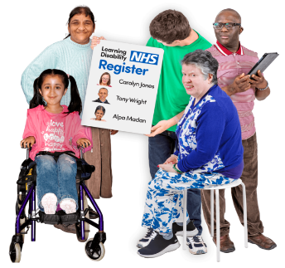 | Working with GP Surgeries to make sure the right people are on the LD Register.  Making sure that from the age of 14 people are invited for their Annual Health Check.
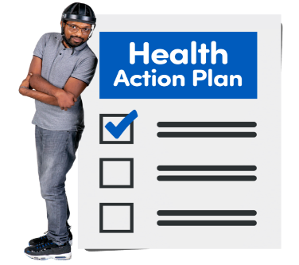 | Working with GP Surgeries to improve Health Action Plans.  Making sure that following an Annual Health Check you get a copy of your Health Action Plan.
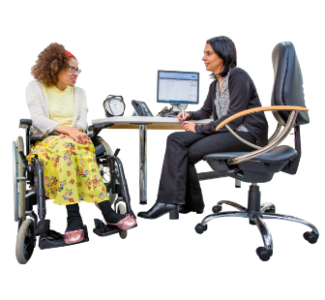 | Ensure that Annual Health Checks are good quality.  Support GPs to include important physical health checks.
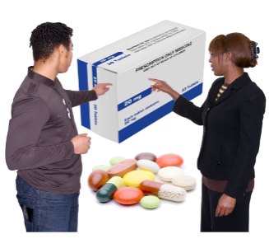 | Working with GP’s to review medication on a regular basis.  This is important so that you only take the medication you need.
 | Working with GPs to make earlier diagnosis of conditions before they become hard to manage.

Aim 2: Cancer Screening
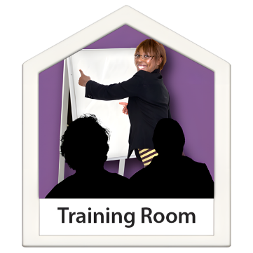 | Support additional training and awareness on the signs and symptoms of cancers.  Help to identify other ways of looking for changes, causes and by cancer.
   | Work with you to help them understand the importance of cancer screening.
   | Encourage GPs to access Easy Read information to support the understanding of different cancers.
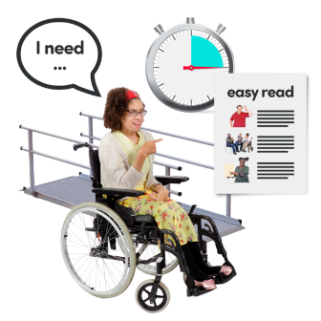 | Support health professionals to consider reasonable adjustments.

Aim 3: Prevention of obesity and weight management

 | Improved access to health lifestyle information.  Easy read information to support understanding.
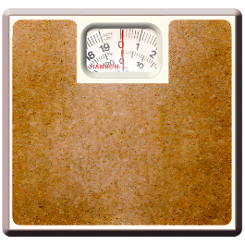  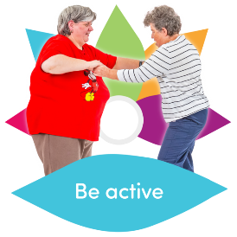 | Weight management programmes based within Bedford and Central Bedfordshire.
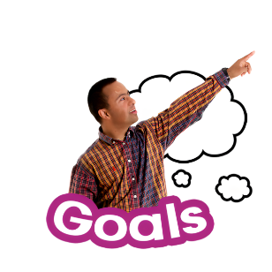   | Earlier help and advice provided to stop obesity becoming an issue in adulthood
 | Help to make changes you can stick to for the rest of your life to keep to a healthy weight.
 | Help to do more sport and exercise.

Aim 4: Aspiration Pneumonia
 | Care staff to be trained to be aware of the soft signs of illness and deterioration.
   | Working with healthcare professionals to reduce the risk of repeat admission to hospital
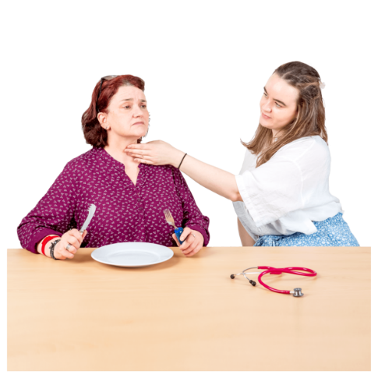 | Make sure you have a swallowing assessment if you need it, so food/fluid isn’t going the wrong way and have a plan to help you!
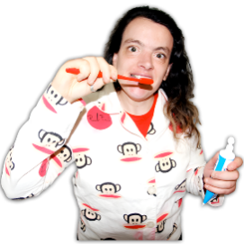  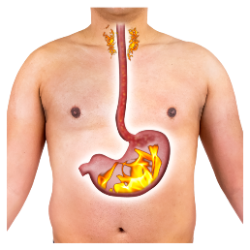 | Make sure that you are well so do not have higher risk of aspiration pneumonia such as reflux, breathing issues, poor oral care and seizures
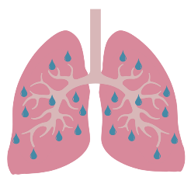  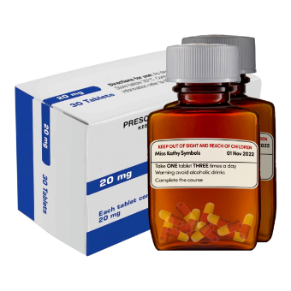 | Make sure you get antibiotics quickly to treat the aspiration pneumonia and not go into hospital
Aim 5: Constipation
   | Help you to understand the importance of eating a healthy diet.
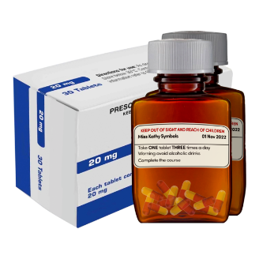 | Awareness of medication which can contribute to constipation
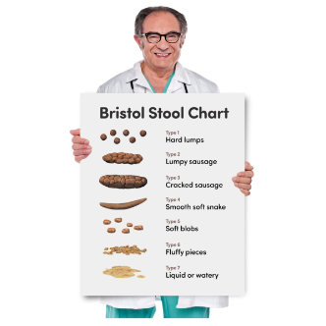  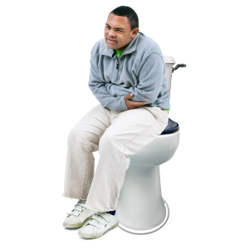 | Encourage use of bowel management plans.
  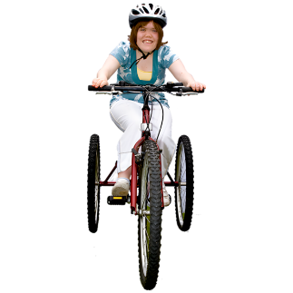 | Raise awareness of exercise
 | Raise awareness to drink lots of drinks

