

COVID-19 Hospital Hub Directorate Mobile Clinics for Inpatients Vaccination

Version number: | 10.0
Consultation Groups | Pharmacy, Infection Prevention and Control,  Resuscitation Officer, Estates, digital,  Clinical directors and borough lead nurses
Approved by (Sponsor Group) | Medicines Committee
Date approved | 10th April 2025
Ratified by: | Chairs Action Chief Medical Officer
Date ratified: | 1st October 2025
Name of originator/author: | Lead Pharmacist Vaccinations and Antimicrobials
Executive Director lead: | Chief Medical Officer
Implementation Date: | October 2025
Last Review Date | October 2025
Next Review date: | October 2026

Services | Applicable
Trust wide | All staff who working in the Hospital hub  COVID-19 vaccination pathway
Mental Health and LD
Community Health Services

Version Control Summary

Version | Date | Author | Status | Comment
1 | 03/2/21 | Claire Mckenna & Jennifer Melville
2 | 7/12/21 | Roberta Contino | Pfizer, Moderna and Booster doses added
3 | 14/09/22 | Roberta Contino | Astra Zeneca removed  Pfizer Bivalent and Moderna Spikevax Bivalent added
4 | 06/01/2023 | Alex Webster  Dr Mike O’Hanlon  Roberta Contino  Salimah Dhalla  Janette Clark  Lewis Pope | JAC documented vaccination via non- prescribers using NP or PGD added  Patient and Staff pathways added  Resus checklist added  Responsibilities amendment  EPMA - Appendix 5 updated
5 | 04/09/2023 | Roberta Contino  Alex Webster  Lewis Pope | Moderna and Pfizer 30mcg removed  Comirnaty® Original/Omicron BA.4-5 added  Staff and patient pathway updated  EPMA -Appendix 5 updated
6 | 28/09/2023 | Roberta Contino  Alex Webster  Lewis Pope | Comirnaty® Original/Omicron BA.4-5 removed  Comirnaty® Omicron XBB.1.5 added  EPMA - Appendix 5 updated
7 | 08/04/2024 | Roberta Contino  Lewis Pope | Spikevax® XBB.1.5 added  EPMA – Appendix 5 updated
8 | 09/10/2024 | Alex Webster  Lewis Pope | Spikevax® JN.1 added.  EPMA – Appendix 5 updated
8.1 | 20/11/2024 | Alex Webster  Lewis Pope | Comirnaty® JN.1 Added.  Spikevax® JN.1 Removed  EPMA – Appendix 5 updated
9 | 18/03/2025 | Alex Webster  Lewis Pope  Saema Arain  Andrea Okoloekwe | Comirnaty® JN.1 Added/updated  Spikevax® JN.1 Added/updated.  Appendix 3-5 Updated.
10 | 01/09/2025 | Roberta Contino  Alex Webster  Lewis Pope | Comirnaty® 30 KP.2 added  Appendix 4 and 5 updated

CONTENTS | PAGE NO
1. Introduction | 4
2. Purpose | 4
3. Inpatient Prioritisation | 5
4. Model – Mobile vaccinations | 5
5. Workforce | 5
6. Training | 7
7. Medicines Supply | 8
8. At admission | 10
9. Prescribing | 10
10. Preparation and Administration Comirnaty KP.2 30 microgram/dose vaccine | 11
11. Incident reporting and adverse drug reactions | 12
12. Medical Emergencies | 12
13. Documentation | 13
14. Stocktake | 13
15. At discharge | 13
Appendix 1: Pathway 1: Mobile Vaccination Outreach Patient COVID and Flu Vaccination Pathway | 14
Appendix 2: Pathway 2: Mobile Vaccination Outreach Staff COVID and Flu Vaccination Pathway | 15
Appendix 3: Resurrection equipment. Roving Team | 15
Appendix 4: 6 DOSE VIAL Comirnaty KP.2 30 microgram/dose vaccine Log | 17
Appendix 5: How to prescribe COVID-19 vaccine on CMM EPMA (Comirnaty KP.2 30 microgram/dose vaccine) | 18
Appendix 6: Management of Anaphylaxis in the Vaccination Setting | 21
Appendix 7: Risk reduction measures for preventing contamination of vials when moving between inpatient wards | 22

Introduction

Please note that as a vaccination manufacturer can change mid-campaign. Only Comirnaty® KP.2 30 microgram/dose has been included in this policy.
Please get in touch with roberta.contino@nhs.net or alex.webster1@nhs.net to confirm what vaccination is being used currently.
- There are a comprehensive list of documents supporting the national COVID-19 vaccination programme. There is also advice in the Roving and Mobile model access, to make sure there are clear protocols in place to control access, both for staff and patients attending vaccinations. This protocol intends to signpost to the key national documents that should be read and followed, as well as provide guidance on the governance arrangements that should be in place with partner organisations such as the PCNs and the LVS sites

- East London NHS Foundation Trust (ELFT) and its staff are committed to the safe, effective and timely provision of COVID-19 vaccines to patients in its care and health and social care staff.

Related Policies
- Medicines policy
- SOP for Fridge and Clinical room temperature monitoring for safe storage of medicines
- Resuscitation Policy
- Anaphylaxis recognition and treatment policy
- Infection prevention and Control Policy Manual
- Covid-19 IPC Policy
- Cardio-pulmonary resuscitation COVID-19 (Exceptional) SOP
- Mental capacity policy
- Medicines Reconciliation Policy

2. Purpose
To outline processes for management of inpatient vaccinations via mobile teams from hospital hub clinics and safe governance and medicines management principles for COVID-19 vaccine use.

3. Inpatient prioritisation
- All eligible inpatients who consent will be offered the vaccine as inpatients.

Area | Patient group
Fothergill, Sally Sherman, Cazaubon  East Ham Care Centre, Shrewsbury Rd, Forest  Gate, London E7 8QP | Older adults  All current inpatients
Leadenhall  Tower Hamlets Center for Mental Health, Mile End Hospital, E1 4DG | Older adults  All current inpatients
Fountains Court (Limited numbers due to Covid positive cases)  Merton Road,  Bedfordshire Bedford MK40 3AF | Older adults  All current inpatients
Cedar House  Bedford Health Village,  3 Kimbolton Road, Bedfordshire MK40 2NT | Mental Health Rehabilitation – care home all current inpatients
Poplars  Mayer Way, Off Houghton Road, Houghton  Regis, Bedfordshire LU5 5BF | Older adults  All current inpatients
Learning difficulties ward  John Howard Centre, 12 Kenworthy Rd,  Homerton, London E9 5TD | Older adults  All current inpatients
Inpatient wards  Wolfson House, Posnanski Court, 311-315  Green Lanes, Finsbury Park, London N4 2ES | Identified at risk patients according to cohort
Inpatient wards  John Howard Centre, 12 Kenworthy Rd,  Homerton, London E9 5TD | Identified at risk patients according to cohort
All adult mental health | At risk patients

4. Model – Mobile Vaccinations (see Appendix 1 Patient Pathway and Appendix 2 Staff Pathway)

- Ward MDT is responsible for identifying inpatients eligible for receiving COVID-19 vaccine.
- Mobile vaccinators will be deployed from Mile End Hospital - East London NHS FT on ELFT inpatient wards and premises.
- Vaccinations will occur in an allocated room on the ward, large enough to accommodate up to two roving vaccination team members (one Vaccination lead RHCP, one vaccinator) as well as the patient and ward staff member.
- The roving vaccination team must be assigned a member of the ward team to support with escorting patients to the clinic and summoning support if required (i.e. rapid response team, crash team or emergency services).
- Experienced vaccinators and administration staff will vaccinate eligible inpatients at ward level.
- Authority to administer will be by individual patient prescription or Patient Group Direction (PGD) if the patient is consented by vaccination lead nurse on EPMA or on a paper drug chart (EHCC Fothergill and Sally Sherman only).
- Patients will be provided with information leaflet and vaccination card.
- Administration will be documented on CMM EPMA and entered on NIVS
- Mobile vaccine team will follow guidance and SOP on safe transfer of vaccine maintaining the cool chain – see attached SOP Roving and Mobile models

- Pharmacy Department – Mile End Hospital will be the only central site within ELFT storing the Covid-19 vaccines
- Movement of stock will be within ELFT directorate premises
- All appropriate measures to prevent contamination of the vials once punctured will be applied. See Appendix 7 for further information.
- Once the ward patients are vaccinated, staff who wish can also have their vaccine

5. Workforce

- Ward doctor or Vaccination lead nurse to undertake health questionnaire, obtain patient consent and prescribe vaccine on CMM EPMA or paper chart. They will also assist in any medical emergencies.
- Ward pharmacists advise on governance, undertake clinical screening, offer appropriate advice, and organise supplies. A dedicated pharmacist is responsible for daily stocktake at each site.
- Ward admin/lead
- Care Coordinator
- Roving clinics will have the following staff:
- Registered experienced COVID-19 nurse vaccinator
- Experienced administration staff
- Local vaccinator (training)

Responsibilities:

Ward doctor and/or Vaccination Lead Nurse | Health questionnaire  Patient consent  Prescription/documenting on EPMA
Ward doctor | Documentation on RIO  Documentation on discharge notification form (NODF)  Contact GP if needed regarding administration of vaccine  Assist any medical emergencies
Ward pharmacist | Vaccine governance  Clinical screening  Clinical advice  Ordering vials for mobile clinic  Stocktake  Screening NODF to ensure details included
Ward lead / admin | Ensure second dose added to ward diary Ensure second dose plan included in discharge planning/CPA
Care coordinator | Involved to coordinate additional dose planning
Mobile team nurse | Preparation vials  Administering dose on EPMA
Mobile team admin | Entering data on NIVS

6. Training
COVID-19-specific training, BLS and anaphylaxis
- All registered nursing staff running COVID-19 Clinics and administering COVID-19 vaccines require specific training according to their vaccination experience:
  - Experienced and competent vaccinators who have been vaccinated within the past 12 months
  - Registered Health Care Professionals new to, or returning to vaccination after a prolonged period
  - See the document to access the required training checklist:
https://assets.publishing.service.gov.uk/government/uploads/system/uploads/attachment_data/file/969903/Core_competency_assessment_tool_March2021.pdf

Standard operating procedures (SOPs)
- All nurses undertaking preparation and administration of the vaccine must read and sign that they have understood SOP PCV14 for Comirnaty® KP.2 30 micrograms/dose.
- All nurses undertaking stocktake and waste of the vaccine must read and sign that they have understood SOP for Disposal of Damaged, Used or Expired COVID-19 Vaccine at the Hospital hub clinic, SOP HCV-7 Stocktaking and Reconciliation of Comirnaty® KP.2 30 micrograms/dose
- Clinic Leads to hold log of vaccinators signed off for above SOPs. Pharmacy team to have oversight of this.

7. Medicines supply

Allocation of vaccine to hospital hub
- Allocations are made via a central mechanism from UKHSA and ICB
- Standard Operating Procedure (SOPs) for stock control, management of waste and reporting structures are required for central teams to manage allocations. Therefore, it is important to keep tight control over these areas.

Presentation of vaccine
Comirnaty® KP.2 30 micrograms/dose: (Only from 12 years of age and older)

- This is a multidose vial that contains 6 doses of 0.3mL.
- One dose (0.3 mL) contains 30 micrograms of Cemivameran, a COVID−19 mRNA Vaccine (nucleoside modified, embedded in lipid nanoparticles).
- Cemivameran is a single-stranded, 5'-capped messenger RNA (mRNA) produced using a cell-free in vitro transcription from the corresponding DNA templates, encoding the viral spike (S) protein of SARS-CoV-2 (Omicron KP.2).

Pharmacy Site contact details:
City and Hackney Centre for Mental Health | City and Hackney Pharmacy  Office Lead named contact – Susana Fontelo | elft.pharmacycityandhackney@nhs.net
Tower Hamlets Centre for Mental Health | Mile End Hospital Pharmacy  Lead named contact – Bhavin Karania, Iffah Salim and Jennifer Clifford | elft.pharmacytowerhamlets@nhs.net
Newham Centre for Mental  Health | Newham pharmacy office  Lead named contact - Veena Shivnath | elft.pharmacynewham@nhs.net
Wolfson House (Forensics) | Mile End Hospital Pharmacy  Lead named contact - Bhavin Karania, Iffah Salim and Jennifer Clifford | elft.pharmacytowerhamlets@nhs.net
John Howard Centre (Forensics) | Mile End Hospital Pharmacy  Lead named contact - Bhavin Karania, Iffah Salim and Jennifer Clifford | elft.pharmacytowerhamlets@nhs.net
Luton Wellbeing Service, Calnwood Court | Luton pharmacy office  Lead named contact - Natasha Patel | elft.pharmacyluton@nhs.net

How to order from your pharmacy team
- Teams need to liaise with the pharmacy in advance to ensure vaccinations are prescribed for the allocated roving clinic day.
- Pharmacy staff to prepare and issue the number of doses required for the mobile clinic.
- Nursing staff to collect consumables and cool box containing the vaccines from the pharmacy team

Collecting stock from Pharmacy at the Mile-end pharmacy and receiving stock in clinic

- Pharmacy will prepare the cool box to hold the vials requested for transport to inpatient ward.
- Pharmacy will issue the administrations logs for each vial
- The pharmacy will supply syringes for the number of doses in each vial.
- The pharmacy will supply Patient Information Leaflets and Vaccination record cards for the number of doses issued.
- Cold chain to be maintained 2-8ºC for non-punctured vials.
- Prior to use, pre-filled syringes can be stored for up to 12 hours at temperatures between 8 °C and 30 °C and can be handled in room light conditions.
- Follow the trust SOP on fridge and room temperature management
- Once at the clinic, the cool box should be opened as close to the fridge as possible, and vials should be placed in the refrigerator. NB Vials need to be kept in the original manufacturer packaging.
- Should not be stacked more than two boxes high

Cool boxes
• See best practice for cool boxes here.

Stock remaining at end of clinic
- Ideally all doses should be used from vials issued that day.
- All remaining partially used or unused vials need to be returned to pharmacy, only if the cold chain has been maintained.
- Implement a temperature monitoring remote system that ensures cold chain and alerts pharmacy team that excursion has occurred.
- See SOP HCV-7 Stocktaking and Reconciliation of Comirnaty® KP.2 30 micrograms/dose.

8. At admission
• At admission, the patient must have a medicines reconciliation by a pharmacist/pharmacy technician which states whether the patient has received the COVID-19 vaccine already or not (ward doctor at weekends) this will be communicated to the MDT.

9. Prescribing
- The ward doctor or vaccination lead nurse will be responsible for prescribing or consenting using a PSD or PGD Comirnaty® KP.2 30 micrograms/dose to inpatients on the relevant site.
- National protocols for vaccinations can be found here.
- The prescription needs to be written for administration on the agreed roving clinic day or patients can be consented by the roving vaccination lead nurse on arrival to ward.
- Up-to-date information on the vaccine can be found The green book, chapter 14a
- COVID-19 Vaccination information for healthcare practitioners
- The prescription will be made on CMM EPMA - See Appendix 5
- For Fothergill, Sally Sherman, Archer unit and for SMI community prescribe on an inpatient drug chart in the once only section:
- At the time of the first prescription the second dose should be added as a place holder on EPMA (see Appendix 5) and the date added to the ward diary.
- The ward doctor or vaccination lead nurse will undertake health assessment for eligibility of COVID-19 vaccine and consent the patient. This will be documented in the patient RIO progress notes
- Inpatients only who meet eligibility and are within recommended JVCI cohorts should be vaccinated.

Consent
- Consent must be obtained from inpatients prior to prescribing and documented on RIO. Where a patient lacks capacity to provide informed consent to vaccination a best interest decision will need to be determined and decision fully documented on RIO.
- The Consultant doctor is responsible for best interest decisions and these must be documented.
- Where appropriate, the person’s advocates or those with power of attorney should be consulted, and if there is a deputy or attorney with relevant authority then consent must be sought from them to be able to make a decision on the person’s behalf to receive the vaccination.
- See National Government guidance here.
- Useful reading and guidance on capacity and COVID-19 vaccinations can be found:
Obtaining consent is discussed in Chapter 2 of “Immunisation against infection disease” (the Green Book)

COVID-19 Vaccination and the MCA – the first Court of Protection judgment

10 Preparation and administration - Comirnaty® KP.2 30 micrograms/dose vaccine

- Ensure the of Comirnaty® KP.2 30 micrograms/dose vaccine has been prescribed correctly on EPMA and vaccinator is satisfied that the prescription is safe.
- Prepare and administer vaccine according to SOP PCV14 for Comirnaty® KP.2 30 micrograms/dose.
- Each vial contains at least six doses. After withdrawing the final dose, liquid is usual to remain in the vial.
- Complete the sign-out sheet (Appendix 4) for each vial taken out of the cool box; these must be returned to the pharmacist/pharmacy at the end of each day.
- The administration and administering nurse will complete the NIVS entry, including repeating the health questionnaire with the patient.
- Patient information leaflets should be provided to the patient post-dose. See Public Health England Covid-19 Vaccination, ‘ What to expect after your vaccination patient information leaflet here.
- Information on the Comirnaty® KP.2 30 micrograms/dose Covid-19 vaccine can be found in the Green Book

11. Incident reporting and Adverse drug reactions
- Inphase–All incidents and near misses relating to any aspect of the process of end to end deployment of COVID-19 vaccines must be reported on the INPHASE system. Within the ‘incident description’ section, the keyword “COVIDVACC” must be included.

- Adverse Drug Reaction reporting - Suspected adverse reactions following administration of COVID-19 vaccine should be reported on the DATIX (if uncommon, serious or significant) and to the MHRA using the specially established Coronavirus Yellow Card reporting scheme (https://coronavirus-yellowcard.mhra.gov.uk/or call 0800 731 6789). As a new vaccine product, MHRA have a specific interest in the reporting of adverse drug reactions for the new COVID-19 vaccines.

    - Common/minor side effects – DO NOT report on Inphase. You can report these to the MHRA via the Coronavirus Yellow Card reporting scheme.

    - Uncommon/Serious/Significant side effects - Report on Inphase and to the MHRA via the Coronavirus Yellow Card reporting scheme.

Adverse Drug Reactions:

Very common side effects include:

- Having a painful, heavy feeling and tenderness in the arm where you had the injection.
- This tends to be worst around 1-2 days after the vaccine
- Feeling tired
- Headache
- General aches or mild flu-like symptoms

Although feeling feverish is not uncommon for 2-3 days, a high temperature is unusual and may indicate you have COVID-19 or another infection. Advise the person the normal dose of paracetamol (follow the advice in the packaging) to help with common side effects. These side effects usually last less than a week.

12. Medical emergencies
- All staff will have BLS and anaphylaxis training
- The Roving vaccination team will supply:
- 2 x Anaphylaxis Kit.
(The ward must have the equipment noted in Appendix 3. The vaccination team may be able to provide some equipment if prior notice is given)
- As much as possible the team on the ward where the patient is vaccinated should be prepared for possible adverse events. There should be at least 2 registered nurses on duty when the vaccine is given, at least one of whom should have completed Immediate Life Support and is available to support the patient if adverse event occurs. In the event of a medical emergency, additional support should be provided by the Duty Senior Nurse, Rapid Response Team/Emergency Nursing Team and Duty Doctor.
- Anaphylaxis – See Appendix 6 and Resus Council Guidance
https://www.resus.org.uk/about-us/news-and-events/anaphylaxis-guidance-vaccination-settings
- Dial 999 for medical emergencies, or 2222 if applies to site.

13. Documentation
- Documentation of administration is completed in the https://www.ravs.england.nhs.uk/reports.
- CMM EPMA see Appendix 5.
- The Ward nurse in charge is responsible for documenting RIO progress notes.
- All vaccine administration information and plans for second doses must be included in the Discharge notification to the GP (NODF)

14. Stocktake
- Clinic and pharmacy staff to be involved in daily stocktake
- For Comirnaty® KP.2 30 micrograms/dose Covid Follow SOP HCV-7 Stocktaking and Reconciliation.

15. At discharge
- The information must be included in the discharge notification

Where can I find more information?
As information is constantly being reviewed and updated nationally as more information is identified, staff are advised to look at the latest information on the gov.uk websites

See the Green book, chapter 14a, COVID-19 Vaccines

See the Green book, chapter 8, Vaccine safety and the Management of adverse events following immunisation.

- See the National PGD for Autumn 2025 COVID 19 programme. Click here

Appendix 1

Pathway 1: Mobile Vaccination Outreach Patient COVID and Flu Vaccination Pathway

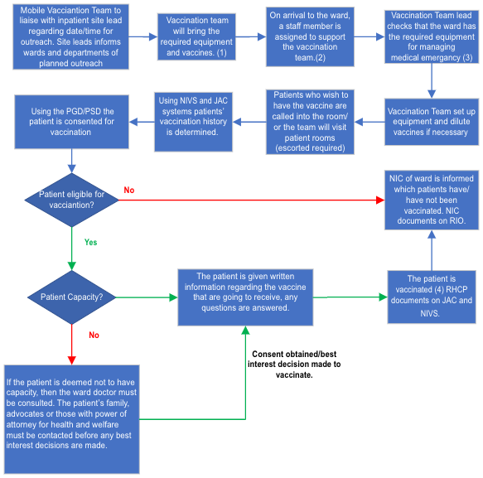

1: The vaccination team will bring:
- Vaccines stored in cool box and temperatures checked hourly.
- Spare Ice packs.
- Syringes, needles, plasters, alcohol gel, alcohol swaps, cotton buds.
- Dilution packs.
- Information Leaflets and vaccination cards.
2: Support required from the ward staff member assigned to the vaccination team:
- Escorting patient to the clinic.
- Escorting vaccine staff to patient rooms if required.
- Summoning support if required (rapid response team, crash team or emergency services).
3: The vaccination team will supply:
- 2 x Anaphylaxis Kit.
The ward must have the equipment noted in appendix. The vaccination team may be able to provide some equipment if prior notice is given.

4: The vaccination team will be responsible for any post vaccination monitoring if required. In the event of an adverse reaction the ward team may be required to assist.
Appendix 2
Pathway 2: Mobile Vaccination Outreach Staff COVID and Flu Vaccination Pathway

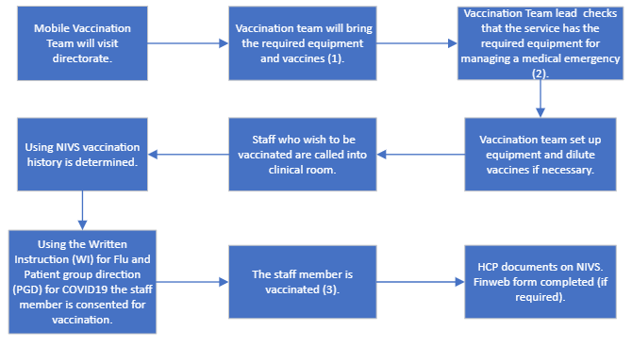

1: The vaccination team will bring:
- Vaccines stored in cool box and temperatures checked hourly.
- Spare Ice packs.
- Syringes, needles, plasters, alcohol gel, alcohol swaps, cotton buds.
- Dilution packs.
- Information Leaflets and vaccination cards.

2: The vaccination team will supply:
- 2 x Anaphylaxis Kit.
The ward must have the equipment noted in appendix. The vaccination team may be able to provide some equipment if prior notice is given.

3. The vaccination team will be responsible for any post-

vaccination monitoring if required. In the event of an adverse reactions, the ward team may be required to assist.

Appendix 3: RESUSCITATION EQUIPEMENT. ROVING TEAM

Roving vaccination team will bring; he vaccination team will supply:
2 x Anaphylaxis Kit.
The ward must have the equipment noted in appendix. The vaccination team may be able to provide some equipment if prior notice is given.

Vaccination Team lead checks that the ward had the required equipment for managing a medical emergency.

No. | Ward stock
1 | Defibrillator (AED) - pads pre-attached
1 | Spare Hands Free Defibrillator Pads in AED case lid (compatible with AED)
1 | Spare defibrillator battery in AED case lid (compatible with AED)
1 | AED Starter Kit (prep-kit)
1 | Sharps Bin (empty)
1 | Pocket Mask
1 | Oxygen Cylinder (minimum 3/4 full, seals removed, main valve opened)
1 | Stethoscope
1 | Fingertip pulse oximeter
1 | Large First Aid (Please complete separate audit)
1 | Pen torch
1 | Blood Glucose Monitor
1 | Blood Glucose Test Strips
5 | Lancets
1 | Electronic Blood Pressure Machine (Batteries installed and working)
1 | Infrared Thermometer
2 | Adult non-rebreathe mask
1 | Adult Bag Valve Mask.
 | Roving Vaccination Team
2 | Anaphylactic Shock Kit

Appendix 4:
This can be used for Comirnaty® KP.2 30 micrograms/dose
6 DOSE VIAL Comirnaty® KP.2 30 micrograms/dose (use a separate log for each vial)
Only have 1 vial in use at any time. Prior to use, pre-filled syringes can be stored for up to 12 hours at temperatures between 8 °C and 30 °C and can be handled in room light conditions.

Date:
Ward mobile clinic:
Vial batch Number:
Time vial taken out of fridge:
Expiry Time (12hours):

Dose withdrawn | Volume drawn up | Time drawn up | Drawn up by | Checked by  (if applicable)
1 | 0.3ml
2 | 0.3ml
3 | 0.3ml
4 | 0.3ml
5 | 0.3ml
6 | 0.3ml

Please scan and RETURN this Vaccine log to PHARMACY email address at the end of clinic

Appendix 5: How to prescribe COVID-19 vaccine on CMM EPMA

Prescribing a COVID-19 Comirnaty KP.2 mRNA Vaccine (for 1st, 2nd and/or Booster dose)

1. Select ‘Add Drug’ and search for ‘COVID-19’. Select ‘COVID-19 Comirnaty KP.2 mRNA Vaccine’.

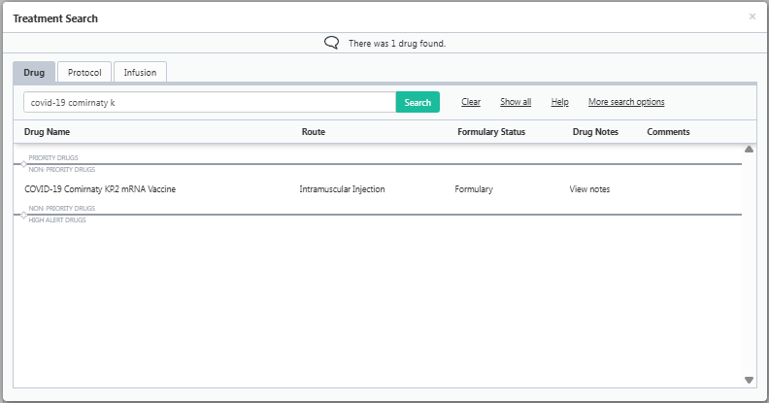

2. On selecting ‘COVID-19 Comirnaty KP.2 mRNA Vaccine’ the below drug note will appear.

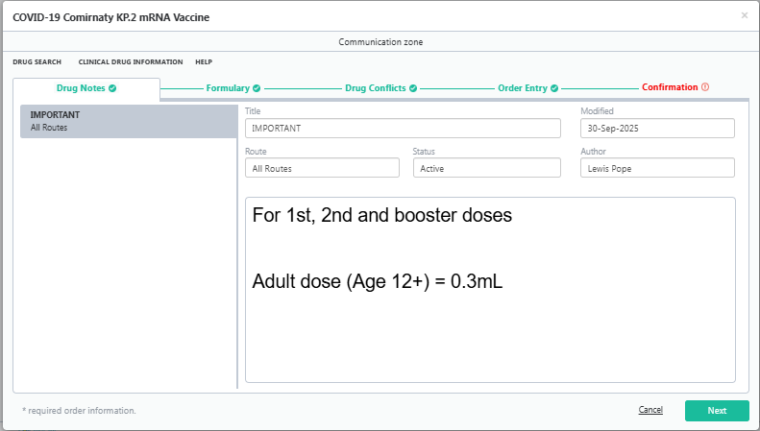

3. On the ‘Order Entry’ page, ensure all the details are correct. The dose will be set to a STAT Order and will default to be administered on the day of prescribing. It is therefore important to ensure ‘start on’ date and time are correct. Select ‘Next’

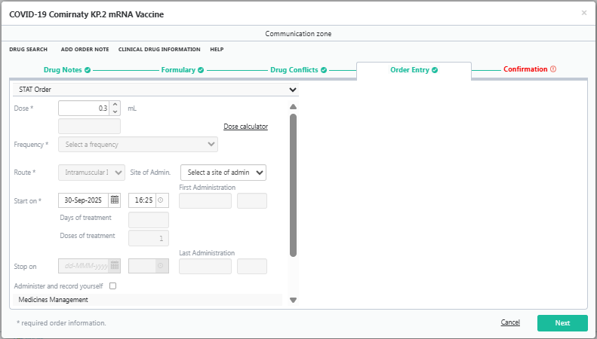

4. Ensure the details are correct on the ‘Confirmation’ tab and select ‘Confirm’.

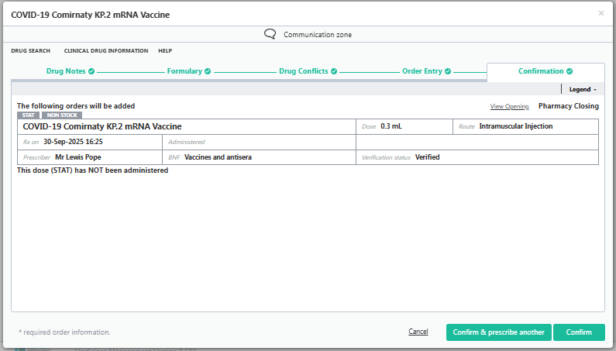
5. Once the dose has been prescribed, it will appear on ‘Inpatient Rx’ as per the screenshot below

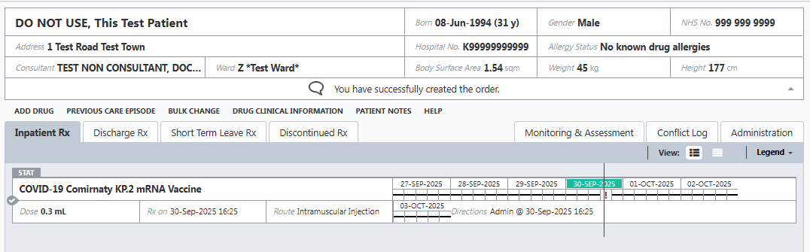

Appendix 6: Management of Anaphylaxis in the vaccination setting

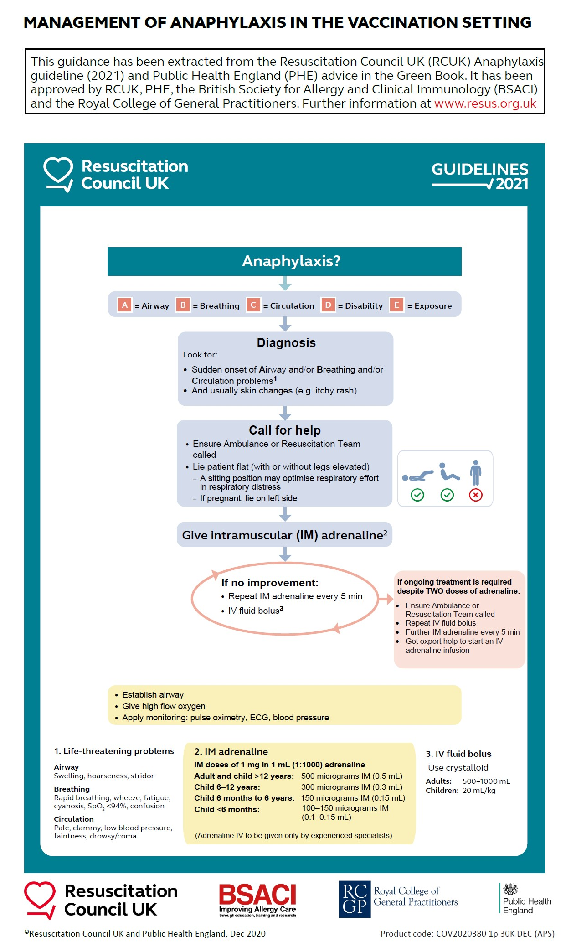

Appendix 7: Risk reduction measures for preventing contamination of vials
The roving model is based on a single site administration; however, the vials may be moved within that site for administration to patients on different wards.
Follow these risk reduction measures to prevent harm through administration of a contaminated dose of vaccine.
Risk reduction measures:
- Aseptic technique is of paramount importance.
- Minimise the time between the first and last puncture within the maximum time period of 6 hours.
- Ensure the vial is transported and stored within a validated cool box for the 6 hour period.
- Remove the vial from a validated cool box immediately before withdrawing the first dose and replace it immediately after withdrawing the last dose to be administered on any 1 ward.
- Swab the entire vial and then the bung, with 70% alcohol swab after removal from the validated cool box.
- Swab the entire vial with alcohol swab before replacing it in the cool box.
- If failure of aseptic technique is suspected, discard punctured vials.

