ELFT Allied Health Professionals Conference:
Connecting and Celebrating ELFT AHPS
Tuesday 21st October 2025
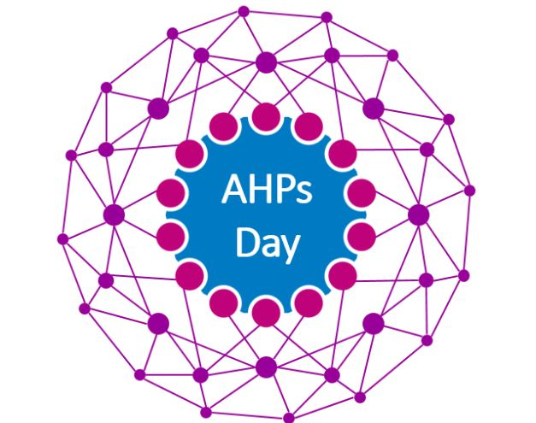

Location: Hybrid Event
- Join Online: Microsoft Teams via link http://bit.ly/3VWRl3Y
- In-person: ELFT HQ, 2nd Floor Conference Suite (Please only attend in person if you have booked a ticket)
Time |  | Lead
9-9.30am | Arrival, Tea and Coffee
9.30 -9.40am | Welcome to the Day | Edwin Ndlovu ELFT COO and Deputy Chief CEO
9.40 -10.10am | Session 1: AHP Leadership  - AHPs Deliver: NHS 10 Year Strategy -Fit for the Future?  - Our ELFT AHP Plan | Philippa Wright London Regional Chief AHP  Fiona Kelly ELFT Director of AHPs
10.10-10.20am | Move to Professional Networks (Separate MS Teams Links will be shared)
10.20-11.00 | Session 1: AHP Professional Networks & Connections  - Which professional networks do you connect to?  - What are the opportunities, challenges and priorities for your professional group? | ELFT Professional/Senior Leads  - Speech & Language  - Dietetics  - Podiatry  - Physiotherapy  - Occupational Therapy  - Arts Therapies (Music, Drama, Dance, Art)  - Support workers
11.00-11.15 | Break
11.15-12.00 | Session 2: AHPs – Moving from Analogue to Digital  - Digital Empowerment: Transforming AHP Clinical Pathways for Better Care (15 min)  - Unlocking Digital Potential: AHPs Starting the Journey Toward Smarter Care (30 min) | Tim Hunter ELFT CNIO & ELFT AHP Digital Network  Amy Simpson (Therapy Lead Beds CHS)  Polly Bowler (Arts Therapist) and Martin Grieg (RIO Team)
12.00-12.45pm | Hot Lunch Provided | Conference Room 2
12.45-1.45pm | Session 3: AHPs Delivering High Quality, Safe, Effective Care  - Optimising AHP Expertise & Capacity: Reflections on AHP Pro & Job Planning (10 min & 5 min Q&A)  - Outcome-Driven Care:  What’s New in the Pathways App? (10 min & 5 min Q&A)  - Therapeutic Engagement in Action: Enhancing Safety on Ruby Ward (10 min & 5 min Q&A)  - Partnering for Better Care: The Optimal Handed Care Project (10 min& 5 min Q&A) | Graham Copnell AHP Professional Development Lead & Rushmi Kanjee (Podiatry Professional Development Lead Beds & Luton)  Pathways (Forensic OT Team)  Aida Mumtaz (OT Tech) and QI Project Team  Alex Hadayah (Head of AHPs CHS London)
1.45 -2.30pm | Session 4: Developing AHP Research and Innovation  - Building ELFT AHP Research Capacity & Capability (15 mins)  - My Research Journey (10 Mins)  - Service Evaluation: “Service User Participation in Social Enterprise” (10 min)  - Encompass: “Co-adapted participatory group programme for parents/carers of children with complex Neurodisability” (10 min) | Dr Catherine Carr (ELFT AHP Strategic Research Lead)  Irem Denis (Dietitian, NIHR Developing AHP Research Leaders)  Lucy (Forensic OT) and Lauren Manville (Forensic SaLT).  Kirsten Prest (Occupational Therapist SCYPS and Parent Partners)
2.30 -2.50pm | Break
2.50-3pm | ELFT: Looking to the Future | Lorraine Sunduza ELFT CEO
3-3.50pm | Session 5: AHPs leading Prevention and Community Care  - Developing Community Integrated Neighbourhood Teams (15 mins)  - Barnsley Street Neighbourhood Mental Health Centre – Developing a New Model of Care (15 Mins)  - LD Community Transition Service (15 mins)  - Developing a Trust Wide Living Well Community of Practice (5 min) | Richard Fradgley (Deputy CEO & Executive Director Integrated Care)  Laura Coffin and Abbie Hull-Steward (Occupational Therapists)  Danielle Maule Head OT  Fiona Kelly and Marion Levine
3.50-4.15pm | AHP Awards | Dr David Bridle ELFT Medical Director
4.15-4.30pm | Summary and Close | Fiona Kelly ELFT AHP Director



