My End of Life Wishes

SPLD Advance Care Plan

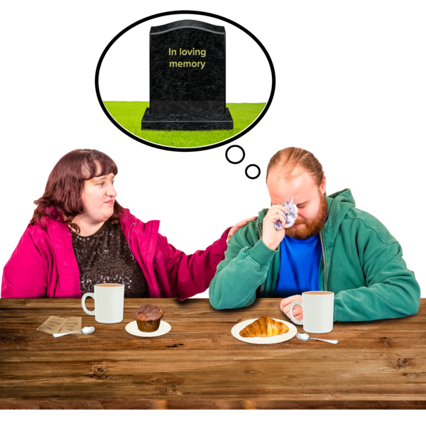

About Me
My Wishes after death

This Plan belongs to:
 | My name is:  I like to be called:
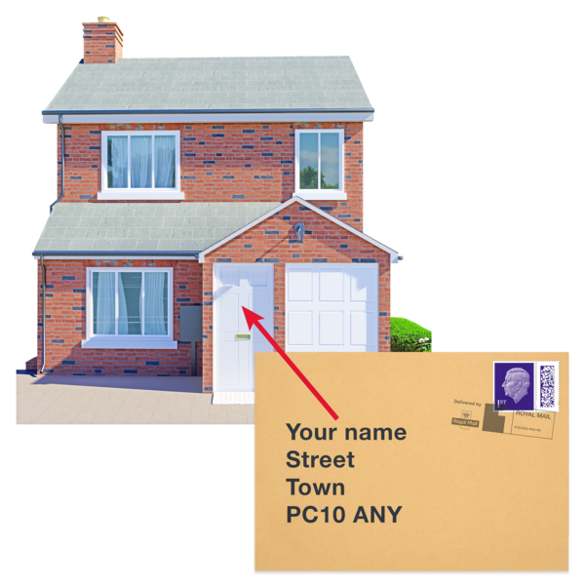 | I live at:
  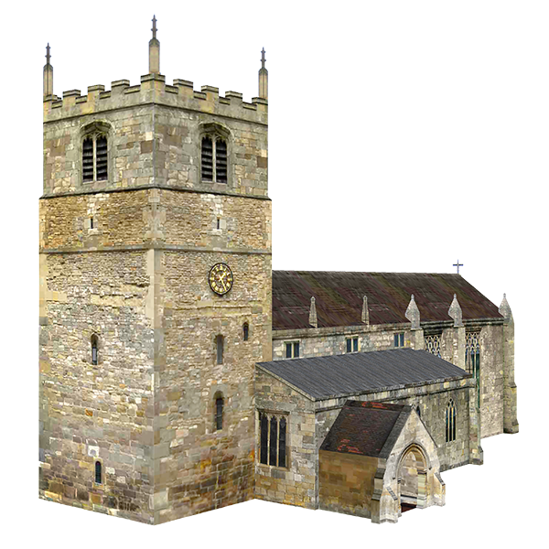 | My religion is
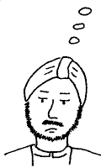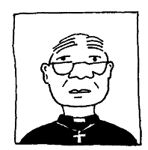 | Name of Priest/ Vicar/ Iman to be contacted:
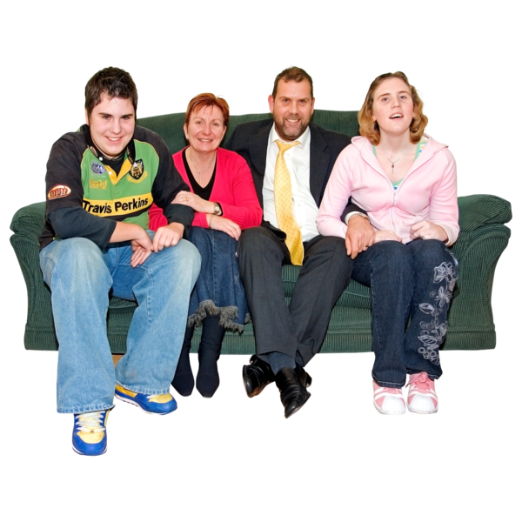 | My next of kin/carer is:
 | Their address is:

Things to do in the event of my death:  ____________________________________________  ____________________________________________  ____________________________________________  ____________________________________________ |  |  |  | 
Other people involved in bringing this plan together were: _______________________________________  ____________________________________________  ____________________________________________  ____________________________________________  ____________________________________________ |  |  |  | 
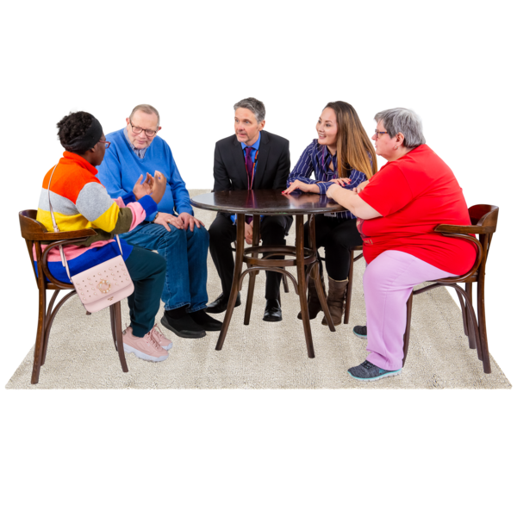 | This was a “Best interest discussion decision” discussion
 | Yes |  | No |  | 
 | circle choice
 | Where ever possible I would like to be cared for in my own home if I am very ill
 | Yes |  | No
 | circle choice

My Burial or Cremation.
Burial   |  | I have decided that I would prefer to be buried.
 |  | Yes |  |  | No
 |  | circle choice
I have a place in a family burial plot or I have purchased a plot
Yes |  |  |  | No
circle choice
If yes details:

If no I would like to be buried at:

Cremation |  | I have decided that I would like to be cremated
 |  | Yes |  |  | No
 |  | circle choice
 |  | I would like this to take place at:
 |  | I would like my ashes to be:

About my funeral service
Add picture | I would like the service to take place at: ______________  ____________________________________________________________________________________________  ______________________________________________
I would like the service to be |  | Formal | Yes |  |  |  | No
 |  | informal | Yes |  |  |  | No
 |  | circle choice
Add picture | I would like _____________________________________ to take part in my service  Their address is _________________________________ Tel number : ________________________________
Music   | I would like the following pieces of music to be played:  - __________________________________________  - __________________________________________  - __________________________________________
 | I would like the following to be read:  - __________________________________________  - __________________________________________
About my funeral service (Continued.)
Add picture | I would like these things to be placed in my coffin with me.___________________________________________  ____________________________________________________________________________________________
 | I would like flowers at my funeral
 |  |  |  | Yes |  |  |  | No
 |  |  |  | circle choice
Add picture | My favourite flowers are ___________________________  ____________________________________________________________________________________________

Donations  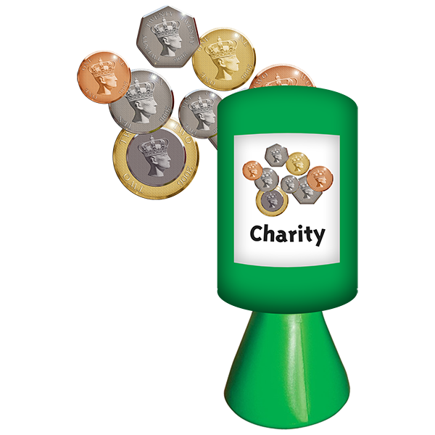 | Rather than flowers people may donate to: ____________________________________________________________________________________________  ______________________________________________
 | Yes |  | No
 | circle choice

About my Funeral.
I would like where my ashes or body is buried
to be marked with: (circle choice)
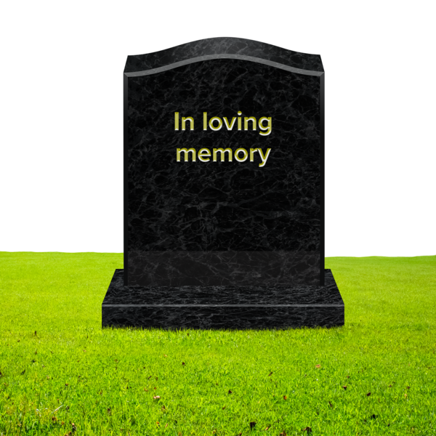
 | Yes |  |  |  | No
 | circle choice
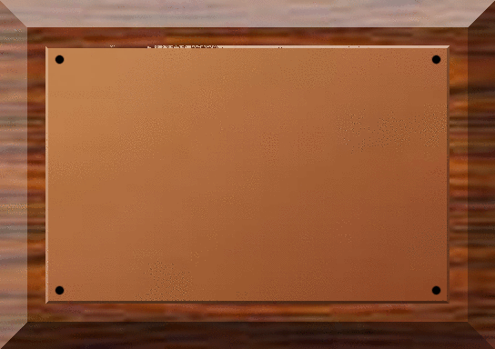
 | Yes |  |  |  | No
 | circle choice

 | Yes |  |  |  | No
 | circle choice
 | And I would like: (e.g. a tree planted)
 | Yes |  |  | No
 | circle choice
 | What tree?

About My Will.
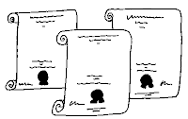 | I have/have not made a will made a:
 | Yes |  | No
 | circle choice
My will is kept with (name)

Address: ___________________________________________

___________________________________________

______________________________________
Funeral Plan.  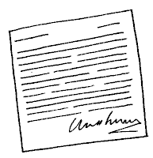 | I have/have not got a Funeral Plan.
 | Yes |  | No
circle choice
My funeral plan details are as follows:

Name of Plan: ___________________________
Policy Number: __________________________

 | My wishes about my things.
I would like my things to go to: _________________
____________________________________________________________________________________________
______________________________________________
 |  | I would like my clothes to go to: _____________________  ____________________________________________________________________________________________  ______________________________________________
 | Advanced Directives on the acceptance of refusal of treatment | I would like you to help me: _____________________  ____________________________________________________________________________________________  ____________________________________________________________________________________________________________________________________________________________________________________________________________________________________________________________________________________
 | Organ Donation | I have registered as an organ donor
 | Organ Donation | Yes |  |  | No
 | Organ Donation | circle choice
 | Organ Donation | My donation card is kept:
Other thoughts or things to consider: |  |  |  | 

Best Interest Discussion.  It has been agreed that this person is unable to confirm their wishes in respect of their death.  To assist _______________________ with this a meeting has taken place with their representatives (family, staff) to complete this plan on their behalf. |  |  |  |  | 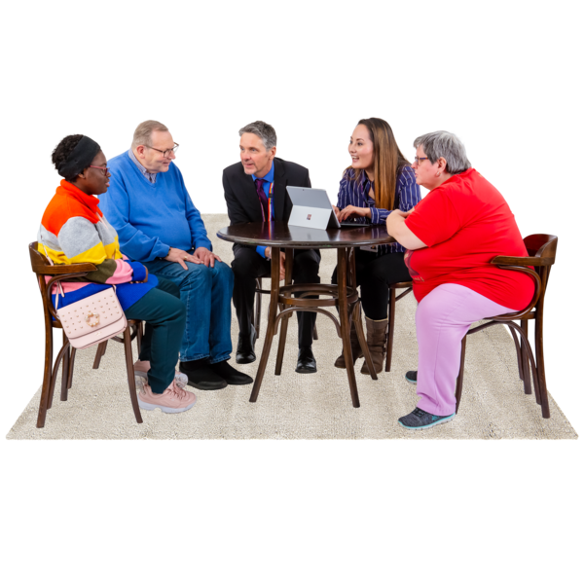
Who was involved in the discussion? (Print name and title).
Plan completed by ______________________________________________

Date Initiated: ……………………….... If the person’s wishes or feelings change please record and date these changes on the next page. |  |  |  |  |  | 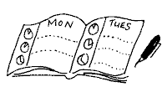
Review Dates

