Specialist Service for people who have a Learning Disability

All about Anxiety



What is it and where to get help




What is Anxiety?

This is a booklet about anxiety.

Anxiety is when you feel very worried or scared.

Everyone feels worried sometimes.

Many things make us feel worried like meeting new people or going to new places.

Sometimes these thoughts and feelings can stay for a while and effect how you live your life.

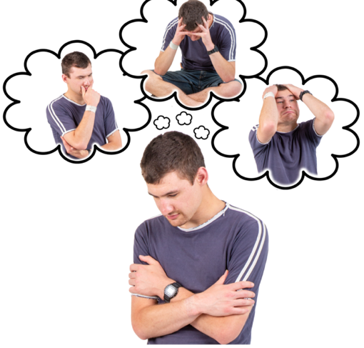


Anxiety is different from fear.

Fear is what we feel when we are in real danger right now.

Anxiety is a problem if it doesn’t go away.

It can make it hard to live your life.

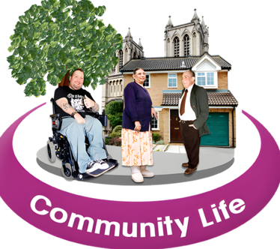

Here are some things that can happen in our body when we feel anxious:
Here are some things that might happen when we feel anxious:
Here are some things that might happen when we feel anxious:
Here are some things that might happen when we feel anxious:




Trouble sleeping Heartbeat faster Sweating

Here are some things that might happen when we feel anxious:


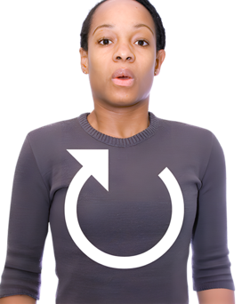
Here are some things that might happen when we feel anxious:
Here are some things that might happen when we feel anxious:

Fast breathing Tummy Hurting Feeling Shaky

Here are some things that might happen when we feel anxious:
Here are some things that might happen when we feel anxious:

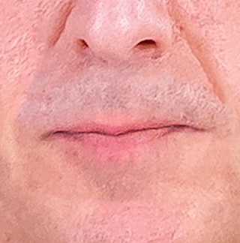
Here are some things that might happen when we feel anxious:

Dry Mouth Feeling Tired Increase/ Decrease Appetite

How anxiety can affect you

Thoughts
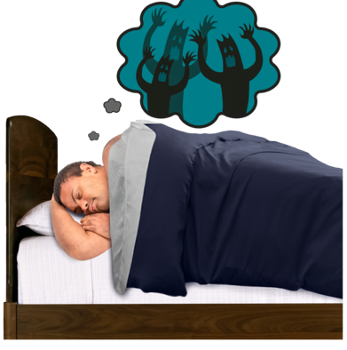
You can worry about what might happen.

You might feel like you have a lot on your mind or find you are overthinking.

It might be hard for you to make decisions as your worried about what might happen.

How anxiety affects what you do
You might check things over and over again to try stop worrying.

You might get angrier quicker.

You might stay away from people or places you used to enjoy.

It might be hard to sleep or focus because you are so worried.

Some people try to manage these feelings by drinking alcohol or taking drugs.

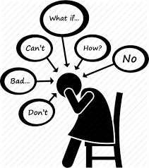

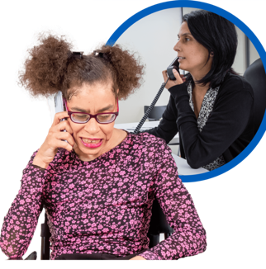
It is important that you talk to a family member, friend or professional like a doctor about how you are feeling.

Especially if you are having thoughts about or are hurting yourself.

Here are some things that you can try when you feel anxious:

our


Talking it through
Talking to family or friends can help when we feel worried. They might have felt the same way before. Sharing our worries can make them feel smaller and easier to handle.


Going for a walk
Getting outside and getting fresh air can help keep us busy.


Exercise
Exercise helps us feel good. It makes us calm by reducing stress


Relaxation
Yoga and deep breathing can help us feel calm. They help us manage anxiety by controlling our breath.

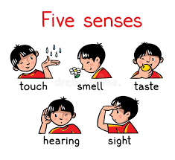
Mindfulness
Mindfulness helps us focus on our senses like seeing, touching, hearing, feeling, and tasting. This keeps us in the present.


Listen to music or try an activity you enjoy
This can help remind us what we like doing. This can also help us feel calmer. Examples can be colouring or a word search.

Relaxation: Let’s try box breathing together

Sit in a position that feels comfy

Start to notice your breathing

- Take a breath in whilst counting to 4 seconds
- Hold your breath for 4 seconds
- Let your breath out your mouth for 4 seconds
- Hold again and repeat

Box breathing video: https://www.youtube.com/watch?v=ruElUiVoQPQ

Mindfulness: Sensory exercise

Lets try a grounding exercise to help us feel calmer.

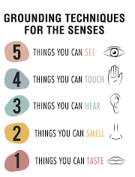

Where you can get help

National Support
Easy Read Guide to Anxiety

https://www.learningdisabilities.org.uk/learning-disabilities/publications/easy-read-guide-anxiety
Here are some things that might happen when we feel anxious:

Here are some things that might happen when we feel anxious:

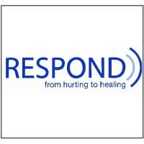
Respond

Telephone: 020 7383 0700

Respond is a national based charity that provide therapy and specialist support for those who have a learning disability and or autism.
http://www.respond.org.uk/

Here are some things that might happen when we feel anxious:

Foundation for People with Learning Disability

“We believe that people with learning disabilities should have the same rights and choices as everyone else in society”.

This website can give you more information and support on anxiety.

https://www.learningdisabilities.org.uk/learning-disabilities/a-to-z/a/anxiety.

Here are some things that might happen when we feel anxious:

Learning disability helpline

This helpline offers advice and information on all aspects of learning disabilities including employment and housing.

http://www.mencap.org.uk/



Here are some things that might happen when we feel anxious:
Choice Support

This is a social care charity who works across most of England providing support to those with a learning disability autism and mental health needs.
http://www.choicesupport.org.uk/


Local Support

Bedfordshire Down’s Syndrome

This is local charity providing support, workshop, coffee mornings and therapy sessions to families with down syndrome children.
https://www.bedsdownssyndrome.co.uk/
Here are some things that might happen when we feel anxious:

Here are some things that might happen when we feel anxious:

Here are some things that might happen when we feel anxious:
Disability Resource Centre Bedford

Providing disability support services including local groups.
https://drcbeds.org.uk/what-we-do/


Here are some things that might happen when we feel anxious:


Bedford Mencap

Providing disability support services including local groups.
https://drcbeds.org.uk/what-we-do/

Mind BLMK

Mind is a mental health charity supporting positive mental health across Bedford, Luton and Milton Keynes.
This is a service for anyone struggling with their mental health so you may need additional support to access this service.

https://www.mind-blmk.org.uk/



Intensive Support Team

IST are a crisis team for adults with a learning disability in Bedfordshire. The team are available Monday-Sunday between the hours of 8am-9pm.
Telephone: 01234 310538.

Outside of these times or if you are in immediate danger, please call the Mental Health Crisis Line on 111 (Option 2). Or 999. The Samaritans also provide support: 116 123.



