Specialist Service for people who have a Learning Disability

All about Autism





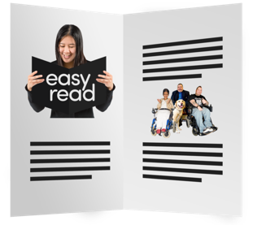
What is Autism?

This is a booklet about Autism.

Autism is sometimes called a spectrum or Autism Spectrum Disorder.

This means autism can look different to everyone.





Autism is not a learning disability.

About half of autistic people may also have a learning disability.

Autism is a difference in how you think and see the world around you.

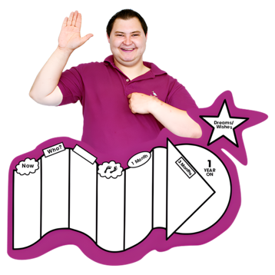

What is like being Autistic

Autistic people are different from others in certain ways:
- The way you talk, listen and understand things
- The activities you like to do and how you like to do them
- They way you think
- How much you like or don’t like things like touch, noise, lights and food
Autism:
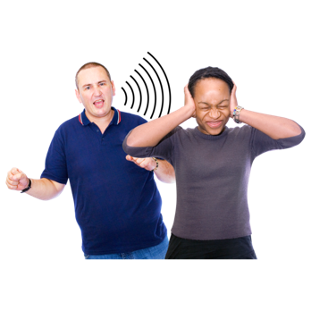

Some autistic people are different in the way they use and understand:
- Speech
- Tone of voice
- Gesture
- Eye contact
- Conversations- you might prefer to talk about what interests you rather than how the weather is.
- Turn taking
- Not interested
- Talk for longer than other people or not know when to let the other person speak

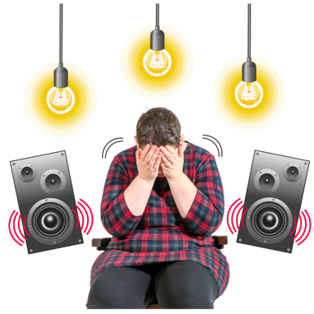

You might like these things or find them too much for your senses:
Here are some things that might happen when we feel anxious:
Here are some things that might happen when we feel anxious:
Here are some things that might happen when we feel anxious:
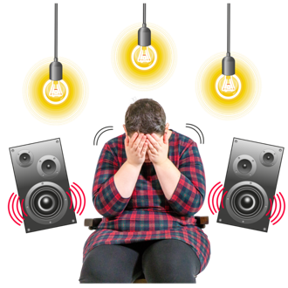
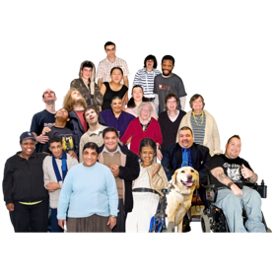


Noise Crowds Lights

Here are some things that might happen when we feel anxious:



Here are some things that might happen when we feel anxious:
Here are some things that might happen when we feel anxious:

Textures Different foods strong smells

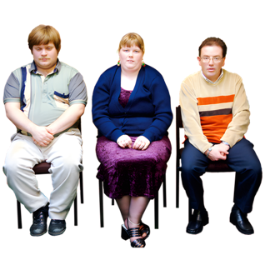
Here are some things that might happen when we feel anxious:

People touching you

Where you can get support

National Support

The National Autistic Society

National Autistic Society provides support and information for autistic individuals.

https://www.autism.org.uk/what-we-do/welsh-peer-support-groups/toolkit/easy-read-guidance

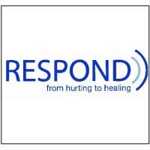
Respond

Telephone: 020 7383 0700

Respond is a national based charity that provide therapy and specialist support for those who have a learning disability and or autism.
http://www.respond.org.uk/

Here are some things that might happen when we feel anxious:

Learning disability helpline

This helpline offers advice and information on all aspects of learning disabilities including employment and housing.

http://www.mencap.org.uk/

Here are some things that might happen when we feel anxious:
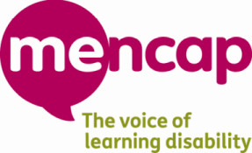

Here are some things that might happen when we feel anxious:
Choice Support

This is a social care charity who works across most of England providing support to those with a learning disability autism and mental health needs.
http://www.choicesupport.org.uk/



Local Support

Autism Bedfordshire

Local support service for Bedfordshire.

https://www.autismbedfordshire.net/support-for-adults/

Here are some things that might happen when we feel anxious:
Bedford Mencap

Providing disability support services including local groups.
https://drcbeds.org.uk/what-we-do/
Here are some things that might happen when we feel anxious:
Disability Resource Centre Bedford

Providing disability support services including local groups.
https://drcbeds.org.uk/what-we-do/
Here are some things that might happen when we feel anxious:





Mind BLMK

Mind is a mental health charity supporting positive mental health across Bedford, Luton and Milton Keynes.
This is a service for anyone struggling with their mental health so you may need additional support to access this service.

https://www.mind-blmk.org.uk/

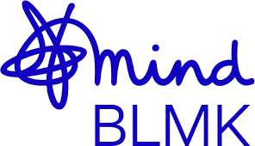

Intensive Support Team

IST are a crisis team for adults with a learning disability in Bedfordshire. The team are available Monday-Sunday between the hours of 8am-9pm.
Telephone: 01234 310538.

Outside of these times or if you are in immediate danger, please call the Mental Health Crisis Line on 111 (Option 2). Or 999.


