Specialist Service for people who have a Learning Disability

All about Depression



What is it and where to get help




What is Depression?

This is a booklet about depression.

Depression is when you feel very sad or down.

Everyone feels sad sometimes.

Lots of different things can make us feel sad.

Sometimes these thoughts and feelings can stay for a while and affect how you live your life.

Sometimes people can get depressed.

ก




Sometimes people can become depressed after they lose someone they love.

Sometimes it is hard to know why you feel down.

It is important to talk to someone when you feel depressed about how you are feeling.



Here are some things that can happen in our body when we feel depressed:
Here are some things that might happen when we feel anxious:
Here are some things that might happen when we feel anxious:
Here are some things that might happen when we feel anxious:




Not enjoying what you used too

Trouble sleeping Crying more often

Here are some things that might happen when we feel anxious:

Here are some things that might happen when we feel anxious:
Here are some things that might happen when we feel anxious:



Eating too much/ little
Feeling Irritable
Feeling Restless

Here are some things that might happen when we feel anxious:


Here are some things that might happen when we feel anxious:

Feel Life is not worth living Feeling Tired

How depression can affect you

Thoughts
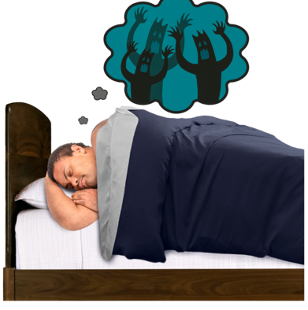
Some people have thoughts of hurting themselves.

You might feel like you have a lot on your mind.

It might be hard for you to make decisions or plans.

How depression affects what you do
You might not want to get out of bed.

You might stop leaving the house.

You might stay away from people or places you used to enjoy.

It might be hard to sleep or focus on activities.

Some people try to manage these feelings by drinking alcohol or taking drugs.

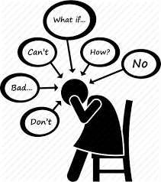

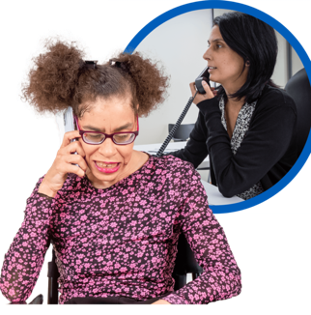
It is important that you talk to a family member, friend or professional like a doctor about how you are feeling.

Especially if you are having thoughts about or are hurting yourself.

Here are some things that you can try when you feel depressed:

our


Talking it through
Talking to family or friends can help when we feel down. They might have felt the same way before.


Going for a walk
Getting outside and getting fresh air can help keep us busy.


Exercise
Exercise helps us feel good. It makes us calm by reducing stress.


Planning activities
You can try planning small activities that you used to enjoy. Plan one activity a day and see how you feel after.


Write your thoughts down
It can be helpful to write how you are feeling down.


Listen to music or try an activity you enjoy
This can help remind us what we like doing. This can also help us feel calmer.

Activity Planning
Below is a planner to help you plan some activities with examples.
This could even be planning to get up and have a shower.
Little activities make a difference when we are feeling low.

Monday | Tuesday | Wednesday | Thursday | Friday | Saturday | Sunday
 |  |  |  | 

Where you can get help

National Support
Here are some things that might happen when we feel anxious:
Easy Read Guide to Depression

https://www.learningdisabilities.org.uk/learning-disabilities/publications/feeling-down-looking-after-my-mental-health

Here are some things that might happen when we feel anxious:
Here are some things that might happen when we feel anxious:

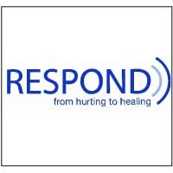
Respond

Telephone: 020 7383 0700

Respond is a national based charity that provide therapy and specialist support for those who have a learning disability and or autism.
http://www.respond.org.uk/

Here are some things that might happen when we feel anxious:

Foundation for People with Learning Disability

“We believe that people with learning disabilities should have the same rights and choices as everyone else in society”.

This website can give you more information and support on anxiety.

https://www.learningdisabilities.org.uk/learning-disabilities/a-to-z/a/anxiety.

Here are some things that might happen when we feel anxious:

Learning disability helpline

This helpline offers advice and information on all aspects of learning disabilities including employment and housing.

http://www.mencap.org.uk/



Choice Support

This is a social care charity who works across most of England providing support to those with a learning disability autism and mental health needs.
http://www.choicesupport.org.uk/



Local Support

Bedfordshire Down’s Syndrome

This is local charity providing support, workshop, coffee mornings and therapy sessions to families with down syndrome children.
https://www.bedsdownssyndrome.co.uk/
Here are some things that might happen when we feel anxious:

Here are some things that might happen when we feel anxious:
Bedford Mencap

Providing disability support services including local groups.
https://drcbeds.org.uk/what-we-do/
Here are some things that might happen when we feel anxious:
Disability Resource Centre Bedford

Providing disability support services including local groups.
https://drcbeds.org.uk/what-we-do/
Here are some things that might happen when we feel anxious:





Mind BLMK

Mind is a mental health charity supporting positive mental health across Bedford, Luton and Milton Keynes.
This is a service for anyone struggling with their mental health so you may need additional support to access this service.

https://www.mind-blmk.org.uk/



Intensive Support Team

IST are a crisis team for adults with a learning disability in Bedfordshire. The team are available Monday-Sunday between the hours of 8am-9pm.
Telephone: 01234 310538.

Outside of these times or if you are in immediate danger, please call the Mental Health Crisis Line on 111 (Option 2). Or 999.


