‘Planning my end of life care’
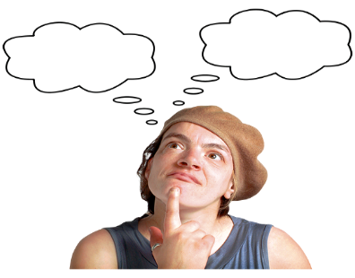 | This pack is about you planning your end of life care.
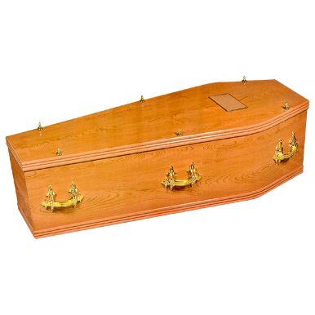 | Nobody likes to think about death and dying.  It’s important for us to think about what we might want to happen when we die.
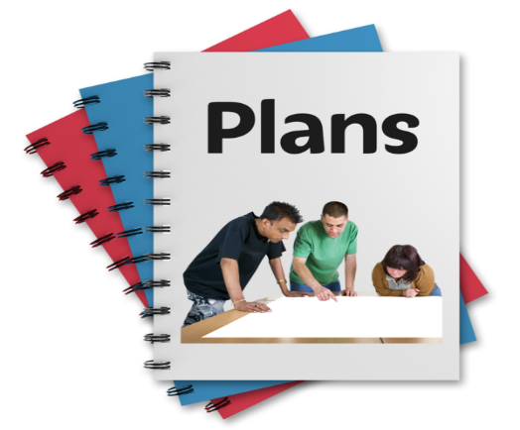 | An Advance Care Plan tells other people:  - The things that you want to happen when do die.  - Where you might want to die.  - How you want to be cared for.
  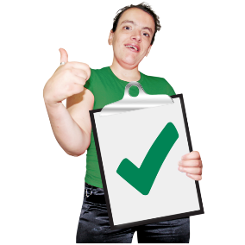 | It is important that you get to choose how you die.  It is important that you get to say how you are cared for when you are dying.
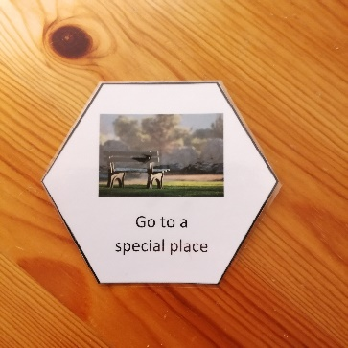 | In this pack there are lots of cards. The show different steps in planning your care at the end of your life.
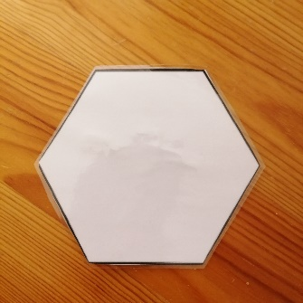 | There are some blank cards so that you can add your own ideas.
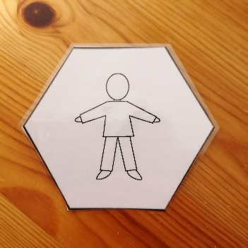 | Start with the ‘person’ card in the middle. This is you!
  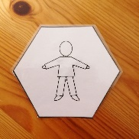 | Look through the cards. Put the things that are important to you near the person card.
 | Put the things that are not so important to you further away from the person card.
 | Talk with the people who support you about your choices.
 | Remember - it is your choice how you want to die.

