
MY HEALTH AND ME

This information will help my carers and family and NHS staff who support me to have a better understanding of my needs.
It is my property and should always be returned to me. If it gets lost, please speak to the Health Equalities Service.
NHS Number:
Hospital Number:

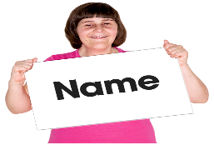
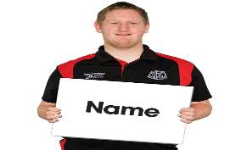
My Name Is
(Include a photo if you want to)

I like to be called:

Mental Capacity Act 2005

I have a learning disability. Please do not assume that I cannot make my own decisions.
If I am assessed as lacking the capacity to consent to my treatment, the following people must be involved in any decisions made in my best interests.

Name | Next of Kin | Contact Details

Important Information about me
c
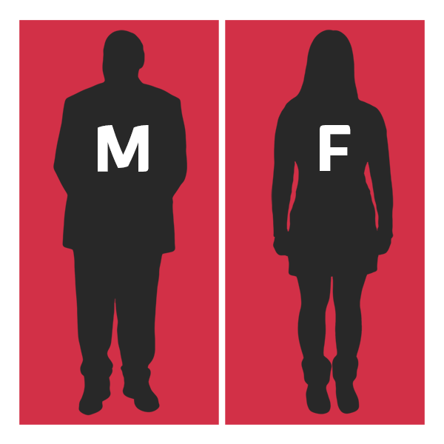 | I want people to refer to me as: Male (he/ his) Female (she/ her) Non binary (there/ them)
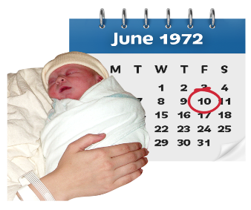 | Date of Birth:
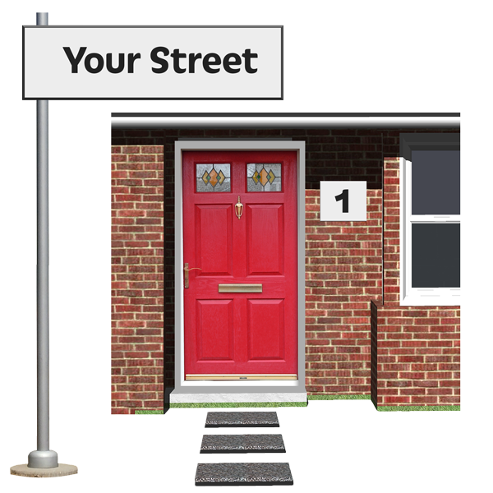 | Address and telephone number:  I live alone/ I live with family/ I live with carers/ In supported living or residential care
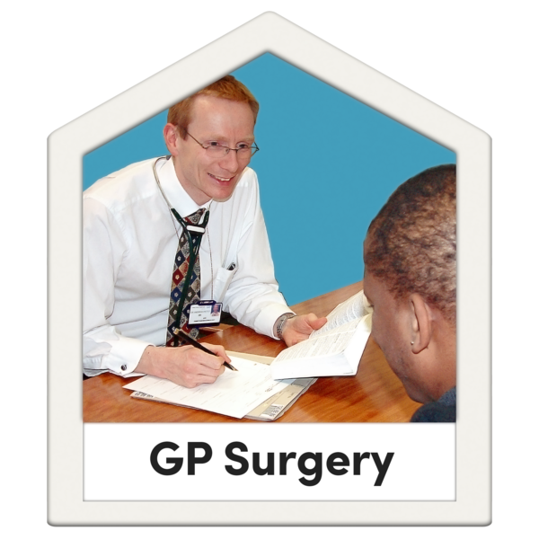 | GP Details:
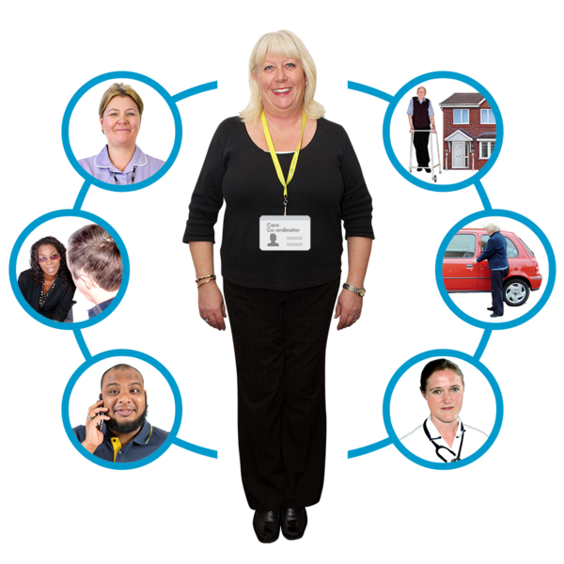 | People involved in my health care:
 | Family/ Next of Kin Contact/ Carer or advocate details.  Does anyone in my family have a Power of Attorney?
   | Religion and Ethnicity/ Cultural Needs:
Things you must know about me

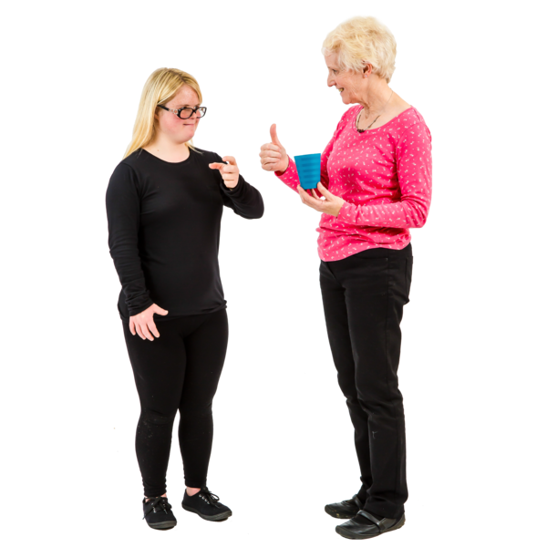 | Communication: how to communicate with me/ how I tell you I am in pain.

My mental health and emotional well-being and how to communicate with me

 | What things I like (what makes me happy)
 | What things I don’t like (what makes me sad)
 | What makes me angry?
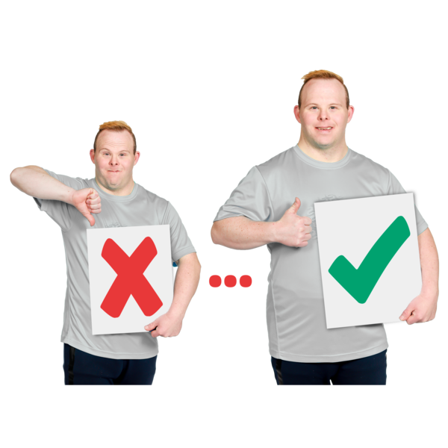 | What can people to do to make me feel better?

Important things you must know about me:

Medical History
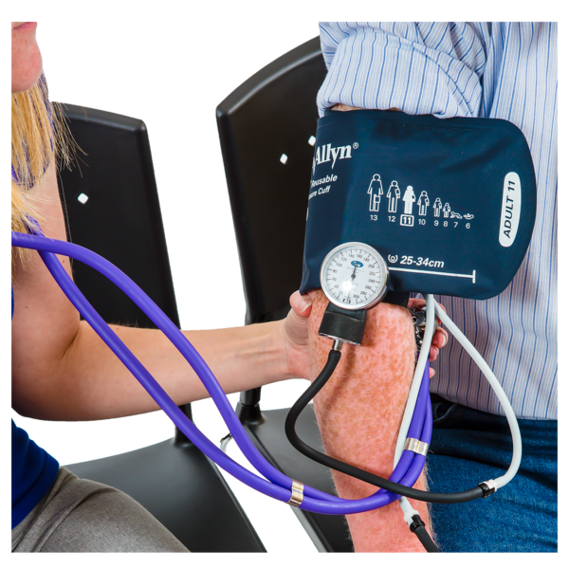 | Diagnosis :( medical conditions) and treatment plans- this can include the things you need help with when you are in hospital.
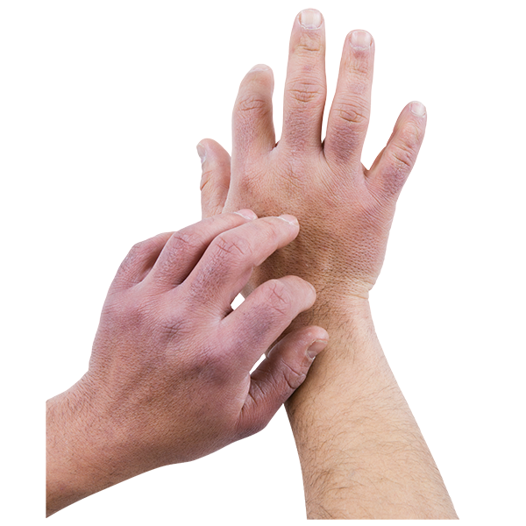 | Allergies:

Important things to know about my medication and how I take them
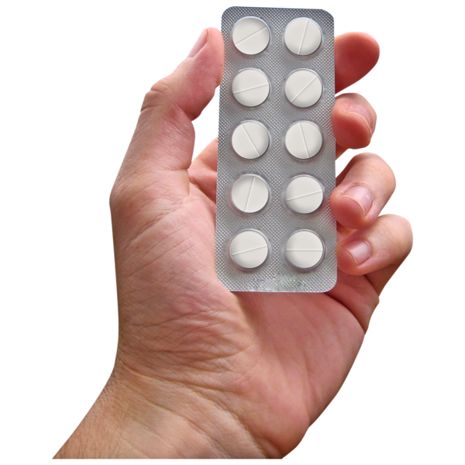

Medication and what it is for | Dose and how often I take it | How I take this | When it should next be reviewed
My care and support needs- what I need you to help me with

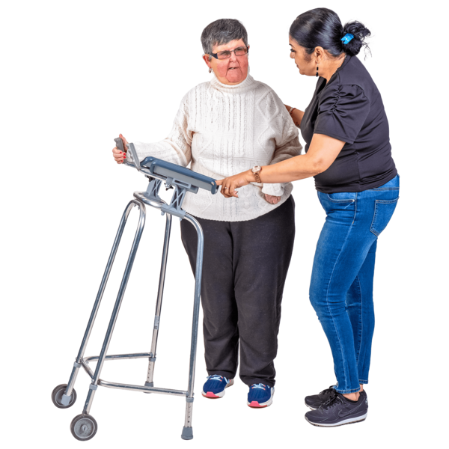 | Moving around/ mobility:
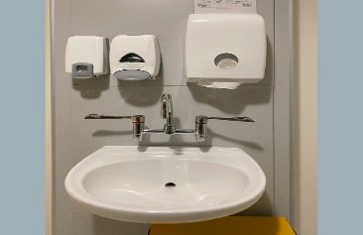 | Support with washing and dressing:
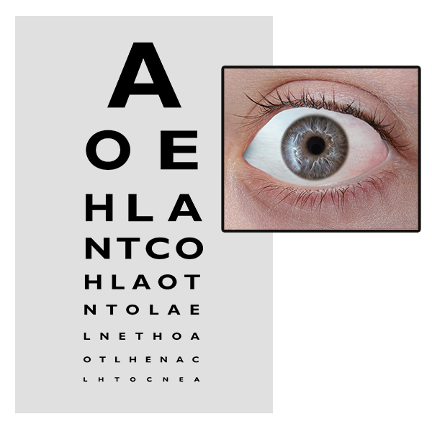 | Seeing/ Hearing:
 | How I eat food (cut up/ soft/pureed):
 | How I drink (thickened fluids)
 | How I stay safe:
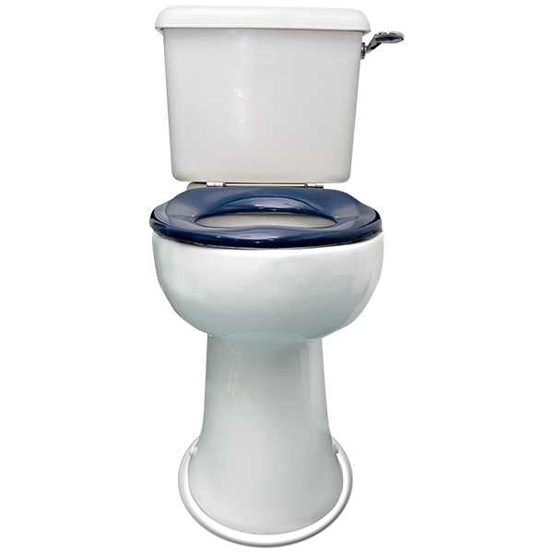 | How I use the toilet:
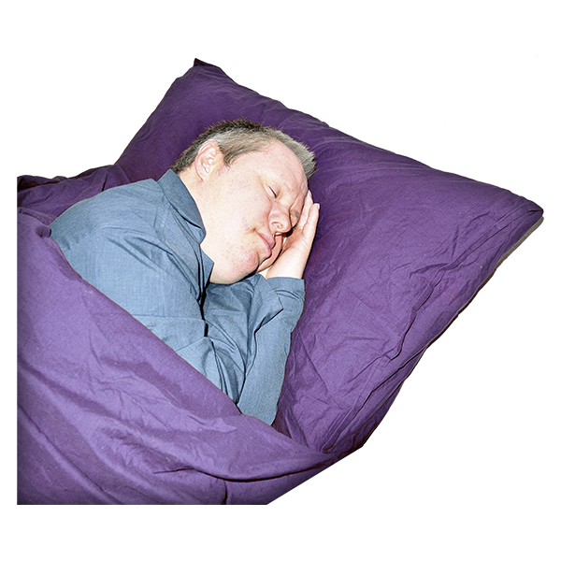 | How I sleep (what help I need)
My Sexual Health Needs- What is important for you to know.
You do not have to complete this section if you feel it is not appropriate

 |     I am in an intimate relationship with someone. (You do not have to tell us who this is)  Yes ☐ No ☐
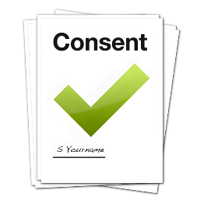 | I can consent to being in a relationship with someone.  Yes ☐ No ☐
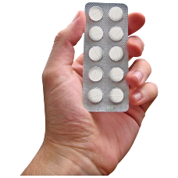 | I use contraception which may interfere with my medication.  The name of the contraception I use is:
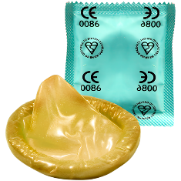 | I need condoms to keep myself safe from infections.
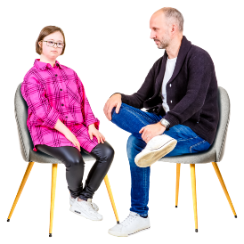 | Other things that are important for you to know about my sexual health:

Reasonable adjustments- things I need you to do to help me have a better experience

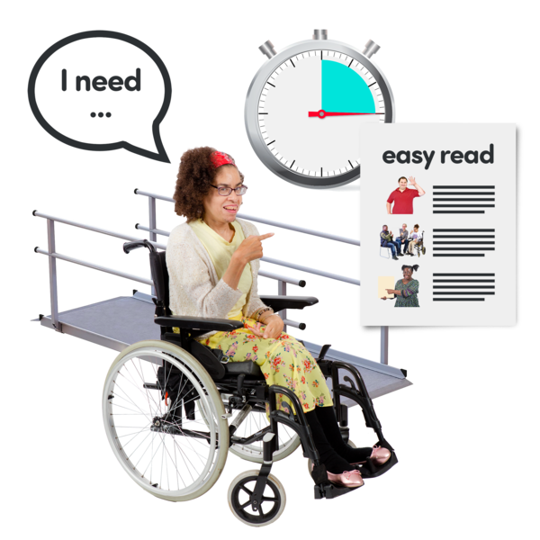

When I am in hospital I need you to help me by doing these things?



Diary of Health Appointments

Date/ Time | Reason for attending | Outcome | Action?/ Action outcome
Date/ Time | Reason for attending | Outcome | Action?/ Action outcome

Document completed on:

