Specialist Service for people who have a Learning Disability

All about Obsessive Compulsive Disorder



What is it and where to get help



What is Obsessive Compulsive
Disorder?

This is a booklet about OCD.

OCD is a mental illness that can make you feel really distressed.

OCD can make you feel worried about things.

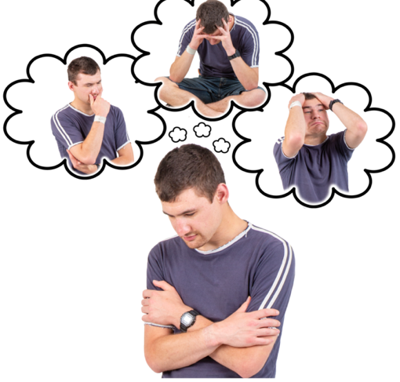

You might have thoughts that go round and round in your head. These might be thoughts you do not want to have,

This is called an obsession.

You might also do things over and over again such as turning on light switches. You might do these things to make you feel better at the time.

This is called a compulsion.



Here are some things that can happen in our body with OCD:
Here are some things that might happen when we feel anxious:
Here are some things that might happen when we feel anxious:
Here are some things that might happen when we feel anxious:




Being really aware of your body and sensations
Trouble sleeping Heartbeat fast

Here are some things that might happen when we feel anxious:
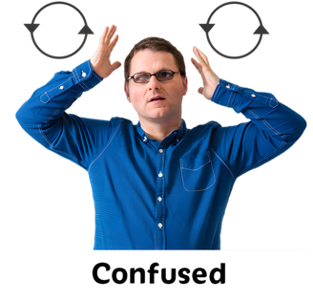

Here are some things that might happen when we feel anxious:
Here are some things that might happen when we feel anxious:


Fast breathing
Feeling confused
Feel frustrated quickly


Here are some things that might happen when we feel anxious:

Feeling tired

How OCD can affect you

Thoughts
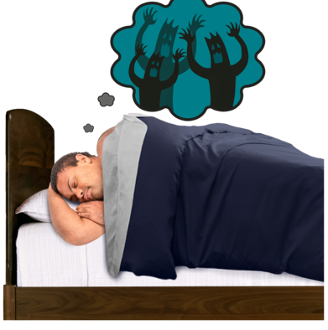
You might worry about different things.

You might worry that something you have done will hurt people.

You might worry about germs.

You might worry about doing something you do not want to do.

How OCD affects what you do
You might do different things over and over again.

You might check things lots of times, like a tap or light switch.

You might want to have everything tidy or keep things in order.

You might have lots of baths or wash your hands.

This can led to a cycle where you always feel worried and find it hard to stop compulsions.




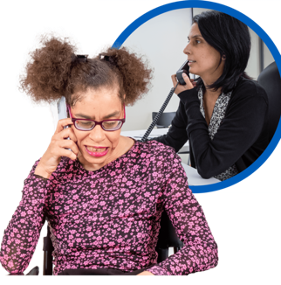
It is important that you talk to a family member, friend or professional like a doctor about how you are feeling.

Especially if you are having thoughts about or are hurting yourself.

Here are some things that you can try with OCD:

our


Talking it through
Talking to family or friends can help when we feel distressed.


Distracting yourself
Some people find distractions helpful such as watching TV, listening to music. painting, walking outside or going to sleep.

Look after yourself
Try make sure you are getting enough sleep, eating often and doing some exercise.


Making very small changes
Making very small changes helps move towards things that really scare you.

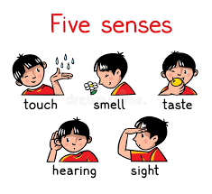
Mindfulness
Mindfulness helps us focus on our senses like seeing, touching, hearing, feeling, and tasting. This keeps us in the present


Listen to music or try an activity you enjoy
This can help remind us what we like doing. This can also help us feel calmer.

Where you can get help

National Support
Here are some things that might happen when we feel anxious:
Easy Read looking after my mental health guide

https://www.learningdisabilities.org.uk/learning-disabilities/publications/feeling-down-looking-after-my-mental-health
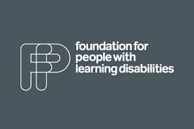
Here are some things that might happen when we feel anxious:
Here are some things that might happen when we feel anxious:

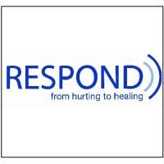
Respond

Telephone: 020 7383 0700

Respond is a national based charity that provide therapy and specialist support for those who have a learning disability and or autism.
http://www.respond.org.uk/

Here are some things that might happen when we feel anxious:

OCD UK

National support group for people with OCD

Advice line: 03332 127 890
Email: support@ocduk.org
www.ocduk.org



Learning disability helpline

This helpline offers advice and information on all aspects of learning disabilities including employment and housing.

http://www.mencap.org.uk/



Choice Support

This is a social care charity who works across most of England providing support to those with a learning disability autism and mental health needs.
http://www.choicesupport.org.uk/



Local Support
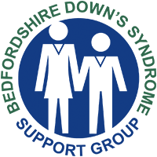
Bedfordshire Down’s Syndrome

This is local charity providing support, workshop, coffee mornings and therapy sessions to families with down syndrome children.
https://www.bedsdownssyndrome.co.uk/
Here are some things that might happen when we feel anxious:

Here are some things that might happen when we feel anxious:
Bedford Mencap

Providing disability support services including local groups.
https://drcbeds.org.uk/what-we-do/
Here are some things that might happen when we feel anxious:
Disability Resource Centre Bedford

Providing disability support services including local groups.
https://drcbeds.org.uk/what-we-do/
Here are some things that might happen when we feel anxious:





Mind BLMK

Mind is a mental health charity supporting positive mental health across Bedford, Luton and Milton Keynes.
This is a service for anyone struggling with their mental health so you may need additional support to access this service.

https://www.mind-blmk.org.uk/



Intensive Support Team

IST are a crisis team for adults with a learning disability in Bedfordshire. The team are available Monday-Sunday between the hours of 8am-9pm.
Telephone: 01234 310538.

Outside of these times or if you are in immediate danger, please call the Mental Health Crisis Line on 111 (Option 2). Or 999.


