Specialist Service for people who have a Learning Disability

All about Psychosis



What is it and where to get help




What is Psychosis?

This is a booklet about psychosis.

Psychosis is a mental illness where someone might not seem like themselves.

People with psychosis can feel really confused.

People with psychosis can feel really unsafe, worried and scared.




In Psychosis people can hear people talking when there is no one there.

They might see things that are not there.

They might worry that people are trying to harm them or check things more often.

They might behave differently to how they might usually.

They might find it hard to think clearly.

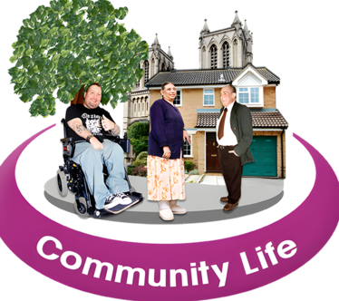

Here are some things that can happen in our body with Psychosis:
Here are some things that might happen when we feel anxious:
Here are some things that might happen when we feel anxious:
Here are some things that might happen when we feel anxious:




Trouble sleeping Heartbeat fast Speak fast and jumbled

Here are some things that might happen when we feel anxious:


Here are some things that might happen when we feel anxious:
Here are some things that might happen when we feel anxious:


Fast breathing Feel frustrated quickly Feeling confused


Here are some things that might happen when we feel anxious:

Feeling tired

How Psychosis can affect you

Thoughts
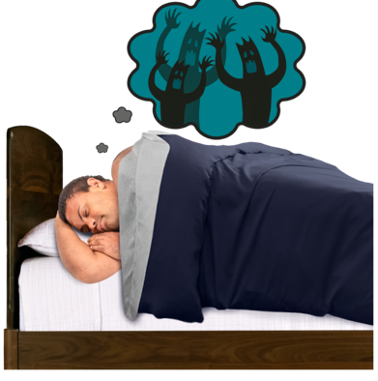
You can worry about what might happen.

You might feel like you are unable to trust others or worry they might hurt you.

You might hear voices or people that are not there.

How psychosis affects what you do
You might see things that are not there.

You might feel like others do not understand you.

You might stay away from people or places you used to enjoy.

It might be hard to sleep or focus because you are so worried.

Some people try to manage these feelings by drinking alcohol or taking drugs.

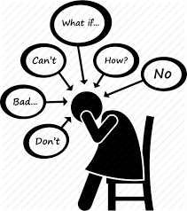

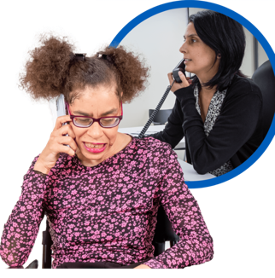
It is important that you talk to a family member, friend or professional like a doctor about how you are feeling.

Especially if you are having thoughts about or are hurting yourself.

Here are some things that you can try when you have psychosis:

our


Talking it through
Talking to family or friends can help when we feel distressed.


Distracting yourself
Some people find distractions helpful such as watching TV, listening to music. Painting or walking outside.

Look after yourself
Try make sure you are getting enough sleep, eating often and doing some exercise.


Peer Support
Peer support can help us to talk to other people who have had similar experiences.

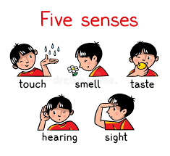
Mindfulness
Mindfulness helps us focus on our senses like seeing, touching, hearing, feeling, and tasting. This keeps us in the present.


Listen to music or try an activity you enjoy
This can help remind us what we like doing. This can also help us feel calmer.

Where you can get help

National Support
Here are some things that might happen when we feel anxious:
Easy Read looking after my mental health guide

https://www.learningdisabilities.org.uk/learning-disabilities/publications/feeling-down-looking-after-my-mental-health

Here are some things that might happen when we feel anxious:
Here are some things that might happen when we feel anxious:

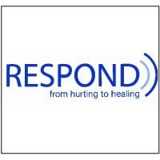
Respond

Telephone: 020 7383 0700

Respond is a national based charity that provide therapy and specialist support for those who have a learning disability and or autism.
http://www.respond.org.uk/

Here are some things that might happen when we feel anxious:

Foundation for People with Learning Disability

“We believe that people with learning disabilities should have the same rights and choices as everyone else in society”.

This website can give you more information and support on anxiety.

https://www.learningdisabilities.org.uk/learning-disabilities/a-to-z/a/anxiety.

Here are some things that might happen when we feel anxious:

Learning disability helpline

This helpline offers advice and information on all aspects of learning disabilities including employment and housing.

http://www.mencap.org.uk/



Choice Support

This is a social care charity who works across most of England providing support to those with a learning disability autism and mental health needs.
http://www.choicesupport.org.uk/



Local Support

Bedfordshire Down’s Syndrome

This is local charity providing support, workshop, coffee mornings and therapy sessions to families with down syndrome children.
https://www.bedsdownssyndrome.co.uk/
Here are some things that might happen when we feel anxious:

Here are some things that might happen when we feel anxious:
Bedford Mencap

Providing disability support services including local groups.
https://drcbeds.org.uk/what-we-do/
Here are some things that might happen when we feel anxious:
Disability Resource Centre Bedford

Providing disability support services including local groups.
https://drcbeds.org.uk/what-we-do/
Here are some things that might happen when we feel anxious:





Mind BLMK

Mind is a mental health charity supporting positive mental health across Bedford, Luton and Milton Keynes.
This is a service for anyone struggling with their mental health so you may need additional support to access this service.

https://www.mind-blmk.org.uk/



Intensive Support Team

IST are a crisis team for adults with a learning disability in Bedfordshire. The team are available Monday-Sunday between the hours of 8am-9pm.
Telephone: 01234 310538.

Outside of these times or if you are in immediate danger, please call the Mental Health Crisis Line on 111 (Option 2). Or 999.


