Specialist Service for people who have a Learning Disability

All about Trauma



What is it and where to get help




What is Trauma?

This is a booklet about Trauma.

Trauma is what happens to your mind and body after an event that is scary.

Lots of different things can cause trauma.

Sometimes something scary can happen once or lots of times.

ก


You might only start to feel down or stressed a long time after something scary happens.

It might take you a long time to feel better.



Here are some things that can happen in our body when we experience trauma:
Here are some things that might happen when we feel anxious:
Here are some things that might happen when we feel anxious:
Here are some things that might happen when we feel anxious:




Trouble sleeping Crying more often Not enjoy what you used too
(bad dreams)
Here are some things that might happen when we feel anxious:


Here are some things that might happen when we feel anxious:
Here are some things that might happen when we feel anxious:


Feeling stressed
Having headaches
Feeling irritable

Here are some things that might happen when we feel anxious:


Here are some things that might happen when we feel anxious:

Pain in your body. Feeling tired

How Trauma can affect you

Thoughts
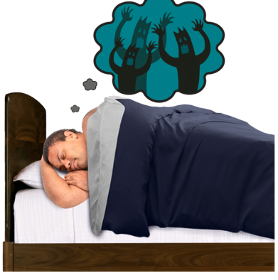
Some people think about the scary event that happened a lot of the time.

You might feel like you have a lot on your mind.

Your thoughts might feel so real that it feels like the scary event is happening again.

It might be hard for you to make decisions or plans.

How trauma affects what you do
You might not want to get out of bed.

You might stop leaving the house.

You might stay away from people or places you used to enjoy.

It might be hard to sleep or focus on activities.

You might have nightmares.

You might try to do anything to not think of the scary event that happened.

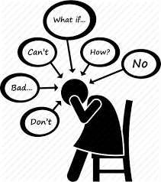

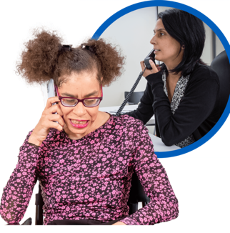
It is important that you talk to a family member, friend or professional like a doctor about how you are feeling.

Especially if you are having thoughts about or are hurting yourself.

Here are some things that you can try when you experience trauma:

our

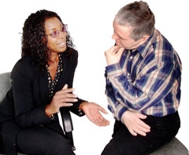
Talking it through
Talking to family or friends can help when we feel down. They might have felt the same way before.


Going for a walk
Getting outside and getting fresh air can help keep us busy.


Exercise
Exercise helps us feel good. It makes us calm by reducing stress.


Planning activities
You can try planning small activities that you used to enjoy. Plan one activity a day and see how you feel after.


Write your thoughts down
It can be helpful to write how you are feeling down.


Spend time somewhere you feel safe
You can spend time somewhere you feel safe or use a grounding technique.

Grounding Exercise
Below is some grounding techniques we can try together.

Grounding techniques help us to come back in the present moment, when we might be having lots of scary thoughts.

5 – 4 – 3 – 2 - 1
Ground Technique

5 Things you can see
4 Things you can touch

3
Things you can hear
2
Things you can smell
1
Things you can taste



Where you can get help
Easy Read Guide to Trauma

https://www.bild.org.uk/wp-content/uploads/2020/01/What-is-Trauma-and-top-ten-tips-for-LD-senate-Easy-Read-1.3.2021.pdf

Supporting those with a learning disability who have experienced trauma:
https://www.bild.org.uk/wp-content/uploads/2020/03/Top-10-tips-re-trauma-informed-care.pdf
National Support


Here are some things that might happen when we feel anxious:
Here are some things that might happen when we feel anxious:

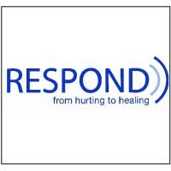
Respond

Telephone: 020 7383 0700

Respond is a national based charity that provide therapy and specialist support for those who have a learning disability and or autism.
http://www.respond.org.uk/

Here are some things that might happen when we feel anxious:

Foundation for People with Learning Disability

“We believe that people with learning disabilities should have the same rights and choices as everyone else in society”.

This website can give you more information and support on anxiety.

https://www.learningdisabilities.org.uk/learning-disabilities/a-to-z/a/anxiety.

Here are some things that might happen when we feel anxious:



Learning disability helpline

This helpline offers advice and information on all aspects of learning disabilities including employment and housing.

http://www.mencap.org.uk/



Choice Support

This is a social care charity who works across most of England providing support to those with a learning disability autism and mental health needs.
http://www.choicesupport.org.uk/



Local Support

Bedfordshire Down’s Syndrome

This is local charity providing support, workshop, coffee mornings and therapy sessions to families with down syndrome children.
https://www.bedsdownssyndrome.co.uk/
Here are some things that might happen when we feel anxious:

Here are some things that might happen when we feel anxious:
Bedford Mencap

Providing disability support services including local groups.
https://drcbeds.org.uk/what-we-do/
Here are some things that might happen when we feel anxious:
Disability Resource Centre Bedford

Providing disability support services including local groups.
https://drcbeds.org.uk/what-we-do/
Here are some things that might happen when we feel anxious:





Mind BLMK

Mind is a mental health charity supporting positive mental health across Bedford, Luton and Milton Keynes.
This is a service for anyone struggling with their mental health so you may need additional support to access this service.

https://www.mind-blmk.org.uk/



Intensive Support Team

IST are a crisis team for adults with a learning disability in Bedfordshire. The team are available Monday-Sunday between the hours of 8am-9pm.
Telephone: 01234 310538.

Outside of these times or if you are in immediate danger, please call the Mental Health Crisis Line on 111 (Option 2). Or 999.


