

Complaints made easy…concise guide to undertaking and managing complaint investigations



October 2025

An effective complaints management process is a vital part of high-quality health and social care, helping services and individuals learn how to do things better when things do not go according to plan.
For people to speak up about their concerns, they need to be confident the system will act in in response. To build trust, East London NHS Foundation Trust needs to consistently demonstrate that they are taking people’s complaints seriously.
Managing complaints can be time-consuming and resource intensive. However, when handled effectively, complaints offer valuable opportunities for clinical learning, improved patient safety, and enhanced satisfaction for both patients and staff.
This concise guide outlines the optimal approach to conducting complaint investigations in a timely and thorough manner, ensuring the best possible outcomes for service users and Trust staff alike.
The guide should be read in conjunction with the Trust’s Compliments, PALS and Complaints Policy and its Frequently Asked Questions document.

Index
What is good complaint handing……………………………………………3
Trust complaint process……………………………………………………..4
Key words and terms…………..…………………………………………….5
Time limits for responding to complaints..................……………………..5
Getting things right…………………………………………………………...6
Putting things right……………………………………………………………6
Just and fair proactive complaint management for staff………………….7
Effective staff meetings with staff involved in complaints………………...7
Enhancing recollection of episode…………………………………………..8
Focused questioning………………………………………………………….8
Writing staff statements………………………………………………………9
Writing the complaint response letter: the do’s and do nots…………....10
Action plans to prevent repeat of episode leading to complaint………..11
Appendix 1: Terms of reference letter to complainant…………………...12
Appendix 2: Investigating Officer checklist………………………………..13

Document Control
Version Number | 1.0
Date Approved | October 2025
Review Date | October 2027
Document Owner | Complaints and PALS Team, East London NHS Foundation Trust
Author | Head of Complaints and PALS Gov

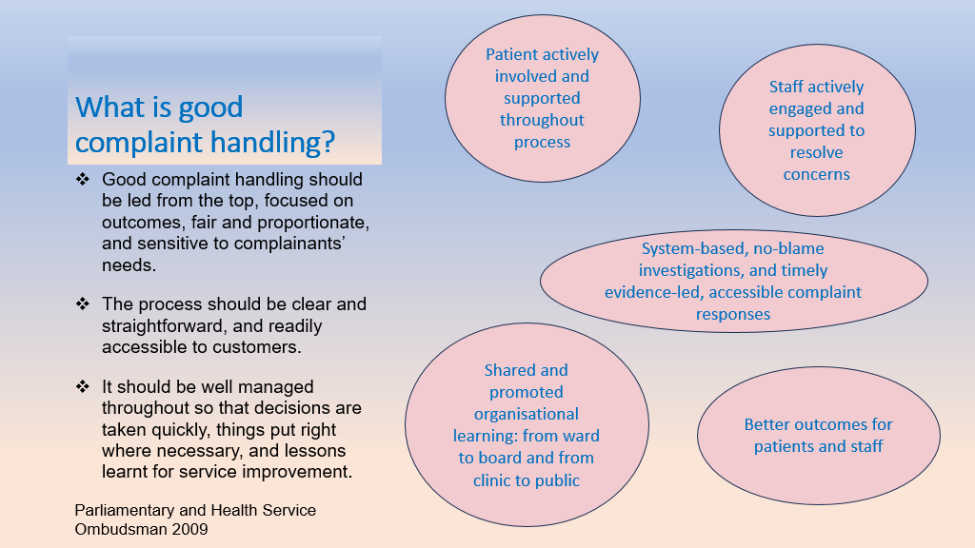
Overview of Trust complaints process
Stage One |  |  | Stage One |  |  | Stage Two |  |  | Learning
Complaint received:  - In remit  - Consent / Capacity  - Logged on inphase  - Acknowledge complaint (Complaints Team) |  |  | Write draft complaint response:  - Review clinical records, refer to applicable guidance and/or expected practice |  |  | Response to Stage One response received from complainant:  - Service complained about ask for Investigating Officer from a different service to review concerns |  |  | With Complaints Team, identify opportunities for learning from complaint, for example:  - Gaps in service  - Staff training  - Local and Trust-wide
Complaint shared with service complained about:  - Investigating Officer allocated  - See Investigating Officer checklist |  |  | - Compare what happened to what should have happened – if there is a difference between the two, explain why and its likely impact |  |  | Follow same process as Stage One:  - Consider if further staff meetings are necessary  - Only consider those issues which relate to original episode of care |  |  | Criteria to be applied for action plan:  - Incident complained about highlighted gaps in service provision which may adversely affect patient experience  - Recurrent issue or theme  - Incident caused physical and/or psychological harm and/or moral injury  - Breach of statutory or mandatory requirement  - Complaint assessed as High or Extreme on risk rating  - Complainant / service –user request change to service provision
Investigating Officer:  - Offer to talk / meet with complainant  - Agree terms of reference  - Identify staff involved  - Arrange to meet with key staff  - Signpost staff to support and allow colleague to attend meeting |  |  | - Avoid apportioning blame to individual staff or groups of staff  - Explore systemic, human and cultural factors which gave rise to incident  - Not the ‘who’, but the ‘when’ and ‘why’ |  |  | Use Stage Two response template and share draft response with:  - Staff met with  - Complaints Team for quality assurance
Meeting with staff:  - Practice Just Culture principles  - Free recollection of incident  - Open then more directed questions  - Record meeting / take notes and share afterwards |  |  | Share draft response with and invite comment:  - Staff met with  - Relevant leads / managers and local senior management  - Complaints Team for quality assurance  - Send response to complainant |  |  | - Stage Two response signed-off by Chief Executive  - Complainant signposted to Parliamentary and Health Service Ombudsman if concerns remain unresolved  - Send response to complainant |  |  | Action plan should include:  - Specific actions taken or planned to remedy shortcomings  - Timescales for completion  - Name of person(s) responsible for each action  - When actions will begin and be completed  - Involvement of complainant

Key words and terms

Stage one complaints | Formal complaint reviewed by the service complained about.
Investigating officer | Staff member asked to investigate the complaint.
Terms of reference | Those areas of concerns to be investigated.
Just Culture | No blame investigations which look at systemic, cultural and human factors which may have contributed to the incident complained about.
Stage two complaints | Complainant is unhappy with the Stage one response; complaint needs to be allocated to an Investigating officer from outside the service originally complained about.

Time limit for responding to complaints

The NHS Complaint Regulations say that a complaint must be responded to within six months. The Trust aims to respond to those that are considered straightforward in 25 working days. In circumstances where concerns are complex, involve other agencies and/or where those involved with the episode of complaint are unavailable, the investigation will take longer, up to 45 days or 60 days.
Where extensions are required to the time limit, or if the complaint needs to be put on hold, the complainant should be consulted and their agreement sought. Delays to a complaint should be the exception and there must be valid reasons. For example, obtaining information from multiple sources.

Getting things right
What are our objectives?
- Satisfactory resolution for complainant.
- Speedy and comprehensive complaint investigation with all issues addressed in an impartial manner.
- Learn about and improve services.
- Steps taken to prevent recurrence.
What does the complainant want to achieve?
- Acknowledgment that there was an issue.
- Apology for shortcoming in service.
- Explanation of why things went wrong.
- Assurance that issue will not be repeated.
Putting things right

Who should investigate?
- Seniority proportionate to complaint – for example, a complaint about a consultant may be reviewed by another consultant.
- Staff not involved in care.
- Staff with capacity and no immediate annual leave.
- Consider independent expert opinion early in investigation.
Understanding the complaint.
- Use Investigating Officer checklist (please see appendix 1).
- Access relevant health records.
- Establish and agree terms of reference.
- Prepare chronology of events relating to complaint.
- Identify and advise staff involved in care complained about.
- Refer to relevant guidelines and/or expected practice.
Collect information relevant to the complaint.
- Speak to and meet with complainant (in person or via teams) – and agree when and how to update them of complaint investigation progress.
- Obtain staff statements if considered necessary.
- Meet with key staff.
- Keep audit trail of investigation.

Just and fair proactive complaint management for staff
- No blame, system-based investigations – why, when and how, not who, who with and what.
- Confidence and safety to speak-up.
- Support readily available and offered to staff.
- Updated on complaint progress.
- Draft response shared for comment with those staff met with before draft is sent for quality assurance.
- Good practice feedback to staff.
- Equal balance between staff taking responsibility for actions and being supported to learn and improve from feedback.
Effective meetings with staff involved in complaint

- Has the interviewee had a copy of the complaint and the opportunity to review any relevant records?
- Do you need someone to take notes?
- Meeting should be face to face where possible or recorded on teams.
- Interviewee is likely to be anxious - relaxed and calm approach to build confidence.
- Take charge and direct the interview – explain what will happen.
- Establish a rapport, offer empathy and reassure of no-blame, just culture principles.
- Ask primarily open questions.
- Do not interrupt – keep questions for when staff have finished.
Open with –
- “Can you tell me what happened that day? Tell me everything you can remember?”
- “Say it as you think it, even if it seems trivial” – prevents self-editing.
- If a contradiction arises with what another interviewee or statement has said – deal with difference later in meeting after you have heard a full account.
- Avoid judgemental or confrontational questions.
- Inconsistencies – if interviewee gives inconsistent information do not challenge immediately. Elicit as much information as you can and then ask calmly to explain inconsistency.
Enhancing recollection of episode

- Allow interviewee time to answer one question at a time.
- Display empathy and offer reassurance of no-blame look at the episode.
- Avoid distractions or being side tracked.
- Free recall.
- Encourage staff to think back to the event and to just before that.
- Enquire about detail such as the environment, anything significant about that day, anything else that was going on – will assist in reliving the events. Following your open-ended question – follow up with specific questions.
- Move to questioning in detail the relevant factors – drill down.

Focused questioning

- This is the phase to focus on specific details and clarify inconsistencies.
- Maintain concentration by focusing in one aspect of the event before moving to another.
- Continue to probe closely.
- Invite final questions and comments.
- Explain what will happen next.
- Offer to provide copy of recording, transcript and/or written note of meeting.
- Advise what support is available.
- Thank staff for their time.

Writing statements

- Be as honest and open as possible.
- Chronological order of episode.
- Describe the facts only, making clear which are from memory and which can be supported by the clinical records.
- Be as detailed as possible stating times, dates and locations.
- Respond to the questions and issues raised in the complaint letter.
- Comment on any concerns that specifically relate to your involvement.
- Where relevant refer to Trust policies and guidelines, whether these were adhered to and if they were not adhered to the reasons why.
- Use plain English. Do not use abbreviations and explain medical terms.
- Identify other staff who were involved or may have been witness to any relevant conversations.
- Statements must be signed and dated. Name should be printed next to signature and should include job title.
- Avoid:
- Giving your personal opinions on the conduct of the patient or other staff/departments.
- Making assumptions about what other people were doing or thinking.
- Repeating conversations that you were told about but not involved in
- Being unnecessarily defensive to the issues raised.
Writing the complaint response letter
- Do ask yourself:
- What would good care look like in this case?
- Is there anything more that could have been done?
- Is there a significant difference between what happened and what should have happened? If so, what was the impact?
- Do:
- Make sure you answer all the heads of complaint in a complaint letter
- Use letter templates sent in the process pack.
- Make sure reply is evidence based, referencing applicable guidance, standards and/or expected practice.
- Use plain English and explain technical terms.
- Ensure the tone is empathetic and not defensive.
- Compare what happened to what should have happened, and if there is a difference, explain the likely impact.
- Explicitly say whether you have found shortcomings – if care was in line with guidance / expected practice, say so.
- Make sure it is clinically robust.
- Explain how we will put things right if there were shortcomings in care.
- And remember to:
- Apologise if necessary, but make it genuine.
- Not ‘I am sorry if you feel that the care was poor’.
- But ‘I am sorry for the shortcomings in care provided’.
- Do not:
- Get key facts wrong.
- Keep information from the complainant even if the Trust got it wrong.
- Make promises you cannot keep.
- Approach complaints in a defensive way.
- Presume you know what the complainant or patient has suffered or how they feel.
- Blame staff – look for systemic, cultural and human factors which may have contributed to the episode.
Action plans to prevent repeat of episode leading to complaint

The complaint process does not end with the complaint response. Where shortcomings in care and service are identified, steps may be taken to help ensure they are not repeated. An action plan should be produced – please consult the Compliments, PALS and Complaints guidance for fuller details. In summary:
- A good action plan will –
- Say what went wrong and identify the cause of the problem.
- Explain what action will be taken to help prevent the error being repeated.
- Who will take that action?
- Provide timescales of action.
- Explain how and when Trust will ensure action plan is implemented and acted on.
- When will actions be reviewed/audited.
- Include evidence for actions already taken.
- Will be shared with the complainant.

Appendix 1: Terms of reference letter to complainant
PRIVATE and CONFIDENTIAL |  | Complaints and PALS  East London NHS Foundation Trust  9 Alie St  London E1 8DE  Telephone: 0800 085 8354  Email: elft.complaints@nhs.net  Website: www.elft.nhs.uk  Date: DD Month YYYY
Addressee Name
Address
Postcode
Email

Our case reference:
Your case reference:

Dear XXXXXXXXX,

Your concerns about East London NHS Foundation Trust
Thank you for meeting with me/Further to our recent telephone conversation about your complaint correspondence, I have provided a summary of our discussions below:
- Acknowledge the impact the events had on the complainant.
- Outline any issues already resolved through discussion (for example an apology/explanation)
- Bullet point the agreed specific issues to be investigated
- Confirm what outcome is expected
- What the Trust can do to address the issue/s
- Confirm what the Trust cannot do where appropriate
- Confirm the agreed timescale
- Ask whether complainant requires support – for example, advocacy, translation

If you agree with the summary or wish to discuss further, please contact me at XXXXXXXXX to confirm the scope of this investigation. Alternatively, you may write to me if you prefer at the address above.
If I do not hear back from you by DDMMYYYY, I will assume you are satisfied with the above and will proceed with the investigation. Your feedback is important to us, and I appreciate your attention to this matter.

Yours sincerely/faithfully

[Name]
[Job title]

Copied:

Appendix 2: Investigating Officer Checklist
Investigating Officer’s Check List

Please find below some questions you may find helpful in assisting you through the complaints process to ensure that all required points have been actioned. If you do have any concerns or worries, please contact the Complaints and PALS Team who will be happy to offer advice, guidance and support during your investigation.
YES/NO
Tick when completed
1 | Have you read and fully understood the complaint?  - What are you investigating  - Do you know the outcome which the complainant is looking for  - Have you planed your investigation
2 | If the complaint is being made on behalf of the service user, has the necessary consent been obtained?
3 | Have you contacted the complainant to introduce yourself, provided your contact details and discussed concerns / clarification?  - Set out the issues the complainant wants to be investigated  - Agree which is the complainant’s preferred communication
4 | Do you understand what outcome/resolution the complainant is seeking – what outcome does the complainant want to happen, for example: apology / staff training / appointment  - Set out outcomes requested by the person making the complaint  - Have you explained to the complainant whether their resolution(s) are achievable or unachievable  It is important to manage the complainants’ expectations and not to overpromise
5 | Have you agreed a timeframe with the complainant – each complaint should be resolved and replied to within 25 working days. On occasions this will not be possible, and you may have to ensure you set a realistic timeframe for completion  - If there is a delay during the investigation which means you need to revise your timeframe, inform the complainant, explain why and then agree a new response date  - Have you advised the Complaints Team of the delay and provided the new response date?  Be aware of your annual leave, clinical workload and the 10-day quality review
6 | Have you written to the complainant using the complaints template outlining the complaint investigation Terms of Reference (TOR)?  - Have you talked with / e-mailed the complainant to outline the complaints investigation Terms of Reference?  - Have you completed the Terms of Reference document and shared this with the Complaints Team  Please send a copy to the Complaints and PALS Team
7 | Keep on track of the complaint  - Plan your investigation with a timeframe.  - Monitor the smooth running of the investigation  - Provide regular updates and keep the Complaints Team updated, and provide reasons for any delays
8 | Identify and gather evidence – a good investigation starts with a thorough review of the circumstances complained about  - Have you contacted staff as applicable for statements or request they attend a meeting?  - Have you interviewed all witnesses and reviewed all relevant documentation, for example policies, procedures and patient records  - Have you offered the interviewees the opportunity to amend the meetings notes in terms of the accuracy of the information given.  - Have you followed this up in writing using the provided template letter?  - Have you gathered all the information/statements for your investigation?
9 | Have you completed the Complaint response letter – checking for errors and ensured that it is factually correct?  - Have you reviewed your investigation documentation?  - Did the investigation identify any recommendations/lessons learned?
10 | Have you completed the supplied Action Plan template? Are the Actions SMART with a date in the format DD/MM/YYYY  - Have you discussed the Action Plan with the responsible manager?
11 | Have you drafted the first response letter? Please note that the letter provides guidance for completion.  - Has the letter been checked to ensure that jargon is limited, and clinical terms and acronyms been explained in layperson terms?  - Does the letter answer all the questions raised by the complainant?  - Does the letter compare what happened with what should have happened and, if there is a gap between the two, explain why and its likely impact?  - Does the letter apply Just Culture Principles and avoid blaming individual or groups of staff, focusing instead on systemic and cultural factors which may have given rise to any incident / shortcomings in care?  - Has the letter been sent to the Complaints Team for review?
12 | Have you provided all the above information to the Complaints Team?  - Your complaint response and Action Plan  - Keep a record of the complaint and all relevant evidence – ask the Complaints Team to upload to Inphase  This will provide a full audit trial and will be needed if the complaint is referred to the Parliamentary and Health Service Ombudsman.

