

Antipsychotics and Mood Stabilisers
Physical Health Monitoring
Guidance

Version number: | 1.1
Consultation Groups | Medicines Committee  Physical Health Group  Primary Care
Approved by (Sponsor Group) | Medicines Committee
Date approved | 12 November 2025
Ratified by: | Medicines Committee
Date ratified: | 12 November 2025
Name of originator/author: | Lead Pharmacist Vaccinations and Antimicrobials
Executive Director lead: | Chief Medical Officer
Implementation Date: | November 2025
Next Review date: | November 2028

Services | Applicable
Trust wide | X
Mental Health and LD
Community Health Services | X

Version Control Summary

Version | Date | Author | Status | Comment
1.0 | October 2025 | Roberta Contino – Lead Pharmacist Vaccinations, Antimicrobials and Physical Health | Final | Replacing ‘Standards for physical health monitoring of patients on antipsychotic treatment’. All guidance now on this new policy
1.1 | November 2025 | Roberta Contino – Lead Pharmacist Vaccinations, Antimicrobials and Physical Health | Final | Clozapine monitoring: Troponin and CRP levels added (page 11)  Lithium monitoring:  Calcium level added (page 14)

Contents
Paragraph | Page
- PURPOSE | 4
- INTRODUCTION | 4
- STAFF RESPONSIBILITIES | 5
- ANTIPSYCHOTICS AND MOOD STABILISERS INITIATION | 5
- ANTIPSYCHOTICS AND MOOD STABILISERS CONTINUATION: MONITORING REQUIREMENTS | 6
- Amisulpride  - Aripiprazole  - Carbamazepine  - Cariprazine  - Clozapine  - Haloperidol  - Lamotrigine  - Lithium  - Lurasidone  - Olanzapine  - Quetiapine  - Risperidone/Paliperidone  - Typical Antipsychotics  - Valproate | 7  8  9  10  11  12  13  14  15  16  17  18  19  20
- GLUCOSE AND DIABETES MONITORING | 21
- CHOLESTEROL AND LIPID MONITORING | 22
- WEIGHT GAIN AND WEIGHT MONITORING | 22
- MANAGEMENT OF ABNORMAL RESULTS  - QTc Prolongation  - Hyperprolactinaemia  - ExtraPyramidal Side Effects (EPSE)  - Neuroleptic Malignant Syndrome (NMS)  - High Dose Antipsychotic Therapy (HDAT) | 23  24  25  25  25  26
- Contact Details and Further Information | 27
- References | 28
Appendix 1 Choice of medication in specific medical conditions  Appendix 2 Interactions with antipsychotic medication  Appendix 3 Risk factors for QTc Prolongation | 29  32  34

- PURPOSE

This guidance sets out the standards for the physical health monitoring of antipsychotic and mood stabilisers medication in East London NHS FT Trust adult, older adult, rehabilitation and learning disability services.
Each service area will identify how their service will implement the minimum standards described in this guidance and address any additional needs of service users cared for within that area.

This policy should be read in conjunction with the following policies of ELFT NHS Foundation Trust:

- Clozapine Policy
- Guidelines for the identification, monitoring and management of psychotropic induced hyperprolactinaemia
- High Dose Antipsychotic Medication
- Medicines Policy
- Physical Healthcare Policy
- Prescribing Policy for Long-Acting Depot
- Protocol for Safe Use of Lithium
- Rapid Tranquilisation Policy
- Valproate Policy

- INTRODUCTION

Antipsychotics and Mood Stabilisers have known adverse drug effects that can affect the physical health of patients, including weight gain, hyperlipidaemia, hyperglycaemia and diabetes. Monitoring of patients for these effects following initiation of treatment can help improve physical health outcomes.

All patients on Antipsychotics and Mood Stabilisers should have a Physical Health Check at least annually. Mental Health services have a duty of care to ensure physical health checks are completed.

For patients initiated on certain medications (including atypical antipsychotics, mood stabilisers, drugs for dementia and stimulants), MH services are responsible for monitoring physical health and medication side-effects for the first 12 months, or until the patient’s condition has stabilised, whichever is longer. Responsibility may then transfer to primary care under shared care arrangements.

There is a range of different guidance around which checks are required for which patients, including from NHS England, NICE and local policy from ELFT. This document seeks to enable clinicians to understand as simply as possible the requirements for patients in their particular settings but is not exhaustive.

- STAFF RESPONSIBILITIES

Clinicians
Clinicians are responsible for initiating and overseeing physical health monitoring for all patients prescribed antipsychotics and mood stabilisers. They must ensure appropriate baseline assessments are completed, monitoring schedules are followed in line with ELFT and NICE guidance, and results are reviewed to inform ongoing treatment decisions.

Ward Manager
It is the responsibility of the ward or team manager to ensure that recommended monitoring equipment is available, regularly checked and maintained. The manager must also ensure that staff are trained and competent in conducting required physical health checks and that monitoring processes are embedded in ward practice.

Nurses
Nursing staff are responsible for carrying out scheduled physical health observations, documenting results accurately, and escalating any abnormal findings to the responsible clinician. They should promote patient engagement in physical health monitoring and ensure timely follow-up of outstanding tests.

Pharmacists
Pharmacists are responsible for reviewing prescribed antipsychotics and mood stabilisers to ensure appropriate monitoring is in place. They should provide advice on potential side effects, check for drug interactions and liaise with clinicians and nursing staff regarding any concerns or missed monitoring parameters.

- ANTIPSYCHOTICS AND MOOD STABILISERS INITIATION

Antipsychotic and Mood Stabiliser medications should NOT be initiated in Primary Care. All formulations of antipsychotic medication should only be initiated by a specialist Secondary Care Mental Health service in ELFT.

Initial physical measurements, observations and examination must be conducted within 24 hours of admission by admitting doctor and nurse. Baseline investigations including blood tests must be conducted within 72 hours of admission to the ward. In the case of patients refusing baseline tests, this must be clearly documented and repeat attempts undertaken throughout the admission with the expectation that all checks have been undertaken by the time they are discharged.

- ANTIPSYCHOTICS AND MOOD STABILISERS CONTINUATION: MONITORING REQUIREMENTS

Below is a recommended list of tests which should be carried out for antipsychotic and mood stabiliser medications. These are the minimum standards of physical health monitoring for those who are on a standard dose of, and are stable on antipsychotic or mood stabiliser therapy.

This list is not exhaustive and the need for additional monitoring will be dictated by individual patient risk factors. All results should be documented in the patient notes (including refusals) and communicated to the relevant teams/services.

Where a patient refuses any monitoring, an explanation should be given to them of the purpose of monitoring and the risks involved with continuing treatment without monitoring. The decision to continue treatment without monitoring should be discussed with the patient and specialist. Patients who refuse any monitoring should be reoffered monitoring at regular opportunities.

The Clinical Monitoring guidance below should be used in conjunction with the intervention framework (Lester UK adaptation) for monitoring physical health. If a person has rapid or excessive weight gain, abnormal lipid levels or problems with blood glucose management, consider a referral to a specialist.

AMISULPRIDE

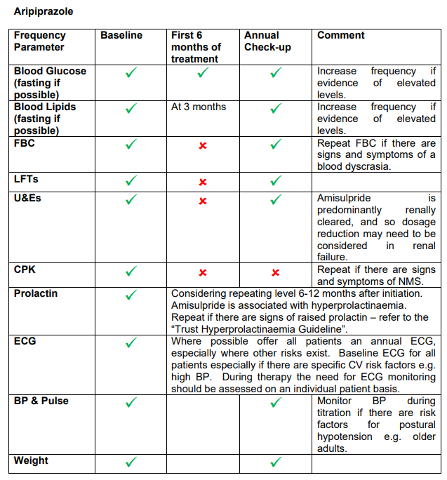

ARIPIPRAZOLE

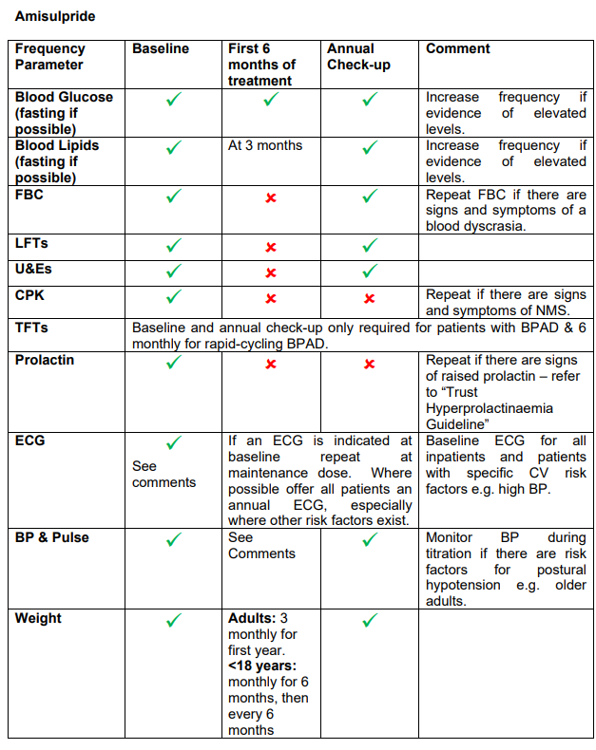

CARBAMAZEPINE

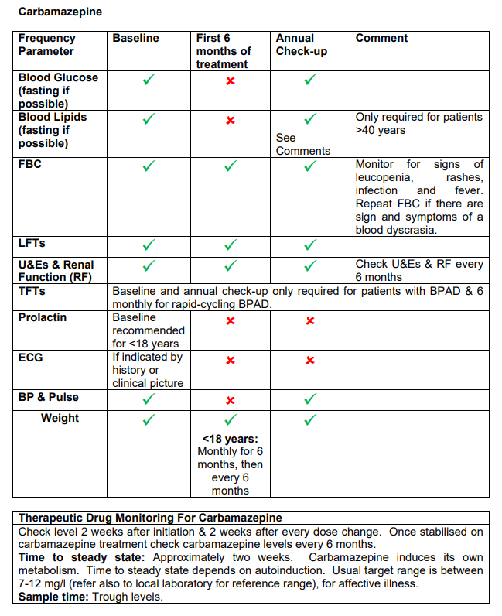

CARIPRAZINE

CLOZAPINE

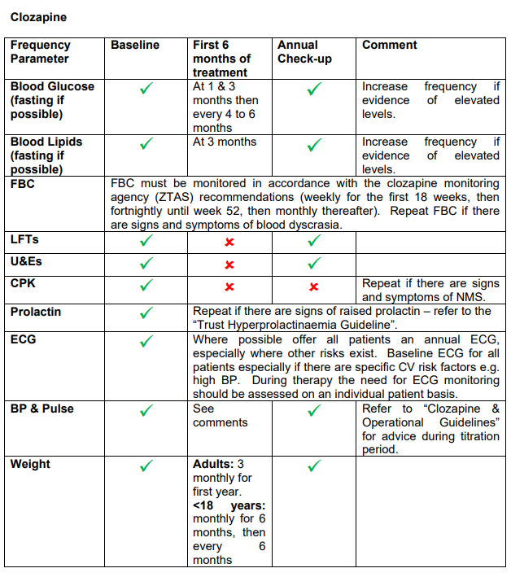
 | Baseline | First 4 weeks | Annual Check | Comments
Troponin* |  | Weekly for the first 4 weeks | Routine Troponin is not required, unless symptoms occur or CRP becomes elevated | Refer to Clozapine Policy for more details
CRP* |  | Weekly for the first 4 weeks |  | If fever + tachycardia + raised CRP or Troponin (or if any abnormalities appear): Daily CRP and Troponin measures until stable

* CRP >100mg/L or troponin result twice the usual reference range can be an indicator of myocarditis or cardiomyopathy: STOP CLOZAPINE; repeat echo
HALOPERIDOL

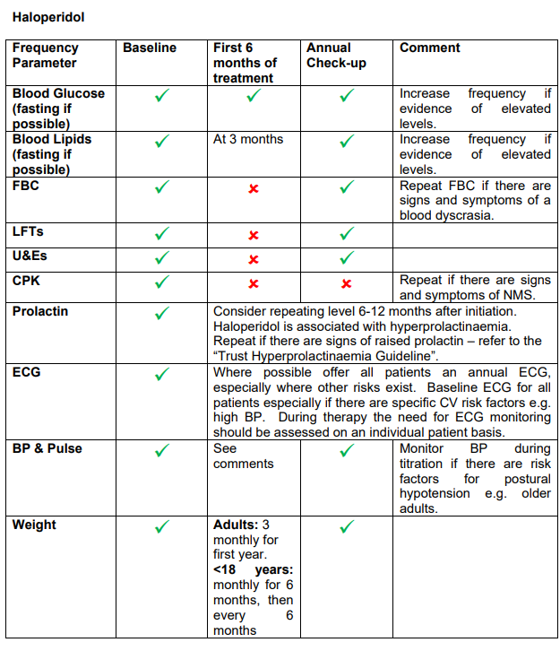

LAMOTRIGINE (Medical advice should be sought immediately if a rash develops)

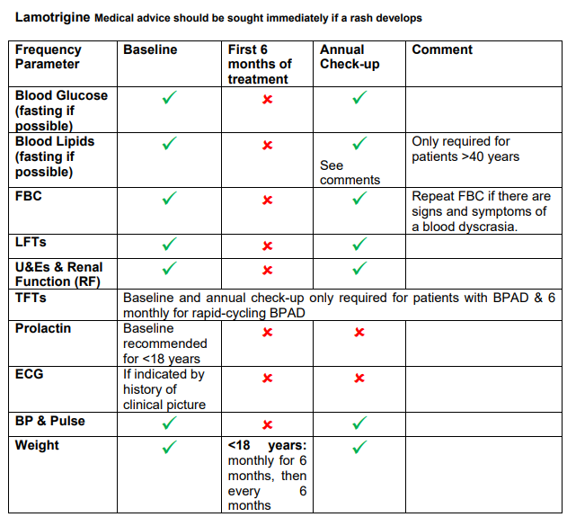

LITHIUM * (Ensure patient has been given a “Lithium Alert Card” & “Lithium Record book)

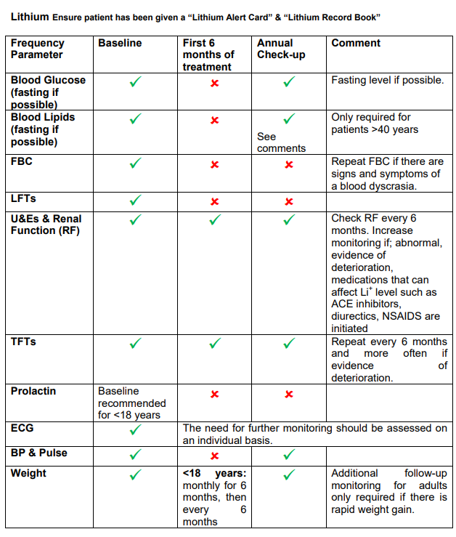
 | Baseline | First 6 months of treatment | Annual  Check | Comments
Calcium |  |  |  | More frequent testing than 6 months if there is evidence of raised Calcium level
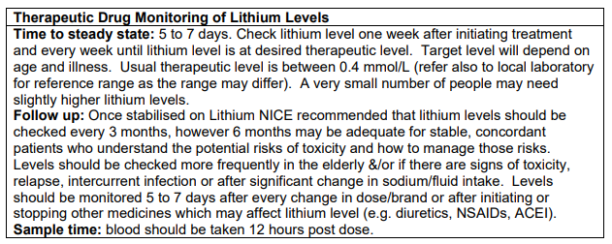
*Refer to the “Protocol for the Safe Use of Lithium” for more details

LURASIDONE

OLANZAPINE

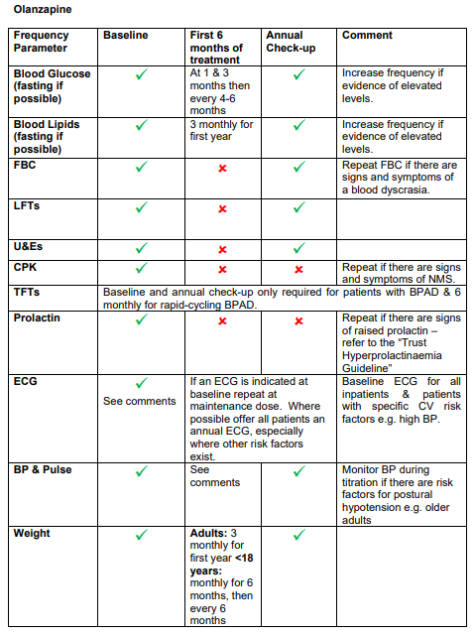

QUETIAPINE

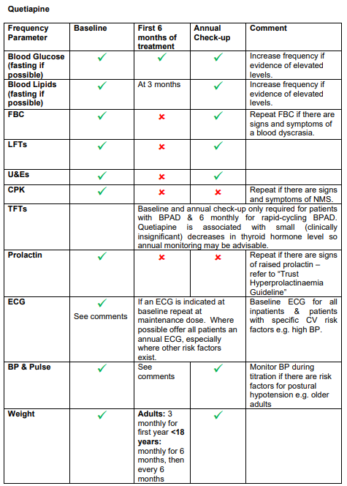

RISPERIDONE/PALIPERIDONE

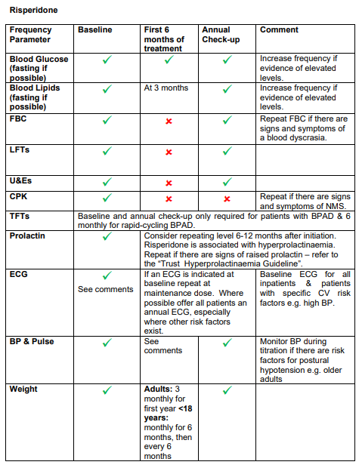

TYPICAL ANTIPSYCHOTICS (see separate table for Haloperidol)

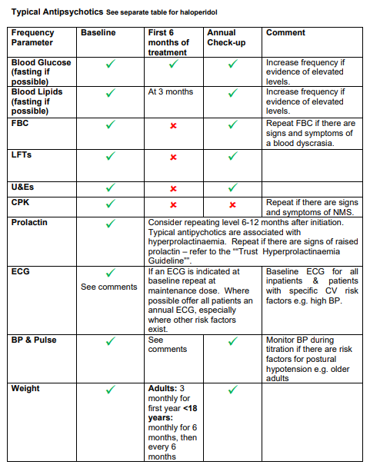

VALPROATE *

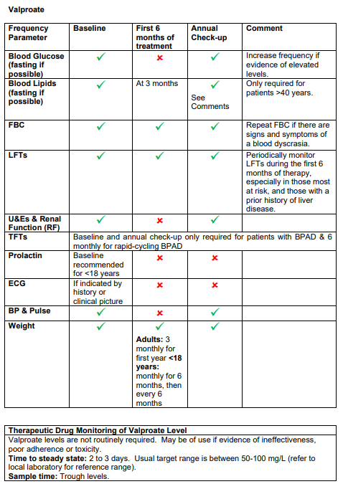
* Refer to the “Valproate Policy” for more details

- GLUCOSE AND DIABETES MONITORING

Increases in glucose occur early on after initiating treatment with antipsychotics and may be difficult to reverse. As changes in glycosylated haemoglobin (HbA1c) occur only after a few weeks, fasting glucose tests should be carried out in preference to HbA1c after treatment initiation. In the long-term blood glucose control can be monitored using HbA1c (as this is more feasible to arrange for patients), however fasting glucose together with HbA1c is preferred at all time-points to determine immediate and long-term impact on blood glucose. Where there is concern about the validity of the HbA1c reading (e.g. in HIV or sickle cell disease) then fasting glucose should always be used. Where a patient also has HIV, discuss concerns about blood glucose levels with their HIV consultant.

Monitor fasting glucose and/or HbA1c:
• at 12 weeks
• at 6 months
• at 1 year
• annually thereafter

Increased frequency of testing should be considered for patients at risk of diabetes or where results are high. Medicines that are High Risk for causing diabetes include Clozapine and Olanzapine.
All patients should be given dietary and lifestyle advice to help prevent the development of diabetes.
Management of high glucose should be in line with NICE guidance “type 2 diabetes in adults: management.” https://www.nice.org.uk/guidance/ng28

Diabetes UK provides guides on diet and diabetes:
Enjoy Food Guides (download only) - Diabetes UK Shop

Further diabetes guidelines by NCL JFC can be found at:
http://ncl-mon.nhs.uk/faq/guidelines/

The Lester UK adaptation tool for monitoring physical health provides further advice on threshold values used in blood glucose monitoring.

- CHOLESTEROL AND LIPID MONITORING

Increases in cholesterol and triglycerides can occur after initiating antipsychotics and may continue to increase over the longer term if they are not managed. Increased cholesterol is an established risk factor for cardiovascular disease and intervention to treat dyslipidaemia is known to reduce morbidity and mortality.

Monitor lipids:
• at 12 weeks
• at 6 months
• at 1 year
• annually thereafter

Patients with high cholesterol should be given dietary advice and may need treatment in line with NICE guidance on “cardiovascular disease: risk assessment and reduction, including lipid modification”
https://www.nice.org.uk/guidance/cg181?unlid=737326192016290182

Patients with diabetes in particular may need aggressive treatment to lower cholesterol.
Further advice on the management of antipsychotic induced dyslipidaemia is available in the British Association of Psychopharmacology guideline on the management of weight gain, metabolic disturbances and cardiovascular risk associated with psychosis and antipsychotic treatment:
https://www.bap.org.uk/pdfs/BAP_Guidelines-Metabolic.pdf

The NHS provides information on cholesterol including information on how to reduce cholesterol:
http://www.nhs.uk/Livewell/Healthyhearts/Pages/Cholesterol.aspx

Further statin prescribing and lipid modification guidelines by NCL JFC can be found at: http://ncl-mon.nhs.uk/faq/guidelines/

The Lester UK adaptation tool for monitoring physical health provides further advice on threshold values used in blood lipid monitoring.

- WEIGHT GAIN AND WEIGHT MONITORING

Weight gain occurs early on after initiating treatment with antipsychotics and is difficult to reverse. It is therefore important to monitor weight closely during initiation and intervene promptly where weight gain occurs. Patients should be encouraged to weigh themselves and keep a record which can be discussed at each contact.
Monitor weight:
• weekly for the first 6 weeks
• at 12 weeks
• at 1 year
• annually thereafter

Medicines that are High Risk for causing weight gain include Clozapine and Olanzapine. Quetiapine and Risperidone have a moderate risk of causing weight gain. Haloperidol has a low risk of causing weight gain and to a low extent.

All patients should be given dietary and lifestyle advice to prevent weight gain. Lifestyle interventions are first line for reversing weight gain.

The NHS provides a range of resources on healthy eating and weight loss. http://www.nhs.uk/livewell/healthy-eating/Pages/Healthyeating.aspx

The Lester UK adaptation tool for monitoring physical health provides further advice on threshold values used in weight monitoring.

- MANAGEMENT OF ABNORMAL RESULTS

  - QTc prolongation
The QT interval broadly relates to the duration of cardiac repolarisation. Some antipsychotics are linked to prolongation of the cardiac QT interval, a risk factor for the ventricular arrhythmia torsade de pointes, which is often fatal. Overall risk is probably dose-related. Medicine interactions (involving enzyme inhibition) are important (See Appendix 2 for medication interactions). See Appendix 3 for risk factors for QT prolongation.

Table 1: Management of QT prolongation in patients receiving antipsychotic medicines
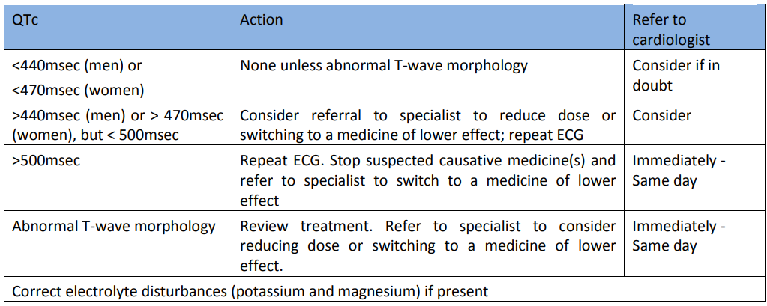
  - Hyperprolactinaemia
Dopamine inhibits prolactin release and so dopamine antagonists can be expected to increase prolactin plasma levels. All antipsychotics cause measurable increases in prolactin but some do not increase prolactin above the normal range at standard doses.

Hyperprolactinaemia is often superficially asymptomatic and there is some evidence that Hyperprolactinaemia does not affect subjective quality of life. Persistent elevated levels of plasma prolactin is associated with sexual dysfunction, reductions in bone mineral density, menstrual disturbances, breast growth, galactorrhoea, suppression of the hypothalamic-pituitary-gonadal axis, and a possible increase in the risk of breast cancer.

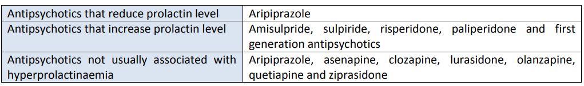

Table 2: Prolactin concentration interpretation
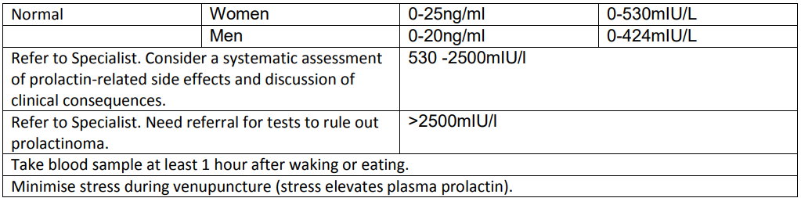

  - ExtraPyramidal Side Effects (EPSE)
Including Dystonia (uncontrolled muscular spasm), Pseudo-parkinsonism (tremor etc.), Akathisia (restlessness), Tardive Dyskinesia (abnormal movements) should be considered for a referral to a specialist for a review.

  - Neuroleptic Malignant Syndrome (NMS)
Neuroleptic Malignant Syndrome is a rare, but potentially serious or even fatal adverse effect of all antipsychotics. It is a syndrome of muscular rigidity and sympathetic hyperactivity occurring as a result of dopaminergic antagonism in the context of psychological stressors and genetic predisposition.

Signs and symptoms (Presentation varies considerably): Fever, diaphoresis, rigidity, confusion, fluctuating consciousness, fluctuating blood pressure, tachycardia, elevated creatinine kinase, leucocytosis, altered liver function tests.

Risk factors for NMS:
• high potency first generation antipsychotics
• recent or rapid dose increase
• rapid dose reduction
• abrupt withdrawal of anticholinergics
• antipsychotic polypharmacy
• agitation
• dehydration
• psychosis
• organic brain disease
• alcoholism
• Parkinson’s disease
• hyperthyroidism
• psychomotor agitation
• mental retardation

If Neuroleptic Malignant Syndrome suspected the patient must be sent to A&E

  - High Dose Antipsychotic Therapy (HDAT)
High Dose Antipsychotic Therapy (HDAT) is defined as a total daily dose of a single antipsychotic which exceeds the upper limit stated in the SPC or BNF with respect to the age of the patient and the indication being treated or a total daily dose of two or more antipsychotics which exceeds the SPC or BNF maximum using the percentage method. The percentage method requires converting the dose of each medicine into a percentage of the BNF maximum recommended dose for that medicine and adding these together (See Antipsychotic Dosage Ready Reckoner). A cumulative dose of more than 100% is high dose antipsychotic prescribing

Doses of antipsychotics prescribed above the maximum licensed dosages are off-label. The GP must be informed of the off-label use of the medicine and be willing to accept clinical and legal responsibility for prescribing. The specialist is responsible for ensuring that appropriate information is provided to the GP and the GP agrees to continue the prescription. If the GP does not wish to continue the prescription this needs to be discussed with the specialist recommending treatment

High doses of antipsychotics might worsen already compromised cognitive function in their patients (particularly older people). High dose antipsychotics have a greater liability for extrapyramidal side effects for which anticholinergic/anti-Parkinsonism medicines might be required which also may worsen cognitive function. Dose-related side effects include extrapyramidal side effects, tachycardia, postural hypotension, sedation, seizures, and hyperprolactinamia.

Additional monitoring will be advised by the specialist. All patients on HDAT should have regular ECGs (baseline, when steady state serum levels have been reached after each dosage increment and then every 6 to 12 months). Additional biochemical/ECG monitoring is advised if medicines that are known to cause electrolyte disturbances or QTc prolongation are subsequently co-prescribed (Appendix 3 Risk factors for QT prolongation)

- CONTACT DETAILS AND FURTHER INFORMATION:

Mental Health Crisis Line/Crisis Support - ELFT Crisis Lines - Open 24 hours a day
The helpline is for people of any age who may have long-term psychological issues or who have had a sudden crisis such as a shock, bereavement, relationship issues, etc. They offer confidential expert advice and guidance, support and referrals to local services if needed.

City & Hackney
Freephone 0800 073 0006/NHS 111, Option 2

Newham
Freephone 0800 073 0006/NHS 111, Option 2

Tower Hamlets
Freephone 0800 073 0003/ NHS 111, Option 2

To find a Summary Product Characteristics: https://www.medicines.org.uk/emc/

The Choice and Medication Website is a patient friendly website which can be provided to patients. Leaflets on medications, including in different languages and formats and fact sheets on a number of areas including weight gain, hyperprolactinaemia, EPSEs and metabolic adverse effects.

YoungMinds is a unique new website about mental health medication for young people aged 13-25. It has been created by YoungMinds and funded by Comic Relief and the Nominet Trust as part of the Innovation Labs project which has developed a range of digital projects to improve young people's mental health.

- REFERENCES

- NICE: Antipsychotics (last revised April 2024): https://cks.nice.org.uk/topics/bipolar-disorder/prescribing-information/antipsychotics/#monitoring.
- NICE: Psychosis and schizophrenia in adults: prevention and management (CG178) (last updated 1 March 2014): https://www.nice.org.uk/guidance/cg178.
- NICE: Bipolar disorder: assessment and management (CG185) (last updated 21 December 2023): https://www.nice.org.uk/guidance/cg185
- Taylor, DM., Barnes, T. & Young, AH. (2021). The Maudsley Prescribing Guidelines in Psychiatry (14th Ed).
- MHRA. (2020). Clozapine and other antipsychotics: monitoring blood concentrations for toxicity: https://www.gov.uk/drug-safety-update/clozapine-and-other-antipsychotics-monitoring-blood-concentrations-for-toxicity.
- British Association for Psychopharmacology. (2016). BAP guidelines on the management of weight gain, metabolic disturbances and cardiovascular risk associated with psychosis and antipsychotic drug treatment. https://www.bap.org.uk/pdfs/BAP_Guidelines-Metabolic.pdf.
- High Dose Antipsychotic Monitoring Guidelines (ELFT)
- The risks and benefits of high dose antipsychotic medication (revised January 2023), Royal College of Psychiatrists: https://www.rcpsych.ac.uk/docs/default-source/improving-care/better-mh-policy/college-reports/college-report-cr190.pdf?sfvrsn=54f5d9a2_2.
- Guidelines for the Identification, Monitoring and Management of Psychotropic Induced Hyperprolactinaemia Incorporating Guidance for General Practitioners (Nov 2024; ELFT)
- Management of Depot Antipsychotics in Primary Care (March 2024; ELFT)
- Positive cardio metabolic health resource, Lester UK Adaptation, 2014 update www.rcpsych.ac.uk/quality/NAS/resources

