Family and Carer Information Sheet: Learning Difficulty or Learning Disability?

Distinguishing between Learning Difficulties and Learning Disabilities is often seen as quite a complex issue.

In general, a Learning Disability constitutes a condition which affects learning and intelligence across all areas of life, whereas a Learning Difficulty constitutes a condition which creates an obstacle to a specific form of learning, but does not affect the overall IQ of an individual. For example, Down’s syndrome is classed as a Learning Disability, whereas dyslexia is classed as a Learning Difficulty, in that it only affects an individual’s relationship to the processing of information, usually manifested in problems with reading, writing, and spelling.

It is possible for a person to have both a Learning Disability and a Learning Difficulty. For example; they might have Autism (a social and communication Learning Difficulty) as well as a diagnosed Learning Disability. Autism is not a learning disability but around half of autistic people may also have a learning disability.

Learning Disability: Valuing People
One of the most commonly used definitions in the UK is that contained in the Valuing People and Valuing People Now strategies. This states that a Learning Disability includes the presence of:

- a significantly reduced ability to understand new or complex information, to learn new skills (impaired intelligence), with;
- a reduced ability to cope independently (impaired social functioning);
- which started before adulthood, with a lasting effect on development.

The causes include genetic factors, infections before birth, brain injury or damage at birth, brain infections or brain damage after birth. However, for many who are diagnosed with having a general Learning Disability, the cause remains unknown. Other terms that have been used include ‘intellectual disabilities’ and ‘developmental disabilities’, both of which are used internationally but not commonly used in the UK.

Learning Difficulty | Learning Disability
Dyslexia | Down’s syndrome
Dyspraxia | Genetic conditions
Dyscalculia | William’s Syndrome
ADHD (Attention Deficit Hyperactivity Disorder) | Angelman Syndrome
Autism (ASD) | Fragile X
Rett’s Syndrome
Di George Syndrome
… | …

Let’s take a closer look at what this means in reality for people who are affected by these conditions.

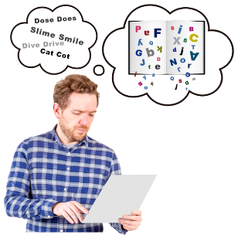
Learning difficulties
Learning difficulties is a broad term to describe conditions that will affect a person’s ability to learn in a traditional classroom setting. Someone with a learning difficulty will need to learn and take in information in a specialised or adapted way. Their need for this should not be seen as having an intellectual challenge.

Learning difficulties are usually diagnosed in childhood, although children and adults can be diagnosed with learning difficulties at any time in their lives. Learning difficulties are usually lifelong conditions. It is possible for someone to have multiple different learning difficulties.

Everyone with diagnosed learning difficulties has rights that are laid out in the Equality Act (2010). Under this Act, employers and services must make reasonable adjustments to support the person to fully participate and reach their potential. This includes making information accessible, like providing Easy Read materials. Or, for example, if someone with dyslexia could be given more time to complete a reading or writing task at work. This would be a reasonable adjustment to support them.

Learning disabilities
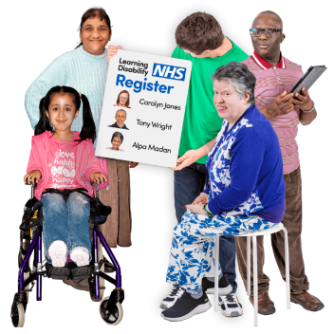
Learning disability affects every individual differently. It is often difficult to identify if someone has a learning disability. A learning disability is a lifelong condition that starts before adulthood. It can be defined as:

- A reduced ability to understand new or difficult information and to learn new skills.
- A reduced ability to cope and live independently.
- Having a lasting effect on development.
- A reduced intellectual ability and difficulty with everyday activities which affects someone for their whole lives. For example: household tasks, socialising or managing money.
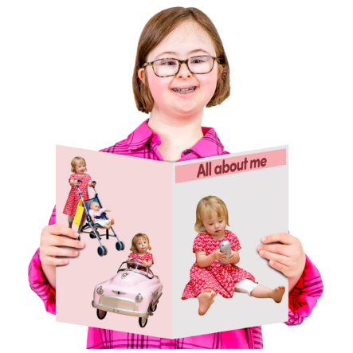
Someone with a learning disability may have difficulty with:

• Remembering basic information, for example their date of birth or address.
• Understanding and writing text, and filling in forms.
• Explaining emotional experiences.
• Understanding and processing new information.
• Understanding and telling the time, or a chronological order of events.
• Recognising risks.
• Recognising signs, numbers or money.
• Planning and organising activities for themselves.

People with learning disabilities will need support throughout their life. However, the level and type of support will differ from person to person. Someone with a mild learning disability may only need support with something like applying for a job. Someone with profound learning disabilities may need round the clock care and support with all aspects of their life.

As with learning difficulties, learning disability is also covered by the Equality Act (2010). People with learning disabilities can expect the businesses and services they use to make reasonable adjustments to help them participate. For example, someone may need an Easy Read version of an appointment letter, health materials, an agreement or form, a report or information about a consultation so that they can provide feedback. These would be reasonable adjustments.

