Healthroster policy 2025_ELFT
ROSTER GUIDELINES
FOR USE WITH THE E-ROSTERING SYSTEM

Version number: | 3.6
Consultation Groups | HR Staff, Trade Union Representatives; Line Managers
Approved by (Sponsor Group) | JSC Policy Sub Committee
Date approved | 14th May 2024
Ratified by: | Joint Staff Committee
Date ratified: | 7th August 2024
Name and Job Title of author: | HealthRoster Project Manager
Executive Director lead: | Chief People Officer
Implementation Date: | September 2024
Last Review Date | April 2024
Next Review date: | April 2027

Services | Applicable to
Trust wide | √
Mental Health and LD

Community Health Services

Version Control Summary

Version | Date | Author | Status | Comment
3.5 | April 2024 | Archana Sanap, John Peers | Final | Holiday of lifetime entitlement recording, On-Call emergency work recording, Loop App, bank and agency shifts booking and approval (p13) and Minor changes to the formatting.
3.6 | January 2025 | Archana Sanap, John Peers | Interim Review | Roster publishing process reviewed and amended. Exec oversight meetings added to the process. Minor formatting changes.

Table of Contents

 | Subject | Page
 | Introduction and Purpose | 3
 | Responsibilities | 4
 | Local Staffing Profiles | 5
 | Communicating Policy to Staff | 6
 | Principles of Producing Duty Rosters | 6
 | Validation / Approval | 7
 | Skill Mix and Shift Staffing | 9
 | Unsocial Hours | 10
 | On-Call and Call Out (Emergency Work) | 10
 | Students | 10
 | Staff Requests/Employee Online | 11
 | Non–Effective Periods Annual Leave/ Sickness | 12
 | Changes to Published Rota | 14
 | New Staff | 14
 | Booking and Authorising of Temporary Staff | 14
 | Key Performance Indicators | 16
 | Appendices:
1 | Board to Ward Roles and Responsibilities for Staffing Establishment | 18
2 | Guide to Producing a Roster | 21
3 | HealthRoster’s Protocol for Weekly Bank Monthly Unsocial Hour Timesheets | 24
4 | Working Time Directive Compliance | 22
5 | Safer Care Escalating Concerns Flowchart | 23

The HealthRoster Policy is to be read in conjunction with the Carter Report, Carter – Best Practice Documentation, Temporary Staffing Policy, Annual and Special Leave Policy, Managing Sickness Absence Policy, Temporary staffing Policy, On-Call policy, Holiday of lifetime guidance and Work-life balance policy

- INTRODUCTION & PURPOSE

1.1 The objective of this policy is to establish uniform working practices concerning staff working hours, work patterns, and absence management across the organisation. This policy aims to enhance the effective utilisation of permanent staff members rostered within the organisation. The policy seeks to provide transparency and management control over time and attendance, ultimately reducing the dependency on temporary staff by:

- Improving the utilisation of Substantive staff and reducing bank and agency spend by giving the ward/ unit managers clear visibility of staff contracted hours.
- Ensuring that rosters are fair, consistent and fit for purpose, with the appropriate skill mix, to ensure safe, high-quality standards of care
- Providing a request system for staff.
- Improve the monitoring and management of sickness and absence by department and/or individuals, generating comparisons, identifying trends and priorities for action improving the planning of unavailable working days e.g. annual leave and study leave to enable the requirements of the European Working Time Directive (eWTD) to be balanced with the needs of the service delivery.
- Providing a mechanism for reporting and monitoring against set trust key performance indicators (KPIs).
- Facilitating the payment of social and unsociable hours of staff through data being entered on HealthRoster.

  - Application

1.2.1 This policy must be used where a roster is created using HealthRoster excluding Medical Staff. HealthRoster is an electronic system that has been specifically designed for matrons/clinical leads, ward managers/team leads and others to roster staff to an agreed staffing profile of clinical and non-clinical demand for the department. It will store personnel data providing visibility of a person’s availability and contractual obligations.

  - Definitions

1.3.1 Some terms are defined below to assist in understanding:

Non-patient care (non-effective/Unavailability) working days | Relates to days that staff are not available for the roster i.e. annual leave, study days, management days, sickness, paternity leave, maternity and carer leave
One request | One shift or day off
Permanent | Staff who have permanent contracted hours
Temporary | Bank and other temporary workers
Variations in shifts | Differing start and finish times to regular shifts.
Overhead | This relates to the percentage of non-patient care working days that are included in each establishment.
Personal pattern | The staff works the same shift pattern over a period of time (Weekly/Monthly/quarterly etc.)
Roster | A schedule of time and attendance for each staff member within a ward/unit
Demand Template | The number of shifts per day that you can allocate to your  substantive and temporary staff, within your budgeted WTE
WTE | Whole Time Equivalent
Partially  Approved Roster | Rosters that have been analysed and agreed upon by the Roster Creator
Fully Approved  Roster | Rosters that have been analysed by the Roster Approver and published to the workforce

- RESPONSIBILITIES

  - Line managers/matrons/lead nurses are responsible to engage in annual staff establishment reviews that are set up to understand clinical demand and workforce requirements to meet safer staffing requirements. Staff establishment reviews contribute to budget setting and roster demand templates for each shift. Directors of Nursing will be responsible for the coordinating and collating of safer staffing requirement data to present to the Chief Nurse including any recommendations to improve safer staffing.

  - Matrons/ clinical leads are responsible for ensuring that:
- their expenditure does not exceed the allocated budget in all wards, units and departments (hereafter referred to as departments);
- all staff’s annual leave records on HealthRoster using the Annual Leave calculator.
- establishments are updated as identified on HealthRoster and the safe staffing of each department lies with line managers, even if they do not undertake the task of producing the duty roster.
- Band 7 and above receive Safer Staffing and Health Roster training before they are allocated this responsibility.

  - Lead Nurses / Clinical Leads/ Designated Deputies (hereafter referred to as Senior Managers) are responsible for ensuring:
- all rosters comply with KPIs and effective management of staffing resources- including staff absent from work or not undertaking clinical duties (investigation/sickness absence or performance management).
- additional duties are appropriately applied and authorised.
- Roster creation and management is only undertaken by staff appropriately trained to do so
- Rosters are produced, overseen and approved as per agreed timelines
- the monitoring and approval of the department duty roster on completion and produce analysis reports and approve all shifts where temporary staff are requested (see Appendix 2)

    - Board to Ward Roles and responsibilities for Staffing Establishment are outlined in Appendix 3.

  - Roster Creators

2.6.1 The designated Roster Creator (RC) is responsible for the creation of all duty rosters, as designated by the line manager. This responsibility must only be assigned to staff who have received the appropriate training and are oriented with the KPIs against which rosters are measured and will usually be staff at Band 7 and above.

  - Rota Co-ordinators

2.7.1 The designated Rota coordinator (Not an Authorised signatory) cannot approve/finalise any rotas and can only be responsible for day-to-day roster maintenance and absence recording.

- LOCAL STAFFING PROFILES

3.1 ALL departments will develop and publish their written locally developed staffing profile.

3.2 These local staffing profiles will include:
- The production of fully approved duty rosters at least 8 (eight) weeks in advance using HealthRoster (see Appendix 1 for guidance);
- Demand analysis detailing the required staffing levels (number of staff) and skill mix (experience of staff required) by shift and by day and this must be reviewed when bed numbers change or patient profiles change or as part of the annual Establishment Reviews.
- Both Trust policy and local rules; including limits to concurrent annual leave at each band and study leave;
- Rules around self - rostering where appropriate;
- Christmas duty requirements;
- Department specific requirements;
- The maximum number of requests that can be considered for days off on any single date;
- How far in advance requests can be entered, in order to ensure that staff joining the team, have a fair chance of adding their requests.

3.3 The Trust supports the principles embedded in Improving Working Lives (IWL) regarding work life balance, flexible working and family friendly working. The Trust will consider requests and respond in line with the Trusts Work-Life Balance Policy.

- COMMUNICATING THE POLICY TO THE STAFF

4.1 Both the Trust-wide policy and ward based safer staffing requirement should be displayed and made readily available to all staff. Copies should be given to all new starters as part of their induction. The Trust-wide policy is available on the Trust intranet.

5.0 PRINCIPLES OF PRODUCING DUTY ROSTERS

5.1 Roster creators should pay attention to:
- Minimum staffing levels (number of staff) and skill mix (experience of staff required and gender) by shift and by day must be reviewed in the light of any significant change to the ward function but at a minimum on a six monthly basis;
- Rules relating to all types of leave, most importantly sickness absence, annual leave, study leave and working time regulations, etc.;
- Religious or cultural off duty requests. Each roster manager will review the off duty requirements to enable such off duty requests where possible, whilst ensuring all wards are covered by contracted staff;
- Ward specific requirements as agreed with a senior manager;
- The maximum number of staff that can be allowed to have annual leave at the same time in the same roster, taking into consideration skill mix;
- The maximum number of requests a member of staff may make in any one rota period;
- Maximum time ahead that requests can be entered, in order to ensure that new staff joining the team have a fair chance of adding their requests;
- The Trust supports the principles of a work-life balance, flexible working and family friendly working, taking into account the needs of the service and patient care. Any flexible working arrangements should be openly acknowledged and published, ie., the number of part-time posts a ward can permit, the number of fixed days (personal patterns) that staff work, which can be safely accommodated per ward.

5.2 Clock change clarification – in the UK, the clocks go forward one hour at 1am on the last Sunday in March, and back one hour at 2am on the last Sunday in October. Those working one extra hour in October, and one hour less in March, need to be recorded as such and need to be paid/given time in lieu as appropriate. This will happen automatically for those that are already on the eRostering system. All areas that are still manually producing pay returns need to ensure that this is marked accordingly.

5.6 Any relevant roster profile must be reviewed if there is movement in the workload driven by changes to number of referrals, clinical caseload, and number of bed changes, the specialty or acuity changes or similar.

5.7 Rosters must be reviewed every six months as a minimum. It is both the matron and rostering team’s responsibility to ensure these reviews occur regularly and are carried out to the required standard.

    - Seven steps to good roster management

5.7.1.1 A duty roster should be produced for all relevant departments at least eight weeks in advance. Departments will use the electronic system. This policy applies to all staff. The 7 steps should create a roster that is safe, cost effective and provide a good working life with developmental opportunities.

- Assemble all necessary information including staff requests
- Know and understand the policies and best practices for planning rosters
- Plan the roster
- Obtain authorisation for the roster
- Publish roster
- Review and adapt the roster in a timely manner whist it is in use
- Record changes to the roster

      - The publication of working rosters will take place simultaneously across all departments in the Trust using HealthRoster. A timetable will be produced by the HealthRoster Support team. Refer to Appendix 2 for the 2024-25 roster production timetable.
      - All rosters must commence on a Monday.

      - Rosters must be fully approved at least 6(six) weeks in advance of the roster start date. This will enable staff to better manage their personal commitments and to give the Nurse Bank more time to fill any vacant shifts.

      - All rosters should be composed to adequately cover the identified and agreed demand utilising permanent staff proportionately across all shifts.

      - Shifts given a high priority on HealthRoster must be filled first, Ward Round/CPA days.

      - If any of the staff are working non–standard shifts such as late starts, this should be entered to avoid misinterpretation.

      - All student and trainee shifts should be included. They should where possible be rostered with their mentors.

- VALIDATION/ APPROVAL

  - Timesheets can only be approved/finalised by a manager who holds a higher banding and should not be a family member or a relative. Those that are approving should be recorded as an authorised signatory with the Trust Finance Department.

  - A completed roster must be reviewed by the Senior Manager prior to this being published.

6.3 Key performance indicators and parameters will be set and monitored during the weekly performance meeting using analysis reports, by the Chief Nurse, Director of Nursing and Senior Manager. Exception reporting will be developed for the Director of Operations and the Director of Clinical Services.

  - The Key Performance Metrics are:

- Roster approval lead time
- Non-patient care working days: Staff’s unavailability during the 4 week roster period is broken down into the following categories. The total percentage of these should equate to the 23% overhead that is built into each establishment.

Annual Leave | 13%
Study Days | 3%
Leave | 7%
- Sickness and Maternity
- Special leave
- Other
Note: As some leave types cannot be predicted the 7% overhead for this type of leave is a guide to trigger exception reporting. Managers need to exercise sensitivity to balance the needs of the individual and the service in the context of the relevant Human Resource policy.

- Lost contracted hours: Contracted hours not used over a 4-week roster period and carried forward to the next roster period.

- Over contracted hours: Hours used over those contracted to work and will be given back to staff in the next roster period.

- Additional shifts: Any shifts allocated that are above the agreed staffing requirements for the department.

- Unfilled shifts: Shifts within the agreed demand that have not been filled by permanent staff, broken down by number of shifts, hours and approximate cost (based on Staff Bank pay scales).

- Requests (departments that self-roster must be acknowledged as being different).

- Contracted staff by WTE.

- Number of bank requests to total bank hours worked.

- Number of vacancies.

- Number of bank requests on weekend and night shifts.

- Number of Agency requests to total agency hours worked.

- Reasons for bank shifts and additional duties

6.4 Any roster that falls outside of the set parameters must be reviewed and scrutinized for approval or rejection. If not approved, it will be returned to the roster creator to re-do. If it is approved, permission will be given to publish. Issues that require further review may include:

- Potential unsafe shifts;
- Shifts for which temporary staff are currently planned;
- Any of the agreed parameters that have been exceeded.

Local oversight panels chaired by Lead Nurses for scrutiny and review against defined KPIs (8 weeks before published) will be used for scrutiny and final oversight of rotas. Ward managers/ Matrons have 1 week to address any areas for improvement and provide assurance to Lead Nurses. Any vacant shifts remaining should then be put to Bank as appropriate by a minimum of two weeks prior to the roster beginning.

Exec oversight for scrutiny and assurance against defined KPIs (7 weeks before published). Lead Nurses will be responsible for completing any agreed actions within 1 week in time for publication.

  - First and second level approvals cannot be given by the same person. Ward managers/team leads should complete first approvals with matrons/clinical leads completing second approvals. Staff approving rotas have a responsibility to ensure they meet defined KPIs and support safer staffing requirements.

- SKILL MIX & SHIFT STAFFING

  - Skill Mix:

- Each department should have an agreed total number of staff and skill mix for each shift, agreed through annual staff establishment reviews and agreed safer staffing requirements. Agreed numbers and skill mix must be achievable within the departmental budget;
- Each area should have an agreed level of staff with specific competencies on each shift (i.e. the ability to take charge, PMVA & Emergency Response Team trained) as agreed with the Lead Nurse concerned;
- In areas where the workload is known to vary according to the day of the week, staff numbers and skill mix should reflect this;
- Band 6 staff and higher should work opposite shifts

  - Shifts:

- Staff will be required to work a variety of shifts and shift patterns as agreed by their line manager;
- Staff may work long shifts, short shifts or a combination of both in order to meet the service requirements. Variations to these shifts may be worked but must be agreed with the Line manager. A written record of the shift agreement will be kept for all variations in shifts and will be reviewed as agreed, and in all instances at least annually;
- All shifts > 6 hours must include a minimum of a 20-minute unpaid break and a minimum of 40-minute unpaid break for shifts of > 12 hours. Night shifts include a 60-minute unpaid break;
- The line manager or person in charge and the individual are responsible for ensuring that breaks are taken;
- Breaks should not be taken at the end of a shift, as their purpose is to provide rest time during the shift;
- Weekend shifts are defined as Friday night, Saturday day or night, Sunday day or night and Bank Holidays;
- Staff may have a minimum of one weekend off per 4-week roster, in normal circumstances (unless they specifically request not to have weekends off). Additional weekends off can be rostered if the departmental requirements allow;
- The number of consecutive standard day shifts recommended for staff to work is 5. Staff may work more than this (to a maximum of 7 followed by a day off) if they specifically request to;
- The number of consecutive 12-hour shifts (long days) recommended for staff to work is no more than 2, this can be increased to three if the staff member requests to do so and the line manager is in agreement;
- Night Duty should not exceed a maximum of 5 consecutive shifts;
- All staff must have 11 hours of rest before their next shift. Where short shifts are the norm, a late to early shift pattern should be avoided. Please seek advice from your manager if in doubt;
- Staff must not work more than an average of 48 hours over 17 weeks unless they have signed a WTD opt-out clause, the Trust will then permit the average to increase to 60 hours;
- Shifts should not be assigned by a family member or relative.

- UNSOCIAL HOURS / TIME OWING

8.1 Unsocial hours/weekend and night shifts should be distributed evenly and fairly, in accordance with agreed contractual restrictions, resulting in all staff having an equal and fair opportunity to work shifts that can incur enhance able payments on top of their basic salaries.

8.2 Requests to undertake additional hours must be discussed and agreed by the unit manager in advance of the hours being worked.

8.3 Any time worked over contracted hours or claimed back as time off in lieu must be recorded on the roster and approved by the team/ward manager.

8.4 The team/ward manager must review and check staffs net hours over a four-week period are balanced and do not exceed the 15 hours set by the Trust. If a Trust employee’s hours balance is over the 15 hours threshold (whether that be owed to the Trust or the Trust employee) then corrective work must be completed to bring this back into the threshold within the next roster period.

8.5 Time off in lieu must be approved by the Matron/ Team Lead and should never exceed more than 15 hours and must be taken by the end of the following roster, or it will be forfeited.

  - Every 8 weeks the Ward Manager must run a report using the ‘My staff hours’ report available to ensure any staff hours that do not balance over a 4 week period are balanced over an 8 week period.

  - Finalisation of the rota is required for payroll purposes by the 4th of each calendar month (Appendix 3).

- ON CALL AND CALL-OUT (EMERGENCY WORK)

  - Staff employed on Agenda for Change contracts should have their on-call periods recorded in Healthroster.

  - The working time during on-call should be recorded in Healthroster.

9.3 Terms and Conditions of On-Call working are contained in the Trusts On-Call Policy for AfC Managers.

- STUDENTS

  - Where long shifts are the norm, the student should undertake 3 shifts per week, but no more than 2 in a row unless there is an exceptional circumstance.

  - Students must not be on duty for more than 48 hours per week. This limit safeguards their health and well-being. It also enables them to undertake shifts where they are making up time.

  - Students should be rostered to work a minimum of 40% of shifts per week with their mentor (2 shifts).

  - Please see the chart below for expectations in relation to weekend and night shift working.

  - Students are required to spend 112.5 hours on nights over their clinical placement. The majority of this would be achieved in their second year.

10.6 Year 1 students do not do night duty.

  - Year 3 students can do night duty either to make up night duty hours from year 2 or as part of their continued placement learning.

  - Designated sign off mentors for pre-registration nursing students must be allocated 1 hour per week with each year 3 final placement student. (NMC Standards 2006 foot note).

- STAFF REQUESTS/EMPLOYEE ONLINE

11.1 Employee Online and Loop app are available to all staff who are rostered in HealthRoster to request all planned working hours, annual leave, study leave and unavailabilities.

11.2 Each department will use the HealthRoster system for staff to make requests for all types of leave via Employee Online and Loop app. These requests will be considered in the light of service needs.

11.3 A comment must be provided indicating whether the request is high priority or low priority.

11.4 Requests for specific shifts or days off can be made. These are known as personal patterns. Service requirements and equity for other staff members must be taken into account when applying these. They must be agreed upon and reviewed every 3 months by the line manager.

11.5 Maximum Number of Requests

11.5.1 Requests will be calculated according to the individual’s shift patterns and hours of work (Table 2) and will be considered in light of the service needs. It cannot be assumed by staff that the roster will be developed to accommodate them. This includes essential requests as service needs will take priority. Staff must be considerate of their colleagues, and the requirement to fulfil their share of weekend and night shifts. Personal patterns are not to be considered as requests.

TABLE 2: Requests According to Hours of Work
Staff Hours per week | Total Number of requests per 4-week roster
31 to 37.5 hours | 6 (high and low priority)
22.5 to 31 hours | 5 (high and low priority)
Less than 22.5 hours | 3 (high and low priority)
Less than 15 hours | 1 (high and low priority)

11.5.2 The Trust supports the principles embedded in Improving Working Lives (IWL) regarding work-life balance, flexible working and family friendly working. However, this should be set against the service need to ensure safe levels of staffing to maximise the quality of patient care and reduce clinical and non-clinical risk. The Trust will seriously consider requests for flexible working but may decline them if this pattern cannot be accommodated into the service needs. Achieving adequate staffing numbers and skill mix is the main priority. All other factors are secondary to this, including requests, preferences, team coverage and study leave.

- NON-EFFECTIVE PERIODS

  - Study Leave

12.1.1 Study leave will be assigned in accordance with the Trust’s Study Leave Policy.

  - Annual Leave

12.2.2 Annual leave is allocated in hours for all members of staff.

12.2.3 The line manager approves all annual Leave and is responsible for managing the annual leave entitlements and records in HealthRoster.

12.2.4 Each department should calculate how many qualified and unqualified staff must be given annual leave in any one week, with a defined limit for each band. An agreed number will be set and must be adhered to. Staff should be made aware of the need to maintain this number constantly throughout the year. Should this number not be met by way of requests, the line manager will allocate leave following discussions with the staff concerned.

12.2.5 No holiday bookings should be made until the line manager has sanctioned the annual leave requested. All annual leave must be booked via Employee Online or Loop.

12.2.6 It must not be assumed that all annual leave for new starters will be honored. This will need to be negotiated to ensure departmental requirements are met.

12.2.7 Half term weeks, school holidays and bank holidays present additional problems. The total amount of leave whether annual or study leave should not be increased because of the well-recorded difficulties in obtaining temporary staff. Discussions should be encouraged between those requesting time off so that each member of staff has an equal chance of being granted annual leave. Annual leave requests for school holidays will be shared equally amongst those requesting.

12.2.8 A maximum of 21 consecutive calendar days of annual leave can be requested. Any more than this will need special approval from the Clinical Lead or Service Lead.

12.3 Bank Holiday

12.3.1 Bank Holidays will be treated as all other weeks in terms of leave. Each department will determine how the usual level of leave will be allocated i.e. a few staff may get some leave as opposed to a small number of staff having blocks of leave. This will depend on the adequacy of staffing at the time. All services to decide local process for rostering over a bank holiday, eg., allocation of shifts and booking of leave.

12.4 Guide for Duty Roster Co-ordinators

12.4.1 Staff should take approximately 40% of their annual leave entitlement by 31st August each year, with approximately 35% being used between September and December, leaving 25% to be taken between January and the end of March.

Dates | % Annual Leave to be taken | Example: 1.0 WTE entitlement of 27 days + 8 bank holidays
Dates | % Annual Leave to be taken | 7.5 hour shifts | 12 hour shifts
1st April to 31st August | 40% | 14 | 9
1st September to 31st December | 35% | 12 | 8
1st January to 31st March | 25% | 9 | 5

If annual leave is not booked and is to be taken ad hoc, it is an individual’s responsibility to ensure it is used before 31st March. Only 5 days of annual leave can be carried forward into the next year on 31st March if authorised by the Clinical Lead or Service Lead.

    - Annual leave must be booked or cancelled before a roster is planned. Annual leave requested after this can only be given if staffing levels permit near the day.

    - Annual leave requests that exceed the documented acceptable level for the department will not be approved.

  - Holiday Of Lifetime

    - Annual leave hours banked under the Holiday of a Lifetime scheme need to be recorded on HealthRoster by the line manager as a separate entitlement.

    - The staff member needs to submit the request to use this entitlement in line with the Annual Leave policy.

    - The line manager will be responsible for inputting the approved Holiday of Lifetime episodes on HealthRoster (step by step guide can be found on the intranet).

- CHANGES TO PUBLISHED ROSTERS

13.1 It will be the responsibility of the line manager and Duty Roster Co-ordinator to amend rosters with non-patient care shifts i.e. sickness, no shows, and additional shifts.

13.2 Shift changes should be kept to a minimum.

13.3 Staff are responsible for negotiating their own changes once the roster is published. These changes must be approved by a senior manager or the deputy.

13.4 All changes should be made with an equal grade and with consideration for the overall skill mix of all shifts being changed.

13.5 Where staff are allocated to a student, shift changes should not occur without ensuring the student either changes with the staff member or is allocated to another suitable member of staff, that the student is aware and that this change is recorded on the roster.

13.6 The actual worked roster must be verified by the Clinical Team Leader/Ward Manager by 5PM every Friday.

- NEW STAFF

14.1 New staff should be rostered for the Trust Induction program at the start of their employment.

14.2 Should new staff need to be added to the roster or staff details change and these amendments are unable to be made, contact the HealthRoster Operations Manager for assistance.

- BOOKING AND AUTHORISING OF TEMPORARY STAFF

  - No replacement staff should be booked without the Matron/Clinical Lead assessing the need for them, the grade that is required and the time that they are needed to start and finish. In the absence or unavailability of the Matron/ clinical lead this authorisation can be granted by the ward manager/team lead. Out of hours the point of escalation and approval will be Duty Senior Nurse.

  - On completion of the roster, the Lead Nurse will review it and either request amendments or approve the roster. To approve a roster the following must be provided:

- The shifts which need bank cover must be identified
- The report for temporary staff requests

  - Temporary staff shifts will only be identified if requests are:

      - within budget;
      - within existing vacancies;
      - either band 5 or less (unless required for covering the Duty Senior Nurse Role);
      - to cover unpaid maternity leave;
      - Essential to ensure patient safety.

Note: Should temporary staff still be required outside these parameters, approval can be provided by the Nurse in Charge of the Shift. Appendix 5 outlines the process for escalating concerns regarding short/staffing.

  - Following approval, requests for temporary staffing can then be forwarded to the Nurse Bank and available shifts released on Loop.

  - Temporary staff cannot be used to take charge of departments unless they are known to the department, have been assessed as competent to do so, and are willing to take charge. This must be approved by the Ward manager or Matron.

  - Staff who have been off sick or taken any paid special leave in the previous 7 days should have a conversation with their line managers to discuss the appropriateness of undertaking bank shift given recent ill health.

  - Staff should not allocate and finalise bank shifts for staff who are working bank shifts in a different team to them.

  - Where managers agree that the substantive staff can work bank shifts to cover workload or undertake particular projects, this should be agreed in writing, to include the banding of the shift, the number of shifts to be worked, the timeframe, the work to be undertaken and where the work will be undertaken (for example from home or from a specified Trust site).

  - All Bank and Agency shifts worked throughout the Trust will need to be recorded and finalised on the HealthRoster.

15.9.1 Escalation (Refer to Trust Incident Reporting Policy and Appendix 5)
15.9.2 Escalation will be undertaken when, either a directorate or Nurse Bank, draws attention to a major problem with staffing. These include:
- Emergency bed pressures;
- Infection outbreaks or to control infection;
- High levels of absence or vacancies of nursing staff;
- High level of unfilled requests of bank and agency staff;
- High dependency patients above those normally managed in the clinical area.

15.10 Staff Redeployment

15.10.1 During staff shortages, it is accepted that staff may be required to work in other clinical areas to provide a safe and efficient service. If an area requires staffing the Senior Nurse for that area is responsible for redeployment of staff within the directorate.

15.10.2 It is recognized that occasionally staffing needs to be viewed as a whole, i.e. cross directorate when staffing deployment in a directorate is not possible. The Senior Nurse is then responsible for contacting the Duty Manager. They will together (out of hours – Duty Manager only), make the final decision as to what area a nurse can be moved from considering staffing cross directorate, ward dependencies and bed occupancy. (Appendix 5)

- KEY PERFORMANCE INDICATORS

Roster Key Performance Indicator Thresholds

TABLE 1: Critical Measures of Success

Table 1 identifies the Key Performance Indicators for each roster, which must be below the amber limit for a roster to be submitted for Lead Nurse/Senior Manager approval. A report on these KPIs will be made available and reported to the Trust performance management team.

TABLE 1: ROSTER KEY PERFORMANCE INDICATOR THRESHOLDS
Group | Key Performance Indicator | Amber Threshold | Red Threshold
Nursing Supply Effectiveness
Nursing Supply Effectiveness | Annual Leave Activation (min staff required) | Set by individual units
Nursing Supply Effectiveness | Annual Leave Minimum % | 11% | n/a
Nursing Supply Effectiveness | Annual Leave Maximum % | 17% | 22%
Nursing Supply Effectiveness | Study Day % | 5% | 7%
Nursing Supply Effectiveness | Working Day % | 2% | 4%
Nursing Supply Effectiveness | Parenting % | 5% | 7%
Rostering Effectiveness | Over Contracted Hours % | 1.5% | 2%
Rostering Effectiveness | Unused Contracted Hours % | 1.5% | 2%
Rostering Effectiveness | Additional Duties (Duties, weekly) | 1 | 3
Rostering Effectiveness | Additional Duties (Hours, 4 weekly) | 1 | 22
Rostering Effectiveness | Bank & Agency Usage % | 5% | 10%
Rostering Effectiveness | Unfilled Roster % | 20% | 30%
Fairness | Duties with Warnings % | 20% | 30%
Fairness | Requested Roster % | 30% | 50%

Appendix 1

Board to Ward Roles and Responsibilities for Staffing Establishment

Non-executive Board Directors:
- Ensure there are robust systems and processes in place across the organisation to make informed and accurate decisions concerning workforce planning and provision.
- Review data on workforce, quality of care and patient safety on a regular basis and hold Executive Directors to account for ensuring that the right staff are in place to provide high quality care to patients.
- Ensure that decisions being taken at a board level, such as implementing cost improvement plans, have sufficiently considered and taken account of impacts on staffing capacity and capability and key quality and outcomes measures.
- Understand the principles which should be followed in workforce planning, and seek assurance that these are being followed in the organisation.

Chief Executive:
- Ensure that the organisation has the right number of staff with the required knowledge and skills to provide safe and effective patient care.
- Ensure that there is an agreed nursing and midwifery establishment for all clinical areas.
- Ensure there are robust systems and processes in place across the organisation to make informed and accurate decisions concerning workforce planning and provision.
- Ensure that appropriate escalation policies are in place and action is taken when staffing falls below that expected.
- Ensure workforce plans are clinically and financially viable, and that they inform education commissioning process in place through the Local Education and Training Board (LETB) and Health Education England (HEE).
- Ensure that the Executive Team have SMART objectives (specific, measurable, achievable, realistic, timely) aligned to staffing and that these are reviewed and performance tracked regularly.

Executive Board Members:
- Report to the Board on nursing, midwifery and care staffing capacity and capability, highlighting concerns and making recommendations where necessary. Workforce data should be triangulated with data on quality of care.
- Where staffing capacity and capability is insufficient to provide safe care to patients and cannot be restored, undertake a full risk assessment and consider the suspension of services and closure of wards in conjunction with the Directors of Operations, Chief Executive and Commissioners.
- Foster a culture of openness and honesty amongst staff, supported by nursing and midwifery leaders, where staff feel able to raise concerns, and concerns are acted upon.

Chief Nurse:
- Develop the nursing and midwifery leadership team to ensure that they understand the principles of workforce planning and can use evidence-based tools informed by their professional judgement to develop workforce plans and make staffing decisions on a day to day basis.
- Assure the Board that there are nursing and midwifery workforce plans in place for all patient care areas/pathways.
- On a monthly basis, report workforce information to the Board on expected versus actual staff in post on a shift-to-shift together with information on key quality and outcome measures.
- Ensure there is an uplift in planned establishments to allow for planned and unplanned leave and ensure absence is managed effectively.

Chief People Officer:
- Ensure that human resources support and policies are available to secure sufficient staffing capacity and capability to provide high quality care to patients.
- Ensure that there are systems and processes in place to capture accurate data on establishment, staffing levels and skill mix, staff movements, training and turnover to inform decisions on workforce planning.
- Develop and implement policies that support all staff working within areas of competence.
- Develop and implement a strategic recruitment plan to provide the required resources and fill current and future vacancies.

Chief Operating Officer:
- Ensure that the management of the organisation supports delivery of the workforce plan and there is sufficient staffing capacity and capability to provide high quality care to patients.
- Ensuring that there are systems and processes in place to capture accurate data on quality of care, patient pathways and volume to inform decisions on workforce planning.

Chief Finance Officer:
- Ensure that finance decisions which could have an impact on staff capacity and capability and patient outcomes are taken with consideration of staffing and workforce planning implications, and that these are reflected in any advice provided for decision to the Board, linking proposals to patient outcomes and quality.

Borough Head Nurses and Modern Matrons:
- Review and approve rosters submitted from wards.
- Reallocate staff and authorise the use of temporary staffing solutions if necessary and where required.
- Continuously review and monitor nursing, midwifery and care staffing capacity and capability across areas of responsibility.
- Produce data/information to inform the Board and management of the organisation, and to inform workforce planning.
- Hold Service Managers to account for having appropriate staffing capacity and capability on a shift-to-shift basis, and following escalation procedures where necessary.

Ward Managers/Team leaders:
- Produce and manage safe and efficient staff rosters.
- Measure quality of care and outcomes achieved for patients and the capacity and capability of staff on a ward-to-ward basis.
- Respond in a timely manner to unplanned changes in staffing, changing patient acuity/dependency or numbers, including the request for and use of temporary staffing where nursing/midwifery shortages are identified.
- Escalate concerns to line manager where staffing capacity and capability are inadequate to meet patient needs.
- Understand the evidence-based methodology used to determine the nursing and/or midwifery staffing in your area of responsibility.

Other Health and Care Staff:
- Complete data returns where requested about the staffing in your workplace to inform workforce planning decisions.
- Participate in discussions and decisions regarding staffing in your clinical area.
- Understand the agreed staffing capacity and capability are for your clinical area on a shift-by-shift basis.
- Raise concerns regarding staffing and/or the quality of clinical care within your organisation when they arise.

Appendix 2
Guide to Producing a Roster

HealthRoster is an electronic system specifically designed for use by Line managers, Duty Roster Co-ordinators, Head Nurses, etc.

It will roster staff to an agreed demand requirement manage staff availability and contracts and allows clear visibility of departmental manning levels. It will also track and produce reports for absence, leave, additional shifts and temporary staff usage (bank, agency, overtime).

HealthRoster can be summarised as shown below:

- Manage Rosters – Details the processes for creating and updating rosters and deleting rosters where they are not required.

- Assign Shifts – Describes the overall parent process for assigning shifts. The process describes the steps involved in filling the roster and references sub processes that explain how the line manager assigns shifts using the Auto Roster and manually. The process also shows how the Head Nurse reviews the proposed departmental roster, fills outstanding shifts using “Show Available People”, and approves the roster for publishing.

- Auto Assign Shifts – The detailed process steps for assigning shifts using the Auto Roster feature. This process describes how the Line manager chooses an Auto Roster favourite (Strict, Moderate or Relaxed), sorts the list of shifts for assignment, and runs the Auto Roster. This process does not describe the internal functional operation of the Auto Roster.

- Assign Shifts Manually – Describes the process for assigning shifts manually, including the processes for swapping and combining shifts, after the Auto Roster has completed. This process describes how HealthRoster indicates whether a duty assignment is a perfect fit, is assigned but with warnings, or whether the duty assignment has been rejected due to a rule violation.

- Assign Shifts to Staff from Other Departments – After the Department Manager has approved their roster it is ready for review by the Head Nurse. The Head Nurse reviews the duty assignments and tries to fill any outstanding vacant shifts. The Head Nurse uses the “Show Available People” feature to check whether suitable staff are available from other departments. This process describes these steps and shows how the Head Nurse assigns a duty to a person from another department.

- Administer Rosters – Once the roster has been published, the Line manager must manage the ongoing changes made to the roster. Examples of changes made to the roster include the recording of “No Shows”, cancelling shifts, and the creation of additional shifts. This process describes how the Line manager accomplishes these tasks.

Guidance notes

Ward managers and matrons are responsible for planning rotas at least six weeks in advance. There should be no planned shortage of staff on wards.

It is the responsibility of all staff to ensure the service has safe staffing levels on our wards.

There are situations and circumstances which occur at short notice which may cause concern due to a staff shortage. It is the responsibility of the nurse in charge of the shift and the following shift to resolve the staffing issue by using the escalation flow chart. Known shortages should be dealt with at the earliest opportunity.

The DSN should make full use of the resources available on site and in conjunction with other locality DSNs, utilising whatever practical steps are needed including providing transport to & from sites across the Trust.

Non-essential activities should be paused.

During normal office hours, senior nurses up to and including lead nurses and other members of the MDT should be utilised on wards, evidence by active recorded engagement including medication administration, close observations and other direct engagement with service users.

On Call Manager/Lead Nurse consider authorising:
- A Breach of Trust working rules limit 60 hours in seven-day period;
- A Breach of Working Time Directive working average of 60 hours for over 17 weeks;
- Overtime payments to substantive staff not Bank registered;
- Service/On-call Director;
- Close service to admission (if more than one ward affected);
- Authorise us of Agency staff.

Each escalation and steps taken to be documented in the DSN records and recorded in Healthroster via a red flag report and if deemed necessary via a Datix report.

Trust staffing red flags:
1. Less than two registered nurses on duty
2. Staff shortage
3. Unable to facilitate patient leave
4. Unable to facilitate planned therapy

Approving a Roster – 1st and 2nd Approval

- The Roster should have been created 8 weeks before off duty commences.
- Shifts should have an agreed total number of staff and skill mix as shown by the establishment templates.
- Creation of the off duty within budget for the ward.
- All staff have at least one weekend off in a 4 week period.
- The number of unfilled shifts that occur on nights and weekends is 0%.
- No more than 5 standard shifts days/nights to be worked consecutively to a maximum of 7 if specifically requested.
- No more than 2 x 12 hours shifts to be worked consecutively, this can be increased to three if the staff member requests to do so and the line manager is in agreement.
- Print ‘My Staff Hours’ Report and select the number of weeks as appropriate:
  - Use this report when checking the Roster Effectiveness Indicators – there should be no hours carried forward.
- Check the Roster Analyser Summary Tab for the following:
  - Roster Effectiveness Indicators
    - Over Contracted Hours - this should be as near to 0 as possible
    - Lost Contracted Hours – this should be as near to 0 as possible
    - Additional Shifts – why have they been used
    - Overtime Hrs – should be 0
  - Fairness and Safety Indicators
    - Requests – no more than agreed within the policy according to hours worked.
    - Shifts with Warnings
    - Check that the policy rules are not being broken by viewing my Roster Stats and reviewing the Rule/Violation column
    - If rules are being broken, contact the Rostering Administrator for further details
    - Shifts without Charge Cover – this should be 0
  - Annual Leave is evenly distributed and is consistent with the % calculated for the ward
  - Mandatory Unfilled Shifts, Sunday/Bank Holiday should be lowest figures
- Check Effectiveness Tab for:
  - Requirements v Availability
  - Staff Unavailability – there should be 0 warnings
  - Filled Shifts – there should be 0 Optional and Additional Shifts unless agreed prior to the creation of the roster
11. Remember to check that Personal Patterns are still valid every 3 months.

If a roster is rejected, an email should be sent to the Roster Creator indicating why it was rejected.

Appendix 3
Roster Production Timetable: 2024-25
Full document can be found here

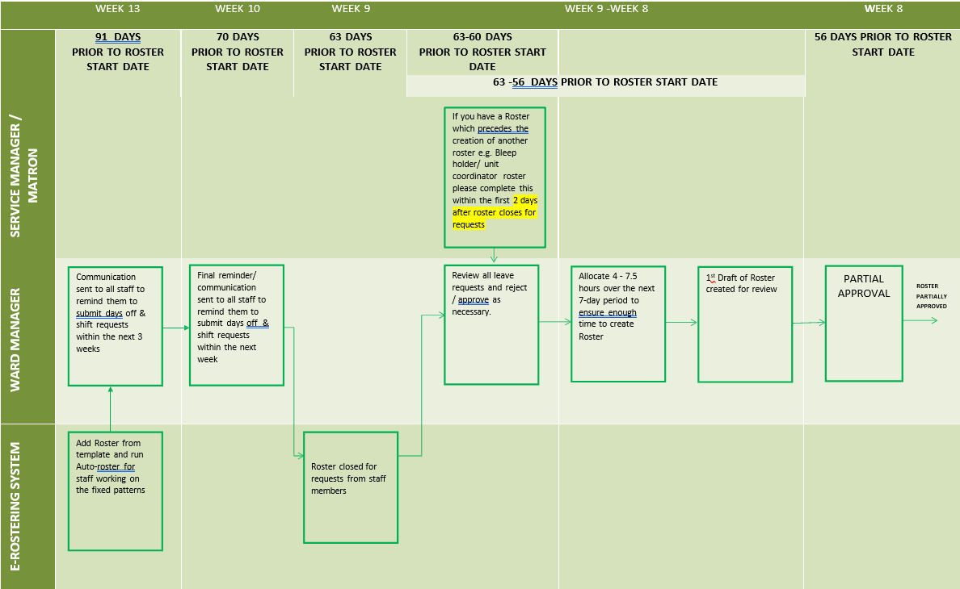
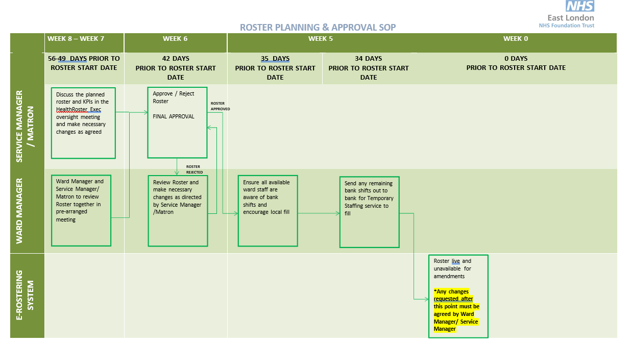
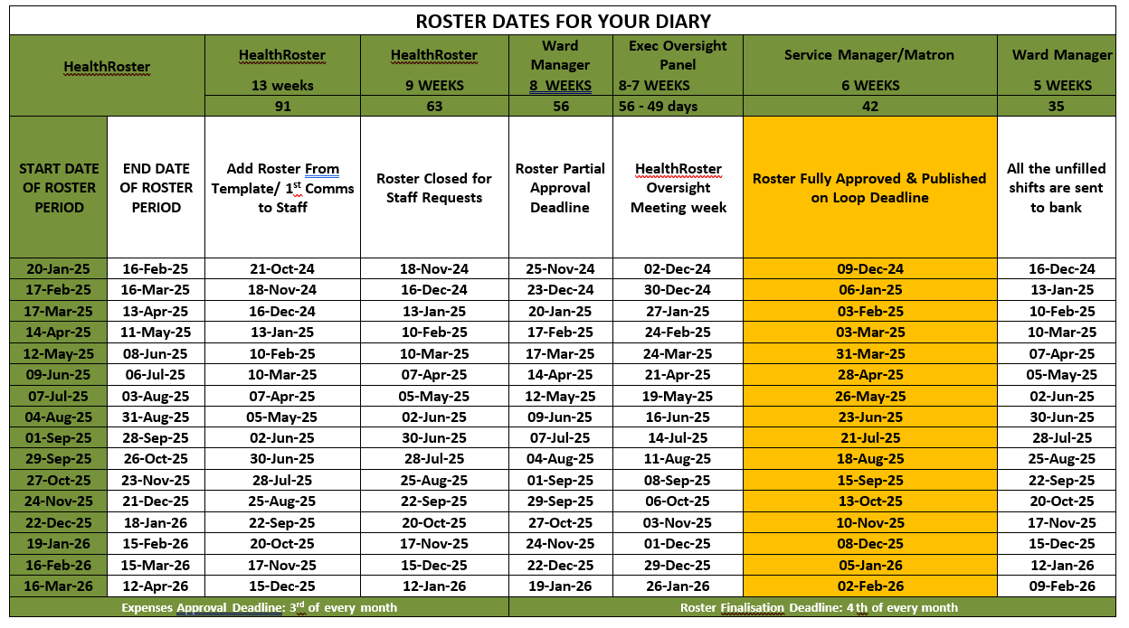

VALIDATION/APPROVAL PROCESS FLOWCHART

Rosters are open for requests 12 weeks before the roster start date

Roster automatically closes to requests 9 weeks before roster start date

Roster Creator autorosters, manually adjusts roster if required, analyses roster and partially approves

Second approver analyses roster and either approves roster or rejects

Roster approved Roster rejected

Gaps in roster are identified and, where applicable, are sent to bank within one week of the roster being published

Local oversight panels chaired by Lead Nurses for scrutiny and review against defined KPIs (8 weeks before rota period)

Exec oversight for scrutiny and assurance against defined KPIs (7 weeks before rota period)

Roster is published 6 weeks before rota period for staff to view on date outlined on roster calendar

Roster is updated weekly by Ward manager/team lead and person in charge on shift

Roster is finalised weekly for bank shifts (latest by 14:00 every Friday) and by the 3rd of every month for the previous month for substantive staff payments

Senior manager to review additional staff and bank staff authorisation and usage

All authorisation for additional staff exceeding safer staffing requirement must be given by ward manager/matron/clinical lead. Out of hours, this is the DSN.
Ward managers/matrons are responsible to review all bank shifts or additional duties to ensure they were appropriately approved and clinically indicated.

Appendix 4

HealthRoster Protocol for Monthly Unsocial Hour Timesheets

Introduction

Rosters are not only a requirement; they are also a legal document and as such can be called into evidence before a court of law, local investigations, complaints and Serious Untoward Incidences. The NMC’s Professional Conduct Committee can also use them as evidence.

Therefore, it is important that Roster Creators and Line Managers are aware of the process of finalisation and their accountability within it.

Finalisation of the Roster is your electronic signature that confirms that the hours worked is a true and actual record. Thus, you cannot finalise your own duty.

Guidelines

Every Friday the Off Duty needs to update with any changes of hours worked annual leave, sickness and study leave.

Once the Roster Creator and Manager are sure that all changes have been made the Roster must be finalised.

By the 2nd of each month (or next working day if the 2nd falls on a weekend or public holiday) the Matron/PIN must ensure that the monthly roster is an accurate account and ensure that it is finalised. This will create the Time Sheet that will be extracted for payroll. It is imperative that you note that once extracted for payroll the timesheets cannot be unlocked and if there are any changes these will have to be sorted out manually at local level with payroll.

Process of finalisation

When the roster creators finalise the rotas, highlight all staff except the Ward manager and the Modern Matron. The Modern Matron needs to finalise the Ward Managers duty and the Borough Lead Nurse (BN) should finalise the Modern Matrons (MM) shifts. If the MM or the BN is not available, an email should be sent to elft.healthrostersupport@nhs.net, confirming that the shifts have been worked and they will finalise. (Ensuring that this is done by the 2nd of each month)

Appendix 5

“Working Time Regulations 1998” – ELFT Rules

In compliance with the Working Time Regulations 1998 (WTR) no member of staff, may work more than 48 hours a week on average whether substantive staff or Bank staff unless they have signed the Individual Working Hours Agreement form.

It is the responsibility of all concerned to ensure that these regulations are not infringed.

The onus is on ward or departmental managers to ensure that all substantive staff working extra hours on their ward have signed the Individual Working Hours Agreement form and have retained a copy for their reference and returned a copy to the Bank.

Providing that the Individual Working Hours Agreement form is signed, a member of staff may work up to a maximum of 60 hours per week. Under no circumstances will a member of staff be permitted to exceed these hours either through undertaking bank/agency work or duties within the Trust or with another organisation. Under the WTR 1998, the average working time, including overtime, should not exceed 48 hours for each 7-day period.

The above will also apply to staff who has entered into substantive employment contract with the Trust (inclusive of both normal and Bank work).

If you are required to work a shift in your post, in doing so you agree that you will not undertake back-to-back shift working, which may include:

- A Late (or a long day) shift followed by a night shift;
- A Night shift followed by any day duty.

You should also ensure that you comply with the following rest periods, which can be averaged out over a seven-day period. However, you should ensure that you receive a minimum of a 90 hour rest period a week.

- 20 Minutes every 6 hours (averaged over a 7-day period);
- hours every 24 hours (averaged over a 7-day period);
- 24-hour continuous rest period every 7-days.

Annual Leave: Individuals should ensure that they take a minimum of 28 days of their annual leave strictly for annual leave/rest purposes and should not undertake any bank/agency work or duties within all localities of the Trust or elsewhere during this time.

In the event that the Trust implements its Emergency Management Plan Director level guidance will apply.

Appendix 6

ESCALATING STAFFING CONCERNS – WARD STAFF
Add red flag in HealthRoster
Informs Director on-call of failure to meet staffing need
DSN to request the physical support of available CNM, and modern matrons
Reviews ward functions

Authorises use of Agency
Requests support of MDT/AHPs

Authorises breach of Trust working time rules
DSN to access the pool of staff within the unit and redeploy if possible
Nursing staff/Nurse in charge to escalate that staffing capacity is unsafe with respect to patient need
Nursing staff to inform bank office and approach known resources
ESCALATE
ESCALATE
ESCALATE
Director On-Call
Lead/On-Call Nurse Manager
DSN
Nursing Staff/Nurse in Charge

