

Medical Device Policy

Version Number | 6.0
Consultation Groups | Medical Devices Committee, CHS Policy Alignment Group
Approved By (Sponsor Group) | Medical Devices Committee
Date Approved | 10 September 2025
Ratified By | Quality Committee
Date Ratified | 26 November 2025
Name of Originator/Author | Medical Device Safety Officer, Deputy Director for Infection Control and Lead for Physical Health, Senior Business Manager
Executive Director Lead | Chief Nurse
Implementation Date | November 2025
Last Review Date | November 2025
Next Review Date | November 2028

Services | Applicable
Trust wide | X
Mental Health and LD (Learning Disabilities)
Community Health Services

Version Control Summary

Version | Date | Author | Status | Comment
01 | March 2008 | DG | Final | Newham PCT Policy
02 | July 2013 | CS | Draft | Trust wide Medical Devices Policy
03 | November 2014 | CS | Draft | Inclusion of software as a medical device.  Recognition of the trust wide provider of medical solutions.
04 | July 2019 | BK | Final | Update to include community services and reformatted.
05 | November 2022 | BK  ED  DH | Final | Update to include key messages, who should read this document, general rule overview, and medical devices SOPS, processes and forms.
06 | November 2025 | BK  ED  MG | Final | Updated all sections in line with MHRA (17th February 2025)

Table of Contents

Section |  | Page
 | Introduction | 5
 | Medical Devices Definition  2.1 Introduction  2.2 Single Use Medical Devices | 5
 | Purpose | 7
 | Scope | 8
 | Regulatory Compliance Systems & Management | 8
 | Roles & Responsibilities | 9
 | Management of Medical Devices Across Their Lifecycle  7.1 Introduction  7.2 Acquisition  7.3 Acceptance  7.4 Records  7.5 Deployment  7.6 Tracking  7.7 Maintenance  7.8 Successful Booking of Repair  7.9 Successful Disposal of Device  7.10 Successful Decommission of Device  7.11 User Servicing  7.12 Scheduled Servicing  7.13 Equipment Faults | 12
 | Procurement | 17
 | Prescribers of Medical Devices  9.1 Dispensing Prescribers | 18
 | Training  10.1 Training and Competence in the Use of Reusable Medical  Devices  10.2 Staff Competence and Professional Accountability | 19
 | Medical Devices Provided to the Trust by External Suppliers  11.1 Governance Requirements  11.2 Roles and Responsibilities  11.3 Instructions/Guidance | 20
 | Re-Sale of Medical Devices | 21
 | Decontamination and Cleaning | 22
 | Contractor Medical Equipment Asset Register  14.1 Local Medical Equipment Asset Register | 22
 | Medical Beds | 23
 | Electronics Software | 24
 | Tele Health and Tele Care  17.1 Home Tele-Health Systems with Connected Monitoring  Devices | 25
 | Reporting Assessment and Reporting  18.1 Risk Assessment  18.2 Reporting Adverse Incidents / Disseminating Medical  Device Alerts  18.3 Local Dissemination Process for Field Safety Notices  for Inpatients  18.4 Local Dissemination Process for Field Safety Notices  for Community Health Services | 25
 | Implementation and Monitoring  19.1 Policy Dissemination  19.2 Training  19.3 Monitoring and Assurance  19.4 Performance Reporting  19.5 Continuous Improvement | 28
 | References | 28
 | Acronyms | 30
 | Key Terms | 30
- Appendices

Appendix 1 | Managing Your Clinical Equipment | 32
Appendix 2 | Medical Device Incident Reporting Flowchart | 33
Appendix 3 | Medical Devices & Equipment Replacement Application Form | 34
Appendix 4 | Decommissioning & Disposal | 35
Appendix 5 | Disposal of Medical Devices SOP | 35
Appendix 6 | Decontamination of Medical Devices | 37
Appendix 7 | Missing Medical Devices Protocol | 38
Appendix 8 | Medical Device Process Flowcharts  8a Acquisitions Flowchart  8b Acceptance Testing Flowchart  8c New Services Flowchart  8d Decontamination Flowchart  8e Repairs Flowchart  8f Removals Flowchart  8g Scheduled Visits Flowchart | 39
Appendix 9 | Terms of Reference for Medical Devices Group | 46
Appendix 10 | MHRA Bed Rail Alert | 49
Appendix 11 | Related Documents/Policies | 51
 | Equality Impact Assessment | 52

1.0 Introduction

ELFT attaches the greatest importance to the safety and care of its patients and considers it essential to provide effective and safe use of Medical Devices/equipment for patient care.

We are also committed to ensuring safe systems of working, safe use of devices, and the provision of training and supervision to this purpose. Healthcare staff play a vital role in ensuring that medical devices are procured safely and used safely and effectively. They are vital for diagnosis, monitoring, rehabilitation and care. Effective management of this important resource is necessary to provide safe and high-quality patient care, clinical and financial governance, including minimising risks relating to adverse incidents.

The Medical Devices Policy is the overarching framework for the East London Foundation Trust (ELFT), which aims to provide clear guidance to staff on the acquisition, use and disposal of all reusable Medical Devices.

It must be recognised that failure, design flaws, or incorrect use of digital health systems can pose risks to patient safety. New digital tools and processes may also introduce unforeseen risks into clinical workflows. To help mitigate these, NHS Digital’s Clinical Safety Team has developed clinical risk management standards to support the safe design, development, deployment, and maintenance of health IT systems.

The rapid growth of digital health technologies—including artificial intelligence, software, and apps—alongside the implementation of the Medical Device Regulation (MDR) and the UK’s ambition to create the world’s most advanced health and care system, presents both opportunities and significant challenges in the medical device landscape.

Mandated under Section 250 of the Health and Social Care Act 2012, these standards must be considered and met by suppliers and healthcare organisations when commissioning or deploying new health IT systems. They are now aligned with the latest medical device regulations for standalone software and apply to all health IT systems, including those regulated as medical devices. Please refer to Figures 2 and 3 for MHRA flowcharts.

2.0 Medical Devices Definition

2.1 Introduction

The Medicines in Healthcare Regulatory Agency (MHRA) 2015 defines a Medical Device as any instrument, apparatus, appliance, material software or other article that may be used on a patient for the purposes of:
- Diagnosis, prevention, monitoring, treatment, or alleviation of disease or injury
- Compensation for an injury or disability
- Investigation, replacement, or modification of anatomy or physiological processes
- Control of conception

Function | Examples
Diagnosis or treatment of disease | - Diagnostic laboratory device  - X-ray machines  - Magnetic resonance imaging (MRI) scanners  - Vascular Catheters  - Dressings  - Surgical Instruments  - Syringes  - Hip replacement implants  - Standalone software for diagnosis
Monitoring of patients | - ECG  - Pulse oximeter  - Apps on mobile device
Critical Care | - Infant incubators  - Blood-gas analysers  - Defibrillators  - Ventilators  - Vascular stents
Improve function and independence of people with physical impairments | - Hoists  - Orthotic and Prosthetic appliances  - Pressure care devices  - Walking aids  - Wheelchairs  - Dressings  - Domiciliary oxygen therapy systems

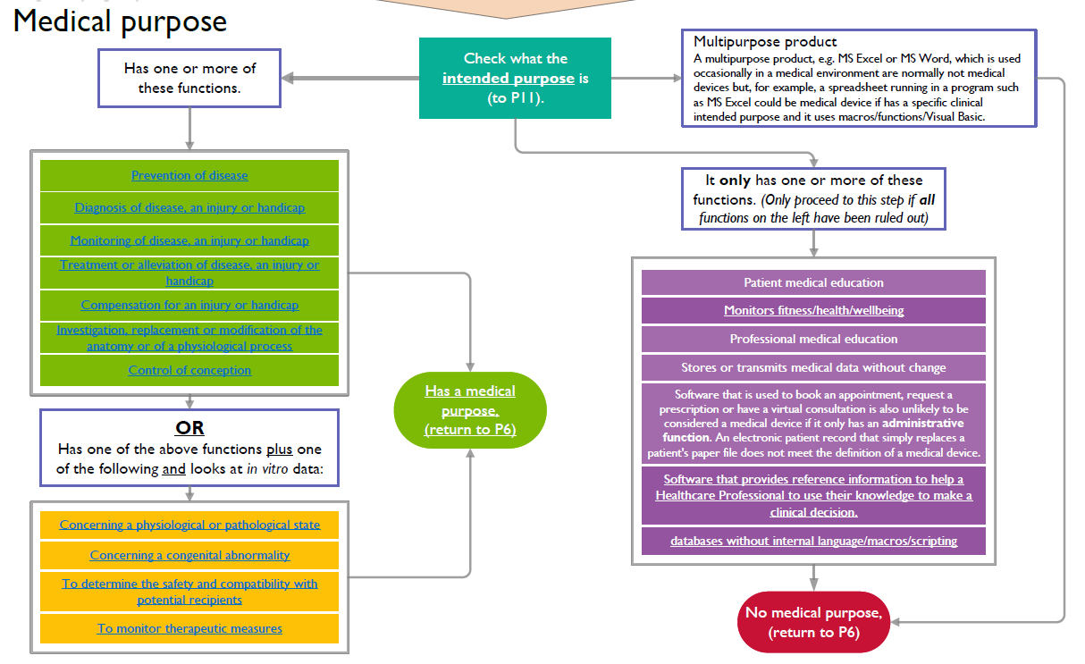
Figure 1. MHRA Medical Devices Purpose Flowchart

Figure 2. MHRA Medical Device Determination Flowchart
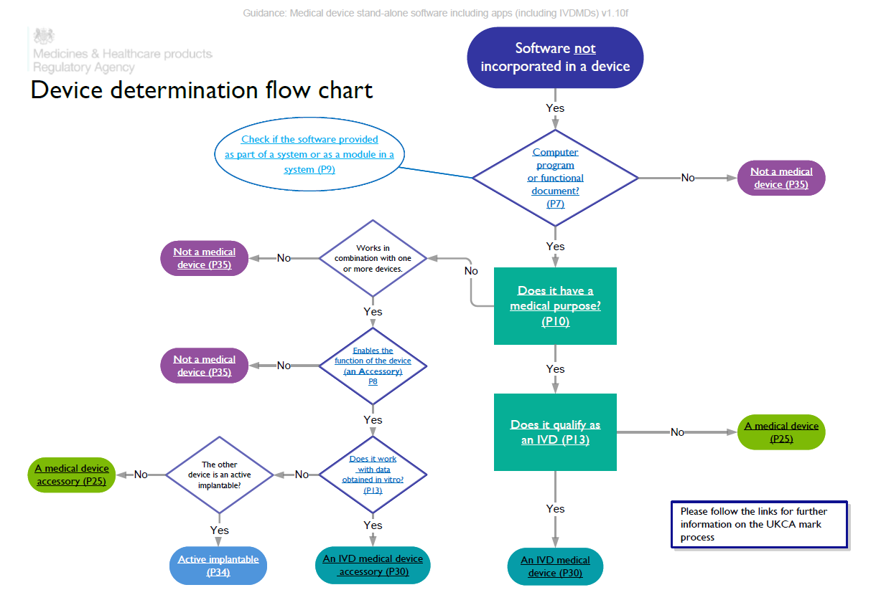

2.2 Single Use Medical Devices

Medical devices designated for single use are not to be re-used under any circumstances. MDA 2000 (04) draws attention to the hazards and risks associated with re-processing and re-using single use items.

Single use – means that the manufacturer:
- Intends the item to be used once and then disposed of.
- Considers the item unsuitable for use on more than one occasion.
- Has insufficient evidence to confirm that re-use would be safe.

Single use Medical Devices should not be re-used as this affects the safety, performance and effectiveness of the device, and exposes staff and patients to harm.

3.0 Purpose

This policy outlines the systems in place to manage and mitigate risks related to the acquisition, deployment, planned preventative maintenance, repair, and disposal of medical devices within the organisation. It also provides guidance on user training and competence.
The policy is informed by, among other sources, the MHRA document Managing Medical Devices – Guidance for Healthcare and Social Services Organisations (2021).
Effective and diligent management of medical devices is essential to support the delivery of high-quality healthcare, ensure compliance with clinical and financial governance, and minimise the risk of adverse events. Without proactive oversight, the likelihood of recurring incidents increases. Safe and effective management not only reduces the risk of harm but also enhances the overall patient experience.

This policy applies to:
- All ELFT staff involved in the procurement, use, maintenance, and disposal of medical devices, including senior clinicians and managers, who are responsible for ensuring safe and effective use.
- All other staff who may assist with medical devices, including agency, student, apprentice, and visiting staff, who must meet the same competency standards.
- Organisational Development staff, due to their role in overseeing training and competency development in medical device use.

4.0 Scope

This policy covers all medical devices purchased by ELFT for inpatient and community services. It does not apply to devices bought by individual patients for personal use.
It outlines good practice for the entire lifecycle of medical devices, including procurement, deployment, training, maintenance, repair, and disposal.

5.0 Regulatory Compliance Systems & Management

This policy outline the roles and responsibilities from East London Foundation Trust (ELFT) from floor to board to include the Medical Devices Team whom oversees Trust’s compliance and adherence with the below legal requirements including systems and management.

Legal and Regulatory Compliance
Staff must comply with the following statutory and regulatory requirements:

- Health and Safety at Work Act 1974 (HSWA)
- Provision and Use of Work Equipment Regulations 1998 (PUWER)
- Lifting Operations and Lifting Equipment Regulations 1998 (LOLER)

These laws place a duty on employers and employees to ensure that any work-based equipment, including medical devices, is used safely and by trained personnel.

This requirement is further supported by guidance from the MHRA, NHS Litigation Authority (NHSLA), and the Care Quality Commission (CQC) as below.

The policy ensures compliance with:
- MHRA Guidance – Managing Medical Devices (2021), which promotes a systematic approach to managing reusable medical devices in healthcare settings.
- In line with the Health and Social Care Act 2008 (Regulated Activities) Regulations 2014, the organisation will ensure that all medical devices and associated equipment are safe, available, suitable for their purpose, and maintained appropriately
- Care Quality Commission (CQC) Fundamental Standards, including:
- Regulation 12 – Requires providers to deliver safe care and treatment, including equipment being safe for use , available when needed and used correctly, to ensure protection of service users from avoidable harm through appropriate maintenance, servicing, and risk management.
- Regulation 15 – Requires equipment to be clean, suitable for use and decontaminated in line with manufacturer instructions, only used by staff who are appropriately trained and competent. Providers must act promptly if equipment is unsafe or unsuitable, including arranging alternatives when needed.

6.0 Roles & Responsibilities

Role | Responsibility
Trust Board & Chief Executive | - The Trust board is responsible for ensuring there are effective systems in place within the organisation.  - Has overall accountability for the safe management of medical devices.
The Chief Nurse | - Is the executive responsible for Medical Devices; this responsibility is delegated to the Lead nurse on Physical Health & Medical Device Safety Officer
The Operational & Clinical Directors | - Through their service managers are to ensure that those services directly managed by the Trust adhere to the standards set out in this policy.
Medical Devices Group | The Trust’s Medical Device Group (MDG) has a responsibility to (see Appendix 9):  - Standardise medical devices and clinical consumables  - Ensure that the Trust adheres to and is compliant with Medicines and Healthcare products Regulatory Agency (MHRA) regulations and standards  - Monitor electrical biomedical physics engineers (Contractor) services  - Review medical device alerts and actions arising.  - Review and approve requests for new medical devices that are not on the recommended list.  - Provide assurance to the Quality Committee that a robust system is in place across the Trust for the safe use of medical devices and effective management of patient safety alerts, ensuring protection of both staff and patients.  - Review all serious incidents involving medical devices, escalate through the internal alert process where appropriate, and support improvements in incident reporting and response.
The Quality Committee | - Oversees Medical Devices including adverse incident reporting and actions required on MHRA’s Medical Devices alerts and manufacturer’s field safety notices. The Quality Committee oversee the development and implementation of the Medical Devices policy.
Chief Clinical Digital Officer | - Will ensure that all new software applications that ELFT uses are reviewed in line with Figure 2 & 3 to assess whether or not it is likely to constitute a Medical Device. MHRA Software flowchart
Medical Devices Safety Officer / | - Ensure all medical device-related incidents are reported electronically on the Trust Incident Reporting Platform, reviewed for learning and improvement, analysed through quarterly and annual reports to identify themes and inform future planning, with findings escalated to the MHRA as appropriate.  - Be an active member of the National Medical Devices Safety Officer (MDSO) Network and collaborate with the Corporate Central Alert System (CAS) Risk Manager on relevant alerts.  - Escalate serious concerns to the Trust Board and MHRA when necessary.  - Provide advice and support to staff on the procurement, safe use, and recommended list of medical devices.  - Offer and coordinate training to ensure safe operation of equipment across services.  - Work with the Infection Control Team prior to procurement to ensure compliance with infection prevention standards.  - Assess maintenance requirements of new devices to inform purchasing decisions.  - Oversee Asset register with Contractor related to medical devices, including planned preventative maintenance (PPM).  - Manage the Capital Bids Replacement Programme (CBRP) and provide progress reports to the Medical Devices Safety Group (MDSG).  - Liaise with Directorates on the rolling programme of equipment replacement, ensuring major replacements are included in business plans.  - Agree and oversee processes for appropriate decommissioning and disposal of devices not covered by existing contracts.  - Provide regular reports to relevant subcommittees as required.
Procurement Team | - Ensure that the recommended items as specified via the Medical Devices Group are on an appropriate catalogue to order and that any orders for non- standard devices or consumables are first approved by the Medical Devices Group.  - Will expedite outstanding orders where necessary.  - Will advise the Medical Devices Group regarding Trust spending rules and regulations.  - Will work with the Medical Devices Group and other appropriate areas to undertake sourcing activities to ensure use of appropriate suppliers and abidance by correct process.
Finance | - The Finance Department will ensure that Medical Devices are procured in line with Trust Standard Financial Instructions.  - They will also monitor and report on spending to the Board as follows: -  - New equipment.  - Replacement equipment.  - Repairs to equipment  - Consumables.  - Contract maintenance.  - Contracting and service level agreements with external stakeholders.  - Will ensure that contracts specify adherence to MHRA regulations
Ward Managers/Team Managers/Matrons | - Purchase equipment only after approval by the Medical Devices Team and through Trust procurement processes.  - Report all new equipment to the MDSO and the Contractor for acceptance testing and inclusion in the asset register.  - Report decommissioned equipment to the Contractor and the MDSO for removal from the asset register.  - Maintain accurate logbooks and inventories of all equipment within each department, including warranty documentation.  - Ensure new equipment is correctly installed with all relevant documentation available for audits and inspections.  - Provide alternative facilities in case of equipment failure.  - Ensure staff are trained, competent, and aware of their responsibilities regarding medical device use, reporting faults, and adherence to policies.  - Implement and maintain systems for routine maintenance, planned preventative maintenance (PPM), cleaning, and decontamination per IPC policies, with records available for audit.  - Report faulty equipment via the online system; remove it from service and notify the MDSO for repair or replacement.  - Assess staff competence regularly, including for resuscitation equipment.  - Replace equipment when it is worn, damaged, obsolete, or no longer serviceable due to lack of spare parts.  - Performance checks and routine maintenance e.g. changing of batteries.
All staff who use medical devices | - Staff should only use a medical device/equipment if they have been trained and deemed competent to use it.  - Identify continuing professional development needs via appraisal and supervision regarding competencies concerning medical devices.  - If a new medical device is purchased and delivered directly to the workplace without first being checked by the maintenance contractors, staff should inform their manager and contractors contacted in order to ensure that Acceptance Checks can be carried out.  - Must ensure that all single use medical devices are disposed of appropriately.  - Reusable medical devices/equipment is cleaned after use.  - Ensure that any equipment that appears to not be working appropriately is taken out of the clinical areas, cleaned, decontaminated and then labelled as faulty and reported via Trust Incident Reporting and inform the manager.  - Report faulty equipment to the MDSO before contacting the Contractor. Will report all adverse or potentially adverse incidents involving medical devices on in-phase Trust reporting system and to inform their line manager.
Patient Safety Manager/ Risk Manager | - Will distribute alert notices through the Central Alert System (CAS) from the Medical and Healthcare Product Regulatory Agency (MHRA) and National Patient Safety Agency (NPSA) to relevant staff.  - Will seek assurance that all actions are completed within the given deadlines and transmit all responses to the Medical Devices Agency (DH) and inform the Medical Devices Group of any actions taken.  - Will provide a report to the Medical Devices Group & Quality Committee of all alerts received via CAS for compliance/governance purposes.
Contractor | - The Contractor will keep an inventory of all Trust Medical Devices, which will be available at all times on request. This will be subject to annual review via the Medical Devices Committee.  - Will register all equipment on the inventory and label with an allocated inventory number. Where labelling is impractical, the owner must keep a separate record cross referencing the item’s identification number with an alternative means of identification (e.g. serial number and description of item).  - Will ensure that equipment in clinical use is safe and in serviceable condition so that it can fulfil the purpose for which it was designed.  - Will carry out planned preventative maintenance (PPM)  - The Contractor will contact MDSO to arrange visits which are convenient to the service.  - The Contractor will report any potential incidents regarding faulty equipment to the: Ward Manager/ Team Leader  - MDSO

7.0 Management of Medical Devices Across Their Life Cycle

7.1 Introduction

Effective management of Medical Devices throughout their life cycle is essential for delivering value to both manufacturers and end users. As devices progress through each stage, they undergo various processes, testing, and regulatory requirements.

All Medical Devices require routine maintenance and/or calibration at intervals recommended by the manufacturer. This may involve checks by users, servicing by a contractor, or support from the manufacturer.

Daily responsibility for the regular maintenance of Medical Devices is with staff.
Medical Devices will have one or more schedules for maintenance, servicing, and calibration.
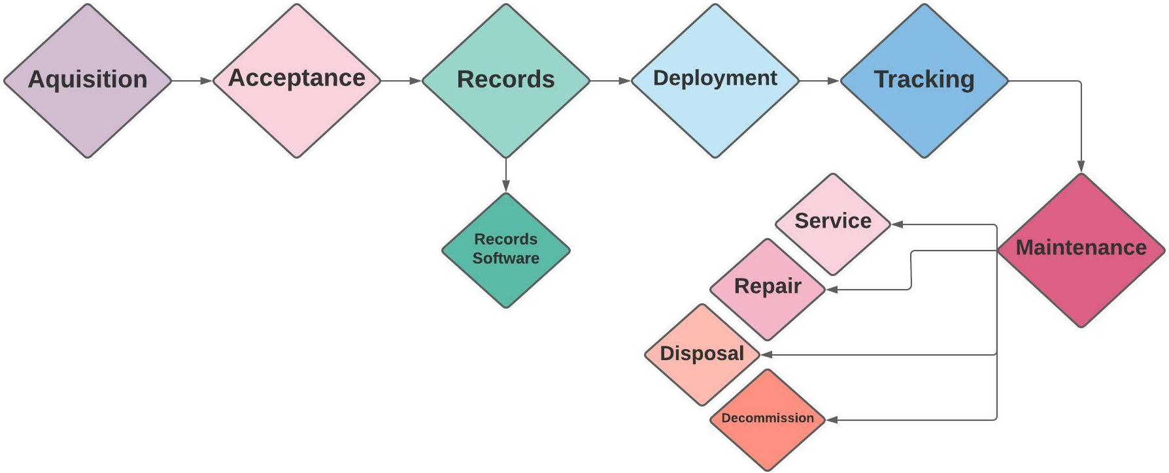

Figure 3. Above outlines the management process of Medical Devices across their life cycle.

7.2 Acquisition

The acquisition of medical devices is a critical phase, ensuring that all equipment introduced into the Trust is safe, effective, and suitable for its intended purpose. Devices may be purchased, leased, or trialled, but must undergo a comprehensive assessment covering safety, suitability, data security, and regulatory compliance in line with MHRA (2024) https://www.gov.uk/government/publications/implementation-of-the-future-regulation-of-medical-devices/implementation-of-the-future-regulations.

Training requirements, installation, commissioning, and ongoing maintenance arrangements must also be considered, along with reliability, warranty, and total cost of ownership. Adequate support, including servicing, calibration, spare parts, and backup devices during downtime, must be ensured to maintain patient safety and service continuity. New medical devices should only be introduced to the Trust through the correct approval and procurement process. For further information please refer to sub-sections 8, 9 and 10 on Procurement, Prescribing and Training. Please refer to Appendix 8a for ELFT’s Acquisition Flowchart.

7.3 Acceptance

Acceptance testing ensures devices meet required standards, are safe, and comply with legislation. The process includes:

Delivery Checks
- Verify correct product, accessories, and usage/maintenance info are supplied
- Confirm specifications match the purchase order or tender
- Ensure devices arrive in good condition and working order
- Follow manufacturer’s instructions for any initial testing, calibration, or adjustment. For further information please refer to Appendix 8b for ELFT’s Acceptance Testing Flowchart.

Safety and Calibration Checks
Certain devices require calibration as part of scheduled maintenance, including:
- Manual defibrillators/monitors
- Blood glucose monitors
- Manufacturer’s service intervals and MHRA electrical safety guidance are followed

Legal Requirements for Electrical Safety
The Electricity at Work Regulations (EWR) and the Health and Safety at Work etc. Act (HASAWA) form the basis of programmes used by hospital technical staff for the regular electrical testing or inspection of portable electrical equipment. Carrying out a risk assessment may determine the need for either an inspection or electrical testing. This is to ensure that East London Foundation Trust;
- Provide and maintain safe equipment and work systems
- Provide necessary information, instruction, training, and supervision
- Ensure electrical equipment is not used beyond its safe capacity
- Maintain systems to prevent danger
- Test electronic devices per IEC 60601-1 and IEC 62353 standards, as applicable

Devices on Loan
Devices on loan must be governed by a written agreement outlining management, responsibilities, and liabilities. Delivery and pre-use checks follow the same procedures as purchased devices unless stated otherwise.

Modifications to Re-usable Devices
No medical device may be modified, altered, or adjusted by unauthorised personnel or without manufacturer consent. All changes require written authorisation.

7.4 Records

Before successfully recording an item to the database Medical Devices contractor must provide evidence of:
- A unique identifier for the device, where appropriate
- The purchase price of the equipment
- A full history, including date of purchase and where appropriate when it was put into use, deployed or installed
- Any specific legal requirements and whether these have been met
- Details of installation and/or where it was deployed
- Risk based maintenance schedule
- Details of service and repairs
- End-of-life date, as appropriate
For new Services, please refer to Appendix 8c for ELFT’s New Services Flowchart.
7.5 Deployment

Before deploying Medical Devices for use, all prior steps relating to Acquisition, Acceptance & Record must be completed.

You have primary responsibility for the way in which medical devices are treated and cared for.
- These responsibilities can also include performance checks before use and routine maintenance, such as charging batteries.
- To ensure safe and effective use of medical devices, you will be provided with training as appropriate and clear manufacturer instructions will accompany each medical device on deployment.
- MDSO will ensure that when manufacturers update their information the document library will be updated and hard copies will be disseminated to training managers, who will facilitate the replacement of existing instructions with revised versions.

7.6 Tracking

All Medical Devices can be tracked using the following information:
- Each medical device has a serial number unique identifier which is applied to the device in the form of a label.
- Each device also has a unique asset tag applied in the form of a label.
- When a device is allocated to a vehicle, station or personal issue, a location label is applied.
- Identification details of all medical devices are logged in the data management system for reference and to facilitate location when required.

7.7 Maintenance

The Trust is responsible for ensuring that medical devices are maintained appropriately. ELFT contracts out this service.
- Arrangements to ensure items subject to inspection, maintenance, or disposal are decontaminated beforehand
- The maintenance database is validated for its intended use and functionality

A service label is attached to each medical device detailing the next service due date.
Service intervals are annual and also determined by the manufacturer’s instructions, operating guidelines and risk assessments where applicable.

Staff authorised to use medical devices should ensure that the device continues to function correctly. This entails regular inspection and care, as recommended in the manufacturer’s user information and local procedures, such as:
- Checking that it is working correctly before use, regular checks
- Reporting faults and damage to the Contractor and MDSO and Trust Incident Reporting Platform.
- Regular cleaning

Decontamination
Items subject to inspection, maintenance, repair or disposal, should be decontaminated, as required, beforehand.
Items should be labelled accordingly and a declaration of contamination status form completed.
Devices intended for single-use only do not require decontamination. Please refer to Appendix 8d for ELFT’s Decontamination Flowchart
Single Use Medical Devices
Wherever possible the Trust will seek to utilise single-use medical devices throughout its clinical operations in order to minimise the risk of infection in accordance with the Trust’s Waste Disposal Policy.

7.8 Successful Booking of Repair

- Report on Trust Incident Reporting Platform to be completed
- MDSO to be informed
- The Contractor to be informed
- Devices beyond economical repair should be replaced for cost effectiveness
- Arrangements for substituting item for repair with a similar device, as appropriate

Medical devices requiring repair should be withdrawn from service as soon as possible and replaced.
The MDSO should be contacted to facilitate the necessary repairs or disposal, as appropriate. Repairs should only be undertaken by ELFT competent contracted Engineer in line with MHRA (2021). Please refer to Appendix 8e for ELFT’s Repairs Flowchart.

7.9 Successful Disposal of Device

Decommissioning
At the end of their scheduled life expectancy, all medical devices will need to be replaced. The expected life cycle of a medical device is held in the equipment inventory records, which is regularly reviewed.
A manufacturer’s recall of a device will take precedence over other considerations.

Preparation
Medical devices deemed unfit for use by an Engineer should be decommissioned. This is to ensure that an inappropriate person does not use the device and expose themselves and/or others to hazards.

Erasing stored data
If a medical device stores patient identifiable data, this should be certified as securely erased before disposal.
The IT Department shall be consulted over the reuse of IT equipment.

7.10 Successful Decommission of Device

Disposal
Some waste products need specialised disposal. Examples include:
- Wastes containing certain metals (e.g. mercury above 3%, some batteries)
- Oil wastes (including polychlorinated biphenyls/PCBs)
- Wastes from coolants
- Radioactive waste
- Healthcare wastes from human or animal origin
- Human waste from natal care, diagnosis, treatment or prevention of disease.

When disposing of medical devices, the MDSO will liaise with other specialists within the Trust, as appropriate to ensure safe disposal and adherence to legislation.
Engineers will also contact the manufacturer, who should be able to provide details of the current waste disposal techniques and processes applicable to their products.

Transport of Medical Devices Before Disposal
When returning medical devices to the manufacturer at end of life, or when transporting devices, Engineers will ensure that they are appropriately packaged and secured.
They will adhere to the legislation that applies to the transport of goods by road and rail:
- The Carriage of Dangerous Goods by Road Regulation
- The Carriage of Dangerous Goods by Rail Regulation
- Chemicals (Hazard Information and Packaging for supply) Regulations

These are covered below.

7.11 User Servicing

User servicing is the responsibility of the user (staff or patient/client). This may involve daily checks e.g. syringe drivers, glucose monitoring machines, DEFIBs, regular cleaning, record of checks and any findings. Users must have the appropriate training before carrying out these checks.

7.12 Scheduled Servicing

Scheduled servicing, maintenance, and calibration of medical devices are carried out by the Contractor on behalf of the Trust. Please refer to Appendix 8g for ELFT’s Scheduled Visits Flowchart.
The Contractor maintains a database of all equipment requiring servicing, with newly purchased items added by the Contractor upon notification from the manager.

The Contractor is responsible for adhering to the agreed servicing schedule, monitored through a bi-monthly contract review with the Trust, led by the Physical Health Lead Nurse. Any contract issues are reported to this lead.

The designated Contractor:
- Maintains the Trust-wide Medical Devices asset register for tracking.
- Responds to repair requests for faulty equipment.
- Conducts acceptance testing on all new devices prior to use.

Planned Preventative Maintenance (PPM) follows manufacturer guidelines and is documented within the equipment database, indicating the required level of maintenance support. Users are responsible for routine maintenance such as cleaning, preparation, and user checks. See Maintenance Flowchart

Damaged or malfunctioning devices must be immediately removed from service, clearly labelled, and reported to the DME&P&P help desk for action.

All medical devices undergoing PPM, repair, removal, loan, or disposal must be decontaminated according to manufacturer instructions or before release by the user or clinical service.

Disposal of equipment follows manufacturer guidance and complies with the Trust’s Standing Financial Instructions, Waste Management Policy, and Waste Electrical and Electronic Equipment (WEEE) Regulations 2006.

7.13 Equipment Faults

Faulty medical devices and equipment must be removed from service and isolated as soon as practicably possible. Such items should be clearly labelled and tagged to prevent inadvertent reuse. They must also be cleaned according to the Infection Policy and decontamination SOP and accompanied by a Declaration of Contamination Status form. The fault should be reported to the contracted engineers.

The contractor will arrange for an engineer to investigate the fault and report back to the manager for appropriate action.
If the faulty equipment has caused, or could have caused, injury to staff or patients/clients, this must be reported through an incident report on the Trust Incident Reporting Platform and may be subject to a report to the MHRA—see the Incident Reporting and Management Procedure.

It is each individual’s responsibility to ensure that the equipment they use is in a serviceable state before clinical use. A serviceable state means:
- No visible damage
- Passing pre-use checks
- Not previously reported as faulty
- Service due date has not expired

All maintenance procedures must follow the manufacturer’s recommendations.

The expected life cycle of each device or piece of equipment should be recorded in the database and regularly reviewed in relation to usage, maintenance, and repair records to determine if adjustments to the end-of-life date are needed. Heavy use or irregular maintenance may shorten the life cycle, while limited use may extend it. Manufacturer recalls take precedence over other considerations.

Factors to consider when assessing equipment lifecycle and replacement:
- Whether the device is damaged or worn beyond economic repair
- Reliability (service history)
- Clinical or technical obsolescence
- Possible benefits of newer models (features, usability, clinical effectiveness, lower running costs)

8.0 Procurement

All medical device purchases must comply with ELFT’s Standing Orders and Standing Financial Instructions (SFIs).

Where practicable, the range of makes and models performing the same clinical function should be standardised. This best-practice approach supports:
- Economies of scale in purchasing equipment and consumables
- Reduced costs for spare parts and training
- Improved operational flexibility across departments
- Reduced clinical risk by minimising variation in device use and maintaining staff competence

The selection process takes into account care objectives and priorities of the healthcare organisation and the needs of the patients. The process should consider whole life costs and follow the national acquisition policy and recommendations, including any regional or national aggregation of procurement where this results in best value for money.
The Procurement Team jointly with Budget Holders and Local Teams should ensure consumables are cost effective for the life of the device if applicable. This would include the cost of the device and its maintenance and the lifetime costs of consumables.

The procurement process should take account of the Trusts standardisation procedures, furthermore; Safety, quality and performance considerations are to be included in all acquisition decisions.

The recommendations of the MHRA and other appropriate bodies are to be considered before selection and acquisition.

Acquisitions must comply with ELFT Asset Management & related Policy and ensure that cybersecurity vulnerabilities are addressed.

When new equipment is being considered for procurement and a shortlist has been established, selected items may undergo demonstration or a defined trial period within the relevant clinical setting. During this phase, feedback must be actively sought from all intended clinical users to assess functionality, usability, and suitability for operational needs.

The Procurement Team will coordinate the trial process in collaboration with clinical leads, ensuring that user feedback is documented and incorporated into the final evaluation. This approach supports evidence-based decision-making and ensures that the selected equipment meets both clinical and organisational requirements.

All trial and evaluation activities must comply with relevant Trust policies, procurement regulations, and clinical governance standards. Any equipment introduced for trial must meet applicable safety and regulatory requirements prior to use in patient care environments
The trial process and outcomes must be formally reviewed by the Procurement Team and relevant clinical stakeholders. A summary report of findings, user feedback, and recommendations should be submitted to the appropriate governance group or decision-making body. This ensures transparency, accountability, and alignment with strategic priorities.

9.0 Prescribers of Medical Devices

As Medical Devices become more sophisticated and frequently used, there are risk implications for the healthcare professionals and patients who use them. Prescription of a Medical Device is the process that ensures only the most appropriate item of equipment is given to a patient or carer as part of an overall treatment plan. Clinical risk is reduced by permitting only appropriately trained healthcare professionals to prescribe a Medical Device for use by patients.

The person prescribing will need to have the knowledge and skills to ensure that:

- An appropriate device has been selected.
- The device has been appropriately maintained and decontaminated.
- It has been adjusted (if necessary) for the individual patient.
- The patient or carer is educated and supported in its use.
- Appropriate documentation has been completed. Competency in the correct use of Medical Devices will ultimately result in a reduction in clinical risk and the delivery of high-quality care.
- For Community Non-Medical prescribers who are advanced practitioners prescribe bespoke items depending on needs of patient using FP10.

9.1 Dispensing Prescribers

Prescribers who also dispense are responsible for maintaining a database that includes:
- Manufacturer’s details.
- Serial number.
- Warranty details.
- Date of distribution.
- End of life.

Prescribers are also responsible for:
- Registering the equipment with the appropriate provider company.
- Informing the GP.
- Ensuring the patient is trained.

10.0 Training

10.1 Training and Competence in the Use of Reusable Medical Devices

The Trust is committed to ensuring that all staff are trained, assessed as competent, and confident in the safe use of medical devices, including reusable and software-based devices. This applies to permanent, temporary, bank, agency, and locum staff.

Responsibilities

Ward Managers and Service Leads
- Identify training needs within their teams and maintain a local training matrix.
- Ensure device-specific training is delivered before staff use equipment.
- Confirm completion of training and competency assessments.
- Schedule annual refresher training and maintain records for audit.
- Delegate competency evaluations to appropriately trained personnel.
- Download and complete competency forms from the Medical Devices Intranet Page
- Completed competency to be filed ready for inspection

Purchasers of Equipment
- Ensure a training plan is in place for any new device introduced.
- Verify that manufacturer training materials and user manuals are available.

Staff Requirements
- Medical devices must only be used by staff who have completed training and been signed off as competent.
- Until competency is confirmed, staff may operate equipment only under supervision.
- Competency must be reviewed annually and documented in appraisal records.
- Staff must report any gaps in confidence or knowledge to their manager.

Decontamination Training
- All staff must receive training on correct cleaning and decontamination procedures for devices they use.
- Compliance will be monitored through quarterly infection control audits. Please see section 13 and Appendix 6.

10.2 Staff Competence and Professional Accountability

Registered Practitioners
- Maintain up-to-date knowledge and skills in line with the NMC Code (2015).
- Undertake regular CPD and competency reviews.

Support Workers, Apprentices, and Visiting Staff
- Work within the scope defined in the Training and Competence Logbook.
- Engage in ongoing development as outlined in the Skills for Care & Skills for Health Code of Conduct (2013).

All Staff
- Must complete induction training, device-specific training, and refresher sessions.
- Competence will be assessed during induction, when learning new skills, and when new equipment is introduced.

11.0 Medical Devices Provided to the Trust by External Suppliers

Medical devices may be made available to the Trust under the following arrangements:
- Loaned or Trial Devices – Provided temporarily to meet short-term clinical needs or support evaluation prior to purchase.
- Rented or Leased Devices – Supplied under commercial agreements for short- or long-term use without immediate capital purchase.

The introduction of any externally supplied device must follow formal governance and risk assessment processes to ensure patient safety, regulatory compliance, and value for money.

11.1 Governance Requirements
- All loan, rental, or trial arrangements must be approved by the Medical Devices Team before deployment.
- A written agreement must outline responsibilities, indemnity, and liability for the device.
- Devices must undergo acceptance testing, risk assessment, and decontamination checks prior to use.
- Manufacturer documentation (including UKCA/CE marking and instructions for use) must be verified.

11.2 Roles and Responsibilities

Medical Devices Team
- Advise on appropriate devices for loan, rental, or trial.
- Ensure indemnity and insurance arrangements are in place before use.
- Maintain a central register of all externally supplied devices, including service history and return dates.
- Collaborate with the Quality Assurance Team to cascade safety notices and monitor compliance.
- Confirm cybersecurity and data protection requirements for devices with software components.

Procurement Team
- Secure cost-effective agreements and verify compliance with Trust procurement standards.
- Ensure contractual terms include adherence to MHRA regulations and Trust policies.

Clinical Services
- Confirm staff training and competency before device use.
- Report any faults or incidents immediately via the Trust Incident Reporting System.
- Get permission from Medical Devices team before accepting a loan device or trialling a device

11.3 Instructions/Guidance

All users, end users and technical staff must have access to manufacturers’ instructions.
It is the responsibility of each Directorate to ensure user manuals are current for the device(s) in use in their area and that revised user manuals are requested when devices receive software upgrades after repair or service.

Each device will have a risk log with appropriate mitigations in the use of the device available as part of the deployment of the solution.

12.0 Resale of Medical Devices

Medical Devices regulations only apply to medical devices being sold for the first time. There is no legislation which specifically covers the resale of medical devices or equipment.

However, used medical devices are still required to be safe under other national provisions including:

- Consumer Protection Act
- Sale & Supply of Goods Act
- Health & Safety at Work Act
- Trade Descriptions Act
- The Electrical Equipment (Safety) Regulations
- Unfair Contract Terms Act

Before any sale or transfer of equipment takes place, both parties should be clear about their legal liabilities (this must include the MDM): When purchasing or acquiring medical devices, organisations may inherit liability for previous incidents or unpaid hire purchase costs if appropriate contracts are not in place. Vendors sometimes ask purchasers to sign disclaimers stating that they accept full future responsibility for the equipment, and devices may be sold on an “as seen” or “buyer beware” (caveat emptor) basis, transferring most liabilities to the purchaser while the vendor may still retain contributory negligence.

In general, the more comprehensive and transparent the information provided by the vendor, the lower the inherited liability. Under the Medical Devices Regulations, manufacturers are required to supply all information necessary to verify that a medical device can operate correctly and safely, including details of maintenance and calibration needed to keep it functioning properly.

This principle of full disclosure should also extend to the sale or donation of used equipment. Accordingly, whenever a device is resold, donated or otherwise transferred, the new owner should receive a clear statement confirming the transfer, a certificate of decontamination, all relevant user manuals and training requirements, full maintenance and servicing details, service and usage histories, quality assurance test records, and any safety updates or MHRA/manufacturer documents released since the device was first supplied.

NOTE: If any of the above information is not available, it may not be appropriate to pass the equipment on to a new user
13.0 Decontamination and Cleaning

Medical devices may serve as vehicles for the transmission of infection to susceptible hosts. Decontamination is the combination of processes (including cleaning, disinfection and sterilization) used to make a re-usable Medical Device safe for further use on patients and handling by staff. The effective decontamination of re-usable Medical Devices is essential in reducing the risk of transmission of infectious agents.

All staff will clean/decontaminate any Medical Device after use in accordance with the manufacturer instructions.

Staff will ensure that all disposable items for single use are disposed of after single use in the appropriate manner.

Staff will ensure that all Medical Devices have a cleaning schedule and that is available as evidence for audit or inspection from both internal and external inspectors.
Appropriate arrangements must be in place for the decontamination of all Medical Devices in service within the Trust. This includes contaminants from the normal use of the equipment, and from any other related activity that might affect it.

Details of the arrangements and processes relevant to the decontamination of Medical Devices can be found in the Trust’s Infection Prevention and Control Policy.

For support and advice about decontamination, contact the Infection Prevention and Control Team.
Please see Infection Prevention and Control Policy Manual & Appendix 5 for Disposal of Medical Devices SOP

14.0 Contractor Medical Equipment Asset Register

All service areas should maintain accurate local registers of devices which are able to demonstrate their maintenance/service history from acquisition through to disposal. The maintenance contractors will maintain an external database (accessible by ELFT staff) of all ELFT Devices and agree on an annual program of planned Preventative Maintenance to ensure devices are safe and accurate. All medical equipment will be entered onto the equipment management database by the Contractor detailing the following:

- Unique identifier for service organization.
- A full history, including date of purchase and where appropriate, when it was put into use, deployed or installed.
- Service schedule (if applicable, and to include calibration).
- Maintenance schedule.
- Supplier and manufacturer.
- Purchase date and warranty period.
- Any specific legal requirements.

14.1 Local Medical Equipment Asset Register

All clinical areas will have a logbook that details the lifespan of all equipment within the clinical area. This will include:

- Documentation on receipt of an item.
- Certificates of calibration.
- Warranties.
- Servicing history.
- Repairs history.
- Decontamination certificates if the item has been returned for repair outside the organization.
- Cleaning and checking schedules.
- Certificate of disposal.

15.0 Medical Beds

Medical beds used within inpatient settings may be purchased or hired according to need.
For existing beds within the Trust, a retrospective risk assessment covering bed-rail use and falls risk must be completed for each service user, in line with the Falls Prevention Policy.

For any new bed (purchased or hired), an independent risk assessment covering bed-rail use and falls risk must be completed before the bed is placed on an inpatient ward.
Medical Devices Team and local services must maintains an up-to-date inventory of all medical equipment, including beds, which is reviewed at least annually or when new equipment is acquired.

This record includes contractual agreements, maintenance schedules and servicing requirements in accordance with manufacturers’ specifications.

Mattress types must be compatible with infection control protocols and patient risk assessments.

Wooden beds are strictly prohibited within the Trust. This decision is based on clinical evidence and infection control guidance indicating that:
- Porous surfaces in wood can harbour bacteria and pathogens, increasing the risk of healthcare-associated infections.
- Cleaning limitations: Wood is more difficult to disinfect thoroughly compared to metal or composite materials.
- Moisture retention in wood can lead to mold growth, which poses respiratory risks to vulnerable patients.
- Durability concerns: Wooden frames are more prone to wear and damage, compromising patient safety over time.

The Trust prioritizes materials that support rigorous hygiene standards and long-term patient safety.

All profiling beds purchased or hired within the Trust must adhere to the following internationally recognised standards:
- BS EN 60601-2-52:2010+A1:2015 Particular requirements for the basic safety and essential performance of medical beds This standard applies to medical beds intended for adults and includes specifications for bed dimensions and permissible gaps between rails and the bed frame to prevent entrapment.
- BS EN 50637:2017 Medical electrical equipment – Particular requirements for the basic safety and essential performance of medical beds for children This standard covers beds designed for children and individuals of small stature, ensuring appropriate safety and performance criteria are met.

In addition, all profiling beds must be:
- Entrapment-free, ensuring no risk of patient injury due to gaps or mechanical hazards.
- Ligature-free when used in mental health settings, to reduce the risk of self-harm and support safe therapeutic environments.

Procurement teams and anyone responsible for purchasing or ordering of beds must verify compliance with these standards prior to acquisition or deployment.

The Trust does not supply medical beds for community service users. Patients in the community assessed as needing a medical bed must be referred to their local authority or district nursing team for assessment and provision. Please see Appendix 10 for MHRA Bedrails Alert and SOP and policy Intranet.

16.0 Electronics Software

The Medical Devices Safety Officer (MDSO), supported by the Lead for Physical Health, will coordinate the evaluation of all prospective medical devices that include software components or are software-based. This process will be conducted in collaboration with IT Services, clinical experts, and the Information Governance Lead to ensure:
- Full compliance with MHRA regulations and UK Medical Device Regulations.
- Alignment with cybersecurity standards, including patch management, vulnerability assessments, and version control.
- Integration with the Trust’s Clinical Safety Case and Digital Safety Programme.

Directorates proposing digital or software-based medical device projects must prepare a comprehensive report for submission to the Digital Strategy Board. This report must include:
- Clinical and operational benefits.
- Risk assessment and mitigation strategies (including cybersecurity risks).
- Deployment and maintenance plan.
- Data protection and information governance compliance.

The Director of IT & Systems will review all new software applications to determine whether they constitute a medical device under MHRA guidance. Any product, including clinical information systems, decision-support tools, or telehealth platforms, will undergo formal classification and risk assessment prior to deployment.

Where software qualifies as a medical device, the Medical Devices Team will:
- Request and verify manufacturer documentation (including UKCA/CE marking and conformity assessment).
- Ensure cybersecurity measures are in place (e.g., encryption, secure updates, penetration testing).
- Seek MHRA guidance in cases of uncertainty.

Certified software-based medical devices (e.g., electronic health records, diagnostic apps) will be included in the Clinical Safety Case and managed under the IT Clinical Safety Programme.

Before deployment, the Medical Devices Group, IT, and Information Governance will jointly:
- Validate system safety and compliance.
- Approve risk mitigation measures.
- Confirm cybersecurity resilience to prevent patient safety compromise.

All services proposing digital projects must contact the Digital Programme Management Office (PMO) at elft.digitalpio@nhs.net for initial review and governance alignment.

17.0 Tele-Health and Tele-Care

Tele-Health is the delivery of health services or information using telecommunications technologies. It enables monitoring of vital signs such as blood pressure, heart rate, blood oxygen levels, weight, and blood glucose in a patient’s home. The data can be transmitted to a healthcare professional, allowing observation without the patient leaving home. Increasingly, data may be stored on a server, and software may interpret the information, which could be considered a medical device.

Software used in Tele-Health may or may not be classified as a medical device under MEDEV 2.1/6 (f.4) for home care monitoring (wired or mobile). Standalone software for archiving or transferring patient results is not an IVD device, as results remain readable and understandable by the user without software intervention. Similarly, the telecommunication system itself (mobile, wireless, wired, etc.) is not considered a medical device. Tele-Health systems that manipulate or act on transmitted data can be regarded as medical devices.

For example, the Trust’s Florence simple Tele-Health system is not classified as a medical device. The MHRA advises that Florence is most likely not a medical device, as it functions primarily as a transport and storage medium for raw data and does not de-skill clinical work (e.g., by performing clinical calculations or interpreting data). While MHRA guidance is not legally definitive, it remains the most reliable regulatory advice available.

17.1 Home Tele-Health Systems with Connected Monitoring Devices

MHRA requires individual devices to be CE marked as Medical Devices but does not require a system to be CE marked as a Medical Device unless it is placed on the market as a single product. Items such as the hub and possibly the motion detector (depending on the claims of the manufacturer) are not likely to be CE marked Medical Devices as they do not have a medical purpose. However, the software that runs on the server and interprets or interpolates the patient data is likely to be a Medical Device and would be regulated as such.

18.0 Risk Assessment and Reporting

18.1 Risk Assessment

In line with the Medicines and Healthcare Products Regulatory Agency (MHRA) guidance and the Learning from Patient Safety Events (LFPSE) Framework, risk assessments are to be conducted or reviewed as appropriate prior to new devices being accepted into Trust service and prior to allocation to a service user in the community for individual use.

These risk assessments should be implemented:
- Post incident review
- Change of model or function
- As advised by the Trust or legislation
- As directed by a patient safety alert in line with MHRA requirements

Risk assessments are to be logged, with a copy retained within the service, and brought to the attention of “users” at the earliest opportunity.

Medical Devices are to be risk assessed by a competent person delegated by the Service Lead and documented to ensure that any hazards and risks identified are appropriately recorded. Mitigating actions should be taken in relation to usage (including assembly, disassembly, and accessories), training, maintenance, servicing, decontamination, and disposal associated with a particular device.

18.2 Reporting Adverse Incidents / Dissemination Medical Device Alerts

For all incidents involving Medical Devices that occur within the Trust. In the first instance staff are to ensure that any patient and/or staff wellbeing or safety is not compromised, then immediately remove the item from use. The department manager must then be informed as soon as possible after the incident. Staff must complete an Incident Report form and retain the device should an investigation be required. There is also a requirement to report incidents involving Medical Devices to various external agencies where it is implicated in a "patient safety incident.”. Once equipment involved in an incident has been removed from use, users must do the following:

Quarantine the suspect device, together with any associated consumables.
Inform the MDSO as soon as possible after the event.
The equipment should clearly label ‘FAULTY EQUIPMENT – DO NOT USE’.
The department manager should then liaise with the MDSO and the Physical Health Lead who will determine if the equipment is safe to use.

Adverse incidents can be easily reported online through the Yellow Card scheme:
https://yellowcard.mhra.gov.uk/

The National Patient Safety Alerting Committee (NaPSAC,) set up 2018 is developing common standards will also have a role in ensuring alerts are received and takes identified actions. These standards and thresholds agreed by NaPSAC will underpin CQC’s inspection of National Patient Safety Alerts and any regulatory response to non-compliance.

The role of NaPSAC
- Developing common standards and thresholds for National Patient Safety Alerts
- Developing a single recognizable consistent format for National Patient Safety Alerts
- Overseeing the development of a process to ensure all alert issuers reach these common standards and thresholds.

Central Alert System (CAS) from the Medical and Healthcare Product Regulatory Agency (MHRA) and National Patient Safety Agency (NPSA).

The Trust generates and also receives medical device safety alerts from external agencies such as the Medicines and Healthcare Products Regulatory Agency (MHRA), the National Patient Safety Agency (NPSA) and others through the Central Reporting System. The Central Alert System Lead distributes to the relevant speciality leads, ensuring they are disseminated throughout the organisation and followed up on the implementation of actions required by information received from alert notices and recorded on the Trust Incident Reporting Platform. The Central Alert System Lead provides a report to the Trust Medical Devices group and Quality Committee of all alerts received via CAS for compliance/governance purposes. This includes monitoring responses within the given deadlines and transmits all responses via the national Central Alert System (CAS). All staff are responsible for ensuring they read and act upon any safety alerts that are distributed to them.

ELFT’s response to these alerts is monitored by both the CQC and Commissioners who can impose financial penalties on the organisation if these alerts are not actioned within the deadlines stated in the alert. The Managing Safety Alerts Procedure outlines the procedures and process for providing assurance to the trust that alerts have been actioned as documented a recorded on the Trusts central electronic system.

18.3 Local Dissemination Process for Field Safety Notices for Inpatients

When a Field Safety Notice (FSN) is issued, the Medical Devices Team will email the Alert and Feedback Form to Matrons and Lead Nurses who must forward the alert to Physical Health Nurses, who will begin collecting evidence as required.

If the FSN is for information only:
- Physical Health Nurses email the alert to Team Managers (with read receipts) and update the Safety Alert Tracker.
- Team Managers cascade the alert to staff and discuss it in Team Meetings.
- Physical Health Nurses send tracker data to the relevant Trust Lead.

If the FSN is for action:
- Physical Health Leads email the alert to Team Managers.
- Team Managers complete the required actions, fill in the Feedback Form, and then return it to Physical Health Nurses.
- Physical Health Nurses update the tracker and forward all feedback forms to the MDSO, copying the Medical Devices inbox.

The alert remains open until all actions are completed. Non-response from any service will result in an incident report raised by the Central Team.

18.4 Local Dissemination Process for Field Safety Notices for Community Health Services

When a Field Safety Notice (FSN) is issued, the Medical Devices Team will email the Alert and Feedback Form, including relevant action points, to CAS Champions, who are responsible for coordinating the local response.

If the FSN is for information only:
- CAS Champions email the alert to Team Managers (with read receipts) and update the Safety Alert Tracker.
- Team Managers cascade the alert to staff and discuss it during team meetings.
- CAS Champions extract tracker data and send it to the relevant Trust Lead.

If the FSN is for action:
- CAS Champions email the alert to Team Managers.
- Team Managers complete the required actions, fill in the Feedback Form, and return it to the relevant CAS Champion.
- CAS Champions update the tracker and forward all completed feedback forms to the relevant Trust Lead.

The alert remains open until all required actions are completed. If a service does not respond, the Central Team will raise an incident report.

19.0 Implementation and Monitoring

19.1 Policy Dissemination
- The approved policy will be published on the Trust Intranet and promoted via the Communications Team.
- Managers are responsible for cascading the policy within their teams and ensuring staff understand their responsibilities.
- Key points of the policy must be included in local induction programmes and discussed during annual appraisals.

19.2 Training
- Where significant changes are introduced, targeted training sessions or e-learning modules will be provided.
- All staff must confirm awareness of the policy through local compliance checks.

19.3 Monitoring and Assurance
- Compliance with this policy will be monitored through:
- Quarterly audits of medical device management (procurement, maintenance, training records).
- Incident trend analysis for device-related events.
- Review of MHRA alert response times and completion of required actions.
- Local Quality Groups will oversee implementation within directorates and report findings to the Quality Committee.

19.4 Performance Reporting
- Directorate Quality Groups will produce an annual compliance report summarising:
- Audit results
- Training completion rates
- Incident data and lessons learned
- This report will be submitted to the Medical Devices Group and the Quality Committee for assurance and continuous improvement.

19.5 Continuous Improvement
- Findings from audits and incident reviews will inform updates to the policy and associated SOPs.
- Any gaps identified will be addressed through action plans monitored by the Medical Devices Group.

20.0 References

- Care Quality Commission (CQC) (2014) Regulation 15: Premises and equipment – Essential Standards of Quality and Safety. https://www.cqc.org.uk/guidance-providers/regulations-enforcement/regulation-15-premises-equipment (Accessed: 17 September 2025).
- Care Quality Commission (CQC) (2014) Regulation 16: Receiving and acting on complaints – Medical Devices Regulations 2002. https://www.cqc.org.uk/guidance-providers/regulations-enforcement/regulation-16-receiving-acting-complaints (Accessed: 17 September 2025).
- Department of Health and MHRA (2021) Managing Medical Devices – Guidance for healthcare & social services organisations (January 2021). https://assets.publishing.service.gov.uk/government/uploads/system/uploads/attachment_data/file/982127/Managing_medical_devices.pdf (Accessed: 17 September 2025).
- GOV.UK (2014, December 18) Decontamination and infection control. Medicines and Healthcare products Regulatory Agency; Department of Health and Social Care. https://www.gov.uk/government/collections/decontamination-and-infection-control (Accessed: 17 September 2025).
- Health and Safety Executive (HSE) (1998) The Lifting Operations and Lifting Equipment Regulations 1998, SI 1998/2307. London: The Stationery Office. https://www.legislation.gov.uk/uksi/1998/2307/contents/made (Accessed: 17 September 2025).
- Medicines and Healthcare products Regulatory Agency (MHRA) (2006) Directive 2007/47/EC: Medical Devices Directive amendment, transposed into UK law by The Medical Devices (Amendment) Regulations 2008 (SI 2008/2936). Medicines and Healthcare products Regulatory Agency. https://www.legislation.gov.uk/uksi/2008/2936 (Accessed: 17 September 2025).
- MHRA (2024) How MHRA ensures the safety and quality of medical devices: report a non-compliant medical device enforcement process. GOV.UK. https://www.gov.uk/government/publications/report-a-non-compliant-medical-device-enforcementprocess/how-mhra-ensures-the-safety-and-quality-of-medical-devices (Accessed: 17 September 2025).
- MHRA (2023) Medical device stand-alone software including apps (including IVDMDs). Medicines and Healthcare products Regulatory Agency. Available at: https://assets.publishing.service.gov.uk/media/64a7d22d7a4c230013bba33c/Medical_device_stand-alone_software_including_apps__including_IVDMDs_.pdf (Accessed: 17 September 2025).
- MHRA (2021) Medicines and Medical Devices Regulations – What you need to know. GOV.UK. https://www.gov.uk/government/publications/report-a-non-compliant-medical-device-enforcement-process/how-mhra-ensures-the-safety-and-quality-of-medical-devices (Accessed: 17 September 2025).
- Skills for Care (2013) Code of Conduct for Healthcare Support Workers and Adult Social Care Workers in England. https://www.skillsforcare.org.uk/Documents/Standards-legislation/Code-of-Conduct/Code-of-Conduct.pdf (Accessed: 17 September 2025).
- UK Department of Health (2012) Instrument amending health regulations: S.I. 2012/9780111522752. London: The Stationery Office. https://www.legislation.gov.uk/ukdsi/2012/9780111522752 (Accessed: 17 September 2025).
- UK Government (1974) Health and Safety at Work etc. Act 1974, Chapter 37. London: Her Majesty’s Stationery Office. https://www.legislation.gov.uk/ukpga/1974/37 (Accessed: 17 September 2025).
- UK Government (2025). Implementation of the future regulations. https://www.gov.uk/government/publications/implementation-of-the-future-regulation-of-medical-devices/implementation-of-the-future-regulations (Accessed: 1 October 2025).
- UK Government (2020) Post-Brexit UK domestic legislation. https://www.legislation.gov.uk/eu-legislation-and-uk-law (Accessed: 17 September 2025).
- UK Government (2012) The Health and Social Care Act 2008 (Regulated Activities) (Amendment) Regulations 2012 (SI 2012/9780111522752). London: The Stationery Office. https://www.legislation.gov.uk/ukdsi/2012/9780111522752 (Accessed: 17 September 2025).
- UK Government (1998) The Provision and Use of Work Equipment Regulations 1998, SI 1998/2306. London: The Stationery Office. https://www.legislation.gov.uk/uksi/1998/2306/contents/made (Accessed: 17 September 2025).
- UK Government / Medicines and Healthcare products Regulatory Agency (MHRA) (2025) Regulating medical devices in the UK. GOV.UK. Available at: https://www.gov.uk/guidance/regulating-medical-devices-in-the-uk (Accessed: 22 September 2025).
- UK Statutory Instrument 2008 No. 2936. (2008) The Blood Safety and Quality Regulations 2005 (as amended). London: The Stationery Office. https://www.legislation.gov.uk/uksi/2008/2936/made (Accessed: 17 September 2025).

21.0 Acronyms

Acronym | Definition
IPC | Infection Prevention and Control
MDG | Medical Device Group
MDSO | Medical Devices Safety Officer also known as Medical Devices Lead
WEEE | Waste Electrical and Electronic Equipment

22.0 Key Terms

Term | Definition
Acceptance Testing | This process is carried out by the maintenance contractors on all new equipment to check the equipment meets safety standards.
Asset Register | An inventory of all medical devices, records of which must be available locally
Asset Tag | All reusable medical devices should be tagged indicating date of last maintenance together with the asset number of the device which is traceable on the Asset Register.
Care Quality Commission (CQC) Outcomes | External auditors to NHS organisations. Responsible for assessing the organisation’s compliance against safety outcomes.  Outcome 11: Safety, availability, and suitability of equipment includes monitoring of maintenance of devices, recording skills and competency of staff in the use of devices and compliance with legislation in relation to procurement.
CAS alerts | Central Alert System - The system is used to alert organisations to patient safety alerts (PSA); medical device alerts (MDA) and medication alerts.
CE | The letters CE appear on many products traded in the European Economic Area (EEA). The marking signifies that products sold in the EEA have been assessed to meet high safety, health, and environmental protection requirements.
Cleaning | Physical removal of organic matter and infectious agents.
Decontamination | A combination of processes which removes or destroys contamination so that infectious agents or other contaminants cannot reach a susceptible site in sufficient quantities to initiate infection or other harmful response.
Disinfection | Reduction in viable infectious agents.
Field Safety Notices (FSN) | Information received from Manufacturers or from MHRA regarding issue/s with devices that require correction or sometimes just for information.
Medical Device | Any instrument, apparatus, appliance, material or other article whether used alone or in combination, intended by the manufacturer to be used for human beings for the purpose of control of conception; diagnosis, prevention, monitoring, treatment or alleviation of disease; diagnosis, monitoring, treatment, alleviation of or compensation for an injury or handicap; investigation, replacement or modification of the anatomy or physiological process.  Some examples of medical devices include sphygmomanometer (blood pressure monitor), thermometers, electrocardiograph machine (ECG), thermometers, hoists, syringes and needles. Pulse oximeters, blood glucose meter and weighing scales.
MHRA | Medicines and Healthcare products Regulatory Agency regulates medicines, medical devices, and blood components for transfusion the UK.
Non-Presented Items | Items not presented in a timely manner for servicing in line with MHRA guidance. This could be because items are lost or not available. This needs to be reported on the Trust Incident Reporting System & MDSO.
Planned Preventative Maintenance (PPM) | Cyclical programme for servicing devices. Frequency is based on legislation and the manufacturer’s recommendations.
Pre-Acquisition Questionnaire (PAQ) | Used by NHS organisations involved in the planning and procurement of medical devices.
Reusable medical device | Any medical device that is designed to be used on more than one patient, on more than one occasion. When the term medical device is used in this document it refers to reusable medical devices unless the term single-use is specifically stated. E.g. thermometers, pulse oximeter. Hoists
RiO | Patient electronic Record
Single use device | Any medical device intended to be used on an individual patient during a single procedure and then to be discarded.
Sterilization | Render an object free from all viable infectious agents.

23. Appendices

Appendix 1: Managing Your Clinical Equipment

When reporting a fault please give:
A brief description of the problem

The asset number, make, model and serial number of the item – check the Asset Tag for this and your name, location and telephone number

Let them know if the problem is urgent or not urgent. This allows them to schedule their attendance appropriately.

Appendix 2: Medical Device Incident Reporting Flowchart

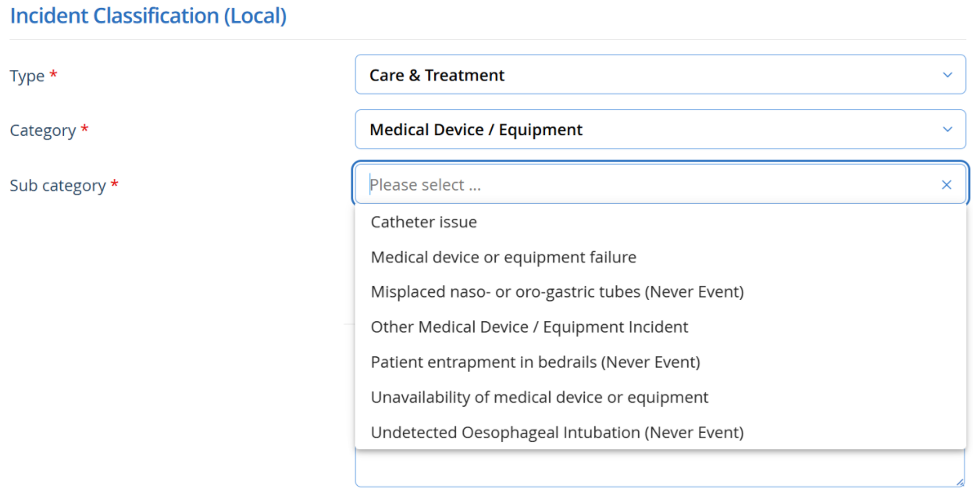

Appendix 3: Medical Devices & Equipment Replacement Application Form

MS Form Link

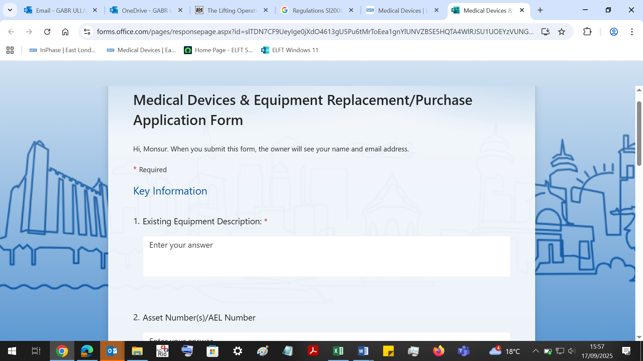

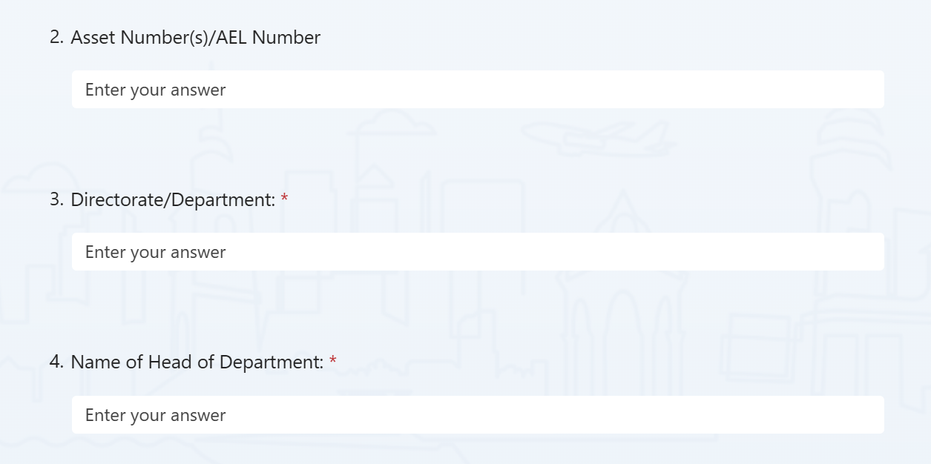

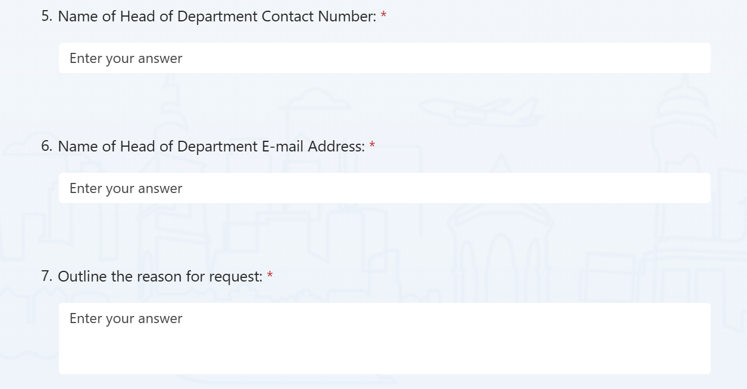

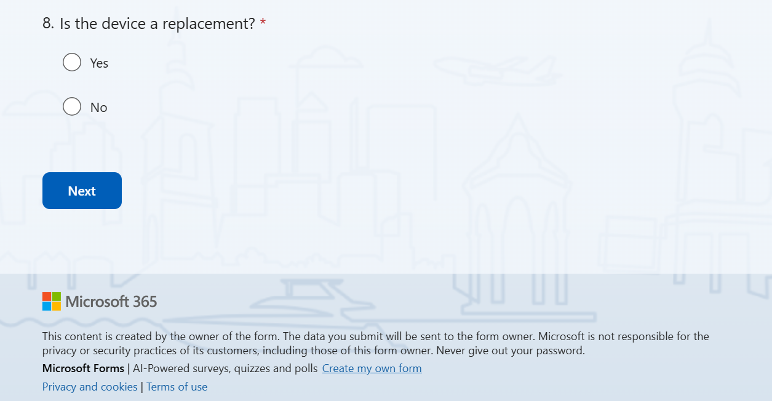
Appendix 4: Decommissioning and Disposal

Decommissioning aims to make equipment safe and unusable, while minimising damage to the environment. Equipment deemed unfit for use should be decommissioned. This should include decontamination, making safe and unusable. This is to ensure that inappropriate persons do not use the equipment and expose themselves or others to hazards. Users should consult the Medical Devices Team or the Estates department for advice before decommissioning commences. Disposal of electrical/electronic equipment should comply with the Waste Electrical and Electronic Regulations 2013. Consult the Medical Devices Team or the Estates Department in the first instance. Some waste products need specialised disposal.

Examples include:
- Wastes containing certain metals (e.g. Mercury above 3% and some batteries)
- Oil wastes.
- Wastes from coolants.
- Radioactive waste.
- Healthcare waste from human or animal origin.
- Human waste from care, diagnosis, treatment or prevention of disease. Where applicable, equipment should be decontaminated before disposal or transfer to a third party and supplied with a certificate of decontamination. When returning Medical Devices to the manufacturer at end of life, or when transporting devices, ensure that they are appropriately packaged and secured. Issues that should be addressed include: strength of packaging materials, protecting sharp edges and ensuring that the device cannot get damaged during transit. Legislation applies to the transport of goods by road and rail the carriage of dangerous goods and use of transportable pressure equipment (amendment) regulations 2011
- Chemicals (hazard information and packing for supply) regulations 2009
- The radioactive material (road transport) regulations 2002
- If a device stores patient identifiable data, this should be securely erased or hard drives removed and sent to IT for destruction when the device is decommissioned. Data on any device should be forensically unrecoverable.

Appendix 5: Disposal of Medical Devices Standard Operating Procedure

Purpose

This SOP has been produced for all those who are responsible for the management of single-use and reusable medical devices when the devices are no longer required This is to ensure all medical devices are replaced as/when required and used devices are disposed of in line with waste regulations. Disposal must comply with relevant Health and Safety legislation, local directives and WEEE legislation. Medical devices must always be decontaminated before reuse, relocation, sale, donation or disposal.

Who does the procedure apply to?
- Authorised Staff of diagnostic and therapeutic equipment
- Ward/Department Managers

When should the procedure be applied?
- When a medical device requires replacing: it has passed its life expectancy or spare parts are unavailable
- When a medical device is condemned
- When a medical device needs to be disposed of

Notification
When a medical device has passed its life expectancy or unavailability of spare parts but is still usable, the contracted engineer will issue the user with a Notification Form.

This is to inform the user that the device will need replacement and if the contracted company is able to replace this device they shall replace it, where the contracted company is not able to replace the devices, this shall be raised with the MDSO.

This device can still be used until the stated date.

Condemnation

When a medical device is permanently removed from use, servicing engineer will issue the user with a Condemnation Certificate and the user shall forward the certificate to the MDSO who will arrange for removal. The Condemnation Certificate will be signed by the condemning engineer and countersigned by service manager or Clinical Lead for that service when the device has been physically removed from service. A Condemnation Certificate will be issued for one of the following criteria:
- worn out beyond economic repair
- damaged beyond economic repair
- unreliable through service history
- clinically or technically obsolete
- spare parts no longer available when a repair is required
- unable to be cleaned effectively prior to disinfection and/or sterilisation
- a device identified in accordance with MPCE local procedure

Once a Condemnation Certificate has been issued under no circumstances must the device be brought back into service?

Disposal

Disposal of medical devices can be arranged through Hilditch Group in line with the guidance of MHRA Managing Medical Devices 2021. The service shall email the MDSO and inform them about devices to be disposed. They should include the condemnation certificate. MDSO shall arrange for the disposal of the condemned devices. For medical devices with patient identifiable information managers should ensure that all patient identifiable data is securely and correctly removed/deleted from the equipment prior to disposal. The Trust has a duty to maintain the security and confidentiality of patient information.

Devices will be either transferred to a Trust approved auctioneer or waste disposal agent in compliance with all national and legal requirements (WEEE regulations) for safe environmental disposal of the device(s).

Condemned devices should be disinfected and packed per infection control protocol
Staff should remove all Trust identifiable labels attached to the medical devices before they are removed from Trust premises for disposal or sale through an approved auctioneer.

Appendix 6: Decontamination of Medical Devices

Routine decontamination of reusable non-invasive care equipment must be done according to manufacturers’ instructions and using suitable cleaning products that are in line with local policy. It should be undertaken:

- Between each use
- After blood and/or body fluid or other visible contamination
- At regular predefined intervals as part of an equipment cleaning protocol
- Before inspection, servicing or repair (Health Protection Scotland, 2015)

The level of decontamination required depends on the level of risk associated with the item.

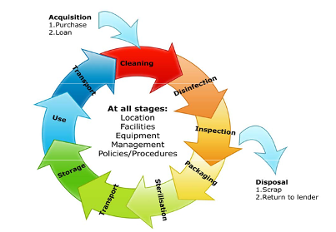
Effective decontamination of medical devices is essential in reducing the risk of cross infection. To ensure that this responsibility is exercised in a responsible and effective way the whole process of decontamination must be considered before purchasing and acquisition of health care equipment, decontamination, transport, storage, disposal. This requires effective management systems covering a range of disciplines and locations across the Trust. It is essential to establish methods of decontamination at the earliest stage of acquisition.

Appendix 7: Missing Medical Devices Protocol

Introduction
The Medicines and Healthcare Products Regulatory Agency (MHRA) requires that all re-usable medical devices are serviced annually and stored safely. Compliance with these requirements is essential to ensure patient safety, maintain regulatory standards and protect Trust assets.

Purpose and Scope
This protocol outlines the procedure for teams to follow when a medical device is missing. Annual servicing often highlights items that are lost or unavailable, which creates financial costs for the Trust and undermines assurance about safe storage and use of devices.

Team Responsibilities
- Safe storage – All medical devices must be stored and decontaminated at the team base after use so they remain accessible and ready for service. Devices must not be stored in cars or homes to prevent theft, damage or battery leakage.
- Tracking devices – Each team must have a clear system to record the sign-in and sign-out of medical devices (e.g. a logbook or electronic register). Missing items must be traced and returned to base at the earliest opportunity.
- Availability for servicing – Team managers and staff are responsible for ensuring all devices are available on the scheduled service date.
- Service date compliance – Staff must check that re-usable devices (e.g. BP monitors) are within their annual service date before use. Devices outside their service date must not be used and must be reported to the MDSO.
- Incident reporting – Team managers must complete an incident report for any device that is lost, stolen or unavailable at the time of annual service.
- Repairs and disposal – Faulty equipment must be reported to the MDSO for repair and labelled ‘Do Not Use’. Irreparable devices will be removed from the asset register and disposed of appropriately by the MDSO.
- Procurement – All medical devices must be purchased through the Trust’s procurement system. Devices bought from high-street or unapproved suppliers must not be used on patients.
- Governance – Services should review medical device issues regularly in business meetings and escalate any losses or misuse to the MDSO.

Reference
Medicines and Healthcare Products Regulatory Agency (2021). Managing Medical Devices. Available online.

Appendix 8: Medical Devices Process Flowcharts

Appendix 8a: Acquisitions Flowchart

Appendix 8b: Acceptance Testing Flowchart

Appendix 8c: New Services Flowchart
Appendix 8d: Decontamination Flowchart
Please refer to Appendix 6 for Decontamination SOP

Appendix 8e: Repairs Flowchart

Appendix 8f: Removals Flowchart
Appendix 8g: Scheduled Visits Flowchart

Appendix 9: Medical Devices Group (MDG) Terms of Reference

Date: | May 2025
CHAIR: | Chief Nurse
MINUTE TAKER: | MDG Administrator
MEETING PURPOSE: | The purpose of the MDG is to provide assurance to the Quality Committee that an effective and robust system exists across the Trust for the safe use of ‘Medical Devices’ and ‘Patient Safety Alerts’ to protect staff and patients.  To enable a strategic overview of Medical Devices, developing systems and reviewing evidence in monitoring the Medical Devices Policy  Monitor contracted services.  The MDG will review significant and complex patient safety and medical device alerts specifically to:  Agree action plans and where necessary identify a named lead / executive lead to individual alerts.  Monitor action plans against progress to ensure that action underway dates and deadline dates are met.  Agree circulation and actions for internal alerts and coordinate communication plans.  Agree Capital BID Projects in line with the trust replacement programme.  The MDG will review and agree the process for managing safety alert.  The MDG will review all serious incidents relating to Medical Devices and where necessary escalate to the internal alert process.  The MDG will also support improvements to Medical Device incident reporting.  The MDG Chair will alert the Quality Committee regarding any Medical Device serious incident.
MEETING FREQUENCY: | Quarterly via video conference call.
REPORTING ARRANGEMENTS: | Quarterly to the Quality Committee.
QUORUM | For any meeting of the Committee to proceed, the following combination of members must be present:  (Chair) Either the Chief Nursing Officer or Chief Medical Officer A duly convened meeting of the Committee at which a quorum is present shall be competent to exercise all or any of the authorities, powers and discretions vested in or exercisable by the Committee. Deputy Director of Infection Control or Infection Control Lead  The Medical Devices Safety Officer
ATTENDANCE | Members are expected to attend all meetings or to send apologies to the Chair and Committee secretary at least five clear days* prior to each meeting. A suitable deputy should be sent to cover any absence. Deputies must be appropriately senior and empowered to act and vote on the behalf of the Committee member. Furthermore, members need to advise the Chair in advance if they have to leave the meeting early or are planning to arrive late.
PAPERS | Meeting papers shall be distributed to members and attendees at least five clear days* prior to the meeting.

AIM To ensure that the Trust adheres to and is compliant with MHRA regulations and to ensure that the requirements of Regulation 16 of the Health and Social Care Act 2008 (Regulated Activities) Regulations 2010 are being met “to ensure the safety, availability and suitability of equipment to protect service users and others who may be at risk from the use of unsafe equipment by ensuring that equipment is provided for the purposes of carrying on of a regulated activity”.

OBJECTIVES Strategic overview of medical devices, developing systems and reviewing evidence in monitoring the Medical Devices Policy Monitor contracted services and Safety Alert Actions.

WORKPLAN
- To develop clear lines of accountability for medical devices management throughout the organisation.
- Ensure that the Trust’s Medical Devices policy is up to date and reflects current good practice and guidance.
- Develop mechanisms to ensure that the acquisition of medical devices conforms to Medical Healthcare Regulatory Agency and National Audit Office recommendations.
- Establish procedures for the formal acceptance and procurement of new equipment prior to clinical use.
- Ensure that systems of maintenance of all devices used within the Trust are robust, including contractual arrangements with the designated contractor.
- Develop a system or inventory to record all new purchases and verify the existence of all medical devices employed in the Trust.
- Ensure there are local systems in place to ensure safety in use of medical devices for example training on new devices to meet requirements of Trust policy.
- Ensure there are systems and processes in place to report adverse incidents involving medical devices which are followed up by directorates with lessons learnt in line with the Trust incident policy.
- To evaluate and monitor CAS safety alerts and reporting.
- Develop strategy for communicating developments and medical devices management policy decisions to the appropriate Trust personnel.
- Ensure involvement of clinicians, technical staff and users in relation to any proposed changes, including configuration settings relating to devices, where appropriate.

MDG Membership (Roles/Titles)
Chief Nurse Chair
Medical Director – Community Health Services
Medical Chief Officer
Director of Nursing – Community Health Services
Director of Nursing – Bedford Community Health Services
Director of Nursing – London Mental Health Services
Director for Patient Safety
Chief Pharmacist
Interim Chief Clinical Digital Officer
Digital PMO Lead
Digital Project Management
Lead Nurse for Physical Health
Medical Devices Safety Officer / Medical Devices Lead
Senior Business Manager, Compass Wellbeing CIC
Risk and InPhase Manager
Infection Control Lead Nurse or Deputy Lead Infection Control Nurse

Appendix 10: MHRA Bed Rail Alert – Risk Assessment, Incident Reporting and Quality Care Responsibilities

This section outlines our organisation’s approach to implementing the MHRA guidance on the safe management and use of bed rails. It covers risk assessment, incident reporting, and staff responsibilities in delivering safe, high-quality care when working with partner organisations.

- Purpose

To ensure compliance with MHRA guidance on bed rails and to protect patients from harm caused by entrapment, falls or misuse of bed rails. This policy applies to all staff who specify, supply, fit or monitor bed rails within our organisation.

- Risk Assessment

- A patient-specific risk assessment must be completed before bed rails are used and whenever the patient’s condition or equipment changes.
- The assessment must consider clinical need, cognition, mobility, body size, seizure risk, and likelihood of climbing over rails.
- Equipment compatibility (bed, rails, mattress, overlays) must be checked against manufacturer instructions and relevant standards (BS EN 60601‑2‑52 for adults; BS EN 50637 for paediatrics/atypical anatomy).
- Where equipment does not meet standards, alternative solutions such as low-height beds, mats, alarms or mesh sides must be considered.

- Staff Responsibilities

- Fit and check bed rails safely according to training and manufacturer’s guidance.
- Document risk assessments, consent discussions and review dates in the patient record.
- Escalate any concerns about unsafe or incompatible equipment immediately to the senior nurse/clinician and repairs contractor/estates teams.
- Participate in regular refresher training on the safe use of bed rails and incident reporting.

- Incident Reporting

- All incidents, near misses or suspected equipment defects involving bed rails must be reported promptly via the organisation’s incident reporting system.
- Where applicable, incidents must be escalated to the MHRA via the Yellow Card scheme and to the manufacturer.
- Lessons learned from incidents will be shared with staff and partner organisations to improve safety.

- Working with Partners

- Where bed rails are provided or maintained by partner organisations (e.g. community equipment services, local authorities), our staff will liaise with partners to ensure risk assessments are shared and equipment is compliant.
- Each organisation is responsible for implementing MHRA guidance within its remit and recording its own completion in the Central Alerting System (CAS).
- Our organisation will document any partner-related risks in our risk register and escalate if patient safety could be compromised.
- Quality of Care

- Compliance with this guidance forms part of our quality assurance and patient safety programme.
- Audits of risk assessments, training records and incident reports will be undertaken to ensure continuous improvement.

- Official MHRA Risk Tool QR Code


- References

Medicines and Healthcare products Regulatory Agency (MHRA) 2023. Appendix 1 – Adult Entrapment Risk Checklist. In: Bed rails: management and safe use. [online] GOV.UK. Available at: https://www.gov.uk/guidance/bed-rails-management-and-safe-use [Accessed 11 September 2025].

Medicines and Healthcare products Regulatory Agency (MHRA) 2023. Bed rails: management and safe use. [online] GOV.UK. Available at: https://www.gov.uk/guidance/bed-rails-management-and-safe-use [Accessed 11 September 2025].

Policy and Guidance for Using Bed Rails, Bed Levers & Turning Device Safely and Effectively (2024) https://www.elft.nhs.uk/intranet/documents/policy-and-guidance-using-bed-rails-safely-and-effectively [Accessed 29 September 2025].

Appendix 11: Related Documents/Policies

The policy should be read in conjunction with:

A full list of Trust Policies are available on the intranet.

The policy should be read in conjunction with:
- Clozapine Policy
- Consent to treatment Policy
- Deteriorating Patient Policy (when available)
- Diabetes Policy
- Do Not Attempt Cardiopulmonary Resuscitation Decisions (DNACRD) Policy
- Incident Management Policy
- Infection Prevention and Control Policy Manual
- Ligature Risk Reduction Policy and Procedure
- Manual Handling Policy
- Nutrition and Hydration Policy (2022)
- Policy and Guidance for Using Bed Rails Safely and Effectively
- Rapid Tranquilisation Policy
- Resuscitation Policy
- Tissue Viability Policy
- Safeguarding Policy
- Sepsis Policy (when available)
- Slips, Trips and Falls Management (Inpatient) Policy Falls Policy (2024)
- Smoke Free Policy (2024)
- Venous Thromboembolism; Reducing the Risk (2023)

A full list of Trust Policies are available on the intranet.
24. Equality Impact Assessment

Name of service, function or policy | Medical Devices Policy
Brief description of service, function or policy (purpose) | To provide guidance on the safety of medical devices systems and processes in ELFT.
Is the service, function or policy | ☒ Existing | ☐ New |  |  |  |  | ☐ Under review
Directorate  (If all groups are impacted, please state ‘Trust-wide’) | Trust-wide
Who is completing the EIA?  (name/role) | Ellynerah Danga – Medical Devices Lead and Safety Officer
Which Trusts Strategies are supported by the service? | Population Health |  |  |  |  |  | ☒
Which Trusts Strategies are supported by the service? | The Experience of Care |  |  |  |  |  | ☒
Which Trusts Strategies are supported by the service? | Staff Experience |  |  |  |  |  | ☒
Which Trusts Strategies are supported by the service? | Improved Value |  |  |  |  |  | ☒
Which Trusts Strategies are supported by the service? | None |  |  |  |  |  | ☐
Who will benefit from the service, function or policy? | ☒ Workforce |  |  | ☒ Patients, Service Users, and Carers
How will the service, function, or policy be implemented to:  - Ensure access  - Meet health needs  - Provide a safe and positive experience for everyone? | The policy will be published on the Trust Intranet and promoted via the Communications Team.  Managers will be responsible for cascading the policy within their local teams to ensure staff understand their responsibilities.  Key aspects of the policy will be included in local induction programmes and discussed during supervision/appraisals.
How will the service, function or policy be implemented? | Approval at Medical Device Committee, Trust-wide Physical Health in Mental Health Group, Nursing Steering Group, Chair’s Action by Chief Nurse and Quality Committee.
What are the intended outcomes by delivering the activity? | To adhere to MHRA guidance on Medical Devices in line with Quality care.
How will these outcomes be measured? | The outcomes will be measure by internal audits, quarterly reports to the Medical Devices Committee and follow-up from alerts via Risk Manager.
Who are the key stakeholders for this activity and how have they been involved? | All staff in ELFT whom use medical devices.
Does this service, function or policy impact other existing policies? | ☐ Yes |  |  | ☒ No
Is there any data available that  influences, affects, or shapes this Equality Impact Assessment? | ☐ Yes |  |  |  | ☒ No
Are there gaps in information?  Consider groups that you have not directly engaged with, or existing data that does not provide then full picture. | ☐ Yes |  |  | ☒ No
Does the service, function or policy have a negative impact on any particular group? | Protected Characteristic |  |  |  |  | Yes |  | No | Unclear
 | Age |  |  |  |  | ☐ |  | ☒ | ☐
 | Disability |  |  |  |  | ☐ |  | ☒ | ☐
 | Race |  |  |  |  | ☐ |  | ☒ | ☐
 | Marriage and Civil Partnership |  |  |  |  | ☐ |  | ☒ | ☐
 | Pregnancy and Maternity |  |  |  |  | ☐ |  | ☒ | ☐
 | Gender re-assignment |  |  |  |  | ☐ |  | ☒ | ☐
 | Religion or belief |  |  |  |  | ☐ |  | ☒ | ☐
 | Sex |  |  |  |  | ☐ |  | ☒ | ☐
 | Sexual Orientation |  |  |  |  | ☐ |  | ☒ | ☐
Could the way the service, function, or policy is implemented have an adverse impact on equality of opportunity or good relations between different groups? | ☐ Yes |  |  |  | ☒ No
 | N/A
Where a negative impact has been identified, can changes be made to minimise it? | N/A
Is the service, function, or policy indirectly discriminatory, and can it be justified? | ☐ Yes |  | ☒ No
 | N/A
Is the service, function, or policy intended to increase equality of opportunity by permitting Positive Action or Reasonable Adjustment? | ☐ Yes |  | ☒ No
 | N/A

