Professional handout on differentiating between the terms ‘learning difficulties’ and ‘learning disabilities’: a decision making framework
Distinguishing between Learning Difficulties and Learning Disabilities is often seen as quite a complex issue.
In general, the term ‘learning difficulty’ (whether moderate, severe or profound/ multiple) is often used in educational contexts and by educational professionals (for example by the Department for Education, Ofsted and schools)
Whereas the term ‘learning disability’ is more likely to be used in health and social care contexts and by health and care professionals.
These differences in terminology are often used interchangeably which can create confusion for both professionals and carers, especially when young people are referred into new service areas.
The Department of Health define a learning disability as:
- A significantly reduced ability to understand new or complex information, to learn new skills (impaired intelligence), with a reduced ability to cope independently (impaired social functioning), which started before adulthood.
A learning disability means:
- A reduced ability to understand new or complex information
- A reduced ability to cope independently
- A reduced ability to learn new skills
- It must have started before adulthood, with a lasting effect on development
- Around 1,043,449 people in England (2% of the population) in the UK have a learning disability and this figure is increasing. The numbers known to learning disability services are much smaller: an estimated 236,235 people.
A learning disability is different for everyone. The degree of disability can vary greatly, being classified as mild, moderate, severe or profound. In all cases, a learning disability is a lifelong condition and cannot be cured.
A learning disability is different to a learning difficulty. A learning difficulty is a reduced intellectual ability for a specific form of learning and includes conditions such as dyslexia (reading), dyspraxia (affecting physical co-ordination) and attention deficit hyperactivity disorder (ADHD). A person with a learning disability may also have one or more learning difficulties. Therefore a ‘learning difficulty' is a condition which present with having difficulties in a specific form of learning but does not affect general intellect.
Additionally, there are a number of conditions and neurological disorders that often involve or cause some type of learning disability, including Down’s syndrome, meningitis, epilepsy or cerebral palsy. A learning disability is not a physical disability.
Autism is not a learning disability but around half of autistic people may also have a learning disability. Autism is a lifelong, neurodevelopmental condition which affects how a person communicates with and relates to other people, and how they experience the world around them.
Some conditions or disabilities may be confused with a Learning Disability.
For example:
- Sensory disability e.g. hearing difficulties
- Mental Health / Personality Disorder– this can affect adaptive functioning
- Epilepsy e.g. drugs impairing intellectual functioning
- Dyslexia, Dysphagia, Cerebral Palsy
- Emotional difficulties e.g. behaviours of distress that may sufficiently have disrupted schooling, influencing achievement.
- Attention Deficit Hyperactivity Disorder (A.D.H.D.) or hyperactive disorder.
- Asperger’s syndrome or Autism.
- Dementia
- Acquired Brain Injury
Causes of a learning disability
A learning disability is caused by something which affects the development of the brain either before birth, during birth or in early childhood. Possible causes may include:
- an inherited condition – for example, Fragile X syndrome
- abnormal chromosomes – for example, Down’s syndrome or Turner syndrome
- exposure to environmental toxins or infections and illness during pregnancy
- a very premature birth
- complications during birth, resulting in a lack of oxygen to the baby’s brain
- illness – for example, meningitis or measles; or injury or trauma to the brain in early childhood
Sometimes the cause of a learning disability remains unknown.

Below is the different classifications of a learning disability based on IQ:
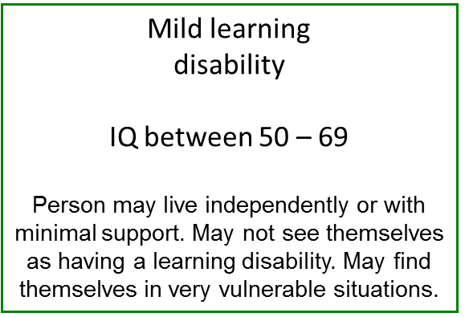
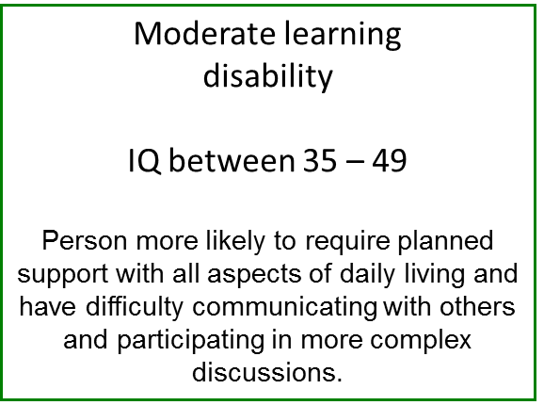

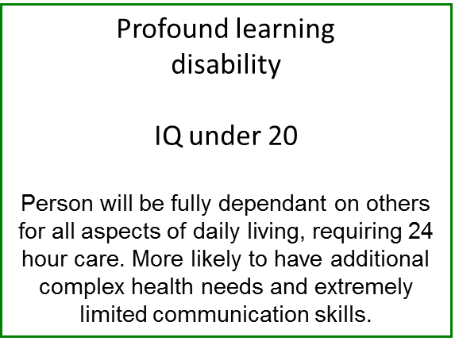
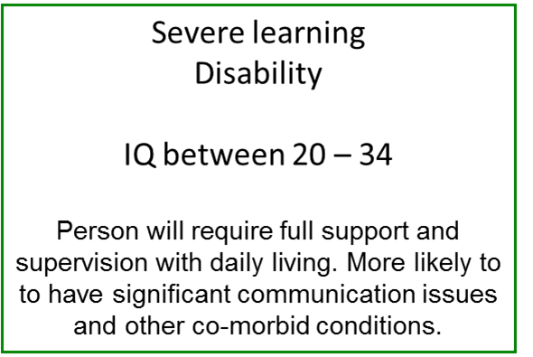

It can be challenging to make a Learning Disability diagnosis at a young age but by the time young people are teenagers, it should be evident what severity of Learning Disability they have. Simple descriptors such as “non-verbal or only limited use of language (single words) and able to understand simple instructions only” might be a good descriptor for a child with severe Learning Disability.
Whether or not a child or young person has a learning difficulty or learning disability, should not affect their ability to access services. Services should always be needs led rather than service led.
Children and young people will be assessed by service professionals using a service’s own eligibility criteria. Children and young people will be able to access services according to their individual needs and not whether they have particular ‘labels’ or diagnoses.
In some instances however it may be helpful to refer to a child or young person’s learning difficulties as a disability or disabilities so that there is a shared understanding of needs between the young person and their family and educational, health and social care professionals.
This decision making guidance can help all those involved with a child or young person consider why and when a change of terminology may be beneficial, who should be involved in making these decisions and how and where this decision should be recorded.

In general:
- Decisions about describing a child or young person as having a disability should be made at any point where it becomes apparent that they have lifelong learning impairments.
- Points of transition are also ideal times to consider this, e.g. following an Annual Review when a child has started school, the Annual Review prior to moving from primary to secondary school, or at the Year 9 Annual Review when attention focuses more intently on preparing for adulthood outcomes.
- Evidence for any changes to needs described in a child’s Education, Health and Care Plan (EHCP) should be ‘triangulated’; from at least three sources and submitted with Annual Review paperwork to have any amendments made to the EHCP.
- It should be noted that whilst needs may be described as disabilities in the body of the Plan, the Ofsted code (category of need) on the front of a Plan will continue to refer to ‘difficulties’ e.g. ‘Severe Learning Difficulties (SLD)’.

Examples
What | When | Why | How | Who
Global developmental delay – a description of delays in reaching developmental milestones written as ‘diagnosis’ or ‘problems’ for children under five. | This is no longer an appropriate description/ diagnosis when a child reaches around 5 years old and starts school.  At their annual review when they are around 5 – 6 years old it will be appropriate to describe a child’s difficulties in other terms. | Other descriptors of difficulties and needs/ diagnoses become more appropriate such as learning difficulties/ learning disabilities | Consider if a child’s needs should be described as difficulties or disabilities. A child’s difficulties should be described as a learning disability if evidence of all:  a) early onset,  b) they have lifelong learning impairment(s)*,  c) additionally, significant difficulties with social and adaptive functioning (life skills)  Where learning disability is identified this should be referred to in the body of the EHC plan however Ofsted code will remain e.g. Severe learning difficulty (SLD); ASD, etc. | Evidence should be ‘triangulated’; there needs to be at least three sources of evidence indicating and agreeing that a child’s difficulties can be regarded as a learning disability. There should be e.g. account from parent/ carer, report/ assessment from school and report/ assessment from a professional involved with the child/ young person, e.g. specialist nurse, speech and language therapist, educational psychologist
What | When | Why | How | Who
Moderate learning difficulties/ Severe Learning Difficulties/ Profound, Multiple Learning Difficulties / Autism Spectrum Disorder | Considerations around preparing for adulthood (PFA) prior to year 9 Annual Review.  At their annual review when the young person is around 13 - 14 years old it will be appropriate to describe difficulties in other terms. This should be changed via the amendment notice to be changed on EHCP | Other descriptors of difficulties and needs/ diagnoses become more appropriate such as learning disabilities | Consider if a child’s needs should be described as difficulties or disabilities. A child’s needs should be described as a learning disability if evidence of all:  a) early onset,  b) they have lifelong learning impairment(s)*,  c) additionally, significant difficulties with social and adaptive functioning (life skills).  Where learning disability is identified this should be referred to in the body of the EHC plan however Ofsted code will remain e.g. Severe learning difficulty (SLD); ASD | Evidence should be ‘triangulated’; there needs to be at least three sources of evidence indicating learning disability. This should be account from parent/ carer, report/ assessment from school and report/ assessment from a professional involved with the child/ young person, e.g. specialist nurse, speech and language therapist, educational psychologist

*this may be evidenced by, e.g. very low scores on standardised cognitive assessment (below 2nd percentile for majority of scales); very low attainment levels, e.g. around half chronological age or below for younger children (below age 7) and at least 5 years below age expectations for older children in most areas of the curriculum; very slow rates of expected progress even within a child’s own terms; pre-key stage standards assessment information; for secondary pupils, working at ‘P levels’ (using Luton’s Looking at Learning assessment tool and Routes for Learning assessment tool for those working below P4)
Note: some children may have isolated area(s) of skill that skew overall scores in upwards direction however these skills may not be useful to them in school/ real life situations so should not preclude a learning disability diagnosis.
See also Local Offers:
Luton Borough Council:-https://directory.luton.gov.uk/kb5/luton/directory/site.page?id=UE2ZKUFx310&localofferchannel=0
Bedford Borough Council: -
https://localoffer.bedford.gov.uk/kb5/bedford/directory/whats_on.page
Central Bedfordshire:
https://www.centralbedfordshire.gov.uk/info/15/special_educational_needs_and_disability_-_local_offer

