

ELFT Trust wide Waiting Times and Access Policy

Version number: | 2.0
Consultation Groups | Key governance leads / Service and Clinical Directors / Performance leads
Approved by (Sponsor Group) | Operations Board Meeting
Date approved | 15th October 2025
Ratified by: | Quality Committee
Date ratified: | 22nd October 2025
Name and Job Title of author: | Associate Director for Planning and Performance
Executive Director lead: | Chief Quality Officer
Implementation Date: | October 2025
Last Review Date | October 2025
Next Review date: | October 2028

Services | Applicable
Trust wide | X
Mental Health and LD
Community Health Services
Primary Care

Version Control Summary

Version | Date | Author | Status | Comment
1.0 | 01 Sept 2025 | Trust wide Planning and Performance Manager | Final Draft | A new policy was required in line with the guidance and CQC recommendations to implement a Trust wide waiting times and access policy. Version 1.0 was never ratified.
2.0 | 19 Sept 2025 | Associate Director of Planning and Performance | Revised Draft | Presented at the Trust’s Operations Board for final recommendations to incorporate into the final draft of the policy. This was the ratified final version.
3.0
4.0

Contents

1.0. Executive Summary 4
2.0. Introduction 5
2.1. Policy Purpose 5
2.2. Who This Policy Affects 5
3.0. Definitions 6
3.1. Referral to Assessment (RTA) and meaningful intervention 6
3.2. Referral to Treatment (RTT) 6
3.3. First Definitive Treatment 6
3.4. Did Not Attend (DNA) / Was Not Brought (WNB) 6
3.5. Managing DNA/WNB Safeguarding Concerns 7
4.0. Scope 7
4.1. Overview of Access Standards by Service Type 8
5.0. Principles and Guidance for Managing Access and Waiting Lists 9
5.1. Principles for managing access and waiting lists 9
6.0. Referral Management 10
6.1. Referral Types Accepted 10
6.2. Referral Processes and Governance 10
6.3. Triage Processes 11
7.0. Appointment Booking and Waiting List Management 12
7.1. Booking and Managing Appointments 12
7.2. Did Not Attend (DNA) 12
7.3. Cancellations 13
7.4. Patient Initiated Follow-Up (PIFU) 13
7.5. Ongoing Monitoring and Reviews 14
8.0. Managing Demand and Capacity Challenges 14
8.1. Principles 14
8.2. Recovery Planning 15
8.3. Quality Improvement (QI) Methodology for Flow and Access 15
8.4. Trustwide Waiting List Monitoring & Governance 15
Appendix 1: Summary of Local Policies 16
Appendix 2: DNA Standard: Adult Mental Health Services 18
Appendix 3: Access and Waiting Time Standards: Adult Mental Health Services 19
Appendix 4: Access and Waiting Time Standards: Community Health Services 22
Appendix 5: Access and Waiting Time Standards: Child and Adolescent Mental Health Services (CAMHS) 24
Appendix 6: Access and Waiting Time Standards: Talking Therapies for Anxiety and Depression 28

Executive Summary

This Trust wide Patient Access Policy sets out East London NHS Foundation Trust’s approach to managing patient access, waiting lists, and non-attendance across Community Health and Mental Health Services. Developed in consultation with operational and performance leads and drawing upon national guidance and leading practices from King’s College Hospital and UHCW, this policy aims to ensure fair, consistent, and timely access to care.

The policy is underpinned by the principles of the NHS Constitution, the 18-week Referral to Treatment (RTT) standard, and the emerging 4-week mental health waiting time standard. It defines responsibilities and expectations for staff and patients, and provides a framework for how services manage referrals, appointment scheduling, cancellations, and Did Not Attends (DNAs)/Was Not Brought (WNBs).

Key features include:

- A unified access model for all ELFT services including Community Health Services, SCYPS, Adult Mental Health Services, CAMHS, Learning Disabilities and Neurodevelopmental Services.

- A clear explanation of clock start and stop rules under both RTT and mental health standards.

- Risk-stratified, patient-centred guidance for managing DNAs and cancellations.

- Strengthened expectations for referral vetting, safeguarding, and outcome recording.

- Monitoring requirements to ensure data quality, performance visibility, and accountability

This policy promotes timely intervention, equitable treatment, and continuous improvement in access management, supporting the delivery of high-quality, person-centred care across all ELFT services.

Introduction

East London NHS Foundation Trust (ELFT) is committed to delivering equitable, timely, and person-centred access to care. This Trust wide policy provides a unified framework for how patient access, waiting lists, and appointment non-attendance (DNA) are to be managed consistently across all ELFT services—including Community Health Services (CHS), Mental Health Services, CAMHS, and Learning Disabilities.

This document has been developed collaboratively with operational and performance leads, drawing on national guidance from NHS England, statutory principles in the NHS Constitution, and local insights from service teams. It is designed to uphold patient rights while enabling safe, effective, and transparent management of clinical pathways.

It also aligns with the NHS 10-year plan and the transformation goals outlined in the Community Mental Health Framework for Adults and Older Adults, which includes the development of a new four-week waiting time standard for non-urgent referrals

This policy reinforces the Trust’s commitment to managing waiting lists not only efficiently, but also with quality and safety at the forefront, ensuring that all decisions reflect clinical risk, patient experience, and best practice standards.

It reflects best practice principles around minimising harm due to delays and incorporates quality measures to monitor not only waiting times but also patient safety and risks.

It supports a whole-system approach, ensuring that referrals, transitions, cancellations, and non-attendance are handled consistently and equitably.

Policy Purpose

This policy aims to standardise and support consistent access to outpatient care, diagnostics, and elective inpatient or day case treatment across ELFT. It ensures:

- That all patients are treated fairly and without delay.
- That national waiting time standards, such as the 18-week RTT target, are met.
- That staff are clear on the expected processes and responsibilities in managing waiting lists, DNA follow-up, and booking protocols.
- That operational delivery is aligned with the Trust's values and national policy commitments.

It acts as a reference point for clinical and administrative teams involved in service access and supports integration of care across services.

Who This Policy Affects

This policy is relevant to:

- All patients accessing care pathways under ELFT, particularly those who require scheduled care including assessment, community clinics or diagnostics

- All ELFT staff involved in referral management, triage, appointment scheduling or patient follow-up. This includes operational managers, clinicians, pathway coordinators and performance leads

- Carers and/or family who support patients to attend appointments and access care

All staff must be competent in using the principles outlined in this policy and should undertake appropriate training or refreshers as needed. The consistent application of this policy underpins fair access to services and ensures compliance with national reporting.

Definitions

The following definitions provide clarity on key terms used throughout this policy. All definitions are informed by national standards, including NHS England guidance on access and waiting time pathways.

Referral to Assessment (RTA) and meaningful intervention

This applies when a referral is made to the Trust to assess whether an individual may require mental health services, including services for people with learning disabilities or autism, and community health services. The assessment may lead to treatment, monitoring, or signposting to other forms of care and support. This is for mental health services.

Referral to Treatment (RTT)

Despite RTT not being submitted nationally by ELFT, services across the Trust follow RTT guidelines. In Mental Health waiting times are measured from referral to assessment, whereas in Community Health Services they are measured from referral to treatment

- A consultant-led service in one in which consultant (e.g., psychiatrist) retains overall clinical responsibility for the patient’s care.

- The classification of a service as consultant-led must be determined locally in line with national definitions. Consultant-led means a consultant retains overall clinical responsibility for the service or team, even if care is delivered by others (e.g Registered Nurses or Therapists).

First Definitive Treatment

Defined nationally as: “An intervention intended to manage a patient’s disease, condition or injury and avoid further intervention.”

It excludes initial assessments, triage, or administrative actions. Treatment can be in the form of a face-to-face contact, telephone consultation or video or virtual contact. The point at which treatment begins should be determined by a clinician and clearly recorded in the patient’s record.

Did Not Attend (DNA) / Was Not Brought (WNB)

A DNA occurs when a patient fails to attend a pre-booked appointment without the service user providing prior notice or cancellation or attends later than the scheduled time with the result that the clinician cannot see them. DNA policies must take into account clinical risk, vulnerability, and the potential impact of disengagement.

For patients on RTT pathways, if a patient DNAs their first appointment following the initial referral that started their RTT clock, this will stop and reset the waiting time clock. This is only applicable for the first DNA. For more guidance on RTT waiting times, please refer to Appendix 4.

Managing DNA/WNB Safeguarding Concerns

When reporting DNA, it is important to be aware of circumstances in which the standard policies cannot be adhered to for safeguarding purposes, for example if they are clinically a vulnerable adult or a child. If a clinically vulnerable patient/child DNAs or WNBs their appointment, this could be a sign of neglect, abuse, or other dangerous situations, and appropriate measures must be to safeguard them. These measures include assessing the immediate risk to the patient, communicating with their GP/referrer/social worker/family member, local named Safeguarding professional, etc. It must be determined if it is safe, both clinically or otherwise, to discharge the patient after a DNA/WNB, and if it is deemed not to be then the patient should remain on the service’s waiting list and appropriate safeguarding interventions made. Services should ensure that a multi-disciplinary team (MDT) review has taken place before discharge.

For example, in SCYPS, when a patient DNA/WNBs, a letter is generated on RiO and is shared with the GP and patient, in which a timeframe to rebook their appointment is provided, after which they will be discharged. In cases where the patient is known to be at risk, the clinician will attempt to contact the patient/their parents directly in order to assess if there are safeguarding risks. If a safeguarding risk is identified, a safeguarding concern will be raised with the local authority.

Service users requiring assertive follow-up or identified as “at risk” also must not be discharged without a review to assess and manage any safeguarding or clinical concerns, regardless of how many times they DNA. In cases where service users are seen by teams that do not hold ongoing caseloads, such as the A&E liaison service, and the individual absconds before a review can be conducted, the team must ensure that safeguarding and clinical concerns are escalated appropriately. This may include notifying the relevant community mental health team, crisis team, or safeguarding lead.

Furthermore, for individuals under Care Programme Approach (CPA), staff must follow CPA guidance to ensure that they are not discharged without a thorough review, particularly where ongoing support or monitoring is required.

For further information, please see local DNA/WNB policies for guidance on how to manage DNAs/WNBs of vulnerable patients (see Appendix 1).

Scope

This policy applies across:

- Adult and Paediatric Community Health Services (CHS)

- Mental Health Services (including CAMHS, and Older Adults)

- Learning Disabilities and Neurodevelopmental Services (including Autism and ADHD services)

Overview of Access Standards by Service Type

East London NHS Foundation Trust delivers both Community Health and Mental Health services. This section outlines the access and waiting time standards applicable to each, in accordance with NHS England guidance.

Adult and Paediatric Community Health Services | Mental Health Services | Learning Disabilities and Neurodevelopmental Services
Community Health Services follow the national 18-week Referral to Treatment (RTT) standard or local RTT KPI standards  Urgent Care Response has a 2 hour target  Primary Care  NHS England has a national standard that 90% of patients with clinically urgent needs should be seen on the same day | Community Mental Health Services follow a variety of standards depending on the service. Community Mental Health Neighbourhood Teams follow the 4-week standard which is a national target  Talking Therapies follow the national standard that 75% of patients should have their first appointment within 6 weeks of referral, and 95% should have a first appointment within 18 weeks of referral  Crisis Services are subject to urgent response standard; The A&E crisis team is expected to respond within 1 hour of the referral or presentation. Crisis Assessment Team (CAT) response time is 4 hours. Please see the breakdown in Appendix 3. Home Treatment Teams have a 24-hour response target, and this is part of the NHS Oversight Framework (NOF)  Early Intervention in Psychosis Service (EIS) has a 2-week national target  Memory Clinics currently have a NEL commissioner target of assessment and diagnosis within 6 and 18 weeks respectively  Perinatal Services have a NEL commissioner target of 28 days | Learning Disabilities services have an 18 week national target to have a first assessment  Autism and ADHD services have a target of 13 weeks for a first assessment in line with the 2025/26 NHS Oversight Framework (NOF)

Services must be clear about which standard applies to each pathway and follow the appropriate monitoring and reporting protocols that have been developed locally.

Principles and Guidance for Managing Access and Waiting Lists

East London NHS Foundation Trust (ELFT) is committed to managing access and waiting lists in a way that ensures fairness, clinical safety, operational consistency, and improved patient experience across all services.

Principles for managing access and waiting lists

This section outlines our guiding principles and vision, which together form the foundation for how referrals, waiting lists, and appointment management should be approached.

We aim to:

- Ensure patients are seen in a timely, and risk stratified approach, based on clinical need and in chronological order

- Provide a consistent, equitable approach to managing referrals and waiting lists across services

- Reduce delays through proactive scheduling and communication with patients

- Improve continuity of care by addressing variation in practice and promoting early intervention

- Use available capacity effectively so patients are treated in the right place, at the right time

- Promote transparency in how access decisions are made and how risks are managed

- Monitor performance rigorously, including RTT compliance and local targets such as community health RTT KPIs, community urgent care response, and the 4-week community mental health standard

- Support staff to take ownership of access processes, including proper documentation and timely escalation of concerns

- Support staff through training and monitoring using existing PowerBI dashboards, reporting tools, and regular performance discussions with leads already in place to support action on waiting times

In line with these principles, service must:

- Review all referrals against referral criteria; those deemed inappropriate must be returned to the referrer (CCing GP) with clear justification or referred onwards to a more suitable alternative service

- Use accurate and up-to-date waiting list data to prioritise cases based upon the date the referral was received

- Apply clear clinical triage processes to distinguish between urgent and routine need

- Engage patients proactively to reduce DNAs and cancellations.

- Engage referrers to ensure that they are aware of the referral criteria to enable appropriate referrals and impart relevant information to patients and carers at referral stage

- Prior to discharging a patient, a multi-disciplinary team (MDT) review must take place to ensure that all aspects of the patient’s care have been considered including clinical stability, ongoing support needs, and the appropriateness of discharge planning.

- Review trends for inappropriate referrals and engage referrers to enable them to refer appropriately

- Conduct harm reviews where patients experience delays, especially breaches of 52 weeks or where risks increase. These are typically undertaken by the team holding clinical responsibility for the patient and help to identify any deterioration in the patient’s condition, missed opportunities for intervention, or increased risks due to delay.

- Manage DNAs and cancellations in line with clinical risk and safeguarding considerations, not through blanket discharge policies

- Forward referrals on to the appropriate service within a Locality where this is possible and inform referrers.

Referral Management

This section outlines the expectations for managing referrals into ELFT services, ensuring clarify, timeliness, and appropriate clinical triage.

Referral Types Accepted

- NHS e-Referrals (ERS)
- Paper or email referrals for services not available on ERS
- Inter-provider transfers (IPT)
- Internal referrals within ELFT
- Transfers from providers outside of ELFT (where appropriate)
- Self-referrals made either online through the service website or by telephone where in scope (e.g. Talking Therapies and Learning Disability Services)

Referral Processes and Governance

- Referrers will assume the referral has been accepted unless informed otherwise within the timescales defined in the relevant service's Standard Operating Procedure (SOP). In some services, such as those with longer waits, acknowledgement of receipt of referral will be sent, but for services such as in Neighbourhood Mental Health Teams (NMHT), where there are shorter waits, this is not typically done. If the referral is not accepted, a clear explanation must be provided and documented in the patient’s Electronic Patient Record (EPR) and shared with the GP or referrer.

- Where referrals lack essential information, the receiving team must request additional details within local SOP-defined timeframes. It is the referrer’s responsibility to respond on time.

- Priority or urgent referrals should be managed by service-specific SOPs, which include escalation and triage criteria.

- For individuals with learning disabilities and/or autism, who have comorbid conditions or behaviours of concern that may require admission, services should use the Dynamic Support Register (DSR) checklist tool—where the person has capacity and provides consent—to support appropriate care coordination and prioritisation.

- An Assertive Outreach Policy is being developed for patients who are referred to this service. This will set out a targeted approach for patients who are harder to reach.

- Transfers and Transitions of Care from Other Providers – The Trust supports a person-centered transfer of service users from other providers and must be accepted in line with clinical need and eligibility ensuring that appropriate documentation and communication has been received from the referring provider. The receiving service should ensure that care plans, risk assessments and relevant clinical information are reviewed to support a smooth transition. The Trust should apply standard access and waiting time principles unless clinical urgency of local commissioning arrangement say otherwise. Where local procedures or integrated care pathways exist, these must be followed.

Triage Processes

All services within the Trust operate a clinical triage process to ensure that referrals are assessed promptly and appropriately based on clinical need. This process is designed to identify the urgency of each referral using the presenting information and any collateral information provided (e.g. from GPs, carers, or other professionals).

Each service has a local operational policy that outlines how triage is conducted, including:

- Criteria for assessing urgency and risk
- Timeframes for triage completion
- Roles and responsibilities of clinical staff
- Escalation procedures for high-risk cases

While the prioritisation criteria varies between services, reflecting the unique clinical risk profiles and needs of their service users, the overarching principle is consistent: to prioritise those at greatest risk or with the most urgent need.

The following principles should be applied to all local triage processes:

- Prioritising service users based on clinical risk, urgency and vulnerability
- Maintaining accurate and up-to-date waiting lists and triage waiting lists
- Documenting triage decisions clearly and consistently
- Reviewing waiting lists regularly to identify changes in risk or need

Appointment Booking and Waiting List Management

A well-managed waiting list includes:

- Offering a reasonable appointment date, and where this is not convenient service users can work with the services to find another suitable time
- Proactive validation to ensure the list remains current
- Prioritisation by clinical urgency and waiting time
- Escalation pathways for long waiters and risk cases
- Clear communication with patients at each stage
- Appropriate offer of reasonable adjustments

Booking and Managing Appointments

Making Appointments:

- Patients will be offered appointments via call, SMS, or letter.
- Appointments are scheduled based on clinical priority and RTT timelines

Reasonable Notice:

- ELFT aims to provide at least three weeks’ notice for routine appointments
- Notice periods will be shorter where timeframes for appointments are under 4 weeks and be subject to local variation

Cancellation & Rearrangement:

- One cancellation is typically permitted, but service users are encouraged to provide at least 24 hours’ notice when cancelling appointments, where possible
- Further cancellations may result in discharge, following clinical review

It is important to consider whether appropriate reasonable adjustments have been made or should be considered, for example for service users with a learning disability of Autism.

Service-Initiated Cancellations:

- Appointments cancelled by the Trust should aim to be rebooked within 72 hours of the original date. However, we recognise that this may not always be feasible due to clinical availability or unforeseen circumstances. Please note, that cancellations by the Trust do not typically affect the RTA or RTT clock in most services, uncles specified by local commissioning arrangements.

Did Not Attend (DNA)

Definition: Missing a booked appointment without providing prior notice.

Did Not Attend (DNA) Management

- A DNA is when a patient does not attend an appointment without providing notice.
- First DNA triggers contact and risk assessment.
- Second or repeated DNAs require clinical review and may result in discharge.
- Vulnerable individuals must not be discharged without appropriate safeguarding checks and consideration of reasonable adjustments

First DNA:

- A review will be conducted to assess any clinical risks.
- Patients may be rebooked or discharged, depending on clinical need

Repeated DNAs (2 or more):

- May lead to discharge unless safeguarding or high-risk factors are identified.

Safeguarding:

- In cases where a clinically vulnerable patient DNA/WNBs, they should not be discharged until it has been determined that it is safe, clinically or otherwise, to do so. There must be a clinical escalation plan in place where a decision could be made to discharge the patient from the waiting list.

Cancellations

- Patient-initiated: One cancellation or DNA allowed; repeated cancellations require clinical review

- Provider-initiated: Must be avoided wherever possible. Reschedule within 72 hours

- All cancellations must be correctly coded in the clinical system

Patient Initiated Follow-Up (PIFU)

Within our Community Health Services, the Trust supports the use of Patient Initiated Follow-up (PIFU) pathways as part of it’s commitment to delivering responsive, patient-centered care. PIFU enables eligible patients to initiate follow-up appointments based on their individual needs, rather than being scheduled automatically.

Key principles of PIFU within ELFT:

- Eligibility and Clinical Suitability: Patients will be offered PIFU where clinically appropriate, based on shared decision-making between the patient and clinician. A clear criterion for inclusion and exclusion is defined by each service, so please refer to local policies and guidance if unsure.

- Information: Patients placed on a PIFU pathway will receive clear written and verbal information explaining how and when to initiate follow-up, including contact details and expected response times

- Access and Equity: The Trust will ensure that PIFU pathways are accessible to all eligible patients, with reasonable adjustment made for those with communication, cognitive or digital access needs

- Monitoring and Review: Services will monitor the use and outcomes of PIFU pathways to ensure safety, effectiveness, and equity. Patients on PIFU will be reviewed periodically to assess ongoing suitability

- Waiting Time Implications: Patients on PIFU pathways are not included in routine follow-up waiting lists. However, once a patient initiates contact and a clinical review determines that an appointment is required, standard waiting time targets will apply from the point of referral

Ongoing Monitoring and Reviews

- Directorate leads must ensure monthly validation and exception reporting. If teams need access to data to support this, please see local PowerBI dashboards here. Links to service-specific dashboards can also be found on your desktop

- Performance teams monitor KPIs including RTT breaches, DNA rates, cancellations by service, and waiting list volume

- Compliance with the new 4-week community MH standard should be monitored through RiO and Power BI dashboards

- Talking Therapies waiting times will be monitored through IAPTUS dashboards as well as weekly CRS meetings and Wait List reports

- This policy will be reviewed annually or earlier in line with regulatory or operational changes

Managing Demand and Capacity Challenges

Effective management of demand and capacity is essential to delivering timely, high-quality care across the Trust. This section outlines ELFT approach to proactively identifying, monitoring and responding to pressures on services, ensuring that waiting times are minimised and recovery is supported through a data-driven and quality improvement (QI) led approach.

Principles

The Trust adopts an approach that includes:

- Routine monitoring of data, referral patterns, caseloads and service throughput via PowerBI dashboards

- Use of predictive modelling and building trajectories to anticipate future demands and understand the mismatch between demand and capacity. In addition, modelling should be informed by changes in population needs and system-level factors. Collaborative working with community and system partners is essential to ensure that modelling reflects the wider context and supports responsive, patient-centered service delivery

- Collaboration across services to share learning

Local teams are supported by performance managers who provide analytical insight and support around recovery planning.

Recovery Planning

When service experience sustained pressure and demand, that considerably outstrips capacity levels within the service, a structured recovery planning process is in place to help teams manage this. When services show a sustained rising trend or breach performance thresholds as highlighted in Section 4, they are required to develop formal recovery plans in agreement with local leadership. The corporate and local performance teams provide support to ensure these plans are robust which includes the following:

- Root cause analysis to understand the drivers of increased demand or reduced capacity

- Development of a Recovery Plan including
  - Clear actions and owners
  - Timescales for improvement
  - Demand and capacity trajectories to facilitate ongoing monitoring

- Using PowerBI to support decision-making processes, ensuring visibility around caseload and flow visualisation, comparative benchmarking across teams, and trajectory monitoring against recovery plans

The link to the recovery planning documentation and training to support teams further can be found on the ELFT intranet page here

Quality Improvement (QI) Methodology for Flow and Access

We embed QI methodology into our approach to managing flow and access challenges. This includes:

- Process mapping to identify inefficiencies in referral and triage pathways
- Driver diagrams to understand contributing factors
- PDSA cycles to test and scale interventions
- Use of Statistical Process Control (SPC) charts to monitor impact over time

QI coaches are available to support teams in applying these tools to their local context

Trustwide Waiting List Monitoring & Governance

Bi-monhtly reports are presented to the Operations and Service Delivery Boards, which are chaired by executive leads. These reports track waiting list trends using statistic process control (SPC) charts, categorised by duration (e.g. 0-4 weeks, 5-52 weeks, 52+ weeks and 104+ weeks).

Additionally, Quarterly Quality Review meetings are in place with the Directorate Management Teams (DMTs), which also focus on a range of indicators, including access to monitor and review progress with Executives.

Prioritisation of services with waiting list challenges is also in place and this is constantly reviewed and presented for oversight in each report with data presented over time to measure impact and recovery. Recovery plans for these priority areas are summarised for the Operations Board and Service Delivery Board meetings providing a key layer of assurance and oversight for the Trust’s quality control system.

Appendix 1: Summary of Local Policies
For a full list of local policies, please note that these are held locally within the services for any additional guidance and support.

Adult Mental Health Services
- Adult Community Mental Health Teams Policy [Bedfordshire]
- Safeguarding Adults Policy and Procedures
- Admission, Transfer and Discharge Policy for Mental Health Services
- Neighbourhood Mental Health Team Operational Policy
- Personalised Care Framework: The Modern CPA Approach

Crisis Services
- Mental Health Liaison and Psychological Medicine (MHLT) Policy
- Home Treatment Team Operational Policy
- Standard Operating Procedure NHS 111
- Business Continuity Plan – East London Crisis Line and NEL 111 Hub Guidance

CAMHS:
- CAMHS and SCYPS Was Not Brought/Did Not Attend Policy
- Transition from Child and Adolescent Mental Health Services to Adult Mental Health Services Policy
- Safeguarding Children Policy [CAMHS & SCYPS]

Specialist Children & Young People’s Service (SCYPS):
- Community Children’s Nursing Service Operational Policy
- Community Paediatrics Dietetics Team (CCNS) Clinical Operational Policy
- Diana Children’s Community Team Operational Policy
- Children in Care Clinical Initial and Review Health Assessments
- SCYPS Engagement and Access Operational Policy (this policy is under review and the link to the updated version will be included upon completion)
- SCYPS Epilepsy Nursing Service Operational Policy

Community Health Services:
- Community Health Services Guidance for recording DNA, Patient & Trust cancellations
Primary Care Services
- NHS GP Booking Guidance (2025)
Talking Therapies:
- Newham Talking Therapies – DNA & Risk Management Policy

Crisis Services:
For further information on crisis, see the following policies:
- Trust-wide Care Programme Approach (CPA) Policy 1.4 | East London NHS Foundation Trust
- Clinical Risk Assessment and Management Policy

Appendix 2: DNA Standard: Adult Mental Health Services
RULE 1: Establishing DNA cause and not rescheduling automatically
Utilising clinic/appointment time to contact users that DNA before rescheduling any appointment. This will help improved appt/clinic efficiency and avoid serial DNA cases.
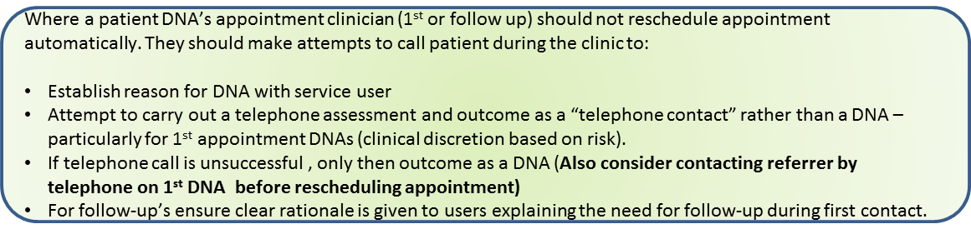

RULE 2: Discharge back to GP
For non-urgent cases (based on clinician discretion) referring back to GP cases where there has been more than two DNAs.
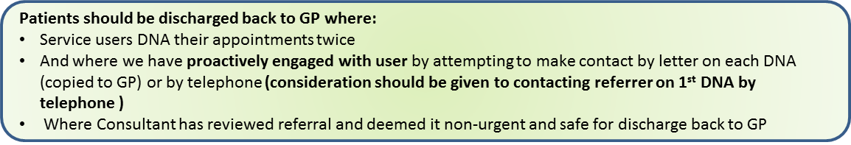

RULE 3: Cancellations
Cancellations should not be coded as a DNA. These will have negative impact on DNA figures. Please note, patient or staff cancellations are currently exempted from the DNA calculations.
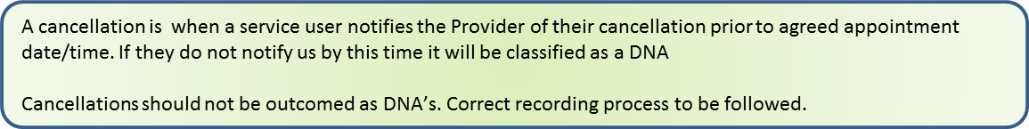

RULE 4: Unplanned contacts/visits & DNAs
Unplanned or unscheduled visits should be captured as unplanned appointment on RiO. If the visit is unsuccessful then the outcome should be coded as cancellations and not DNA.
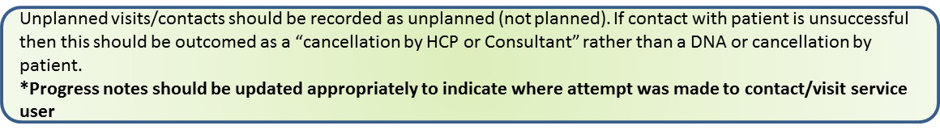

RULE 5: Appropriate recording of indirect contacts
For indirect contacts, please ensure that Face to Face check box is un-ticked.


Appendix 3: Access and Waiting Time Standards: Adult Mental Health Services
The NHS 10-year plan commits to improving timely access for adults with severe mental illness through integrated models of care across primary and community mental health services. This includes the development of a new national four-week waiting time standard for non-urgent referrals, as outlined in the Clinically led Review of Standards (CRS).

Services in Scope
This standard applies to the following services listed in the Mental Health Service Data Set (MHSDS):
- A05 - Primary Care Mental Health Service
- A06 - Community Mental Health Team – Functional
- A08 - Assertive Outreach Team
- A09 - Community Rehabilitation Service
- A12 - Psychotherapy Service
- A13 - Psychological Therapy Service (non-IAPT)
- A16 - Personality Disorder Service
- Community Eating Disorder Services (C10, previously C03)

Service-specific Targets
Service | Target
CMHTs | 4 weeks
EIS | 2 weeks
Memory Clinic | Assessment and diagnosis within 6 and 18 weeks respectively (diagnosis stops the clock)
Perinatal | 28 days
Urgent Care Response | 1-hour, 4-hour and 24-hour targets
Autism Services | 13 weeks

Clock Start
The clock starts when the first request for mental health service is received. Referrals may come from:
- GP
- Home Treatment Team (HTT)
- A&E (Psychiatric Liaison Service)
- Crisis Assessment Team
For specific details on Crisis services, please review the policies in Appendix 1.

Clock Stop
The clock stops when a person:
- Receives an appropriate clinical or social intervention, or
- Has a co-produced care plan in place, and
- Has completed a meaningful assessment with a recorded baseline outcome measure.
Treatment does not always start in the first appointment, in which cases the clock may be stopped in subsequent appointments/contacts. Clock stops on can be found on Reporting Services.
The waiting times table and diagram below shows the ‘clock start’ and ‘clock stop’ as outlined in the Clinically-led Review of Standards Consultation:
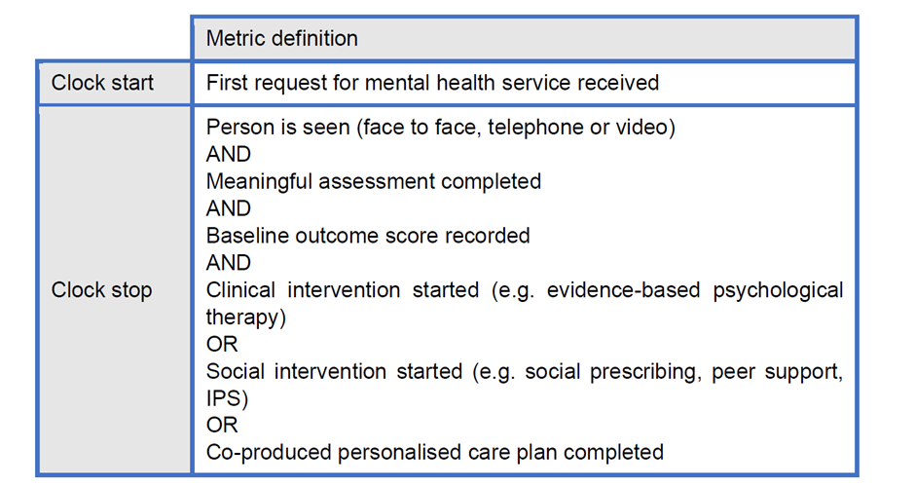
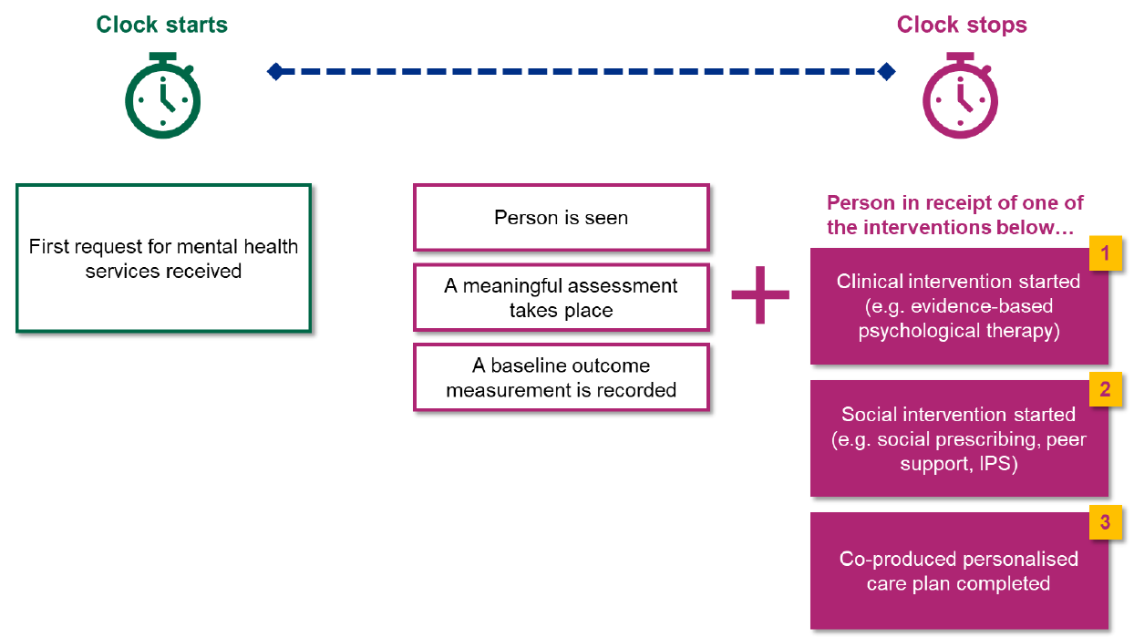
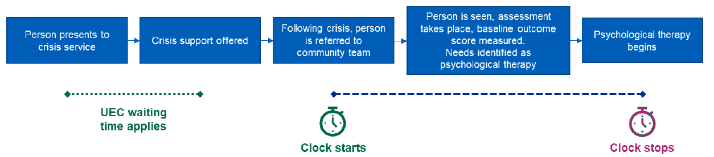
What Counts as a Meaningful Assessment
An assessment that can lead to:
- The start of a clinical or social intervention
- An agreed care plan
Triage or initial signposting assessments do not qualify as a clock stop. Services should follow NICE guidance for comprehensive assessments.

Outcome Tools
The Trust uses the DIALOG tool for adult and older adult services. Other teams may use additional tools as defined in their Standard Operating Procedures (SOPs).

What Constitutes a Valid Intervention (Clock Stop)
(a) Social Interventions
These reflect the holistic model set out in the Community Mental Health Framework. Examples include:
- Financial advice or support
- Housing or homelessness support
- Employment services (e.g. Individual Placement and Support)
- Education or training opportunities
- Social prescribing
- Peer support services
- Social care planning
These may be delivered by ELFT teams or VCSE partners.

(b) Clinical Interventions
Examples include:
- Psychological therapies (CBT, family therapy, counselling)
- Medication initiation
- Occupational therapy or arts therapies
- Physical health interventions (e.g. smoking cessation, weight management)

Appendix 4: Access and Waiting Time Standards: Community Health Services

RTT Framework

1.0 What Starts the Clock

1.1 Referrals by care professionals or services
Rule 1: a waiting time clock starts when any care professional or service permitted by an English NHS commissioner to make such referrals, refers to:
- a) a service that adheres to the 18-week RTT standard, regardless of setting, with the intention that the patient will be assessed and, if appropriate, treated before responsibility is transferred back to the referring health professional or general practitioner (GP)
- b) an interface or referral management or assessment service, which may result in an onward referral to a consultant-led service before responsibility is transferred back to the referring health professional or GP

1.2 Self-referrals
Rule 2: a waiting time clock also starts upon a self-referral by a patient to the above services, where these pathways have been agreed locally by commissioners and providers and once the referral is ratified by a care professional permitted to do so.

1.3 The need for a new clock
Rule 3: upon completion of a consultant-led RTT period, a new waiting time clock only starts:
- a) upon the decision to start a substantively new or different treatment that does not already form part of that patient’s agreed care plan
- b) upon a patient being re-referred into a service as a new referral
- c) when a patient rebooks their appointment following a first appointment ‘did not attend’ (DNA) that stopped and nullified their earlier clock (however, further DNAs do not reset the clock for service users or services, as per ELFT policy)

2.0 RTT: What Stops the Clock

2.1 Clock stops for treatment
Rule 4: a clock stops when:
- a) first definitive treatment starts – this could be:
  - treatment provided by a healthcare professional
  - intervention provided to manage the patient’s disease, condition or injury and avoid further interventions

2.2 Clock stops for ‘non-treatment’
Rule 5: a waiting time clock stops when it is communicated to the patient, and subsequently their GP and/or other referring practitioner without undue delay that:
- a) it is clinically appropriate to return the patient to primary care
- b) a patient declines treatment having been offered it
- c) a clinical decision is made not to treat
- d) a patient DNAs their second appointment following the initial referral that started their waiting time clock, provided that the provider can demonstrate that the appointment was clearly communicated to the patient where clinically appropriate
  - In cases where there are safeguarding risks to the patient, the clock will not be stopped at this point.
- e) a patient DNAs any other appointment and is subsequently discharged back to the care of their GP, provided that:
  - the provider can demonstrate that the appointment was clearly communicated to the patient
  - discharging the patient is not contrary to their best clinical interests
  - discharging the patient is carried out according to local, publicly available or published policies on DNA
  - these local policies are clearly defined and specifically protect the clinical interests of vulnerable patients (for example, children) and are agreed with clinicians, commissioners, patients and other relevant stakeholders

NHS England National Guidance on Recording and Reporting RTT Waiting Times Guidance

Appendix 5: Access and Waiting Time Standards: Child and Adolescent Mental Health Services (CAMHS)
- Overview:
1.1 Current Practice:
CAMHS currently measures waiting times in two parts:
a. Referral to Assessment (first direct contact)
b. Referral to Treatment (second direct contact)

Additionally:
- Children and Young People’s Eating Disorder Services and Crisis Services follow separate national standards.
- Home Treatment Teams also operate under ICB/Collaborative response time targets.

1.2 Upcoming Changes:
CAMHS is moving towards a new model: Referral to First Intervention (including both direct and indirect contacts) within 4 weeks. This differs from the adult standard.

2.0 CAMHS Access Standard:

The below information is taken from: Measuring waiting times in non-urgent community mental health services: Draft Guidance on the new metrics. Draft updated 23/04/24

Children and young people and their families/carers asking for help from community-based mental health services should start to receive help within four weeks of the request for service (referral). This may involve immediate advice, support or a brief intervention, help to access another more appropriate service, the start of a longer-term intervention or agreement about a patient care plan, or the start of a specialist assessment that may take longer.

2.1 Services in Scope
The CYPMH Waiting Times metric will include all children aged 0-17 at date of first referral, to all services across the children and young people’s community mental health pathway, other than exclusions listed below. As CYPMH encompasses a broad pathway we have not detailed all services in scope, but instead list exclusions by exception.
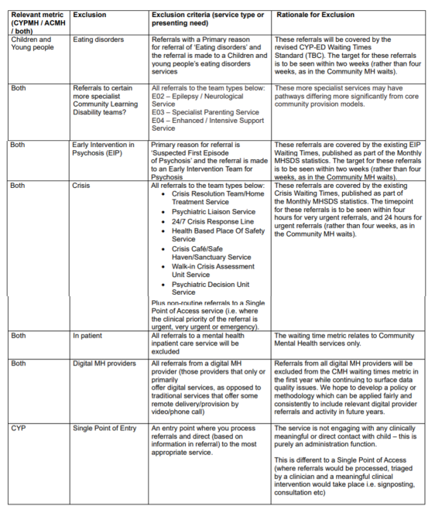

2.2 Clock Start and Clock Stop
The waiting times table and diagram below shows the ‘clock start’ and ‘clock stop’ as outlined in the Clinically-led Review of Standards Consultation:
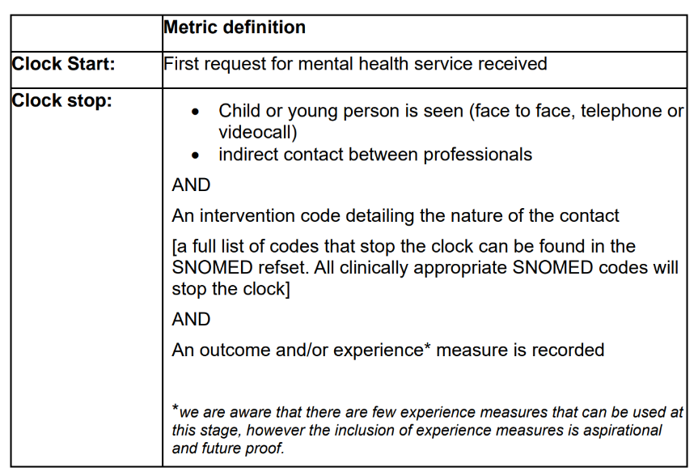
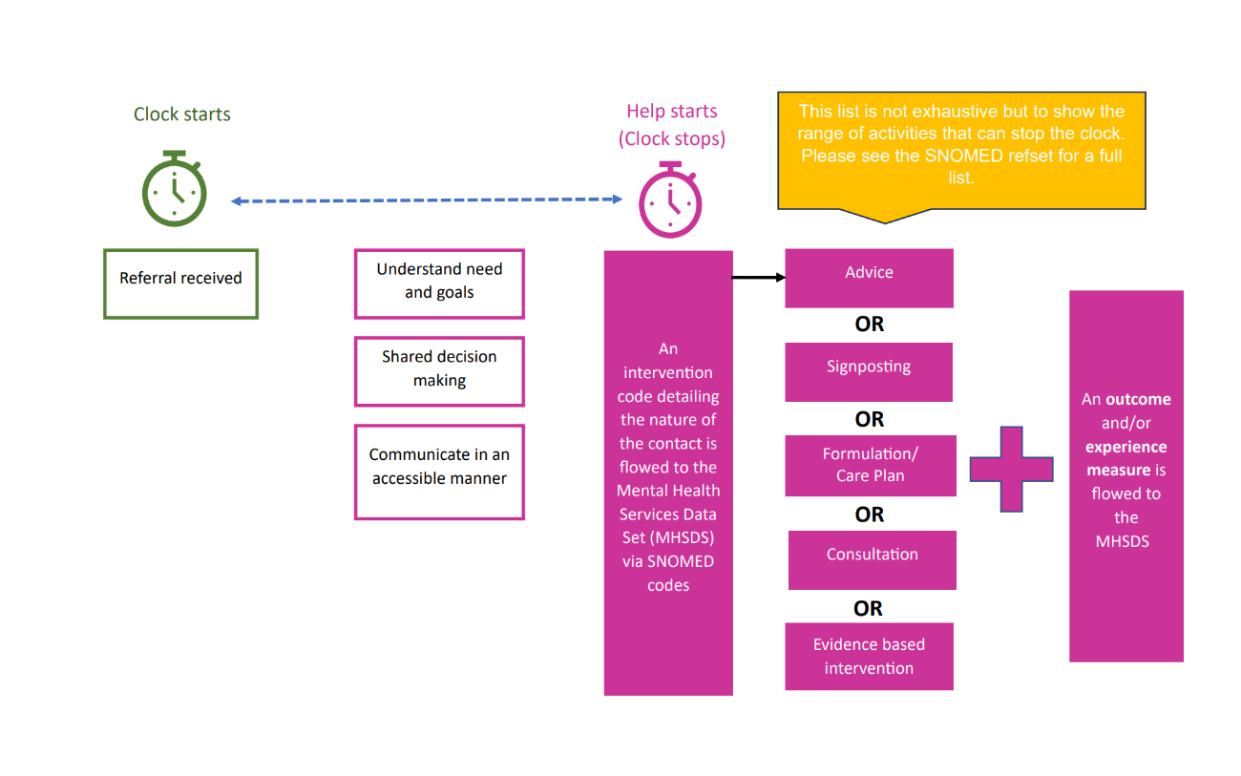
It is essential that:
- Services ensure that, from the first contact, effort is made to understand the needs and perspectives of the child or young person, their parent or carer so that they access the most helpful intervention (whether this be advice, support, a reasonable formulation of the presenting problem, a therapeutic intervention).
- The needs and perspectives of children and young people their parent or carer should be considered in a holistic and compassionate way, so that they feel listened to; the impact of their mental ill health upon their daily life and future plans is understood; different support options are discussed; the chosen intervention is agreed jointly by the clinician and young person/ parent Services understand any interventions that have been used to meet the mental health needs of the child or young person
- Services identify any safeguarding concerns, actual or potential risks of harm to self, and to or from other people.
- Staff communicate in ways that are accessible and appropriate for children and young people.

This is intended to work with frameworks such as iThrive and the Care and Partnership Approach (CAPA).

Appendix 6: Access and Waiting Time Standards: Talking Therapies for Anxiety and Depression

The NHS Talking Therapies, for anxiety and depression programme aims to support as many people as possible, through providing assessment, advice and for those who are likely to benefit, a course of treatment.

All patients will receive an assessment, be given advice and psychoeducation, and either signposted elsewhere or offered a multi-session course of NHS Talking Therapies treatment. A patient is coded as having ‘received a course of NHS Talking Therapies treatment’ if they have been discharged and at least two sessions are recorded as either ‘assessment and treatment’ or ‘treatment’.

Services in Scope
- NHS Talking Therapies for Anxiety and Depression. Within ELFT this includes
- Bedfordshire Talking Therapies
- Newham Talking Therapies
- Tower Hamlets Talking Therapies
- ELFT Digital Therapies when delivering interventions on behalf of one of the three services named above.
- Where ELFT Digital Therapies is delivering Talking Therapies interventions on behalf of another provider Trust, then the locally applicable waiting time targets, DNA policies and recording standards should be followed

Clock Start
The clock starts when the referral is received by the service, either through the online self-referral form, by telephone, or from a GP or another relevant service.

Clock Stop
The clock stops when a person:
Has attended their first MDS (Minimum Data Set) appointment and recorded outcome measures on both the PHQ-9 and the relevant anxiety measure.

Outcome Measures
Most people who are seen in NHS Talking Therapies, for anxiety and depression services report significant levels of both depressive and anxiety related symptoms. Patients complete measures for both depression and anxiety at every session.

Patient health questionnaire – 9 (PHQ-9) is used as the depression measure for all patients.

Generalised anxiety disorder assessment (GAD-7) is the default measure for anxiety. This scale was originally developed to assess the severity of anxiety symptoms in generalised anxiety disorder only.
In cases where there is a specific anxiety disorder identified it would be more appropriate to replace GAD-7 with an appropriate anxiety disorder specific measure (ADSM).
The below tables give the recommended outcome measure for each problem descriptor:

Main mental health problem  (primary problem descriptor) | Depression symptom measure |  | Recommended measure for anxiety symptoms or medically unexplained symptoms (MUS)
Depression | PHQ-9 |  | Generalised anxiety disorder–7  (GAD-7)
Generalised anxiety disorder |  | PHQ-9 |  | GAD-7
Mixed anxiety/depression |  | PHQ-9 |  | GAD-7
No problem descriptor |  | PHQ-9 |  | GAD-7
Chronic pain  (in context of anxiety/ depression) |  | PHQ-9 |  | GAD-7
Agoraphobia |  | PHQ-9 |  | Mobility inventory (MI)
Health anxiety (hypochondriasis) |  | PHQ-9 |  | Health anxiety inventory
OCD |  | PHQ-9 |  | Obsessive-compulsive inventory (OCI)
Panic disorder |  | PHQ-9 |  | Panic disorder severity scale (PDSS)
PTSD |  | PHQ-9 |  | PTSD checklist for DSM-5 (PCL-5)
Social anxiety |  | PHQ-9 |  | Social phobia inventory (SPIN)
Body dysmorphic disorder (BDD) |  | PHQ-9 |  | Body image questionnaire (BIQ) weekly
Chronic fatigue syndrome |  | PHQ-9 |  | Chalder fatigue questionnaire (CFQ)
Irritable bowel syndrome |  | PHQ-9 |  | Francis irritable bowel syndrome (IBS) scale
MUS not otherwise specified |  | PHQ-9 |  | Patient health questionnaire–15 (PHQ-15)

Talking Therapies DNA and cancellations

Where a patient DNAs two appointments within their course of treatment this would generally result in the patient being discharged from the service unless there are significant extenuating circumstances in which case managers may exercise flexibility.

Similarly, where a patient indicates that they will not be available for appointments for an extended period of time (e.g. travelling or hospital inpatient treatment) then the typical course of action would be to discharge the patient and advise them to self-refer again when they expect to have more consistent availability.

