QUICK REFERENCE GUIDE FOR RECORDING ENHANCED OBSERVATIONS ON ELFT INPATIENT WARDS

PowerApp – Fully Stopped
The PowerApp tool is no longer to be used for any part of observation recording.
All observation-related information is now recorded using the systems described below.

Process for ensuring correct R codes are being entered and maintained
What are the steps involved in this work?
What | Who | When
- Print R code reminder poster and put it somewhere visible on the ward | Ward managers | 01/12/25
- Put sticky notes on all monitors reminding staff of the new R codes (RCODE OBSVN01 INT, RCODE OBSVN01 CON) | Ward manager or named staff member | 01/12/25
- Put a rolling agenda item on your handover document outlining the correct R code process | Ward manager or named staff member | 01/12/25
- Remind staff at each handover of the correct R codes and the need to not copy & paste old notes or templates | Nurse in charge or person leading the handover | Daily
- In your daily safety huddles, use PowerBI (ward TV view, task view or detailed view) to review observations & check if they are correct | Whole MDT | Daily
- Allocate a named person in the safety huddle whose job it is to correct RiO entries for service users that are found to be wrong that day | Staff member allocated this role at the safety huddle each day | Daily
Changes to infrastructure (environment, policies, way people work, knowledge, skills)
Posters and sticky notes on the walls and monitors, daily discussions in huddles, daily discussions in handovers, addition of the reminder on handover document

What you need to record – and where
The figures below summarise the standard work agreed after reviewing staff concerns.
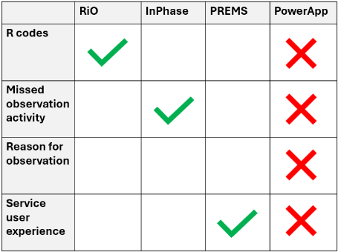

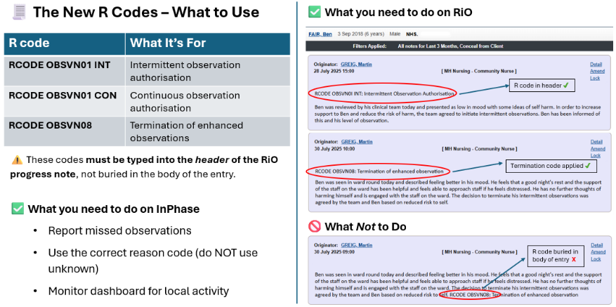

Summary – What this means for your daily practice
✔ RiO = R Codes for initiating and terminating observations (do NOT copy & paste old entries / templates – this may result in the wrong R code being entered)
✔ InPhase = Record missed observations and reasons
✔ PREMS = Record service-user experience
❌ PowerApp = No longer in use
This approach reduces duplication, ensures accuracy, and aligns all wards to the same record-keeping standard.

We have listened carefully to your feedback about the challenges of recording observations across multiple systems. Colleagues told us that duplication and switching between systems created unnecessary workload and confusion.
In response, we have reviewed the observation-recording process and agreed a single, standard approach for all wards.
This quick reference guide outlines exactly what you now need to do.

