ELFT Safeguarding Training Strategy

Safeguarding is a core responsibility of all staff across East London NHS Foundation Trust (ELFT).
This Safeguarding Training Strategy sets out how ELFT ensures that all employees — regardless of role or seniority — are equipped with the knowledge, skills, and competencies required to safeguard children, young people, and adults at risk of abuse or neglect.

1. Introduction
This strategy has been developed in accordance with:
- Safeguarding Children and Young People: Roles and Competencies for Healthcare Staff (RCPCH 2025)
- Adult Safeguarding: Roles and Competencies for Health Care Staff (Second Edition, July 2024)

It outlines the training levels required for different staff groups, the format and frequency of training, and the governance arrangements in place to monitor compliance and effectiveness. The strategy reflects ELFT’s commitment to continuous learning, prevention, and a whole-systems approach to safeguarding.
Training is structured around the principle of “proportionality and role-based competence”, ensuring staff receive safeguarding education that is relevant to their scope of responsibility. It also supports the delivery of safe, person-centred care by embedding key themes including trauma-informed practice, professional curiosity, Making Safeguarding Personal (MSP), ‘think family’ and transitional safeguarding.
By strengthening our collective safeguarding capability, this strategy supports ELFT’s strategic priorities of safety, equity, quality, and continuous improvement, ensuring that safeguarding is not only everyone’s responsibility, but also everyone's strength.

2. Training Levels Overview
Level | Audience | Indicative Duration | Delivery Format | Key Competencies
Level 1 | All staff (non-clinical, estates) | 30 min induction; annual refresher | E-learning | Basic awareness, reporting routes, general responsibilities
Level 2 | Staff with patient/public contact | 3 hours over 3 years | E-learning | Risk recognition, thresholds, referral, Prevent
Level 3  (Foundation including Domestic Abuse) | Staff assessing or delivering care | 12 hrs over 3 years | E-learning and then participatory, scenario-based training. | Risk assessment, Domestic Abuse, MCA  multi-agency
Level 3  (Refresher including Domestic Abuse) | Staff assessing or delivering care | 8 hours over 3 years | Participatory, scenario-based training and attendance at Safeguarding supervision sessions or evidence of learning via the Safeguarding Adult /Children L3 Refresher Evidence Form | Risk assessment, Domestic Abuse, MCA  multi-agency
Level 4 | Named professionals, Safeguarding Leads | 24 hours over 3 years | Supervision, networks, specialist training | Strategic leadership, complex reviews
Level 5 | Designated professionals | Ongoing specialist CPD | Forums, policy development, system leadership | System-level oversight, commissioning
Board | Executives and non-execs | 2 hours annually | Tailored briefings | Strategic accountability, scrutiny

3. Training Delivery and Refresh Cycles
- Levels 1 & 2: via e-learning and basic case-based sessions.
- Level 3 foundation: e-learning and then participatory learning is required (min. 50% activity-based).
- Level 3 refresher: requires 8 hours across 3 years (minimum 2 hours/year suggested).
- Levels 4–5: Reflective practice, supervision, and professional forums.
- Board level: Annual safeguarding assurance and accountability sessions.

4. Governance and Monitoring
The Corporate Safeguarding Team monitors compliance, training feedback, delivers audits, and reports quarterly to the Trust Safeguarding and Quality Committees. Safeguarding training is reviewed every two years. Compliance is tracked via ELA dashboards.

5. Equality, Diversity and Inclusion
Training content reflects cultural competence, racial equity, unconscious bias, and the safeguarding needs of protected groups, including LGBTQ+ and neurodivergent individuals.

6. Safeguarding Training Passport Template
Name | Role/Team | Safeguarding Level and training provider | Date Completed | Next Refresher Due

7. Next Steps & Development
- Consider: Create a new pathway for safeguarding level three training by introducing adult and child safeguarding level three e-learning courses for new starters and an integrated level three refresher training, which new starters will attend after completing the e-learning. This new integrated life-course safeguarding refresher training will include breakout sessions tailored to developmental stage risks.
- Enhance: scenario-based assessments and digital learning tools.
- Introduce: Let’s Change Practice newsletters to cascade learnings.
- Expand: offers to third-party providers.

8. Appendices

- Intercollegiate Document: Safeguarding Children and Young People: Roles and Competencies for Healthcare Staff (RCPCH 2025)
- Intercollegiate Document: Adult Safeguarding: Roles and Competencies for Health Care Staff (Second Edition, July 2024)
- Safeguarding Assurance and Accountability Framework (SAAF)

- Level Three Safeguarding Training Process Map:

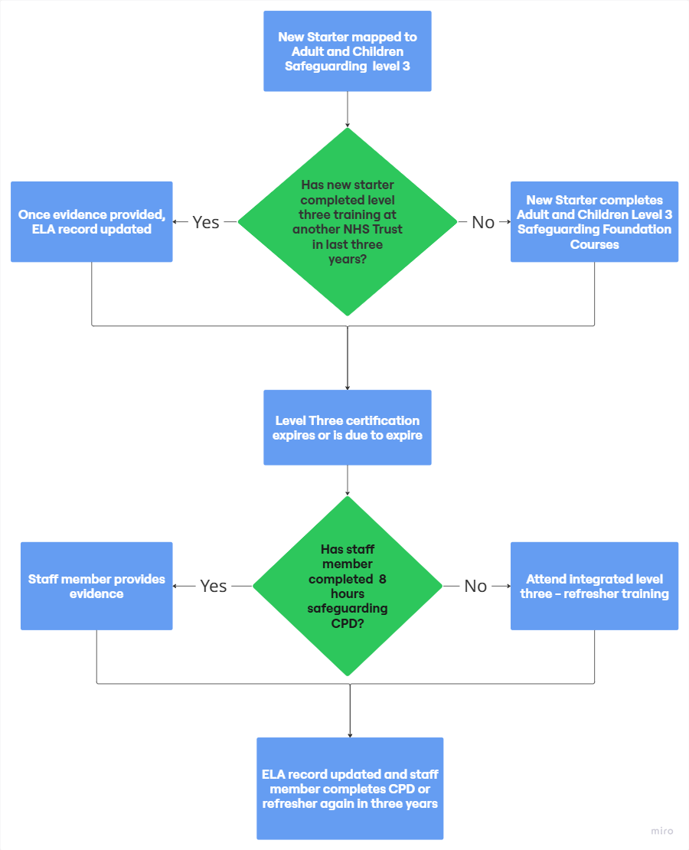

- Safeguarding Passport
Name | Role/Team | Safeguarding Level and training provider | Date Completed | Next Refresher Due

- Level Three Refresher Learning Log

ELFT SAFEGUARDING ADULT/CHILDREN LEVEL 3 REFRESHER EVIDENCE FORM

Full Name
Job Title
Service
Team
Tel Number

Email address
Number of hours training I am required to undertake every 3 years – 8hrs (Adult) 12hrs (Children)

Courses Attended (please type if possible and include as many as apply):
Course Title | Course Organiser  (e.g. safeguarding children partnership by borough or conference provider) | Date | Duration (hours) | Evidence that I have Attached (e.g. scanned certificate)

Final Checklist
- Check you have undertaken the required hours
- Check you have evidence for all courses to hand
- Scan the form and all evidence documents
- Keep an electronic and/or hard copy in your PDP records
- Email the form and evidence documents, with Level 3 Refresher Evidence in the subject line, copying in your line manager, to:

Safeguarding Children Team: elft.safeguardingchildrenteam@nhs.net

Safeguarding Adults Team:
London based team: elft.safeguardingadults@nhs.net
Pan Bedfordshire Teams: elft.sovabl@nhs.net

Declaration:
I have completed the required minimum 8 hours of refresher training to be compliant at Level 3.
Signed:
Date:

- Safeguarding Learning Reflection Record
(to be completed following each individual learning activity)

The purpose of this reflection record is to enable health professionals to record the details of any safeguarding children / adult learning that they complete. This information can be used to inform discussions during 1:1’s and at their annual Appraisal / Personal Development Review (PDR). It can also be used to support revalidation.

Accurate records of all training undertaken including programmes, notes and attendance certificate must be kept for audit purposes.

Date:

Topic and learning activity
What did you learn/key points of the learning activity
How does this relate to the knowledge, skills, attitudes and values and competencies outlined in the intercollegiate Safeguarding Children and Young People; Roles and Competencies for Healthcare Staff?
How will the learning affect your future practice?

